Chapter 8
Water related impacts
September 2019

Chapter 8

Water related impacts

Overview

Groundwater
Groundwater is located beneath the earth’s surface and forms an integral part of the water cycle. Groundwater is stored and transmitted through the tiny pore spaces between soil and rock particles, or cracks, fractures, and crevices with the rock itself. Groundwater is sourced from water that originates above the ground; either from rainfall that has infiltrated into soils or rocks; or from surface water from rivers, streams and other waterways that has seeped into the subsurface. In some cases, groundwater is also required to maintain surface water flows in waterways.
Groundwater can have many and varied uses that may benefit people and the environment – these are generally referred to as ‘beneficial uses’. The main beneficial uses relevant to North East Link are:
- Groundwater users – groundwater extraction for industrial, commercial, municipal supply or stock and domestic purposes
- Groundwater dependent ecosystems (GDEs) – ecosystems that have their species composition and natural ecological processes influenced by groundwater. They require access to groundwater to meet some or all of their water requirements.
PER Technical Appendix B – Groundwater technical report describes the groundwater resources that may support matters of national environmental significance (MNES) and provides an assessment of potential groundwater-related impacts. Potential impacts on groundwater dependent ecosystems are assessed in PER Technical Appendix A – Flora and fauna technical report. Sections 8.2 and 8.3 of this chapter summarise the relevant sections of PER Technical Appendices A and B, addressing the items in Section 2.5.2.1 of the PER Guidelines.

Surface water
Surface water quality and hydrology are important to the health and sustainability of Melbourne’s urban creeks, river systems and floodplains. Changes to surface water also have potential to affect the habitat of listed threatened species and communities, and listed migratory species.
PER Technical Appendix C – Surface water technical report describes the surface water resources that may support MNES and provides an assessment of potential surface water-related impacts. Sections 8.4 and 8.5 of this chapter summarise the relevant sections of PER Technical Appendix C, addressing the items in Section 2.5.2.2 of the PER Guidelines.
The surface water assessment focuses on the key waterways that may impact listed threatened species and ecological communities, and migratory species (or their habitat) that depend on these water resources. These waterways are:
- Banyule Creek
- Yarra River
- Koonung Creek.
Other waterways in the project boundary include three stormwater drainage systems located north of Watsonia which drain to the Plenty River (which itself ultimately joins the Yarra River upstream of the project boundary). While North East Link has the potential to impact surface water in the vicinity of these drainage systems, it is unlikely that any local surface water impacts would have a measurable effect on matters of national environmental significance (MNES). Therefore, these drainage systems are not discussed further in this chapter. Further detail on these drains is provided in PER Technical Appendix C – Surface water technical report.

Groundwater – description of the environment
A description of the existing groundwater environment is provided in Chapter 5 – Description of the environment. This section provides an overview of key aspects of the groundwater environment as relevant to the items in Section 2.5.2.1 of the PER Guidelines.
Since numerical groundwater modelling was undertaken for the preparation of the draft PER, further numerical groundwater modelling has been undertaken. The purpose of the further modelling was to incorporate additional groundwater data collected over a period of approximately 12 months. This enabled:
- Further refinement of model hydraulic parameters
- Refinement of conceptualisations
- Transient calibration to seasonal variations in groundwater levels
- Assessment of whether or not the additional calibration efforts result in changes to the assessment of predicted project-induced groundwater impacts.
The additional groundwater data, and further modelling outcomes, are included throughout this chapter.

Hydrogeological conceptualisations
In accordance with item (b) in Section 2.5.2.1 of the PER Guidelines, this subsection provides hydro-geological conceptualisations of Banyule Creek and the Yarra River. These conceptualisations have been prepared to describe groundwater flows, processes and interactions between elements of the water cycle. The conceptualisations are based on geological settings and inputs from geotechnical investigations, which are described in more detail in PER Technical Appendix B – Groundwater technical report.

Banyule Creek and Koonung Creek
The conceptualisation of groundwater at Banyule Creek is shown in Figure 8-1.
While the conceptualisation could also be applied to Koonung Creek, it is recognised that although the hydrogeological setting of Banyule and Koonung creeks share similarities, their catchments have differences. Banyule Creek flows through a mostly urbanised catchment, with little modification to the creek having occurred. Koonung Creek has undergone significant modification in terms of erosion control, realignment, and channelisation of flow. Its catchment is considerably more modified with the presence of the Eastern Freeway, and these features are not shown on the schematic.
These modifications can influence the hydrogeology. For example:
- The channelisation of flow can reduce inputs from groundwater inflows into the waterway, (for example, bank storage becomes negligible). However, over time, defects in channels, such as cracks, can reinstate some of the hydraulic connection
- The water quality and overall river ecological health can be influenced by channelisation and runoff from urban landscapes
- Riparian vegetation or lack thereof can alter groundwater fluxes entering the waterways
- Constructed wetlands or retarding basins within these areas may spatially shift groundwater dynamics within the existing floodplain. Retarding basins create ponding of water (albeit for short time periods) and opportunities for groundwater recharge. Deeper basins that intersect underlying groundwater may require lining structures (for the basins to operate effectively).
The geology in the conceptualisation has been divided into two aquifer systems. Both creeks are located within a narrow, thin Quaternary age alluvial sequence which has accumulated within a topographic low in the Palaeozoic basement. The Palaeozoic basement is shown as having a thin soil cover, and over much of the northern parts of the alignment—such as at Simpson Barracks—soils are generally one to three metres in thickness. In these areas, the alluvial sediments can be absent and the streambed is mostly founded upon weathered basement rocks, although downstream in the flatter grades the alluvial sediments may form the streambed materials.
Rainfall run-off within the catchment forms flow within the ephemeral creeks. Some rainfall (and groundwater) would be removed by evapotranspiration effects, such as water use by trees and evaporation to the atmosphere. Rainfall infiltrating the ground surface can move laterally within the permeable soils overlying the bedrock. Deeper infiltration of rainfall results in accessions to groundwater. Here, within the bedrock, groundwater would migrate under topographic gradients towards areas of lower elevation. Hydraulic gradients could be steep in undulating and elevated topographies, but could become flatter near lower lying areas and alluvial floodplains nearer the Yarra River. Groundwater would be stored and transmitted by the secondary porous features of the bedrock, such as cracks, joints and fractures. Groundwater would ultimately emerge as springflow or seepage to waterways or the floodplain sediments.
Figure 8-1 shows the groundwater table being higher than the surface water level, which means that groundwater can flow into the stream. However, the nature of interaction between the waterway and groundwater may vary seasonally and along the reach of Banyule Creek and Koonung Creek.
For example, in the Simpson Barracks area, stream flows are ephemeral and mostly related to stormwater run-off in the upper catchment areas. Banyule Creek water quality is generally of low salinity (less than 1,000 µS/cm) which is significantly fresher than native bedrock groundwater (greater than 6,000 µS/cm in nearby bores). This suggests the elevation of surface water levels would be higher than the surrounding groundwater, and so surface water would flow into the groundwater.
However, water quality sampling undertaken by ecological specialists in autumn 2018 in some deeper pools in Banyule Creek downstream of where the creek diverges from River Gum Walk, identified localised, higher salinities. This suggests that influent conditions are present in places. Further downstream within its catchment, on the alluvial floodplain south of Banyule Road, Banyule Creek is shallow and typically less than 1.5 metres deep, and not greatly incised into the floodplain. Preliminary information from the geotechnical program has identified shallow groundwater levels (less than 1.5 metres) and so it may interact with the water table.
In regards to Koonung Creek, there are few groundwater monitoring sites available along its reaches to confirm the surface water and groundwater interaction. Groundwater recharge is likely during flood events on Koonung Creek.

Yarra River
The conceptualisation of groundwater within a generalised Yarra River floodplain is shown in Figure 8-2. The floodplain is shown as a two aquifer system with alluvials consisting of sands, clays and gravels up to 20 metres thick, overlaying bedrock. Elsewhere, the Yarra River streambed may rest directly upon the Palaeozoic bedrock. The streambed conditions of the Yarra River are not well understood as drilling has not been completed close to, or within the streambed.
Owing to the porosity of the alluvial aquifer, it is likely to store larger quantities of groundwater relative to the low porosity bedrock. Recharge to the alluvials can occur through interaction with the Yarra River, or directly through infiltration of rainfall or flood overbanking over the floodplain catchment.

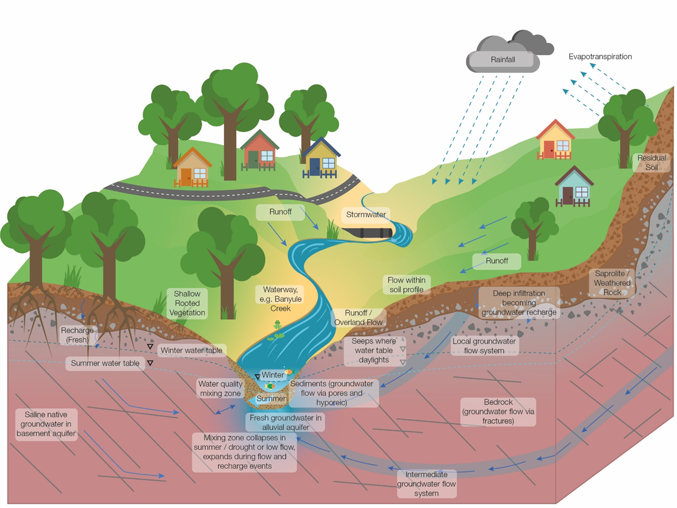
Figure 8-1 Hydrogeological conceptualisation of Banyule Creek
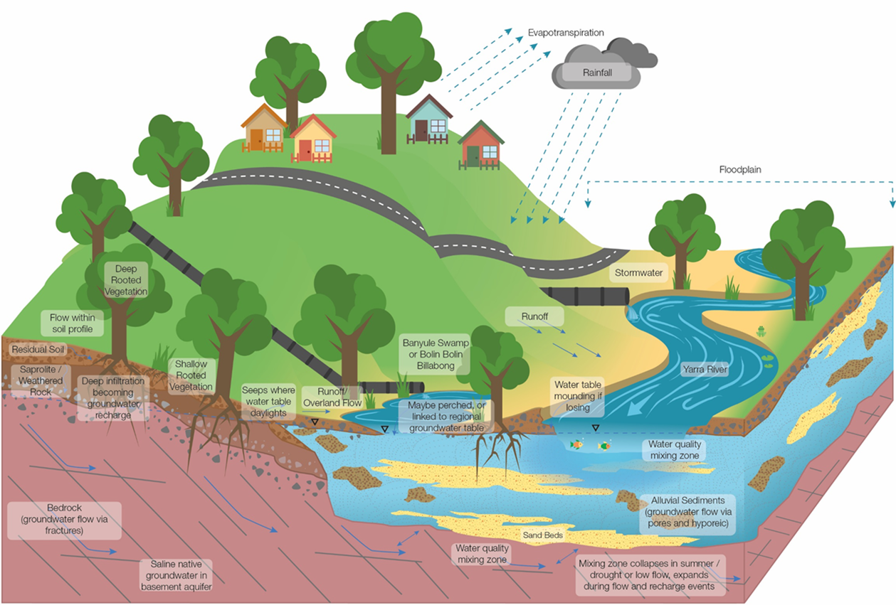
Figure 8-2 Hydrogeological conceptualisation of the Yarra River floodplain

There are a number of swamps and billabongs within the Yarra River floodplain. While annual flooding would have historically topped Banyule Swamp and Banyule Billabong, extractions from the Yarra River (elsewhere in its catchment) have reduced flooding frequencies and these filling events. Bankfull and overbank flows of the Yarra River are interpreted to be the primary sources of water for these wetlands, with other water sourced from local catchment runoff. Connection between Banyule Swamp and Banyule Billabong with groundwater is not known (Melbourne Water conceptualisation, date unknown).
Up to the 1990s, Bolin Bolin Billabong was frequently inundated (at least annually). However, inundation has been less frequent more recently. Water supply to the billabong is primarily from overbank and bankfull flows of the Yarra River. Floodplain inundation requires bankfull flows. The permanent pool of the billabong is suspected as being sustained by groundwater, and may be hydraulically connected to the Yarra River via the alluvium. Water level mapping suggests regional groundwater flow directions are westwards, from the elevated bedrock east of Bulleen Road, towards the billabong.

Groundwater levels
In accordance with item (c) in Section 2.5.2.1 of the PER Guidelines, this subsection provides details of depth to groundwater.
Influences on groundwater level may be natural or man-made. Natural influences are broad scale and typically related to seasonal variability or drought conditions. Man-made influences include groundwater abstraction and the intervention of built structures.
Around the M80 Ring Road (otherwise known as the Metropolitan Ring Road) and south to Lower Plenty Road, the groundwater table is generally at depths of greater than 10 metres below the ground surface. The exceptions to this are lower lying areas such as the Plenty River floodplain, north of Grimshaw Street, and along the Hurstbridge rail line where groundwater is closer to the surface.
From the northern tunnel portal to the Eastern Freeway, the groundwater table is generally less than 10 metres below the ground surface. Within the Yarra River and Koonung Creek floodplains, groundwater levels can be within five metres below the ground surface.
Around the Eastern Freeway, the groundwater table is generally five to 10 metres below the ground surface to the west of Bulleen Road, and potentially less than five metres below the ground surface to the east of Bulleen Road. Shallower groundwater levels are likely to be encountered within the floodplains of the Yarra River and Koonung Creek.
Figure 8-3 shows the modelled groundwater levels for the area.

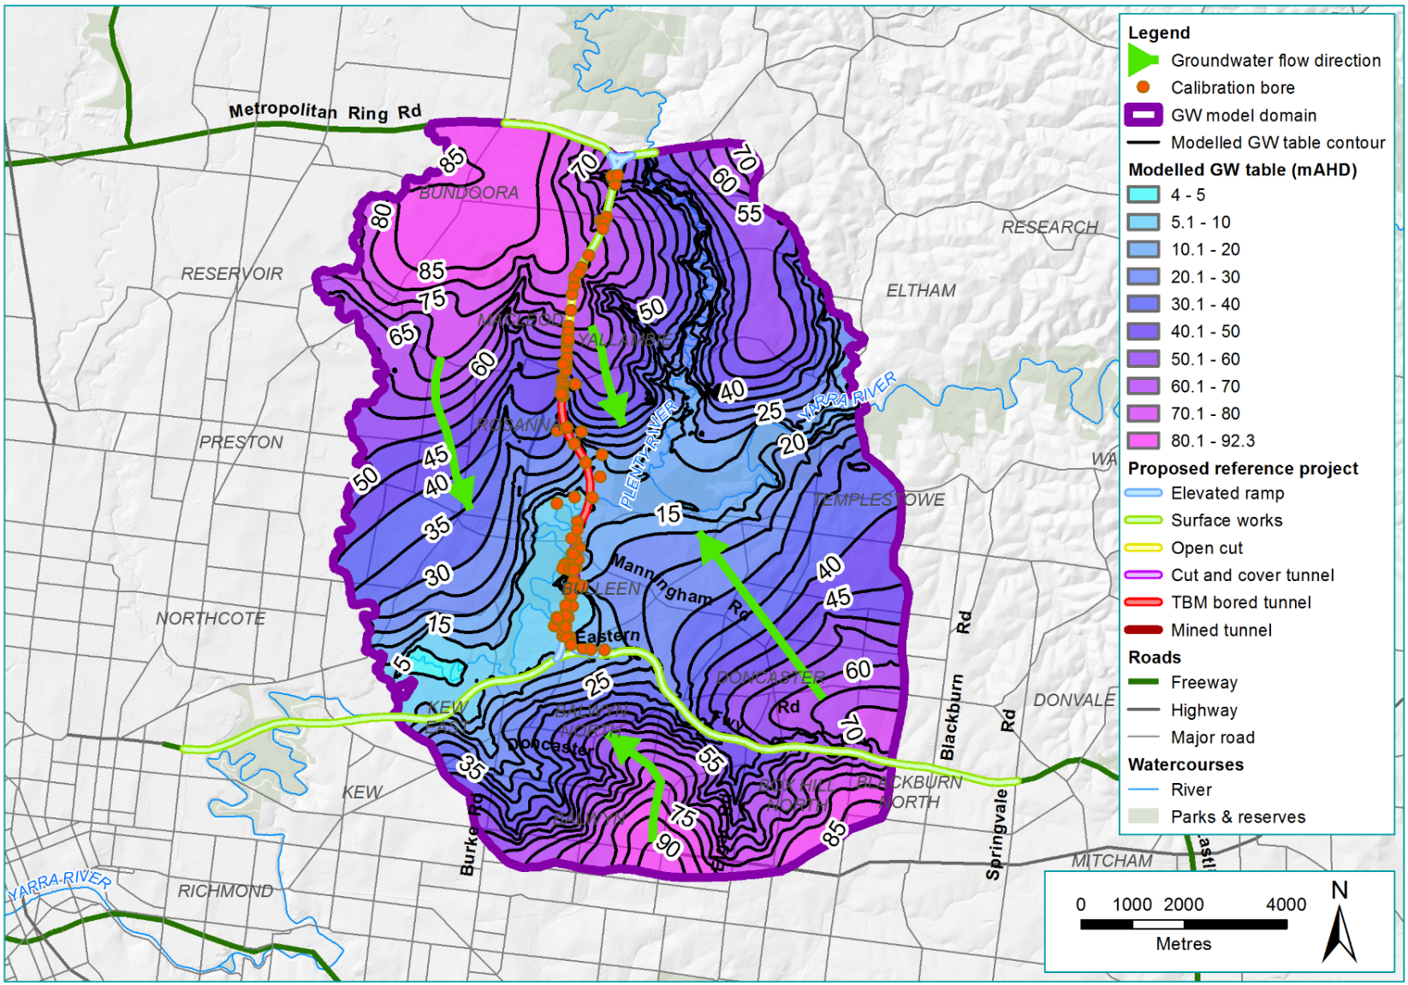
Figure 8-3 Modelled water table, with regional flow, around North East Link

Groundwater characteristics
In accordance with item (c) in Section 2.5.2.1 of the PER Guidelines, this subsection provides details of additional groundwater characteristics. This supplements the information provided in Chapter 5 – Description of the environment. Further information is also provided in PER Technical Appendix B – Groundwater technical report.

Horizontal hydraulic conductivity – site-testing results
Hydraulic conductivity (K) is defined as the ease with which water can move through pore spaces or fractures. It is dependent on the intrinsic permeability of the material, the degree of saturation and the density of the water. Hydraulic conductivity is measured at right angles to the direction of the flow.
To characterise material permeabilities, three approaches were applied during site investigation activities to characterise aquifer hydraulic conductivity:
- Packer testing of geotechnical boreholes – packer testing involves the use of bladders or packers to isolate different regions of the borehole. Water is injected into a zone within the borehole isolated by the packers and measurements made of flow rates over time
- Single bore slug testing of monitoring bores – slug testing measures the water level response in a well after a sudden change in water level (rise or fall)
- Aquifer pumping tests – aquifer pumping tests are conducted to evaluate aquifers by stimulating the aquifer through constant pumping and observing the response in observation wells. Typically occurring over days in duration, they are considered more robust than slug testing.
The testing was mostly focused to those areas of North East Link that would be below grade as either a tunnel or trench structure that intersected the water table. The hydraulic conductivity testing is summarised in Table 8-1 and Table 8-2 for the packer testing and single bore slug testing respectively.
Table 8-1 Hydraulic conductivity estimates – packer testing
Aquifer | No. of tests | Unit | Hydraulic conductivity (K)
 |  |  | Minimum | Maximum | Geometric mean
Bedrock | 62 bores  (342 tests) | Lugeons⁽¹⁾ | 0⁽²⁾ | 198.3 | 1.12
 |  | m/sec (by conversion) | 0 | 2.3 x 10⁻⁵ | 1.2 x 10⁻⁷
 |  | m/day (by conversion) | 0 | 2 | 1.2 x 10⁻²
Notes:
(1) 1 Lugeon ≅ 1.3 x 10⁻⁷ m/sec or ≅ 0.01 m/day
(2) No water uptake during testing.
Table 8-2 Hydraulic conductivity estimates – slug testing
Aquifer | No. of tests | Unit | Hydraulic conductivity (K)
 |  |  | Minimum | Maximum | Geometric mean
Bedrock | 22 | Lugeon (by conversion)⁽¹⁾ | 0.8 | 123 | 8.4
 |  | m/sec | 1.1 x 10⁻⁷ | 1.6 x 10⁻⁵ | 1.1 x 10⁻⁶
 |  | m/day | 9.2 x 10⁻³ | 1.4 | 1 x 10⁻¹
Alluvials | 8 | m/sec | 8.9 x 10⁻⁶ | 2.8 x 10⁻⁴ | 3.8 x 10⁻⁵
 |  | m/day | 7.7 x 10⁻¹ | 24 | 3.3
Note:
(1) 1 Lugeon ≅ 1.3 x 10⁻⁷ m/sec.
Lugeon value is for comparative purposes only – slug tests are not used to determine lugeons.

Storativity and specific yield
Storativity estimates are provided in Table 8-3, while acknowledging that specific yield (Sy) and storativity can be difficult to quantify.
Table 8-3 Published storativities
Formation | Specific yield (Sy) | Storativity (S) | Reference
Alluvials | 0.075 | - | (GHD, 2010)
 | 0.05 to 0.3 | - | (Dahlhaus, Brewin, Leonard, Dyson, & Cherry, 2004)
Palaeozoic Basement (generic) | 0.02 to 0.1 | 1 x 10⁻⁵ | (Leonard, 1992)
 | 0.02 to 0.05 | - | (Dahlhaus, Brewin, Leonard, Dyson, & Cherry, 2004)

Groundwater quality
Based on mapping, the regional groundwater salinity is between 1,000 mg/L Total Dissolved Solids (TDS) and 3,500 mg/L TDS; that is, beneficial use Segments A to B (where Segment A is the least saline, and F the most saline) for most of the study area, with the exception of the Eastern Freeway area. This area has high salinity groundwater (3,000 mg/L to 7,000 mg/L TDS) to the west of Chandler Highway, and east of Doncaster Road.
Selected geotechnical boreholes were converted to groundwater monitoring bores to establish a North East Link groundwater monitoring network. This was to support the engineering design and environment studies as well as any future baseline monitoring. Selected groundwater monitoring bores were sampled using low-flow sampling methods, in accordance with the Groundwater Sampling Guidelines of Victoria’s Environment Protection Authority (EPA). Since the exhibition of the draft PER, additional groundwater data has been collected for the project, and has been included in this final PER.
A summary of the original sampled groundwater is provided in Table 8-4.
Table 8-4 Sampled groundwater quality (original data)
Aquifer | Analyte | Unit | Count | Minimum | Maximum | Average | Geo. mean
Alluvials | pH | pH unit | 7 | 6.3 | 8.3 | 7.37 | 7.33
 | EC | µS/cm | 6 | 1,600 | 12,000 | 4,650 | 3,637
 | TDS | mg/L | 7 | 910 | 6,100 | 2,658 | 2,235
Bedrock | pH | pH unit | 26 | 6 | 8.6 | 7.60 | 7.57
 | EC | µS/cm | 23 | 5,500 | 19,000 | 11,117 | 10,518
 | TDS | mg/L | 26 | 730 | 9,900 | 5,720 | 5,099
Notes:
1. At time of reporting, no North East Link bores were developed in the volcanics (Newer or Older).
2. Whole of study area excludes Commonwealth land
Table 8-5 provides the additional data from the additional investigations.
Table 8-5 Sampled groundwater quality (additional data)
Aquifer | Analyte | Unit | Count | Minimum | Maximum | Average | Geo. mean
Alluvials (whole of project) | pH | pH unit | 39 | 6.24 | 8.3 | 7.08 | 7.07
 | EC | µS/cm | 38 | 1,180 | 13,000 | 5,315 | 3,898
 | TDS | mg/L | 35 | 703 | 7,190 | 2,795 | 2,148
Alluvials (Commonwealth land) | Not present on Commonwealth land (west side of Simpson Barracks)
Bedrock (whole of project) | TDS | mg/L | 104 | 730 | 12,000 | 6,268 | 5,602
Bedrock (Commonwealth land) | pH | pH unit | 24 | 6.7 | 7.8 | 7.4 | 7.4
 | EC | µS/cm | 24 | 8,380 | 18,300 | 12,095 | 11,768
 | TDS | mg/L | 24 | 5,220 | 10,800 | 7,061 | 6,835
Notes:
1. At time of reporting, no North East Link bores were developed in the volcanics (Newer or Older).
2. Whole of study area includes Commonwealth land
3. Some bores have been sampled more than once.

Groundwater dependent ecosystems
In accordance with item (e) in Section 2.5.2.1 of the PER Guidelines, this subsection identifies potential groundwater dependent ecosystems (GDEs) based on depth to groundwater. Further information is provided in PER Technical Appendix A – Flora and fauna technical report.
GDEs are natural ecosystems that require groundwater to meet some or all of their water requirements to maintain their communities of plants, animals, ecological processes or services. If groundwater availability is reduced or groundwater quality decreases, the ecosystems would be adversely impacted.
GDE reliance on groundwater in the study area is potentially via direct groundwater discharge to surface waters (such as baseflow to wetlands – surface expression of groundwater), and/or via evapotranspiration from the water table by vegetation (sub-surface expression). The degree of groundwater dependence typically varies temporally and/or opportunistically, depending on the availability of other sources of water (for example prevailing climate, and runoff during wetter periods). Groundwater dependence is also spatially variable, as dictated by factors including topography, water table depth and vegetation rooting depth, soil types and groundwater quality.
Existing mapping that identifies potential GDEs was used, as well as specific project modelling undertaken, to identify GDEs adjacent to the project boundary (see PER Technical Appendix A – Flora and fauna technical report). This is due to the conservative assumption that all vegetation within North East Link project boundary would be removed, and so any change in groundwater within the project boundary is not relevant. GDEs that have been identified adjacent to North East Link that may be affected based on depth to and reliance on groundwater are described below.

Banyule Creek and surrounds (Simpson Barracks)
At Simpson Barracks, the headwaters of Banyule Creek are mapped as a GDE, relying on the surface expression of groundwater. In addition, parts of the Plains Grassy Woodland mapped within Simpson Barracks are mapped as a GDE. This preliminary mapped data was then used to help determine modelled groundwater dependency, as described below. In the Plains Grassy Woodland, the dominant tree species are River Red Gum in the lower western section closest to the project boundary, in association with Yellow Box and Studley Park Gum.
On the lower slopes of Simpson Barracks, where depth to groundwater is modelled to be 10 metres or less (based on groundwater depth contours), it is assumed that River Red Gums are accessing subsurface groundwater for at least part of the year (such as during summer) or during drought conditions.
On the lower to mid slopes of Simpson Barracks (east of the project boundary) where depth to groundwater is 10 to 20 metres (based on groundwater depth contours), it is assumed that River Red Gums may be accessing subsurface groundwater for at least part of the year (such as during summer) or during drought conditions.
On the upper slopes of Simpson Barracks where depth to groundwater is greater than 20 metres (based on groundwater depth contours), it is assumed that River Red Gum and Yellow Box do not access subsurface groundwater.

Banyule Flats
GDEs are modelled extensively across the Banyule Flats area.

Yarra Flats (including Yarra floodplain, ephemeral Yarra billabongs, and Bolin Bolin Billabong)
At the proposed location of the North East Link southern portal, the majority of the Yarra River floodplain (characterised mainly by Floodplain Riparian Woodland) adjacent to the project boundary is mapped as GDEs, relying on the surface or subsurface expression of groundwater. The GDEs in this area are thought to be accessing an alluvial aquifer, which is understood to be strongly interconnected with Yarra River surface water levels, although local groundwater levels and flux pathways are affected by local geology and topography.
On the floodplain of the Yarra River where depth to groundwater is modelled to be zero to 10 metres, it is assumed that River Red Gums within the Floodplain Riparian Woodland EVC are accessing subsurface groundwater.
In billabongs associated with the Yarra River floodplain, where depth to groundwater is modelled to be zero to five metres, it is assumed these wetlands are largely filled by overland flow during floods or local runoff from natural or stormwater catchment, and so do not have obligate dependency. Connection to groundwater is expected to occur during and immediately following flooding or inundation events, as the water collected in the billabong seeps into the groundwater.
The eastern end of Bolin Bolin Billabong contains a deep pool, with an area of permanent surface water which rarely dries out (approximately once per decade) (Jacobs, 2017). This deep pool spanning an area of approximately 0.2 hectares is recognised by Melbourne Water as groundwater dependent (Jacobs, 2017) and at typical baseflow, the water level is approximately 1.8 metres deep.

Existing groundwater users
To assist with the assessment required by item (i) in Section 2.5.2.1 of the PER Guidelines, this subsection identifies potential groundwater users in the study area.
Groundwater uses are limited within the study area. This is due to the urbanised, mostly residential setting and the brackish to saline groundwater quality, limiting its benefits to potential users. There are 207 bores registered within one kilometre of the project boundary and the bore numbers by use type are summarised in Table 8-6. Two groundwater monitoring bores were also identified at Simpson Barracks during a site inspection. These monitoring bores are not registered and not accounted for in Table 8-6.
Table 8-6 Groundwater users in the study area
Registered use | Element |  |  | Total
 | M80 Ring Road to northern portal | Northern portal to southern portal | Eastern Freeway
Groundwater investigation | 0 | 0 | 37 | 37
Stock and domestic | 0 | 3 | 4 | 7
Use not known | 11 | 9 | 52 | 72
Miscellaneous | 0 | 1 | 0 | 1
Irrigation | 1 | 0 | 0 | 1
Commercial | 0 | 1 | 0 | 1
Observation | 1 | 8 | 79 | 88
Total | 13 | 22 | 172 | 207
Note: Bores with non-groundwater or SEC use classification omitted.
The majority of bores identified in the study area have been installed for either groundwater investigation or groundwater observation purposes and the majority of these are suspected to be for environmental or contaminated land investigation purposes.

Groundwater – relevant impacts and mitigation measures

Overview
North East Link would involve the construction of structures including tunnels and deep trenches located below the water table in some places.
North East Link would be located adjacent to environmentally sensitive areas, with groundwater connected water bodies and GDEs that are potentially sensitive to changes in the elevation of the water table, groundwater fluxes and water quality. These include water bodies such as the Bolin Bolin Billabong, a high value ox‐bow lake on the Yarra River floodplain in Bulleen, and vegetation that is potentially reliant on groundwater to meet some of its water requirements.
The main potential impacts of North East Link on groundwater are likely to be related to changes to the quality and level of groundwater (drawdown and mounding). A general description of how North East Link would likely affect groundwater quality and levels is provided below, with more specific discussions of impacts due to groundwater level changes provided in the subsections that follow.

Groundwater quality
Groundwater quality is not expected to decline during the construction and operation of North East Link. This is partly due to the existing groundwater quality being generally saline, and therefore considered to have a low sensitivity to adverse impacts.
The three main potential causes of a decrease in water quality include:
- Hazardous spills
- Contaminated stormwater runoff that is allowed to seep into the groundwater
- Artificial recharge (injection of fluids into existing aquifers).
Spills are a localised impact, and with standard mitigation are likely to be dealt with quickly enough to prevent a (long-term) reduction in quality. Stormwater runoff would be intercepted by water treatment features along the road alignment to be treated before potentially seeping into the groundwater and reducing the groundwater quality. Aquifer recharge is licenced under the Water Act 1989, with the water quality of any injection fluid needing to be compatible with the existing groundwater quality. For these reasons, a reduction in groundwater quality is not expected.

Drawdown
Changes to groundwater occur when it flows into an excavation or migrates around a cut-off. The lowering of the groundwater level at the excavation site creates a hydraulic gradient towards the excavation or tunnel, so the groundwater moves along that gradient from high pressure to low pressure. The decline in water level is referred to as the ‘drawdown cone’ or ‘cone of depression’ around the pumping bore, or drawdown zone around an excavation.
The extent of groundwater drawdown is influenced by the nature of the aquifer (high or low aquifer transmission capacities), the pumping rate (how quickly water is removed via pump or seepage) and how long the pumping or seepage occurs. Altering the hydraulic gradient may change the groundwater movement from (or to) features such as creeks and rivers, and cause a reduction in water availability at those features. Features such as rivers may stabilise the cone of depression by inducing leakage from the surface water to groundwater, thereby ‘topping up’ groundwater levels. Aquifer thinning or permeability changes (such as lateral changes in the transmission capacity of the aquifer) may increase drawdown, as the cone of depression would expand in order to supply the volume of water being taken from the aquifer.

Mounding
Barriers to regional groundwater flow, such as construction of an impediment, requires groundwater to migrate around that impediment. This can create an increase in groundwater level, or ‘mounding’, on the upstream side of the structure. Downstream of the impediment, there is less groundwater flowing through the aquifer, and groundwater levels tend to decline, resulting in drawdown.
A schematic of the groundwater conditions in the study area before and after the completion of North East Link is provided in Figure 8-4.
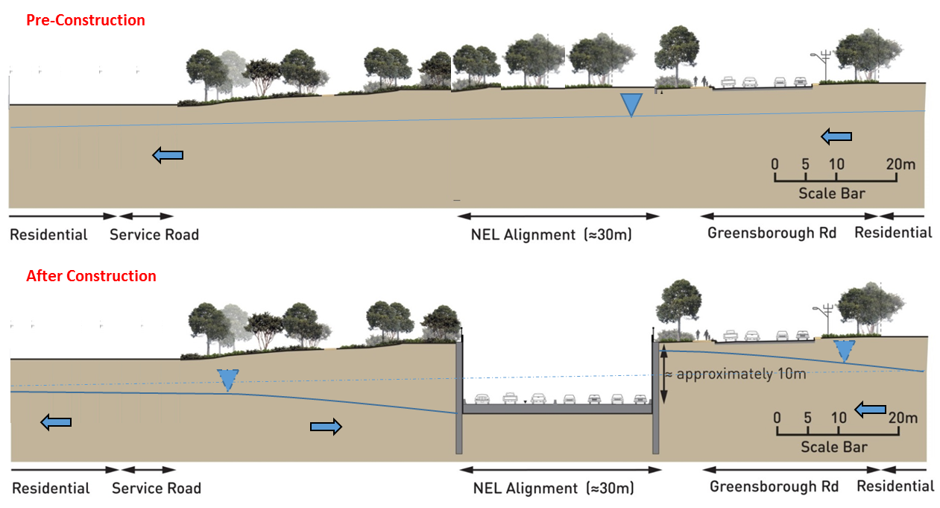
Figure 8-4 Barriers to groundwater flow
Falling groundwater levels on the downstream side of an impediment can adversely affect GDEs and existing groundwater bores, while mounding can create water logging, impacting vegetation or underground structures such as cellars and buried services. Impacts from changes to groundwater levels are greatest nearest the impediment and decrease with increased distance from the impediment.

Mitigation
Relevant mitigation for changes to groundwater level, such as ‘tanking’, are discussed in relation to the groundwater impacts identified in the sections below.

Groundwater modelling
The changes to groundwater levels due to North East Link have been predicted using a numerical groundwater model. This specifically includes the cut and cover structures and tunnels that would be constructed below the existing water table. The model simulates the behaviour of groundwater taking into account the properties of the aquifer, groundwater levels, the tunnel design and the proposed construction methods and duration. The primary objective of the numerical groundwater modelling was to inform potential impacts and risks of the construction of North East Link on sensitive receptors such as the ones described in Section 8.2 above.
Due to uncertainties in the data and model, 200 alternative models were developed, with each model providing plausible predictions for groundwater responses. At the time of the numerical model development there was insufficient data to enable transient calibration. The groundwater outcomes discussed in the sections below are based on the majority of the outcomes that the 200 models predicted. This is why drawdown is discussed in terms of 95th percentile values (that is 95 per cent of the models predict smaller values than the drawdown amount), and mounding in terms of 5th percentile values (that is only 5 per cent of the models predict greater than the mounding amounts).
The groundwater modelling report is provided as Appendix A of the PER Technical Appendix B – Groundwater technical report. The modelling report provides:
- Predictive numerical groundwater modelling
- An assessment of short and long-term analysis of modelling during the construction and operation of North East Link
- Predictions to groundwater recovery and re-equilibration scenarios and impact on nearby groundwater dependent assets
- Details of existing monitoring bores and data collection.
Since the numerical groundwater modelling was undertaken for the preparation of the draft PER, further numerical groundwater modelling has been undertaken. The purpose of the further modelling was to incorporate additional geological and groundwater data collected over a period of approximately 12 months. This enabled transient calibration to seasonal variations in groundwater levels and to assess whether or not the additional calibration efforts result in changes to the assessment of project-induced groundwater impacts.
With the transient calibration and the additional data, the updated model generally resulted in an improved model performance. Whilst the model performance has improved, the overall findings of the model are generally similar to the original. An uncertainty analysis has not been completed as part of the model update, however, predicted drawdowns tend to be less based upon the further modelling. Detail of this further modelling is provided in Appendix B of the PER Technical Appendix B – Groundwater technical report.
The impact discussions in the following sections include the outcomes from both the initial and further modelling.

Dewatering techniques and impacts
In accordance with items (b), (f) and (g) in Section 2.5.2.1 of the PER Guidelines, this subsection provides the results of the initial and further groundwater modelling, and details of proposed dewatering techniques and the impacts of dewatering.
Maps of the predicted changes to groundwater level are included in this section. Due to how the modelling is generated, the maps provided here cannot show the most likely upper limits of both drawdown and mounding together on a single map. Accordingly, likely drawdown is displayed on one map, with likely mounding shown on a separate map.

Impacts and mitigation
Dewatering (lowering the groundwater to allow construction/operation of North East Link) would only be required where the action intersects with groundwater. Groundwater drawdown is a likely effect of the dewatering required, and management of any groundwater captured would need to be considered.
Large areas of North East Link, particularly interchange and upgrade works associated with the M80 Ring Road and the Eastern Freeway, would include works undertaken either at or above ground level, and so lowering of the groundwater table would not be required. Groundwater intersection, and therefore dewatering, is predicted to occur from between Watsonia railway station (north) to near Koonung Creek (south). The greatest drawdowns and therefore the most dewatering would occur nearest the excavation faces, with the drawdown decreasing with distance from the tunnel or excavation.
North East Link would involve construction works below the water table, specifically:
- Tunnels (both via tunnel boring machine (TBM) and mined through conventional methods). TBM tunnelling is proposed between Lower Plenty Road and Manningham Road. Mined tunnelling would occur for a short section south of Manningham Road.
- TBM launch and retrieval portals. Portals at Lower Plenty Road and Manningham Road would involve cut and cover tunnelling. Potential construction methods to support excavation faces may include secant piles, soldier piles and diaphragm walls. Water inflow into these excavations could be limited by the selection of the ground support method. Grouting can be used as an additional control measure.
- Cut and cover tunnelling. Cut and cover tunnelling is proposed between Blamey Road and the Lower Plenty Road TBM portal, and the mined tunnel and the Eastern Freeway. The design indicates these sections would be drained during the construction of North East Link (allowing groundwater seepage) but tanked (watertight) upon its completion. Various ground control methods could be applied similar to those at the portals, such as grouting.
Disturbance to groundwater levels is expected to be greatest during the construction of North East Link when dewatering would generally be at its greatest. The greatest magnitude of dewatering would occur at the northern portal (near the Lower Plenty Road intersection) where the structure would be at its deepest below the water table. Figure 8-5 shows the predicted decrease in groundwater levels for the northern and southern portals during construction, with Figure 8-6 showing the predicted mounding (both using initial modelling). Figure 8-7 shows the groundwater level changes based on the further modelling.
The potential effects of dewatering depend on the relevant receptors in the drawdown and mounding areas (such as ecological, abstractive, waterways). Indirect impacts to ecological receptors due to the changes in groundwater level are discussed in Chapter 7 Impacts on listed threatened species and ecological communities, and on migratory species, and PER Technical Appendix A – Flora and fauna technical report. Potential decreases to the baseflow of waterways are discussed in Section 8.3.3 below.
As discussed in Section 8.2.6, the majority of bores within one kilometre of the reference project are not for abstractive groundwater use, but for monitoring purposes. As alternative water supply options are available (such as reticulated supply) these bores would likely have a low sensitivity to impact. The likely drawdown on the two bores identified as existing within the drawdown area during construction (on Simpson Barracks) is 0.5 to one metre for the initial modelling, and 0.1 to 0.5 metres for the further modelling undertaken. As seasonal changes in groundwater level of 0.5 to one metre could be reasonably expected, and these bores are most likely only used for monitoring purposes, the decrease in groundwater level at these bores is not expected to be significant.
During construction, mounding is predicted to occur mostly on the eastern side of the Manningham Road interchange, with the groundwater level increasing by around five metres (as per initial modelling) or more. However, even with this groundwater level increase, the water table would still be greater than five metres below the surface. As groundwater levels are not predicted to rise to within two metres of the surface, there is no elevated risk of salinity or water logging.
The main mitigation for dewatering is design philosophy, such as designing structures that are tanked, which would minimise groundwater changes by reducing the amount of groundwater inflow into the structures to almost nil. Tanking a structure allows the groundwater to migrate around it, allowing the flow of groundwater to continue, instead of being interrupted and cut off as discussed in Section 8.3.1. While mounding and drawdown still occur around tanked structures, the magnitude of the resulting groundwater change is significantly reduced when compared to a drained (permeable) structure.
The reference project includes a number of structures designed to be tanked which would limit the volumes of groundwater that need to be managed over the longer term.
During the operation of North East Link, as per the initial modelling, these tanked structures may still be subject to minor seepage inflows, but at magnitudes expected to be significantly less than during the construction phase. While the further modelling predicts greater inflow rates for the northern portion of the alignment, the operation inflow is still magnitudes less than during construction. Figure 8-8 shows the predicted groundwater drawdown for the northern and southern portals during the operation of North East Link, with Figure 8-9 showing the predicted mounding (both using the initial modelling). Figure 8-10 shows the groundwater level changes based on the further modelling.
A Groundwater Management Plan would also be required and would include requirements, construction methods and contingencies to maintain and protect groundwater quality. The Groundwater Management Plan would include requirements and methods for:
- Identification, treatment, disposal and handling of contaminated seepage water and slurries including vapours in accordance with relevant legislation and guidelines
- Assessment of barrier and damming effects
- Subsidence management
- Monitoring of dewatering and potential impacts on acid sulfate soils, including unconsolidated sediments and lithified sedimentary rock
- Protection of waterways and potential GDEs
- Management of unexpected contaminated groundwater eg using treatments, source removals, hydraulic controls, grouting and exclusion methods
- Management of possible impact to groundwater monitoring and management by third parties of existing contamination plumes
- Contingency actions when interventions are required.
A Groundwater Management Plan would not be limited to addressing the items above. A contractor would tailor the Groundwater Management Plan to the specific requirements of the project, consult with EPA Victoria in preparing the plan and develop the plan and requirements to a level that satisfies the independent environmental auditor.
Overall, the loss of groundwater from the bedrock aquifer system is not considered significant in terms of the overall resource. The bedrock aquifer is regionally extensive in size and the annual volumes of water take for North East Link would be small compared with the overall recharge.
Mounding would continue to occur on the east side North East Link during operation, especially near Manningham Road interchange. However, while mounding would increase in extent during operation, it would not increase in magnitude. Therefore the water table is predicted to remain over two metres below the ground surface, with no elevated risk of water logging or salinity impacts.

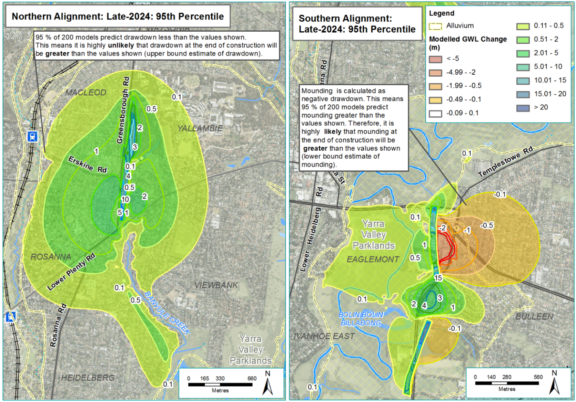
Figure 8-5 Predicted drawdown (positive values) around the northern and southern portals during construction, initial modelling
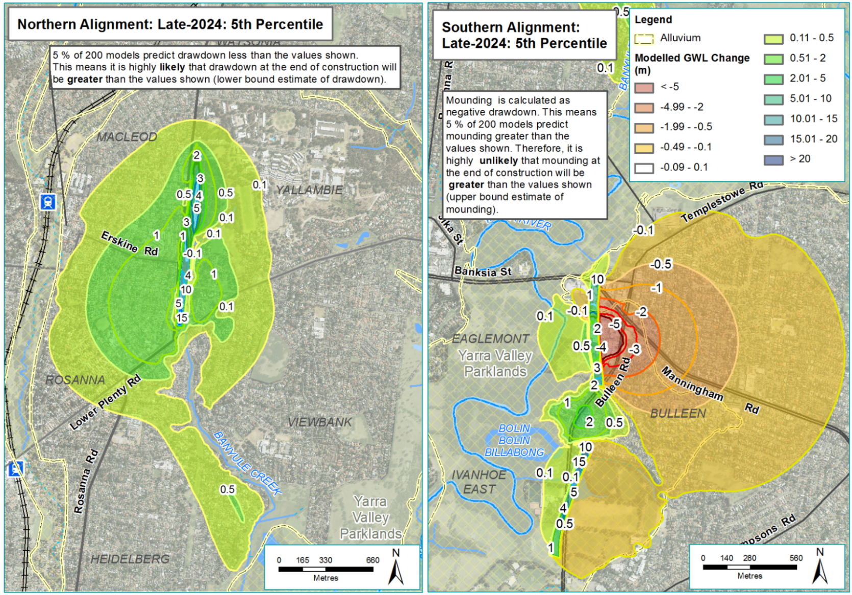
Figure 8-6 Predicted mounding (negative values) around the northern and southern portals during construction, initial modelling
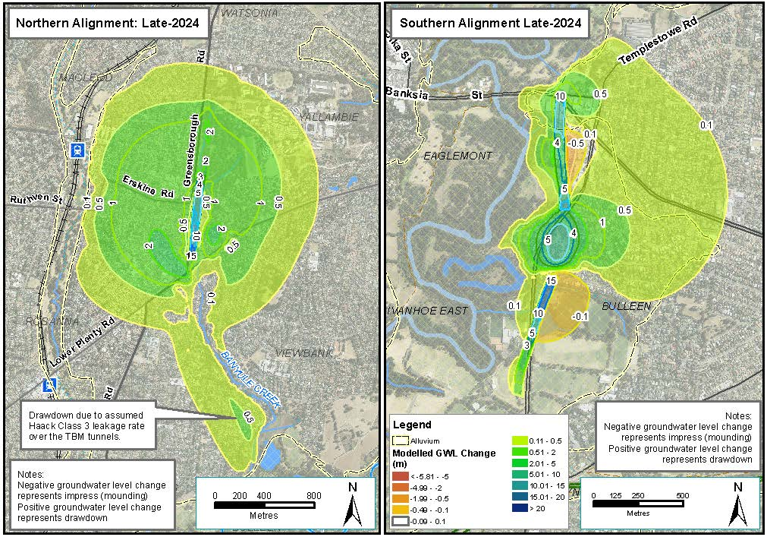
Figure 8-7 Predicted groundwater level changes during construction, further modelling
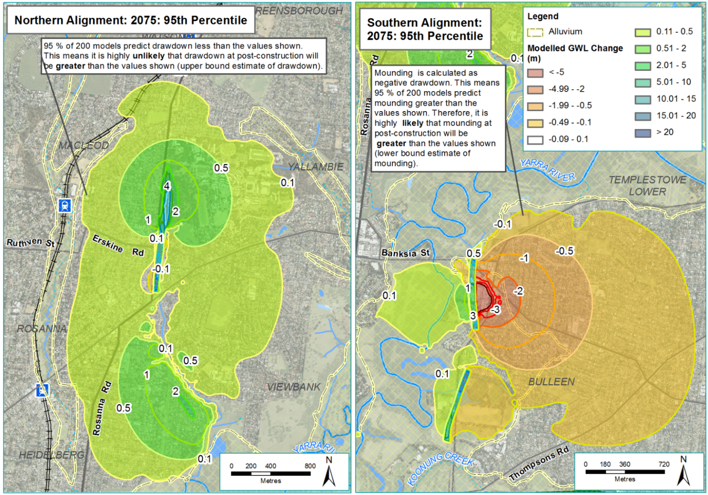
Figure 8-8 Predicted drawdown (positive values) around the northern and southern portals during operation, initial modelling
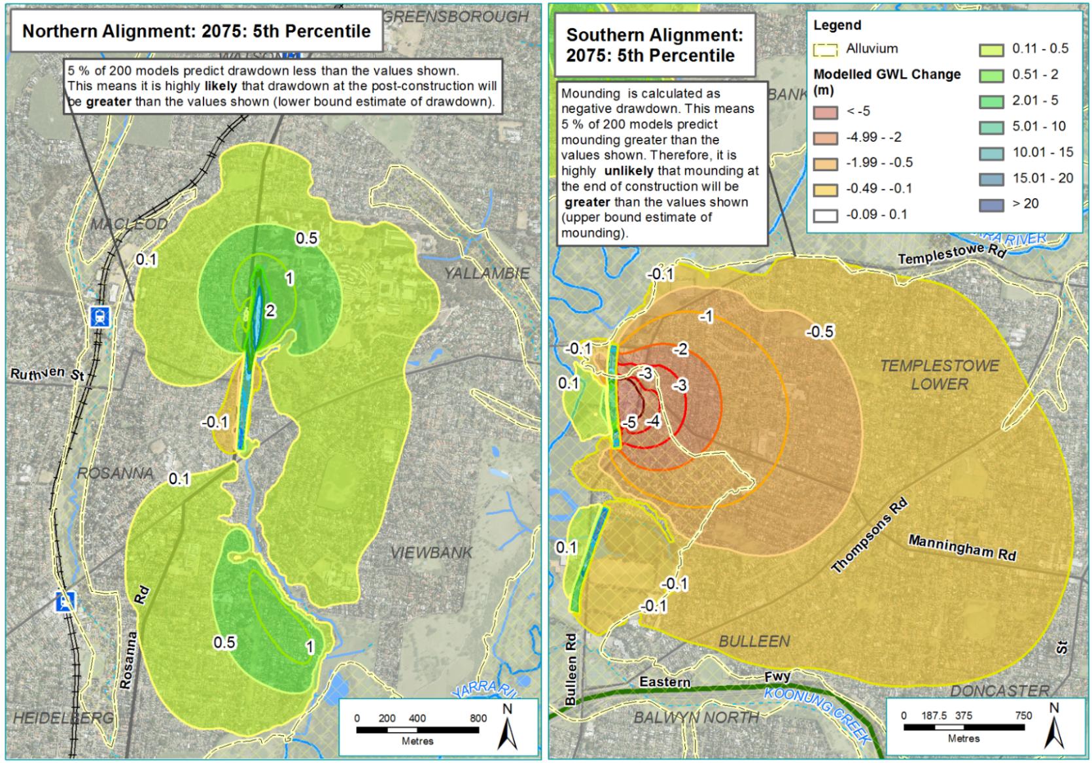
Figure 8-9 Predicted mounding (negative values) around the northern and southern portals during operation, initial modelling
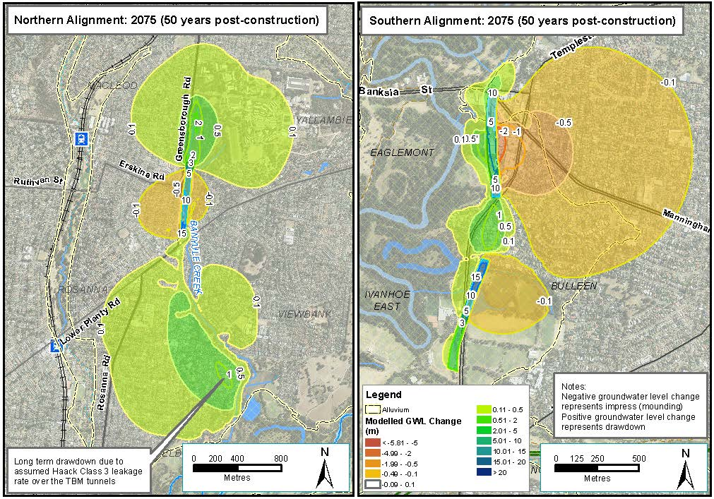
Figure 8-10 Predicted groundwater level changes during operation, further modelling

Groundwater management
At locations where dewatering would be required, techniques to control groundwater flow during the construction and operation of North East could include:
- Pumping – lowering water levels or pressures through the pumping of groundwater, or controlled seepage into excavations
- Exclusion – grouting to prevent inflows, freezing, cut-offs (vertical barriers), slurries and shields. In some cases the water proof lining system would be installed during construction of North East Link.
The management of any captured groundwater would depend on the water quality and the site water requirements:
- Groundwater may undergo treatment such as settling and subsequently be reused for construction activities, including for dust suppression or to make up water for slurries.
- Groundwater could also be reinjected into aquifers to provide hydraulic control on drawdowns. Disposal to groundwater must meet regulatory requirements such as State Environment Protection Policy 2018 (SEPP) (Waters) and Southern Rural Water licensing requirements. Treatment of the water before disposal may also be required to facilitate reinjection, such as to prevent mechanical, chemical or biological clogging.
- Groundwater could also be discharged to sewer, or to surface waterways. Disposal to sewer would require wastewater to meet trade waste acceptability guidelines of Yarra Valley Water. Disposal to waterways must meet regulatory requirements, such as SEPP (Waters) in terms of water quality (physical and chemical). Treatment may be required to achieve regulatory requirements and monitoring may be required to achieve compliance.
A key consideration with how the groundwater would be managed would be its salinity. The average salinity of the Palaeozoic bedrock aquifer is 5,600 mg/L (refer Table 8-5). Structures located in, or adjacent the alluvial floodplain (such as in the southern cut and cover sections) may receive lower salinity inflows. Ultimately, the salt load would be determined from a blend of waters entering North East Link structures, and disposal to sewer would need to meet agreed waste acceptance criteria.

Residual impacts
Once the construction of North East Link is completed, groundwater levels would gradually be restored toward a new equilibrium.

Potential changes to baseflow to the Yarra River and other waterways
In accordance with item (d) in Section 2.5.2.1 of the PER Guidelines, this subsection provides an assessment of the potential changes to groundwater baseflow contributions.

Impacts and mitigation
While there is generally a limited understanding of connectivity between surface and groundwater throughout the study area, waterways and groundwater are known to interact in a number of ways. The key waterways within the project boundary and their interaction with groundwater are discussed below.

Yarra River
Previous studies of the Yarra River suggest that gaining/losing flow conditions in the Yarra River are neutral between Heidelberg and the Chandler Highway across the year. This is largely a result of low to flat hydraulic gradients, and lower recharge rates occurring in the urbanised area. Regional groundwater mapping indicates groundwater flow is predominantly towards the Yarra River. A monitoring bore located at the former Bulleen Drive-in indicates that groundwater levels show a correlation with Yarra River flows.
The TBM tunnels would pass approximately 25 metres below the Yarra River. Tunnelling beneath any waterway results in a risk of altering the groundwater flow between the tunnel and the overlying water. The flow between groundwater and the Yarra River is influenced by the make-up of the bedrock, including faulting and geological structures. North East Link would utilise TBM tunnelling methods that typically adopt low face pressures, which would decrease the risk of altering the hydraulic connection between the groundwater and Yarra River.
Groundwater level drawdowns are predicted to extend beyond the Yarra River for the initial modelling, albeit at a low magnitude (0.1 to 0.5 metres). The volume of flow depleted from the Yarra River, as reduced seepage from groundwater to the streambed is expected to be several orders of magnitude less than the daily flow of the Yarra River: daily river flow of five cubic metres per second; with construction leakage of 0.003 and operational leakage of 0.0006 cubic metres per second. This would be a minor or negligible reduction of the Yarra River’s streamflow. The further modelling predicts a less than one per cent reduction in Yarra River baseflow due to the structures, which is smaller than the 5.5 per cent reduction predicted above by the initial modelling.
Due to the proximity of construction at the proposed Manningham Road TBM launch portal, and risks of connection between the Yarra River and excavations via coarse grained beds within the alluvium (or fracture sets within the bedrock) appropriate construction methods would need to be implemented to minimise inflows during construction to enable safe and stable working conditions and minimise adverse effects on the river flow.

Banyule Creek
Banyule Creek is a small freshwater waterway with its origin located at Simpson Barracks. It is considered to be an ephemeral stream with no permanent baseflow and is located upon the bedrock aquifer system. When the creek enters the Yarra River floodplain (in the lower parts of its catchment) it flows across alluvial sediments. It is known that groundwater in the bedrock aquifer is saline, and while groundwater contributions to the flow of Banyule Creek are possible, it is most likely only a minor contribution, based on the lack of salinity in the creek.
Long-term drawdowns in this region are expected to be around 0.1 to 0.5 metres for both initial and further modelling, which is within the range of seasonal fluctuation, and would be a negligible decrease on any contribution to streamflow.

Banyule Swamp and Banyule Billabong
Banyule Swamp is a wetland located on the margins of the Yarra River floodplain near Banyule Creek. Banyule Billabong is located marginally south of the swamp and is a freshwater marsh of less than two metres in depth and can dry out every four to five years. While annual flooding would have historically topped up the billabong and swamp, water extraction from the Yarra River has reduced flooding events. Overflow from the Yarra River and other water from local catchment run-off are the primary sources of water for the Banyule Swamp and Banyule Billabong. The groundwater dependence of the swamp and billabong is unknown.
As the construction of North East Link through this area would be related to the TBM, which tanks the tunnel as it goes, disturbance to groundwater would likely be minimal and is considered to be of low risk because:
- Tunnelling would be within the bedrock aquifer and would not ‘cut-off’ regional groundwater flow paths in this aquifer—groundwater would be able to migrate above and below the TBM tunnels.
- Alluvial floodplains have higher permeability, recharge rates, and storage relative to the bedrock aquifer, and thus a higher capacity to replace lost groundwater. Drawdowns in the alluvial floodplain would therefore likely be negligible as leakage from the alluvial sediments would prop up water levels in the underlying bedrock aquifer.
- Decrease in contribution to streamflow would be negligible.

Bolin Bolin Billabong
Bolin Bolin Billabong is located in Bulleen and is considered to have significant cultural and ecological value. The billabong has been conceptualised as having three zones:
- A deep pool, typically inundated with up to two metres of water
- Wet-dry arms, which are elevated higher than the deep pool and intermittently inundated to 0.5 metres of water
- Floodplain, elevated above the wet-dry zone and inundated to 0.1-metre depth at a frequency less than the wet-dry arms.
Drawdowns during the construction of North East Link are predicted to extend to the billabong. Some recovery of water levels is expected following construction, but owing to the damming effect on regional groundwater flow lines, drawdown would occur down-gradient of the structure and extend to the billabong, as shown for the initial modelling in Figure 8-8.
The further modelling predicts a marginally larger reduction in groundwater at the Bolin Bolin Billabong partly due to greater drawdown predicted over the mined tunnels to the northeast, (although drawdowns are still very small). The extent of the 0.1 to 0.5 metre drawdown is localised at the deep pool and indicates a reduction in groundwater levels at the deep pool to be towards the lower end of this range over the long term (see Figure 8-10).
See Section 8.5.1 below for further discussion about the potential adverse effects on Bolin Bolin Billabong.

Koonung Creek
Koonung Creek is a heavily modified creek which runs generally parallel to the Eastern Freeway from Springvale Road to its outfall into the Yarra River. The creek was realigned or placed within concrete channels in some places as part of the Eastern Freeway’s construction. The creek flows through a thin sequence of Quaternary age alluvial sediments, which are laterally restricted to the present day course of the creek. Palaeozoic bedrock underlies these sediments, but also outcrops on the margins of the floodplains. In some areas, flow is directly upon a Palaeozoic bedrock streambed.
The location of Koonung Creek is removed from any dewatering activities associated with large structures proposed for North East Link. Some diversion or minor coffer dam works may be required for construction but these are expected to be of short duration and any changes to the groundwater environment are considered to be of low impact to the creek’s overall volume.

Mitigation
The primary mitigations for drawdown (the cause of the impacts discussed above) are discussed in the previous Section 8.3.2. However, the initial predictive numerical groundwater modelling has identified that operation drawdown resulting from the tanked structure is an impediment to regional flow and a cause of potential drawdowns at Bolin Bolin Billabong (also predicted in the further modelling). Mitigation of this drawdown to the billabong may include monitoring of the water levels during construction, and periodical topping up with water. Melbourne Water are actively investigating watering improvements and managing the hydrological regime of the billabong.

Residual impacts
Overall, residual impacts to streamflows are expected to be negligible.

Impacts on groundwater dependent ecosystems
In accordance with item (h) in Section 2.5.2.1 of the PER Guidelines, this subsection provides an assessment of the effects of groundwater extraction on GDEs (described in Section 8.2 above).
To assess levels of groundwater dependency, and therefore potential groundwater impacts to GDEs, a specific model was developed. This model included information on current groundwater depth, known GDEs and native vegetation (including large trees), known rooting depth of native trees, and modelled groundwater drawdown for both construction and operation. Specifically, trees were assessed for their height, which then helped determine their root lengths, which was then used to determine if drawdown of groundwater would adversely affect their health. Further information on GDEs and how they were assessed for impacts is provided in PER Technical Appendix A – Flora and fauna technical report. Groundwater salinity was not factored into assessment.
As noted previously, further numerical groundwater modelling has also been undertaken for the project following the exhibition of the draft PER. The purpose of further modelling was to incorporate additional geological and groundwater data collected over a period of approximately 12 months to enable transient calibration to seasonal variations in groundwater levels and to assess whether or not the additional calibration efforts result in changes to the assessment of project-induced groundwater impacts.
Impacts to GDEs have been reassessed based on the further groundwater modelling. The impacts to GDEs from both the initial and further groundwater modelling are presented in the discussion below.

Impacts and mitigation

Banyule Creek and surrounds (Simpson Barracks) – subsurface GDE
Based on the initial modelling, drawdown for this area is estimated to be in the order of 0.5 metres (short-term) to three metres (long-term). For the further modelling, the drawdown across the GDE at Simpson Barracks is in the range of approximately 0.1 to three metres in the short-term, but for the long-term, this drawdown decreases to approximately 0.1 to two metres across a much smaller extent.
As the depth to groundwater on the upper slopes of Simpson Barracks is greater than 20 metres, it is assumed that vegetation in this area does not access subsurface groundwater. Trees in this zone would therefore be unlikely to be harmed by any potential groundwater drawdown.
Vegetation on the lower slopes of Simpson Barracks are expected to access groundwater for at least part of the year (during summer) or during drought conditions. Groundwater drawdown in these areas is unlikely to negatively affect tree health or cause premature tree death, as the 0.1 to three metres modelled drawdown (for both models) would be unlikely to decrease the water table to a level below which River Red Gum and Studley Park Gum roots could access (based on their surveyed height). Consequently, the tree health impacts in this zone are anticipated to be negligible.
Vegetation on the lower to mid slopes with a groundwater depth zone of 10 to 20 metres has a moderate to high likelihood of being harmed by groundwater drawdown.
Using the initial groundwater modelling, it was found that, in the long-term, approximately 19 large trees were assessed as having a moderate to high likelihood of suffering a decline in health and/or premature death. A further 13 large trees would likely be impacted outside Simpson Barracks by drawdown associated with construction of the northern tunnel portal.
With the further modelling undertaken, the revised potential impacts to large trees and this GDE in the long-term was reassessed. The further modelling showed approximately eight large trees within Simpson Barracks being assessed as having a moderate to high likelihood of being negatively impacted by groundwater drawdown during construction. A further three large trees would likely be impacted outside Simpson Barracks by drawdown associated with construction of the northern tunnel portal.
Areas outside this groundwater depth zone would unlikely be negatively impacted by groundwater changes. Given the aquatic ecosystems in and around Simpson Barracks are not groundwater dependent, the impacts of groundwater modification are not expected to affect aquatic ecosystems in this area.
Mitigation measures potentially include watering of the vegetation through the periods of greatest water stress, particularly in the short-term during construction. As watering is not a feasible or realistic long-term mitigation option, these trees would be regarded as a loss, and offsets would be sought for those large trees with a moderate to high likelihood of suffering premature mortality.

Banyule Flats – surface/subsurface GDE
Short-term and long-term groundwater drawdown due to the construction of North East Link is modelled to be less than 0.1 metres throughout the main tunnelled section which includes ecological values such as the Banyule Flats. The potential for harm to this GDE is considered negligible in this area.

Yarra Flats – surface/subsurface GDE (including Yarra floodplain, ephemeral Yarra billabongs, and Bolin Bolin Billabong)
The initial modelled drawdown for the Yarra floodplain and other billabongs is expected to be between 0.1 metre (short-term) and one metre (long-term). The drawdown extent is predicted to decrease based on the further modelling, covering less of the Yarra Flats, while the predicted drawdown would remain between 0.1 and one metre.
For Bolin Bolin Billabong, the projected drawdown is between 0.1 metre and 0.5 metres.
Modelled drawdown within the Yarra floodplain shows the water table would be unlikely to decrease to a level below that which River Red Gum roots could access, and so would unlikely affect their health or cause premature death.
Drawdown in other billabong areas would unlikely affect the condition of the billabongs as they are ephemeral systems in a constant state of flux, depending on flooding of the Yarra River and seasonal rainfall.
Without mitigation controls, groundwater drawdown during the construction of North East Link is expected to cause some lowering of water levels in the deep pool of Bolin Bolin Billabong. This aquatic habitat is highly changeable, and largely influenced by hydrological cycles of flood and drier spells. There is no evidence the deep pool of the billabong provides refuge habitat for any threatened aquatic species. Therefore, the ecological significance of the lowered water levels is considered negligible. However, the billabong likely provides water for native terrestrial fauna. Managed water levels in this wetland may be required to maintain the ecological condition of the billabong. Melbourne Water are currently actively investigating watering improvements and managing the hydrological regime of the billabong.

Residual impacts
With the implementation of mitigation measures, the overall residual impact would be moderate at Banyule Creek and negligible at Banyule Flats and Yarra Flats.
For more discussion on the ecological impacts on GDEs, refer to PER Technical Appendix A – Flora and fauna technical report.

Impacts on groundwater users
In accordance with item (i) in Section 2.5.2.1 of the PER Guidelines, this subsection provides an assessment of the impacts of North East Link on groundwater users, which are described in Section 8.2.6 above.
As discussed in Section 8.2.6, the majority of bores within one kilometre of the reference project are not for abstractive groundwater use, but for monitoring purposes. As alternative water supply options are available (such as reticulated supply) these bores would likely have a low sensitivity to impact. The likely drawdown on the two bores identified as existing within the drawdown area (at Simpson Barracks) is 0.5 to one metre based on the initial model. Further modelling shows a drawdown at these bores of 0.1 to 0.5 metres
As seasonal changes in groundwater level of 0.5 to one metre could be reasonably expected, and these bores are most likely only used for monitoring purposes, the potential impact is not expected to be large.

Local and regional cumulative impacts
In accordance with item (i) in Section 2.5.2.1 of the PER Guidelines, this subsection provides details of the cumulative impacts from the removal and lowering of groundwater.
Local consideration of changes to groundwater levels takes into account that dewatering may be undertaken in multiple areas simultaneously during construction. In predicting drawdowns, the groundwater assessment has assumed that construction dewatering may occur simultaneously for different parts of North East Link’s construction, as this is considered to be a worst case or conservative scenario.
It is recognised that North East Link could be constructed in a variety of sequences, although ultimately the timing of construction of the north and south portals needs to consider the launch and retrieval of the TBM. There is a commercial driver to minimise construction timeframes and thus the dewatering durations and volumes.
Assessment of regional-scale changes can be problematic because an understanding of other human-made stresses on the groundwater environment is required. It is understood that a number of infrastructure projects would potentially be underway at the same time as the construction of North East Link. These include railway level crossing removals, which may include below grade or rail or road under options, and the Metro Tunnel, which includes a significant length of tunnelling and underground cavern excavation.
Predicted drawdowns are not interpreted to extend to the influence of the Metro Tunnel and so cumulative impacts to the groundwater environment from that project and North East Link are not expected.
A potential consideration is the management of wastewater from North East Link, specifically inflows into drained and tanked structures. The native groundwater quality of the Palaeozoic bedrock is saline and so management options would need to consider salt loads associated with this wastewater (see Section 8.3.2 above).
While it has been assumed the TBM tunnel and associated tanked structures would be completed to an appropriate standard which renders the structures near impermeable, some seepage would still occur. Wastewater would also be captured by the tunnel from stormwater runoff and from vehicles spills. To manage this wastewater, a possible option could be disposal to sewer. Disposal of wastewater from North East Link to sewer represents a potential cumulative impact as wastewater would also be generated from the Metro Tunnel, which may also consider disposal to sewer to manage wastewater inflows.

Surface water – description of the environment
A description of the existing surface water environment is provided in Chapter 5 – Description of the environment. This section provides an overview of key aspects of the surface water environment as relevant to the items in Section 2.5.2.2 of the PER Guidelines.

Surface water quality
In accordance with item (a) in Section 2.5.2.2 of the PER Guidelines, this section provides monitoring data from nearby water quality monitoring sites.
Data was obtained from a number of water quality monitoring stations upstream and downstream from the project boundary:
- Banyule Creek (Waterwatch, 2018):
  - Wetland one at Banyule Creek headwaters, Simpson Barracks, Watsonia (Site ID: ME_YBA006), 13 readings, recorded April 2007 to October 2008
  - Banyule Creek headwaters at Simpson Barracks, Watsonia (Site ID: ME_YBA005), 24 readings, recorded April 2007 to November 2008
  - Banyule Creek at footbridge, Banyule Flats Reserve (Site ID: ME_YBA500), 44 readings, recorded June 2006 to July 2012.
- Yarra River (Melbourne Water, 2015):
  - Yarra River at Kangaroo Ground-Warrandyte Road, Warrandyte, six readings, recorded 2015
  - Yarra River at Chandler Highway, Kew, six readings, recorded 2015.
- Koonung Creek (EPA Victoria, 2018); (Melbourne Water, 2015):
  - Koonung Creek at Tunstall Street, Donvale (Site ID: 4402), 12 readings, recorded April 1998 to March 2008
  - Koonung Creek at Elizabeth Street, Box Hill North (Site ID: 4400), eight readings, recorded October 1994 to March 1995
  - Koonung Creek at Bushy Creek, Doncaster (Site ID: 4450), 10 readings, recorded October 2000 to March 2008
  - Koonung Creek at Bulleen Road, Bulleen, 12 readings, recorded 2015.
The water quality monitoring results are summarised in Table 8-7. Water quality was assessed against the State Environment Protection Policy 2018 (SEPP) (Waters)) objectives, which seek to protect beneficial uses of waterways. Results in bold italics do not meet the SEPP (Waters) objectives.

Surface water – relevant impacts and mitigation measures
Changes to water quality may occur during the construction and operation of North East Link. During construction, impacts may be from:
- Construction activities on existing flow paths including piped flow, causing a change in flow to downstream water quality assets impacting on the performance of the asset
- Hazardous materials being released into waterways
- Construction activities that result in bed or bank erosion
- Construction activities that cause soil or contaminants already present to be released into waterways.
During the operation of North East Link, impacts to surface water quality may be from:
- Project assets increasing the flood frequency or the flooding of the tunnels
- Spills from traffic being released into waterways
- An increase in impervious area leading to more contaminants being released into waterways
- A change in drainage alignment or discharge location concentrating flow and causing bed or bank erosion.

Table 8-7 Water quality monitoring results
Parameter | SEPP (Waters) objective | Banyule Creek |  |  | Yarra River |  |  | Koonung Creek
 |  | ME_YBA  006 | ME_YBA  005 | ME_YBA  500 | ME_YBA  006 | ME_YBA  005 | ME_YBA  500 | ME_YBA  006 | ME_YBA  005 | ME_YBA  500
Dissolved oxygen (% saturation) (25th percentile) | ≥70% | 71.7¹ | 52.6¹ | 53.4¹ | 91.0 | 81.0 | 96.8 | 78.9 | 97.8 | 64
Dissolved oxygen (% saturation) (Maximum) | ≤110% | 76.8¹ | 97.0¹ | 91.7¹ | 100 | 91 | 118 | 90.1 | 115 | 95
Electrical conductivity (EC) at 25°C (75th percentile) | ≤500 µS/cm | 100 | 370 | 750 | 138 | 188 | 990 | NRD | 846 | 583
pH (25th percentile) | ≥6.4 | 7.6 | 7.5 | 7.4 | 7.4 | 7.2 | 7.8 | 7.5 | 7.4 | 7.4
pH (75th percentile) | ≤7.9 | 7.8 | 8.2 | 7.9 | 7.6 | 7.6 | 8.3 | 7.7 | 7.7 | 7.7
Turbidity (75th percentile) | ≤35 NTU | 30 | 40 | 13 | 12 | 28 | 108 | 40 | 216 | 52
Total nitrogen (75th percentile) | ≤1300 µg/l | NRD | NRD | NRD | 700 | 900 | 1,060 | 1,063 | NRD | 1,100
Total phosphorous (75th percentile) | ≤110 µg/l | NRD | NRD | NRD | 30 | 50 | 54 | 96 | NRD | 90
Notes:
NRD = No recorded data
Results in bold italics do not meet SEPP (Waters) objective
(1) Waterwatch samples recorded dissolved oxygen in mg/L and were converted to percentage saturation to compare with the SEPP (Waters) objectives

Impacts on surface water quality
This subsection responds to items (a), part of (b), (c), (d) and (f) in Section 2.5.2.2 of the PER Guidelines that relate to surface water quality.

Impacts and mitigation
The potential for changes in surface water quality sufficient to affect MNES is generally limited, not only by the mitigation measures but also by the urban nature of the existing waterways and the significant dilution of potential pollutants by the time they might impact MNES.

Construction
In the absence of adequate controls, construction works have the potential to result in spills and/or to expose and mobilise sediment and pollutants which may find their way into waterways. The potential for pollution of waterways during construction would be controlled and managed through a Surface Water Management Plan.
While the greatest potential for surface water quality impacts is related to construction works in close proximity to the waterways, adverse water quality outcomes could result from construction activity anywhere within the catchments. The potential for construction works to affect habitat and water quality are limited to the duration of the works and would be limited through detailed design and implementing measures such as:
- Where practical, works would be scheduled to reduce the likelihood of interaction with significant flows, noting that some aspects of construction would likely exist for more than several years
- Appropriately managing the potential for the mobilisation of sediment or other materials (including hazardous materials) by implementing:
  - Hazard prevention (such as off-site servicing to reduce potential for spills)
  - Providing wash down areas, bunds around stockpiles, sedimentation and or holding ponds
  - Careful location and protection of access tracks, stockpiles, plant and sheds
- Offsetting the likely loss of attenuation due to the piping of overland flows with additional appropriately designed storages to manage the potential for downstream flooding or erosion which may otherwise result.
A surface water monitoring program would be developed and implemented prior to the commencement of, and during the construction of North East Link. This program would assess surface water quality in multiple locations at suitable distances upstream and downstream to establish baseline conditions and to understand the construction impacts on receiving waters. The monitoring program would be developed in consultation with EPA Victoria and Melbourne Water and as appropriate with reference to applicable policies and guidelines, including SEPP (Waters of Victoria), Victorian Stormwater Committee’s Victoria Best Practice Environmental Management Guidelines for Urban Stormwater (as published by CSIRO in 1999 with assistance from EPA Victoria and others). This would also inform the development of the Surface Water Management Plan.
Monitoring locations would be identified during the preparation of the Surface Water Management Plan.
The Surface Water Management Plan would set out requirements for:
- Erosion and sediment control measures
- Maintaining key hydrologic and hydraulic functionality and reliability of existing flow paths, drainage lines and floodplain storage
- Retaining existing flow characteristics to maintain waterway stability downstream of construction
- Location and bunding of any contaminated material (including tunnel spoil and stockpiled soil) to the 1% AEP flood level and to the satisfaction of EPA Victoria and the relevant drainage authority
- Works scheduling to reduce flood-related risks
- Bunding of significant excavations including tunnel portals and interchanges to an appropriate level during construction
- Documenting the existing condition of all drainage assets potentially affected by the works (including their immediate surrounds) to enable baseline conditions to be established and potential construction impacts on these assets to be assessed and managed.
The monitoring program would provide a baseline and ongoing data against which performance could be monitored and if necessary, refinements made in a timely manner.

Operation
Additional paved surfaces from new roads and infrastructure from North East Link would increase surface water run-off, causing a higher pollutant load and decrease of surface water quality. The primary cause of pollution during the operation of North East Link would be vehicles, not the impervious surface itself.
There are two main ways that surface water has the potential to be contaminated with the introduction of new roads:
- By contaminated runoff from additional impervious area flowing into waterways
- By spills or accidents occurring on the new roads and flowing into waterways.
North East Link would include the construction of approximately 700,000 square metres of additional pavement. Stormwater runoff from road surfaces that is not treated can contain oils, greases and sediment with the potential to affect water quality if discharged to the stormwater drainage system and subsequently waterways.
To minimise the potential for pollutants to end up in the waterways, North East Link would include a number of water treatment features along the alignment that would filter and treat the stormwater captured by the new road surfaces. These water treatment features would be designed in accordance with water sensitive urban design (WSUD) principles and in consultation with the relevant asset owner or land manager. They include wetlands, bioretention ponds and storage dams which range from approximately 45 m² to 3,000 m² in size. The water treatment features would collect and treat additional runoff from the new roads and ramps in the vicinity.
Modelling was undertaken to test the effectiveness of the proposed water treatment features. This modelling has shown the pollutant reduction requirements of Best Practice Environmental Management Guidelines (1999) (BPEMG) can be achieved using a subset of the potentially available sites. Complying with the BPEMG in operation would assist in meeting the requirements of SEPP (Waters) over the long term for pollutant concentrations in receiving waters.
This impact assessment also investigated the potential for spills of hazardous materials on new roads to increase contaminants released into waterways. To minimise the potential of spilled liquids ending up in waterways, North East Link would include the provision of spill containment capacity on freeway pavements (including ramps) to protect the environment from spills and meet AustRoads requirements. Procedures would be developed for freeway roads and ramps, to be implemented in response to hazardous spills.
Works undertaken within the waterway or floodplains that involve removing soil from the bed or banks of the creek could alter the landform or geomorphic characteristics of the waterway. These changes have the potential to cause erosion and sediment transfer further downstream and change water quality.
All works on waterways or within floodplains would be undertaken to the satisfaction of Melbourne Water or the relevant drainage authority. Waterway modifications would be designed and carried out in a way that mitigates the potential for erosion which could impact the beneficial uses of the waterway.
Bank stability would be maintained by preserving existing flow conditions and minimising works around waterways to the extent practicable and regularly monitoring downstream water quality.

Residual impacts
With appropriate management and controls, the residual impacts on surface water quality leading to potential impacts on MNES during construction are predicted to be limited in extent.

Impacts on surface water quantity from stormwater runoff
This subsection responds to items (b) (apart from those relating to surface water quality) and (e) in Section 2.5.2.2 of the PER Guidelines that relate to surface water quantity.
The construction and operation of North East Link may change stormwater runoff volumes or the frequency, velocity, level and depth of flooding, which in turn may impact MNES. These decreases in water quality would generally be small and are expected to have no direct impact on MNES. However, changes in flow regime may have the potential to affect habitat that may be significant for MNES.

Impacts and mitigation
Changes in flow regime have the potential to affect habitat which may be of significance to MNES. For this to occur there would need to be a change to the flow regime that causes more or less frequent overtopping into the flood plain as well as greater erosion or deposition, or the undergrounding of an open waterway. Measures would be implemented during detailed design and construction of North East Link to minimise changes to the frequency of flooding and the potential for erosion and deposition.
The potential effects of increased stormwater runoff, changes to flood storage and changes to flood conveyance on flooding risk have been assessed. Based on the assessment undertaken, it is expected that flooding risk could be managed locally and in accordance with the requirements of the applicable drainage authority (typically Melbourne Water or the local council).
With respect to floodplain storage, North East Link has the potential to reduce the available floodplain storage associated with Banyule Creek, the Yarra River and Koonung Creek. At Banyule Creek, modelling indicates that local treatment measures would provide adequate mitigation so that downstream environments were not adversely affected. For the Yarra River, potentially a significant receptor in terms of MNES, the expected decreases in water quality are proportionally small and in themselves not likely to be significant. However, mitigation works may be required to address the potential for cumulative impacts from numerous projects over time to prevent the incremental reduction in performance of the overall system from lots of small independently insignificant changes. If needed, this mitigation would be designed in consultation with Melbourne Water. While the effects and potential mitigation mechanism are still being refined for Koonung Creek, the expectation is that design development and modelling would verify that local and downstream decreases in quality can be mitigated.
While undergrounding open waterways during construction, surface waterway diversions and associated earthworks would likely be minimised, it is expected these activities would occur along parts of Banyule Creek and Koonung Creek. Table 8-8 summarises the activities resulting in changes to these creeks.
Table 8-8 Summary of changes to Banyule Creek and Koonung Creek
Waterway | Activities that may lead to changes in waterways
Banyule Creek | Construction activities would include the diversion of approximately 1,400 m of open drain, creek, and tributaries, from Blamey Road to Lower Plenty Road replacing this section of the creek with two pipes and overland flow paths with a new retarding basin upstream of Lower Plenty Road. No changes are proposed south of Lower Plenty Road.
Koonung Creek | Construction activities would include underground diversion or realignment of separate sections of creek totalling approximately 1,500 m in length. A number of sections would be enclosed and covered (five sections totalling approximately 1 km, with covered sections ranging from 100 to 500 m). In addition, two sections of Koonung Creek (100 m and 400 m in length) would be diverted to a constructed naturalised channel.

These works would remove some waterway habitat locally in these areas. Some of these waterway and waterbody changes would have a relatively short-term impact on habitat, while vegetation is re-established. These works would be also affect some areas permanently. Given the highly modified nature of much of Koonung Creek, it is anticipated that with the exception of locations where open waterways would be undergrounded, from a surface water perspective the long-term operational impact would be minimal with respect to the quality of the habitat which may support MNES.
The Trinity Grammar wetlands used for irrigation water storage currently receive flow from a diversion from an urban stormwater system to the east. The construction of North East Link is expected to require the emptying of this irrigation water storage. This dewatering might potentially be assisted by modifying the existing diversion of flows from the urban catchment to the east to reduce flows to the storage. This could change the flows feeding the Trinity Grammar wetlands during construction, which may potentially adversely affect habitat which may be important for MNES.
Once the construction is complete, it is likely the flow to the Trinity Grammar wetlands would revert to the existing arrangement and so remain unchanged during the operation of North East Link. However, maintaining the irrigation function of the wetlands may be satisfied in a number of ways, which may involve changes to the source and volume of flow to the wetlands.
The potential for works associated with North East Link to affect habitat would be limited to the duration of the works and be managed through design and implementation of measures including:
- The potential to mobilise sediment or other materials (including hazardous materials) would be appropriately managed through design of works on waterways and in accordance with a Construction Environmental Management Plan and a Surface Water Management Plan
- The likely loss of attenuation due to the piping of overland flows would be offset with additional appropriately designed storages to manage the potential for downstream flooding or erosion which may otherwise result. This would be undertaken in consultation with relevant authorities as required
- Where waterway modifications are necessary, they would consider the need for, amongst other things, maximising to the extent practicable the environmental conditions including habitat, connectivity, refuge and hydraulic conditions to support aquatic ecosystems of the waterways.

Residual impacts
With appropriate management and controls, the residual impacts on MNES during the operation of North East Link are predicted to be limited in extent. The most significant residual impacts would be associated with the removal and underground diversion of existing open channels. The significance of the loss of this potential MNES habitat is assessed in Chapter 7 – Impacts on listed threatened species and ecological communities, and on migratory species.

