Reference: WES1805.04

30 May 2018

WORKS REMINDER

Upgrading Williamstown Road, under the West Gate Freeway
Further to our previous notification on 30 April 2018, Works notification: Ongoing works at Williamstown Road / West Gate Freeway interchange – reference WES1804.01, we wish to advise of ongoing night works around Williamstown Road between the entry and exit ramps.
Where
- Williamstown Road interchange, as well as on the West Gate Freeway between the entry and exit ramps – see map over page

When
- Works will continue from 12 June 2018, 9pm - 5am, nightly.
- While night works will continue for several months, more information on what to expect in the next six weeks is provided below.

Construction activity scheduled for the next six weeks will include:
- utility service identification;
- vegetation and tree removal;
- traffic signal modifications;
- modifications to existing freeway ramp signals and CCTV;
- relocation of existing incident management boom gates;
- removing traffic islands and installing temporary ones;
- earthworks, including removing dirt and drainage installation;
- excavating portions of the road which requires rock breaking;
- reinstating the road surface once works are completed;
- asphalt construction and kerbing works; and
- general construction.

What to be aware of:
- equipment used for these works include chain saws and mulchers, rock hammers, road saws and rattle guns, resulting in periods of increased construction noise;
- work crews will aim to complete high noise activity first to minimise impact to the surrounding community;
- we will try to complete these works ahead of schedule;
- we will monitor noise levels and take action to reduce noise as much as possible;
- construction vehicles including excavators, tandem trucks and cranes will be moving in and out of the work areas;
- road plates will be placed over trenched areas at the end of each shift to make it safe for the road to be open to traffic; and
- traffic changes including lane, road and ramp closures will be required - latest traffic updates are available at westgatetunnelproject.vic.gov.au

Please note that works may be rescheduled in the event of bad weather or other unavoidable circumstances.
For updates and more information about our works please visit westgatetunnel.vic.gov.au or contact us using the details below.

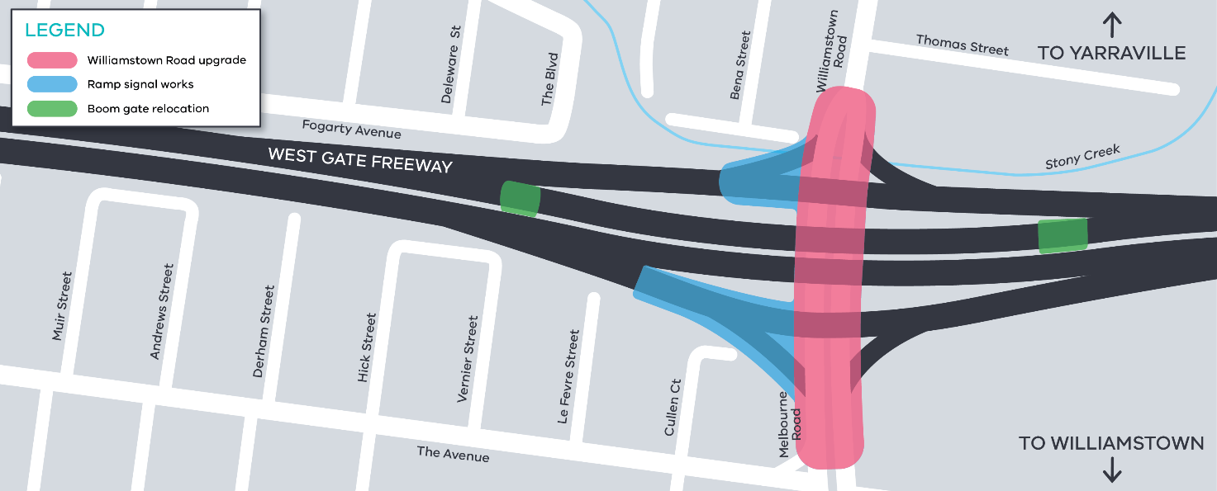
Location of works around Williamstown Road
Contact us

Please contact us if you have any questions or feedback about these works.
westgatetunnelproject.vic.gov.au
westgatetunnelproject@wda.vic.gov.au
1800 105 105
facebook.com/westgatetunnelproject
@westgatetunnel
West Gate Tunnel Project
GPO Box 4509
Melbourne Victoria 3001
Interpreter service: 13 14 50

