Reference: WES1901.10
30 January 2019
Works update – Beevers Street & Wally Court closure

Construction is well underway on Beevers Street to relocate some existing overhead power lines that currently run along the West Gate Freeway with stage one works nearing completion.
Stage two of these works will begin shortly, and as part of these works a section of Beevers Street and all of Wally Court will be closed to vehicles.
Temporary closure of Beevers Street & Wally Court
Monday 4 February – Wednesday 20 February 2019
During this time:
- a section of Beevers Street and all of Wally Court will be closed to vehicles; and
- driveway and footpath access to your property will be maintained.

Where to park your vehicle:
- please ensure you do not park your vehicle in the construction area (stage two) during this time as access will be blocked and you will be unable to access your vehicle; and
- please see the map over the page for location details.

What you could expect:
- an increase in construction vehicles within the area;
- an increase in construction noise during the day from our machinery and trucks; and
- water spray trucks to help manage dust and dirt and loads will be covered when dirt and rock are being transported.

These works will generally be carried out from Monday to Friday between 7am - 6pm and Saturdays between 7am - 3pm, however some night works may be required.

When works are scheduled out of hours and may have a direct impact on you, we will provide further information to you before works start.

Please note that works and timings may change in the event of bad weather or other unavoidable circumstances.
For updates and more information about our works please visit westgatetunnelproject.vic.gov.au or contact us using the details below.

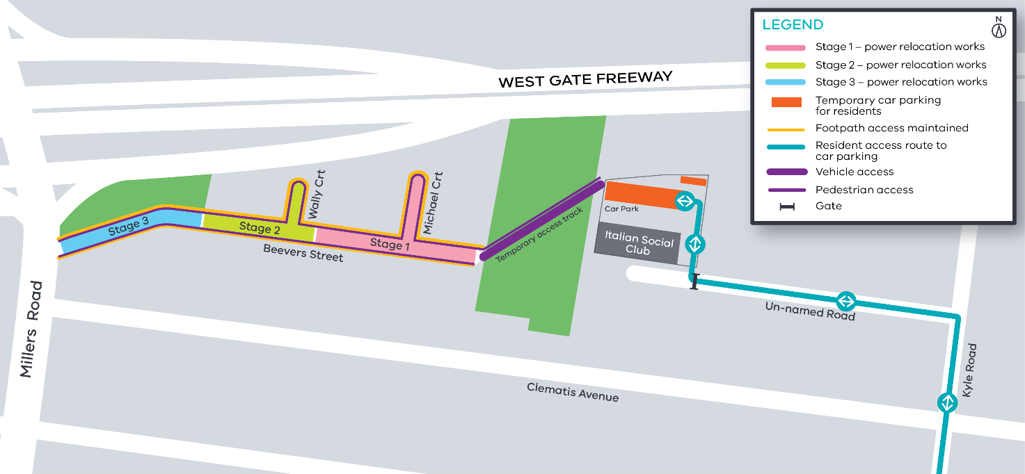
Contact us
Please contact us if you have any questions or feedback about these works.
 | westgatetunnelproject.vic.gov.au |  | facebook.com/westgatetunnelproject
 | info@wgta.vic.gov.au |  | @westgatetunnel
 | 1800 105 105 |  | West Gate Tunnel Project  GPO Box 4509  Melbourne Victoria 3001
 | Interpreter service: 13 14 50

