WES1903.01
8 March 2019

Works notification: Williamstown Road / West Gate Freeway interchange and Fogarty Avenue
Works around the Williamstown Road / West Gate Freeway interchange and those on Fogarty Avenue are progressing well, with a range of new activities set to start in the coming weeks.
Below is a summary of these activities and what you can expect to see in the area from March through to May 2019. All identified night works will commence in mid-March and will continue for approximately eight weeks. Advance notice will be provided to for noisy works likely to impact residents.

Williamstown Road sewer pipe diversion
Work has started to divert a large sewer pipe that runs under the West Gate Freeway. We need to relocate this as it is in the way of the entry to the tunnel.

This will involve pipe-jacking by digging and building the new sewer pipe beneath the freeway.

These works will also involve excavating manhole shafts at the following locations:

Melbourne Road compound and end of Cullen Court, Spotswood
- day works are currently underway which include road excavation and rock breaking.

Traffic island at the Williamstown Road inbound exit ramp
- over four consecutive weekends starting from Friday 15 March, day and night works at the shaft including rock breaking will occur;
- full closure of the Williamstown Road inbound exit ramp during this time; and
- we will be in contact with directly impacted residents prior to these works starting.

Reserve at the eastern end of Fogarty Avenue
- tree clearing from Wednesday 13 March at the reserve, east end of Fogarty Avenue, prior to construction site set-up; and
- temporary closure of the pedestrian and cycling path in the reserve from Wednesday 13 March with a detour in place.
Williamstown Road inbound exit ramp
We expect to start installing the new permanent noise wall along the Williamstown Road inbound exit ramp from early April.

We’re also working to partially open the upgraded ramp. Traffic will be temporarily switched to the new lanes, which will allow work to continue for the inbound tunnel entrance.
These works will include:
- piling along the ramp, to support the new permanent noise wall;
- installing new noise wall panels;
- installing stormwater drains; and
- pavement works to construct new lanes for the ramp.
Night works will be required and advance notice will be provided for noisy works.
West Gate Freeway bridge and Williamstown Road
Works to prepare for widening of the bridge over Williamstown Road are continuing, including installing new barriers. Traffic will be switched back onto the upgraded bridge and resurfaced inbound traffic lanes in May.
Work on Williamstown Road is ongoing including installing a new water main pipeline on the west side of Williamstown Road.

The pedestrian detour on the east side under the bridge will remain in place while these works are underway.
These works will include:
- installing new barriers on the bridge;
- asphalt works on two freeway lanes, east of the bridge;
- installing a new water pipeline; and
- reinstating the road once works are completed.
Ongoing night works will be required and advance notice provided for noisy works.

Inbound tunnel entrance
Following early works to prepare the site in late 2018, construction of the tunnel entrance is now underway, safely behind traffic barriers.
These works will include:
- earthworks including excavation of soil;
- building a platform to establish a safe working area for construction workers; and
- piling, to help form the tunnel entrance.

Please see map 1 below for location details of these works.

Map 1: Upcoming works at the Williamstown Road interchange
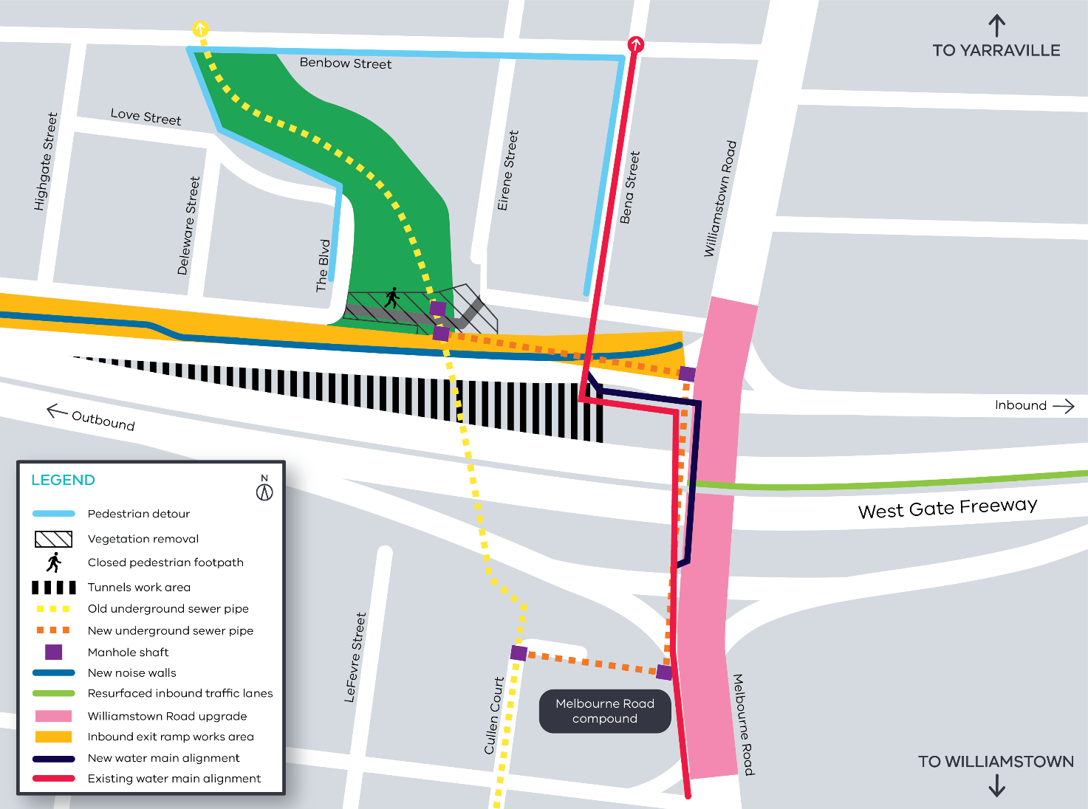

Fogarty Avenue and West Gate Freeway widening works
Traffic changes to Fogarty Avenue and The Avenue

Sections of Fogarty Avenue and The Avenue will need to be closed during drainage and underground powerline installation works.

As a result, the current closure of The Avenue underneath Newport Railway bridge will be extended. Please check the website for road closure dates. You can also subscribe to weekly traffic alerts by emailing us on westgatetunnelproject@wda.vic.gov.au

Changes to bus route 432 are still in place and will continue throughout 2019. More information can be found on Public Transport Victoria’s website at www.ptv.vic.gov.au/live-travel-updates.

We’re continuing to excavate the road along Fogarty Avenue to install a new drainage pipe and move some overhead power lines underground. A section of the reserve near Fogarty Avenue will also be excavated as part of the drainage works following the sewer pipe diversion.
We’re also building the new permanent noise wall along Fogarty Avenue as a continuation from the Williamstown Road inbound exit ramp.

These works will include:
- temporary closure of the pedestrian and cycling path in the reserve from Wednesday 13 March, with a detour in place;
- reinstating the excavated area in the reserve;
- constructing a retaining wall opposite the Footscray Hockey Club;
- trenching works to install the drainage pipe along The Avenue;
- moving some overhead power lines underground;
- piling works to support the new noise wall; and
- earthworks to prepare the area for freeway widening.

Newport Railway bridge and freeway centre median

Work is continuing to widen the Newport Railway bridge and the freeway.

We will be clearing the centre median on the freeway (the space between the inbound and outbound carriageways).

Once this has been completed we will be able to gain better access to the bridges and continue investigation and preparatory works.

These works will include:
- using a high-pressure water jet to identify underground services;
- tree and vegetation clearing;
- stripping the top layer of soil;
- installing temporary safety barriers;
- removal of existing barriers with rock breakers;
- removing signs and light poles;
- pavement construction; and
- removing road signage.

Ongoing night works will be required throughout March, April and May. Advance notice will be provided for noisy works.

West Gate Freeway (outbound) between Williamstown Road and The Avenue
Work is continuing to install a permanent noise wall along the West Gate Freeway (outbound) between Williamstown Road and The Avenue.

Other construction activity in this area includes early works to start building the new pedestrian and cycling bridge, near Muir Street.
These works will include:
- moving earth to clear the way for a new permanent noise wall;
- constructing piles along the freeway, to support the new permanent noise wall;
- constructing a new retaining wall and installing noise wall panels; and
- piling and concrete works for the new pedestrian and cycling bridge.

Please see map 2 below for location details of these works.

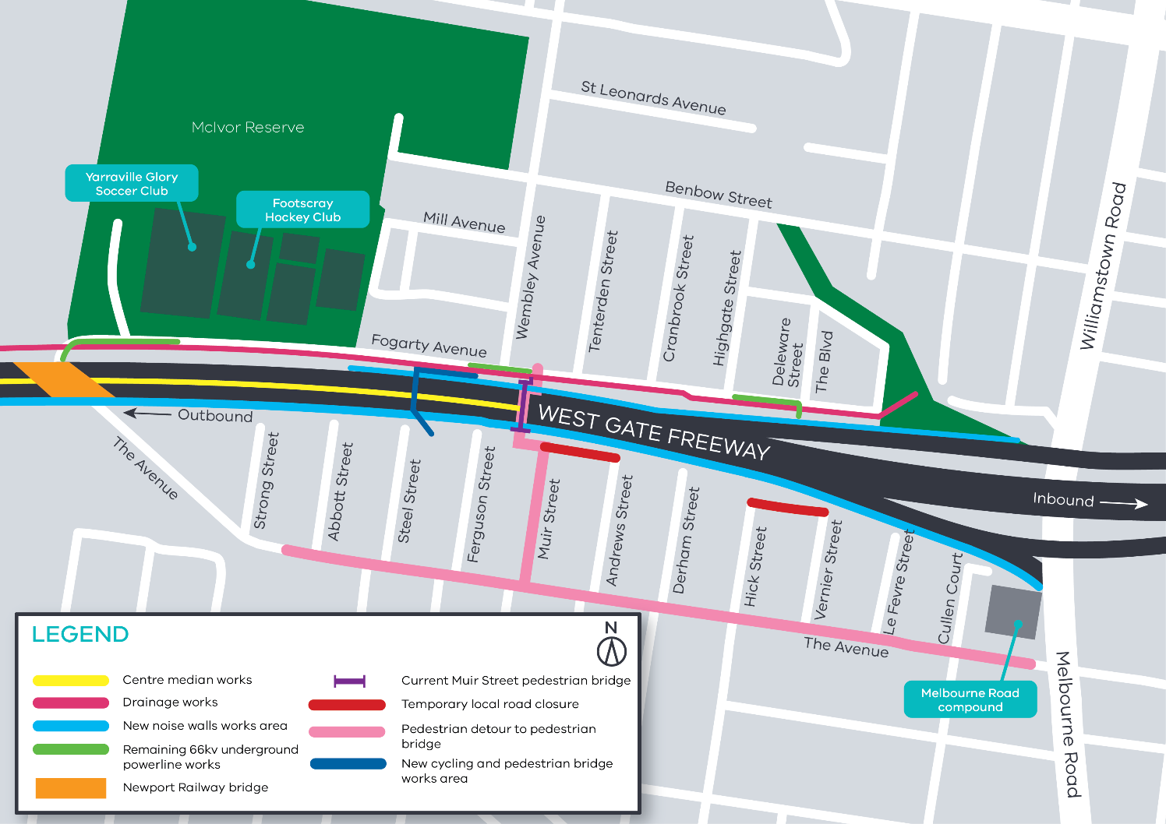
Map 2: Upcoming works at Fogarty Avenue, Newport Railway bridge and West Gate Freeway

What to expect during these works:

- work will be completed behind safety barriers;
- construction vehicles including excavators, piling rigs, water trucks and concrete trucks will be moving in and out of the work areas via our access routes;
- increase in construction vehicles regularly using designated routes including local roads within residential areas. This will include light vehicles, heavy trucks, concrete trucks and delivery of large equipment;
- construction noise from work activities including machinery and trucks which will increase at times while we excavate the road and break and remove rock from the area;
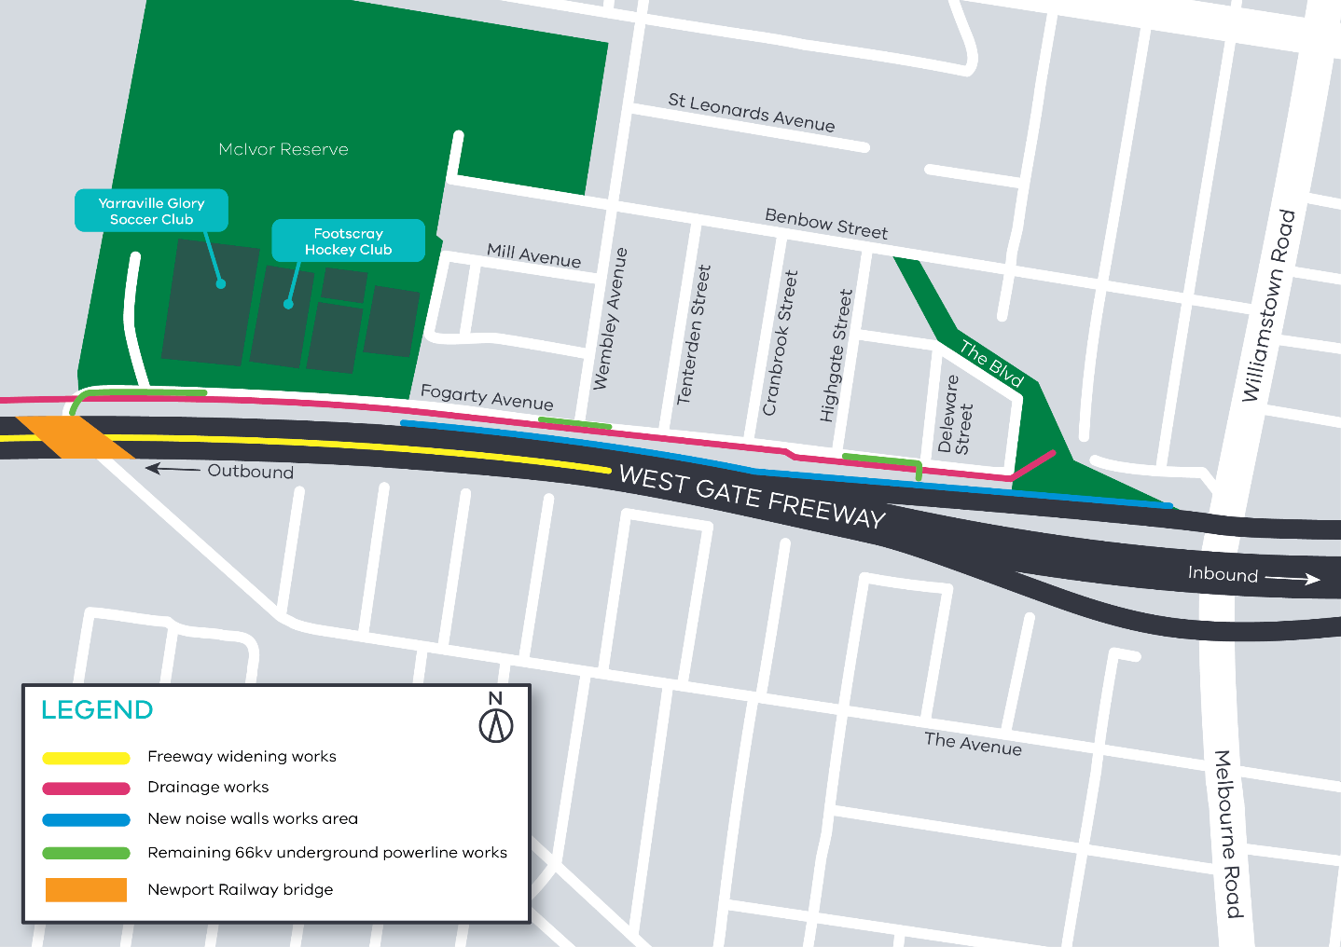
- there will be no vibration and noise impacts from pipe-jacking the new sewer pipe as the work will take place deep underground;
- water spray trucks and road sweepers will be used to manage dust and dirt during works, and trucks removing dirt and rock from the site will be covered;
- where access to residential driveways are required to be temporarily blocked due to works, we will advise residents directly; and
- traffic changes including ramp, lane and road closures will be required; signed detours will be in place.

For the latest updates visit westgatetunnelproject.vic.gov.au/traveldisruptions.

Day works will be undertaken from Monday to Friday between 7am to 6pm and Saturday from 7am to 3pm.

Please note that works may be rescheduled in the event of bad weather or other
unavoidable circumstances. For updates and more information about our works please visit westgatetunnel.vic.gov.au.
Contact us
Please contact us if you have any questions or feedback about these works.
westgatetunnelproject.vic.gov.au
info@wgta.vic.gov.au
1800 105 105
facebook.com/westgatetunnelproject
@westgatetunnel
West Gate Tunnel Project
GPO Box 4509
Melbourne Victoria 3001
Interpreter service: 13 14 50

