Reference: WES1907.04
2 July 2019
Works update – Temporary closure of Paringa Road

The safe undergrounding of the existing overhead power lines along Paringa Road is nearly complete. For the next stage of works, Paringa Road will be closed to vehicles from Tuesday 9 July until Saturday 27 July while the power poles and overhead power lines are removed. We will also install temporary noise walls along Paringa Road during this time.
Temporary closures along Paringa Road
During this time:
- vehicle access and parking on Paringa Road will be temporarily blocked
- driveway and footpath access to your property will be maintained, and
- the carpark behind the 16 shops will remain open but access will be temporarily relocated to Langshaw Street.
Where to park your vehicle:
- please ensure you do not park your vehicle in the construction area during this time as access will be blocked and you will be unable to access your vehicle.

Waste collection changes:
- while Paringa Road is closed, please place your rubbish bins on the east side (the Millers Road side) of Lee Street, Bond Street, Chambers Road or Langshaw Street so they can be collected by the waste contractor
- please ensure your bin is moved by 11pm on Tuesday nights while the works are underway for collection by Council early on Wednesday mornings.

Longer term traffic changes
After the power poles have been removed and the temporary noise wall is installed, Paringa Road will be reduced to one-way traffic from east to west until the new permanent noise wall is built. There will be no stopping on Paringa Road, but the footpath will remain open.

Construction of the permanent noise walls is expected to begin in August 2019. More information about this will be provided closer to the time.

What you could expect:
- an increase in construction vehicles within the area
- an increase in construction noise during the day from our machinery and trucks
- water spray trucks to help manage dust and dirt and loads will be covered when dirt and rock are being transported.

These works will generally be carried out from Monday to Friday between 7am - 6pm and Saturdays between 7am - 1pm. However, some night works might be required. If works are scheduled out of hours or if you are located close to the works, we will provide you with further information before the works start.

Please note that works and timings may change in the event of bad weather or other unavoidable circumstances.
For updates and more information about our works please visit westgatetunnelproject.vic.gov.au or contact us using the details below.
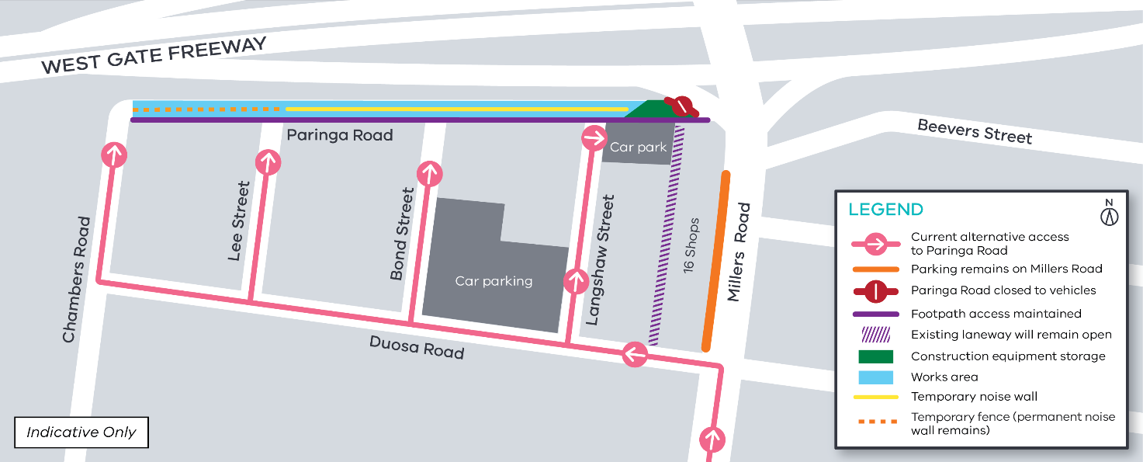

Thank you
We appreciate our work can be disruptive and we thank you for your understanding and cooperation.
Contact us
Please contact us if you have any questions or feedback about these works.
 | westgatetunnelproject.vic.gov.au |  | facebook.com/westgatetunnelproject
 | info@wgta.vic.gov.au |  | @westgatetunnel
 | 1800 105 105 |  | West Gate Tunnel Project  GPO Box 4509  Melbourne Victoria 3001
 | Interpreter service: 13 14 50

