WES1908.02

5 August 2019

Works notification: Installation of new noise walls about to begin along Freemans Road

The West Gate Tunnel Project team will soon begin installing a short section of new, high-quality permanent noise walls in your area.

The section of wall between Freemans Road and the Rosala Avenue pedestrian overpass needs to be built before the rest of the new noise walls in your area to prepare for installation of the new Rosala Avenue pedestrian overpass later this year.

The new noise wall will be around eight to nine metres high and made of textured concrete panels, topped with pale blue and green acrylic panels in some sections.

As well as being more attractive, the new noise walls will provide residents much better protection from freeway noise than the old noise walls. They have been designed to achieve a daytime average noise level of 63dB(A) at nearby houses, which will mean a significant reduction in noise levels for many residents. Where space permits, planting will also be used to screen the noise walls.

Where a temporary noise wall has been erected, it will remain in place until the new noise wall is complete. Because the area near the corner of Freemans Road is limited for space, we have been unable to install a temporary noise wall. Instead, a fence has been installed to screen the work site and freeway traffic in this area.

When
- piling will start from 21 August 2019 and take approximately three days
- installation of the new noise wall posts and panels will take approximately six weeks and is expected to be completed by the end of September 2019.

Where
- Freemans Road to the Rosala Avenue pedestrian overpass.

What you can expect during the construction
- construction vehicles including piling rigs, excavators, concrete trucks and pumps, earthmoving equipment and cranes will be moving in and out of the work areas
- construction noise from our machinery and trucks will increase at times while we complete piling and excavation works
- dust and dirt will be minimised by using water spray trucks, street sweepers and covering dirt and rock when it’s transported
- main access to the construction site will be via the West Gate Freeway entry gate at the Millers Road outbound entry ramp, with minimal site access required via local roads
- traffic changes including lane, road and ramp closures might be required. The latest traffic updates are available at westgatetunnelproject.vic.gov.au/traveldisruptions

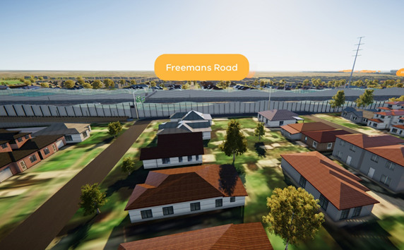
Artist impression of the new noise walls

These works will generally be carried out from Monday to Friday between 7am - 6pm and Saturdays between 7am - 1pm, however some night works might be required. If works are scheduled out of hours or at night, we’ll provide further information to you before works start.

Please note works might be rescheduled in the event of bad weather or other unavoidable circumstances.

Contact us
Please contact us if you have any questions or feedback about these works.
 | westgatetunnelproject.vic.gov.au |  | facebook.com/westgatetunnelproject
 | info@wgta.vic.gov.au |  | @westgatetunnel
 | 1800 105 105 |  | West Gate Tunnel Project  GPO Box 4509, Melbourne VIC 3001
 | Interpreter service: 13 14 50
IMPORTANT: You’re welcome to contact us to arrange a phone call or face-to-face meeting if you’d like more information.

