WES1910.02
28 October 2019

Works update: Millers Road interchange
October 2019 to February 2020

As part of widening the West Gate Freeway, we recently moved the traffic under the freeway bridges on Millers Road to the outer lanes to prepare the centre median area, and for the following activities. Please see the map over the page for location details.
Strengthening the freeway bridges above Millers Road
October 2019 to February 2020
To set up the Millers Road bridges for future use, we will be undertaking strengthening works under the bridges which includes:
- lifting up the bridges to remove and replace the bearings which sit between the bridge deck and the piers. The bearings allow for some bridge movement and reduce stress on the rigid parts of the bridge
- due to the location of the work and the amount of scaffolding required, the shared use path will be protected by a gantry structure with lighting during this time
- widening the beams and installing external steel tensioning strands.
To undertake these works, we will need lanes and road closures. Please visit our website for more information.
Widening the freeway bridges above Millers Road
October 2019 to December 2019
To create more lanes on the West Gate Freeway, we need to widen the freeway bridges above Millers Road. This will include:
- constructing new bridge piers and protection barriers in the centre median area. This work will be done at night to allow for lane closures on Millers Road
- installing new bridge beams
- hydro-demolition of the concrete on the edges of the existing bridges. Hydro-demolition is noisy work. It must be done at night because it creates a lot of water which requires sections of Millers Road directly beneath the work area to be closed intermittently.
Ongoing works around Millers Road interchange
October 2019 – February 2020
Ongoing activities in the area include:
- installing new freeway drainage on three of the ramps
- piling for the new noise walls.
We are planning a construction blitz campaign during January 2020. More detail about the work involved in this campaign will be provided soon.

Where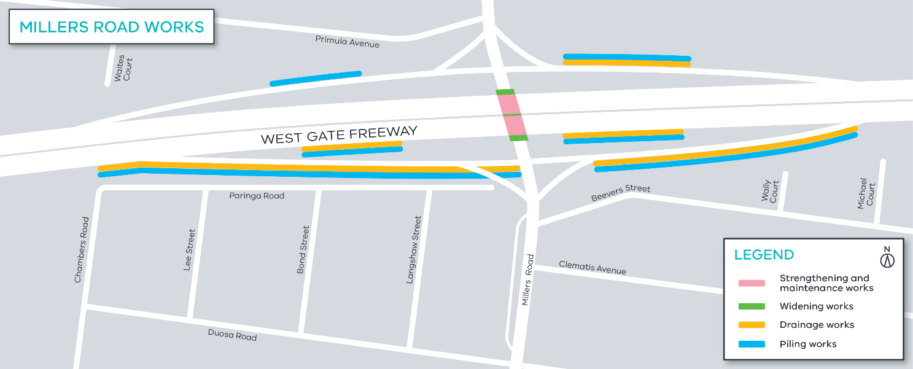

What to expect while we undertake these works
- construction vehicles including concrete trucks and pumps, earthmoving equipment and cranes will be moving in and out of the work areas
- construction noise from trucks, compactors, road saws, drills, piling, hydro-demolition equipment and general construction machinery
- road closures will be required at some stages of the work and detours will be in place when this happens. The latest traffic updates are available at westgatetunnelproject.vic.gov.au/

These works will generally be carried out from Monday to Friday between 7am-6pm and Saturdays between 7am-1pm, however some night works will be required.

When works are scheduled out of hours, or if you are located close to the works, we will provide further information to you before these works start.

Please note that works may be rescheduled in the event of bad weather or other unavoidable circumstances.

Contact us
Please contact us if you have any questions or feedback about these works.
 | westgatetunnelproject.vic.gov.au |  | facebook.com/westgatetunnelproject
 | info@wgta.vic.gov.au |  | @westgatetunnel
 | 1800 105 105 |  | West Gate Tunnel Project  GPO Box 4509, Melbourne VIC 3001
 | Interpreter service: 13 14 50

