29 June 2020 WES2006.06

Works notification: Tree removals at Donald McLean Reserve and West Gate Freeway
To make space for the Donald McLean Reserve noise walls and to allow construction of the Hyde St Ramps, trees located within the project boundary in Donald McLean Reserve, the Williamstown Road outbound entry ramp and the West Gate Golf Course will be removed.
These works will be carried out over approximately nine nights, starting on Sunday 12 July until the end of July.
The tree removals must be carried out overnight because we need to close traffic lanes to allow the work to be completed safely.

What you can expect to see and hear:
- construction vehicles and equipment, including chainsaws and a mulcher
- directional lighting
- noise from the use of chainsaws and mulcher
- changed traffic conditions including lane closures between the hours of 8pm to 5am, with signage in place.

Works area
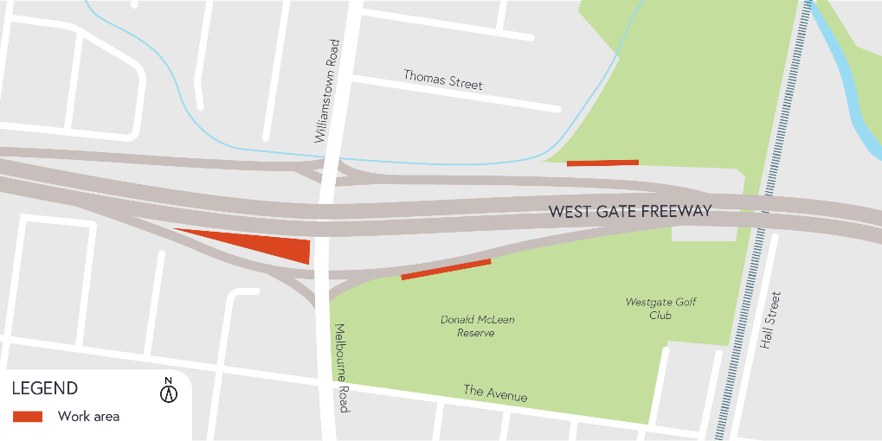

Hours of work
The work will be carried out over approximately nine nights starting Sunday 12 July from 8pm to 5am.

COVID-19 update
The health and safety of our workers is our key priority as we continue to deliver the West Gate Tunnel Project, as is supporting physical distancing measures in line with current health advice. We have strict protocols in place to protect the safety of our construction workforce and the community. These include enhanced industrial cleaning arrangements and measures to reduce staff contact including staggered shifts and physical distancing. For more information and advice about Coronavirus, please visit coronavirus.vic.gov.au.

Thank you
We appreciate our work can be disruptive and thank you for your understanding and cooperation, particularly during these unprecedented and challenging times.

Please note that works are subject to change and may be rescheduled in the event of unexpected impacts to the construction program. Thank you for your patience during these works.

For updates and more information about our works, please visit westgatetunnelproject.vic.gov.au or call us on 1800 105 105.

