11 May 2020

Works notification: The Muir Street overpass will be closed and removed overnight on Saturday 23 May 2020
To make way for widening the West Gate Freeway, we need to close and safely remove the existing pedestrian overpass that connects Muir Street and Fogarty Avenue.
The West Gate Freeway will be closed overnight between Williamstown Road and the M80 Interchange while the overpass is removed. A fully signed detour route will be in place during the closure, with details on the project website.
Construction of the new overpass is taking longer than initially planned and while we don’t yet have a definite date, we expect the new overpass will be installed later this year.
Unfortunately, this means we have to remove the existing overpass before the new one is installed so we can continue widening the West Gate Freeway. This is because the next stage of widening involves moving traffic to the outer lanes of the freeway where the ramps of the existing overpass are located.

WES2004.03

Alternative access arrangements: courtesy shuttle bus
We are running a courtesy shuttle bus for pedestrians to cross between the north and south sides of the West Gate Freeway. This will be especially important for students of Wembley Primary School. The shuttle bus service will be free for users. It will run at intervals between 8am and 7:15pm seven days a week. See the map over page for location of bus stops. Please remember social distancing measures in line with current health advice when using the shuttle bus.
We will run the service at its current schedule for one month. After this time, depending on user demand, we will assess the frequency and continuation of the service. Check out the website for more details and updates about this service.
If you require special assistance during this time, please contact us using the details over the page.

When
- the existing pedestrian overpass will be removed overnight on Saturday 23 May 2020
- the piers and ramps will be demolished over the following week during day works
- the new walking and cycling overpass will be installed later this year.

What to expect during these works
- using saw cutters at night to separate the existing overpass into two segments
- lifting the overpass segments using a crane, and placing onto trucks for removal at night

- where possible, construction lights will be directed away from homes when working at night
- removing the piers and ramps from the end of Muir Street (southern side) and adjacent to
Fogarty Avenue (northern side) during day works
- during the pier and ramp removals, construction vehicles, including excavators and trucks, will use local roads for access
- the overpass will be recycled; the concrete will be mixed with other pavement rock to build new roads, and the steel will be reused for many purposes.

Walking and cycling detour, and bus stops and routes
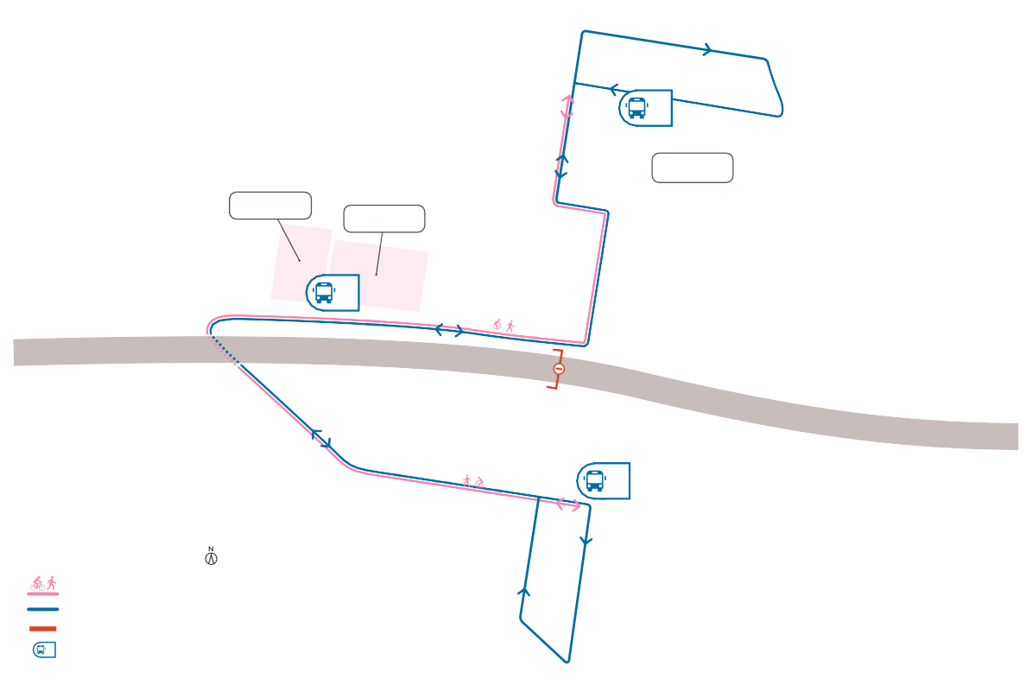
While there is no overpass in place, pedestrians and cyclists should use the detours as shown below, including the courtesy bus. Access to the Footscray Hockey Club, Yarraville Glory Soccer Club and local residents on Fogarty Avenue will be maintained at all times.
3
McIvor Reserve
Wembley Primary School
Yarraville Glory Soccer Club
Footscray Hockey Club
1
2
LEGEND
Pedestrian and cyclist detour
Courtesy shuttle bus Overpass removed
#
Courtesy bus stop
Francis Street
Hawkhurst Street
Benbow Street
Wembley Avenue
Tenterden Street
Williamstown Road

Works will be carried out from Monday to Friday between 7am to 6pm and Saturdays between 7am to 1pm, with out of hours and night works required. Advance notice of out of hours works will be provided to directly impacted residents.
Fogarty Avenue
The Avenue
WEST GATE FREEWAY
Melbourne Road
Strong Street
Abbott Street
Steel Street
Ferguson Street
Kernot Street
Muir Street
Watt Street

Rosala Avenue pedestrian overpass
The Rosala Avenue overpass will also be removed on Saturday 23 May 2020 for the reasons outlined above.

Covid-19 update
The health and safety of our workers is our key priority as we continue to deliver the West Gate Tunnel Project, as is supporting physical distancing measures in line with current health advice. We have strict protocols in place to protect the safety of our construction workforce, including enhanced industrial cleaning arrangements, and measures to reduce staff contact, including staggered shifts and physical distancing. For more information and advice about Coronavirus, please visit coronavirus.vic.gov.au

Please note works could be rescheduled in the event of bad weather or other unavoidable circumstances. We thank you for your patience while we carry out these important works.
The latest traffic updates are available at www.westgatetunnelproject.vic.gov.au/traveldisruptions

westgatetunnelproject.vic.gov.au info@wgta.vic.gov.au
1800 105 105
West Gate Tunnel Project Info Centre Corner of Somerville Rd and Whitehall St Yarraville VIC 3013
Follow us on social media Please contact us if you would like this
information in an accessible format.

Translation service – For languages other than English, please call 13 14 50.

Authorised by the Victorian Government, 1 Treasury Place, Melbourne

