27 July 2020 WES2007.01

Works notification: Installation of new Muir Street walking and cycling overpass
We are progressing works to build the new walking and cycling overpass over the West Gate Freeway (between Muir Street and Fogarty Avenue), which is on track to open later in 2020.
As part of these works, there will be an increase in construction activity taking place in your area until November 2020. Below is a summary of the activities you can expect to see in the area from late July until November.

Ongoing to late July
- Works have been ongoing for the installation of staircases and concrete panels for the overpass ramps and you can expect to see these works continue until the end of the month.
- Sections of the permanent noise wall will be installed along Fogarty Avenue.

From August to early September
- We will be pouring concrete for the overpass piers and then lifting beams for the overpass into place. The beams will be delivered to site approximately 3 days before installation. The delivery will happen at night and will require sections of The Avenue and Fogarty Avenue to be closed.
- Night works and freeway lane closures will be required to lift the beams into place.
- We will also be undertaking centre median and line marking works on the freeway during this period.

From September to November
- Installing the new 70-metre overpass structure and constructing the new walking and cycling path, including pouring concrete overnight. We need to close the freeway to safely complete these activities.
- From late September to November, we will be installing the cladding and balustrades on the overpass and removing the temporary noise wall in locations where the permanent wall has been completed.
- Expected opening of the new overpass. We will be providing further updates on the opening time closer to the date.
Traffic changes along Fogarty Avenue
- There will be a closure of Fogarty Avenue between Tenterden Street and Wembley Avenue with traffic management on-site to maintain access for residents. This will be in place until late October 2020.
Night works and road closures will be required for these works and advance notice will be provided for noisy works likely to impact residents.

Zoom community pop up
In early August, we will hold a virtual pop up session to talk through the works and answer any questions you may have about these works.
If you would like to attend, please register your interest at info@wgta.vic.gov.au or call 1800 105 105 and quote New walking and cycling overpass virtual pop up in the subject line. We will send you an invite with the details for the session.

What to expect during these works
- freeway closures and night works when we need to deliver large beams and equipment to site
- more activity with an increase in construction traffic and equipment in your area
- increased noise and vibration from excavators, concrete trucks and pumps, earthmoving equipment and cranes moving in and out of work areas
- traffic changes including freeway and local road closures (property access will be maintained) will be required. Signed detours will be in place.

For the latest traffic updates visit westgatetunnelproject.vic.gov.au/traveldisruptions.

Hours of work

Works will be carried out from Monday to Friday between 7am to 6pm and Saturdays between 7am to 1pm, with out-of-hours and night works required. Advance notice of night works will be provided to directly impacted residents.

Works area

While the overpass is constructed, pedestrians and cyclists should follow detour signage and listen to traffic controllers around the site. For the most up to date information on detours and changes to local access, please visit westgatetunnelproject.vic.gov.au/traveldisruptions.
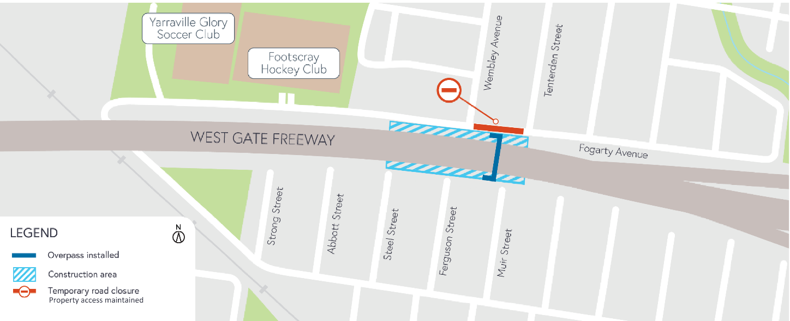

Covid-19 update
The health and safety of our workers is our key priority as we continue to deliver the West Gate Tunnel Project, as is supporting physical distancing measures in line with current health advice. We have strict protocols in place to protect the safety of our construction workforce and the community. These include enhanced industrial cleaning arrangements and measures to reduce staff contact including staggered shifts and physical distancing. For more information and advice about Coronavirus, please visit coronavirus.vic.gov.au.
Thank you
We appreciate our work can be disruptive and thank you for your understanding and cooperation, particularly during these unprecedented and challenging times.
Please note that works are subject to change and may be rescheduled in the event of unexpected impacts to the construction program.
For updates and more information about our works, please visit westgatetunnelproject.vic.gov.au or call us on 1800 105 105.

