2 December 2020 WES2012.02

Reminder notification: Opening of new Muir Street walking and cycling overpass and access route
We are pleased to let you know that from Wednesday 9 December the overpass will be open for use. Please note that there will be people working on the overpass to install remaining cladding, lighting and finishing works.
The new overpass provides an improved and safer connection for the community – with new lighting, security cameras and accessibility for all users.
The overpass can be accessed on the south side of the freeway via the ramp at the end of Muir Street. On the north side of the freeway, access is via the ramp on Fogarty Avenue, near Tenterden Street.
The new staircases will not be available to use until early 2021. A temporary set up will be in place which will require cyclists to dismount while using the overpass.
Courtesy shuttle bus service
From Wednesday 9 December when the new Muir Street overpass is open, the Community Shuttle Service will stop operating.
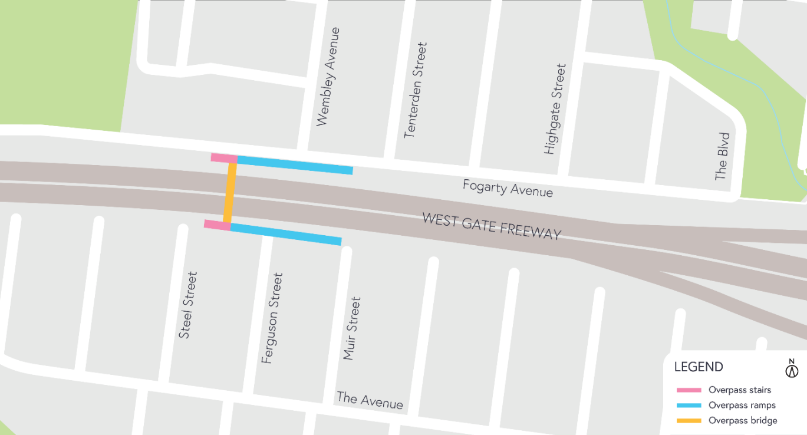

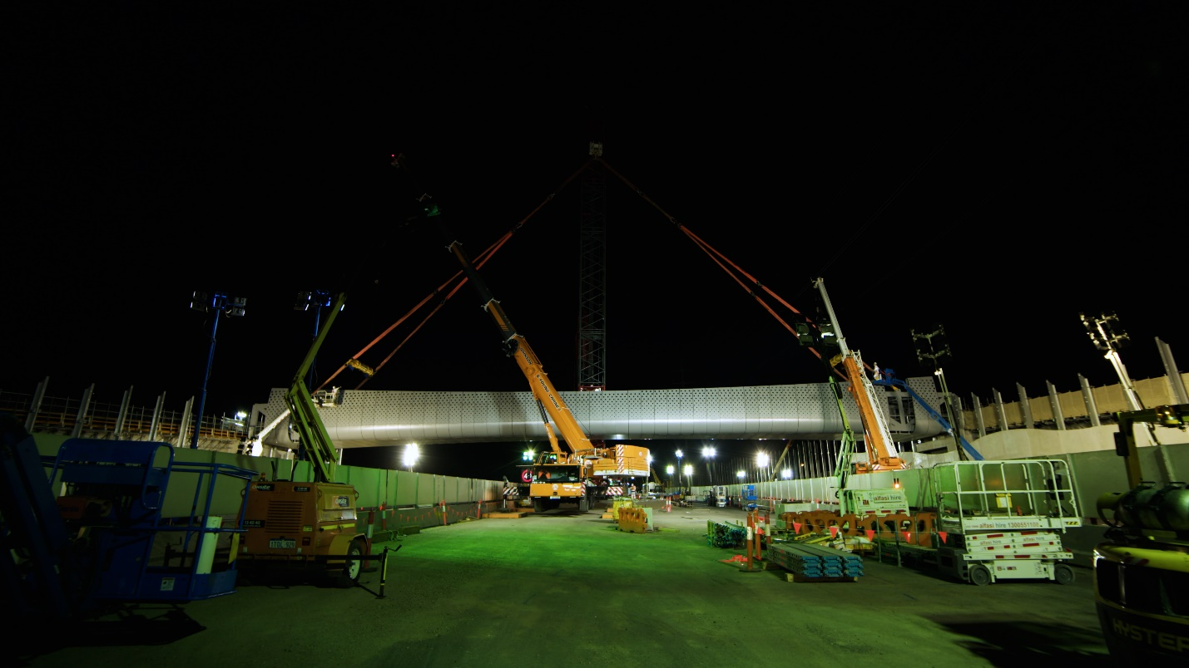
The Muir Street walking and cycling overpass is safely positioned across the West Gate Freeway

Thank you
We appreciate our work can be disruptive and thank you for your understanding and cooperation, particularly during these unprecedented and challenging times.
Please note that works are subject to change and may be rescheduled in the event of unexpected impacts to the construction program.
For updates and more information about our works, please visit westgatetunnelproject.vic.gov.au or call us on 1800 105 105.

