09 March 2021 WES2102.04R

Works reminder: Hyde Street Ramps piling night works
We are getting on with building the new Hyde Street Ramps, which means starting the piling works at the Williamstown Road and West Gate Freeway interchange.
These works have been rescheduled to begin on 15 March.
Below is a summary of what you can expect during these works.

Williamstown Road and West Gate Freeway piling works

- piling works will start from 15 March and are expected to take approximately two weeks to complete
- works will be carried out at night as we need to close traffic lanes to allow the work to be done safely
- drilling six piles on Williamstown Road – three each on the north and south sides of the freeway
- putting in protection around the new piles and existing bridge piers, including installing permanent barriers

Traffic impacts

We will need to close Williamstown Road most nights in both directions (under the West Gate Freeway) from 9pm to 5am. On-road signs will be in place to advise of detours and work zone speed limits will be enforced. For latest updates, dates of closures and detour route information visit: bigbuild.vic.gov.au/disruptions

What to expect during these works:
- work will be completed behind safety traffic barriers
- construction vehicles including excavators, rollers, piling rigs, water trucks and concrete trucks will be moving in and out of the work areas via our access routes
- construction noise, including intermittent short term noise at night, from work activities including machinery and trucks. Vibration may be experienced from piling works
- water spray trucks and road sweepers will be used to manage dust and dirt during works.
- trucks removing dirt and rock from the site will be covered
- traffic changes including lane and road closures will be required. Signed detours will be in place.

Hours of work

Piling works will be required to be done at night, between 9pm and 5am, as we need to close traffic lanes. Other works in the area will be completed during our usual work hours, Monday to Friday between 7am – 6pm and Saturdays between 7am – 1pm.

Work area:

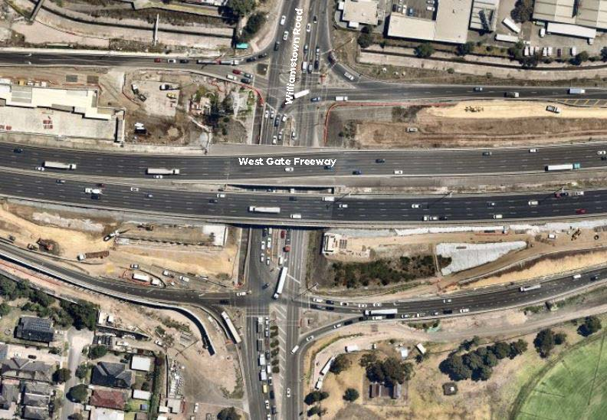
Legend
Piling works

Please note that works are subject to change and may be rescheduled in the event of unexpected impacts to the construction program. Thank you for your patience during these works.

For updates and more information about our works, please visit westgatetunnelproject.vic.gov.au or call us on 1800 105 105.

