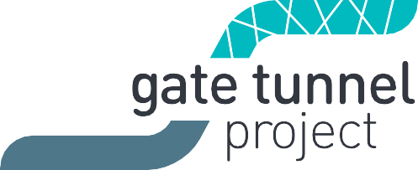
West Gate Tunnel Project
GPO Box 33312
Melbourne Victoria 3004
1800 105 105
westgatetunnelproject.vic.gov.au westgatetunnelproject@wda.vic.gov.au

Reference: EAS1807.1

6 August 2018

WORKS NOTIFICATION: Footscray Road works from 19 August 2018

Construction will soon start on Footscray Road to build the new elevated road that will connect the West Gate Tunnel to the CBD and CityLink. This will be done in stages. Stage 1 is scheduled to be underway between 19 August 2018 and February 2019.
The first stage of construction along Footscray Road will include:
- Installation of temporary safety barriers and minor lane reconfiguration along the outbound carriageway at night from 19 August – installing barriers will take up to two weeks;
- Relocation of the shared use path onto a temporary surface away from the construction area from August;
- Up to 170 trees and shrubs will be removed from the southern nature strip from September;
- Temporary removal of up to six bus stops along Footscray Road from September until project completion. One bus stop in each direction east of Dock Link Road will be maintained;
- Disconnection of existing street lighting and installation of temporary lighting from September;
- Drainage works from October;
- Construction of temporary roadway, ongoing from October, to prepare for the next stage of works, which requires traffic to be shifted away from the centre of the road; and
- Pier construction, including piling, at Dock Link Road and Mackenzie Road, ongoing from October, to carry the elevated road.

What you could expect while we undertake these works:
- Mobilising equipment including piling rigs, excavators and trucks to remove material;
- Temporary changes and diversion to the shared use path while we build the new path;
- Slightly narrower lanes and speed reduction to 60km/h on the outbound carriageway;
- Temporary closure of up to six bus stop locations on Footscray Road by PTV. More information can be found at www.ptv.vic.gov.au;
- Dust and dirt will be minimised by using spray trucks and covering dirt and rock when it is being transported;
- Construction noise such as excavating and reversing beepers from our machinery and trucks.

These works will generally be carried out Monday to Friday between 7am-6pm and Saturdays between 7am-3pm; however, some night works will be required.

When works are scheduled out of hours, or if you’re located close to the works, we will provide further information to you before these works start.’

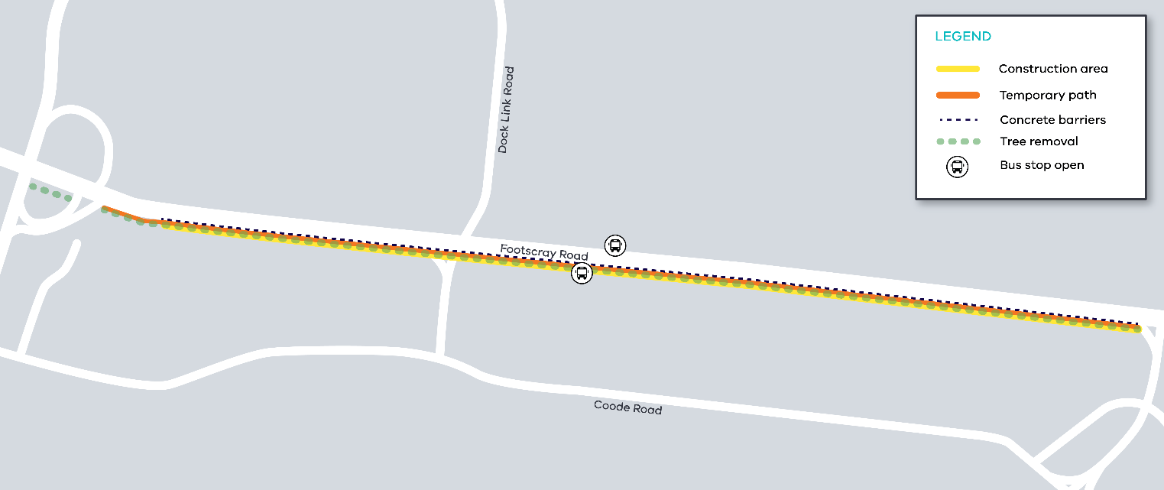
Figure 1 Footscray Road Works
What to be aware of
- Night time traffic lane closures will be in place at times. All lanes will remain open during the day. For the latest traffic updates visit westgatetunnelproject.vic.gov.au/traveldisruptions/
- We will notify you if there are any significant changes to the timing of our works.

Please note that works may be rescheduled in the event of bad weather or other unavoidable circumstances.
For updates and more information about our works please visit westgatetunnel.vic.gov.au or contact us using the details below.

Contact us
Please contact us if you have any questions or feedback about these works.

westgatetunnelproject.vic.gov.au
westgatetunnelproject@wda.vic.gov.au
1800 105 105
facebook.com/westgatetunnelproject
@westgatetunnel
West Gate Tunnel Project GPO Box 4509
Melbourne Victoria 3001
Interpreter service: 13 14 50

