February 2020

Works notification: Wurundjeri Way Extension

You may have noticed that works have commenced within the rail corridor near Dynon Road to build a shared use path bridge and the city connections for the West Gate Tunnel Project.

Over the coming months, works will commence to build the new Wurundjeri Way Extension, an elevated road connecting to Dynon Road and the new elevated Footscray Road that will link the West Gate Tunnel to the city.

Building the Wurundjeri Way Extension
Works to build the Wurundjeri Way Extension are commencing over the coming months. These works will take place from Dynon Road through to the existing Wurundjeri Way.
Works will include:
- Site investigations
- Establishment of new work sites
- Piling preparation and piling works.

Site Investigations
Site investigation works will continue to further identify utility services and better understand ground and road conditions as we prepare new work areas.
Traffic management will be in place during investigation works and we will provide further notification to residents and businesses that will be directly impacted.
When: February 2020 - Ongoing between 7am and 5pm and when required at night, between 7pm and 5am.

Establishment of new work sites
New work sites will be established over the coming months within E Gate and the rail corridor.
Works will include:
- Mobilising equipment including piling rigs, excavators and trucks
- Construction noise such as excavating and reversing beepers from machinery and trucks
- Demolition of sheds, warehouses and rail structures within the rail corridor
- Piling pad construction.
When: Ongoing from February 2020 between 7am and 5pm.

Piling works
Piling works will commence to build the foundations of the piers for the elevated road from late March 2020 and will take up to seven months to complete. Piles will be constructed using a combination of bored and driven piling.
Works will take place within E Gate beginning near Dynon Road, moving south - east toward Dudley Street and Wurundjeri Way. Piling locations are shown in the map below.

What is piling?
Piling is the process of installing large posts into the ground, which support the foundations of a superstructure (such as an elevated road).
Piling works can create increased levels of noise and may also cause some vibration.
Assessments have been conducted, which indicate the noise levels are expected to remain within permissible levels as advised within the project’s Environmental Performance Requirements.
Noise and vibration may be noticeable during these works. Works are scheduled to take place between 7am to 5pm and when required between 7pm and 5am.
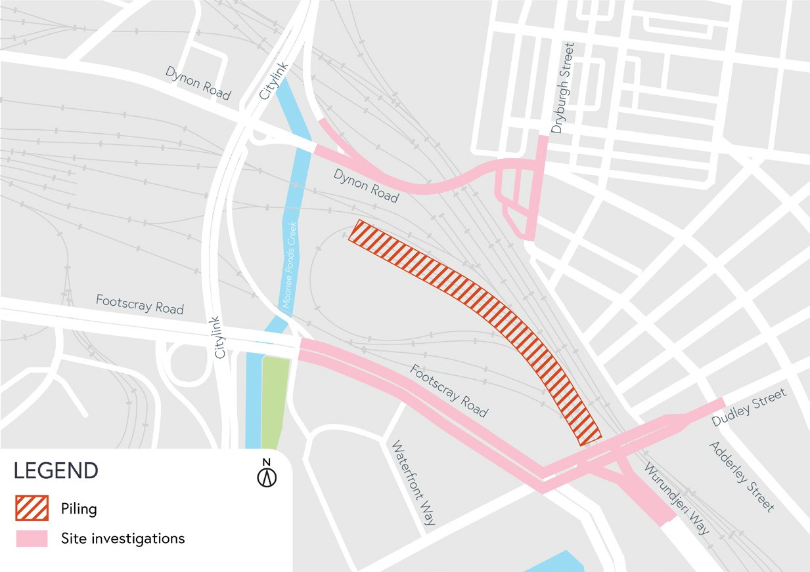

What to expect during construction:
- Works completed both during the day and at night time
- We will notify you if there are any significant changes to the timing of our works
- Traffic management will be in place to manage changed conditions including temporary access changes and signage to guide road users and cyclists
- Dust will be managed on-site
- Piling works can create increased levels of noise and may also cause some vibration
- Assessments have been conducted, which indicate the noise levels are expected to remain within permissible levels as documented in the project’s Environmental Performance Requirements.

We thank you for your patience during these works.

westgatetunnelproject.vic.gov.au info@wgta.vic.gov.au
1800 105 105
West Gate Tunnel Project Info Centre Corner of Somerville Rd and Whitehall St Yarraville VIC 3013
Follow us on social media Please contact us if you would like this
information in an accessible format.

Translation service – For languages other than English, please call 13 14 50.

Authorised by the Victorian Government, 1 Treasury Place, Melbourne

