27 April 2021 WES2104.01

Works notification: Millers Road / West Gate Freeway area
We’re continuing to widen the West Gate Freeway and upgrade the Millers Road interchange, with a significant amount of work recently completed behind the barriers.
Soon you will be able to see changes on the ground and around the Millers Road interchange. Below is a summary of the activities you can expect in the area from May through to August 2021:
- pour concrete onto the newly installed bridge beams over Millers Road to create what will become the new centre lanes on the freeway
- remove scaffolding following successful installation of the new bridge beams
- set up new site access areas to the Millers Road exit and entry ramps for finishing works
- install support panels underneath the West Gate Freeway
- build the new walking and cycling path on Millers Road underneath the freeway
- install new noise walls along the Millers Road ramps – more information on this is below.

Nightly closures at Millers Road
Millers Road will need to closed regularly in both directions (under the West Gate Freeway) and the inbound entry ramp from 9pm to 5am. This is so we can continue widening the freeway. The inbound exit ramp and outbound ramps will also be closed when we are installing new noise walls. Fully signed detour routes will be in place during the road closure. At times, Williamstown Road will also be closed at the same time. We will keep you updated on the progress of works and closures.
For updates, dates of closures and detour route information, visit www.bigbuild.vic.gov.au/disruptions
Noise wall installation at Millers Road exit ramps
From mid-May
You may have seen that we’ve recently started installing new noise wall panels along the Millers Road outbound entry ramp. From early May, we will begin installing new noise wall panels at both the Millers Road inbound exit ramp and Millers Road outbound exit ramp. See map on the next page for location details.
Noise walls will extend further west along the freeway (see map on the next page). We will be in touch with directly impacted residents prior to installation.
Night works will be required to install the noise wall panels. Advance notice will be provided for noisy works likely to impact residents.
Freeway widening works between Millers Road and Grieve Parade
May to mid-2021
We are also continuing to widen the freeway between Millers Road and Grieve Parade, focusing on creating new lanes in the centre median. Once these works are complete in mid-2021, citybound traffic will be shifted south, opening up more space for widening works to continue along the inbound carriageway.

Freeway widening works include laying new cables for lighting, installing light poles, new drainage, putting down a new road surface and placing new asphalt and installing barriers.
Night works will be required including when asphalting to create the new traffic lanes. Advance notice will be provided for noisy works likely to impact residents.
Primula Avenue changes
Earlier this year we heard from motorists having difficulties exiting Primula Avenue to perform a right turn onto Millers Road. As a result, the stop line at Primula Avenue has been moved further to the east, making exiting Primula Avenue onto Millers Road easier for traffic heading north and south.
We’re monitoring this change and encourage you to contact us at info@wgta.vic.gov.au if you have any feedback.
What to expect during these works:
- ongoing night works to continue widening works
- construction vehicles including forklifts, elevating work platforms and cranes
- construction noise from work activities including machinery and trucks
- Vibration may be experienced when we lay new pavement using a roller
- water spray trucks and road sweepers will be used to manage dust and dirt during works
- pedestrian access will always be maintained. Please follow instructions of traffic controllers
- traffic changes including lane, road and ramp closures will be required. Signed detours will be in place.
Hours of work
Our usual hours of work are Monday to Friday between 7am-6pm, and Saturdays between 7am-1pm. However, for the activities mentioned above, we will need to work at night, between 9pm and 5am. This is so we can close roads and ramps to give us the space needed to work safely.
Work area
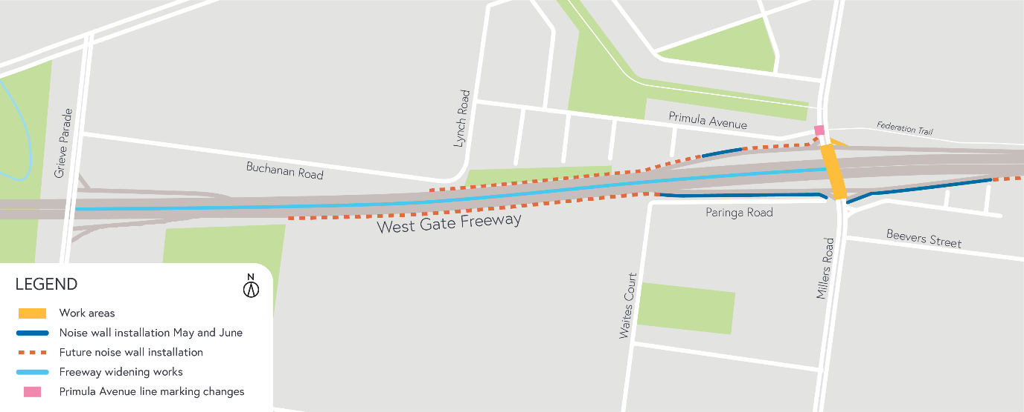
Please note that works are subject to change and may be rescheduled in the event of unexpected impacts to the construction program. Thank you for your patience during these works.
For updates and more information about our works, please visit westgatetunnelproject.vic.gov.au or call us on 1800 105 105.

westgatetunnelproject.vic.gov.au  info@wgta.vic.gov.au  1800 105 105  West Gate Tunnel Project Info Centre  Corner of Somerville Rd and Whitehall St  Yarraville VIC 3013 | Follow us on social media |  |  | Please contact us if you would like this  information in an accessible format.
Translation service – For languages
other than English, please call 13 14 50.

