Executive Summary

North East Link
North East Link is Victoria’s largest ever road project. North East Link provides a new freeway-standard connection between the M80 Ring Road and an upgraded Eastern Freeway, completing the missing link in Melbourne’s metropolitan ring road. It will give the city a fully completed orbital connection for the first time. The project includes Victoria’s longest twin road tunnel and also delivers Melbourne’s first dedicated high-speed busway, new public open space and extensive walking and cycling links.
North East Link is a new express connection with more than six kilometres of the link constructed in tunnel to minimise impacts on residential areas and communities. As part of the project, the Eastern Freeway would be upgraded to modern-day standards, including additional lanes and new technology for safer and faster trips. The upgrade would incorporate dedicated express bus lanes between Doncaster and the city that are separate from cars and trucks.
The project has three elements:
- M80 Ring Road to the northern portal – From the M80 Ring Road at Plenty Road and the Greensborough Bypass at Plenty River Drive, North East Link would extend to the northern tunnel portal near Blamey Road using a combination of above, below and at surface road sections. New road interchanges would be provided at the M80 Ring Road and Grimshaw Street.
- Northern portal to southern portal – At the northern portal of the tunnel, the road would transition into twin tunnels that connect to Lower Plenty Road via a new interchange before travelling under residential areas, Banyule Flats and the Yarra River to a new interchange at Manningham Road. The tunnel would then continue to the southern portal located south of the Veneto Club.

- Eastern Freeway – From around Hoddle Street in the west through to Springvale Road in the east, modifications to the Eastern Freeway would include widening to accommodate future traffic volumes and new dedicated bus lanes for the Doncaster Busway. A new interchange at Bulleen Road would connect North East Link to the Eastern Freeway.
Around 25 kilometres of new and upgraded walking and cycling links would be provided as part of the project, including an eastern bike corridor, two new Yarra River crossings and the completion of missing walking and cycling connections.
North East Link responsibilities
The Major Transport Infrastructure Authority (MTIA) is the proponent for the North East Link project. The MTIA is an administrative office within the Victorian Department of Transport with responsibility that oversees major transport projects.
North East Link Project (NELP) is an organisation based within MTIA that is responsible for developing and delivering North East Link, including the preparation of this Environment Effects Statement (EES).

The new dedicated Doncaster Busway would allow faster and more frequent bus services from Doncaster to the inner city along the Eastern Freeway.
Five new land bridges in the project’s northern element would maintain connectivity across the new road and create significant new public open space and parkland.
An Urban Design Strategy has been developed to ensure that the project incorporates a high quality urban design that would deliver a positive civic legacy for local communities in Melbourne’s north-east, making a strong and lasting contribution to the city’s public realm.
North East Link also has a commitment to facilitate economic development opportunities and build a skilled local workforce. The project would create thousands of new construction jobs, peaking at around 2,800.
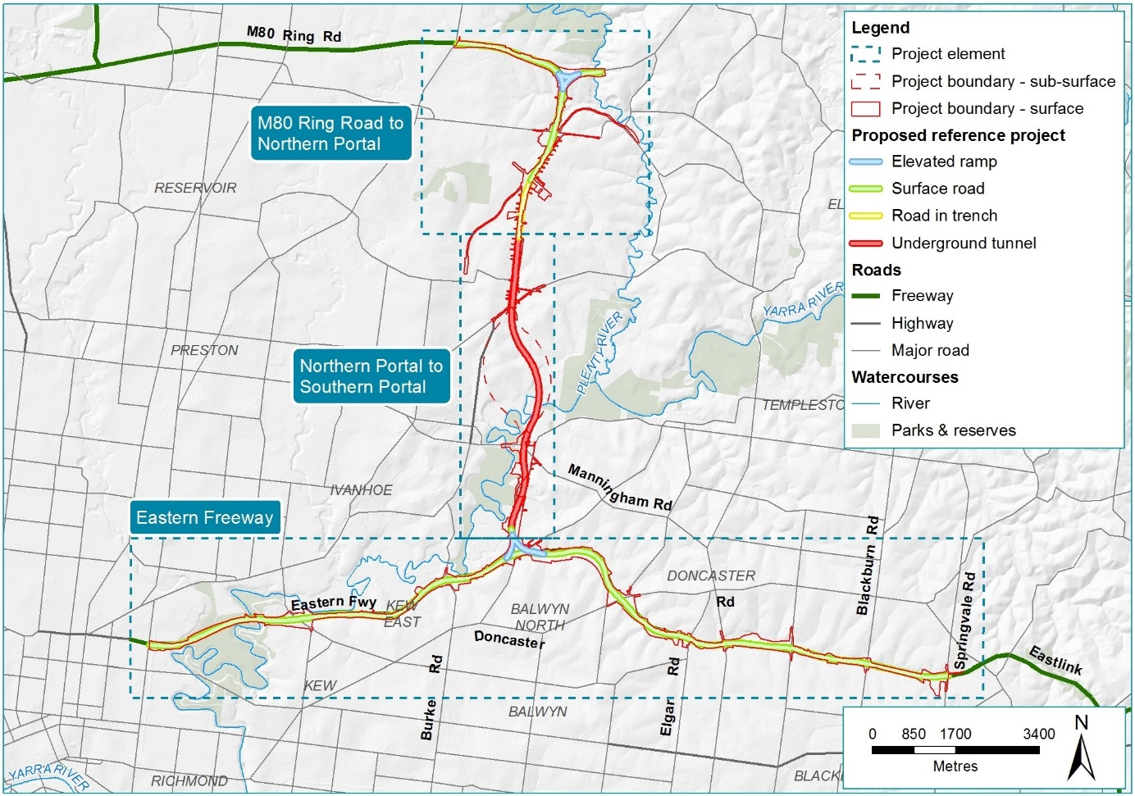
Figure 1 Overview of North East Link

Benefits of North East Link
North East Link would deliver significant transport and traffic improvements, along with substantial benefits for businesses, commuters, communities and the wider economy.

Traffic and transport improvements
North East Link is planned to be a safe and efficient connection for up to 135,000 vehicles a day by 2036, reducing travel times through the north-east and across the city, drawing trucks away from the arterial road network and stopping ‘rat-runs’ along congested north-south roads.
The project is expected to deliver significant positive transport outcomes, including:
- Redistribution of traffic away from local and arterial roads – with the biggest reductions in traffic expected to occur on Rosanna Road (a reduction of approximately 12,000 vehicles per day by 2036 compared to the ‘no project’ scenario), Greensborough Road (a reduction of 19,000 vehicles per day) and Plenty Road (a reduction of 9,900 vehicles per day)
- Less congestion at existing bottlenecks – including a 16 per cent reduction in total traffic volumes crossing the Yarra River at the five existing crossings by 2036. Daily traffic volumes are forecast to reduce along Manningham Road (by 13,300 vehicles), Fitzsimons Lane (16,600 vehicles), Burke Road (7,900 vehicles), Chandler Highway (6,100 vehicles) and Warrandyte Bridge (6,100 vehicles)
- Faster travel times across the north-east – with users of North East Link saving up to 35 minutes between the M80 Ring Road and the Eastern Freeway, and travel times along the Greensborough Road/Rosanna Road/Bulleen Road corridor, the Eastern Freeway between Springvale Road and Hoddle Street, and key routes crossing the Yarra River improving by between 10 and 17 minutes
- Large decreases in the number of trucks using arterial roads in the north-east each day – including along Greensborough Road (7,400 less trucks per day), Bulleen Road (2,400 less trucks), Manningham Road (3,000 less trucks) and Rosanna Road (2,800 less trucks – up to 75 per cent less than the 2036 ‘no project’ scenario)
- Faster bus travel times along the Eastern Freeway – with the dedicated busway delivering improvements of up to 30 per cent in travel times to Hoddle Street, and travel times and speeds expected to improve for all bus and tram services in the north-east
- Faster and more reliable travel times for freight – enabling significant cost savings for firms and industries moving goods along cross-city routes and to and from major industrial precincts and Melbourne Airport
- New and upgraded walking and cycling paths – delivering improved accessibility for pedestrians and cyclists across the north-east
- Improved road network performance – with time spent travelling in congested conditions decreasing across the north-east and average vehicle speeds within the north-east improving compared to the rest of Melbourne.

More productive businesses
North East Link would deliver direct benefits to businesses in Melbourne’s north, north-east and south-east by improving their access to other parts of the city and to major freight and export gateways.
When deciding where to locate, businesses consider how connected a place is to sources of workers, suppliers and customers. Better connections between the north, east and south-east of Melbourne delivered by North East Link would help to attract more investment to these areas by making them more viable options for business start-ups, expansions and relocations. Improved connectivity and accessibility would also enhance the ability of businesses to share infrastructure and to match workers to jobs. Overall, the improved connectivity provided by North East Link is estimated to create $250 million in economic value each year.
Enhancing transport connections also provides benefits by promoting business clustering – the geographic concentration and connection of businesses, suppliers and other associated groups. More than half a billion dollars ($590 million) in economic value is expected to accrue to businesses across the life of the project.
North East Link would also improve access for businesses to a larger pool of workers, including providing better access to the La Trobe National Employment and Innovation Cluster (NEIC). The North East Link business case estimated that the project would give businesses in the north-east access to an additional 62,000 workers and create around 5,500 new jobs.

More competitive and efficient supply chains
Better cross-city connections would provide the basis for a range of supply chain improvements and efficiencies, which would reduce transport costs for businesses. These savings would flow through to lower consumer prices, as well as generating productivity benefits across the wider economy.
Broader benefits would be enjoyed by businesses across Melbourne, particularly those involved in the physical delivery of goods and services. Manufacturing firms in Melbourne’s east and south-east would be able to access Melbourne Airport and key distribution facilities in the city’s north more efficiently. Some capacity on the M1 corridor would also be released, providing further efficiency for freight movements.
Providing an alternative, fully connected route for High Priority Freight Vehicles (HPFV) would reduce reliance on the M1 corridor for heavy vehicle freight movements and allow for more line haul freight to be carried on HPFVs between the city’s north and south-east.
Overall, improvements to the city’s transport network due to North East Link are anticipated to reduce vehicle operating costs for freight vehicles by an estimated $148 million each year, with further savings of $427 million each year from better freight connectivity.

Greater accessibility for households
North East Link would reduce congestion and improve travel times, improving residents’ access to employment opportunities, expanding the range and number of jobs available and boosting household income levels – particularly in the city’s outer suburbs where access to these opportunities is restricted. The North East Link business case estimated that workers in the north-east would have access to an additional 56,000 job opportunities once the project is operating.
Households in Melbourne’s south-east would also experience travel time savings, with journeys between the north and south-east expected to be up to 35 minutes faster. Residents in Melbourne’s north-east who rely on public transport to access the inner and central city would benefit from faster travel times due to the dedicated, high-speed busway.
Households in the north-east would also be better connected to educational facilities, helping to develop a skilled labour pool and improving the range of accessible jobs. Overall, the better connectivity provided by North East Link is anticipated to generate $324 million in economic benefits to Victorian households each year.

Liveable communities and neighbourhoods
More efficient links between the north, east and south-east of Melbourne would reduce the reliance on local and arterial roads by removing non-local traffic. Traffic volumes would be reduced on a number of roads in the north-east including Rosanna Road, Greensborough Road, Manningham Road and Fitzsimons Lane. This is expected to benefit these areas through improved air quality, less traffic noise, reduced congestion and fewer road accidents.
Freeing up arterial connections in Melbourne’s north-east to carry the appropriate vehicles and trips would also improve residents’ access to important local destinations such as schools, recreational facilities and parks. These benefits would contribute to more liveable and attractive neighbourhoods, and a better quality of life for people living in Melbourne’s north-east.

New ‘green’ land bridges
The construction of five land bridges over North East Link between Grimshaw Street and Lower Plenty Road in Watsonia would create approximately 8,500 m² of ‘green’ public open space. The land bridges would provide new north-south linear parkland between Wittman Reserve and Winsor Reserve incorporating informal parkland areas for passive recreation, a series of walking paths and a north-south cycling route. Tree planting and landscaping would provide shade and potential habitat, and filter views of North East Link infrastructure from adjacent residential areas and roads. The land bridges would be designed in response to the project’s Urban Design Strategy.

New and upgraded walking and cycling links
North East Link would deliver around 25 kilometres of new and upgraded walking and cycling links, providing better and safer connections between residential areas and to the inner city. The project includes:
- Improved cycling paths along the Eastern Freeway, providing a fast and direct connection between the inner city and the eastern suburbs
- New and upgraded walking and cycling connections in Bulleen and Heidelberg, including a new bridge across the Yarra River connecting Yarra Street and Banksia Park, new shared use paths along the eastern side of Bulleen Road to Thompsons Road, and a new bridge at the Bulleen Road overpass at the Eastern Freeway
- Completing missing links in the Greensborough Road corridor, including extensive new walking and cycling paths, grade separated crossings and a new Greensborough Road to La Trobe University on-road cycling route
- Five replacement shared use walking and cycling bridges over the Eastern Freeway, including a new bridge and boardwalk linking to Koonung Creek.

New dedicated busway
As part of North East Link, a new dedicated busway would provide full-time, completely segregated bus lanes between Doncaster Road and Hoddle Street – a significant improvement on the existing arrangements for buses travelling along the Eastern Freeway.
The new express capacity provided by North East Link would allow more frequent services on the four routes expected to use the busway. Travel times for buses running along the Eastern Freeway would improve by up to 30 per cent with North East Link. As a result of these time savings and the increase in overall services, patronage across all four routes is forecast to increase. The busway would be supported by improvements to the Doncaster Park and Ride facility.
High quality urban design for a positive community legacy
Given the scale and extent of infrastructure required for North East Link, the urban design for the project must respond to a range of social, functional, environmental and engineering challenges. An Urban Design Strategy has been developed to ensure that the project delivers a high quality and architecturally significant urban design that leaves a positive civic legacy and creates attractive, useful, safe and environmentally sustainable places.
The Urban Design Strategy sets principles, objectives and detailed place-specific requirements to guide development of the project across its planning, procurement, detailed design and delivery phases. The strategy aims to minimise negative visual and other impacts, and maximise positive outcomes for communities along the project corridor.
The project contractors would be required to reflect the Urban Design Strategy in the detailed design of North East Link. The urban and landscape plans would be referred to the Urban Design Advisory Panel for review.

Planning for North East Link
Planning for North East Link has been informed by stringent and comprehensive environmental impact assessments that have incorporated community input and feedback received during the development of the EES.

Requirement for an EES
North East Link is being assessed under Victoria’s Environment Effects Act 1978, which provides for the assessment of proposed projects that could have a significant effect on the environment. On 2 February 2018, the Minister for Planning determined that the proponent for North East Link must prepare an EES to inform the Minister’s assessment of the project. The Minister’s reasons for this determination included that the project is ‘a large-scale infrastructure construction project ... in an intensively developed area’, with works having ‘the potential for significant environmental effects on a range of environmental values’. The Minister determined that an EES process will provide ‘a robust, transparent and integrated framework’ for assessing the project’s potential environmental effects and evaluating ‘the effectiveness of proposed measures to avoid, minimise, manage and offset’ these effects and related risks.
In June 2018, the Minister published Scoping Requirements setting out the specific environmental matters to be investigated and documented in the North East Link EES.

The EES process
Victoria’s EES process is rigorous and transparent and is designed to ensure that major projects are designed, constructed and operated to minimise adverse environmental and community impacts. The process is outlined in Figure 2.
An EES does not recommend or approve a project. Rather, the EES tests a project’s ability to meet relevant laws, regulatory requirements and standards. It gives decision-makers (such as Ministers, EPA Victoria and other statutory authorities) the information they need to determine whether approvals required under Victorian and Commonwealth legislation should be granted and, if so, what conditions should apply to the project.
The EES identifies and assesses the potential environmental effects of the project, including those associated with temporary and permanent structures, proposed construction methods and operational requirements. The North East Link EES presents the results of 18 specialist environmental impact assessments conducted to address the Scoping Requirements set by the Minister for Planning.
The EES process also provides opportunities for members of the public to make submissions about the project.
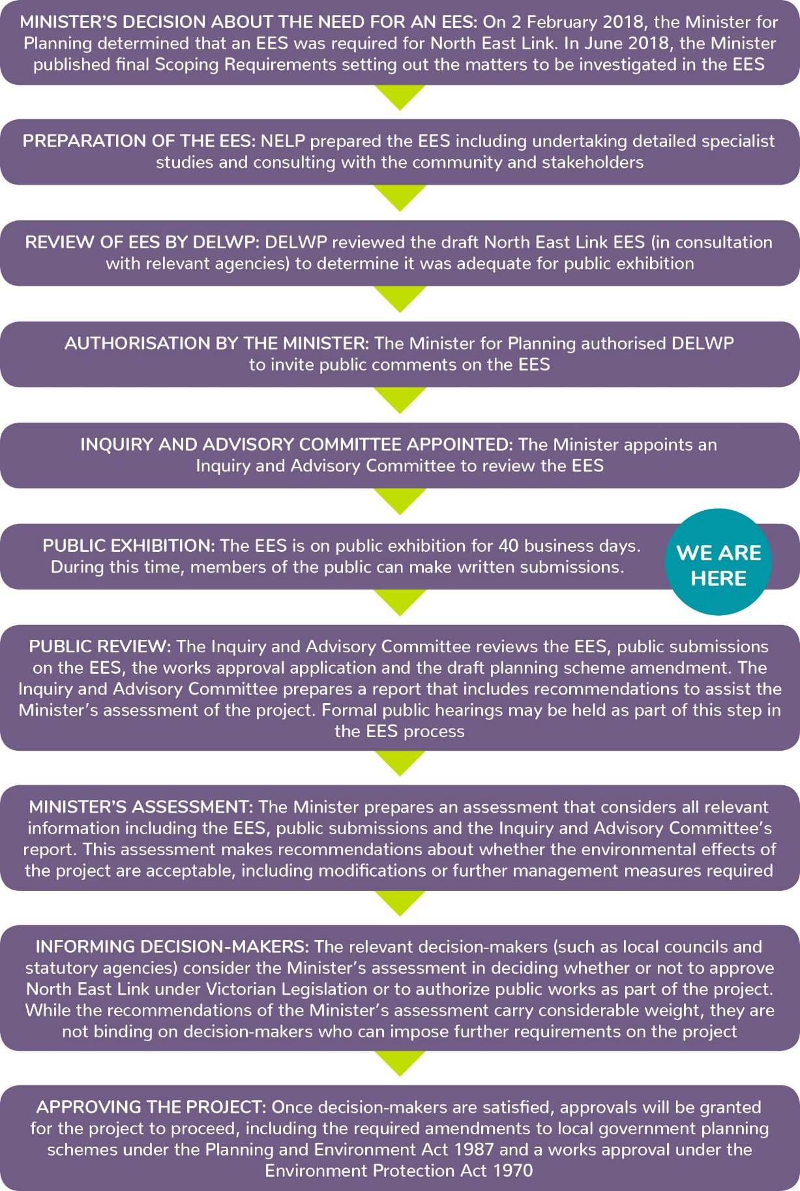
Figure 2 North East Link EES process

Approach to EES assessment
The EES has adopted a performance-based approach to assess a reference project. The reference project is not the final design for North East Link but demonstrates the project's feasibility and ability to achieve acceptable outcomes. The project contractors could make further refinements provided these changes meet the approved project objectives, satisfy the EPRs set for the project and are within the designated project boundary (the area within which all permanent structures and temporary construction compounds must be located).
The EPRs set out the minimum environmental objectives and outcomes the project must achieve across its design, construction and operation phases – irrespective of the final design selected for the project. They include requirements to comply with regulations and guidelines set by government and statutory authorities; achieve specific levels or limits; meet recognised standards; and/or adopt industry best-practice or well-tested approaches and methods. The EPRs have been incorporated into a detailed Environmental Management Framework (EMF), which outlines how the project will meet all statutory requirements, protect environmental values and mitigate adverse environmental effects. A full list of the EPRs proposed for North East Link is provided in Chapter 27 Environmental Management Framework.

Project approvals

Victorian approvals
The key approvals required under Victorian legislation for the project to proceed are:
- Amendments to the Banyule, Boroondara, Manningham, Nillumbik, Whitehorse, Whittlesea and Yarra planning schemes under the Planning and Environment Act 1987
- Works approval for a road tunnel ventilation system under the Environment Protection Act 1970.
In addition, where an EES is required under the Environment Effects Act 1978, the project proponent must also prepare a Cultural Heritage Management Plan (CHMP) under the Aboriginal Heritage Act 2006.

Commonwealth approvals
Part of North East Link would be located on Commonwealth land (at Simpson Barracks in Watsonia). More widely, the project has the potential to impact on Matters of National Environmental Significance (MNES) protected under the Commonwealth Environment Protection and Biodiversity Conservation Act 1999 (EPBC Act). Accordingly the project requires assessment and approval under the EPBC Act.
Further information about the EPBC Act assessment and approval process, including documents submitted to the Australian Government about the project, are available on the North East Link website: <northeastlink.vic.gov.au/environment/planning-and-approvals>.

North East Link elements, features and activities

M80 Ring Road to northern portal
This element would extend from the M80 Ring Road to the northern tunnel portal near Blamey Road. The project would include sections of road at ground surface level, elevated roads for the M80 Ring Road interchange and roads below ground level where they connect to the northern portal. Key project features include:
- A new free-flowing interchange connecting the M80 Ring Road and Greensborough Bypass to North East Link
- A new interchange at Grimshaw Street to separate North East Link through traffic
- New and upgraded road sections extending from the M80 Ring Road at Plenty Road and Greensborough Bypass at Plenty River Drive to Blamey Road, along with alterations to arterial and local roads
- Five new land bridges strategically located over the new road between Grimshaw Street and Lower Plenty Road, providing around 8,500 m² of public open space, parkland and walking and cycling links
- Modifications to the Watsonia railway station car park
- Extending the length of the current Hurstbridge rail line underpass (just north of Watsonia railway station) due to the footprint of North East Link’s main carriageways and Grimshaw Street ramps and service roads. Upgrades to rail signalling infrastructure may also be required
- New or modified noise walls to mitigate noise in residential areas and achieve the project’s noise objectives
- New and upgraded walking and cycling paths and crossings
- Realignment of Banyule Creek from near its origins within the Simpson Barracks to Lower Plenty Road
- Protection and relocation of utilities, including the relocation of two telecommunications towers, electricity transmission lines, three water mains and Melbourne Water’s Watsonia water pressure reducing station.
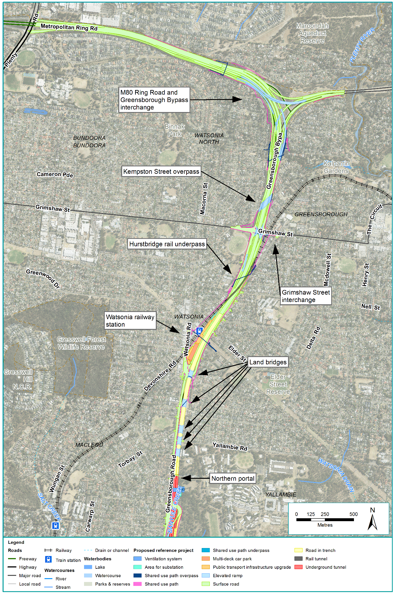
Figure 3 M80 Ring Road to northern portal element
Construction works in this element would extend over four years, commencing in late 2021. Significant construction activities would occur around the site of the new northern interchange with North East Link and the Grimshaw Street interchange. Several construction compounds would be established adjacent to the new link to store materials and equipment, accommodate project workers and allow local access to construction work sites. The potential locations of construction compounds are shown in Chapter 8 Project Description.

Northern portal to southern portal
This element would extend in tunnel from the northern portal at Blamey Road to the southern portal south of the Veneto Club, Bulleen. Key project features would include:
- Six kilometres of twin three-lane tunnels with three traffic lanes in each direction
- Cross passages between the tunnels every 120 metres for operations access and for evacuation in an emergency
- A tunnel management system to allow speed limits to be varied and incidents to be managed safely and promptly
- Ancillary infrastructure to support the operation and management of the tunnels, including additional power supply, tunnel ventilation system and water treatment facilities
- Two ventilation structures each around 40 metres high – one located in the vicinity of the northern tunnel portal near Blamey Road (within Simpson Barracks) and the other near the southern tunnel portal at Bulleen Oval (west of Bulleen Road)
- A motorway operations centre at the Manningham Road interchange to oversee North East Link operations
- Interchanges at Lower Plenty Road and Manningham Road
- New or modified noise walls at the Lower Plenty Road interchange, the Manningham Road interchange and the southern portal to mitigate noise in residential areas and meet the project’s noise objectives
- Modifications to Bulleen Road to connect to the Manningham Road interchange, maintain access to Manningham Road and connect to the Eastern Freeway
- New and improved walking and cycling paths, including a new shared use path along Bulleen Road
- Changes to waterways and drainage
- Protection and relocation of utilities, including the relocation of a wireless telecommunications base station in Bulleen and the Melbourne Water Yarra East Main sewer along Bulleen Road.
The proposed tunnel alignment runs underneath the Yarra River, where the top of the tunnel would be at least 20 metres beneath the river. At its deepest point, in the vicinity of Sevenoaks Avenue in Heidelberg, the top of the tunnel would be approximately 40 metres underground. Along their entire length, the tunnels would be separated horizontally by approximately 15 metres.
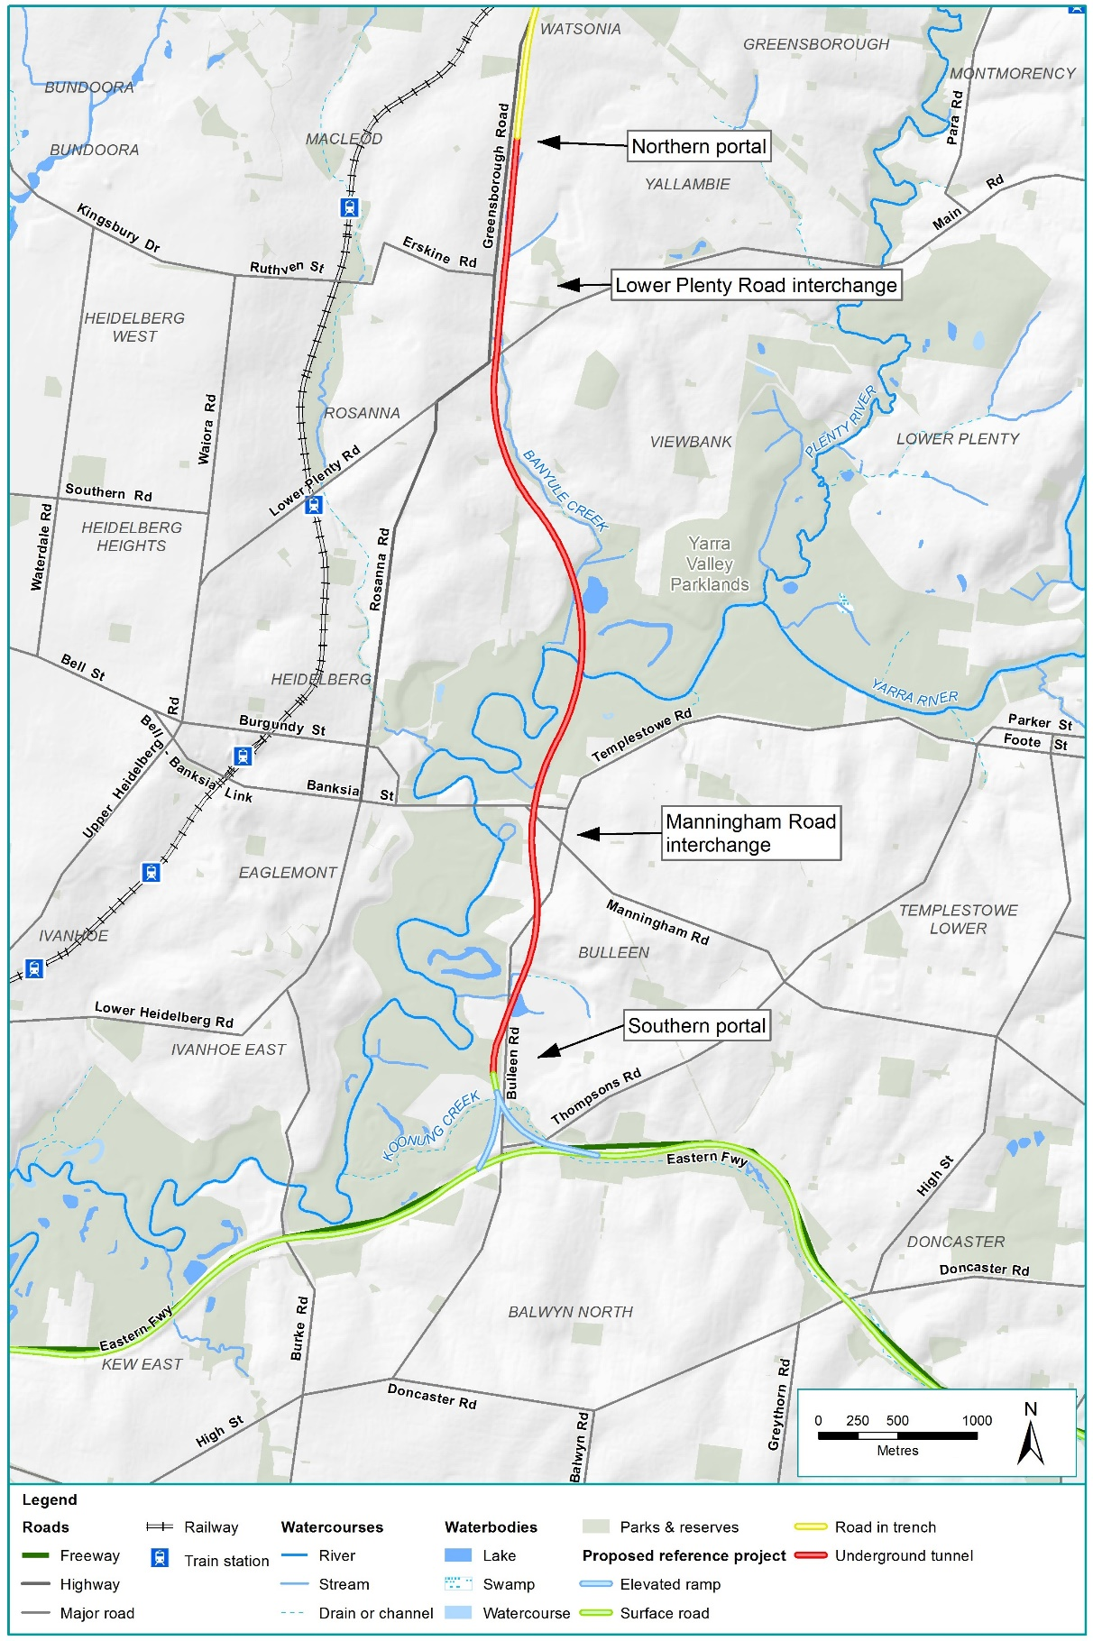
Figure 4 Northern portal to southern portal element
Construction works in this element would extend over seven years, commencing in mid-2020.
The tunnels would be constructed using three different construction methods to suit existing ground conditions and minimise above ground disturbance where possible:
- Cut and cover construction uses excavation equipment to dig a large trench in the ground in which the rectangular tunnel structure is constructed. This method would be used between Blamey Road and Lower Plenty Road, Bridge Street and Golden Way, and Rocklea Street and the southern portal.
- Bored tunnels use a tunnel boring machine (TBM) to excavate through soil and rock, with the tunnel lining being constructed as the excavation progresses. Two TBMs, each approximately 15.5 metres in diameter, would be used for three kilometres of the tunnels between Lower Plenty Road and Bridge Street. The TBMs would operate continuously, progressing at an estimated average rate of 60 metres per week.
- A short section of the twin tunnels (approximately 400 metres long) south of the Manningham Road interchange would be constructed using the mined tunnel method. Two excavation machines (road headers) would be used for this section, progressing at an average rate of 10 metres per week.
A large construction compound would be required to launch and support the TBMs, provide laydown areas for construction materials and assist with spoil removal. Two options have been considered for this main site: a northern site at Lower Plenty Road (extending north to Blamey Road) and a southern site at Bridge Street (extending to Golden Way) – both are assessed in the EES. Some smaller compounds would also be established. The proposed locations of construction compounds are shown in Chapter 8 Project Description.

Eastern Freeway
The Eastern Freeway upgrades would occur from around Hoddle Street in the west to Springvale Road in the east. Key project features include:
- A new interchange at Bulleen Road to connect the Eastern Freeway to the new section of North East Link
- A new dedicated busway along the Eastern Freeway and an upgrade to the Doncaster Park and Ride
- Road widening between Chandler Highway and Springvale Road
- New elevated ramps between Tram Road and Middleborough Road to facilitate access and eliminate weaving
- Replacement of the Doncaster Road bridge to accommodate road widening
- New and upgraded noise walls along sections of the Eastern Freeway to mitigate noise for residents adjacent to the freeway and meet the project’s noise objectives
- New and upgraded walking and cycling paths, including a new North East Bicycle Corridor following the Eastern Freeway, new grade separated crossings and bridges along the freeway and a new Yarra River crossing
- Diversion and piping sections of Koonung Creek in some locations (totalling approximately 1.6 kilometres).
Traffic would be separated into dedicated ‘channels’ between Bulleen Road and Middleborough Road in the eastbound direction and between Tram Road and Bulleen Road in the westbound direction. At these locations, the inner traffic lanes would be for ‘express’ movements and would be physically separated from the outer lanes. The outer lanes would be ‘collector-distributor’ channels, providing dedicated access to freeway on- and off-ramps.
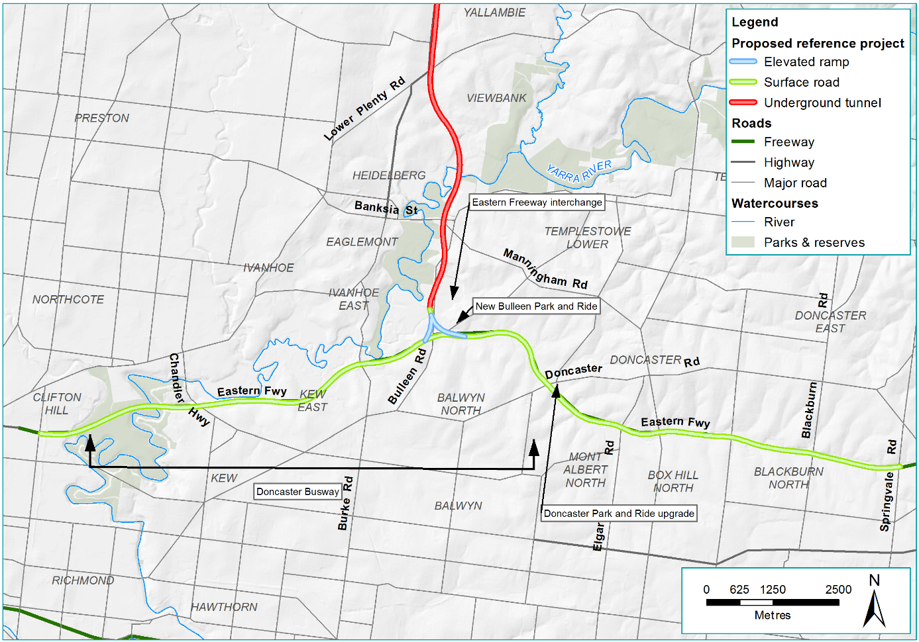
Figure 5 Eastern Freeway element
Construction works in this element would extend over five years from 2021. Works would start with construction of the new Eastern Freeway interchange, followed by upgrading of the Eastern Freeway east and Eastern Freeway west commencing in mid-2022 and mid-2023 respectively.
Construction activities would move progressively along the freeway, supported by a number of construction compounds of varying sizes immediately adjacent to the freeway. The proposed locations of these potential compounds are shown in Chapter 8 Project Description.

Assessing North East Link’s impacts
The progressive development of North East Link has resulted in a reference project that would minimise major adverse impacts. The technical studies conducted for the EES have assessed the project’s potential risks and the likelihood of adverse impacts occurring, and identified recommended measures to avoid, minimise or manage these impacts.
The main impacts anticipated as a result of the construction and operation of North East Link are summarised below. Further details are provided in the main EES report and in the specialist impact assessments attached as technical appendices to the EES.

Transport

Construction
Construction of North East Link would impact the road network through changed road conditions, traffic flows and travel times. Construction activities have the potential to impact the transport network, including motor vehicles, public transport and pedestrians and cyclists. These activities would be managed carefully to minimise traffic and transport disruptions, as has been done successfully for recent major transport projects in Melbourne such as the CityLink Tulla Widening, Monash Freeway upgrades, the Metro Tunnel and the West Gate Tunnel.
To mitigate traffic impacts during construction, the EPRs would require the project contractors to:
- Develop and implement Transport Management Plans (TMPs), informed by an appropriate level of transport modelling. The TMPs would include requirements for maintaining transport capacity in the peak periods and minimising impacts on local streets and community and commercial facilities. The plans would also identify potential construction traffic routes, establish the requirements for limiting construction haulage during the peak periods and outline measures to ensure connectivity and safety for all transport network users during construction
- Undertake independent road safety audits after each stage of detailed design and post-construction
- Monitor transport impacts during construction and provide real-time traffic information to travellers during the construction period. Where monitoring identifies adverse impacts, appropriate mitigation measures would be implemented
- Convene a Transport Management Liaison Group with representatives from the Victorian Government, VicRoads, local councils, emergency services and other relevant agencies to exchange information and discuss issues associated with the TMPs.
During construction, additional traffic would be generated by workers accessing construction sites and trucks delivering materials and equipment and transporting spoil. The highest number of daily truck trips during the project’s construction period is estimated to be between 3,500 and 3,700. The TMPs would outline requirements for spoil to be transported along designated haulage routes that give trucks efficient access to the freeway and arterial road network, minimising the impact on local traffic and local roads wherever possible.
Road closures and diversions would be required to enable construction of North East Link. The TMPs would outline measures to minimise the impact to transport users and surrounding areas, while allowing sufficient space for safe construction works. Construction would be scheduled in stages so that multiple roads are not closed at the same time and lane closures would only be permitted outside of peak periods. Longer term lane closures are anticipated at several locations, including the Greensborough Bypass between Grimshaw Street and Watsonia Road, Grimshaw Street, Manningham Road, Bridge Street and Doncaster Road. Detours, diversions and other measures would be implemented through the TMPs to reduce impacts at these locations.
Traffic lanes on the Eastern Freeway would be temporarily realigned to provide space for construction activities and some lane closures would also be likely. Transport capacity along the freeway would be maintained during the peak periods, with lane closures occurring outside these periods and any full closures of the freeway occurring overnight.
There would be some disruption to public transport services during the construction period. Passenger operations would be temporarily disrupted where North East Link crosses the Hurstbridge rail line around Watsonia railway station. Any closures would be determined in consultation with Public Transport Victoria. Works would be carried out overnight and at weekends where possible, but some longer closures of the line may be required (up to several weeks). Replacement buses would transfer passengers between stations at these times. Existing car parking facilities at Watsonia railway station and the Doncaster Park and Ride would be affected during construction. At these locations, temporary car parking would be provided to maintain the existing overall number of spaces.
Travel times for some bus routes would be affected by lane closures or speed reductions, and some bus stops may need to be relocated temporarily.
The majority of pedestrian and cycling paths would remain open. However, some temporary closures and diversions would be required at the Macorna Street pedestrian bridge and sections of the shared use paths along the Eastern Freeway. Short-term closures are also expected to be required for pedestrian bridges along the M80 Ring Road, in Watsonia and along the Eastern Freeway. These closures would occur overnight or possibly over long weekends, depending on the staging of construction works. The TMPs would outline measures to mitigate impacts on users of these paths, including the provision of suitable temporary diversions.

Operation
Once open, North East Link would redistribute traffic away from arterial and local roads onto the freeway network, reducing traffic volumes and congestion on local and arterial roads in the north-east. The project would benefit public transport users by introducing the new Doncaster Busway and would also improve accessibility for pedestrians and cyclists through the construction of new and upgraded shared use paths.
While large decreases in traffic volumes would occur along key arterial roads and the Yarra River crossings, increases are predicted along the Greensborough Bypass (east of the M80 Ring Road), Watsonia Road and some arterial roads south of the Eastern Freeway. These increases would occur mostly outside of the peak periods, with no material increase in congestion or delays anticipated in the peak periods.
The increase in traffic travelling on the freeway network would be accommodated by additional traffic lanes and ramp metering on the M80 Ring Road and Eastern Freeway. No net increase in traffic is anticipated for roads in the Melbourne CBD.
It is possible that some drivers may choose not to use North East Link to avoid paying tolls. This situation has been accounted for in the modelling undertaken to plan and design the project. Even if some vehicles choose not to use all or part of North East Link to avoid paying tolls, the north-east arterial road network would still experience an overall reduction in traffic volumes due to the project.
The design of the project would allow for maintenance activities, emergency access and incident management in the tunnels and along the freeway. Routine maintenance works would generally occur overnight to minimise impacts on the surrounding road network. Traffic that would normally use North East Link may need to be diverted temporarily onto arterial roads during routine maintenance activities or when incidents occur. Heavy vehicle curfews along Rosanna Road would continue to apply during any periods where temporary traffic diversions are required.

Traffic monitoring would be undertaken on selected roads (arterial and non-arterial) identified in consultation with the relevant transportation authorities and local councils for up to two years after construction ends.

Amenity and wellbeing
Stringent air quality, noise and vibration standards and requirements would apply to North East Link to protect the health and wellbeing of residents and the amenity of open spaces and community facilities.
Impacts on human health
A comprehensive human health impact assessment has been conducted for the EES. The assessment considered the potential health impacts of changes to traffic conditions, amenity and community assets across the project.
The assessment found that the application of the EPRs – such as those designed to minimise impacts related to air quality, noise and vibration and maintain access to community facilities – would manage risks appropriately and there would be no significant or measurable impacts on the health of the community.

Air quality
North East Link would be constructed and operated in accordance with applicable air quality regulatory standards and environmental policies, and best practice guidelines.
Construction activities would generate dust, some odours and vehicle emissions. These activities would be managed in accordance with the State Environment Protection Policy (SEPP) (Air Quality Management) and EPA Victoria’s Best Practice Environmental Guidelines for Major Construction Sites and Environmental Guidelines for the Concrete Batching Industry. A Dust and Air Quality Management and Monitoring Plan would outline measures to control dust, fumes and odours, which could include watering unsealed surfaces, erecting screens and windbreaks at work sites, scheduling known dust- and odour-generating activities during favourable weather conditions and revegetating disturbed surfaces as soon as practicable. The plan would provide for air quality impacts to be monitored during construction at particularly sensitive locations.
The project’s Spoil Management Plan (see Contamination and soil impacts) would include requirements for the storage, handling, transport and disposal of spoil that minimise dust and odour generation. Air quality monitoring would be carried out at nominated locations close to work sites. Adopting these measures would maintain air quality to the required standards during construction.
Once North East Link opens, air quality would improve along many arterial roads in the north-east due to reduced traffic volumes, compared to a ‘no project’ scenario. This includes Rosanna Road, where concentrations of particulate matter (PM) and nitrogen oxide (NO₂) would decrease significantly.
Nevertheless, air quality would diminish at a small number of locations due to higher traffic volumes, including along Bulleen Road, Grimshaw Street and Greensborough Road. Air quality would also decrease in the immediate vicinity of the Eastern Freeway and the M80 Ring Road. The largest increases in maximum pollutant concentrations are predicted to occur along the North East Link alignment between Yallambie Road and the M80 Ring Road interchange. Notwithstanding, these changes are not considered to be associated with significant or measurable impacts on community health.
The vehicle emissions assumed for the EES impact assessment are conservative and do not account for improvements in vehicle technology beyond 2020 that are expected to drive a future reduction in emissions, which would improve air quality. This means that emissions from the operation of North East Link may be overestimated. At a project level, best practice management options would be implemented to reduce the impact of higher vehicle emissions, including vegetation and noise walls between the road and adjoining residential areas. These measures, combined with developments in low emissions vehicle technology and a greater take-up of hybrid and electric vehicles, would further mitigate air quality impacts from North East Link.
The tunnel ventilation system would be designed and operated to achieve best practice in managing emissions and to comply with the licence issued by EPA Victoria and SEPP (Air Quality Management) requirements. The system would be required to achieve zero emissions from the tunnel portals, with all vehicle emissions being discharged higher into the atmosphere via the two ventilation structures. Conservative air dispersion modelling undertaken for the EES indicates that the tunnel ventilation structure emissions would meet the applicable standards for most pollutants. PM levels would exceed the SEPP criteria because of the existing background concentrations of these pollutants; however, the tunnel emissions would represent a very small contribution to these already high levels.
The project contractors would monitor and report on in-tunnel air quality and ventilation structure emissions during operation and take remedial action to EPA Victoria’s satisfaction if the standards set out in the EPRs and the EPA Victoria licence are not met.
Overall, the applicable EPA Victoria standards would be met for most pollutants across the project area. The exception would be maximum 24-hour and annual average PM concentrations in some locations, which would exceed the SEPP (Ambient Air Quality) criteria. As noted above, this is because background concentrations of PM already exceed the SEPP criteria. Improvements in technology are expected to reduce vehicle emissions in the future, which would lead in turn to reductions in background concentrations of PM.
To measure the air quality impacts of North East Link, an ambient air quality monitoring program would be established in consultation with EPA Victoria, commencing at least one year before the project starts operating.

Noise
North East Link would adopt a conservative approach to the application of noise criteria to the project. Where Victoria has no specific guidelines (for example, daytime construction noise targets), relevant interstate or accepted international guidelines have been adopted.
Construction noise impacts would be managed in accordance with EPA Victoria Noise Control Guidelines and by achieving project-specific noise guideline targets. A Construction Noise and Vibration Management Plan (CNVMP) would outline measures to achieve these targets, which could include temporary noise walls and acoustic sheds, giving advance notice of planned noisy activities to nearby areas, scheduling noisy work at less sensitive times and providing respite periods from very noisy works.
The noise guideline targets may be exceeded at some locations for short periods of time (several days), with the greatest number of properties affected likely to be adjacent to the road corridor in Watsonia North and Greensborough and those adjacent to excavation works in Watsonia and Macleod. Consideration would be given to relocating residents where noise and/vibration levels are too high for extended periods.
When operating, North East Link would be required to comply with VicRoads’ Traffic Noise Reduction Policy, applied conservatively (ie categorises all roads as new, rather than upgraded for the M80 Ring Road and the Eastern Freeway). The EPRs would require traffic noise from North East Link project roads to be:
- No greater than 63 dBA between 6am and midnight for residential dwellings, aged persons homes, hospitals, motels and other buildings of a residential nature
- No greater than 63 dBA between 6am and 6pm at schools, kindergartens, libraries and other noise-sensitive community buildings.
In addition, these places are located on non-project roads within 100 metres of North East Link, the combined traffic noise from North East Link and other roads must not be more than 2 dBA higher than the predicted levels under a ‘no project’ scenario.
Achieving these limits is expected to reduce existing levels of traffic noise at more than 2,300 residential properties and maintain the current traffic noise environment at more than 8,200 properties. In addition, many properties in adjoining suburbs would experience an operational traffic noise benefit from the removal of vehicles, particularly heavy vehicles, from the wider regional road network.
The EES impact assessment initially identified around 11,500 residential or noise-sensitive buildings as potentially being affected by traffic noise. However, following the application of mitigation measures (such as low noise pavements and noise walls), 159 noise-sensitive buildings were assessed as potentially exceeding the 63 dBA traffic noise limit set by the EPRs. These properties would experience a noticeable noise increase (between 2 dBA and 5 dBA), with one property experiencing a noise increase of between 5 dBA and 10 dBA. These properties would qualify for further at-property noise treatments to mitigate impacts such as glazing upgrades and insulation.
New or modified noise walls would be provided in a number of locations to achieve the project’s noise limits. Noise walls would be installed ahead of construction works, where feasible, and would be designed in response to the project’s Urban Design Strategy.
Traffic noise would be measured prior to North East Link opening and monitored during operation. Remedial action would be taken if these measurements show that the project’s traffic noise limits are not being met. Mitigation actions would be taken in accordance with the CNVMP and in consultation with property owners, occupants and managers.

Vibration
North East Link would adopt more stringent vibration criteria than required by Victorian regulations or approval authorities. Where Victoria has no specific guidelines (for example, human-comfort vibration assessment procedures and acceptable amenity and structural damage levels), accepted international standards and guidelines have been adopted.
Construction activities such as piling and the use of vibratory rollers, rock‐breakers and hydraulic hammers have the potential to cause an increased level of vibration at residential and other sensitive properties. Vibration impacts would be controlled to avoid cosmetic damage to structures by using measures such as restricting hours of operation, using lower vibration equipment in place of rock-breakers and undertaking vibration monitoring and trials.
The design of the North East Link tunnels would minimise vibration and regenerated noise impacts. The EES impact assessment found that relatively minor levels of perceptible vibration and audible regenerated noise would occur during construction of the tunnels, portals and cross passages, particularly where the depth of the tunnel beneath the surface is shallower. People and places directly above or in close proximity to tunnelling excavation would experience these impacts for relatively short periods of time (up to three weeks).
As an added precaution, project-specific guideline targets would be set by the EPRs to minimise construction vibration impacts on utility assets, structures and amenity. These guideline targets would be achieved through measures such as selecting quieter machinery, making adjustments to construction equipment and careful programming of construction activities. Providing the community with information about tunnelling works and giving advance notice of activities that could cause vibration and regenerated noise would also be important.
Meeting the guideline targets would result in vibration or regenerated noise levels that are acceptable to the majority of people and limit the potential for physical damage to buildings, infrastructure and utility assets. The EES impact assessment found that no structural damage is anticipated as a result of tunnelling activities during construction. Where conditions are encountered that produce vibration and regenerated noise above the target levels, action would be taken to protect the amenity of residents and prevent damage to buildings structures, sensitive equipment and utility assets.

Business
Once operational, North East Link is expected to generate substantial direct benefits for businesses through reduced travel times and decreased congestion, making it easier to do business, build a skilled workforce and increase productivity. Better transport connections between Melbourne’s north, east and south-east are expected to make these areas more attractive locations for businesses (see Benefits of North East Link).
A number of commercial properties would need to be acquired for the project, with the majority being in the Bulleen Industrial Precinct. Table 1 summarises the number of businesses that would be acquired in each precinct, and whether they would be affected by permanent acquisition or temporary occupation. Disruption to these businesses would range from minor to major, depending upon their circumstances.
Commercial property acquisition would be undertaken in accordance with the Land Acquisition and Compensation Act 1986 and the Major Transport Projects Facilitation Act 2009, with compensation for displaced businesses assessed on a case-by-case basis. Upon confirmation of the project’s permanent land acquisition requirements, NELP would provide reasonable notice to affected landowners and offer a high level of assistance to displaced businesses.
Table 1 Businesses affected by permanent acquisition and temporary occupation
Element | Permanent land acquisition | Temporary land occupation
M80 Ring road to northern portal | 7 | 0
Northern portal to southern portal | 90 | 3
Eastern Freeway | 5 | 0

While a significant number of businesses are located in the M80 Ring Road to northern portal element, only seven would be displaced due to land acquisition, all located along Greensborough Road. Some of these properties are currently subject to a VicRoads Public Acquisition Overlay, indicating the longer term viability of these businesses is already vulnerable without the project.
In the Northern portal to south portal element, up to 90 businesses would be acquired including more than 80 in the Bulleen Industrial Precinct. Currently, the precinct comprises around 110 businesses, operating largely as an automotive cluster and providing jobs to approximately 1,000 people who live mainly in surrounding suburbs. Relocation of these businesses would potentially disrupt their supply chains, customer relationships, employment bases and ability to retain staff. The displacement of these businesses may also affect the character and productivity of the automotive cluster in the precinct, with remaining businesses possibly having to source new suppliers and build new commercial relationships.
Construction of North East Link would likely impact five businesses within the Eastern Freeway element. Four businesses located within the Boroondara Tennis Centre would be displaced. The other business – Freeway Public Golf Course with associated pro shop – could be maintained on the site through reconfiguration of the golf course.
In the event that local relocation options cannot be found, the closure of businesses due to permanent property acquisition could reduce the availability of local jobs and force residents to travel further to access services elsewhere.
The successful relocation of displaced businesses would reduce disruption to these firms and their customers and workers, as well as to those businesses remaining in the Bulleen Industrial Precinct. However, the displacement of a large number of businesses at the same time increases the difficulty of finding appropriate new premises. NELP is assessing industrial and commercial land and precinct opportunities to help businesses identify potential relocation options. NELP is also assisting displaced businesses adjacent to the Eastern Freeway interchange with their future planning. The EPRs would require the project to continue to minimise disruption to businesses affected by permanent acquisition or temporary occupation.
Construction of North East Link could disrupt businesses in close proximity to compounds and work sites due to changes in amenity (such as increased noise and dust) and traffic conditions. These impacts would be minimised and managed by applying the relevant EPRs for air quality, noise, vibration and implementing the TMPs. The project contractors would be required to minimise any reduction in the level of access, amenity or function of any business or commercial facility and to give businesses adequate notice of potential impacts and temporary access arrangements. Emergency access would be maintained at all times and permanent access to businesses affected by construction activities would be restored (or relocated as agreed with the property owner) when works are completed. Business Liaison Groups have been established to provide a forum for working with businesses to record, manage and resolve their concerns about project activities.
Once North East Link opens, some local businesses may be affected by the redistribution of traffic, altered access arrangements, a reduction in passing trade and changed business visibility. However, other businesses would benefit from decreased traffic volumes along some arterial roads, reduced congestion and better access to Melbourne Airport and major industrial and commercial precincts.
Tolls would apply to vehicles travelling on the new road but there would be no new tolls on existing roads (including the Eastern Freeway). Business surveys conducted for the EES indicated that tolls are not a significant concern for most businesses, with many rating higher travel speeds and more reliable travel times as being more important than the potential increased cost of tolls. The proposed tolling structure and strategy are not included within the scope of the EES.

Social and community
North East Link is expected to deliver significant social and community benefits, including better access for households to jobs and important local destinations, improved walking and cycling connections and reduced volumes of traffic and fewer trucks on arterial roads through the north-east (see Benefits of North East Link).
The EPRs would require the final design and construction of the project to minimise disruption to residents and users of community facilities due to the permanent acquisition or temporary occupation of land. Nevertheless, up to 36 residential properties would be permanently acquired across the project corridor, as shown in Table 2. These properties are located in the municipalities of Banyule and Manningham.
Table 2 Residential properties affected by permanent acquisition
Element | Residential properties acquired
M80 Ring road to northern portal | 18
Northern portal to southern portal | 18
Eastern Freeway | None

Acquisition would disrupt established social networks and neighbourhoods, and some residents may have to relocate outside the area and re-establish in new communities. Relocation of residents is likely to disrupt people’s lifestyles, pose demands on individual and family time, and cause worry due to uncertainty. People may also experience a loss of their social and community ties. The severity of these effects would vary depending upon the individuals and their circumstances.
Residential property acquisition would be undertaken in accordance with the Land Acquisition and Compensation Act 1986 and the Major Transport Projects Facilitation Act 2009. Compensation would be provided for landowners and occupants with an interest in properties acquired for the project and assistance would be offered to residents and households affected by property acquisition. The project would continue to use a case management approach to assisting affected households and respond appropriately to the special needs of vulnerable landowners and occupants.
North East Link would permanently acquire public land within Banyule, Boroondara and Manningham (including part of the Freeway Public Golf Course, Boroondara Tennis Centre and part of Bulleen Park). The Bulleen Swim Centre (operating on privately owned land) would be fully acquired. Borlase Reserve would be acquired to the extent that its current use would no longer be viable. NELP is working with affected sporting clubs, user groups and local councils to provide alternatives for displaced facilities and recreational activities.
During construction, the project would require full or partial temporary occupation of a number of reserves and recreational facilities (including part of the grounds at three private schools), most of which are clustered around the southern extent of Bulleen Road and the area surrounding the Eastern Freeway. NELP is consulting with the affected schools, user groups, facilities managers and sporting clubs and associations to minimise any impacts. Solutions may include increasing the capacity of nearby sites to accommodate increased use for a temporary period. All reserves and recreational facilities occupied during construction would be reinstated.
Adverse impacts on nearby community facilities and residents during construction relate mainly to temporary amenity impacts, such as traffic disruption, noise and dust emissions, and changes to access and connectivity. These impacts would be managed by applying the relevant EPRs, implementing a Communications and Community Engagement Plan (see Consulting with the community) and consulting with local councils and the users, owners and managers of these facilities.
Once North East Link opens, the application of the EPRs would reduce the overall significance of potential impacts on residents and the function and viability of community facilities. At many locations, residents and communities would benefit from reduced traffic noise and the improved accessibility and connectivity delivered by improved walking and cycling links and the new dedicated busway along the Eastern Freeway. It is important to note that without North East Link, communities in the north-east would face a deterioration of social and employment opportunities due to an increasingly congested arterial road network that cannot keep pace with population growth and rising travel demand.

Land use planning
The main impacts associated with land use planning are related to the acquisition and temporary occupation of private property and public open space. Permanent change in land use would result from acquisition where land that is currently used for open space, residential, commercial, industrial and Commonwealth land purposes would no longer be available for that purpose. These impacts would be experienced particularly at the Bulleen Industrial Precinct, recreational facilities along Bulleen Road, residential land subject to acquisition and some areas of open space across the project.
While the EES impact assessment found that – with the application of the EPRs – North East Link would be largely consistent with State and local planning policies, land acquisition within the Bulleen Industrial Precinct would be inconsistent with policies that seek to maintain existing industrial land uses. NELP is working with Manningham City Council to minimise the loss of industrial land in the area. Manningham City Council is seeking to retain employment land use once construction is complete.
Overall, open space acquired or used temporarily for the project is relatively small in area. Across the project corridor, NELP would work with local councils to identify how the project could make a positive contribution to existing public open spaces and local landscapes, respond to local planning strategies and minimise any inconsistencies with strategic land use plans.
The EPRs would require the project to minimise its design and operational footprint and avoid, where possible, impacts on sensitive land uses such as residential properties, parks and reserves, recreational and community facilities and sensitive landscapes around the Yarra River.
The installation of noise walls and elevated structures would potentially cause increased overshadowing at up to 45 residential dwellings along the southern side of the M80 Ring Road, isolated locations along the Greensborough Bypass and along the southern side of the Eastern Freeway. During the detailed design phase, the project would be required to minimise any overshadowing from elevated structures and noise walls. This could include lowering the height and changing the positioning of structures, and using materials that allow more light to reach rooftop solar panels.
A change in land use due to the acquisition or temporary occupation of properties may also provide an opportunity to redevelop the local area post-construction. These land use changes would require separate approvals.

Landscape and visual
While North East Link would extend across a large geographic area, the project’s landscape and visual impacts would be minimised by the long section of tunnel and by the Eastern Freeway upgrades being contained largely within the existing freeway footprint. In particular, the project has been designed to minimise impacts on residential properties.
However, in some locations where permanent new infrastructure would be located close to properties, the potential visual impacts could be high. This would primarily occur where there is insufficient space for vegetation buffers to screen or filter views of noise walls and elevated structures. In locations where new infrastructure would be located at a distance from the viewpoint and where there is space available for landscaping, the impacts would be far less significant.
Places assessed in the EES as potentially having medium to high landscape and visual impacts over the longer term include:
- Locations close to the Lower Plenty Road interchange and the M80 Ring Road interchange in Greensborough where there is limited room for planted buffers adjacent to elevated structures and new or higher noise walls, including Greensborough Road north of Teresa Street Hamlet Street and Saxon Court
- Residential streets with largely unfiltered views of new noise walls, elevated structures or relocated transmission towers, including Frensham Road and Sellars Street in Watsonia North, Borlase Street in Yallambie, Estelle Street in Bulleen and Columba Street in Balwyn North
- Simpson Barracks and sporting complexes in Bulleen with views of the proposed ventilation structures
- Locations in Koonung Creek Reserve and Koonung Creek wetlands with views of a shared use overpass and/or higher or closer noise walls
- Some places along the Koonung Creek Trail and River Circuit Trail with views of noise walls and a shared use overpass.
These impacts would be reduced through the application of the EPRs, which would require the project’s final detailed design to minimise landscape and visual, overlooking and shading impacts, and to maximise opportunities to enhance public amenity, open space and facilities. The project’s landscape plans must provide for the vegetation screening of visually impacted public and residential areas and community spaces. Extensive landscaping and planting post-construction, including the creation of the five new ‘green’ land bridges (see Benefits of North East Link), would also mitigate adverse landscape and visual impacts.
During construction, there would be medium to high visual impacts in the Ridgeline and Koonung Creek areas and medium impacts in the Yarra River Valley, due to the number of residences with views towards construction activities, particularly along the Eastern Freeway. Some residents directly adjacent to the construction compounds would have their views to parkland blocked by hoardings and fences, while some more elevated properties would look directly into the compounds. These impacts would be temporary; however, they could last for most of the seven-year construction period in some places.
To address and reduce these impacts, the EPRS would require the project contractors to minimise landscape impacts during construction and the visual impacts of construction works. This could include temporary landscape treatments, aesthetic hoardings and planted screenings. All areas disturbed by temporary and construction works would be reinstated in consultation with the relevant land manager.
Measures would be implemented to minimise light spill during construction to protect the amenity of adjacent neighbourhoods, parks, native fauna habitat and community facilities. Lighting used during the project’s operation would be designed to minimise obtrusive effects and meet relevant standards.

Heritage

Aboriginal cultural heritage
North East Link has been designed to minimise impacts on areas of Aboriginal cultural heritage sensitivity. Nevertheless, project construction has the potential to impact 14 Aboriginal cultural heritage places. This includes:
- Two artefact scatters that may have been previously impacted by construction of the M80 Ring Road
- Two scarred trees (which would likely be de-registered as non-cultural items), three heritage overlay places and two artefact scatters in the northern portal to southern portal elements
- Five places in the Eastern Freeway element, comprising three artefact scatters, an Aboriginal historical place and a place of historical reference.
As areas within and adjacent to the project corridor have a rich and extensive history of Aboriginal occupation, the project also has the potential to come into contact with unknown values and places, such as sub-surface artefact scatters.
Potential impacts to known and unknown Aboriginal cultural heritage places would be managed by compliance with the Cultural Heritage Management Plan being prepared for North East Link. This would make recommendations to minimise, avoid or mitigate the impact to Aboriginal cultural heritage values. While in some cases harm to Aboriginal cultural heritage cannot be avoided, the CHMP would redress this harm to some degree by allowing the collection of scientific and cultural data that may otherwise be unobtainable.
Running parallel to the CHMP, a cultural values mapping investigation is being conducted with the Wurundjeri Woi-wurrung Cultural Heritage Aboriginal Corporation to provide a greater appreciation of Aboriginal cultural heritage values in addition to those values covered more formally by the relevant legislative framework.
Bolin Bolin Billabong – a historical site where Aboriginal people camped along the Yarra River – has high cultural significance to the Wurundjeri people and has been declared a ‘no go zone’ for surface works.

Historical cultural heritage
Placing a large section of the link in tunnel – especially through the sensitive areas of the Yarra River and its environs – means that impacts on significant historical heritage buildings and places have largely been avoided. In other parts of the project, there are relatively few locations where project works would intersect or otherwise have an impact on historical heritage places or values; however, potential impacts would include:
- Minimal disturbance of former Fairlea Women’s Prison and Yarra Bend Lunatic Asylum sites in Northcote due to activities associated with providing new and upgraded walking and cycling paths. Any impacts would be managed by the project’s Archaeological Management Plan and by undertaking research at the site ahead of construction commencing
- Changes to the first stage of the Eastern Freeway from Hoddle Street to Bulleen Road, which has heritage value in the history of freeway design. In the detailed design phase, efforts would be made to retain the fabric and aesthetic qualities of this stage of the freeway consistent with its original design and new freeway infrastructure would be designed with regard for the original design qualities.
Under the reference project, a large River Red Gum on Bridge Street in Bulleen would need to be removed to construct the Manningham Road interchange. The tree is believed to be more than 300 years old and is listed in the National Trust of Australia Significant Tree Register. It is also the subject of a local council Heritage Overlay. Whilst options to avoid loss of this tree were investigated, it is not possible with the reference project because of the alignment of the tunnel and the geometry of the ramps at the Manningham interchange. Archival photographic records would be taken of the tree before construction starts in accordance with Heritage Victoria’s specifications, supplemented by a written history that incorporates oral history sources. While the loss of the tree cannot be mitigated, these actions would provide appropriate recognition of its significance.
The EPRs would require the project's detailed design to minimise impacts on the cultural heritage values of these and other heritage places in consultation with Heritage Victoria and/or local councils. Prior to construction starting, further measures would be identified to protect heritage places, structures or features.
Where works involve subsurface disturbance, an Archaeological Management Plan would guide investigation and management of the site to the satisfaction of the Executive Director, Heritage Victoria. The plan would detail measures to minimise and manage disturbance of any archaeological sites and values affected by the works, such as archival photographic recordings, background historical research and artefact analysis, preservation and storage.
Changes to the setting and character of the Simpson Barracks site – notably the Assembly Place and commemorative plantings – may hold value for the Barracks and its personnel; however, they would not undermine the historical values of the place as a whole. Impacts would be restricted to the western section of the Barracks and to buildings and facilities that comprise a small part of the total complex. Simpson Barracks would be consulted about how best to manage these impacts.

Ground movement
Ground movement is expected on any project that involves excavation and tunnelling. Geotechnical investigations and modelling of potential ground movement impacts due to North East Link have demonstrated that the project can be constructed and operated with negligible to slight risk of damage to the majority of buildings and other structures. This indicates that there is potential for some cosmetic damage to a small number of buildings in the study area. There is also potential for ground movement to impact a sculptural installation, ‘Helmet’, during tunnelling under Banksia Park. It is envisaged that this sculpture would be relocated for the duration of tunnelling works in this area.
EPRs are proposed to ensure that any risks to buildings and structures above the tunnels are minimised. A geotechnical model would inform the design of the tunnels and the construction techniques to be adopted. The model would be used to assess potential ground movement effects and set trigger levels for taking additional mitigation action. A Ground Movement Plan would identify the location of assets and structures that may be susceptible to damage and include acceptability criteria, monitoring procedures and appropriate mitigation measures. Condition surveys of potentially affected properties and infrastructure would be conducted before construction commences; post-construction assessments would ascertain if the project works had caused any damage; and any repair works would be undertaken in consultation with the property or asset owner.

Groundwater
Groundwater is water that lies beneath the earth’s surface. Groundwater has multiple uses: it is used for drinking water, irrigation, stock watering and industrial or commercial purposes, and sustains trees, vegetation, wetlands and waterways. Construction and operation of North East Link has the potential to change groundwater levels and affect groundwater availability and quality, with potential impacts on human health, buildings and structures, and the environment.
The North East Link tunnels and drainage systems would be designed and constructed to minimise groundwater drawdown and limit changes to groundwater levels, using well-tested engineering controls, drainage techniques and tunnelling methods.
Informed by further groundwater modelling, a Groundwater Management Plan would be implemented to protect groundwater quality and manage the project’s interaction with groundwater. Groundwater monitoring would be undertaken prior to construction to establish baseline water levels and quality, confirm the adequacy of the project’s proposed design and construction methods, and to identify any additional measures required to mitigate potential groundwater impacts. Monitoring of groundwater levels, flows and quality would continue throughout the project’s construction and operation to confirm that groundwater is being managed appropriately and to identify where and when additional measures might be required. This includes the identification and implementation of contingency measures to restore groundwater levels and to prevent the loss of water for trees and ecosystems.
Investigations to date have not found significant areas of groundwater contamination in the North East Link project area and the potential for encountering groundwater contamination during the project’s operations is considered to be low. However, works underground (such as the construction of the road trench and tunnels) would increase the likelihood of exposure to contamination and of disturbing and mobilising contaminated groundwater, causing it to migrate to new areas. Given previous land uses, there is a possibility that contamination may exist in some discrete locations, such as at the fuel service station on the corner of Greensborough Road and Yallambie Road, at the former Bulleen Drive-in site and near Watsonia railway station. The risk of mobilising contaminated groundwater at these sites would be investigated further before construction starts. The Groundwater Management Plan would include requirements and methods to manage unexpected contaminated groundwater in accordance with relevant regulations, standards and best practice controls and construction methods.
The tunnels and other underground infrastructure would continue to influence groundwater conditions near the project once it opens. While levels of groundwater drawdown would be less in the operation phase than during construction, groundwater-related impacts could occur as the aquifer readjusts. In particular, a small level of drawdown is anticipated at Bolin Bolin Billabong (see Ecology impacts) and north and south of Lower Plenty Road. No groundwater drawdown is predicted beneath Banyule Swamp. The Operations Environmental Management Plan (OEMP) required by the EPRs would establish procedures for managing, monitoring, reusing and disposing of groundwater inflows during operation that comply with the relevant regulations and SEPPs.
Following the application of the EPRs, groundwater impacts to human health, buildings and structures, and the environment have been assessed to be low. No regional changes to groundwater would occur and most anticipated changes to groundwater levels would be located adjacent to the tunnels.

Contamination and soil
Any major tunnelling project in a dense urban area has the potential to encounter contaminated soil, rock and groundwater, as well as industrial waste, chemicals, asbestos and gases. However, the area surrounding North East Link is relatively benign from a contamination perspective compared to other parts of Melbourne. As past pastoral land uses have given way to urban development with minor commercial and industrial uses, heavy industry and other sources of major contamination are absent from the area and no broad-scale contamination exists.
Contaminated soil, industrial waste and asbestos are known to be present at a small number of locations, such as the former quarry at the junction of the M80 Ring Road and the Greensborough Bypass, Bulleen Industrial Precinct and former landfill sites. Acid sulfate soil and rock are also known to occur within the project area.
Overall, an estimated 6.1 million cubic metres of spoil would be generated for the construction of North East Link. The great majority of this spoil is expected to be ‘clean fill’ (material that can potentially be re-used or recycled). Opportunities for reusing this spoil would be investigated and spoil that is unable to be reused would be transported to suitable disposal sites along designated haulage routes.
Before construction starts, detailed site investigations would be conducted (including additional soil sampling) to clarify the presence, nature and possible extent of any contamination and to inform spoil and waste management measures.
A Spoil Management Plan, developed in consultation with EPA Victoria, would incorporate processes and measures for identifying, excavating, storing, handling and disposing of clean fill, contaminated spoil, asbestos, industrial waste and hazardous substances. The plan must satisfy EPA Victoria and Worksafe Victoria that health and safety procedures are in place to minimise risks to workers, visitors and the general public. The plan would also provide methods for the appropriate treatment or remediation of contaminated land and groundwater caused or exacerbated by project construction.
The Spoil Management Plan would include requirements and methods to minimise impacts from the disturbance of acid sulfate soil and ensure that these soils are managed safely in accordance with EPA Victoria guidelines. The EPRs would also require the project contractors to identify and minimise risks from the disturbance of former landfills.
The CEMP and OEMP would include stringent procedures and controls for managing chemicals, fuels and hazardous materials in accordance with the relevant regulations and guidelines. These measures – combined with the non-industrial nature of the area surrounding the project – mean that the potential impacts to human health, the environment and amenity from the project encountering contamination have been assessed as low.

Surface water
Runoff from exposed surface areas at construction work sites and permanent above ground structures, discharges from the tunnel drainage system and spills would have the potential to affect water quality during the project’s construction and operation. These impacts would be minimised by:
- Requiring all discharges and runoff from the project to meet SEPP (Waters) and comply with EPA Victoria’s Best Practice Environmental Management Guidelines for Urban Stormwater
- Implementing a Surface Water Management Plan that mandates best practice sediment and erosion control and monitoring in accordance with EPA Victoria guidelines
- Designing and constructing spill containment capacity to meet AustRoads requirements
- Minimising waste water and incorporating new water treatment features into the project design to minimise the potential for pollutants to end up in waterways
- Retaining or replacing existing water quality treatment assets to maintain or exceed their current performance
- Monitoring water quality prior to and during construction.
While construction activities within Banyule Creek and Koonung Creek would alter the natural features and characteristics of these creeks, both waterways are highly urbanised and heavily modified and have poor water quality. Activities affecting these waterways are shown below.
Table 3 Activities affecting waterways
Waterway | Construction activities
Banyule Creek | Approximately 1,400 metres of open drain, creek, and tributaries would be diverted from Blamey Road to Lower Plenty Road, replacing this section of the creek with culverts and overland flow paths with a new retarding basin upstream of Lower Plenty Road.
Koonung Creek | Underground diversion or realignment of sections of the creek would total approximately 1,600 metres and require the clearing of vegetation in the floodplain prior to the re-establishment of new vegetation. Some currently piped sections of Koonung Creek would be realigned and returned to a naturalised open channel.
The EPRs would require these activities (and all works on waterways) to be undertaken to the satisfaction of Melbourne Water or the relevant drainage authority. Any waterway modifications would be required to mitigate changes to water flows and minimise the potential for erosion and sediment plumes. Appropriate measures would be taken to maintain the bank stability of waterways to the satisfaction of Melbourne Water or the relevant drainage authority.
Post-construction, the project contractors would be required to maximise the visual and aesthetic amenity and environmental conditions of these waterways having regard to the relevant strategies, policies and plans for the waterway and in consultation with Melbourne Water or the relevant drainage authority.
The EPRs would require the project to maintain existing storage and available water supply for the irrigation of sporting fields. The area currently used for a private dam within the Trinity Grammar School Sporting Complex would be required to build the southern extent of the tunnels. The dam would be modified during construction and suitable water supply reinstated post-construction. An alternative stormwater supply would be provided during construction to irrigate the Trinity Grammar Sporting Complex and Marcellin College ovals.
Upstream waterway modifications would be considered to minimise impacts on the Trinity Grammar wetland and a suitable water supply would be maintained for the Bolin Bolin Integrated Water Management Project if local drainage needs to be rerouted temporarily for construction of the tunnels.
There are many locations where the project would interface with an existing floodplain. At these locations, the obstruction of existing flow paths by construction works and temporary and permanent project structures would have the potential to change the existing flood extent and increase flood levels. Project works and structures must not increase overall flood risk or modify the flow regime of waterways without the consent of Melbourne Water or any other relevant drainage authority.
Flood risk would be assessed by modelling of the design of works and structures to demonstrate that the project meets flood level, flow and velocity requirements. The CEMP and OEMP would include measures to maintain existing flow paths, drainage lines and floodplain storage during construction and operation. With the application of the EPRs, the EES impact assessment determined that there could be a localised minor increase in flood water levels.
Overall, the risks to water quality, water supply and flooding have been assessed to be low to medium. Additional design refinements during the detailed design phase would further minimise surface water impacts.

Ecology
While the area traversed by North East Link is highly urbanised, the Yarra River floodplain and parklands retain substantial ecological values and provide a secluded, natural environment that is highly valued and enjoyed by local communities and visitors from across Melbourne. Planning for North East Link has largely avoided any impacts to the Yarra River corridor by opting to build a significant portion of the project as tunnels.
Threatened and non-threatened native flora species and ecological communities are present within the project boundary, including several vulnerable and endangered Ecological Vegetation Classes (EVCs – vegetation communities that are native to Victoria). Three threatened flora species were recorded during the EES impact assessment – Matted Flax-lily Dianella amoena, Arching Flax-lily Dianella longifolia var. grandis and Studley Park Gum Eucalyptus X studleyensis and one species was assumed present – River Swamp Wallaby-grass Amphibromus fluitans.
While habitat within the project boundary is highly urbanised and fragmented, it does support threatened and non-threatened native fauna. Areas of the highest ecological value for fauna occur near the Yarra River and its associated floodplain in the Banyule and Bulleen area. While 23 threatened species are considered to have a moderate or high likelihood of being present in the project boundary (at least occasionally), surveys undertaken for the EES suggest that only the Grey-headed Flying Fox Pteropus poliocephalus and Powerful Owl Ninox strenua are resident, and that other species, including Latham’s Snipe Gallinago hardwickii and Swift Parrot Lathamus discolour are likely to visit.
Six threatened aquatic species – Australian Grayling Prototroctes maraena, Australian Mudfish Neochanna cleaver, Macquarie Perch Macquaria australasica, Murray Cod Maccullochella peelii, Broad Shelled Turtle Chelodina expansa and Murray River Turtle Emydura macquarii − have a moderate or high likelihood of occurrence within the project area. Limited numbers of these species are likely to be present in the Yarra River, which would not be affected by the project. These species are not expected to be in Banyule or Koonung Creeks or in disconnected waterbodies such as the Bolin Bolin Billabong and Banyule Swamp.
The project’s ecological impacts would be minimised by tunnelling under environmentally sensitive areas, such as along the Yarra River floodplain; however, there would still be potential impacts to flora, fauna and ecological communities in other areas. The key findings of the ecology assessment are as follows:
- Up to 52 hectares of native vegetation, 104 large trees within patches of native vegetation and 190 scattered native trees (75 large trees, 115 small trees) would potentially be lost due to land clearing for the project’s construction. Included within these estimates are 32 large scattered trees that could be lost once the project opens due to groundwater drawdown associated with construction of the northern portal.
- Land clearing required for the project’s construction would potentially impact three threatened flora species: Matted Flax-lily Dianella amoena, Arching Flax-lily Dianella longifolia var. grandis and Studley Park Gum Eucalyptus X studleyensis.
- The project’s construction would cause localised impacts on non-threatened terrestrial fauna; however, changes to the landscape would not affect the viability of any species.
- A small level of groundwater drawdown (between 0.1 to 0.5 metres) is anticipated at Bolin Bolin Billabong, which could potentially lower the water level in the deep pool at the eastern end of the billabong. The EES impact assessment found that any effects would be minor as water levels in the pool already vary considerably due to seasonal flooding and drying cycles, and the ecosystem is periodically refreshed during overbank flooding or managed inundation events from the Yarra River.
- The project would have negligible impacts on the threatened terrestrial and aquatic fauna species that use habitats within the project boundary.
During the detailed design phase, the EPRs would require the project to minimise the removal of native vegetation and fauna habitat and minimise impacts on riparian, riverbed and aquatic habitat and habitat connectivity. A salvage and translocation plan would be implemented before construction commences to move the directly affected population of Matted-flax lily at Simpson Barracks to suitable alternative sites. Where the removal of native trees and vegetation is unavoidable, these losses would be offset in accordance with the 2017 DELWP Guidelines for the removal, destruction or lopping of native vegetation.
No-go zones would be established for each of the following places: the Grey-headed Flying fox campsite within Yarra Bend Park, Bolin Bolin Billabong, a portion of the former Bulleen Drive-in site abutting the Yarra River, the Plains Grassy Woodland patch near the intersection of the M80 Ring Road and Plenty Road, and for surface works, the Banyule Flats and Warringal Parklands.
The CEMP for the project must include requirements and methods for:
- Managing any fauna displaced due to vegetation removal in compliance with the Wildlife Act
- Undertaking pre-clearing surveys to confirm the location of any fauna immediately prior to tree removal
- Reporting the incidental finding of threatened flora or fauna and stopping clearing works until an evaluation is undertaken and approval granted to proceed
- Avoiding the spread or introduction of weeds and pathogens.
A Groundwater Dependent Ecosystem Monitoring and Mitigation Plan would monitor flora, fauna and ecological communities potentially impacted by groundwater drawdown during the project's construction and operation. This would include modelling and monitoring of groundwater before and during construction activities and measures such as watering for stressed vegetation.

Planted trees
The project area contains high numbers of planted trees, particularly within the existing road zones of the M80 Ring Road and the Eastern Freeway. Tree canopy makes a vital contribution to the wellbeing and liveability of urban neighbourhoods by absorbing heat retained by roads and buildings, supporting cleaner air and water, insulating against noise pollution and providing local habitat. Recognising these benefits, councils across Melbourne − including those within the North East link project boundary − have adopted strategies and plans to maintain the integrity of the urban tree canopy and extend the ‘urban forest’. While the scale, location and extent of North East Link means that the removal of planted trees is unavoidable, the project has been designed to minimise tree removals and would be required to protect as many trees as possible and to replace and increase tree canopy cover.
Approximately 15,800 planted trees would need to be removed to construct North East Link, as summarised in Table 4. As shown in the table, almost three quarters of these trees (73 per cent) would be within areas reserved for future road uses.
There is the potential for an additional 10,100 trees to be affected, as summarised in Table 5. Potentially impacted trees include those located within the project boundary but not within the actual footprint of the reference project. More than half (57 per cent) of these potential tree removals would be within the existing road zone.
Table 4 Planted trees planned for removal
Element | Total trees planned for removal | Trees within the road zone  (% of total)
M80 Ring road to northern portal | 7,882 | 7,077 (90%)
Northern portal to southern portal | 905 | 95 (10%)
Eastern Freeway | 7,027 | 4,287 (61%)
Total | 15,814 | 11,459 (72%)

Table 5 Trees potentially impacted
Element | Trees potentially impacted | Trees within the road zone  (% of total)
M80 Ring road to northern portal | 2,108 | 1,099 (52%)
Northern portal to southern portal | 318 | 86 (27%)
Eastern Freeway | 7,707 | 4,677 (61%)
Total | 10,133 | 5,862 (58%)

Of the approximately 25,900 planted trees planned for removal or potentially impacted, approximately two-thirds are categorised as medium or long-term viable (MLTV) trees (semi-mature and mature trees with a life expectancy of more than 10 years). It should be noted that these anticipated losses would be reduced further through application of the EPRs during the project’s detailed design phase.
The EPRs would require tree retention to be maximised and canopy loss to be minimised. Particular attention would be given to retaining and minimising impacts to MLTV trees. Specific actions required by the EPRs would include:
- Implementation of a Tree Removal Plan as part of the CEMP that identifies all trees within the project boundary (including their condition and arboricultural value), nominates trees to be removed or retained and outlines a protocol for tree removal
- Further arboriculture assessments to inform the detailed design and selection of construction methods to minimise impacts to trees
- Tree Protection Plan(s) developed and implemented in accordance with AS4970-2009 Protection of Trees on Development Sites. The plan(s) must provide details of any protection actions that would be taken to ensure that retained trees are adequately protected from the impact of construction or related activities
- A post-construction assessment to confirm the actual number of trees removed
- Monitoring of trees subject to protection for two years after construction works are completed in that particular location, with further action taken to protect, maintain or replace trees showing signs of stress or damage.
A Tree Canopy Replacement Plan would be implemented to re-establish trees and urban forest canopy cover lost as a result of the project. The plan would replace canopy lost due to the project and achieve a net gain in tree canopy cover over time. The plan must show the location, size and species of replacement trees and specify requirements to support the long-term viability of replacement plantings, such as appropriate soil conditions and ongoing maintenance. The plan would be developed in consultation with the relevant land managers and have regard to local policies, strategies and initiatives.
Landscaping Plans would show the number, location, size and species of replacement trees and vegetation planted within the project area, combined with spatial modelling to determine vulnerability to heat and pedestrian activity, areas where planted trees could replace canopy gaps or provide corridors for biodiversity or assist with stormwater management. The plans must include measures to ensure the long-term viability of replacement plantings (such as the reinstatement of soils at sufficient quality and volumes) and provide for the vegetation screening of areas visually impacted by the project (see Landscape and visual impacts).

Managing the project’s impacts
North East Link would be designed, constructed, operated and maintained in accordance with an Environmental Management Framework (EMF), which provides a comprehensive and transparent means for managing the environmental impacts of the project.
The EMF specifies the proposed environmental management arrangements for delivering North East Link, identifying clear accountabilities for applying the EPRs and the processes to be followed in preparing, reviewing, approving and implementing environmental management plans.
Responsibilities for key aspects of the project’s environmental management under the EMF would be shared between the Minister for Planning, the relevant approval authorities, NELP, VicRoads and the appointed project contractors.
Compliance with the EMF and EPRs would be enforced by NELP on behalf of the Victorian Government through contractual arrangements with the contractors appointed to deliver the project. The North East Link Incorporated Document – which would become part of the Banyule, Boroondara, Manningham, Nillumbik, Whitehorse, Whittlesea and Yarra Planning Schemes – would require the project to be developed in accordance with the EMF, EPRs, Urban Design Strategy and Urban Design and Landscape Plan, all of which would require approval by the Minister for Planning.
These comprehensive governance arrangements for environmental management are intended to ensure that the project’s environmental risks are identified and managed appropriately, and that adverse impacts are avoided, managed and mitigated as required by the EMF, EPRs, approval conditions and all relevant laws, policies and guidelines.
The proposed EMF and EPRs for the project are exhibited as Chapter 27 of the EES.

Consulting with the community
Extensive community and stakeholder engagement has played an important part in shaping North East Link and would continue to be a critical feature of the project as it progresses.
NELP recognises that public participation is essential for achieving high quality outcomes from North East Link. In the lead-up to the EES, a comprehensive consultation program has kept the public informed about the project’s progress, sought input on North East Link’s objectives and design concepts, and identified and responded to community and stakeholder concerns.
To meet the Minister for Planning’s Scoping Requirements for the EES, NELP prepared and implemented an engagement plan to familiarise the public with the reference project for North East Link, explain the EES process and provide information about formal avenues for participating in the impact assessment process and making submissions on the EES. The plan was published on the Department of Environment, Land, Water and Planning website in June 2018.
A wide range of approaches and tools has been used to provide the best opportunities for public involvement in the project. Activities to date have included:
- Meeting and speaking one-on-one with directly affected residents, businesses, landowners, sporting clubs and community groups
- Meeting with local businesses to understand their needs and keep them informed, including providing support and mentoring for businesses in the Bulleen industrial Precinct
- Conducing community information sessions and workshops, distributing printed and digital information and communicating project updates via social media
- Working in collaboration with the Wurundjeri people to identify Aboriginal cultural heritage sites and values
- Developing an Urban Design Strategy in conjunction with community and stakeholder groups, including the formation of an Urban Design Advisory Panel to advise on and advocate for high quality design outcomes for the project
- Actively seeking and applying community feedback to inform the impact assessments conducted for the EES and to further refine and shape the project design.
Feedback received from the community and stakeholders directly informed the selection of a preferred corridor, helped to identify areas of community concern or interest so these could be considered in technical studies and informed the development of the reference project. The specialist impact assessments conducted for the EES addressed community feedback by undertaking further investigations into particular issues and by proposing specific EPRs and/or mitigation measures in line with community or stakeholder recommendations.

Concluding the EES process
Following public exhibition of the EES, the Inquiry and Advisory Committee appointed by the Minister for Planning will consider the EES and public submissions. The inquiry will make recommendations to assist the Minister’s assessment of the environmental effects under the Environment Effects Act. The committee is expected to conduct formal public hearings at which NELP and people who have made submissions can make presentations.
Following receipt of the committee’s report, an assessment of the project will be made by the Minister for Planning. The Minister’s assessment makes recommendations about whether the environmental effects of the project are acceptable, along with any modifications or further management measures the Minister considers appropriate. In preparing this assessment, the Minister considers all relevant information, including the EES documents, public submissions and the report from the Inquiry and Advisory Committee.
The relevant decision-makers for the approvals required by the project would then consider the Minister’s assessment. Final decisions regarding planning and approvals are expected in late 2019.

