11 June 2021 WES2106.01

Installation of new noise walls panels
From next week until the end of September, the West Gate Tunnel Project team will be installing new noise walls panels at night between Steel Street and Vernier Street in Spotswood.
The work will not occur every night, but when each custom-made panel becomes available and when we can access areas.
 | Impact | Date
 | Occasional noise from nightworks (between 9pm and 5am) | 16 June to 30 September
 | Increased truck movements | 16 June to 30 September
 | Occasional night-time lighting | 16 June to 30 September
 | Occasional West Gate Freeway lane closures | 16 June to 30 September
The concrete noise wall panels, which will be topped with blue or green acrylic panels, will generally vary between eight and nine metres in height.
They will provide much better protection from freeway noise than the old noise walls, designed to achieve a daytime average of 63dBA (A-weighted decibels) at nearby homes. At the moment some residents are experiencing noise levels of up to 70dBA so this will mean a significant reduction in noise levels.
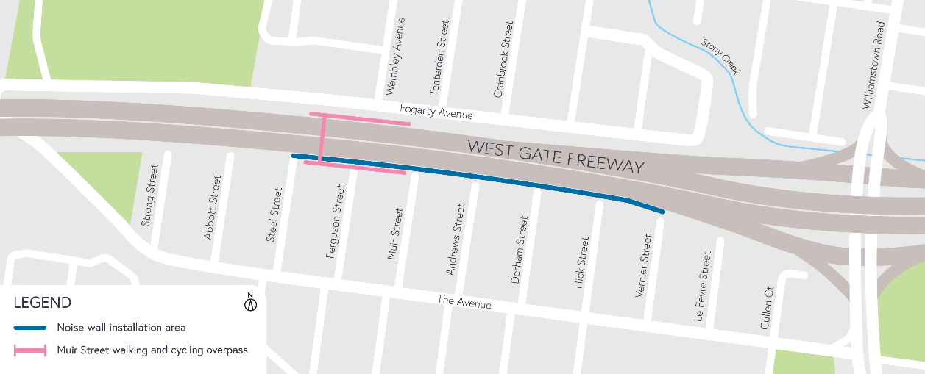

Location of noise wall panel installation

What you can expect during the works:
- Construction vehicles moving in and out of work areas between Steel and Vernier streets, while main access to the sites will be from the West Gate Freeway, with minimal access required through local roads
- Some sound from cranes installing the noise wall panels
- Lighting will be used during night works, and will be angled away from homes where possible
- Freeway lane closures will occasionally be required. The latest traffic updates are always available at bigbuild.vic.gov.au/disruptions
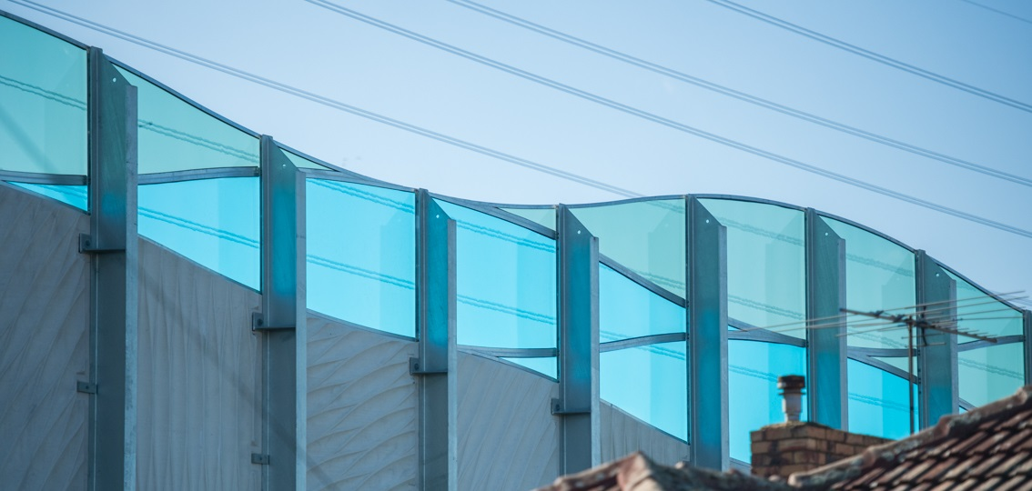
Noise walls we’ve recently installed along the West Gate Freeway in Spotswood
Hours of work
To minimise travel disruptions on the West Gate Freeway, these works will be done at night between 9pm and 5am.
Thank you
We appreciate our work can be disruptive and thank you for your understanding.
Please note that works could be rescheduled in the event of unexpected impacts.
For updates or any concerns about these works, please visit westgatetunnelproject.vic.gov.au or call 1800 105 105.

