ARDEN STATION PRECINCT DEVELOPMENT
PLAN
TAS-CYP-ARD-ZWD-PLA-XLP-AEN-X0001
REV H AMENDMENT – MINISTERIAL SUBMISSION

Wednesday, 27 October 2021

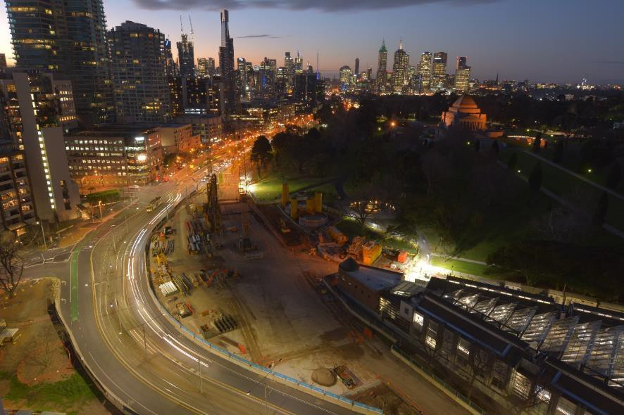

ACKNOWLEDGMENT TO COUNTRY
We acknowledge the land on which the Metro Tunnel Project is being delivered, is the traditional land for the People of the Kulin Nation. We respect their spiritual beliefs and acknowledge their ongoing connection with their Country.
We would also like to pay our respect to Elders past, present and future.

DOCUMENT CONTROL AND AMENDMENT
The current reviewed and approved version of this Plan is available on IMS for all project personnel to access. Downloaded Plans are deemed uncontrolled and it is the responsibility of the user to ensure they are using the latest revision. The responsibility for maintenance, review, update and approval of this Plan is as per the Delegation of Authority Matrix. All changes to this document are noted.

Document Number
Document Title | Arden Station Precinct Development Plan
Document Path | Cross Yarra Partnership
Document Template | Management Plan Template

REVISION RECORD

Revision | Date | Reason for Issue | Prepared by
A | 25/10/2017 | Stakeholder Consultation | Madeleine Alafaci
B | 27/11/2017 | Public Display | Madeleine Alafaci
C | 25/01/2018 | Submission for Victorian Government review | Madeleine Alafaci
D | 09/02/2018 | Submission to the Minister for Planning, including amendments following a review from DELWP | Madeleine Alafaci
E | 07/07/2021 | Amendment – Stakeholder Consultation DRAFT | Sabrina Chapman
F | 09/08/2021 | Amendment – Draft for Public Display | Sabrina Chapman
G | 23/09/2021 | Amendment: Review by Victorian Government Development Plan Review  Committee | Sabrina Chapman
H | 27/10/2021 | Amendment: Ministerial Submission | Sabrina Chapman

APPROVALS

Name | Signature | Date
Sabrina Chapman |  | 27/10/2021

Mat Peel | 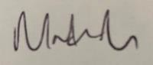 | 27/10/2021
Mark Wells 27/10/2021

DEFINITIONS

STANDARD TERMS AND DEFINITIONS

Term | Definition
Project | The Metro Tunnel Project (MTP)
Company | Cross Yarra Partnership (CYP)
Client | Rail Projects Victoria (RPV)
Package Contractors | Contractors for the Early Works, TAS PPP, RSA and RIA work Packages in the Metro Tunnel Project
TAS Package | The Tunnel and Stations PPP Package (CYP’s project)

ABBREVIATIONS

Term | Definition
ARI | Average Recurrence Interval
CoM | City of Melbourne
CPTED | Crime Prevention Through Environmental Design
CYP | Cross Yarra Partnership
DoT | Department of Transport
EES | Environment Effects Statement
EMF | Environmental Management Framework
EPA | Environment Protection Authority Victoria
EPR | Environmental Performance Requirements
HV | Heritage Victoria
OVGA | Office of Victorian Government Architect
PS&TR | Project Scope and Technical Requirements
PSA | Planning Scheme Amendment
PTV | Public Transport Victoria
RPV | Rail Projects Victoria
RIA | Rail Infrastructure Alliance
RPV | Rail Projects Victoria
TBM | Tunnel Boring Machine
The Project | The Metro Tunnel, or The Metro Tunnel Project

UDAAP | Urban Design Architectural Advice Panel
UDS | Urban Design Strategy
VHI | Victorian Heritage Inventory
WSUD | Water Sensitive Urban Design

PROJECT AND SCOPE
The Metro Tunnel Project is one of the largest transport infrastructure projects ever undertaken in Australia. It will deliver twin nine kilometre rail tunnels from Kensington to South Yarra as part of a new end-to-end Sunshine to Dandenong line. In addition to the tunnel, new underground stations will be established at the Arden, Parkville, and Domain precincts and two new stations in the CBD precinct.
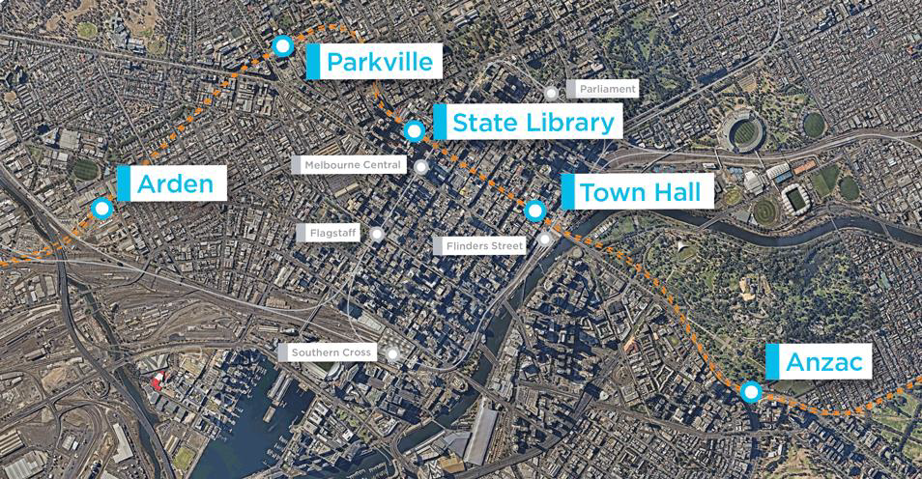

CONSORTIUM STRUCTURE
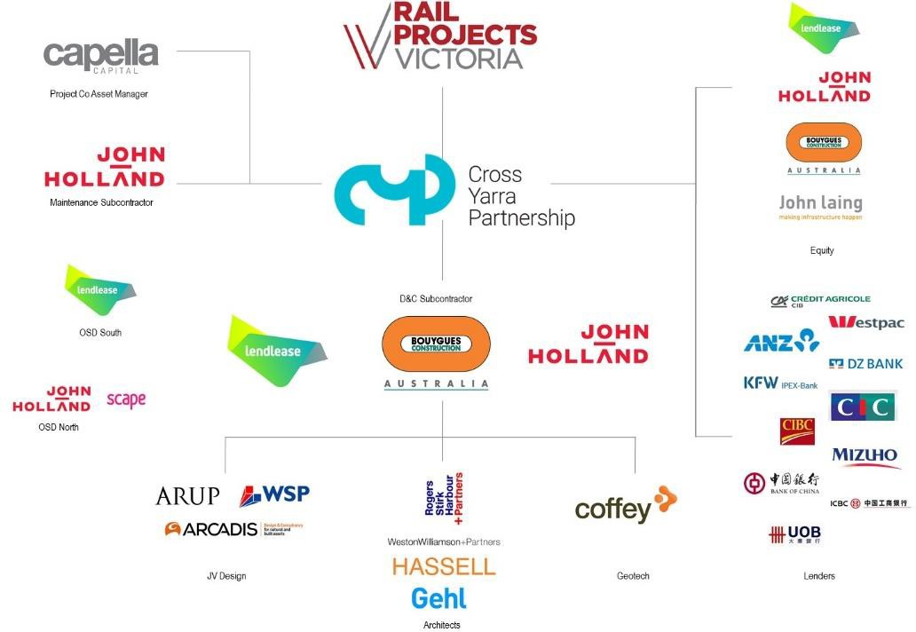

CONTENTS

EXECUTIVE SUMMARY 10
- INTRODUCTION 16
  - PURPOSE OF THIS DEVELOPMENT PLAN 16
  - INCORPORATED DOCUMENT CONDITIONS 17
  - COMMUNITY AND STAKEHOLDER ENGAGEMENT 19
    - EARLY ENGAGEMENT AND PUBLIC DISPLAY PERIOD 20
    - STAKEHOLDER AND COMMUNITY ENGAGEMENT DURING DETAILED DESIGN
................................................................................................................................... 21
- SITE CONTEXT 24
  - BROADER CONTEXT AND STRATEGIC POSITIONING 24
  - HISTORICAL AND NATURAL CONTEXT 27
  - EXISTING SITE CONDITIONS 27
- SCOPE OF WORKS IN ARDEN STATION PRECINCT 28
- DESIGN RESPONSE 31
  - DESIGN DEVELOPMENT 31
  - DESIGN PRINCIPLES FOR METRO TUNNEL PROJECT 33
    - VISION AND KEY DIRECTIONS 33
    - PRECINCT-SPECIFIC DESIGN ISSUES 35
  - CONSISTENCY WITH URBAN DESIGN STRATEGY 35
    - ARCHITECTURAL RESPONSE 36
    - LANDSCAPE RESPONSE 37
    - PUBLIC REALM RESPONSE 40
    - COMMUNITY EXPERIENCE 41
    - LIGHTING 51
    - SIGNAGE 51
    - ANCILLARY FEATURES 51
    - MATERIALS AND FINISHES 52
    - CRIME PREVENTION THROUGH ENVIRONMENTAL DESIGN 52
  - CONSISTENCY WITH ENVIRONMENTAL MANAGEMENT FRAMEWORK 54
    - AQUATIC ECOLOGY AND RIVER HEALTH 55
    - ARBORICULTURE 55
    - HISTORICAL CULTURAL HERITAGE 56
    - LAND USE AND PLANNING 57
    - LANDSCAPE AND VISUAL 58
    - SOCIAL AND COMMUNITY 58
    - SURFACE WATER 59
    - TRANSPORT 59
- CONCLUSION 62
APPENDIX A: ARDEN STATION PRECINCT SITE LAYOUT PLAN 64
APPENDIX B: ARDEN STATION PRECINCT ARCHITECTURAL PLANS AND ELEVATIONS 65
APPENDIX C: ARDEN STATION PRECINCT LANDSCAPE PLANS AND ELEVATIONS 66
APPENDIX D: ARDEN STATION PRECINCT PUBLIC REALM PLANS 67
APPENDIX E: ARDEN STATION PRECINCT URBAN DESIGN STRATEGY GUIDELINES ASSESSMENT 68
APPENDIX F: ARDEN STATION PRECINCT ENVIRONMENTAL PERFORMANCE REQUIREMENTS ASSESSMENT 69

Figures
Figure 1 – Development Plan consultation process (blue refers to Early Engagement, orange refers to Public Display Period, and green refers to Stakeholder Engagement during detailed design)
Figure 2 – Five-minute walking catchment of Arden Station Figure 3 – Highlights of the draft Arden Structure Plan (2020) Figure 4 - Arden Station precinct surface works
Figure 5 – Arden precinct flood management strategy Figure 6 – Arden Station user experience design
Figure 7 – DDA access within the Arden Station precinct
Figure 8 – Pedestrian movements through the Arden Station precinct Figure 9 – Bicycle facilities in the Arden Station precinct
Figure 10 – Transport integration within the Arden Station precinct Figure 11 – Arden’s transport network 2051

Tables
Table 1 – Amendments to Arden Station Precinct Development Plan since Ministerial Approval (08/03/2018)
Table 2 – Response to conditions of the Incorporated Document
Table 3 – CYP public realm principles integrated into the Arden Station precinct Table 4 – Summary of RPV’s Environmental Management Framework
Table 5 – Design response to relevant aquatic ecology and river health EPR Table 6 – Design response to relevant arboriculture EPRs
Table 7 – Design response to relevant historical cultural heritage EPRs Table 8 – Design response to relevant land use and planning EPRs Table 9 – Design response to relevant landscape and visual EPR Table 10 – Design response to relevant social and community EPR Table 11 – Design response to relevant surface water EPRs
Table 12 – Design response to relevant transport EPRs

EXECUTIVE SUMMARY
Cross Yarra Partnership (CYP) has been contracted by Rail Projects Victoria (RPV) to design, build and maintain the stations and tunnels for the Metro Tunnel Project (the Project). The Project includes:
- Twin nine-kilometre rail tunnels from the west of the city to the south-east as part of a new Sunbury to Cranbourne/Pakenham line
- Five new underground stations: Arden Station, Parkville Station (under Grattan Street), State Library Station (at the northern end of Swanston Street), Town Hall Station (at the southern extent of Swanston Street) and Anzac Station (under Domain Interchange on St Kilda Road)
- A new Intake Substation at Arden and the two tunnel portals at South Yarra (Eastern Portal) and South Kensington (Western Portal).
Arden is to become a new destination and community of Melbourne – a place to work, live and visit – with a character that is modern, industrial, youthful and gritty. Arden Station will be the catalyst for the urban renewal of this precinct, and will be the heart of its economic, social and civic intensity.
In response, CYP has designed the Arden Station precinct as an integrated public building and landmark that connects seamlessly with the objectives and strategies outlined in the draft Arden Structure Plan (2020) for the proposed future Arden Urban Renewal Precinct.
The Arden Station precinct public realm design will create new spaces for transit users and the community to interact with and enjoy. A station plaza on Laurens Street provides a meeting place at the station entry set back from the street, while a new green laneway servicing the rear of the station building provides an inviting green space, set amongst trees, encouraging visitors to enjoy the surrounds. Project works will change the streetscape of Laurens Street, encouraging ongoing urban renewal in an area currently heavily dominated by industrial uses. Works along Barwise Street will reinvigorate an underused space and the design will reinstate a greener more sustainable precinct as a legacy for future development opportunities.
This Arden Station Precinct Development Plan presents the scope and extent of the built form of CYP’s works for the Arden Station precinct, including the new Arden Station from the entrance to the ticket gate for Day 1 operation. This Development Plan is a requirement of Clause 4.7 of the Melbourne Metro Rail Project Incorporated Document (the Incorporated Document), which requires Development Plans be prepared for each of the five stations, two portals and any other above ground works or structures that are part of the Project. This Development Plan must be submitted to and approved by the Minister for Planning.
The Project has already undergone an extensive and robust planning assessment process. As part of this, RPV published an Environment Effects Statement (EES) and draft Planning Scheme Amendment that included an integrated assessment of the potential environmental, social, economic and planning impacts of the Project, and the approach to managing these impacts.
In developing the EES, RPV undertook a comprehensive engagement program to seek input from stakeholders and the community. This included stakeholders and the community having the opportunity to provide formal submissions during a public exhibition period, which were then presented to an Inquiry and Advisory Committee. This committee then considered the EES and submissions, and prepared a report for the Minister for Planning.
In December 2016, the Minister for Planning released his Assessment of the environmental effects of the Project. The Minister subsequently approved a Planning Scheme Amendment for the Project, which inserted the Incorporated Document into the Melbourne, Port Phillip, Stonnington and Maribyrnong Planning Schemes.
In accordance with Clause 4.7 of the Incorporated Document, this plan includes:
- Site layout plan (refer to Appendix A: Arden Station Precinct Site Layout Plan)
- Architectural plans and elevations (refer to Appendix B: Arden Station Precinct Architectural Plans and Elevations)

- Landscape plans and elevations (refer to Appendix C: Arden Station Precinct Landscape Plans and Elevations)
- Public realm plans (refer to Appendix D: Arden Station Precinct Public Realm Plans)
- An explanation demonstrating how this Development Plan is in accordance with the approved Urban Design Strategy (refer to Section 4.3 and Appendix E: Arden Station Precinct Urban Design Strategy guidelines assessment)
- An explanation demonstrating how this Development Plan is in accordance with the approved Environmental Management Framework particularly the Environmental Performance Requirements (refer to Section 4.4 and Appendix F: Arden Station Precinct Environmental Performance Requirements assessment).
The CYP design for the Arden Station precinct has incorporated feedback from a range of stakeholders including those identified in the Incorporated Document; the Office of the Victorian Government Architect, City of Melbourne, Department of Transport (previously known as Transport for Victoria, VicRoads and Public Transport Victoria), Melbourne Water and Heritage Victoria.
The previous version of this Arden Station Precinct Development Plan was approved by the Minister for Planning on Thursday 8 March 2018. Under the Project’s Incorporated Document, and in accordance with Clause 4.7.8, CYP is seeking an amendment to this Development Plan.
In accordance with the Incorporated Document requirements, the amended version of this Arden Station Precinct Development Plan was made available for public inspection for 15 business days from Monday 9 August 2021 until Friday 27 August 2021 on the Engage Victoria website along with an opportunity to provide written comments.
The amendments to this Development Plan improve the design in line with the design principles for the Metro Tunnel Project and include changes to the architectural layout, landscape design and public realm components of the Project. These amendments have been made to improve access to the Arden Station, enhance flood protection and provide more greenery through retaining and planting more trees, with 32 less trees removed than identified during the EES and 15 less than the previously approved Development Plan.
Consultation with key stakeholders has been ongoing during the preparation of these amendments. This includes the Victorian Planning Authority as well as the list of stakeholders identified in the Incorporated Document; the Office of the Victorian Government Architect, City of Melbourne, Department of Transport, Melbourne Water and Heritage Victoria.
This Development Plan presents the scope and extent of the built form of CYP’s works in the Arden Station precinct with associated construction works to occur within the Project Land boundary and construction impacts to be managed in accordance with the approved Environmental Management Framework. This includes separately prepared Environmental Management System, Construction Environmental Management Plan, Site Environmental Implementation Plans and aspect-specific management plans (as specified in the Environmental Performance Requirements).

CHANGE REGISTER
In accordance with Clause 4.7.8 of the Incorporated Document, an amendment is sought to this Arden Station Precinct Development Plan.
The Project’s design has developed through an iterative process informed by phases of specialist technical assessment integrated with stakeholder and community engagement. This has included public exhibition of the concept design as part of the EES and public display of the detailed design as part of the development plan.
Design development has continued, with CYP preparing approximately 450 Design Packages that relate to specialist technical disciplines and geographic areas. In accordance with the project contract, Design Packages have been reviewed by RPV and the Independent Reviewer, and subject to specified consultation with relevant stakeholders such as the Office of the Victorian Government Architect, City of Melbourne, Department of Transport, Melbourne Water and the Victorian Planning Authority.
Design development has led to changes at the Arden Station precinct including to improve access to the Arden Station, enhance flood protection and provide more greenery through retaining and planting more trees.
Table 1 provides an overview of these changes and where these are documented within this Arden Station Precinct Development Plan. CYP seeks comments on these changes from the stakeholders.
Table 1 – Amendments to Arden Station Precinct Development Plan since Ministerial Approval (08/03/2018)

Section | Amendment
General | Updated references to this ‘Arden Station Precinct Development Plan’ and ‘Arden Station precinct’ following the re-naming of the stations by RPV
Executive Summary | Details added to outline that this Arden Station Precinct Development Plan was previously approved by the Minister for Planning on Thursday 8 March 2018 and that CYP are now seeking amendment to the architectural layout,  landscape design and public realm design of this Development Plan
1 Introduction | Details added to outline that this Arden Station Precinct Development Plan was previously approved by the Minister for Planning on 8 March 2018 and  that CYP are now seeking an amendment to this Development Plan
1.2 Incorporated Document Conditions | Table 2 Clauses 4.7.5, 4.7.6, 4.7.7 and 4.7.8 responses amended to reflect the revised Incorporated Document (May 2018), Arden Station Precinct Development Plan approval process to date and the amendment going  forward
1.3.2 Stakeholder Engagement during  detailed design | New section added to outline stakeholder engagement post-Ministerial Approval of this Arden Station Precinct Development Plan, and during  detailed design
Figure 1 | Updated to include the additional consultation process post-Ministerial Approval of this Arden Station Precinct Development Plan
2.1 Broader context and strategic positioning | Updated to reflect that the Arden Vision (2018) and draft Arden Structure Plan (2020) have been prepared and apply to the Arden Station precinct  Details added regarding the consistency of this Arden Station Precinct Development Plan with the draft Arden Structure Plan (2020)
Figure 3 | The Draft Arden Vision and Framework has been replaced with the highlights from the recent draft Arden Structure Plan (2020)
3 Scope of works in  Arden Station precinct | Updated to reflect the amendments to the scope of works including the  inclusion of a separated raised bicycle path on the west side of Laurens Street and that the flood management area that was proposed in the

Section | Amendment
previous submission of this Development Plan will be maintained as grassed areas
Figure 4 | Figure amended to reflect the revised design
4.1 Design development | Additional details added to explain the design development process post- Ministerial Approval.  Changes can be found in Appendix B: Architectural Plans and Appendix C: Landscape Plans and Elevations.
Table 3 | Updated to reflect that the Arden Station precinct design response to the  design principles for Metro Tunnel Project is consistent with the draft Arden Structure Plan (2020)
4.3.1 Architectural response | Updated to reflect that:  - The northern retail terrace and the interfacing retail entrances have been raised  - The number of entry arches has reduced from 16 to 15.  Additional details also added to show how the Arden Station design is consistent with the draft Arden Structure Plan (2020).  Changes can be found in Appendix B: Architectural Plans, including General Arrangement Site Plan TAS-CYP-AR-00-DRG-ARC-ARD-711000-DP.
Figure 5 | Figure 5 (Arden (North Melbourne) precinct components) has been removed as all the Arden Station precinct components are now shown in Figure 4
4.3.2 Landscape response | Updated to reflect the amendments to tree removal and retention as well as tree planting  Details added to explain that flood management will be addressed through the precinct-wide flood management strategy contained in the draft Arden Structure Plan (2020). As such, the flood management area that was proposed in the previous submission of this Development Plan will be maintained as a grassed area.  Changes can be found in Appendix C: Landscape Plans and Elevations, including Landscape Architecture Planting Plan – Sheets 01-11 TAS-CYP-  AR-00-DRG-AUD-ARD-712201-DP to TAS-CYP-AR-00-DRG-AUD-ARD- 712211-DP.
Figure 6 | New figure added to illustrate the Arden flood management strategy as identified in the draft Arden Structure Plan (2020)
4.3.3 Public realm response | Updated to reflect the increased width of Station Lane and amendments to the public realm features along Barwise Street, Laurens Lane and Station  Lane. Changes can be found in Appendix D: Public Realm Plans.
4.3.4 Community experience | Updated to reflect the new separated bicycle path on the west side of Laurens Street and relocation of the Disability Discrimination Act 2002 (DDA) ramp from Barwise Street to the station entry on Laurens Street. Changes  can be found in Appendix D: Public Realm Plans.
4.3.4.1 Universal access | Updated to reflect the relocation of the DDA ramp from Barwise Street to the station entry on Laurens Street, addition of the new stairs and DDA ramp from Station Lane at the buildings rear and relocation of the Changing Places facility and retail units. Changes can be found in Appendix D: Public Realm  Plans.
4.3.4.2 Pedestrian access | Updated to reflect the re-orientation of the ticket gates

Section | Amendment
4.3.4.3 Bicycle access | Updated to reflect the incorporation of a new separated raised bicycle path on the west side of Laurens Street and removal of the undercover bike storage south-west of the station building  Details added regarding the consistency of the design with the proposed Strategic Cycling Corridor network identified in the draft Arden Structure Plan (2020).  Changes can be found in Appendix D: Public Realm Plans.
4.3.4.4 Transport integration | Updated to reflect that the design allows for the future development of the wider transport network as outlined in the draft Arden Structure Plan (2020).
Figure 8 | Figure amended to reflect revised design
Figure 9 | Figure amended to reflect revised design
Figure 10 | Figure amended to reflect revised design
Figure 11 | New figure added to show DDA access within the Arden Station precinct
Figure 12 | New figure added that shows the projected Arden transport network in 2051 as outlined in the draft Arden Structure Plan (2020)
4.3.8 Materials and finishes | Updated to reflect the amendments to the materiality and finishes of Western Building and skylights
4.3.9 Crime prevention through environmental design (CPTED) | Updated to reflect that a CPTED review has been undertaken for the station design since the previous Development Plan submission  Details added regarding the outcome of the CPTED review and the design response to the identified CPTED issues
4.4.1 Aquatic ecology and river health | Updated to reflect that the flood management area in the previous submission of this Development Plan has been maintained as a grassed area, consistent with the precinct-wide flood management strategy outlined in  the draft Arden Structure Plan (2020)
4.4.2 Arboriculture (EPRs AR1 and AR3) | Tree removals and planting numbers updated to reflect the revised design as follows:  - 90 trees are proposed for removal (105 trees were proposed for removal in the previous submission of this Development Plan)  - 103 new trees are proposed for planting (approximately 98 trees were  proposed for planting in the previous submission of this Development Plan).
4.4.7 Surface water (EPRs SW1 and SW2) | Details added to explain that the northern retail terrace and the interfacing retail entrances have been raised to provide better flood protection  Updated to reflect that the proposed flood management area in the previous submission of this Development Plan will be maintained as a grassed area
5 Conclusion | Updated to reflect changes throughout this Arden Station Precinct Development Plan
Appendix A | Drawings updated to reflect the revised design
Appendix B | Drawings updated to reflect the revised design
Appendix C | Drawings updated to reflect the revised design
Appendix D | Drawings updated to reflect the revised design
Appendix E | Responses to the Urban Design Strategy updated to reflect the revised design

Section | Amendment
Appendix F | Responses to the Environmental Performance Requirements updated to reflect the revised design

INTRODUCTION
Cross Yarra Partnership (CYP) has been contracted by Rail Projects Victoria (RPV) (a division of the Major Transport Infrastructure Authority, an administrative office in relation to the Department of Transport) to design, build and maintain the stations and tunnels for the Metro Tunnel Project (the Project). The Project includes:
- Twin nine-kilometre rail tunnels from the west of the city to the south-east as part of a new Sunbury to Cranbourne/Pakenham line
- Five new underground stations: Arden Station, Parkville Station (under Grattan Street), State Library Station (at the northern extent of Swanston Street), Town Hall Station (at the southern extent of Swanston Street and Anzac Station (under Domain Interchange on St Kilda Road)
- A new Intake Substation at Arden and the two tunnel portals at South Yarra (Eastern Portal) and South Kensington (Western Portal).
The Project has already undergone an extensive and robust planning assessment process. As part of this, RPV published:
- An Environment Effects Statement (EES) that included an integrated assessment of the potential environmental, social, economic and planning impacts of the Project, and the approach to managing these impacts
- A Draft Planning Scheme Amendment (PSA) that detailed changes to the Planning Scheme that were recommended to protect the tunnels, stations and associated infrastructure and guide future development in their vicinity.
In developing these, RPV undertook a comprehensive engagement program to seek input from stakeholders and the community. This included stakeholders and the community having the opportunity to provide formal submissions during a public exhibition period, which were then presented to an Inquiry and Advisory Committee. This committee then considered the EES and submissions, and prepared a report for the Minister for Planning.
In December 2016, the Minister for Planning released his Assessment of the environmental effects of the Project. The Minister subsequently approved a Planning Scheme Amendment for the Project, which inserted the Melbourne Metro Rail Project Incorporated Document (the Incorporated Document) into the Melbourne, Port Phillip, Stonnington and Maribyrnong Planning Schemes.
As a condition of the Incorporated Document, a Development Plan must be approved by the Minister for Planning for each of the five stations, two portals, rail turnback at West Footscray Station and any other above ground works or structures that are part of the Project.
The Arden Station Precinct Development Plan was approved by the Minister for Planning on Thursday 8 March 2018. Under the Project’s Incorporated Document, and in accordance with Clause 4.7.8, CYP are seeking an amendment to this Arden Station Precinct Development Plan.

PURPOSE OF THIS DEVELOPMENT PLAN
This Arden Station Precinct Development Plan presents the scope and extent of the built form of CYP’s works for the Arden Station precinct, including the new Arden Station from the entrance to the ticket gate for Day 1 operation. In accordance with Clause 4.7.3 of the Incorporated Document, this plan includes:
- Site layout plans
- Architectural, landscape and public realm plans and elevations
- An explanation demonstrating how this Development Plan is in accordance with the relevant sections of the approved Urban Design Strategy and Environmental Management Framework particularly the Environmental Performance Requirements.

This Development Plan does not cover the built form of the broader Arden Urban Renewal Precinct referred to under the draft Arden Structure Plan (2020), which will be delivered by others subject to a separate planning process.

INCORPORATED DOCUMENT CONDITIONS
The use and development permitted by the Incorporated Document must be undertaken in accordance with the stated conditions, including Clause 4.7 that requires Development Plans be prepared prior to the commencement of any relevant development. Table 2 provides a response against each requirement of Clause 4.7 for this Development Plan.
Table 2 – Response to conditions of the Incorporated Document

Clause | Conditions | Response
4.7.1 | Subject to Clause 4.13, a Development Plan must be approved by the Minister for Planning for development that relates to each of the following:  - Western tunnel portal  - Eastern tunnel portal  - Arden (North Melbourne) Station  - Parkville Station  - CBD North (State Library) Station  - CBD South (Town Hall) Station  - Domain (Anzac) Station  - Rail turnback at West Footscray Station  - Any other above ground works or structures that are part of the Project.  *Clause 4.13 relates to Project preparatory works and are subject to separate approval requirement. | This Arden Station Precinct Development Plan presents the scope and extent of the built form of CYP’s works in the Arden Station precinct, including new Arden Station from the entrance to the to the ticket gate.
4.7.2 | A Development Plan must address works that are associated with each of the items listed in Clause  4.7.1. A Development Plan for a station must address underground areas from the station entrance to the ticket gate. | CYP’s works to the ticket gate are described in Section 3 and the drawings in Appendix A: Arden Station Precinct Site Layout Plan, Appendix B: Arden Station Precinct Architectural Plans and Elevations, Appendix C: Arden Station Precinct Landscape Plans and Elevations and Appendix D: Arden Station Precinct Public Realm Plans.
4.7.3 | A Development Plan must include:
 | a) A site layout plan/s | Site layout plans in Appendix A: Arden Station Precinct Site Layout Plan.
 | b) Architectural, landscape and public realm plans and elevations including lighting, signage, pedestrian access, bicycle access and other ancillary facilities | Architectural plans in Appendix B: Arden Station Precinct Architectural Plans and Elevations.  Landscape plans in Appendix C: Arden Station Precinct

Clause | Conditions | Response
Landscape Plans and Elevations.
Public realm plans in Appendix D: Arden Station Precinct Public Realm Plans.
 | c) An explanation demonstrating how the Development Plan (including materials and external finishes) is in accordance with the approved Environmental Performance Requirements included within the Environmental Management Framework. | Consistency with Urban Design Strategy in Section 4.3 and Appendix E: Arden Station Precinct Urban Design Strategy guidelines assessment.  Consistency with Environmental Management Framework in Section 4.4 and Appendix F: Arden Station Precinct Environmental Performance Requirements assessment.
4.7.4 | Prior to submission of a Development Plan to the Minister for Planning for approval under Clause 4.7.1, a Development Plan must be:  - Provided to the Office of the Victorian Government Architect and relevant council/s for consultation  - Where relevant, provided to the Roads Corporation, Public Transport Development Authority, Melbourne Water and Heritage Victoria for consultation  - Made available for public inspection and comment on a clearly identifiable Project website for 15 business days. The website must set out details about the entity and contact details to which written comments can be directed during that time and specify the time and manner for the making of written comments.  For the avoidance of doubt, consultation in accordance with (a) and (b) can occur prior to or after the public inspection and comment period in (c).  Before, or on the same day as a Development Plan is made available in accordance with Clause 4.7.4(c), a notice must be published in a newspaper generally circulating in the area to which a Development Plan applies informing the community of the matters set out in Clause 4.7.4(c). | Stakeholder and community consultation is outlined in Section 1.3 and Figure 1.
4.7.5 | A Development Plan submitted to the Minister for Planning for approval under Clause 4.7.1 must be accompanied by all written comments received under Clause 4.7.4 and a summary of consultation and response to issues raised during the consultation. | CYP provided the Minister for Planning with a comment / response register containing all written comments made by stakeholders and the community in relation to this

Clause | Conditions | Response
4.7.6 | Before deciding whether to approve a Development Plan under Clause 4.7.1, the Minister for Planning must consider all written comments received under Clause 4.7.4 and the consultation and response summary provided under Clause 4.7.5. | Arden Station Precinct Development Plan.  As part of the amendment to this Arden Station Precinct Development Plan, CYP will provide the Minister for Planning with additional written comments made by stakeholders.
4.7.7 | A Development Plan must be approved by the Minister for Planning prior to the commencement of any development relating to an item in Clause 4.6.1, except for Early Works that are carried out in accordance with Clause 4.9. | The Arden Station Precinct Development Plan was approved by the Minister on Thursday 8 March 2018.  Following the approval of the Development Plan, CYP commenced works on the Arden Station.  Early Works was undertaken in accordance with Clause  4.10 and preparatory works was undertaken in accordance with Clause 4.13.
4.7.8 | A Development Plan may be prepared and approved in stages or parts, and may be amended from time to time with the approval of the Minister for Planning.  The Minister must require an application for approval of an amendment to a Development Plan to comply with the requirements of Clauses 4.7.3, 4.7.4, 4.7.5 and 4.7.6 unless, in the opinion of the Minister:  - the proposed amendment:  - does not result in a material detriment to any person; or  - a person who may suffer a material detriment as a result of the Minister’s approval of the amendment has already been sufficiently consulted in respect of the amendment; and  - any amendment does not involve any change to an approved Environmental Performance Requirement. | This Development Plan presents the built form of CYP’s works in the Arden Station precinct.  CYP are seeking an amendment to this Arden Station Precinct Development Plan, in accordance with Clause 4.7.8, and approval will be sought from the Minister for Planning.
4.7.9 | For land to which a Development Plan applies, development must be carried out in accordance with an approved Development Plan. | CYP will develop the Arden Station precinct in accordance with this Development Plan.

COMMUNITY AND STAKEHOLDER ENGAGEMENT
The Metro Tunnel is a city-shaping project, and as such it is vital to draw on the ideas, expertise and aspirations of the community and stakeholders to inform the planning, construction and future operation of the Project. There have been two distinct periods of community and stakeholder engagement:

- The Early Engagement Period sought to gain targeted feedback from key stakeholders to help inform drafts of the Development Plan, whilst the Public Display Period sought to obtain further feedback from the broader community
- Following approval of the Arden Station Precinct Development Plan on Thursday 8 March 2018, further stakeholder engagement and another Public Display Period has been undertaken during detailed design. This sought to refine any outstanding design issues with key stakeholders and feedback sought from the broader community.

EARLY ENGAGEMENT AND PUBLIC DISPLAY PERIOD
The consultation requirements of the Incorporated Document are shown in Figure 1. In addressing these it is important to note that RPV has already undertaken a comprehensive engagement program to seek input from stakeholders and the community. As part of preparing the EES, stakeholders and the community had the opportunity to provide formal submissions during a public exhibition period, and these were then presented to an Inquiry and Advisory Committee. This committee then considered the EES and submissions, and prepared a report for the Minister for Planning.
This Arden Station Precinct Development Plan builds on that previous consultation, with CYP having already consulted with each of the relevant stakeholders identified in the Incorporated Document, being:
- Office of the Victorian Government Architect (OVGA)
- City of Melbourne
- Department of Transport (previously known as VicRoads, Public Transport Victoria and Transport for Victoria)
- Melbourne Water
- Heritage Victoria.
In accordance with the Incorporated Document requirements, the previous version of this Arden Station Precinct Development Plan was made available for public inspection for 15 business days from Monday 27 November 2017 until Friday 15 December 2017 on the Metro Tunnel website along with an opportunity to provide written comments. As part of this process a notice was published in The Age and Herald Sun newspapers to inform the community on Monday 27 November 2017.
In addition to the requirements of the Incorporated Document, CYP consulted with other key stakeholders to understand their key issues and concerns including:
- Victorian Planning Authority
- Lost Dogs Home
- North Melbourne Football Club
- CityWide
- Nick Theodossi Prestige Cars
- George Weston Foods.
During the public inspection period CYP held nine community information sessions which were located along the project alignment. The sessions were as follows:
- Thursday 30 November 2017 – 11am – 2pm at Seasons Botanic Gardens
- Thursday 30 November 2017 – 5.30pm – 8.30pm at Seasons Botanic Gardens
- Monday 4 December 2017 –5.30pm – 8.30pm at Meat Market
- Tuesday 5 December 2017 – 11am – 2pm at Melbourne Town Hall

- Tuesday 5 December 2017 – 5.30pm – 8.30pm Melbourne Town Hall
- Wednesday 6 December 2017 – 8am – 11am at Royal Melbourne Hospital (Melbourne Health)
- Saturday 9 December 2017 – 11am – 2pm at North Melbourne Football Club
- Monday 11 December 2017 – 11am – 2pm at the Victorian Comprehensive Cancer Centre (VCCC)
- Tuesday 12 December 2017 – 5.30pm – 8.30pm – Melbourne Town Hall.
At all nine community sessions attendees were invited to come and ask questions about the station precinct draft Development Plans and technical specialists were available to answer any queries. Instructions on how to access the online submission portal and paper submission copies were provided.
Two of the open community sessions were held at locations near the proposed Arden Station. These sessions were held at the Meat Market on Monday 4 December 2017 and North Melbourne Football Club on Saturday 9 December 2017. Metro Tunnel social media accounts also posted links to the draft station precinct Development Plans and online submission portal, and featured information on the time and locations of the community information sessions. Additionally, a session that presented this Development Plan was held with the Arden/Kensington Community Reference Group on Tuesday 5 December 2017.
During the public display period 150 targeted emails to key stakeholders were emailed, as well as e- newsletters sent out to subscribers of the Metro Tunnel Project updates, which provided links to the five station precinct Development Plans on the RPV website. In addition to the community information sessions and emails a further 32,500 letter drops occurred to addresses adjacent to the Project.
Overall, 1,507 public submissions were received across all five station precincts and 44 of these submissions provided comments on this Arden Station Precinct Development Plan.
As part of the previous submission to the Minister for Planning, CYP provided all written comments received during the early engagement and public display period, and a summary of consultation and responses to the issues and queries raised.

STAKEHOLDER AND COMMUNITY ENGAGEMENT DURING DETAILED DESIGN
The Minister for Planning approved the Arden Station Precinct Development Plan on Thursday 8 March 2018. Since approval, the design for the Arden Station has progressed through to detailed design. In accordance with the Incorporated Document, ongoing consultation has taken place with key stakeholders throughout this period through design presentations, meetings, workshops and formal design package reviews. The key stakeholders included:
- Victorian Planning Authority
- Office of the Victorian Government Architect (OVGA)
- City of Melbourne
- Department of Transport (previously known as VicRoads, Public Transport Victoria and Transport for Victoria)
- Melbourne Water
- Rail Projects Victoria (RPV)
- Metro Trains Melbourne (MTM).
In close collaboration with the above stakeholders, a number of changes have been made to the Project to improve the design. As a result, there have been amendments to the architectural layout,

landscape design and public realm components of the Project. These amendments have been made to improve access to the Arden Station, enhance flood protection and provide more greenery through retaining and planting more trees. Section 4.1 includes a full list of those changes. Where relevant, the proposed changes have been incorporated into the Project’s response to the Urban Design Strategy under the relevant sub-headings in Section 4.3.
In accordance with the Incorporated Document requirements, the amended version of this Arden Station Precinct Development Plan was made available for public inspection for 15 business days from Monday 9 August 2021 until Friday 27 August 2021 on the Engage Victoria website along with an opportunity to provide written comments. As part of this process a notice was published in The Age and Herald Sun newspapers to inform the community on Monday 9 August 2021. Additionally, RPV issued a media release on Monday 9 August 2021 marking the start of the public display period and noting where the Development Plan could be viewed.
In addition to the requirements of the Incorporated Document, CYP consulted with other key stakeholders to understand their key issues and concerns including:
- Victorian Planning Authority
- North Melbourne Football Club
- Nick Theodossi Prestige Cars
- Mauri ANZ
- CHEP
- Irwin Stockfeeds
- Naturelinks
- Bicycle Network Victoria
- North and West Melbourne Association
- North Melbourne Residents Association.
During the public inspection period, CYP held one online community information session on Wednesday 18 August 2021 – 6:00pm-7:00pm via Zoom meeting (due to COVID-19).
At the online information session, attendees were able to ask questions about the Arden Station Precinct Development Plan and technical specialists were available to answer any queries. An invitation to the online session was distributed to 2,565 stakeholders within the Project’s identified North Melbourne notification catchment. At the session, instructions on how to access the online submission portal were provided.
19 targeted emails were sent to stakeholders advising of the upcoming release of the amended Development Plan for public consultation. Metro Tunnel social media accounts also posted links to the draft Arden Station Precinct Development Plan and online submission portal. Additionally, a session that presented this Development Plan was held with the Arden / Parkville Community Reference Group on Friday 9 July 2021.
Overall, 18 submissions were received on this Arden Station Precinct Development Plan.
As part of the submission to the Minister for Planning, CYP will provide all written comments received during the detailed design public display period, and a summary of consultation and responses to the issues and queries raised.

Prepare draft Development Plan

Early Engagement
Consult with Office of the Victorian Government Architect, relevant Councils and Transport Authorities, Melbourne Water, Heritage Victoria

Revise draft Development Plan

Finalise Development Plan

Ministerial Approval

Detailed Design
Prepare major amendment to Development Plan

Public Display Period
Community Information Sessions, e-newsletters, letter-box drops and available on Metro Tunnel website for comment

Engagement during Detailed Design
Consult with Office of the Victorian Government Architect, relevant Councils, Victorian Planning Authority, Department of Transport, Melbourne Water, Rail Projects Victoria and Metro Trains Melbourne

Revise amended Development Plan

Public Display Period during Detailed Design
Community Information Sessions, e-newsletters, letter-box drops and available on Metro Tunnel website for public inspection and comment

Finalise amended Development Plan

Submission to the Minister for Planning

Figure 1 – Development Plan consultation process (blue refers to Early Engagement, orange refers to Public Display Period, and green refers to Stakeholder Engagement during detailed design)

SITE CONTEXT
This section describes how the strategic, physical and natural context of the Arden Station precinct has been considered in the design development process.
As an example of this context setting, Figure 2 provides a snapshot of the five minute walkable catchment from Arden Station.
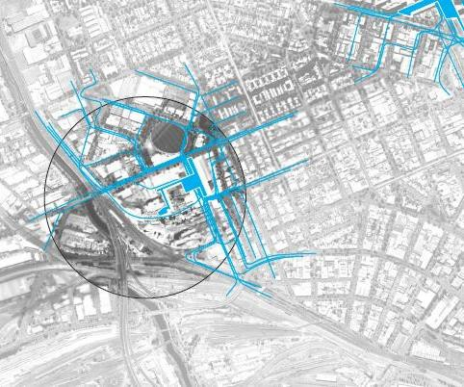
Figure 2 – Five-minute walking catchment of Arden Station

ARDEN STATION PRECINCT BROADER CONTEXT AND STRATEGIC POSITIONING
The Arden precinct is to become a new destination and community of Melbourne – a place to work, live and visit. The station will be the catalyst for the urban renewal of this precinct, and will be the heart of its economic, social and civic intensity. It will also have a direct influence on the site’s eventual configuration.
While land in the Arden precinct has been primarily industrial in recent times, this area is set to become a major new commercial and residential precinct within the next 30 years. In 2012, the City of Melbourne released the Arden Macaulay Structure Plan that articulated the framework for the redevelopment of 144 hectares of brownfield land as a new, mixed-use precinct. The Arden Macaulay Structure Plan (2012) was implemented in 2017 through Planning Scheme Amendment

C190 to the Melbourne Planning Scheme. This Project is strategically important to Melbourne’s growth and economic development and supports the objectives of Plan Melbourne 2017-2050.
In September 2016, the Draft Arden Vision and Framework document was prepared which provided design objectives and strategic directions for the Arden precinct. This framework responded to the development of Arden Station, proposing an urban framework building upon the future station and included directions regarding principles for sustainable movement based on a transportation modal hierarchy, water sensitive design and diverse public realm. Following feedback from stakeholders and community consultation on the Draft Arden Vision and Framework, Arden Vision was prepared in 2018. The Arden Vision (2018) sets out eight key directions for the Arden precinct acknowledging the role of the future Arden Station as a catalyst for Arden’s transformation into a new employment hub.
Building upon the key directions in the Arden Vision (2018), the draft Arden Structure Plan (2020) identifies the next key steps that will be made to achieve the vision for the Arden precinct. This includes a number of objectives and associated strategies that introduce new initiatives across the precinct including opportunities in relation to the future Arden Station. Highlights of this Structure Plan are shown in Figure 3. In consultation with the Victorian Planning Authority and City of Melbourne, the design of the Arden Station is consistent with the draft Arden Structure Plan (2020) and provides the flexibility to integrate within the Plan’s proposed initiatives:
- The draft Arden Structure Plan (2020) identifies space for a second future station entrance, to be accommodated on the corner of the future Fogarty and Queensberry Street extension. CYP’s station design leaves available the option for this future entrance to be added, indicatively shown in Figure 11
- The draft Arden Structure Plan (2020) identifies opportunities for development surrounding the Western Building, such as activation of the south wall of the building through provision of a small retail or bookable community centre. The Western Building accommodates essential services to the station such as electrical service rooms, and as such it is not possible to build directly on top of this building. However, CYP’s design of the Western Building allows for any opportunities to activate the facades for future development
- The draft Arden Structure Plan (2020) proposes a new Capital City open space to the south-west of the station building (shown in orange in Figure 3). Capital City open spaces are iconic and synonymous with the character and identity of Melbourne and are often used to stage activities and events of international, national, state and metropolitan importance. In line with this initiative, CYP’s design of Arden Station proposes to maintain that area as a grassed area for the future Capital City open space
- The draft Arden Structure Plan (2020) proposes an innovation hub to the north-west of the station building, south of Barwise Street. This innovation hub will act as a ‘front door’ to the precinct that connects prospective businesses, travelling academics or clients to the opportunities that will emerge from the clustering of businesses in Arden. CYP’s design of Arden Station maintains that area as a grassed area which will provide for its future transformation into an innovation hub
- The draft Arden Structure Plan (2020) proposes four Strategic Cycling Corridors across the Arden precinct including Laurens Street (refer to Figure 11). These corridors are designed to improve cycling to and around major activity centres and are routes that cater for the highest cycling volumes, whilst offering protection from other vehicles. Consistent with this, CYP’s design of Arden Station has a separated, raised bicycle path on the west side of Laurens Street, while re- instating the painted on-road bicycle lanes on the east side of the street.
The draft Arden Structure Plan (2020) will be finalised following the feedback from the community and will supersede the Arden Macaulay Structure Plan (2012).
The Arden Station will set the tone for this important urban renewal project. The Day 1 entrance to the station at Laurens Street and the surrounding public realm will seed the character and benchmark the Arden precinct’s identity.

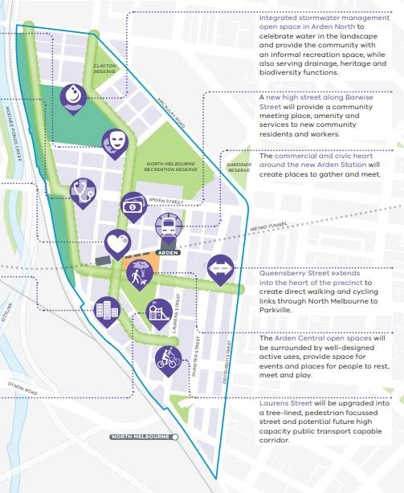
Figure 3 – Highlights of the draft Arden Structure Plan (2020)
Source: Draft Arden Structure Plan (2020) – page 9

HISTORICAL AND NATURAL CONTEXT
An understanding of the Arden precinct’s natural features and history is the starting point for developing the public realm identity for the area. The site’s natural tendency to flooding, as well as its industrial heritage, as described in the EES, have informed the design response.
Prior to European settlement, a chain of shallow ponds ran along the length of the Moonee Ponds Creek watercourse in the area now known as Arden. These ponds were isolated during Melbourne’s drier seasons and flowed in wetter months after heavy rains.
The area would have provided a water source as well as abundant plant and wildlife resources for Aboriginal people. Camp locations along nutrient-rich flood plains suggest that, at certain times of the year, Aboriginal people happily took advantage of the area’s seasonal bounty. Eels and murnongs (yam daisy) appear to have been particularly prominent food sources along the creek.
The pre-European natural landscape at the site of the station was Ecological Vegetation Class (EVC) Plains Grassland/Plains Grassy Woodland Mosaic (EVC 897), transitioning to Escarpment Shrubland (EVC 895) along Moonee Ponds Creek

EXISTING SITE CONDITIONS
The Arden Station precinct is located on under-used industrial land. The station’s Day 1 entrance point will be on Laurens Street, an existing north-south road currently of mixed use.
The series of large sheds fronting Laurens Street have been removed for the station. East of Laurens Street land is a mix of residential, commercial and industrial uses with Dryburgh Street marking the eastern boundary of Arden's planned redevelopment, as per the draft Arden Structure Plan (2020).
Mature plane trees along Laurens Street currently provide both amenity and shade. CYP will protect and maintain these trees, along with some peppercorn trees located within the site that also contribute to the area’s amenity.
The narrow-width footpath along the west side of Laurens Street is further constrained by the presence of both trees and property boundaries. The footpath’s existing width is not adequate for the street’s proposed role as a highly pedestrianised street and transit interchange.

SCOPE OF WORKS IN ARDEN STATION PRECINCT
This Arden Station Precinct Development Plan presents the scope and extent of the built form of CYP’s works for the Arden Station precinct, including the new Arden Station from the entrance to the ticket gate for Day 1 operation. Figure 4 shows these works within the Arden Station precinct which includes:
- New underground train station with entrance to the ticket gate from Laurens Street
- New station plaza addressing Laurens Street at the corner of Barwise Street
- Bicycle parking along Laurens Street, Station Lane and Laurens Lane (further detail provided in Section 4.3.4.3 and Figure 9)
- Footpath widening on the west side of Laurens Street between Arden and Queensberry streets including new signage, street furniture, lighting and tree planting
- Barwise Street works including paved footpaths and street surface, tree planting for shade, station parking bays and development of two service laneways, one servicing the rear of the main station building (Station Lane) and other servicing the Western Building (Fogarty Street)
- New signalised pedestrian road crossing and updated bicycle paths on the east side of Laurens Street
- A new separated raised bicycle path on the west side of Laurens Street. Note the majority of the bicycle lanes within the CYP extent of works are two metres in width, however this reduces in width to 1.5 metres behind kerb along the southbound carriageway of Laurens Street to eliminate dooring issues between the bicycle lane and the taxi bays, park and ride bays and the bus bay
- New grassed areas south of Barwise Street, west and south-west of the Day 1 station entry. Note these areas were proposed as Flood Management Area in the previous Development Plan and will not be publicly accessible (refer to Section 4.3.2).
Arden Station is designed to accommodate potential future over-site development. However, any future over-site development will be subject to a separate, future planning process.
A new traction power intake substation is required. This is covered in the Intake Substation Development Plan which was approved by the Minister for Planning on Thursday 26 March 2020.
This Development Plan presents the scope and extent of the built form of CYP’s works for the Arden Station precinct with associated construction works to occur within the Project Land boundary (refer to plans in Appendix A: Arden Station Precinct Site Layout Plan) and construction impacts to be managed in accordance with the approved Environmental Management Framework (refer to Section
4.4 and Appendix F: Arden Station Precinct Environmental Performance Requirements assessment).
The Arden Station precinct associated works area generally includes land south of Barwise Street, east and north of the rail reserve and west of Laurens Street. The associated works area also includes the following road reserves:
- Barwise Street (entirety)
- Laurens Street from approximately Weston Milling to Arden Street
- Queensberry Street from Laurens Street to Munster Terrace
- Arden Street from Lloyd Street to Langford Street.
This associated works area is shown on the plan included in Appendix A: Arden Station Precinct Site Layout Plan.
As considered in the EES, the nature of works within the Arden Station precinct associated works area will change over time and will be characterised by the following CYP activities:

- Site establishment: Site establishment at Arden includes set-up of site offices and staff amenities, laydown areas, and plant and equipment required for managing and receiving tunnelling spoil (i.e. batch plant and separation plants, compressor station, water treatment plant, muck bins and muck loading facilities, fabrication sheds). Provision for flood water storage and tunnel air ventilation and extraction plant would also be located on site. The TBM launch site support services will include grouting plant, gantry cranes, spoil handling system, water treatment plant and facilities to assemble the TBM
- Civil / Structural: Piling (diaphragm walls) and excavation of the station box at Arden will be undertaken using a bottom-up, cut and cover method. The station will be constructed from the base slab upwards, eventually restoring the surface above the excavation. During this process sections of the station box excavation will be used to launch the TBM. The final phase of this stage includes associated road works, including tram works and bike and pedestrian infrastructure
- Fit out: This phase of the Project includes the fit out of station infrastructure, surface and subsurface levels, including ticket halls, station platforms, passenger access, emergency egress, ventilation and smoke controls, staff rooms and equipment rooms. This stage of the Project also includes the landscaping of the station precinct
- Mechanical, Electrical and Process: This phase of the Project includes the installation of power and electrical infrastructure to the station and platforms
- Testing and commissioning: These works ensure that all new station infrastructure, from ticket gates and vertical transport to signalling and rolling stock (by others) meet the requirements of Victorian Rail Safety legislation and is fit for purpose on Day 1
- Operation: The operational phase of the Project will include activities associated with the day to day operation of the train station, including but not limited to, train services (by others). CYP will undertake preventative and corrective maintenance of all installed assets to ensure reliability and availability of station infrastructure for day to day operations. CYP will hand back, to government, broader precinct assets to facilitate development of the Victorian Planning Authority’s draft Arden Structure Plan (2020).
To manage potential impacts, CYP has prepared an Environmental Management System, Construction Environmental Management Plan and Operations Environmental Management Plan. The aspect-specific control measures are identified in a series of specific management plans with precinct specific controls identified in a Site Environmental Implementation Plan. This has been approved by RPV and the Project’s Independent Reviewer, and was subject to separate stakeholder consultation requirements and reviewed by the Independent Environmental Auditor, including quarterly audits of performance throughout construction.

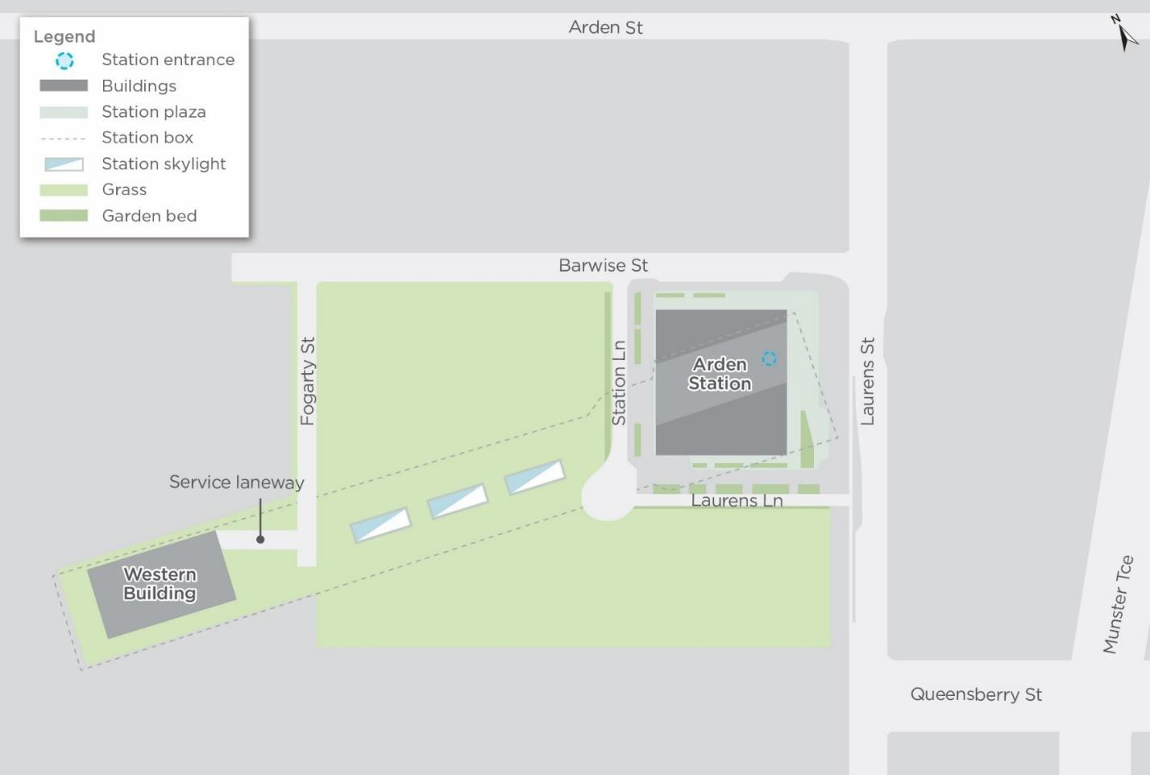
Figure 4 - Arden Station precinct surface works

DESIGN RESPONSE

DESIGN DEVELOPMENT
The Project’s design has been developed through an iterative process informed by phases of specialist technical assessment integrated with stakeholder and community engagement.
In 2016, RPV publicly exhibited the Project concept design in the EES and as a draft Planning Scheme Amendment.
CYP’s design development has been informed by the approved Planning Scheme Amendment, in particular the Incorporated Document conditions that led to the Minister for Planning approving:
- RPV’s Urban Design Strategy – the Project must be designed in accordance with the approved Urban Design Strategy. Developed by RPV with input from the OVGA, local councils and key stakeholders, the Urban Design Strategy sets out the design vision, key directions, objectives and design guidelines across the Project and for each precinct
- RPV’s Environmental Management Framework – the Project must be designed in accordance with the approved Environmental Management Framework, which provides a transparent and integrated governance framework to manage the environmental aspects of the Project. This framework includes Environmental Performance Requirements (EPRs), which are performance- based management requirements, and provides clear accountabilities for the delivery and monitoring of the EPRs so that the environmental effects of the Project are appropriately managed.
This is reflected in the design presented in this Arden Station Precinct Development Plan with the following sections explaining how this design is in accordance with the design guidelines from the Urban Design Strategy, and Environmental Performance Requirements from the Environmental Management Framework.
The previous version of this Arden Station Precinct Development Plan was approved by the Minister for Planning on Thursday 8 March 2018. Following an iterative consultation period during detailed design, amendments to the architectural layout, landscape design and public realm components of the Project include:
- Architectural layout and design:
  - Reduced number of ground concourse entry arches from 16 to 15 as part of the design development. This change has not altered the building footprint (refer to Section 4.3.1)
  - Improved pedestrian movement by re-orientating the ticket gates from a north-south alignment to a north-west south-east alignment, in response to the expected pedestrian traffic from the west (refer to Section 4.3.4.2)
  - Improved sightlines from the customer service centre, achieved through re-arranging the retail units and ‘Changing Places’ in accordance with MTM’s requirements (refer to Sections 4.3.4.1 and 4.3.9)
  - Enhanced flood protection by raising the northern retail terrace and the interfacing retail entrances as part of the architectural design development (refer to Section 4.3.1)
  - Changes to the materials and finishes of the Western Building and skylights, informed by consultation with the Victorian Planning Authority and the OVGA (refer to Section 4.3.8)
  - Changes to the ground level around the skylights. The previous Development Plan submission had ground level raising locally around the skylight. The design for ground level is now relatively flat, allowing for the skylights to appear raised. This has increased public safety and security, as well as providing a cleaner Day 1 interface for future development as part of the draft Arden Structure Plan (2020) (refer to Section 4.3.1)

- Landscape design and public realm components:
  - Incorporation of a separated raised bicycle path on the west side of Laurens Street, developed in consultation with the Victorian Planning Authority and City of Melbourne. Note the majority of the bicycle lanes within the CYP extent of works are two metres in width, however this reduces in width to 1.5 metres behind kerb along the southbound carriageway of Laurens Street to eliminate dooring issues between the bicycle lane and the taxi bays, park and ride bays and the bus bay (refer to Section 4.3.4.3)
  - Space provision for an additional 200 future bike parking spaces located near the proposed future station entries, west of the station building (refer to Section 4.3.4.3 and Figure 9)
  - Relocation of the Melbourne bike share stands from Laurens Lane to Laurens Street, near the station entry DDA ramp (refer to Section 4.3.4.3 and Figure 9)
  - More equitable access and intuitive wayfinding, achieved by relocating the proposed DDA access to front of house on Laurens Street and adding additional stairs and a DDA access ramp on the south-west corner of the station building, to provide access to Station Lane (refer to Section 4.3.4.1)
  - Relocation of several parking spaces, including moving two universal access vehicle bays west on Barwise Street (towards Station Lane) and moving the MTM staff parking bays east on Barwise Street (towards Laurens Street). In addition, two loading bays have been relocated from Laurens Street north to Barwise Street east (refer to Figure 9)
  - Replacement of the undercover bike station that was proposed on the south-west corner of the station building with a DDA ramp and stairs (off Station Lane) providing access to the station. The total number of bicycle parking spaces has remained unchanged due to the proposed additional bike parking spaces on Station Lane and Laurens Lane (refer to Section 4.3.4.3)
  - Increased total road reserve width of Station Lane to better accommodate the potential future entry to the station and pedestrian access. This was requested by the Victorian Planning Authority and City of Melbourne (refer to Section 4.3.4.2)
  - Improved public realm features, such as additional Water Sensitive Urban Design (WSUD) features (including a long linear sunken garden), trees, bike hoops and public seating areas on Station Lane, as shown in the amended precinct public realm plans in Appendix D: Arden Station Precinct Public Realm Plans (refer also to Section 4.3.3)
  - Increased extent of public realm around the Western Building by revising the kerb alignment of Station Lane, as depicted in the amended precinct public realm plans in Appendix D: Arden Station Precinct Public Realm Plans (refer also to Section 4.3.4.2)
  - Design development of Laurens Lane to include fire booster relocation, increased plinth terrace area and adjustments to the stair alignment to better address access requirements to station services, increased scale of WSUD and garden beds and re-arrangement of street furniture as shown in the amended precinct public realm plans in Appendix D: Arden Station Precinct Public Realm Plans (refer also to Section 4.3.4.2)
  - Barwise Street plinth terrace has been introduced as part of raising the northern retail terrace to further address flood protection (refer to Section 4.3.1). Accordingly, ramps and stairs have been adjusted to provide better access to the retail units, shown on the amended precinct public realm plans in Appendix D: Arden Station Precinct Public Realm Plans
  - Incorporation of linear garden beds (including a rain garden) at the northern edge of the proposed outdoor dining area on Barwise Street. This is proposed to clearly define the pedestrian avenue and retail spill out/ outdoor dining, reflected in the amended precinct public realm plans in Appendix D: Arden Station Precinct Public Realm Plans
  - The flood management areas that were proposed in the previous Development Plan submission have been maintained as grassed areas through design development, in consultation with Melbourne Water and the Victorian Planning Authority (refer to Section 4.3.2)

  - As per the City of Melbourne’s request, bluestone paving previously proposed on Barwise Street (west), between Laurens Street (west) and Queensberry Street, and between Barwise and Arden Street has been removed (refer to Section 4.3.8). Materials and finishes are shown in the Materials Schedule in Appendix B: Arden Station Precinct Architectural Plans and Elevations and in Appendix D: Arden Station Precinct Public Realm Plans
  - Additional lighting detail is provided and amendments to the proposed locations are shown in the amended precinct public realm plans in Appendix D: Arden Station Precinct Public Realm Plans (refer also to Section 4.3.5)
  - Retention of additional trees, particularly on Laurens Street, with design changes resulting in 32 less trees being removed than identified during the EES and 15 less than the previously approved Development Plan. Shown in the Planting Plans in Appendix C: Arden Station Precinct Landscape Plans and Elevations
  - Additional tree planting on Barwise Street and Station Lane in consultation with the City of Melbourne, shown in the Planting Plans in Appendix C: Arden Station Precinct Landscape Plans and Elevations
  - Repositioned trees on Laurens Street, Barwise Street and Station Lane for consistent spacing, shown on the amended landscape plans in Appendix C: Arden Station Precinct Landscape Plans and Elevations
  - Re-alignment of the hoarding proposed at Day 1, to prevent public access to the Western Building, Fogarty Street and Station Lane turning circle (refer to Section 4.3.9).

DESIGN PRINCIPLES FOR METRO TUNNEL PROJECT

VISION AND KEY DIRECTIONS
The Urban Design Strategy establishes an Urban Design Vision that is:
“A legacy of outstanding rail stations and associated public spaces that put people first, contribute to Melbourne’s reputation for design excellence, and deliver an overall substantial benefit in terms of urban quality for Melbourne, for the transport network, and for local areas influenced by the project”.
Under this, it identifies six key design themes or project-wide directions, being:
- Make new and improved connections
- Make great public places
- Balance line-wide consistency with site responsiveness
- Support integrated site redevelopment
- Design to help manage construction impacts
- Design for the future.
Each of these key directions has objectives with associated design guidelines to inform the design response. In order to address these project wide key directions, CYP developed six public realm principles to guide the design and support the delivery of the Urban Design Vision. Table 3 summarises how each of these public realm principles is integrated into design and specifically addressed in the Arden Station precinct.

Table 3 – CYP public realm principles integrated into the Arden Station precinct

Principle | Principle integrated into design | Design response for Arden Station precinct
Performance for people | Our public realm design provides for seamless, simple and intuitive experiences for people in each of the station precincts. | The new station will provide integrated transport with Laurens Street enhanced to facilitate improved movement. The station entrance located on the north- west edge of the precinct is near the established community in the precinct. The station architecture and plaza together provide an identity and legible marker for the station, which is visible from surrounding streets. Arden Station’s identity will be defined clearly on Day 1 operation, with the surrounding precinct having the potential of redevelopment and further public realm extension.
More Melbourne | There will be more and better-quality public spaces proposed as a result of the Metro. New cultural and creative programs generated and tested in the lead up to Day 1 operation will inform the design of each public realm space. | The Arden Station precinct will re-vitalise the area and create a new public realm area from land that was previously industrial. The new station plaza will be a place for passengers, and a place for the community, to enjoy.
Context and nature | The public realm has been designed to promote views, way finding and help draw daylight and fresh air into and through each station. This helps to amplify the local character of each station’s neighbourhood and authentically reflect the nature and character of each place. This approach is supported through planting, the careful use of materials and finishes as well as the design and placement of civic furniture. | The design responds to Arden’s unique character. The station entry and plaza has embraced and incorporated aspects of the surrounding natural and industrial context as a way of enhancing a unique identity for a new precinct of Melbourne. Materials within the existing industrial urban context such as brick, concrete and steel will be used throughout the public realm. The soft landscape will incorporate local species of the pre-European landscape providing a connection to country and will feature plants suitable for inundation and treatment of storm water. The location of civic furniture will speak to the Day 1 station entry on Laurens Street. The station will be open and light, achieved through the construction of three sky lights above the station concourse.
Sustainable and resilient | The public realm designs associated with each station are focused on being ecologically conscious and designed to be resilient and adaptable to climate change. Resources required to maintain the landscape are reduced because of the quality and detailing proposed. Urban forestry, water use and biodiversity strategies have been employed that reference the RPV’s Urban Design Strategy, Environmental Performance Requirements and the Living Infrastructure Plan. | The many sustainability features include promotion of tree pits and garden beds in the plaza and the design of Laurens Street allows for storm water infiltration and capture. The trees within the public realm will provide shade and assist with maintaining air quality. The Arden Station precinct is susceptible to flooding which is challenging for the development of the site. Strategic placement of the station to the higher natural levels of the site will not worsen existing flooding for the 1 in 100-year Average Recurrence Interval (ARI) event.  The adoption of Water Sensitive Urban Design principles will be applied to the public realm design. This approach will help mitigate flood issues and optimise the development potential of Arden. In addition, the station design has been developed in consultation with the Victorian Planning Authority and City of Melbourne to ensure that it is consistent with the Arden flood management strategy outlined in the draft Arden Structure Plan (2020).
Functional, efficient and safe | Legible, accessible and clearly defined public realm spaces provide for a highly functional and efficient environment for people to use.  Increased passenger space in each station is supported by safe, inviting and generous public realm areas. This provides a seamless transition for  passengers from the moment they | The plaza provides an efficient, safe and open arrangement of facilities and amenities for passengers and the community. Bicycle parking, drop off, bus stops and taxi areas are all conveniently located in clear sightline from the station entrance. The integrated retail tenancies provide additional passive surveillance and amenity. A separated raised bicycle path on the west side of Laurens Street will cater for  the highest cycling volumes whilst offering protection

Principle | Principle integrated into design | Design response for Arden Station precinct
 | leave the train through to the public realm. | from other vehicles, consistent with the draft Arden Structure Plan (2020).
A quality legacy | The quality of each public realm space proposed supports the move towards a “turn up and go’ Metro system. The investment in the quality of the public realm spaces proposed for today can help provide the confidence for others to invest time, capital and energy into further precinct development. | The Arden Station precinct will become the focal point of the local area. The new plaza will provide the functional and legible requirements for passengers alighting, boarding and transferring. It will also be a ‘place’ for local everyday life, to support retail, social interaction and amenity. The consolidation of the Day 1 entry creates the flexibility needed for the design of future entries, streets and public spaces in the centre of the precinct.

PRECINCT-SPECIFIC DESIGN ISSUES
The Urban Design Strategy identifies precinct-specific design issues for Arden. As with the project wide key direction, each of these issues has objectives with associated design guidelines to inform the design response.
The Arden precinct is set to become a major commercial and residential precinct within the Melbourne municipality in the next 30 years. It is noted that the Arden precinct is subject to flooding due to the close proximity to the Moonee Ponds Creek, but also due to topographic constraints it is also susceptible to flooding from overland flow from the local catchment. In response to this, the station has been designed to ensure flood protection and surface water mitigation. This is further discussed in Section 4.4.7. The Day 1 station entry has been designed to allow for future development of the surrounding area and permits future over-site development (which is not included in this Development Plan).

CONSISTENCY WITH URBAN DESIGN STRATEGY
The CYP design vision for the Arden Station precinct is to create a focal point for the area.
The public realm components of the precinct will create visual links and enhance existing features with key components being:
- Station Entry Plaza — reinforces the station identity and intermodal functions for commuters, but also a new place, in its own right, for the community
- Laurens Street — existing tree-lined street that is being widened and enhanced for its new role as a more pedestrian and public transport-focussed street
- Barwise Street — retains its operational service function for existing properties, and incorporates street trees, improving pedestrian amenity.
The different precinct components serve different urban purposes and are enriched by a variety of programs incorporated into the design.
The design drawings of the resultant built form for the Arden Station precinct attached as follows:
- Site layout plan (Appendix A: Arden Station Precinct Site Layout Plan)
- Architectural plans and elevations (Appendix B: Arden Station Precinct Architectural Plans and Elevations)
- Landscape plans and elevations (Appendix C: Arden Station Precinct Landscape Plans and Elevations)
- Public realm plans (Appendix D: Arden Station Precinct Public Realm Plans).

Additionally, Appendix E: Arden Station Precinct Urban Design Strategy guidelines assessment has an assessment of the design guidelines in the Urban Design Strategy that includes cross references to where each relevant design guideline is addressed in this Development Plan.
Figure 4 outlines the different components that combine to create the Arden Station precinct.

ARCHITECTURAL RESPONSE
Arden is to become a new destination and community of Melbourne – a place to work, live and visit – with a character that is modern, industrial, youthful and gritty. Arden Station will be the catalyst for the urban renewal of this precinct, and will be the heart of its economic, social and civic intensity.
Arden Station has been designed to integrate into the urban fabric of the industrial precinct of inner northern Melbourne through the use of arches in the built form and the proposed materiality of the station precinct.
The design response is also reflective of the natural context in which the Arden Station precinct is proposed. The proximity to the Moonee Ponds Creek provides an opportunity for integration of the design into this emerging open space and biodiversity corridor, as envisaged in the draft Arden Structure Plan (2020). In response to the susceptibility of flooding, careful design of the station has been considered, with Arden Station’s entrance, northern retail terrace and interfacing retail entrances raised 1.5 metres above ground level to prevent flood events. In addition to this level change, there is a floodgate incorporated into design which allows for an additional 0.5 metre flood protection ensuring the station is protected from the 1 in 1000 year ARI flood event. This is in accordance with Melbourne Water flood management standards.
The inclusion of a terraced station entrance is a necessary level change in the design to help mitigate this. The northern retail terrace and the interfacing retail entrances have been raised by 800 mm to ensure appropriate flood protection, in accordance with Melbourne Water’s flood management standards. Additionally, it creates spaces for informal social gathering and waiting. The Arden Station also features retail provision for a café into the station building plaza and terraces for outdoor dining via the level changes built into the design. These retail units have been slightly relocated in the amended design to improve sightlines from the customer service centre (refer to Section 4.3.4.1).
The plaza will feature seating and other civic furniture to invite people to stay and enjoy the Arden Station precinct.
The design of the Arden Station precinct has been carried out in a manner to anchor the redevelopment of the broader Arden Urban Renewal Precinct. By having the new Arden Station address Laurens Street from Day 1, it ensures the station building allows for the future redevelopment of the broader Arden Urban Renewal Precinct. The station is consistent with the draft Arden Structure Plan (2020) which outlines the intended future development pattern of the site, including a design that provides the option for future entrances to be added, such as on the corner of the future Fogarty Street and Queensberry Street extension intersection. This potential future entrance is indicatively shown in Figure 11.
As part of the design development, there have been amendments to the architectural design of the station building. As a result, the number of ground concourse entry arches has been reduced from 16 to 15 without altering the building footprint. In addition, there has been a change to the ground level around the skylights. The previous Development Plan submission had ground level raising locally around the skylight. The design for ground level is now relatively flat, allowing for the skylights to appear raised. This has increased public safety and security, as well as providing a cleaner Day 1 interface for future development as part of the draft Arden Structure Plan (2020).
The Western Building is ancillary to the station building and will house the plant room space. The Western Building has a resilient, but introspective manner, sharing the same strong architectural forms as the Arden Station building itself. As outlined in Section 2.1, the draft Arden Structure Plan (2020) envisages opportunities for future development of the interface with this building, such as activation of the south wall of the building through provision of a small retail or bookable community space. The architectural design of the Western Building facades allows for future development of the Arden Station precinct, as outlined in the Arden Structure Plan (2020).

In addition to these station architectural design outcomes, the operational elements of the Project’s stations will also be consistent with the broader public transport system in metropolitan Melbourne. Steps have been taken to ensure architectural design allows for consistency of the new stations with the existing network, particularly in relation to station elements such as ticketing machines, ticket barriers and customer service facilities through adherence to requirements such as Metro Trains Melbourne (MTM) standards and the Project’s contractual Project Scope & Technical Requirements (PS&TR). Arden Station’s architectural response also addresses the need for amenities, such as public toilets and Changing Places, locating them in paid zones beyond ticket gates, similar to other stations across the network. Design development processes have been undertaken to ensure the design of the station and these operational elements work together and result in a space which is highly useable and provides seamless orientation.
The design of Arden Station anticipates growth in Melbourne’s population and any subsequent changes in activity patterns resulting from the Project. At Arden, this is expected to be significant with the redevelopment of the site for commercial and residential purposes. As such, Arden Station has been designed to meet expected 2046 patronage figures, with an additional 25% demand capacity to take into account any sharp spikes in transit use or greater population growth than expected.
The relevant architectural drawings showing works at ground level are attached in Appendix B: Arden Station Precinct Architectural Plans and Elevations:
- TAS-CYP-AR-00-DRG-ARC-ARD-711100-DP
- TAS-CYP-AR-00-DRG-ARC-ARD-711102-DP
- TAS-CYP-AR-00-DRG-ARC-ARD-711103-DP.
There are no relevant architectural drawings showing works below ground level as the ticket gate is located on the ground floor.
The relevant architectural elevation drawings showing works at ground level and underground are attached in Appendix B: Arden Station Precinct Architectural Plans and Elevations:
- TAS-CYP-AR-00-DRG-ARC-ARD-714000-DP
- TAS-CYP-AR-00-DRG-ARC-ARD-714002-DP
- TAS-CYP-AR-00-DRG-ARC-ARD-714003-DP
- TAS-CYP-AR-00-DRG-ARC-ARD-714004-DP
- TAS-CYP-AR-00-DRG-ARC-ARD-714005-DP
- TAS-CYP-AR-00-DRG-ARC-ARD-714012-DP
- TAS-CYP-AR-00-DRG-ARC-ARD-714013-DP.

LANDSCAPE RESPONSE
Mature plane trees and peppercorns along Laurens Street currently provide both amenity and shade. It is anticipated that these trees will be kept. There are currently few trees and little greenery within the precinct. In close collaboration with the City of Melbourne, the amended Development Plan retains more trees than the previous Development Plan submission. As part of project works, 90 trees will be removed. 60 of these trees have been removed during early works with an additional 30 to be removed due to CYP design. In total, this is 32 less trees than identified during the EES and 15 less than was presented in the previously approved Development Plan.
Additional trees are also proposed for planting on Barwise Street and Station Lane in the amended design. The CYP design reinstates approximately 103 new trees within the Arden Station precinct, which is more trees and more greenery than currently present. This will contribute to the project goal of increasing overall tree canopy coverage and providing landscaped areas within the public realm, as well as provide a comfortable microclimate for passengers and the community provided through

dense canopy tree planting. The large station unpaid ticket concourse will provide further public space that is protected from the sun and rain.
Trees will be planted in several different conditions:
- Directly in garden beds or biofiltration areas where there will be large natural soil conditions
- Within paved areas trees will be planted in tree pits with structural soil below the pavement. Passive irrigation and water treatment of stormwater will be integrated where feasible
- Trees located above the station structure will have sufficient soil depth. Where trees are surrounded by paving, they will be installed within tree trenches with structural soil.
Proposed species are Australian native plants with low water demand and strong climate change resilience characteristics endemic to the Moonee Ponds Creek area and Victorian Volcanic Plain Bioregion. Planting is supported by rainwater and stormwater runoff from adjacent surfaces to provide passive irrigation. Details regarding plant species are included in the Planting Schedule contained in Appendix C: Arden Station Precinct Landscape Plans and Elevations.
The water sensitive design approach will deliver positive visual benefits to the area in terms of landscaping and planting – these will all have contextual identity linked to the site’s existing ecosystem.
The previous Arden Station Precinct Development Plan proposed flood management areas with an approximate 0.5 metre depth, built to the west of the station entrance. In close consultation with Melbourne Water and the Victorian Planning Authority, these areas have been maintained as grassed areas which will provide for the future Capital City open space and innovation hub as identified in the draft Arden Structure Plan (2020) (refer to Section 2.1). Flooding across the Arden precinct will be managed by the precinct-wide flood management strategy contained in the draft Arden Structure Plan (2020). To ensure flooding is safely managed in the entire Arden precinct, this Strategy proposes a number of mechanisms across the Arden Urban Renewal Precinct such as new integrated stormwater management open space, north of Arden Street. Refer to Figure 5 for an overview of the Arden’s flood management strategy.
The relevant landscape drawings are attached in Appendix C: Arden Station Precinct Landscape Plans and Elevations:
- TAS-CYP-AR-00-DRG-AUD-ARD-710001-DP
- TAS-CYP-AR-00-DRG-AUD-ARD-710002-DP
- TAS-CYP-AR-00-DRG-AUD-ARD-710011-DP
- TAS-CYP-AR-00-DRG-AUD-ARD-712201-DP
- TAS-CYP-AR-00-DRG-AUD-ARD-712202-DP
- TAS-CYP-AR-00-DRG-AUD-ARD-712203-DP
- TAS-CYP-AR-00-DRG-AUD-ARD-712204-DP
- TAS-CYP-AR-00-DRG-AUD-ARD-712205-DP
- TAS-CYP-AR-00-DRG-AUD-ARD-712206-DP
- TAS-CYP-AR-00-DRG-AUD-ARD-712207-DP
- TAS-CYP-AR-00-DRG-AUD-ARD-712208-DP
- TAS-CYP-AR-00-DRG-AUD-ARD-712209-DP
- TAS-CYP-AR-00-DRG-AUD-ARD-712210-DP
- TAS-CYP-AR-00-DRG-AUD-ARD-712211-DP
- TAS-CYP-AR-00-DRG-AUD-ARD-714200-DP

- TAS-CYP-AR-00-DRG-AUD-ARD-714201-DP.

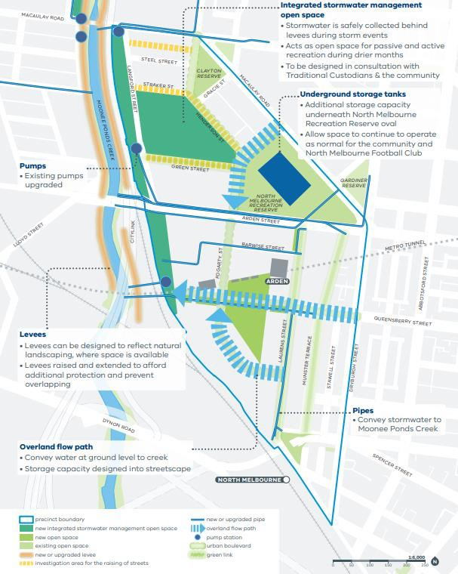
Figure 5 – Arden precinct flood management strategy
Source: Draft Arden Structure Plan (2020) – page 77

PUBLIC REALM RESPONSE
The Arden Station precinct public realm design response will create new spaces for transit users and the community to interact and enjoy. The station plaza on Laurens Street provides a meeting place at the station entry set back from Laurens Street, while the new ‘Laurens Lane’ provides an inviting and green space, set amongst trees, encouraging visitors to enjoy the surrounds. Project works will change the streetscape of Laurens Street, encouraging ongoing urban renewal in an area currently heavily dominated by industrial uses. Works along Barwise Street will reinvigorate an underused space and the design will reinstate a greener more sustainable precinct as a legacy with future development opportunities.
Laurens Street will accommodate a main station entry and exit point for Day 1 operation as well as the associated functional requirements including bicycle access, pedestrian crossings, kiss-and-ride, taxi zone and bus stops (for future bus routes), and private vehicle thoroughfare. The majority of bicycle parking will be accessible via Barwise Street and the service road entry to the station. The station plaza will feature a number of retail stores providing passengers with an opportunity to buy refreshments and food whilst within the Arden Station precinct. There is also a digital passenger information display proposed to enhance the user experience, and to ensure safety the station precinct will be monitored by video surveillance.
Two new service laneways will be developed as part of the Project. This includes a service laneway; Station Lane, at the rear of the main station building, which will also provide cyclist and pedestrian access. In consultation with the Victorian Planning Authority and City of Melbourne, the total road reserve width of the Station Lane has been increased to 16m in this amended Development Plan to better accommodate the potential future entry to the station and pedestrian access. Another service laneway off Barwise Street; Fogarty Street, will service the Western Building. This laneway aligns with the proposed extension of Fogarty Street (north of the Arden Station) and can be integrated into the future development of the Arden precinct’s transport network, illustrated in Figure 11.
As part of the design development, there have been amendments to the public realm features. The total extent of public realm has increased around the Western Building by revising the kerb alignment of Station Lane. A plinth terrace has been introduced on Barwise Street which has led to adjustments to the ramps and stairs to provide access to the retail units. This change is associated with the raised interfacing retail entrances to better address flood protection, as discussed in Section 4.3.1. Linear garden beds (including a rain garden) have also been incorporated along the northern edge of the outdoor dining area on Barwise Street. These garden beds will help to clearly define the proposed pedestrian avenue and retail spill out/ outdoor dining. In addition, public realm features along Station Lane and Laurens Lane have been subject to change. On Station Lane, improved features such as additional WSUD features (including a long linear sunken garden), trees, bike hoops and public seating areas are proposed. Laurens Lane design has been amended by relocating the fire booster, increasing the plinth terrace area and adjusting the stair alignment to address access requirements to station services, increasing the scale of WSUD and garden beds and re-arranging street furniture.
Integrated art that speaks to the above themes will be included in Arden Station precinct finishings. A collaborative commission for areas of the landscape with various designers will form part of our Connection to Country Strategy. By celebrating the unique character of the precinct and amplifying these qualities, the Project supports a unique identity and connection to place, country and heritage. Provisional locations for the implementation of art installations is provided.
The relevant public realm drawings listed below are attached in Appendix D: Arden Station Precinct Public Realm Plans:
- TAS-CYP-AR-00-DRG-AUD-ARD-710001-DP
- TAS-CYP-AR-00-DRG-AUD-ARD-710002-DP
- TAS-CYP-AR-00-DRG-AUD-ARD-712101-DP
- TAS-CYP-AR-00-DRG-AUD-ARD-712102-DP
- TAS-CYP-AR-00-DRG-AUD-ARD-712103-DP

- TAS-CYP-AR-00-DRG-AUD-ARD-712104-DP
- TAS-CYP-AR-00-DRG-AUD-ARD-712105-DP
- TAS-CYP-AR-00-DRG-AUD-ARD-712106-DP
- TAS-CYP-AR-00-DRG-AUD-ARD-712107-DP
- TAS-CYP-AR-00-DRG-AUD-ARD-712108-DP.

COMMUNITY EXPERIENCE
The Arden Station precinct has been designed to allow seamless movement through both the station and public realm.
The Arden Station precinct presents an opportunity for urban renewal in an area heavily dominated by industrial uses. The precinct is located at the intersection between Laurens Street and Barwise Street, in a space that is currently underused by pedestrians and cyclists. Existing conditions at the site mean that access to public transport is poor and the quiet streets are primarily used by private vehicles. The precinct design will transform this space to prioritise pedestrians and cyclists and their access to the station, while taking into account the needs of businesses in the area.
Upon Project completion, on Day 1, the Arden Station precinct will:
- Be integrated into the broader pedestrian network via existing pedestrian paths along Arden Street and Queensberry Street. New pedestrian connections will be provided along Laurens Street and Barwise Street, linking the new Arden Station precinct into the existing surrounding space (refer to Figure 8). This also in accordance with the draft Arden Structure Plan (2020) (refer to Figure 11)
- Have cyclist access through the Arden Station precinct. A new separated raised bicycle path and a shared on-road bike path will be provided west and east of Laurens Street, respectively. These bicycle paths will link into the existing bike paths along Arden Street and Queensberry Street and will provide direct access to the Arden Station precinct (refer to Figure 9). The provision of bicycle paths enhances the existing connections to surrounding bike routes, such as the Moonee Ponds Creek trail, and allows for the future development of the precinct to enhance cyclist connections (as identified within the draft Arden Structure Plan (2020) and shown in Figure 11). Bicycle hoops are provided in multiple locations within the precinct, providing cyclists the opportunity to easily access transport services (refer to Figure 9)
- Integrate a bus stop along Laurens Street, providing connections to further destinations within Melbourne (refer to Figure 10). The design allows for the future development of additional transport connections, as identified in the draft Arden Structure Plan (2020) (refer to Figure 11)
- Allow users access to the new station at Arden from Laurens Street, via steps or a graded ramp. In the amended design, the proposed DDA ramps have been relocated from Barwise Street to the station entry on Laurens Street to improve intuitive wayfinding and visual connectivity. This entrance feeds into an unpaid plaza space, with ticketed barriers leading to the escalators that descend to the train platforms below. There will be three escalators providing access up to and down from the platforms. Two lifts are located adjacent to the escalators providing additional access to the platforms. Mobility impaired users will be able to get from the station entrance, to the platform, step free (refer to Figure 7)
- Have a station concourse and train platforms located underground that feature natural light from the three skylights positioned to the west of the station entrance. The unpaid concourse area will feature retail space and station facilities such as ticket machines. The station has been designed in a manner to reduce the need for signage, encouraging intuitive wayfinding through the design.

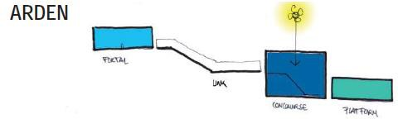
Figure 6 – Arden Station user experience design

UNIVERSAL ACCESS
Universal access has been incorporated into the design of Arden Station precinct. Two universal access vehicle bays for disabled parking are provided on Barwise Street, and two kiss-and-ride bays are located on Laurens Street. There is step-free access to the station platform, via a pedestrian ramp from Laurens Street up to the station infrastructure and a lift down to the station platform. As part of the amendments to the Arden Station Precinct Development Plan, the DDA ramp has been relocated from Barwise Street to the station entry on Laurens Street. This relocation improves intuitive wayfinding and visual connectivity for those arriving at the station. Additionally, a new DDA ramp and stairs are proposed from Station Lane at the buildings rear, which will provide disabled and able-bodied access to station facilities from the western redevelopment area. Pedestrian ramps have been designed in accordance with Section 23 of the Disability Discrimination Act 1992. A Changing Places facility is also included in the station building, to provide suitable support for people who cannot use standard accessible toilet facilities. Along with the retail units, the Changing Places facility has been rearranged through design development of the station to improve sightlines from the customer service centre, in accordance with the MTM’s requirements. These features ensure that all precinct users can access the station, regardless of physical ability, on opening and into the future.
DDA access within the Arden Station precinct is shown in Figure 7.

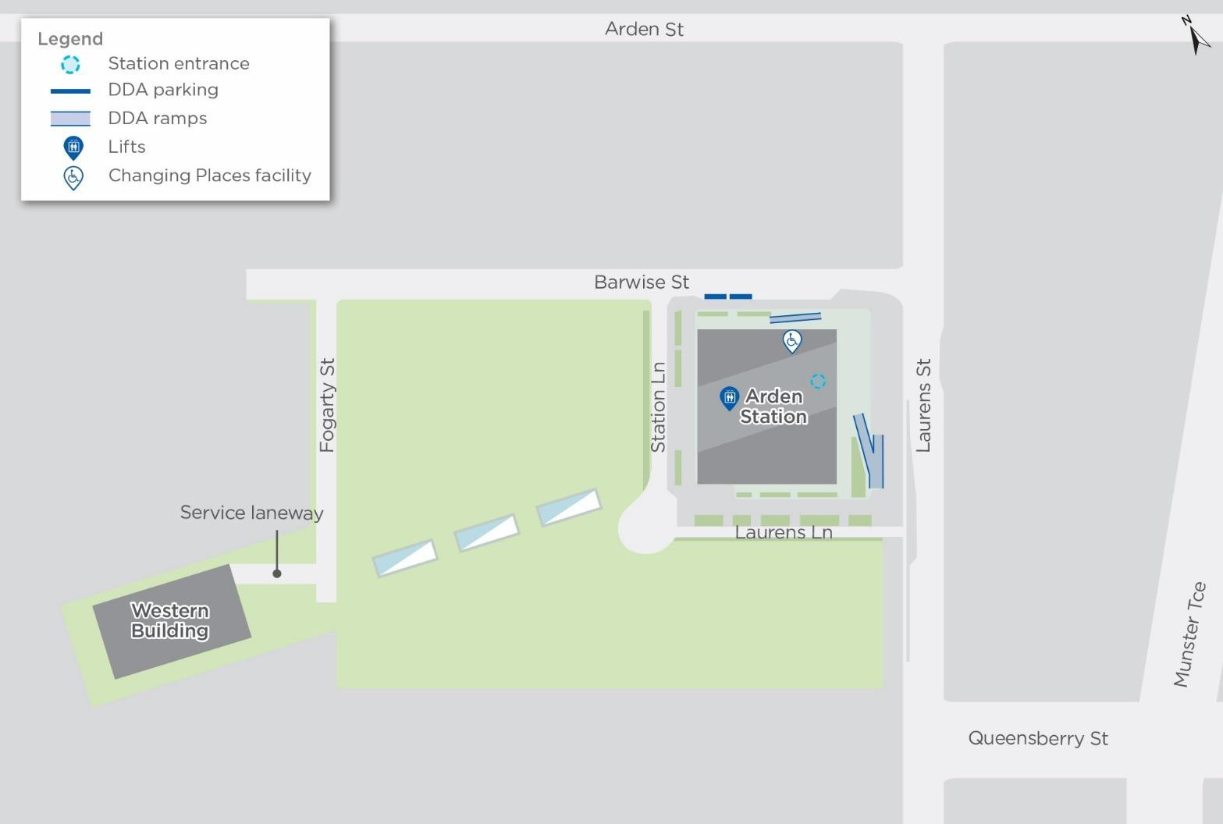
Figure 7 – DDA access within the Arden Station precinct

PEDESTRIAN ACCESS
Most station passenger movements will involve pedestrian journeys to the Station or interchanging with the connecting bus or Moonee Ponds Creek Trail cycling trail. For passengers commuting to and from the Station by foot the precinct design accommodates movement using a series of dedicated pedestrian crossings on Laurens Street and Queensberry Street. The pedestrian movement network through the Arden Station precinct is shown in Figure 8. The station features one set of ramps, stairs and lifts to link with universal access bays on the northern side of the station entry and the bus stops (for future bus routes) to the west on Laurens Street. This will create a swift movement between bus and train modes through a short walk that utilises the dedicated pedestrian crossings.
During detailed design, opportunities were investigated to improve pedestrian access with the ticket gates re-oriented to improve pedestrian movement in response to the expected pedestrian traffic from the west. In the previous design, the ticket gates were orientated in a north-south alignment, however this has been changed to a north-west south-east alignment to better face Barwise Street. In addition, the total road reserve width of Station Lane has been increased to 16m as requested by City of Melbourne and the Victorian Planning Authority to better accommodate pedestrian access for the future station entrance. This change allows for better integration with the draft Arden Structure Plan (2020) which proposes the Station Lane to be a pedestrian priority zone (refer to Figure 11).
This amendment has led to additional pavement on Station Lane to accommodate the additional road width, the inclusion of planted landscape beds, one additional tree and additional bike parking.
Private parking spaces will not be increased as part of the station works, as the area’s walkability has been increased through enhancements to the footpaths, including widening on Laurens Street. The Arden Station precinct will also provide universal access compliant parking bays and access to the station via ramps and lifts ensuring station access for all passengers (refer to Section 4.3.4.1).

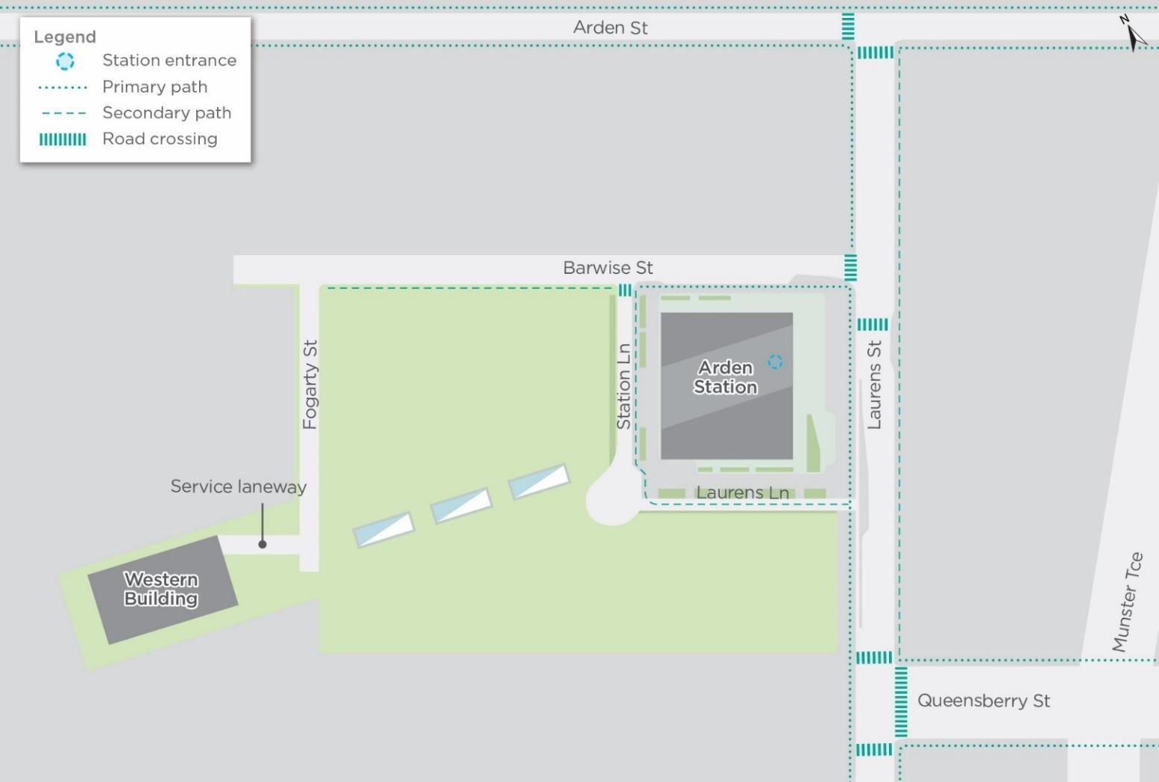
Figure 8 – Pedestrian movements through the Arden Station precinct

BICYCLE ACCESS
Improving Melbourne’s cycling network and encouraging active transport and intermodal connections with Melbourne’s metro system is an important Project objective.
Our design provides high-quality bicycle paths and generous amounts of bicycle parking. These will facilitate sustainable transport and healthy lifestyle options for commuters and the station’s surrounding communities. On Day 1, 126 bike-parking spaces will be available in and around Arden Station. The design also has provision for an additional 200 secure bike spaces located near the proposed future station entries, west of the station building, and the design provides for Melbourne bike share stands. In the amended drawings, these bike share facilities have been relocated from Laurens Lane to Laurens Street, near the station entry DDA ramp.
As outlined in Section 4.3.4.1, a new DDA ramp and additional stairs are proposed from Station Lane. This change has led to the displacement of an undercover bike storage that was previously proposed on the south-west corner of the station building. However, the total number of bike-parking spaces has remained unchanged in this amended Development Plan due to the additional spaces provided on Station Lane and Laurens Lane.
In close consultation with the Victorian Planning Authority and City of Melbourne, the design has been amended to incorporate a separated raised bicycle path on the west side of Laurens Street. Note the majority of the bicycle lanes within the CYP extent of works are two metres in width, however this reduces in width to 1.5 metres behind kerb along the southbound carriageway of Laurens Street to eliminate dooring issues between the bicycle lane and the taxi bays, park and ride bays and the bus bay. This supports the draft Arden Structure Plan (2020) that identifies Laurens Street as part of a proposed Strategic Cycling Corridor network. As discussed in Section 2.1, those cycling corridors are proposed to improve cycling to and around major activity centres and cater for the highest cycling volumes while offering protection from other vehicles (refer to Figure 11). The existing painted-on road bicycle lanes on the east side of Laurens Street will be reinstated, providing good access from the surrounding network to the station.
Bicycle facilities in the Arden Station precinct are shown in Figure 9.

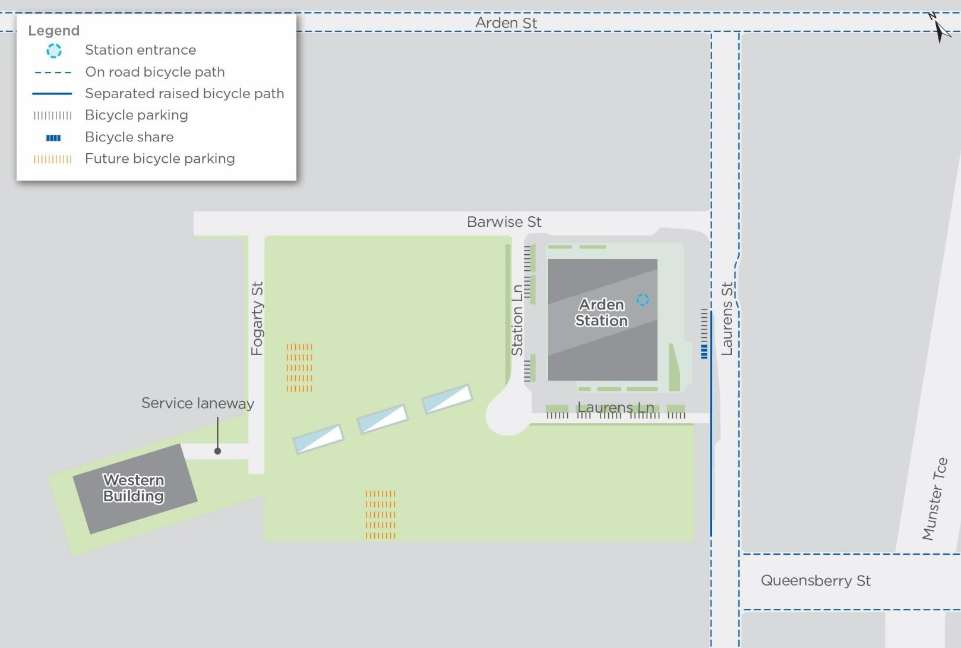
Figure 9 – Bicycle facilities in the Arden Station precinct

TRANSPORT INTEGRATION
The Arden Station precinct has been designed with a preferred transport hierarchy that focuses on pedestrians followed by cyclists, public transport, service vehicles and finally private automobiles.
The station precinct needs to accommodate easy passenger arrival and drop off via future bus services, cars and taxis. On Day 1, bus stops (for future bus routes) and separate kiss-and-ride and taxi spaces are provided directly outside the station on Laurens Street. The design also includes allowance for additional future bus stops. Universal access parking bays are conveniently located at the north of the station with direct access to the north ramp to the concourse.
Bicycle parking is provided at station entries to make cycling both attractive and a safe way of travelling to Arden Station (refer to bicycle facilities in Figure 9). New bus stops (for future bus routes) with shelters on Laurens Street will allow passengers to readily connect with trains. While kiss-and- ride, service vehicles, provision for rail replacement bus services and taxi bays have been integrated into the public realm — these are located on Laurens Street, south of Laurens Lane. These arrangements are shown on Figure 10. Additionally, the design accommodates station staff parking on Barwise Street.
The Arden Station design is consistent with the future development of the wider transport network as proposed within the draft Arden Structure Plan (2020). This includes the future extension of Fogarty Street and Queensberry Street as illustrated in Figure 11. In addition, while there are currently no tram services that stop at Arden Station, the design of the station precinct allows for future tram extensions along Arden Street and / or Laurens Street that have been identified as ‘high capacity public transport capable’ in the draft Arden Structure Plan (2020).

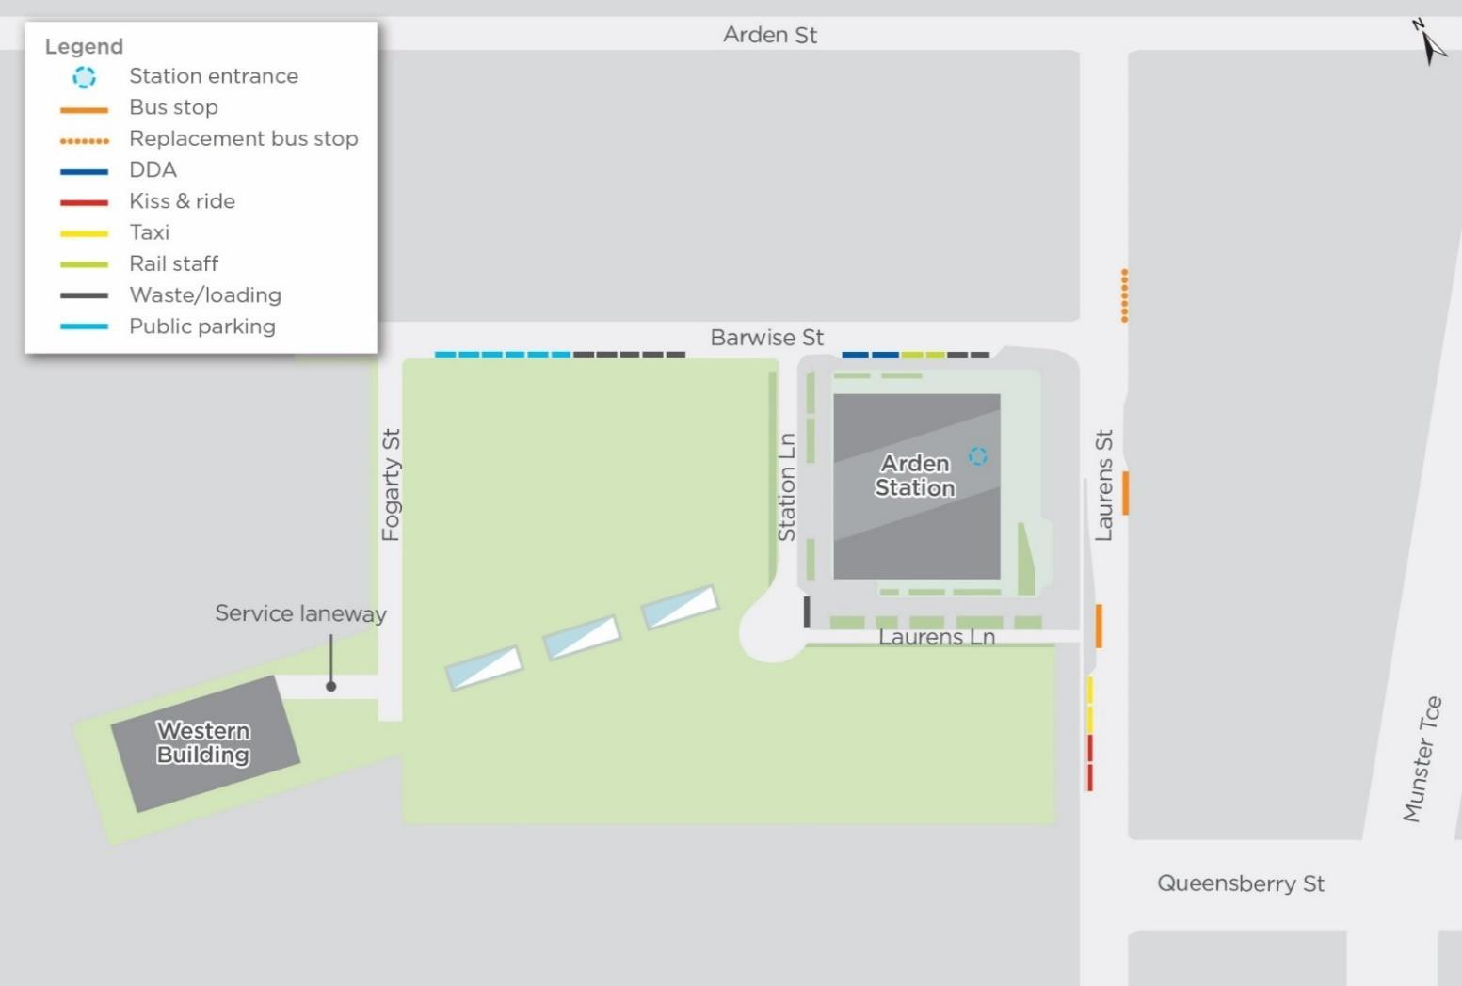
Figure 10 – Transport integration within the Arden Station precinct

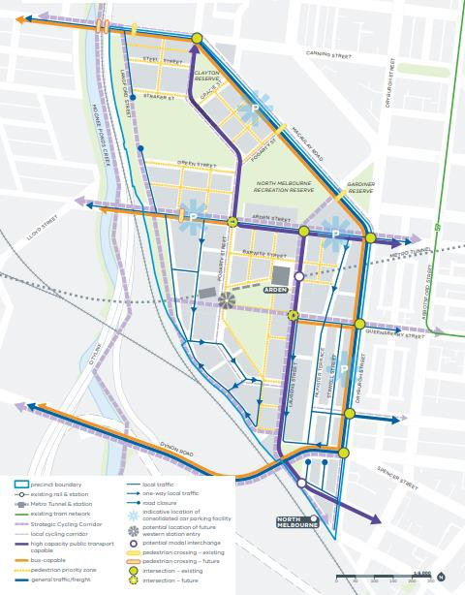

Figure 11 – Arden’s transport network 2051
Source: Draft Arden Structure Plan (2020) – page 65

LIGHTING
The public realm lighting is designed with deliberate consideration of the experience of those visiting the station and its surrounds, recognising that the station precinct is a key part of the passenger’s journey. Lighting will intuitively guide passengers in their journey from the streets through the station plaza and to the entrance.
Natural light will enter the station concourse through a series of skylights installed at ground level.
Street and pathway lighting will come from pole-mounted lights, at a scale and form to suit the purpose and local context. Green space and seating within the station plaza invites passengers to spend a moment interacting with the precinct and the local community.
During detailed design, additional details have been provided regarding lighting specifications. The location of the proposed lights have also been amended and are now shown in the amended public realm plans in Appendix D: Arden Station Precinct Public Realm Plans.

SIGNAGE
Careful effort has been taken in planning and designing the stations to reduce the amount of signage required. Internal and external spaces have been designed to support intuitive movement with minimal reliance on signage. Signage is presented in a logical sequence based on providing the right information at the right time and in the right place.
A family of sign types has been developed and applied consistently across all stations and their precincts. Signs are categorised into four main functional groups; identification, directional, information and statutory.
The signage system has been designed based on PTV signage guidelines. This ensures a system that is consistent, predictable and recognisable to users across Melbourne’s transport network. A combination of static and digital signage has been used to provide an element of permanence and consistency, while allowing the flexibility to change and adapt where necessary.
For the departing passenger, stations will be identified from a distance by a 5m high illuminated station marker sign located at street level. Entrances to the stations will be identified with a legible city totem and station name sign above all entry points. At the concourse level, directional signs will highlight the location of station facilities and direct passengers down to platforms. Once on the platform, information for departing passengers will be contained within and above the platform screen doors.
For a passenger arriving on the train, station names located trackside and along the platform will confirm arrival at the station. After alighting, ‘way out’ signage will direct passengers to the nearest escalators/stairs and lifts. Signage content on the platform is kept to a minimum to promote easy decision making and ensure passengers exit safely and efficiently. At concourse level, directional signage clearly indicates where each of the exit points are located, and which street each of the escalators/stairs and lifts lead to. Exit guides (in the form of a map) provide further information for passengers requiring more detail. At street level, a legible city totem is located close to all exit points to help passengers locate key destinations and nearby bus stops.
Location and signage hierarchy is detailed in Appendix A: Arden Station Precinct Site Layout Plan, drawing TAS-CYP-AR-00-DRG-AUD-ARD-710200-DP.

ANCILLARY FEATURES
Station ventilation structures and a chiller plant have been consolidated and strategically placed within the station building to avoid being visible in the public realm. This placement makes them less visibly obtrusive, reducing their potential to impede on sightlines and future development of the Arden Station precinct.

Other maintenance and back of house facilities are located in the Western Building, located off Fogarty Street. The footprint of this building has been reduced through incorporating as much infrastructure underground as possible, without precluding OSD. This building is intended to be integrated into the future development of the Arden precinct, as identified in the draft Arden Structure Plan (2020) (refer to Sections 2.1 and 4.3.1).

MATERIALS AND FINISHES
The station design features materials and finishes that have been selected in consultation with City of Melbourne and the OVGA, and comply with the City of Melbourne Design Standards as per the project scoping and technical requirements. The materials and finishes generally reflect City of Melbourne’s durable and distinctive palette. This approach will help to define Arden Station as part of Melbourne’s municipal brand identity, offering visual links and references that are readily identifiable as ‘Melbourne’.
Materials and detailing have been incorporated as references to the specific industrial context of the Arden Station precinct. This includes materials such as brick, concrete and ceramic. Other finishes, such as stone, and concrete framing and glass screening is reflective of other Project stations and strengthens the line-wide identity. This approach ensures that while a consistent line-wide style is evident across the Project’s stations, the unique character of the Arden Station precinct is maintained and integration with the local context is achieved.
Ongoing stakeholder consultation with the City of Melbourne and OVGA through detailed design has resulted in an amendment to the Western Building façade materiality, as well as the skylights. The external faces of the Western Building are now proposed as brick facing and precast concrete to provide a more flexible façade that can be integrated within the draft Arden Structure Plan (2020). In addition, following consultation with the OVGA, the skylight materiality is proposed as white stone, to integrate into the landscaping of the central open space.
The paving materiality has also been subject to amendments in some locations, such as the removal of bluestone paving from Barwise Street and Laurens Street (west) in consultation with City of Melbourne.
Materials and finishes are detailed in the Materials Schedule in Appendix B: Arden Station Precinct Architectural Plans and Elevations and in Appendix D: Arden Station Precinct Public Realm Plans.

CRIME PREVENTION THROUGH ENVIRONMENTAL DESIGN
Each station’s relationship to the surrounding precinct differs, with Arden Station configured to allow natural pedestrian flows from both the existing area and future development within the precinct. This helps to guide and manage pedestrian access while providing natural or passive surveillance qualities to Arden Station precinct. Natural access control and passive surveillance, in addition to territorial reinforcement, make up the three basic strategies of Crime Prevention through Environmental Design (CPTED).
The design concept of access control is directed primarily at decreasing criminal accessibility. Natural access control restricts criminal intrusion, in particular into areas where they are not easily observed. This is achieved by limiting access and increasing natural surveillance. Design initiatives integrated into the Arden Station precinct which aim to accomplish this include the use of gates, fences, walls, footpaths, landscaping and lighting to:
- Clearly guide the public to and from specific entrances and exits
- Prevent or discourage public access to or from dark or unmonitored areas
- Enable intruders to be more easily recognised.

Natural, or passive surveillance, is a design concept that aims to keep potential offenders and intruders under observation through the creation of environments where there is sufficient opportunity for people engaged in their normal behaviour to observe the space around them. This is sometimes also referred to as “eyes on the street”. Design features of the Arden Station precinct which have been employed to increase natural and passive surveillance include:
- Design and placement of physical features to maximise visibility. For example, Arden Station features a clear through building orientation, providing passive surveillance toward Laurens Street and the new Service Lane
- Plantings have been selected to maximise visibility via high-canopy trees, and low growing shrubs and ground covers (less than 500 millimetre high)
- Placement of persons or activities to maximize surveillance possibilities, such as commercial retail units which encourage persons to linger in the vicinity, helping underpin perceptions of safety.
Territorial reinforcement, the third basis of CPTED, focuses on the delineation of private space from semi-public and public spaces, creating a sense of ownership. This in turn identifies intruders, making them less likely to offend. While not necessarily the domain of the design for the Arden Station precinct given its status as a public building, simple design measures have been employed to reduce the potential for anti-social behaviour including:
- Reinforcing existing natural surveillance and natural access control strategies with additional symbolic or social ones to enhance a feeling of legitimate ownership
- Designing a space to accommodate long-term and continued use and to fit its intended purpose
- Using pavement treatments, landscaping, art, signage, screening and fences to define and outline ownership of space.
A CPTED review of Arden Station has been undertaken since the Arden Station Precinct Development Plan was approved by the Minister for Planning on Thursday 8 March 2018. This review aimed to identify opportunities and record requirements for implementing passive security strategies into the Arden Station’s design, in line with the CPTED principles. The outcome of this review indicated a number of CPTED issues in relation to the design. Those issues and associated response strategies are discussed below.
Station Lane and Laurens Lane were seen as vulnerable, due to being setback from the street and partially shielded by the station structure itself. In response, the design supports activation and surveillance through the new parking and loading bays as well as outdoor retail terrace on Barwise Street, arched open space station entry (station plaza) and outdoor retail terrace on the east side of the station.
Natural surveillance was raised as an issue in the CPTED review. This specifically applied to the grassed areas on the southern and western sides of the station. To address this issue, clear views will be maintained through tree pruning as the tree matures to maintain tree trunks to 3m, and limiting the ground level planting species height to a maximum of 0.5m. In addition, retail units and outdoor terraces will provide eyes on the street. Appropriate lighting and CCTV will also assist with addressing this issue. Passive surveillance has been facilitated through careful specification of shrub and tree species, and placement of urban furniture and signage in the public realm to ensure sightlines are not impeded. Also, the retail units and Changing Places facility have been relocated in accordance with MTM’s requirements to provide better sightlines from the customer service centre to those facilities.
The CPTED review describes the natural access to the grassed areas west of the station building as an issue due to the potential attractiveness of the skylights for vandalism and the potential for pedestrians to use the space as a short-cut. In response, security hoarding will be provided to restrict public access to undeveloped areas and skylights.

CONSISTENCY WITH ENVIRONMENTAL MANAGEMENT FRAMEWORK
The Environmental Management Framework provides a transparent and integrated governance framework to manage the environmental aspects of the entire project. A summary of the framework is provided in Table 4.
Table 4 – Summary of RPV’s Environmental Management Framework

Topic | Summary
Contract structure | Outlines the RPV procurement strategy which includes different delivery packages including an Early Works Managing Contractor, Tunnels & Stations Public Private Partnership (CYP), Rail Infrastructure Alliance and Rail Systems Alliance
Roles and responsibilities | Defines roles and responsibilities for the Minister for Planning, regulators and agencies, RPV, PTV, project contractors (for the delivery packages above), Independent Reviewer and Independent Environmental Auditor.
Environmental management plans and documentation | Provides the requirements for project contractors to have an Environmental Management System, Development Plans, Early Works Plan/s, Construction Environmental Management Plan, Operations Environmental Management Plan, Transport Management Plan/s, Business Disruption Plan, Construction Noise & Vibration Management Plan, Site Environmental Implementation Plans, Work Method Statements and records and checklists.
Evaluating environmental performance | Provides the requirements for project contractors in relation to monitoring, reporting and auditing environmental performance.
Environmental Performance Requirements (EPRs) | EPRs are performance-based requirements that define the project-wide environmental outcomes that must be achieved during design, construction and operation of the Project. This performance-based approach allows for a delivery model with sufficient flexibility to encourage innovation by the project contractors to determine how any approved EPR would be achieved.
Residential Impact Management Guidelines | Appended to the framework, the guidelines provide direction to the project contractors on how to address residual impacts on residential amenity so far as is reasonably practicable and appropriate.
Business Support Guidelines for Construction | Appended to the framework, the guidelines provide a framework for project contractors to address residual impacts on businesses so far as reasonably practicable and appropriate.
The Environmental Management Framework rightly extends well beyond just the application to this Development Plan, which presents the scope and extent of the built form of CYP’s works in the Arden Station precinct. This includes:
- Construction impacts – addressed by CYP’s Environmental Management System, Construction Environmental Management Plan, Site Environment Implementation Plans, Early Works Management Plan and aspect-specific management plans (as specified in the Incorporated Document and EPRs). This has been subject to separate stakeholder consultation requirements and review by the Independent Environmental Auditor, including quarterly audits of performance throughout construction
- Operational impacts – addressed by CYP’s Environmental Management System and Operations Environmental Management Plan. This has been subject to separate stakeholder consultation requirements and review by the Independent Environmental Auditor
- Geographically-specific – location specific requirements that are not in the Arden Station precinct have been addressed in the relevant precinct Development Plan
- Specific to another project contractor – compliance by other project contractors (e.g. Early Works Managing Contractor) has been addressed in the relevant environmental management documentation of that project contractor.

An assessment of each EPR is provided in Appendix F: Arden Station Precinct Environmental Performance Requirements assessment. This identifies key EPRs relevant to this Development Plan and these are presented below.

AQUATIC ECOLOGY AND RIVER HEALTH
Table 5 provides the CYP design response to the relevant aquatic ecology and river health EPRs.
Table 5 – Design response to relevant aquatic ecology and river health EPRs

EPR | Design Response
EPR AE1: Stormwater treatment  EPR AE7: Stormwater treatment | The design of the Arden Station precinct has been developed in consultation with Melbourne Water and City of Melbourne.  The Arden floodplain has been considered within the precinct design development, with Water Sensitive Urban Design (WUSD) principles also included. Measures integrated into the Arden Station precinct will ensure that stormwater entering bodies of water complies with the relevant Environmental Performance Requirements (EPR AE1 and EPR AE7). In meeting these requirements, the Project has implemented design measures that align with the City of Melbourne water management plan.  Broadly, these objectives include:  - Reducing flood risk in lower elevated areas of flood catchment areas  - Increasing soil moisture  - Mimicking the natural water cycle by retaining more rainwater in the upper section of catchments, reducing stormwater runoff  - Providing passive irrigation to plants reducing potable water demand. In order to meet these objectives and satisfy the relevant Environmental  Performance Requirements (EPR AE1 and EPR AE7), the following design measures have been implemented in the Arden Station precinct design:  - Maintaining the area to the west of the station building as grassed, identified in close consultation with Melbourne Water and Victorian Planning Authority. This is consistent with the precinct-wide flood management strategy outlined in the draft Arden Structure Plan (2020)  - Provision of tree pits containing large soil volumes which are fed by drainage grates have been integrated into the public realm hardscape design. These measures both provide passive irrigation and assist with stormwater management.  Landscape drawings in Appendix C: Arden Station Precinct Landscape Plans and Elevations show the location of these water sensitive urban design plantings across the Arden Station precinct, incorporating water sensitive urban design measures.

ARBORICULTURE
Table 6 provides the CYP design response to the relevant arboriculture EPRs.
Table 6 – Design response to relevant arboriculture EPRs

EPR | Design Response
EPR AR1: Maximise tree retention | The design of the Arden Station precinct has been developed in consultation with City of Melbourne.  The removal of trees has been avoided, where possible, with particular emphasis given to the retention of mature trees, such as those along Laurens Street. This has been achieved through the placement of the station box, which has been reduced in size. Additionally, surface works pertaining to the strategic placement of street furniture and ancillary structures such as emergency egress and vent shafts have been designed to maximise the retention of existing trees within the Arden Station precinct.  As part of project works, 90 trees will be removed. 60 of these trees have been  removed during early works with an additional 30 to be removed due to CYP design. Design changes have improved tree retention with 32 less trees removed than

EPR | Design Response
identified during the EES and 15 less than the previously approved Development Plan. None of the trees proposed for removal are considered native vegetation in accordance with the DELWP Guidelines for the removal, destruction or lopping of native vegetation (2017) (or under the previous Permitted Clearing of Native Vegetation - Biodiversity Assessment Guidelines (2013).
The retained and removed trees are shown on the landscape plans in Appendix C: Arden Station Precinct Landscape Plans and Elevations.
EPR AR2: Tree soil and water supply | The design of the Arden Station precinct identifies soil zones for tree planting. At Arden, trees will be planted in several different conditions:  - Directly in garden bed or lawn areas where there will be natural large soil volumes  - In paved areas where tree pits with structural soil systems created below the pavements. These will typically allow stormwater to enter the tree pit providing passive irrigation and water treatment.  Tree pits depth in paved areas will vary based on whether they are located over the station box, or not. Typically, from surface level tree pits will vary in depth from 1.8-  1.4 metres. The width and length of tree pits also varies, depending on the depth of the pit achievable, as well as how many trees can share a trench. Tree pits will have structural soil cell systems, which allows uncompacted soil to be placed under ridged surface pavements. The actual size and configuration will be subject to the location of underground utilities.  CYP will work with a specialist soil scientist to develop a high-performance soil specification and profile that balances the optimal soil requirements for storm water drainage, as well as for long term tree growth.  The soil zone for tree planting and water sensitive urban design are shown on the public realm plans in Appendix D: Arden Station Precinct Public Realm Plans and landscape plans in Appendix C: Arden Station Precinct Landscape Plans and Elevations.
EPR AR3: Tree replacement | The design of the Arden Station precinct has been developed in consultation with City of Melbourne.  The design for the Arden Station precinct includes reinstating trees throughout the precinct. Overall there will be approximately 103 new trees within the Arden Station precinct. This will help achieve RPV’s objective of doubling tree canopy by 2040 across the Metro Tunnel Project.  A tree replacement program will be developed in further consultation will City of Melbourne. This will ensure tree replacement is carried out in alignment with council strategies.  The reinstated trees are shown on the landscape plans in Appendix C: Arden Station Precinct Landscape Plans and Elevations.

HISTORICAL CULTURAL HERITAGE
Table 7 provides the CYP design response to the relevant historical cultural heritage EPRs.
Table 7 – Design response to relevant historical cultural heritage EPRs

EPR | Design Response
EPR CH1: Minimise heritage impact  EPR CH7: Archaeological heritage  EPR CH10: Response to heritage places  EPR CH23: Heritage street fabric | The design of the Arden Station precinct was developed in consultation with Heritage Victoria and City of Melbourne. This has resulted in cultural heritage informing the Arden Station precinct design response, in accordance with the Project’s Heritage Interpretation Strategy.  The former North Melbourne pottery complex is listed on the Victorian Heritage Inventory (VHI) and is located within the Arden precinct. Approval was obtained from Heritage Victoria for associated construction works within this site, which included the development of an archaeological management plan.  There is no known heritage fabric at the existing Arden Station precinct, however  Arden's industrial heritage is expressed through the proposed materials, finishes and detailing of the station building and plaza. The design blends transport typology (the

EPR | Design Response
bridge crossing inspiration and the proposed transport infrastructure) with the existing industrial nature of the area.
As part of the Connection to Country Strategy, a collaborative commission for areas of the landscape has been undertaken with various designers. By celebrating the unique character of the precinct and amplifying these qualities, the Project supports a unique identity and connection to place, country and heritage. Provisional locations for the implementation of art installations is provided.
The proposed hardscape and furniture for the public realm will feature materials and finishes that reflect City of Melbourne's durable and distinctive palette, including bluestone paving, and stainless steel furniture. Many elements at Arden are made from brick, stone and stainless steel to enhance the precinct’s identity. The station structure design opts for red brick, providing a connection to the industrial history of the surrounding Arden Station precinct.
Plant selection at Arden includes a predominantly native and indigenous plant palette which further highlights the historical significance and cultural values of the site.
The public realm response incorporating heritage values are discussed in Section
4.3.3 and shown on the public realm plans in Appendix D: Arden Station Precinct Public Realm Plans.
CH12: Langford Street pumping station | The Intake Substation is located at an alternative location to the concept design option proposed in the EES and will therefore have no heritage impact on the Langford Street Pumping Station. The Intake Substation is the subject of a separate Development Plan.

LAND USE AND PLANNING
Table 8 provides the CYP design response to the relevant land use and planning EPRs.
Table 8 – Design response to relevant land use and planning EPRs

EPR | Design Response
EPR LU1: Minimise impact on existing land use | The design of the Arden Station precinct was developed in consultation with City of Melbourne.  Due to the largely vacant, industrial nature of the new Arden Station precinct, and its status as a key redevelopment precinct for Melbourne, precinct design seeks to reduce limitations on the development capacity of the site. Examples of this include:  - The design of the Arden Station building, housing the station entrance, has been located close to the intersection of Laurens and Barwise Street creating flexibility for the design of future station entries, precinct streets and public spaces across the Arden redevelopment precinct  - The scale of development, namely the station building, is reflective of the existing surrounding built environment.  The design of Arden Station also provides additional public open space with the development of a station plaza at the intersection of Laurens and Barwise Streets. This strengthens the connection between Arden Station and the existing area beyond. This new area of public open space will become a meeting point for existing and future residents and workers in the Arden Station precinct.  The public realm shown on the public realm drawings is included in Appendix D: Arden Station Precinct Public Realm Plans.
EPR LU2: Master plans | The design of the Arden Station precinct was developed in consultation with City of Melbourne and the Victorian Planning Authority and is consistent with the draft Arden Structure Plan (2020).
EPR LU3: Design of Arden Station | The design is in accordance with the Urban Design Strategy and the draft Arden Structure Plan (released June 2020), and was developed in consultation with the Victorian Planning Authority and City of Melbourne.  The Urban Design Strategy requires the precinct to have regard for a number of  public realm elements, including but not limited to creating new and improved connections as well as making great public places. The design of the Arden Station

EPR | Design Response
precinct is consistent with the Urban Design Strategy requirements, for example, incorporating the development of a public plaza at the station’s entrance, utilising land that was previously used for industrial purposes.
The design of the precinct is consistent with the draft Arden Structure Plan (2020) and allows for the future development of land for public open space across the broader Arden area. It also provides provision for a future station entrance and opportunities for development of the interface with the Western Building such as activation of the building’s south facade through provision of a small retail or bookable community space.
Furthermore, the precincts design has taken a comprehensive, integrated approach to managing water in the Arden Station precinct. Examples of this include the use of Water Sensitive Urban Design (WSUD) plantings across the precinct to help manage local stormwater. In addition, the station entrance, northern retail terrace and interfacing retail entrances will be raised 1.5 metres above ground level to protect the station from being flooded from the 1 in 100 year ARI flood event level (this also includes an additional 0.5 metre high active flood protection barrier at the ticket gate to protect against the 1 in 1000 year ARI flood event). This is in accordance with Melbourne Water flood management standards.
Landscape drawings included in Appendix C: Arden Station Precinct Landscape Plans and Elevations show the design response for the Arden Station precinct incorporating WSUD principles such as plantings and passive drainage/irrigation utilising the natural flow of water.
A detailed assessment of consistency with the Urban Design Strategy is provided Section 4.3.
EPR LU4: Urban Design Strategy | The design of the Arden Station precinct is in accordance with the Urban Design Strategy and was developed in consultation with the Urban Design and Architectural Advice Panel (UDAAP). A detailed assessment of consistency with the Urban Design Strategy is provided in Appendix E: Arden Station Precinct Urban Design Strategy guidelines assessment and Section 4.3.

LANDSCAPE AND VISUAL
Table 9 provides the CYP design response to the relevant landscape and visual EPRs.
Table 9 – Design response to relevant landscape and visual EPRs

EPR | Design Response
EPR LV1: Reduce visual impact  EPR LV2: Re-establishment of public open space | The design of the Arden Station precinct was developed in consultation with the Office of the Victorian Government Architect, Victorian Planning Authority and City of Melbourne.  The design has given consideration to visual impact on the surrounding built form. While there are few sensitive receptors in the Arden Station precinct, the design of the station is of a similar scale to the surrounding built environment and is located in such a way as to not impede on any existing view lines. Further, the design of the station utilises soft landscaping treatments to minimise any visual impacts arising from the stations development.  Due to the location of the Arden Station precinct in a redevelopment area, there is minimal impact on public open space. The proposed Arden Station precinct incorporates a station plaza at the intersection of Lauren and Barwise Streets into design, creating a space for community interaction.  The public open space is shown on the landscape plans in Appendix C: Arden Station Precinct Landscape Plans and Elevations.

SOCIAL AND COMMUNITY
Table 10 provides the CYP design response to the relevant social and community EPR.

Table 10 – Design response to relevant social and community EPR

EPR | Design Response
EPR SC8: Re-establish public open space | The design of the Arden Station precinct has been developed in consultation with City of Melbourne.  Due to the predominantly industrial nature of the site, the Arden Station precinct has limited public open space. While no open space master plan exists for the precinct, following completion of construction, development will generally be in accordance with the draft Arden Structure Plan (2020). This framework outlines future areas to be used for public open space which the Arden Station Precinct Development Plan either aligns with, such as the station forecourt plaza, or allows for future development.  The public open space and landscape plans are shown in Appendix C: Arden Station Precinct Landscape Plans and Elevations and Appendix D: Arden Station Precinct Public Realm Plans, respectively.

SURFACE WATER
Table 11 provides the CYP design response to the relevant surface water EPRs.
Table 11 – Design response to relevant surface water EPRs

EPR | Design Response
EPR SW1: Flood design  EPR SW2: Water sensitive urban design | The design of the Arden Station precinct was developed in consultation with Melbourne Water, City of Melbourne and the Victorian Planning Authority, and inline with the flood management strategy outlined in the draft Arden Structure Plan (2020).  The Arden site is subject to flooding which is challenging for the development potential of the site.  The adoption of a water sensitive landscape design throughout the whole of the precinct will help to manage local stormwater. The Arden Station precinct will embrace this challenge and provide an ecological sponge. All tree pits and garden beds in the plaza and Laurens Street, will be designed to allow for stormwater infiltration.  A bio-filtration water feature rain garden will be located at the entry to the station. This will capture stormwater and be planted with ephemeral species. The feature will allow water to pond, hold and then be directed into terraced cascades before being collected in stormwater detention areas.  Arden Station's entrance, northern retail terrace and interfacing retail entrances will be raised 1.5 metres above ground level to protect the station from being flooded from the 1 in 100 year ARI flood event level (this also includes an additional 0.5 metre high active flood protection barrier at the ticket gate to protect against the 1 in 1000 year ARI flood event). This is in accordance with Melbourne Water flood management standards.  The Arden Station precinct design of water sensitive urban design is shown on the landscape plans in Appendix C: Arden Station Precinct Landscape Plans and Elevations, and a detailed assessment of consistency with the Urban Design Strategy is provided in Appendix E: Arden Station Precinct Urban Design Strategy guidelines assessment and Section 4.3.

TRANSPORT
Table 12 provides the CYP design response to the relevant transport EPRs.

Table 12 – Design response to relevant transport EPRs

EPR | Design Response
EPR T7: Operational road transport | The design of the Arden road network has been undertaken in consultation with the Department of Transport (previously known as VicRoads, Transport for Victoria and Public Transport Victoria) and City of Melbourne.  The existing Arden area road network will remain unchanged as a result of the Project. There will however be a reduction of approximately 24 car parking spaces within the precinct, with reinstated parking spaces provided along Laurens Street, Barwise Street and a new service laneway created off Barwise Street (Station Lane), servicing the back of house areas of the station.  Two new service laneways off Barwise Street will be constructed, servicing the main station building and Western Building. The service laneway closest to the Western Building can be incorporated into the future Fogarty Street extension as intended in the draft Arden Structure Plan (2020).  This new road will ultimately be integrated into the broader draft Arden Structure Plan (2020) at a later date. Additionally, the station design allows for the extension of Queensberry Street (or Fogarty as discussed above) into the Arden Station precinct.
EPR T8: Operational public transport | The design of the Arden road network has been undertaken in consultation with the Department of Transport (previously known as VicRoads, Transport for Victoria and Public Transport Victoria) and City of Melbourne.  The design of the Arden Station precinct has taken transport interchange into consideration through ensuring easy passenger arrival from bus, car or taxi drop off as well as potential future tram connections.  At present there is no bus route servicing the Arden Station location, however two bus stops will be provided on Laurens Street directly adjacent the station entry, on either side of the road, providing opportunity for a future bus route to provide greater local area transport. This will also include a train replacement bus stop. Two Kiss- and-ride bays and taxi rank will also be provided along Laurens Street.  While there are currently no tram services that stop at Arden Station, the design of the station precinct allows for future development along Arden Street and / or Laurens Street for public transport, as outlined in the draft Arden Structure Plan (2020).
EPR T9: Operational active transport | The design of the Arden road network has been undertaken in consultation with the Department of Transport (previously known as VicRoads, Transport for Victoria and Public Transport Victoria) and City of Melbourne.  As Arden is located in what is currently an industrial area, the existing active transport network is poorly defined.  The Project will deliver improvements to both the active transport network and the public realm to develop a high-quality walking and cycling environment. This will include footpath widening, new signalised pedestrian road crossings, additional tree planting, street furniture, new signage and lighting, bicycle lanes (including a separated raised bicycle path on Laurens Street west, and an on-road bicycle path on Laurens Street east) and generous bicycle parking. The design also supports the universal access to the Arden Station through the provision of DDA ramps and a Changing Places facility. These improvements will enhance the active transport experience in the Arden Station precinct.  The design prioritises pedestrians and cyclists. Upon completion of the Project, the Arden area will be somewhat isolated as the majority of areas with planned new developments will not yet exist. The entrance of the station on Laurens Street will be approximately 80 metres from the intersections of both Arden and Queensberry streets. These streets are the main pedestrian routes for passengers approaching the station, so this entrance location provides maximum catchment opportunity and visibility for approaching passengers on foot and bicycle. The station plaza has been designed to orientate passengers and direct them towards the station entry or connecting transport facilities as well as provide a gathering and waiting area.  The design of the station building has incorporated bicycle storage to encourage and cater for active bicycle users. 126 secure bike-parking spaces will be provided on Day 1. Additional space has been allocated for a further 200 bike parking spaces (future provision) and Bike Share parking, facilitating sustainable transport and healthy lifestyle options for commuters and the station’s surrounding communities.

EPR | Design Response
EPR T10: Waste collection | The design of the Arden road network has been undertaken in consultation with the Department of Transport (previously known as VicRoads, Transport for Victoria and Public Transport Victoria) and City of Melbourne. Waste collection bays have been provided at the rear of the station building, in the new purpose-built Station Lane as well as on Barwise Street.  These waste (and loading) bays have been strategically located in areas that minimise traffic and pedestrian obstruction, primarily by locating these facilities in the new service lane. Loading bays are given dedicated road space to ensure they do not conflict with areas of heavy pedestrian movement.

CONCLUSION
This Arden Station Precinct Development Plan presents the built form of CYP’s works in the Arden Station precinct, including for the new Arden Station from the station entrance to the ticket gate for Day 1 operation. In accordance with Clause 4.7 of the Incorporated Document, this plan includes:
- Site layout plan (refer to Appendix A: Arden Station Precinct Site Layout Plan)
- Architectural plans and elevations (refer to Appendix B: Arden Station Precinct Architectural Plans and Elevations)
- Landscape plans and elevations (refer to Appendix C: Arden Station Precinct Landscape Plans and Elevations)
- Public realm plans (refer to Appendix D: Arden Station Precinct Public Realm Plans)
- An explanation demonstrating how this Development Plan is in accordance with the relevant sections of the approved Urban Design Strategy (refer to Section 4.3 and Appendix E: Arden Station Precinct Urban Design Strategy guidelines assessment)
- An explanation demonstrating how this Development Plan is in accordance with the relevant sections of the approved Environmental Management Framework particularly the Environmental Performance Requirements (refer to Section 4.4 and Appendix F: Arden Station Precinct Environmental Performance Requirements assessment).
RPV’s Urban Design Strategy established the following Urban Design Vision for the project:
“A legacy of outstanding rail stations and associated public spaces that put people first, contribute to Melbourne’s reputation for design excellence, and deliver an overall substantial benefit in terms of urban quality for Melbourne, for the transport network, and for local areas influenced by the project.”
In response, CYP has designed the Arden Station as an integrated public building and landmark that connects seamlessly with the proposed future Arden Urban Renewal Precinct, as identified in the draft Arden Structure Plan (2020).
The Arden Station precinct public realm design will create new spaces for transit users and the community to interact with and enjoy. A station plaza on Laurens Street provides a meeting place at the station entry set back from the street, while a new green laneway servicing the rear of the station building provides an inviting and green space, set amongst trees, encouraging visitors to enjoy the surrounds. Project works will change the streetscape of Laurens Street, encouraging ongoing urban renewal in an area currently heavily dominated by industrial uses. Works along Barwise Street will reinvigorate an underused space and the design will reinstate a greener more sustainable precinct as a legacy for future development opportunities.
The CYP design for the Arden Station precinct has incorporated feedback from a range of stakeholders including those identified in the Incorporated Document; the Office of the Victorian Government Architect, City of Melbourne, the Department of Transport (previously known as VicRoads, Transport for Victoria and Public Transport Victoria), Melbourne Water and Heritage Victoria.
The previous version of this Arden Station Precinct Development Plan was approved by the Minister for Planning on Thursday 8 March 2018. Under the Project’s Incorporated Document, and in accordance with Clause 4.7.8, CYP is seeking an amendment to this Development Plan.
In accordance with the Incorporated Document requirements, the amended version of this Arden Station Precinct Development Plan was made available for public inspection for 15 business days from Monday 9 August 2021 until Friday 27 August 2021 on the Engage Victoria website along with an opportunity to provide written comments.
The amendments to this Development Plan improve the design in line with the design principles for the Metro Tunnel Project and include changes to the architectural layout, landscape design and public realm components of the Project. These amendments have been made to improve access to

the Arden Station, enhance flood protection and provide more greenery through retaining and planting more trees, with 32 less trees removed than identified during the EES and 15 less than the previously approved Development Plan.
Consultation with key stakeholders has been ongoing during the preparation of these amendments. This includes the Victorian Planning Authority as well as the list of stakeholders identified in the Incorporated Document; the Office of the Victorian Government Architect, City of Melbourne, Department of Transport (previously VicRoads, Public Transport Victoria and Transport for Victoria), Melbourne Water and Heritage Victoria.
This Development Plan presents the scope and extent of the built form of CYP’s works in the Arden Station precinct with associated construction works to occur within the Project Land boundary and construction impacts to be managed in accordance with the approved Environmental Management Framework. This includes separately prepared Environmental Management System, Construction Environmental Management Plan, Site Environmental Implementation Plans and aspect-specific management plans (as specified in the Environmental Performance Requirements).

