- INTRODUCTION

SECTION PAGE SECTION PAGE

  - Purpose of this document 1.2
  - Removal of the Edithvale and
Bonbeach level crossings 1.4
    - Background to the projects 1.4
    - Objectives of the projects 1.4
    - Applying the Transport Integration Act 1.5
    - Developing the projects 1.5
1.3 Edithvale level crossing removal project 1.6
    - Location 1.6
    - Project description 1.6
1.4 Bonbeach level crossing removal project 1.6
    - Location 1.6
    - Project description 1.9
1.5 Delivering the projects 1.9
    - Proponent 1.9
    - Project procurement 1.9
1.5.3 Major Transport Projects
Facilitation Act 2009 1.10
    - Timelines 1.10
1.6 Environment Effects Statement 1.11
    - Requirement for an EES 1.11
    - Role of the EES 1.12
    - EES process 1.12
    - Consultation 1.12
    - Scoping requirements and
evaluation objectives 1.14
  - Project approvals 1.16
    - Commonwealth approvals 1.16
    - Victorian approvals 1.16
  - Environmental compliance 1.17
  - Approach to the EES 1.17
    - Environmental impact assessment 1.17
    - Environmental Performance
Requirements 1.18
    - Environmental Management
Framework 1.18
  - EES structure 1.19

Purpose of this document

The purpose of this Environment Effects Statement (EES) is to assess the environmental effects of the proposed Edithvale and Bonbeach level crossing removal projects.
The two projects would lower the Frankston railway line into two trenches, one at Edithvale Road, Edithvale and one at Station Street/Bondi Road, Bonbeach.
The primary focus of the EES is to assess how the trenches could impact on regional groundwater movements and water quality, and what effect this could have on the internationally-important Edithvale-Seaford Wetlands, and other groundwater uses.
The EES also addresses a number of other potential impacts to inform an Environmental Management Framework for the projects.
Fourteen specialist technical studies have been prepared and the findings of these studies are set out in the EES.
The EES informs the public and stakeholders about the projects, their potential impacts and how
those impacts can be avoided, minimised or managed so that any member of the community can make a submission.
The EES and any submissions will be considered by an Inquiry appointed by the Minister for Planning. The Inquiry will provide a report to the Minister.
The Minister for Planning will consider the EES, submissions and the Inquiry report, and issue a written assessment of the projects. This document, called the ‘Minister’s Assessment’, will inform statutory decision-makers responsible for issuing environmental approvals for the projects.
In addition, the Commonwealth Minister for the Environment and Energy has determined that the level crossing removal projects at Edithvale and Bonbeach require approval under the Environment Protection and Biodiversity Conservation Act 1999 (EPBC Act). This is due to the potential cumulative impact on the internationally-important Edithvale-Seaford Wetlands, listed threatened species and migratory species. This EES also considers the Matters of National Environmental Significance for assessment under that Act.

Figure 1.1 Edithvale and Bonbeach level crossings

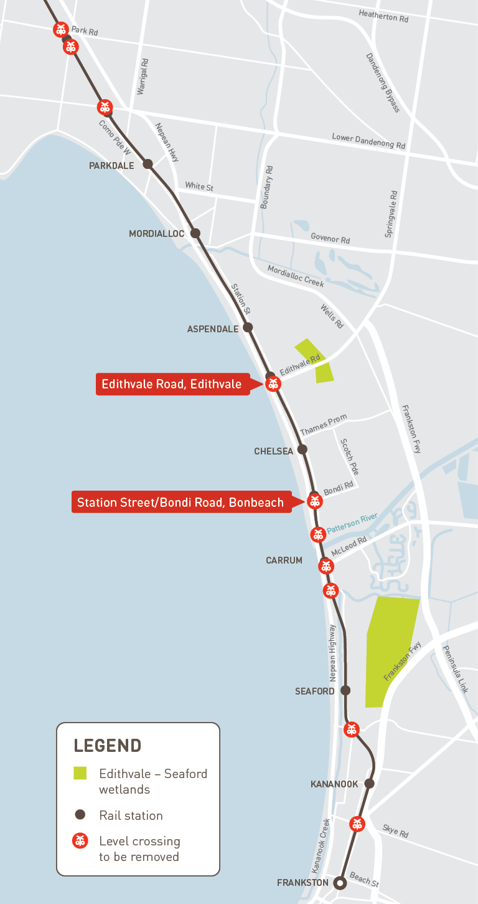

Removal of the Edithvale and Bonbeach level crossings

Background to the projects
The Victorian Government is removing 50 of the state's most dangerous and congested level crossings, including the crossings at Edithvale Road, Edithvale (Edithvale) and Station Street/Bondi Road, Bonbeach (Bonbeach) on the Frankston rail line.
The Frankston rail line serves some of Melbourne’s most vital economic centres, as well as vast and growing residential catchments. The corridor currently serves a population of around 250,000 people, which is forecast to grow to around 500,000 people by 2036. It also provides access to the significant industrial precinct and transport gateway at the Port of Hastings, and a key metropolitan activity centre at Frankston. The Frankston Hospital and Monash University campus in Frankston are significant regional employers.
The Level Crossing Removal Authority (LXRA) undertook early planning work, technical investigations and consultation during 2016 to determine the best solution for removing level crossings along the Frankston rail line.
In February 2017, the Victorian Government announced that the level crossings at Edithvale and Bonbeach would be removed by lowering the rail into a trench at each location. New stations would also be built at Edithvale and Bonbeach as part of each project.
On 5 April 2017, the Minister for Planning requested that LXRA prepare an Environment Effects Statement under the Environment Effects Act 1978 (EE Act) to assess the potential environmental effects of the projects.

Objectives of the projects
The Edithvale and Bonbeach level crossing removal projects are part of the Victorian Government’s Level Crossings Removal Program (LXRP). The objectives of the program, which are consistent with the objectives of the Transport Integration Act 2010 (TI Act), are to:
- deliver significant safety improvements for drivers, cyclists and pedestrians
- improve travel around the local areas – for train users, pedestrians, cyclists and drivers
- get people home safer and faster
- make our roads more reliable, enabling people to better predict their travel times
- stimulate economic growth by creating jobs during construction
- revitalise local communities, including modernisation of station precincts
- enable more trains to run more often and on time.
Each level crossing removal project contributes to the objectives of the overall LXRP.
The program also includes the Metropolitan Network Modernisation Program improvements (including new train stations, improved public transport access, and new pedestrian and cycling links) and amenity improvements such as landscaping and streetscape improvements.
Within this broader context, the specific objectives of the Edithvale and Bonbeach level crossing removal projects are to:
- improve transport safety in the Edithvale and Bonbeach areas
- reduce traffic congestion in the Edithvale and Bonbeach areas
- generate local jobs and stimulate the local economy
- facilitate additional train services on the Frankston rail line.

The projects also include significant upgrades to the existing Edithvale and Bonbeach stations, which are reaching the end of their intended design life, as well as improvements to public areas around the stations.
The benefits of the removal of the Edithvale and Bonbeach level crossings align with the projects’ objectives through:
- eliminating the risk of collision between trains and vehicles, cyclists and pedestrians
- improving amenity at Edithvale and Bonbeach stations, contributing to improved transport safety
- eliminating the traffic delays associated with the level crossings for the 14,000 vehicles that use the Edithvale level crossing and the 4,500 vehicles that use the Bonbeach level crossing each weekday
- generating hundreds of jobs within the local areas for the duration of the construction program
- facilitating more train services on the Frankston line.
Refer to Chapter 2 Rationale and project descriptions for further discussion of project benefits.

Applying the Transport Integration Act
The TI Act is Victoria’s principal transport statute. It requires that all decisions affecting the transport system be made within the same integrated decision-making framework and support the same objectives.
The TI Act provides a framework with six transport system objectives and eight decision-making principles (how we deliver this aim). The Victorian Government has developed a framework to help people understand three related objectives of the TI Act – economic prosperity, social and economic inclusion and environmental stability (State of Victoria, 2012¹).
At the strategic level, the business case for the LXRP was developed and endorsed within this policy framework, implementing the requirements of the TI Act. The LXRP includes the removal of the Edithvale and Bonbeach level crossings.
The objectives and decision-making principles of the TI Act have, in addition, been further applied to the detailed development of the Edithvale and Bonbeach level crossing projects.
The Minister for Planning must consider the objectives and decision-making principles of the TI Act and determine the weight to be given to each of them when assessing this EES and deciding whether to approve the planning scheme amendments for the projects. LXRA is also required to have regard to these objectives and principles and determine the weight to be given to them when exercising its powers and performing
its functions under the relevant legislation.

Developing the projects
The development of each project has progressed from preliminary options assessment to selection of a preferred ‘rail under road’ (trench) option to a design.
Across each of the development phases, the design was refined through an iterative process involving technical and environmental assessments, and community and stakeholder consultation. This process has ensured the objectives of the projects are met, that the relevant legislative and policy requirements are addressed, and the potential risks and adverse environmental impacts are minimised.
Refer to Chapter 2 Rationale and project descriptions for design details, including proposed construction methodologies for each project. Refer to Chapter 12 Community and stakeholder engagement for
a description of the consultation conducted.
An overview of each project design is provided in Sections 1.3 (Edithvale) and 1.4 (Bonbeach).

1 State of Victoria (2012). Transport and the triple bottom line – Transport’s role in driving the economic, social and environmental objectives of the Transport Integration Act 2010.

Edithvale level crossing removal project

Location
The level crossing at Edithvale Road is located south of the existing Edithvale train station between Nepean Highway and Station Street. It is approximately 32 kilometres from Flinders Street Station. Edithvale Road runs in an east-west direction between the Nepean Highway and Wells Road, and is a declared arterial road linking Edithvale and surrounding suburbs to the Nepean Highway, the Mornington Peninsula Freeway (M11) and to Melbourne’s eastern suburbs via Springvale Road, Eastlink and Westall Road.
The Edithvale project area is located predominantly within the existing rail reserve owned by VicTrack. The rail reserve was established in the early 1880s and has been disturbed by more than a century of rail-related activities.
The Edithvale project area extends from Lincoln Parade, Aspendale to Chelsea Road, Chelsea. It includes the rail corridor and all of Station Street and Nepean Highway to the east and west, and small sections of adjacent road reserves.
Existing pedestrian and cyclist crossings in proximity to the level crossing are located at Lochiel Avenue, Edithvale Road, Denman Avenue, Fraser Avenue and Berry Avenue.
No private land will be required for the project.
An overview of the Edithvale project area is shown in Figure 1.2.

Project description
The Edithvale project involves removing the level crossing by lowering the Frankston rail line into a trench under Edithvale Road while maintaining Edithvale Road at the current road level.
The trench would be constructed between Lochiel Avenue and Berry Avenue. It would be up to 1,300 metres in length, 14 metres wide at the narrowest point, widening up to 24 metres at the new Edithvale Station.
The rail track would be approximately eight metres below ground level at its lowest point at Edithvale Station and therefore the maximum depth of excavation would be 14 metres to allow for underground infrastructure (below the rail track) to collect and divert rain water from the trench. Barriers, fencing and screening would be erected along the trench at road level to prevent access by vehicles or people. Decking above the rail trench would be required to provide for the new station building, car parking and a substation required
to ensure sufficient power is available for passenger services on the Frankston rail line. New pedestrian bridges would be constructed to retain pedestrian access across the rail line. A new station at the same location as the existing station would be constructed with disability discrimination compliant access to the below-ground train platforms.

Bonbeach level crossing removal project

Location
The level crossing at Station Street/Bondi Road is located south of the Bonbeach train station between Nepean Highway and Station Street. It is approximately 35 kilometres from Flinders Street Station.
The Bonbeach project area is located predominantly within the existing rail reserve owned by VicTrack. The rail reserve was established in the early 1880s and has been disturbed by more than a century of rail-related activities.
The Bonbeach project area extends from Chelsea Road, Chelsea to Patterson River, Bonbeach. It includes the rail corridor and all of Station Street and Nepean Highway located to the east and west, and small sections of adjacent road reserves.
Existing pedestrian and cyclist crossings across the rail corridor are located at Golden Avenue, Wellwood Road, Bondi Road and The Glade.
No private land will be required for the project.
An overview of the Bonbeach area is shown in Figure 1.3.

Figure 1.2 Edithvale project area
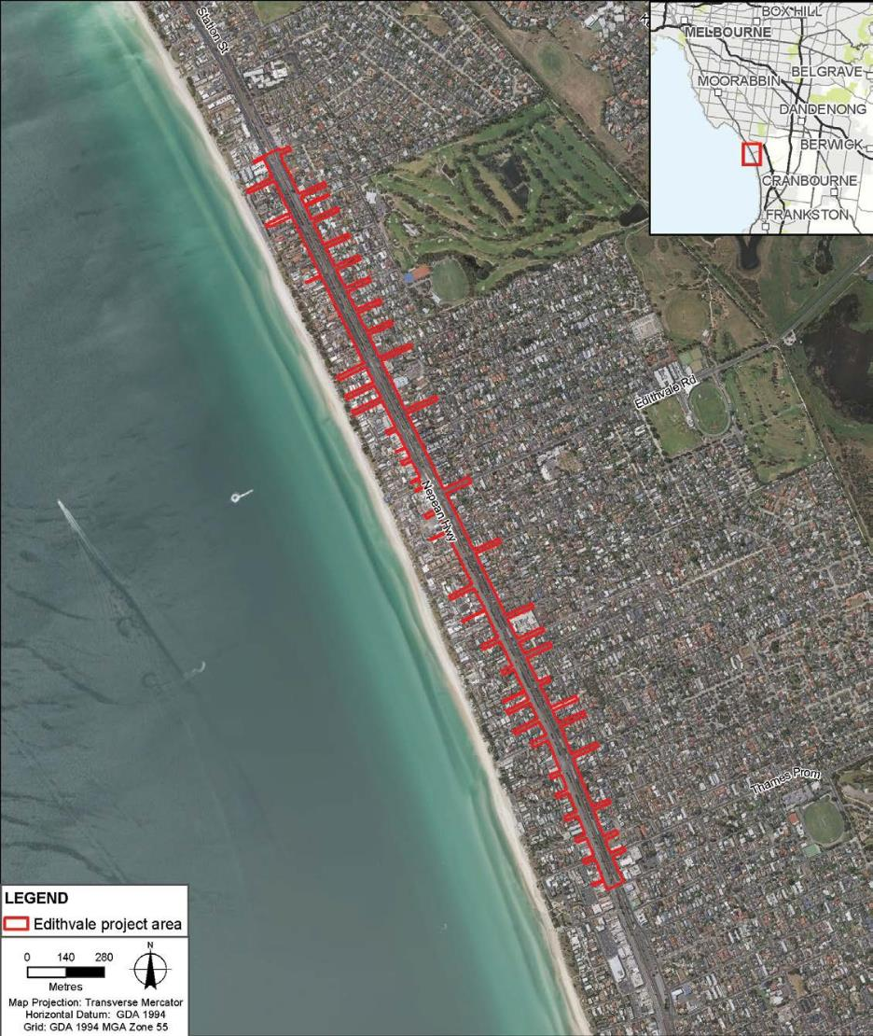

Figure 1.3 Bonbeach project area
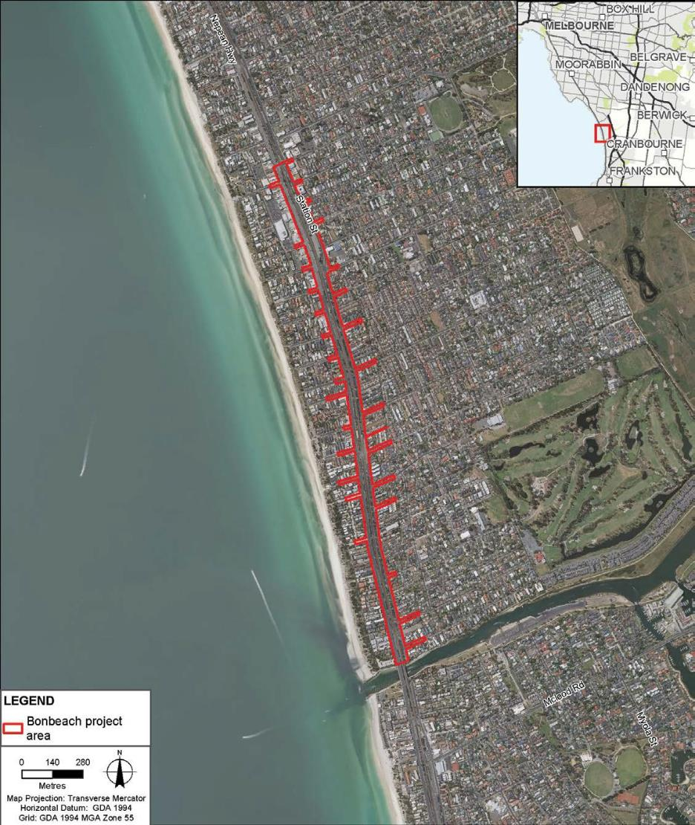

    - Project description
The Bonbeach project involves removing the level crossing by lowering the Frankston rail line into a trench under Bondi Road while maintaining Bondi Road at the current road level.
The trench would be constructed between Golden Avenue and The Glade. It would be up to 1,200 metres in length and 14 metres wide at its narrowest point, widening up to 24 metres at the new Bonbeach Station platforms. The rail track would be approximately eight metres below ground level at its lowest
point at Bonbeach Station and therefore the maximum depth of excavation would be 14 metres to allow for underground infrastructure (below the rail track) to collect and divert rain water from the trench. Barriers, fencing and screening would be erected along the trench at road level to prevent access by vehicles or people. Decking above the rail trench would provide for the new station building and car parking. New pedestrian bridges would be constructed to retain pedestrian access across the rail line. A new station at the same location as the existing station would be constructed with disability discrimination compliant access to the below-ground train platforms.

Delivering the projects

Proponent
LXRA is an administrative office of the Department of Economic Development, Jobs, Transport and Resources (DEDJTR) and is one of several Victorian Government agencies delivering its integrated transport policy objectives.
LXRA is responsible for the delivery of the 50 level crossing removals, including the level crossings at Edithvale and Bonbeach, for the Victorian Government.
LXRA is responsible for:
- developing the design of the level crossing removal projects
- coordinating technical investigations
- preparing this EES
- engaging and informing stakeholders and the wider community
- obtaining the key planning and environmental approvals
- coordinating procurement activities to appoint a private sector construction partner
- coordinating the commissioning of the new infrastructure
- delivering the projects as a member of the construction Alliance (refer to Section 1.5.2).
LXRA and DEDJTR have a sound environmental management record, and promotes sustainable development within its projects. Neither organisation has been subject to any proceedings under a Commonwealth or State law for the protection of the environment or the conservation and sustainable use of natural resources. A copy of LXRAs environment and sustainability policies are provided in Attachment IV LXRA corporate policies.
Once the construction is complete, LXRA would return the finished rail infrastructure to VicTrack, the Victorian Government body which owns Victoria’s transport land, assets and infrastructure. Rail operations will be conducted by Metro Trains Melbourne (MTM) in accordance with network demand.

Project procurement
The projects would be delivered through an Alliance model in which the preferred construction partner works alongside LXRA and MTM to prepare detailed designs and construct the project. A private sector construction partner would be appointed following receipt of all necessary environmental and planning approvals, with construction planned to commence in 2019. The level crossing would be removed by 2022.
LXRA staff would work within the Alliance team and LXRA would also provide corporate oversight of the Alliance’s performance.

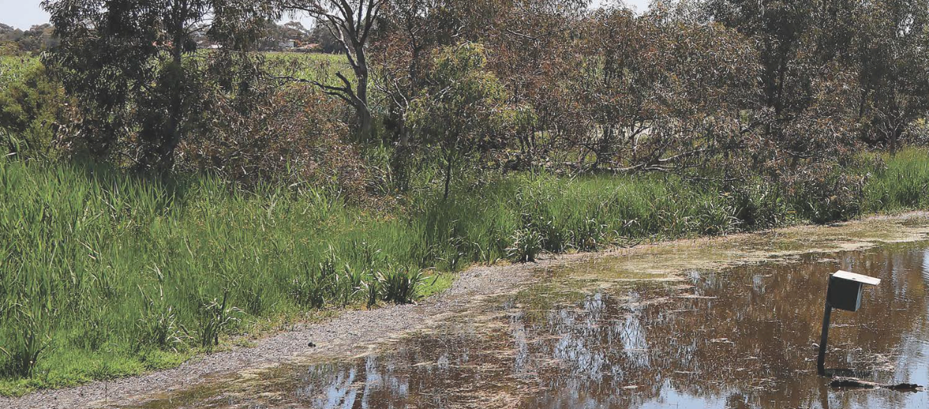
Major Transport Projects Facilitation Act 2009
The projects were declared by the Premier to be major transport projects under the Major Transport Projects Facilitation Act 2009 (MTPF Act) on 21 September 2017. Under the Premier’s declaration, the provisions of the MTPF Act apply to the projects with the exception of Part 3 (Assessment and approval of major transport projects) and Part 8 (Assessment Committees).
The effect of the declaration is that once project approvals are obtained, LXRA can facilitate delivery
of the projects by using the delivery provisions of the MTPF Act. This will streamline public land access and temporary road closures and utility relocation.
The Minister for Public Transport has been appointed as the Project Minister and the Secretary of DEDJTR as the project proponent for both projects.

Timelines
The timeframes for procurement, design, construction and operation of the Edithvale and Bonbeach level crossing removal projects are shown in Figure 1.4 below.

Figure 1.4 Project timeline

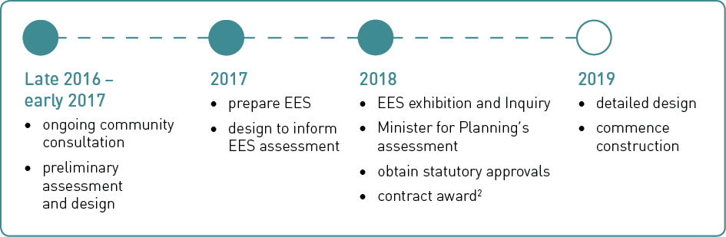

The Edithvale and Bonbeach level crossing removal projects would require an occupation and shutdown of the rail corridor of six weeks, with two- to four-month closures of each train station. All construction activity, including preparatory works, landscaping and traffic management, would occur over an 18-month period.

- Following receipt of all statutory approvals

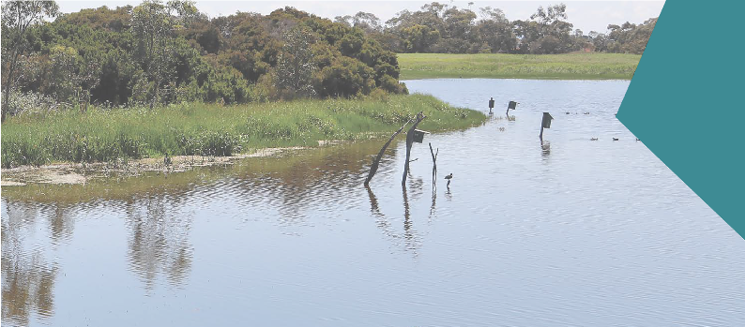Environment Effects Statement

Requirement for an EES
Victoria’s EE Act sets out the process under which the Minister for Planning may require the proponent of a project to prepare an EES.
LXRA submitted a referral under the EE Act to the Minister for Planning describing the potentially significant effects of the projects following a preliminary assessment of the proposed projects.
On 5 April 2017, the Minister for Planning determined that an EES was required to inform the Minister’s assessment of the projects and the approvals required for the projects.
The Minister’s reasons for making this decision included that the project works have ‘the potential for a range of significant environmental effects’. In particular the project could potentially have significant effects on:
- The regional groundwater regime resulting in potential changes to hydrological conditions at the Ramsar listed Edithvale-Seaford Wetlands.
- The ecological character and habitat values of the Edithvale-Seaford Wetlands, and the dependent flora and fauna, in particular the critical components of habitat for listed waterbirds, due to alterations in the groundwater regime.
- The protected beneficial uses of groundwater, due to alterations in the groundwater regime, along with risks to human health, recreation and ecosystems due to changes in water quality from activation and excavation of potentially acid sulfate soils and from interception/movement of existing contaminated soil and groundwater.
The Minister’s decision determined that ‘other potential effects on the social or environmental setting are unlikely to be significant and should be readily addressed and mitigated through existing statutory processes’ including under the Environment Protection Act 1970 and Planning and Environment Act 1987.

Role of the EES
The EES will inform the Minister for Planning’s assessment of the project and other decision-makers.
An EES is not an approval process in itself. An EES is an assessment that demonstrates the ability of the projects to meet statutory requirements. It provides decision-makers (including ministers and other statutory authorities) with the information they need to make decisions about whether statutory approvals for the project should be granted and, if so, what conditions should apply. The necessary statutory approvals required for the Edithvale and Bonbeach level crossing removal projects are outlined in Attachment I Legislation and Policy Report.
This EES:
- describes the proposed Edithvale and Bonbeach level crossing removal projects
- describes the existing environment that may be affected by the projects
- identifies the potential effects of the projects on the environment
- recommends ways to avoid, minimise, offset or manage any adverse effects
- proposes an environmental management framework for managing and monitoring environmental effects during implementation of the projects.

EES process
The EES process is designed to be rigorous and transparent, with opportunities provided for input from stakeholders and the wider community. Figure 1.5 provides an overview of the main steps in the EES process for the level crossing removal projects, aligned with the project-wide statutory approvals that will need to be obtained before the projects can proceed. As Figure 1.5 shows, supporting documents relating to these project-wide approvals are prepared alongside the EES. These approvals are discussed in Section 1.7.
The Victorian Government’s EES process is accredited to assess impacts on Matters of National Environmental Significance under the EPBC Act through the Bilateral (Assessment) Agreement between the Commonwealth and the State of Victoria. This EES therefore also considers Matters of National Environmental Significance.
The administrative procedures for the steps outlined in Figure 1.5 are set out in the Ministerial guidelines for assessment of environmental effects under the EE Act, available on the Department of Environment, Land, Water and Planning (DELWP) website <www.delwp.vic.gov.au>.
Statutory decision-makers consider the Minister for Planning’s assessment of the environmental effects of the projects after the approaches to avoiding, minimising or managing impacts set out in this EES are taken into account.
The Commonwealth Minister or delegate will receive the Minister for Planning’s assessment under the EE Act at the conclusion of the EES process and use it as the basis for deciding on the approval of the projects under the EPBC Act.

Consultation
A Consultation Plan was developed to inform the public and consult with individuals and stakeholders potentially affected by the projects. The plan outlined opportunities for input into the EES process, including raising specific issues of concern, identifying potential impacts, proposing possible mitigation measures and providing additional information to inform the project’s technical specialist investigations and design.
A program for community consultation, stakeholder engagement and communications is proposed for the implementation of the projects. This would include opportunities for local stakeholders to engage with LXRA to seek responses to issues that might arise during the implementation of the projects. The program is described in Chapter 12 Community and stakeholder engagement.

Figure 1.5 Key steps in the EES process

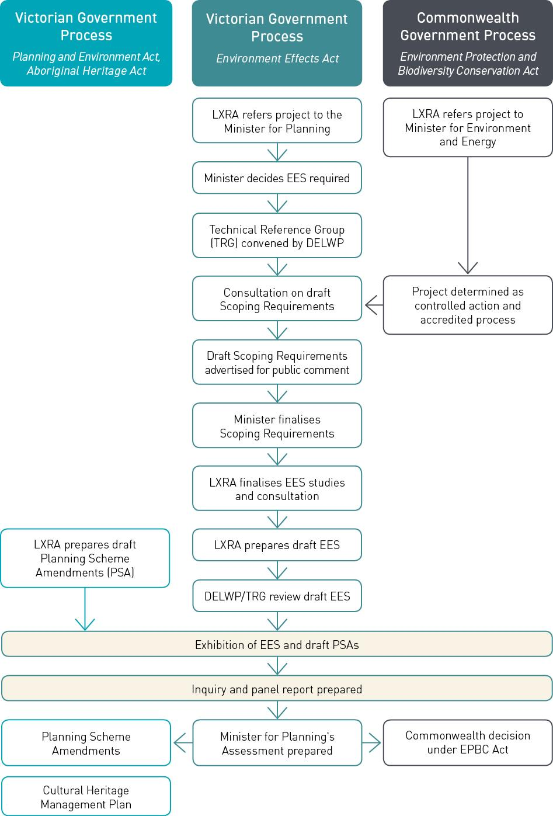

    - 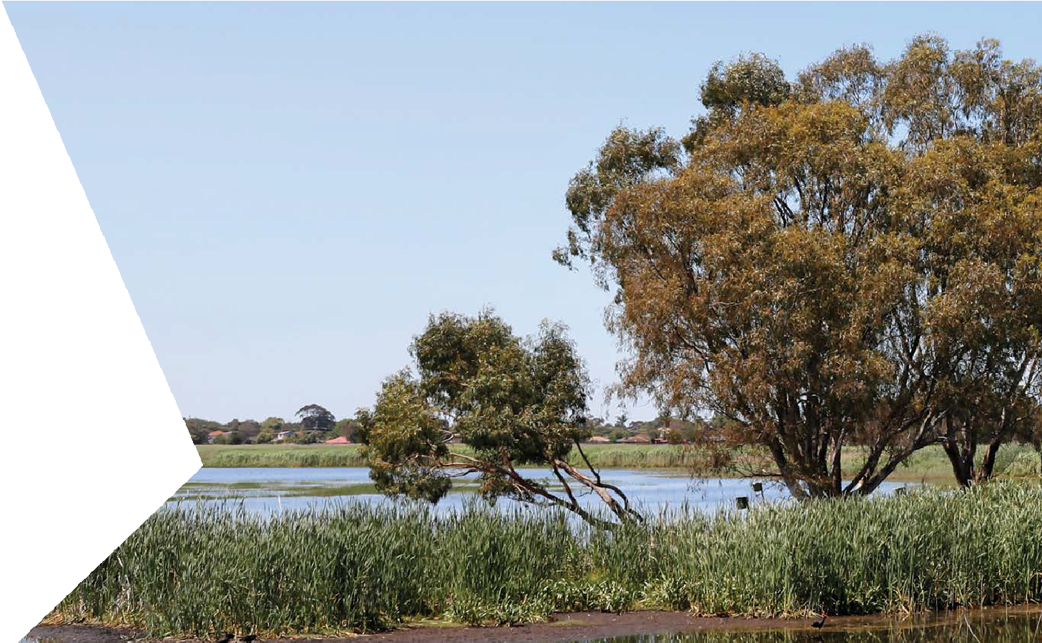Scoping requirements and evaluation objectives
The matters to be investigated and documented in the Edithvale and Bonbeach Level Crossing Removal Projects EES are set out in the ‘Scoping Requirements’ issued by the Minister. The purpose of the Scoping Requirements are to ensure that the EES:
- properly responds to the decision made by the Minister for Planning that an EES is required
- identifies potential significant environmental effects of the Edithvale and Bonbeach level crossing removal project works
- explains how the environmental effects of the works are proposed to be managed for the different stages and aspects of the Edithvale and Bonbeach level crossing removal projects
- provides sufficient and appropriate information to allow the Minister to assess the environmental effects of the works under the EE Act.
Draft Scoping Requirements were exhibited by the Department of Environment, Land, Water and Planning (DELWP) for public comment. After considering public submissions, the Minister published final Scoping Requirements
in September 2017. This EES has been prepared in accordance with the final Scoping Requirements.
The Scoping Requirements established draft evaluation objectives for the EES (listed in Table 1.1). These objectives reflect the decision of the Minister for Planning on the need for an EES. The objectives also identify key issues related to how the trenches could impact on regional groundwater movements and what effect this could have on the Edithvale-Seaford Wetlands, and how the trenches could expose pre-existing contamination and potential acid sulfate soils which could possibly affect human health, recreation and ecosystems.
The EES may also address other significant issues not identified in the Scoping Requirements that emerge during the EES investigations and consultation process to inform the development of the Environmental Management Framework.

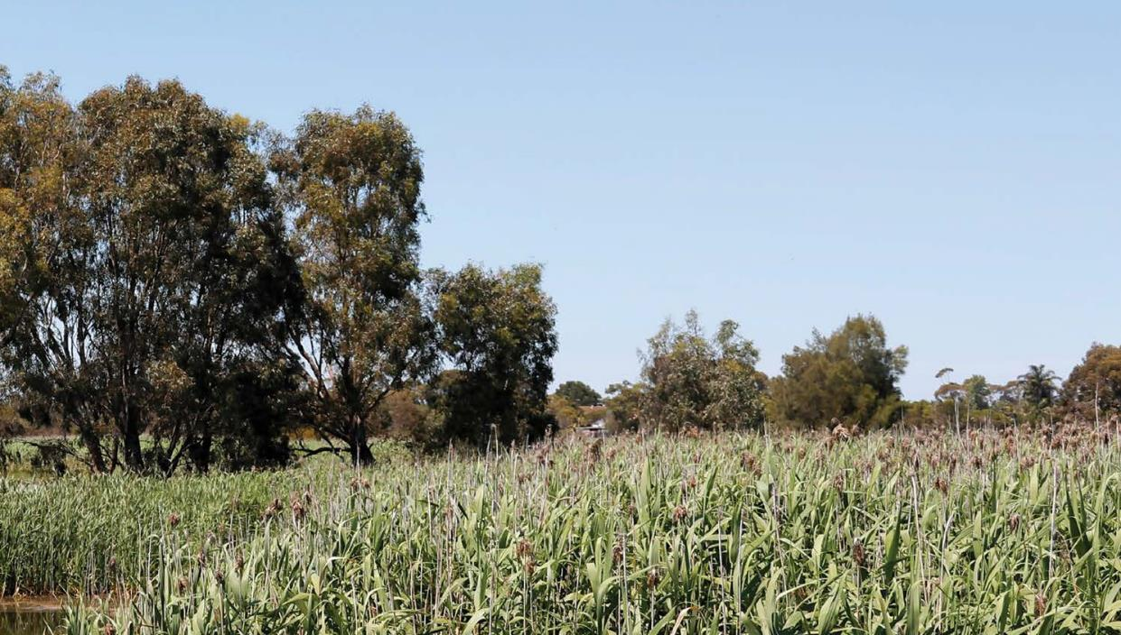
Table 1.1 Draft evaluation objectives

Draft evaluation objectives | Key legislation
Groundwater  To minimise effects on the regional groundwater regime and quality particularly as they might impact on the hydrology of the Edithvale-Seaford Wetlands and elsewhere on other beneficial users | Environment Protection and Biodiversity Conservation Act 1999 National Environment Protection Council Act 1994 Environment Protection Act 1970  Water Act 1989  National Water Quality Management Strategy 1994
Biodiversity  To avoid, minimise and/or offset adverse effects on native vegetation, listed threatened species and ecological communities, listed migratory species, the Ramsar listed Edithvale-Seaford Wetlands, other protected flora and fauna and groundwater dependent ecosystems | Environment and Biodiversity Protection Act 1999 Planning and Environment Act 1987  Flora and Fauna Guarantee Act 1988 Wildlife Act 1975  Fisheries Act 1995  Catchment and Land Protection Act 1994
Contaminated/acid sulfate soils  To prevent adverse environmental or health effects from disturbing, storing or influencing the transport/ movement of contaminated or acid- forming material | Environment Protection Act 1970 Planning and Environment Act 1987 Catchment and Land Protection Act 1994

Project approvals
The Edithvale and Bonbeach level crossing removal projects must obtain a number of statutory approvals.
Three main approvals are required:
- Commonwealth approval under the EPBC Act
- Planning Scheme Amendment under the Planning and Environment Act 1987
- Cultural Heritage Management Plan (CHMP) under the Aboriginal Heritage Act 2006.
Other approvals are required for specific aspects of the works, for example removal of vegetation protected under the Flora and Fauna Guarantee Act 1988. Details of all the applicable legislation are provided in Attachment I Legislation and Policy Report.

Commonwealth approvals
The Commonwealth EPBC Act provides the legal framework to protect and manage designated Matters of National Environmental Significance. Under the EPBC Act, if the Commonwealth Minister for the Environment decides that a project has, will have, or is likely to have a significant impact on a matter
of national environmental significance, the project becomes a ‘controlled action’ that must be assessed and approved by the Minister before it can proceed.
LXRA referred the Edithvale and Bonbeach level crossing removal projects to the Commonwealth Government under the EPBC Act. On 8 May 2017, the delegate for the Commonwealth Minister for the Environment and Energy determined that the projects are a ‘controlled action’ and that further assessment and approval is required under the EPBC Act before the two projects can proceed. The decision was made due to the potential for significant impacts on the ecological character of the internationally-important Ramsar listed Edithvale-Seaford Wetlands, and the associated listed threatened and migratory flora and fauna, by the projects.

Victorian approvals
The projects require approvals under Victorian legislation, including:
- an amendment to the Kingston Planning Scheme under the Planning and Environment Act 1987 for each project
- a CHMP under the Aboriginal Heritage Act 2006.
Ordinarily, at the conclusion of an EES process, the Minister for Planning may decide to amend the planning scheme under Section 20(4) of the Planning and Environment Act 1987 to facilitate the projects. The proposed amendments would put in place a special type of planning control called an ‘Incorporated Document’. The document would set out the conditions that LXRA must meet during the delivery of the projects. Draft Incorporated Documents for each project are included in Attachment V Draft Planning Scheme Amendments.
Other project approvals required for the projects under Victorian legislation may include:
- a permit to take protected flora under the Flora and Fauna Guarantee Act 1995
- a consent for works within a road reserve under the Road Management Act 2004
- a licence to use groundwater and/or a permit for works on waterways under the Water Act 1989
- a management authorisation to remove any wildlife under the Wildlife Act 1975
- consent under the Coastal Management Act 1995.

1.16 Edithvale and Bonbeach Environment Effects Statement | Introduction

Environmental compliance

In addition to approvals, there are a number of relevant legislation, policies, guidelines and standards that the projects must comply with – such as contingency measures to address unanticipated situations like discovering heritage items.
Some of these have specific requirements for the impact assessment and some have implications for the construction and/or design of the projects. Relevant legislation and its implications for the projects are summarised in Attachment I Legislation and Policy Report and in each relevant technical report attached to this EES.

Approach to the EES

This EES presents each level crossing removal as a separate project.
The projects are described separately because, despite being in close proximity to each other, each level crossing removal is independent of the other in terms of design approach, construction approach and operation. While there is a cumulative benefit of both projects being delivered, each project could be delivered independently and continue to achieve the objectives set out in Section 1.2.2.
While the projects are described separately, the potential cumulative impacts are considered where appropriate. For example, changes to groundwater levels need to be considered in the context of both projects being built. There would also be cumulative impacts from construction activities occurring at the same time for each project. It is recognised in the EES that LXRA proposes to deliver the projects concurrently.
The EES focuses on the potential effects of the permanent infrastructure and construction phase activities. When complete, the infrastructure will be operated in accordance with network demand. The EES assesses how the design of the infrastructure could affect the environmental performance of the train operations.
Construction of the projects would require additional land for temporary laydown areas and offices. The location of these facilities would be remote from the rail corridor. Where planning and other permits may be required they would be obtained separately within the context of the relevant legislation.

    - Environmental impact assessment
The EES Scoping Requirements provide three draft evaluation objectives focusing on outcomes for groundwater, biodiversity and contaminated/acid sulfate soils.
This EES has focused its investigations to respond to the three draft evaluation objectives, with critical studies subject to peer review. In addition, to ensure that all issues are addressed, LXRA has conducted a suite of further investigations, in order to assess the projects and develop the required Environmental Performance Requirements (refer to Section 1.9.2).
In total, 14 specialist technical assessments have evaluated the potential environmental effects (both adverse impacts and benefits) of the Edithvale and Bonbeach designs, including construction methodologies and operational requirements.
The specialist studies also assessed how the adverse environmental effects of the projects can be mitigated as well as matters that should be considered for inclusion in the Environmental Performance Requirements.
The specialists have applied a systems and risk-based approach to identifying and assessing potential environmental effects across interrelated specialist studies, and also considered potential cumulative effects. The risk-based approach is described in Chapter 4 Assessment Framework.
The specialist technical reports are attached to the EES.

Environmental Performance Requirements
One of the key outcomes of the EES process is
to recommend a set of Environmental Performance Requirements (EPRs). The EPRs define the environmental outcomes that must be achieved during design, construction and operation of the Edithvale and Bonbeach level crossing removal projects regardless of the detailed design solutions adopted. Under the performance-based approach being adopted for the projects, it would be up to the Alliance to determine how best to achieve the EPRs. The implementation of the Environmental Management Framework (see Section 1.9.3) would provide oversight of the Alliance’s achievement
of the EPRs.
The 14 technical specialists developed an initial set of EPRs as part of their impact assessments. These assessments evaluated the environmental effects of the projects and the proposed construction methodologies. Through the risk assessment process, the initial set of EPRs was refined to
a final set of EPRs that reflect the findings of the impact assessment and the designs.
The approach adopted to develop and refine the EPRs and assess environmental risks and impacts is described in Chapter 4 Assessment Framework. A full list of the EPRs for the project is set out in Chapter 9 Environmental Management Framework.

Environmental Management Framework
LXRA would prepare and implement an Environmental Management Framework (EMF) for the projects. The proposed EMF and EPRs are included in this EES in Chapter 9 Environmental Management Framework.
The EMF is the overarching framework for addressing all environmental requirements for the projects and includes the EPRs.
Under the proposed planning scheme amendment conditions, the EMF would be approved by the Minister for Planning subject to any changes the Minister may require to ensure a robust regime for managing the environmental impacts of the projects.
A key component of the EMF is a Construction Environmental Management Plan (CEMP) that would be prepared for the projects that meets the
requirements of the EMF and any relevant conditions of project approvals.

1.18 Edithvale and Bonbeach Environment Effects Statement | Introduction

EES structure
The structure of this EES is shown in Figure 1.6.

Figure 1.6 Structure of this EES

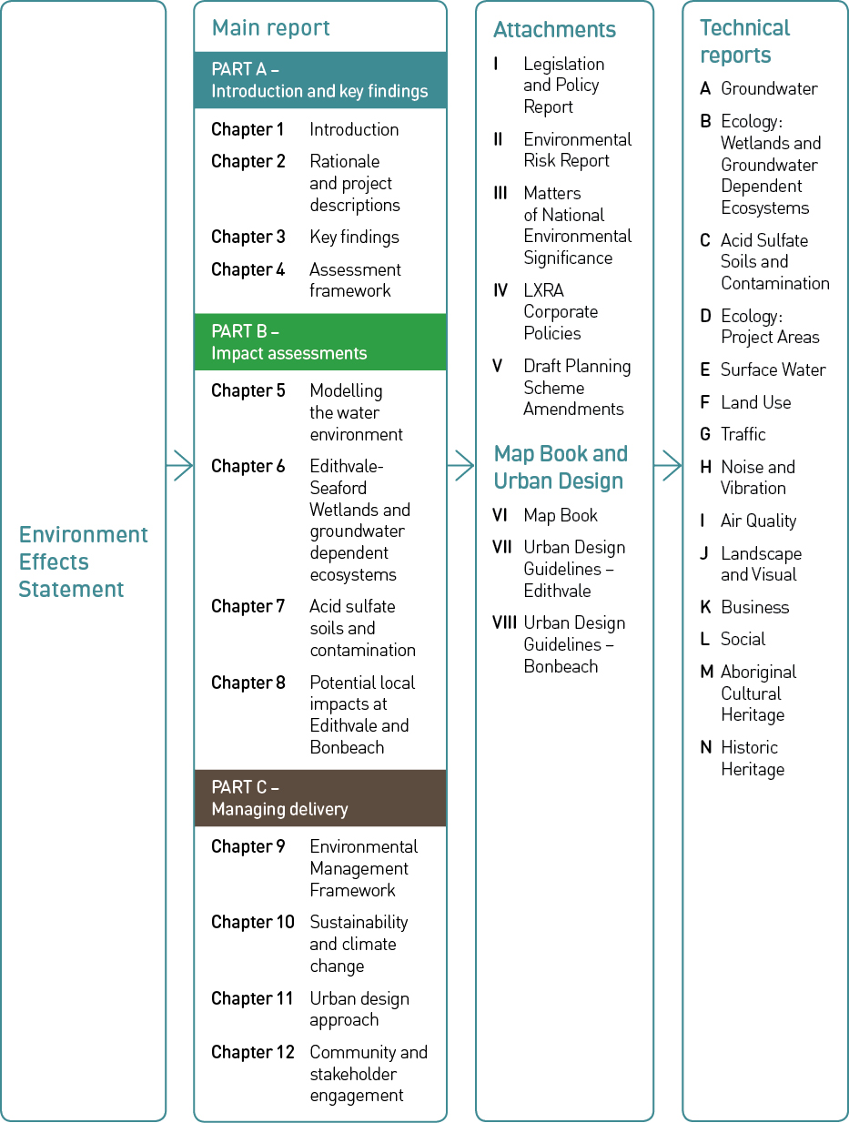

This page has intentionally been left blank

