- SUSTAINABILITY AND CLIMATE CHANGE

SECTION PAGE SECTION PAGE

  - Introduction 10.2
  - Sustainability and the
Environment Effects Statement 10.2
  - Sustainability legislative context 10.3
  - What is sustainability? 10.5
  - LXRA’s sustainability framework 10.6
    - Sustainability strategy 10.6
    - LXRA’s sustainability policy 10.7
    - LXRA’s program climate change
risk assessment framework 10.7
    - Sustainability rating tools 10.7
    - Sustainability outcomes 10.9

  - Integrating climate change in
the impact assessment process 10.11
    - Uncertainty in climate change
scenarios 10.11
    - Climate change in groundwater
impact assessment 10.11
    - Climate change in surface water
impact assessment 10.12
  - Sustainability knowledge sharing 10.12

Introduction

This chapter describes LXRA’s sustainability framework which is applied across all
50 of the level crossing removal projects, including Edithvale and Bonbeach, to ensure that best practice sustainability outcomes are achieved across the planning, design, construction and operation of each project. It also sets out how relevant assessments have taken climate change into account in determining the potential effects of the projects over time.

  - Sustainability and the Environment Effects Statement
Section 3.2 of the Environment Effects Statement (EES) Scoping Requirements states that:

‘the EES should demonstrate how the project will achieve a balance of economic, social and environmental outcomes that contribute to ecologically sustainable development and provide a net community benefit over the short and long term.’
This includes:
- the evaluation of the implications of the project for the implementation of applicable legislation and policy, including the principles and objectives of ecologically sustainable development and environmental protection
- an environmental management approach and performance measures to ensure any effects are identified and avoided, minimised or mitigated
- the development of a numerical hydrogeological model based on a sound conceptual characterisation of the local and regional groundwater systems, to form the basis for assessment of potential effects under current and climate change scenarios
- identify and evaluate effects on groundwater in the vicinity of the project works and the Edithvale-Seaford Wetlands, including the likely extent, magnitude and duration of groundwater level or flow paths during operation, taking into account climate change scenarios
- project environmental performance requirements that define project-wide environmental outcomes to be achieved should be clearly described in the EMF, specifically energy and greenhouse gas emissions (S3.5)

Incorporating climate change risk into relevant EES technical studies has enabled LXRA to assess the predicted impacts of climate change to the Port Phillip area, and ensure that any predicted changes would not be exacerbated by the Bonbeach and Edithvale projects. These findings would inform final design of the projects, and are discussed further in Chapter 5 Modelling the water environment.
In addition, LXRA has mandated that all projects achieve a minimum ‘excellent’ Infrastructure Sustainability (IS) rating and 4 star Green Star rating, which provide a framework for designing and delivering ecologically sustainable development principles in major projects, including:
- reduction in greenhouse gas emissions during construction and operation
- climate change adaptation
- climate change mitigation
- water efficiency
- waste and resource recovery
- energy efficiency
- materials reduction and efficiency
- environmental management and protection.

Sustainability legislative context

Table 10.1 outlines the legislation that is relevant to LXRA’s adoption of sustainability principles and approach.

Table 10.1 Relevant sustainability legislation

Legislation | Implications for the projects
Transport Integration Act 2010 | The Transport Integration Act 2010 requires that the development of the transport system has regard to sustainability and sustainable design. The Act has provisions relevant to LXRA’s sustainability framework, including:  - protecting, conserving and improving the natural environment  - avoiding, minimising and offsetting harm to the local and global environment, including through transport-related emissions and pollutants and the loss of biodiversity  - promoting forms of transport and the use of forms of energy and transport technologies which have the least impact on the natural environment and reduce the overall contribution of transport-related greenhouse gas emissions  - improving the environmental performance of all forms of transport and the forms of energy used in transport  - preparing for and adapting to the challenges presented by climate change.
Climate Change Act 2017 | The Climate Change Act 2017 provides a framework to manage climate change risks, maximise the opportunities that arise from decisive action, and drive Victoria’s transition to a climate resilient community and economy with net zero emissions by 2050.  The Act:  - establishes a long-term emissions reduction target of net zero by 2050  - requires five yearly interim targets, to keep Victoria on track to meet this long-term target  - requires the Victorian Government to consider climate change in all its decision making, policies, processes and programs  - requires the Victorian Government to develop a climate change strategy every five years, which will set out how Victoria will meet its targets and adapt to the impacts of climate change (from 2020)  - requires adaptation action plans for key systems (including the transport system) that are either vulnerable to the impacts of climate change or essential to ensure Victoria is prepared (from 2021)  - establishes a pledging model to reduce emissions from government’s own operations and from key emitting sectors of the economy (including transport)  - establishes a system of periodic reporting to provide transparency, accountability and ensure the community remains informed.

Legislation | Implications for the projects
Environment Protection Act 1970 | The Environment Protection Act 1970 outlines specific principles of integration of economic, social and environmental considerations in major projects:  - sound environmental practices and procedures should be adopted as a basis for ecologically sustainable development for the benefit of all human beings and the environment  - requires the effective integration of economic, social and environmental considerations in decision-making  processes with the need to improve community well-being and the benefit of future generations  - the measures adopted should be cost-effective and in proportion to the significance of the environmental problems being addressed.
Planning and Environment Act 1987 | The purpose of Planning and Environment Act 1987 is to establish a framework for planning the use, development and protection  of land in Victoria. Section 4(1) of the Act outlines planning objectives that are relevant to LXRA’s sustainability goals:  - to provide for the fair, orderly, economic and sustainable use and development of land  - to provide for the protection of natural and man-made resources and the maintenance of ecological processes and genetic diversity  - to secure a pleasant, efficient and safe working, living  and recreational environment for all Victorians and visitors to Victoria.
Kingston Planning Scheme | The Kingston Planning Scheme embeds sustainability and climate change objectives in its local planning policy framework and municipal strategic statement:  - Clause 11.06-6 Sustainability and resilience: Mitigate exposure to natural hazards and adapt to the impacts of climate change, by identifying at-risk areas using the best available climate change science  - Clause 13 Environmental risks and clause 13.01 Climate change impacts: Planning should adopt a best practice environmental management and risk management approach which aims to avoid or minimise environmental degradation and hazards  - Clause 15.02 Sustainable development and Clause 15.02-1 Energy and resource efficiency: Encourage land use and development that is consistent with the efficient use of energy and the minimisation of greenhouse gas emissions.

What is sustainability?
The 1987 Brundtland Commission was influential in defining the meaning of 'sustainable development' (World Commission on Environment and Development, 1987):

“Sustainable development is development that meets the needs of the present without compromising the ability of future generations to meet their own needs.”

The Brundtland definition is largely dependent on the ‘triple bottom line’ approach to sustainability, which focuses on balancing environmental, social, and economic issues to achieve sustainable development, as shown in Figure 10.1.

Figure 10.1 Sustainability Venn diagram
Economy
Society
Sustainability
Environment

Though this definition is frequently cited and has had a powerful influence on the world’s social and ecological agenda, the concept of sustainability has significantly advanced since its inception, especially in the context of urban environments. In defining sustainability for the LXRA Program, there are two principles that have been taken into consideration:
- Permanence – improving the long-term environmental and social benefits of the metropolitan transport network for future generations of Melburnians. This means understanding and increasing the values
of sustainability within a project over the full life cycle.
- Place – recognising how people and nature experience and interact with the metropolitan transport network, and how these interactions influence ecological, cultural and economic exchanges.
Drawing on the Brundtland definition, the triple bottom line approach and these two additional principles, LXRA has adopted the following definition of sustainability for all its projects:

'A sustainable Level Crossing Removal Program recognises people, place, and permanence as it delivers improved mobility across Melbourne’s metropolitan transport network, striving for best practice in planning and construction in order to leave a lasting legacy of environmental, social and economic benefits for current and future Melburnians.'

LXRA’s sustainability framework

LXRA recognises that opportunities to achieve long-term sustainable outcomes would improve if there is a clear, overarching governance framework in place to ensure that sustainability is adopted across all phases
of the level crossing removal program.
For this reason, LXRA has developed a sustainability framework that includes:
- a sustainability strategy
- the LXRA sustainability policy
- the Victorian Climate Change Risk Assessment Framework
- the adoption of two sustainability rating tools.
Figure 10.2 demonstrates how the sustainability framework is directly linked to a broader, global approach to sustainability. The Paris Agreement is the major international driver behind LXRA’s commitment to action on climate change, and the
Victorian Government Climate Change Act 2017 sets out a clear policy framework (consistent
with the Paris Agreement) for managing climate change risks in Victoria.
In order for LXRA’s ambitious targets to be met, LXRA is encouraging other government agencies, the private sector and the wider community to actively engage in the design and delivery of the
Level Crossing Removal Program. For more information on Victoria’s Climate Change framework, visit:
<www.climatechange.vic.gov.au/victorias-climate- change-framework>.

    - Sustainability strategy
Sustainability is at the core of LXRA’s corporate governance principles, and links directly to LXRA’s overarching strategic objectives, which incorporates the principles of Great Network, Great Places, Great Partnerships, Great Engagement and Great People. The strategy aligns specific sustainability outcomes with each of the ‘greats’ and sets out sustainability targets for the different stages of level crossing design, delivery and operation with the intention
of improving sustainability across the entire public transport network.

Figure 10.2 LXRA’s sustainability reach

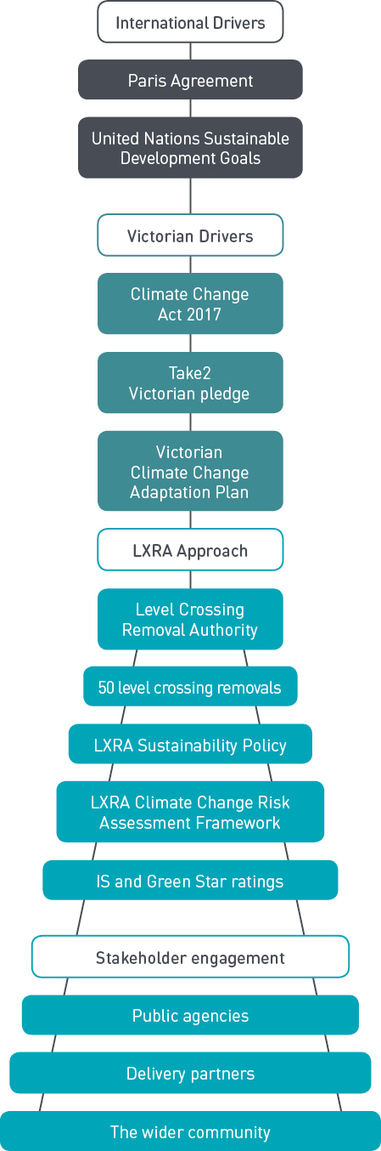
    - LXRA’s sustainability policy
In 2015, LXRA adopted a sustainability policy to ensure the principles of environmental, social and economic sustainability would be included in all our projects. The sustainability policy gives effect to the following vision:

'To achieve excellent environmental, social and economic outcomes across all phases of the level crossing removal project (project) in order to deliver an integrated project that connects the community in an environmentally sustainable manner.'

The sustainability policy works to provide a consistent, Program-wide approach to sustainable infrastructure, in order to deliver an integrated, sustainable transport network. A copy of this policy is provided in EES Attachment IV LXRA corporate policies.

LXRA’s program climate change risk assessment framework
Assessing the risk of climate change to a project and mitigating its impacts is of critical importance to achieving sustainable infrastructure, which is why a climate change assessment is a mandatory requirement under the IS rating tool. To assist contractors, LXRA has developed a climate change risk assessment framework to guide all its projects by responding to climate change in two ways:
- from a program perspective: how can LXRA work with stakeholders to mitigate and adapt to climate change risks across the wider transport network?
- from a project perspective: addressing project-specific climate change risks through design, construction and operation, for example, planning for more frequent and longer heatwaves, and reducing the amount of greenhouse gas emissions to the atmosphere, and ensuring the detailed design responds to these risks.
However, there are two sides in considering climate change for a project. Firstly, a climate change assessment needs to be undertaken to inform the project designs and ensure that the infrastructure remains operable as the climate pressures evolve. Secondly, the potential effects of the project need to be taken into account in the long term, against the backdrop of a changing climate. Section 10.6 details how the risk of climate change has been considered in the EES process.

Sustainability rating tools
To benchmark and monitor performance against the program sustainability vision, LXRA has committed to achieving a program rating of ‘excellent’ under the Infrastructure Sustainability (IS) rating tool and minimum '4 star' under the Green Star rating tool. This requirement is passed onto LXRA's delivery partners on each project.
The adoption of these sustainability rating tools allows LXRA to facilitate a consistent approach to design and delivery for all level crossing removal projects.
In a large-scale major infrastructure project, it can be challenging to ensure that all projects are meeting the sustainability benchmarks that LXRA requires. Sustainability rating tools rely heavily on documented evidence to prove that sustainability is embedded in a project. As such they are very effective in ensuring that standards, procedures and sustainability requirements are addressed consistently across a program as far-reaching as LXRA.
Sustainability rating tools provide:
- a framework for measuring, monitoring and reporting during construction and operation
- enhanced communication between LXRA and stakeholders through a universal language that all stakeholders can understand and adopt
- the ability to target specific sustainability themes that are of importance to LXRA and to individual projects
- a flexible approach, with options to pursue alternative, yet equivalent pathways for meeting targeted themes
- an avenue for the industry to develop innovative sustainability solutions
- independent assessment and verification by third party verification panels comprised of recognised industry experts.

LXRA has identified the need to assess and benchmark sustainability in both the civil infrastructure and station buildings. While there is clear crossover between these two areas, there is no single rating system that exists to rate both. Therefore two rating tools have been identified to deliver these separate delivery outcomes for the Edithvale and Bonbeach projects.
The IS Rating Tool focuses on sustainability in project management, processes and triple-bottom line governance in major projects. This translates into robust consideration of climate change adaptation, improved sustainability management systems and more sustainable procurement systems.
The Green Star Rating Tool focuses on sustainability of buildings, aiming for long-term environmental benefits during operation. This largely translates into reduced operating costs and greater comfort for end users.

The IS Rating Tool
The IS Rating Tool has been developed and is managed by the Infrastructure Sustainability Council of Australia to provide a common national language for sustainability in infrastructure. The IS Rating Tool evaluates sustainability initiatives and potential environmental, social and economic impacts of major infrastructure projects throughout the project lifecycle from funding, planning, procurement, design and delivery to operations and maintenance. The rating is based on a 100-point scale, with points awarded for meeting the requirements of defined criteria in both project design, and the ‘as-built’ infrastructure at project completion.
Every project is required to achieve a minimum ‘excellent’ for both design and as-built ratings.
As the ability to achieve certain points is dependent on the unique context of each project, how the required rating is achieved is largely up to the contractor. However, LXRA does identify a number of criteria as mandatory, including the requirement for a climate change assessment to inform detailed design. This mandatory criteria of project-specific climate change assessment and identification of mitigation and adaptation techniques for construction and operation is how LXRA is addressing climate change risk for the life of the project assets.

The Green Star Rating Tool
The Green Star Rating Tool has been developed and is managed by the Green Building Council of Australia and is the only national and voluntary rating system for buildings and communities. LXRA has adopted the Melbourne Metro Rail Project Green Star Rating Tool, which assesses the sustainability outcomes from the design and construction of new and rebuilt station buildings. Similar to the IS rating tool, Green Star is a points-based tool with points awarded for meeting the requirements of defined criteria in a number of categories. Every level crossing removal project is required to achieve a minimum ‘four star’ rating for both design and as-built ratings. How the rating is achieved is at the discretion of the delivery partner.
What are ‘design’ and ‘as-built’ ratings?
The Edithvale and Bonbeach projects will be pursuing ‘design’ and ‘as-built’ ratings.
The design rating is a formal verification process based on the final design. It ensures the delivery partner is on-track to achieve an ‘excellent’ rating, however as designs can change during construction, is an interim rating that is superseded by the as-built rating once completed.
The as-built rating is the final rating achieved by each project based on the documentary evidence that proves the constructed and completed projects meet the requirements of the relevant criteria. The rating can differ from the design rating as designs can change during delivery.

Sustainability outcomes
LXRA is three years into an the eight-year program of works, and is achieving excellent outcomes through the application of sustainability rating tools. To date, all stations have achieved a 4-Star Green Star rating, and all projects have achieved ‘excellent’ or ‘leading’ rating under the IS Rating Tool for civil infrastructure, demonstrating that LXRA is delivering sustainability initiatives beyond industry best practice.
The Bayswater level crossings removal project is a great example of how previous projects have applied the LXRA sustainability framework to achieve excellent climate change mitigation and adaptation outcomes.
Future infrastructure projects will use this framework and build upon the sustainability initiatives of earlier level crossing removals to ensure continual improvement across the Program.

Bayswater Level Crossing Removal Project – Sustainability Case Study
The removal of the level crossings at Mountain Highway and Scoresby Road, Bayswater is part of the Victorian Government’s Level Crossing Removal Program to remove 50 dangerous and congested level crossings across Melbourne. In late 2015, an Alliance consisting of Laing O’Rourke, Fulton Hogan, AECOM, the Level Crossing Removal Authority, VicRoads, Public Transport Victoria and Metro Trains Melbourne formed to start construction of the $177 million Bayswater Level Crossing Removal Project (LCRP).
The project included:
- lowering the rail line and raising the road at Mountain Highway and Scoresby Road
- rebuilding Bayswater Train Station and creating a new forecourt and public area
- reconstructing the bus interchange and train station car park
- constructing a grade-separated shared-use path
- modifying the streetscape along Mountain Highway.
To solidify the commitment to sustainability, generate ownership and a focus for sustainability across the project team, LXRA introduced a key result area (KRA) for sustainability. To formalise this process, the Alliance pledged to create a culture of sustainability and achieve tangible sustainability performance recognised by the Infrastructure Sustainability (IS) and Green Star Rating schemes.
The project team’s actions to help create a culture of sustainability and take a broader more holistic approach with the sustainability rating tools helped the project find sustainable solutions that provided direct environmental, social, and economic benefits to the project and local community. Figure 10.3 shows a snapshot of the project’s sustainability performance.
Environmental performance indicators were used to measure energy usage, carbon emissions, water consumption, waste, lifecycle impacts of materials and discharges to land, air and water. The Alliance established many sustainability initiatives to generate a reduction in the project’s energy and carbon footprint to ensure operational efficiency of infrastructure assets while changing the way we work.
Examples include project wide LED lighting, altered rail track alignment, use of high performing sustainable materials, and use of a dewatering centrifuge unit that separates water from solids in order to reduce water consumption.
The sustainability initiatives delivered on this project helped to debunk many myths surrounding the ability to achieve sustainable outcomes on major transport infrastructure projects. The sustainability team was able to prove that sustainable initiatives, methods and alternative materials were cost effective.
By exploring financial paybacks on sustainable initiatives introduced in design and engineering, and by better understanding capabilities and services within the supply chain, the team learnt there are many cost effective, untapped sustainable solutions and innovations available in the market. The use of a dewatering centrifuge unit is an excellent example of an initiative which had an economic and environmental driver associated with reducing waste volumes and reusing clean water generated in waste fluids.
Engagement with the community and local stakeholders helped the project team understand their needs and prioritise key issues. Listening to the concerns and opportunities of commuters and other stakeholders, the design team was able to provide smart solutions to improve safety for commuters, access and inclusion of people living with a disability, flow of transport and community connectivity. During construction, the project team engaged with the community to answer questions about the design using innovative digital engineering technology. By engaging with the community and listening to their needs, the Alliance was able to construct a productive and open environment for the community.

The Bayswater Level Crossing Removal Project was the first project completed under the Level Crossing Removal Program certified with a sustainability rating. The project received a ‘leading’ IS design rating with an unprecedented score of 93.5 out of 100 and has set
a new benchmark in sustainable delivery for the rest of the industry to follow.

Figure 10.3 Bayswater level crossing removal project sustainability outcomes

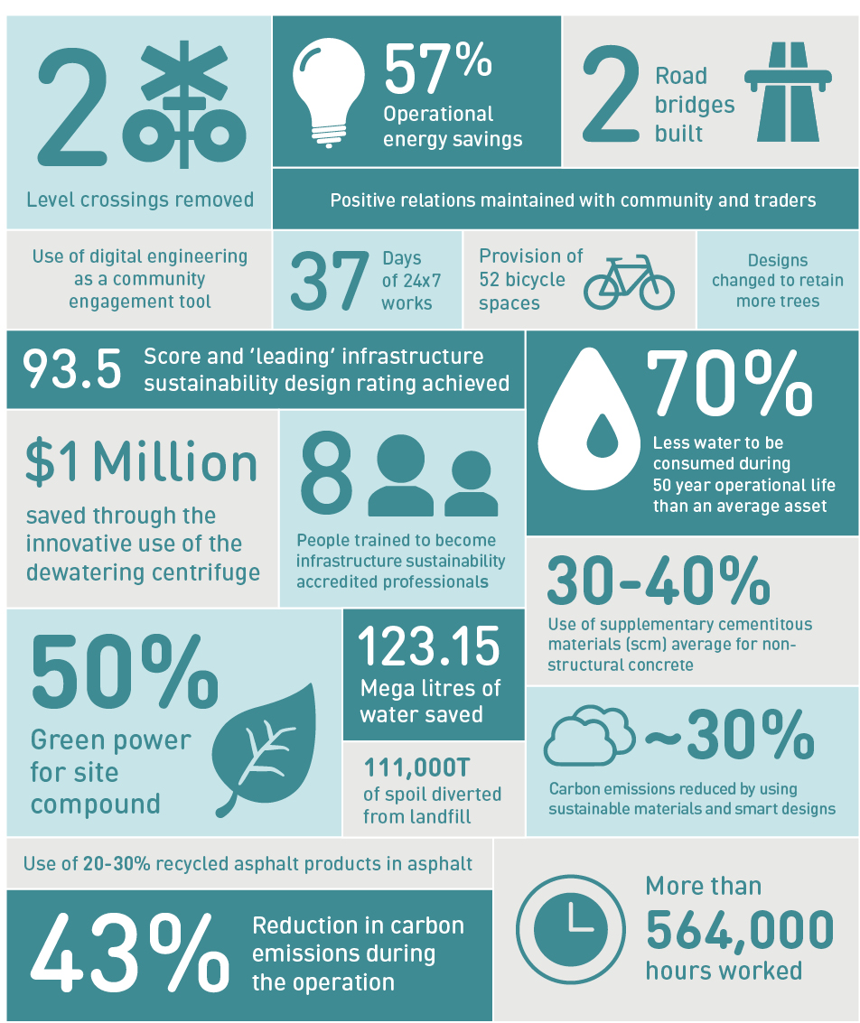

  - Integrating climate change in the impact assessment process

A changing climate is placing ecosystems, property, communities and infrastructure assets under increasing physical risk. Consideration of climate change is of critical importance when assessing immediate and long-term potential environmental effects of a major infrastructure project.
In the coastal areas around Port Phillip Bay, the risk from climate change is attributable to observed and predicted intensification of rainfall and storm events, lower average rainfall, sea level rise, storm surge, coastal erosion, and increased average temperatures and extreme heat events. While some impacts may be assessed as low risk and low magnitude during the first 20 years of operation, the same impact may be exacerbated by climate change on a 50 to 100 year time scale.
As such, the EES has included climate change risk and modelling in both the groundwater and surface water assessments, as set out below, using the best and most recent climate change modelling data for the Port Phillip region. While the EES assessments cover a broad array of climate variables (rainfall intensity, evaporation and sea level rise), other key climate risk variables (greenhouse gas emission reduction, extreme heat, etc.) are addressed through the ISCA and Green Star rating tools, as well as the Urban Design Framework which considers thermal comfort and urban amenity. This is done during early design, construction and operation in order for climate risks to be identified and incorporated into construction and ongoing operation of the rail infrastructure.

Uncertainty in climate change scenarios
It is acknowledged that there still remains a high degree of uncertainty regarding Victoria’s climate future. However, the EES process, and consequent project delivery would use the most up-to-date scientific guidance provided in the Guidelines for Assessing the Impact of Climate Change on Water Supplies in Victoria (DELWP, 2016) and the Planning for Sea Level Rise Guidelines (Melbourne Water, 2017) in order to best manage this uncertainty (EPR reference SS2).

Climate change in groundwater impact assessment
As described in Chapter 5 Modelling the water environment, a numerical groundwater model was developed using available data to predict potential effects for a range of aspects including climate change on the regional groundwater regime as a result of the proposed rail trenches.
The model utilised the Department of Environment, Land, Water and Planning (DELWP) Guidelines for Assessing the Impact of Climate Change on Water Supplies in Victoria 2016 to ensure that the outputs of the model take into account predicted effects of climate change on groundwater resources (EPR reference SS2). The guidelines provide the most up-to-date climate science projections, and describe:
- the major influences on Victoria’s climate and how these have changed over recent decades
- the future climate and runoff projections for Victoria under increased greenhouse gas emissions
- how the future climate, recharge and runoff projections can be applied for water planning.
The groundwater model was calibrated with climate data from the past 20 years (commencing in January 1997), covering a period of extreme climatic conditions that includes the Millennium Drought and conditions of above average rainfall from 2010 to 2011. The same climate data was used for forward predictions, to assess the impacts of the level crossing removal projects under a range of climatic conditions, with the following modifications to account for climate change effects:
- a 0.8m increase in sea level, estimated by increasing the coastal (and tidal) boundary heads
- a reduction in recharge to unconfined aquifers of 52.8 per cent by 2065, as per the high climate change impact scenario for the catchment.
It was found that the climate change effects do not exacerbate the potential impacts to groundwater associated with the proposed construction methods of the Edithvale and Bonbeach projects. This is because higher sea level and reduced recharge further inland result in less groundwater flow from land to sea.
This in turn reduces the net effect of groundwater mounding and drawdown because of the proposed trenches. These results are detailed in EES Technical Report A Groundwater.

Climate change in surface water impact assessment
New rail infrastructure associated with the Edithvale and Bonbeach level crossings should be designed
to be resilient to the impacts of climate change, including both sea level rise and storm intensity. As such, the assessment draws on the Planning for Sea Level Rise Guidelines (Melbourne Water, 2017) that applies to development proposals in areas that will be affected by tidal inundation (including storm surge and wave action). The guidelines provide the most up-to-date climate science projections, and describe:
- how the effects of sea level rise from climate change are to be included within design cases
- how the planning benchmarks for sea level rise established for Victoria should be applied to different development types
- the predicted future flood levels for Port Phillip Bay and Western Port.
For more information and visuals of predicted sea level rise and storm intensity in the Port Phillip and Westernport regions, visit the Planning for Sea Level Rise Guidelines (Melbourne Water, 2017) at <www.melbournewater.com.au/sites/default/files/Planning-for-sea-levels.pdf>.
Using the Planning for Sea Level Rise Guidelines (Melbourne Water, 2017) the surface water assessment has considered:
- a rise in sea level of 0.8 metres, which is the expected increase resulting from climate change by 2100
- continued increases in global greenhouse gas emissions leading to an increase in the frequency and intensity of extreme weather events
- most significantly, a 19 per cent increase in rainfall intensity predicted by Australian Rainfall & Runoff.
It has been found that while increased rainfall intensities would increase nearby flood levels, they would not significantly affect flow paths at either Bonbeach or Edithvale project sites to the extent that they would interact with the rail corridor. However, as the trenches would collect the rain water that falls in it, the stormwater management systems would be designed to consider future rainfall volumes through the engineering design solution described in Technical Report A Groundwater and Chapter 2 Rationale and project descriptions. This will enable the continued operation of the railway while not adversely affecting local flooding if the stormwater is discharged to the local drainage network.

Sustainability knowledge sharing
LXRA facilitates a sustainability coordination committee, comprised of sustainability representatives from all delivery partners and industry stakeholders. The committee captures learnings and innovations from
previous level crossing removal projects in order to improve delivery of future level crossing removal projects. As Edithvale and Bonbeach are two of the last projects in the 50 Level Crossing Removal Program, with construction due to commence in 2019, they stand to benefit greatly from the knowledge sharing process.
Benefits of knowledge sharing include:
- learning from existing projects within the level crossing removal program
- contributing ‘lessons learned’ for future sustainable infrastructure projects
- being involved with the development of new and improved versions of the Infrastructure Sustainability and Green Star rating tools.

