TUN1906.01

4 June 2019

###### Works update: Whitehall Street Construction Areas

Our construction sites on Whitehall Street have transformed over the past few months as preparations continue for the launch of the tunnel boring machines (TBMs), Bella and Vida. We’ve made progress on the TBM launch box, installed the external shed walls on the spoil handling facility and continued works on the covered spoil conveyor belt which can be seen above Somerville Road.

Before we commence tunnelling; however, the attention remains on the North Yarra Main Sewer diversion which is on track for completion in August 2019.

#### Update on North Yarra Main Sewer diversion

The 12 months of work to divert the 600-metre section of the North Yarra Main Sewer is very much nearing completion which will also see the reinstatement of Whitehall Street in August.

Our final pieces of the puzzle over the next couple of months will involve decommissioning the old section of the sewer, creating new connections for adjacent properties and road reinstatement. As a result, there will be some night works and temporary traffic changes in place. Please observe traffic management signage and traffic controllers. Thank you for your patience as we complete these important activities.

**Here’s what to expect from June - August**:

* **June:** Completion of the new sewer connection works along Whitehall Street, between Harris and Youell Streets, for the adjacent properties. We will continue conversations around these works with the affected business owners.
* **June/July:** Decommissioning and backfilling the old section of sewer. These works will include some temporary lane and parking closures on Whitehall Street, north of Somerville Road. Please observe traffic management signage.
* **July/August:** Both upstream and downstream work areas on Whitehall Street will be removed to reinstate the original road conditions. These works will include the removal of temporary traffic signals and signage to allow for Whitehall Street to reopen. This will involve some lane and road closures at night, and over consecutive weekends in mid-July at both Youell/ Whitehall Streets and Somerville Road/Whitehall Street intersections. More information will be provided through our weekly traffic notifications and road signage alerts.
* **August:** Works complete and Whitehall Street will reopen to two-way traffic, the Hyde Street detour will be lifted and the 24hr truck ban on Hyde Street will be reinstated.

Check out what we’ve been up to

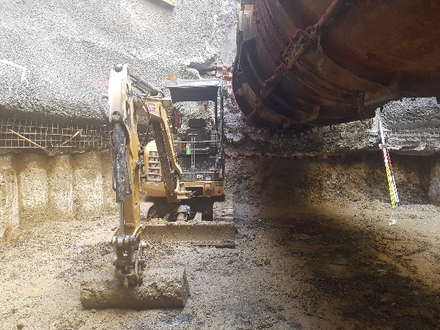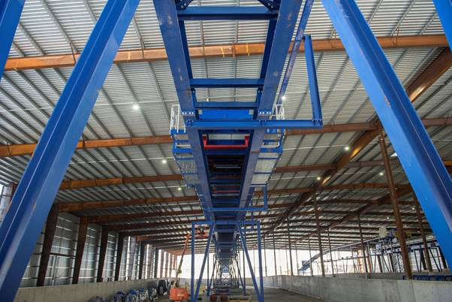

Above: The fit out of the spoil handing facility at the Tunnelling Hub (221 Whitehall Street) is almost complete. The blue steel is the spoil conveyor being constructed.

Above: Temporary mechanical flumes (pictured) were installed in the 130-year-old North Yarra Main Sewer to maintain the sewer flow while we completed the diversion. This shows the excavation below the flume.

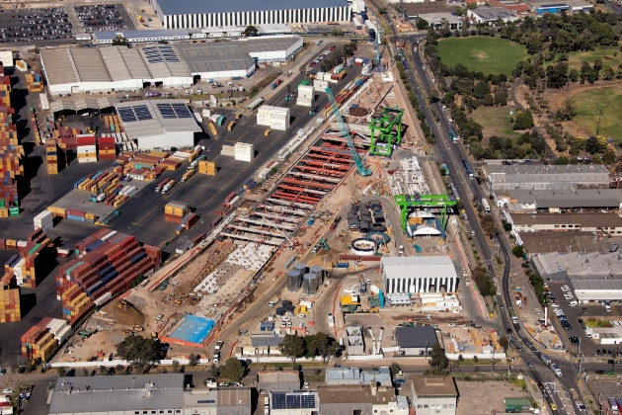

Downstream North Yarra Main Sewer work site

TBM launch box

Spoil Handling Shed

Covered spoil conveyor

500 tonne Gantry Crane to lift TBM and parts into the launch box.

Bella (first TBM) being assembled

Upstream North Yarra Main Sewer work site

An aerial view of our bustling site on Whitehall Street where the TBMs, Bella and Vida will be launched.

**Please note that works are subject to change and could be rescheduled. For more information about the upcoming works and traffic changes, please contact us.**

**Contact us**

Please contact us if you have any questions or feedback about these works.

westgatetunnelproject.vic.gov.au info@wgta.vic.gov.au

1800 105 105

facebook.com/westgatetunnelproject

@westgatetunnel

West Gate Tunnel Project GPO Box 4509

Melbourne Victoria 3001

Interpreter service: 13 14 50

