WES1805.05
23 May 2018

Works notification
West Gate Freeway and Williamstown Road inbound exit ramp

Works to widen the West Gate Freeway have started. Construction along this section of freeway will be extensive and once completed, will provide two extra lanes for motorists travelling inbound, new and more effective noise walls and a new inbound exit ramp.
West Gate Freeway inbound carriageway works
5 June 2018 – ongoing
Before we start work on building the new Williamstown Road inbound exit ramp, we will be:
- clearing vegetation and trees along the freeway, inbound, between The Avenue and Williamstown Road. Day time clearing will take place along the road reserve between the residential properties noise wall;
- investigating utility services that may be impacted by works and potentially require relocation;
- undertaking general construction activities including earthworks, preparing piling pads and removing road fixtures;
- moving equipment such as piling rigs and equipment onto site; and
- installing temporary fencing and access gates to establish a safe working area for construction workers.

At times, the shared user path between The Boulevard and Eirene Street will be used to move equipment into our site. Traffic management and pedestrian detours will be in place during these times.

Installation of temporary and new noise walls
13 June 2018 – ongoing
As part of the West Gate Freeway widening works, new noise walls will be built along the freeway. Noise wall construction along the Williamstown Road inbound exit ramp will start form 13 June 2018. This will include:

- installing a temporary noise wall;
- removing the existing noise wall; and
- constructing the permanent noise wall.
Access for the temporary noise wall construction will be via the shared user path at the end of The Boulevard.

West Gate Freeway outbound carriageway works
29 May - ongoing
Construction activity will also be taking place on the outbound carriage way, which will include:

- tree clearing from Williamstown Road to The Avenue (Newport Rail Line). Night time clearing will take place between the noise wall and the freeway on the outbound carriageway from 4 June for up to 10 nights;
- closure of the pedestrian path between LeFevre Street and Abbott Street from 29 May. Access to the pedestrian bridge will be via The Avenue and Muir Street (see map over page) and;
- noise wall construction on the outbound carriageway, starting from 13 June 2018.

What you could expect while we undertake these works:
- work will be conducted behind safety barriers;
- construction noise from our machinery and trucks, increasing at times while we complete piling and noise wall construction;
- an increase in construction vehicles within the area;
- dust and dirt will be minimised by using water spray trucks and covering dirt and rock when it is being transported;
- detours will be in place to help safely navigate people and vehicles around the work areas; and
- traffic changes including lane and ramp closures will be required - latest traffic updates are available at westgatetunnelproject.vic.gov.au

Works will be carried from Monday to Friday 7am-6pm and Saturday 7am-3pm, however some night works will be required. When works are scheduled out of hours, or if you’re located close to the works, we will provide further information to you before works start.

Please note that works may be rescheduled in the event of bad weather or other unavoidable circumstances.

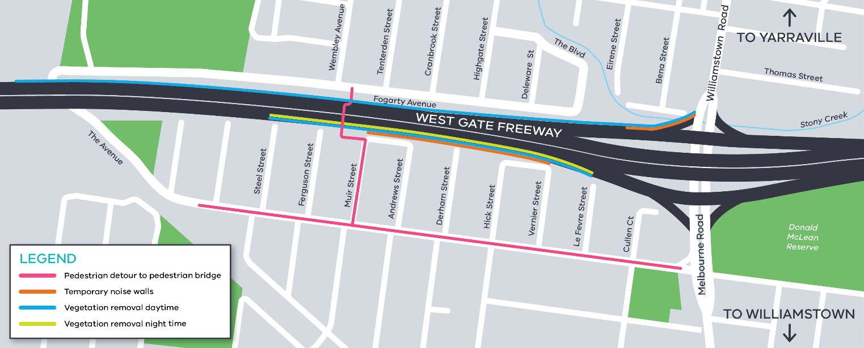
Planned works area - West Gate Freeway and Williamstown Road inbound exit ramp:

For updates and more information about our works please visit westgatetunnel.vic.gov.au or contact us using the details below.

Contact us

Please contact us if you have any questions or feedback about these works.
westgatetunnelproject.vic.gov.au | facebook.com/westgatetunnelproject
westgatetunnelproject@wda.vic.gov.au | @westgatetunnel
1800 105 105 | West Gate Tunnel Project  GPO Box 4509  Melbourne Victoria 3001
Interpreter service: 13 14 50

