Reference: WES1902.13
22 February 2019
Works update – Paringa Road closure

Construction is well underway on Paringa Road to safely relocate some existing power lines that currently run along the West Gate Freeway, to underground. As part of these works, sections of Paringa Road are being progressively closed to vehicles from 18 February until early May 2019.
Temporary closure of Paringa Road between Lee Street and Bond Street
Wednesday 27 February – Monday 18 March 2019
During this time:
- a section of Paringa Road (between Lee Street and Bond Street) will be closed to vehicles – please see the map over the page; and
- driveway and footpath access to your property will be maintained.

How to access your property and where to park your car:
- vehicle access to your property will be re-opened from Wednesday 27 February via Chambers Road;
- vehicle access and parking to some sections of Paringa Road will be temporarily blocked in stages - please see the map over the page for location details;
- driveway and footpath access to your property will be maintained; and
- the carpark behind the 16 shops will remain open.

Where to park your vehicle:
- please ensure you do not park your vehicle in the construction area during this time as access will be blocked and you will be unable to access your vehicle.

What you could expect:
- an increase in construction vehicles within the area;
- an increase in construction noise during the day from our machinery and trucks; and
- water spray trucks to help manage dust and dirt and loads will be covered when dirt and rock are being transported.

These works will generally be carried out from Monday to Friday between 7am - 6pm and Saturdays between 7am - 3pm, however some night works may be required. When works are scheduled out of hours and may have a direct impact on you, we will provide further information before works start.

There are also underground bore works required under the West Gate Freeway at Chambers Road and under Millers Road across to Paringa Road from mid-February 2019. Some of these works will be carried out overnight, and if they will have a direct impact on you, we will provide further information before these works start.

Please note that works and timings may change in the event of bad weather or other unavoidable circumstances.
For updates and more information about our works please visit westgatetunnelproject.vic.gov.au or contact us using the details below.

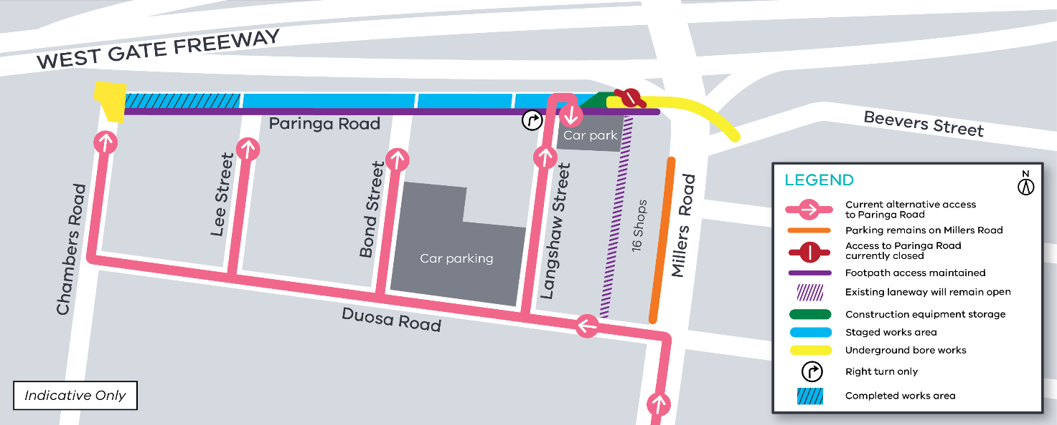
Contact us
Please contact us if you have any questions or feedback about these works.
 | westgatetunnelproject.vic.gov.au |  | facebook.com/westgatetunnelproject
 | info@wgta.vic.gov.au |  | @westgatetunnel
 | 1800 105 105 |  | West Gate Tunnel Project  GPO Box 4509  Melbourne Victoria 3001
 | Interpreter service: 13 14 50

