Reference: WES1904.06
24 April 2019
Works update – temporary road closure
Construction has begun on Fogarty Avenue to safely relocate some existing power lines and install new drainage. As part of these works, Fogarty Avenue will be temporarily closed adjacent to your property.
Temporary closure of Fogarty Avenue
Monday 29 April – Friday 7 June 2019
- vehicle access along Fogarty Avenue between Wembley Avenue and Cranbrook Street will be temporarily blocked from 29 April to 7 June 2019;
- driveway and footpath access to your property will be maintained; and
- parking along sections of Fogarty Avenue will be temporarily unavailable during this time – please see the map overleaf for location details.
Fogarty Avenue is also currently closed from Cranbrook Street to Deleware Street until 31 May – please see the map overleaf for location details.

Where to park your vehicle:
- ensure you do not park your vehicle on Fogarty Avenue between Wembley Avenue and Cranbrook Street, and between Cranbrook Street and Deleware Street during the times above. Access will be blocked and you will be unable to access your vehicle; and
- it is recommended that you park your vehicle on either Wembley Avenue or Tenterden Street for the duration of these works.

What you could expect:
- an increase in construction vehicles within the area;
- an increase in construction noise from our machinery and trucks;
- water spray trucks to help manage dust and dirt and covered loads when dirt and rock are being transported; and
- traffic changes will be required and signed detours will be in place – latest traffic updates are available at westgatetunnelproject.vic.gov.au/traveldisruptions

Fogarty Avenue and The Avenue
As part of the next stage of critical works, Fogarty Avenue is currently closed to through traffic between Wembley Avenue and The Avenue until late August 2019. During this time drivers are required to detour via Williamstown Road, so plan ahead, follow the detour signage and drive safe.

After August 2019, this section of road will re-open under traffic management, while works continue along Fogarty Avenue and The Avenue until later this year. Access to the sporting clubs will be maintained at all times during these works.
These works will generally be carried out from Monday to Friday between 7am - 6pm and Saturdays between 7am - 3pm, however some night works may be required.
When works are scheduled out of hours and may have a direct impact on you, we will provide further information to you before works start.
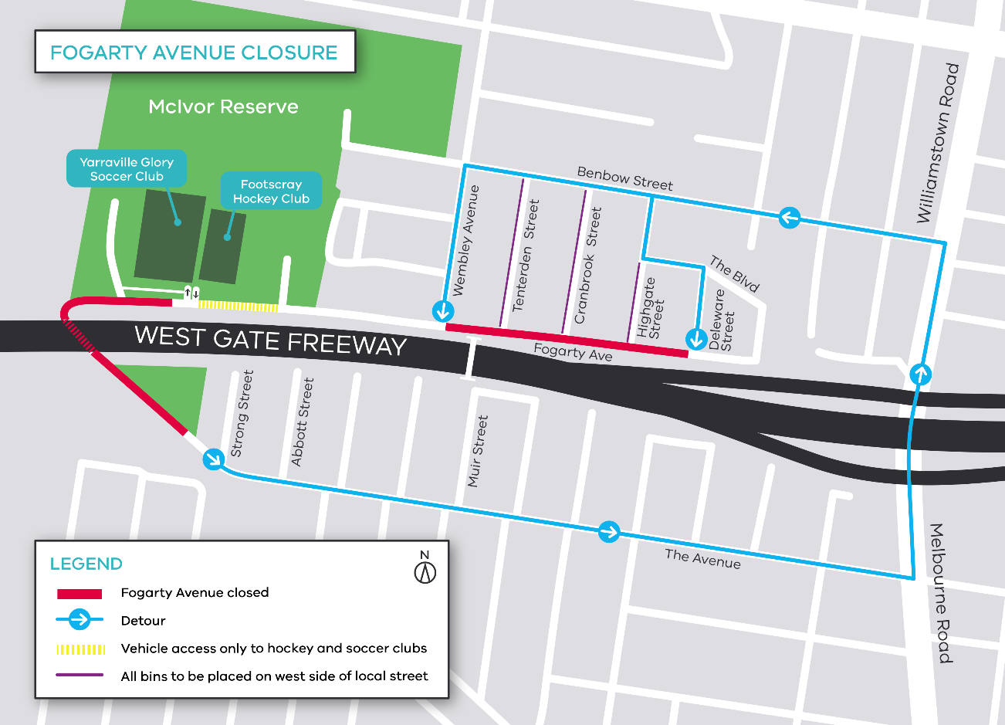

Please note that works may be rescheduled in the event of bad weather or other unavoidable circumstances.
For updates and more information about our works please visit westgatetunnelproject.vic.gov.au or contact us using the details below.

Contact us
Please contact us if you have any questions or feedback about these works.
 | westgatetunnelproject.vic.gov.au |  | facebook.com/westgatetunnelproject
 | info@wgta.vic.gov.au |  | @westgatetunnel
 | 1800 105 105 |  | West Gate Tunnel Project  GPO Box 4509  Melbourne Victoria 3001
 | Interpreter service: 13 14 50

