25 March 2020 WES2001.06(R2)

Reminder notification: Williamstown Road inbound exit ramp 24/7 works

We’re about to enter a new phase of our work on underground services at the Williamstown Road inbound exit ramp. This includes completing sewer relocation works and installing a new water main pipe.
The next stage of works will get underway on 27 March and will run both day and night for two weeks.
Please note the Williamstown Road inbound exit ramp will be closed during this time.

Sewer and water pipe relocation
27 March – 9 April 2020
Work is continuing to complete the relocation of a large underground sewer pipe at the Williamstown Road inbound exit ramp.

We’ll also be removing a redundant gas pipe and installing a new water main pipe underneath the freeway, at the Williamstown Road inbound exit ramp and along Williamstown Road.

These works will be 24 hours a day for two weeks and will include:
- constructing and reinstating the manhole shaft for future access to the sewer pipe
- digging a trench along the Williamstown Road inbound exit ramp, within the construction site
- installing the new water main pipe
- backfilling the trench and reinstating the pavement

Inbound tunnel entrance beam installation
From 26 March 2020
Work is also progressing at the inbound tunnel entrance. From Thursday 26 March, we will start installing beams to form the roof of the tunnel’s entrance.
Installation works will be carried out during the day, however, the large oversized deliveries for the beams will arrive to site at night to minimise traffic disruption. Works at night are not expected to be noisy.

See map for location of works
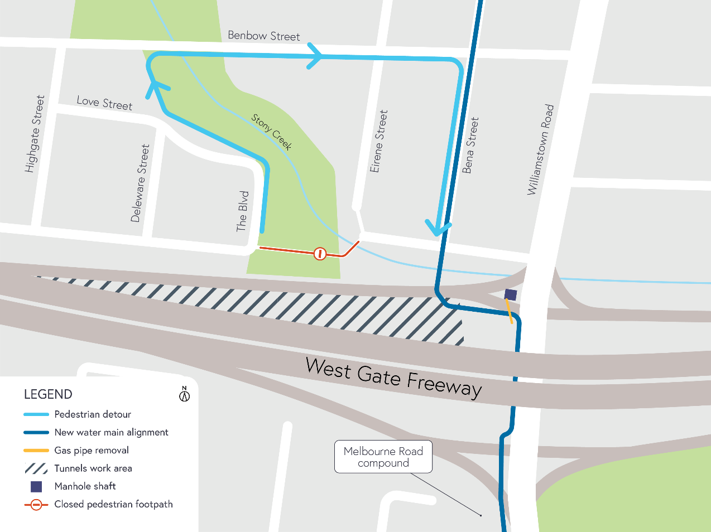

What to expect during these works:
- work will be completed behind safety barriers
- construction vehicles including excavators, water trucks and concrete trucks will be moving in and out of the work areas via our access routes
- construction noise from work activities including machinery and trucks which will increase at times while we dig the trenches and work at night
- water spray trucks and road sweepers will be used to manage dust and dirt during works, and trucks removing dirt and rock from the site will be covered
- traffic changes including ramp, lane and road closures will be required. Signed detours will be in place.

For the latest updates visit westgatetunnelproject.vic.gov.au/traveldisruptions.

Please note that works may be rescheduled in the event of bad weather or other unavoidable circumstances.

For updates and more information about our works please visit westgatetunnel.vic.gov.au or call 1800 105 105

