24 February 2020 WES2002.02

Works notification: Hyde Street ramps – start of works

As part of works on the West Gate Tunnel Project, we will soon begin building two new ramps for the West Gate Freeway. The new ramps will connect trucks directly to local industry and get them off local roads.
The ramp on the northern side of the freeway will provide a new exit ramp for inbound traffic from the West Gate Freeway to a new signalised intersection at Hyde Street.
The ramp on the southern side of the freeway will provide a new entry ramp for westbound traffic from a new intersection at Simcock Avenue and Stephen Street through to the West Gate Freeway.
We’re also building a new elevated Shared Use Path (SUP) that will extend the Federation Trail through to Hyde Street. It will go over the Williamstown Road inbound exit ramp and run alongside the new Hyde Street exit ramp. A separate bridge structure will also connect the SUP to ground level at the Stony Creek Reserve north of Hall Street and include a connection to Spotswood Train Station.
While these works will continue from early 2020 until 2022, below is a summary of what you can expect to see in the coming months:

constructing five new safety nets at the West Gate Golf Club. The nets will protect our onsite team as they work in the area and will remain as a permanent asset for the golf club

constructing one new safety net inside Donald McLean Reserve for the AFL grounds

piling for the new temporary site access bridge at Thomas Street is expected to begin in late March and the bridge is scheduled to be installed in late April. At the end of the project this bridge will be disassembled, and the area will be remediated and landscaped

building new temporary site access tracks and working platforms at Stony Creek Reserve, West Gate Golf Club, Donald McLean Reserve, and the medians on the Williamstown Road eastbound entry ramp and Williamstown Road westbound exit ramp to allow for safe access to work sites

piling works in Stony Creek Reserve. Piling for the northern ramp is due to begin in mid-March and is expected to continue until July 2020

fencing our project boundary in the Stony Creek Reserve at the end of Hughes Street and setting up a site compound within the West Gate Golf Course at Thomas Street

demolishing the northern section of the old Socobell building on Hall Street to make way for the new westbound entry ramp. This is scheduled to begin in March 2020.

Managing contaminated soil
Finding contaminated soil is part and parcel of construction in urban areas, especially in former industrial areas like West Melbourne. We implement strict control measures to protect the community and our workers whenever we discover areas of contamination.

We have found contamination, such as PFAS and asbestos, in soil in some areas of our work sites. All contaminated materials on our project are stored and removed in accordance with EPA and WorkSafe guidelines. At all times a licenced removalist will remove the asbestos contamination and an independent hygienist will oversee the removal works.

What you can expect during construction

construction vehicles including concrete trucks, pumps and cranes will be moving in and out of the work areas

dust and dirt will be minimised by using water spray trucks onsite, street sweepers and covering dirt and rock when it’s transported

noise and vibration may be noticeable during piling works

main access to the construction sites will be via a combination of approved access points from Hall Street, Hyde Street, Simcock Avenue, Thomas Street and the West Gate Freeway ramps. We aim to minimise site access from local roads

all trucks associated with the project must comply with authorised routes. This includes avoiding Hudsons Road west of Hall Street at all times

traffic changes including lane, road and ramp closures might be required. The latest traffic updates are available at westgatetunnelproject.vic.gov.au/traveldisruptions

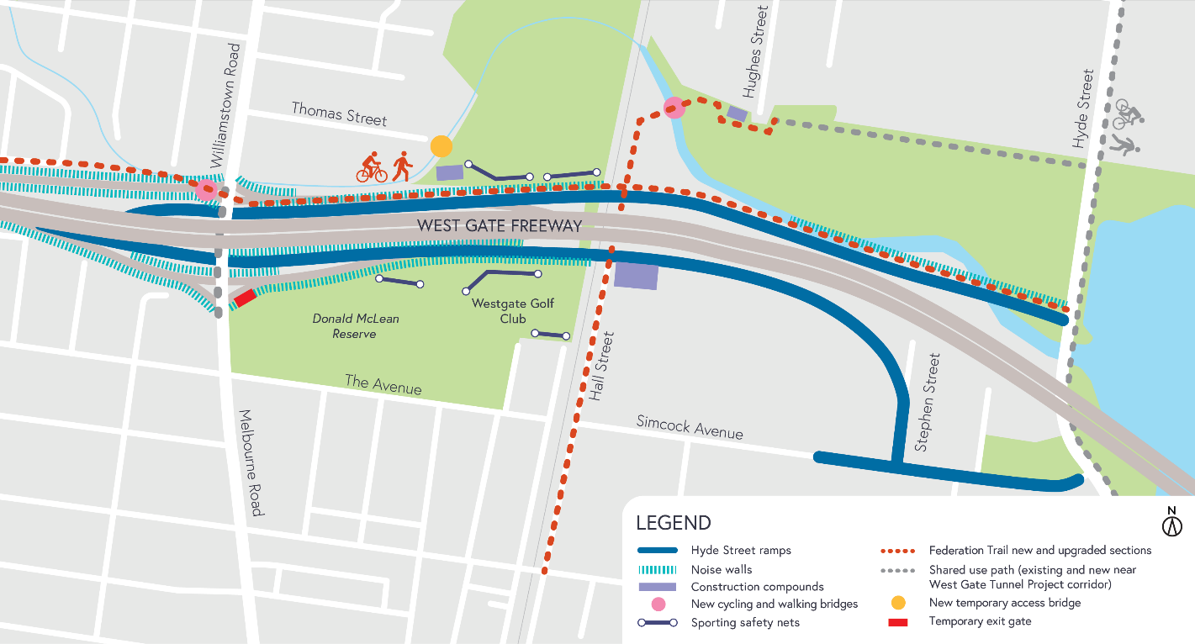

These works will generally be carried out from Monday to Friday between 7am - 6pm and Saturdays between 7am - 1pm, however some night works may be required. If works are scheduled outside of these hours or at night, we’ll provide further information to affected residents and/or businesses before works start.
Please note that works sometimes need to be rescheduled in the event of bad weather or other unavoidable circumstances.
We thank you for your patience during these works.

