31 March 2021 WES2008.01R
Works reminder: Dohertys Road
As part of the West Gate Tunnel Project, we have been working to relocate a watermain along Dohertys Road. We have completed the relocation of the watermain and are now moving onto reinstating the road and opening the additional lanes up to traffic.
Below is an update of what you can expect to see in the Dohertys Road area over the next two months.

Reinstating Dohertys Road

Until end of May 2021

These works will take place within an existing work site that currently occupies the north side of Dohertys Road.

These works will include:
- continuing to restore the areas we needed as part of our relocation works
- moving traffic from the inside lanes to the slow lanes (the outer lanes) and start the reinstatement of the centre median
- finalising connections of services along Dohertys Road
- reopening all traffic lanes on Dohertys Road in both directions and reinstating bus stops back to their original locations once we’ve completed our works
- at times we will require full overnight closures of Dohertys Road between Cherry Lane and Grieve Parade. Fully signed detours will be in place.

Hours of work
Our usual hours of work are Monday to Friday from 7am-6pm, and Saturdays from 7am-1pm. However, some night works will be required.
Once we have reinstated the area and reopened Dohertys Road to both lanes in each direction, our works will be completed.
There may be other closures required on Dohertys Road as part of ongoing works by Major Road Projects Victoria. Stay up to date at bigbuild.vic.gov.au/disruptions
We thank you for your continued patience while we get on with delivering this vital work.

Subscribe for traffic updates
As mentioned above, there will be times where we will need to close Dohertys Road overnight between Cherry Lane and Grieve Parade. If you would like to sign up to receive weekly traffic alert emails please email us on info@wgta.vic.gov.au or call 1800 105 105.
Alternatively, for latest updates, dates of closures and detour route information visit: bigbuild.vic.gov.au/disruptions.

Location of works

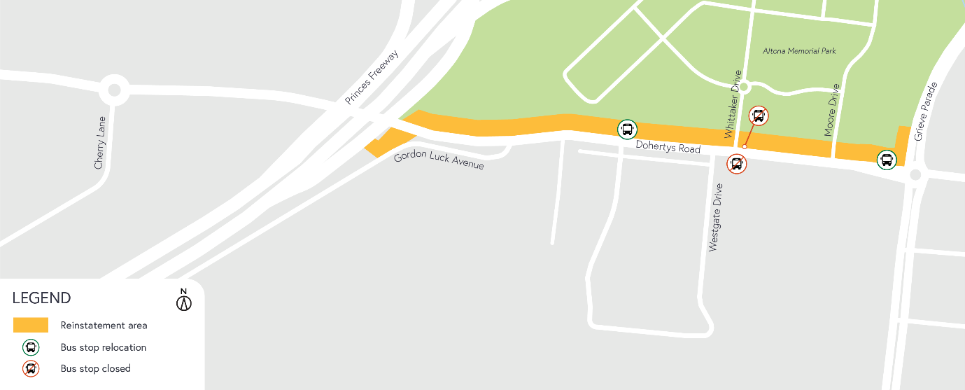

What to expect during these works:
- work will be completed behind safety traffic barriers
- increased noise from our works during the day, including rock-breaking activities
- construction vehicles, including excavators, rollers, water trucks and concrete trucks will be moving in and out of the work areas via our access routes
- construction noise from work activities including machinery and trucks and intermittent localised vibration may be experienced
- water spray trucks and road sweepers will be used to manage dust and dirt during works. Trucks removing dirt and rock from the site will be covered
- traffic changes including lane and road closures will be required. Signed detours will be in place.

For latest updates, dates of closures and detour route information visit: bigbuild.vic.gov.au/disruptions.

Please note that works sometimes need to be rescheduled in the event of bad weather or other unavoidable circumstances.

For updates and more information about our works, see westgatetunnelproject.vic.gov.au or call 1800 105 105.

