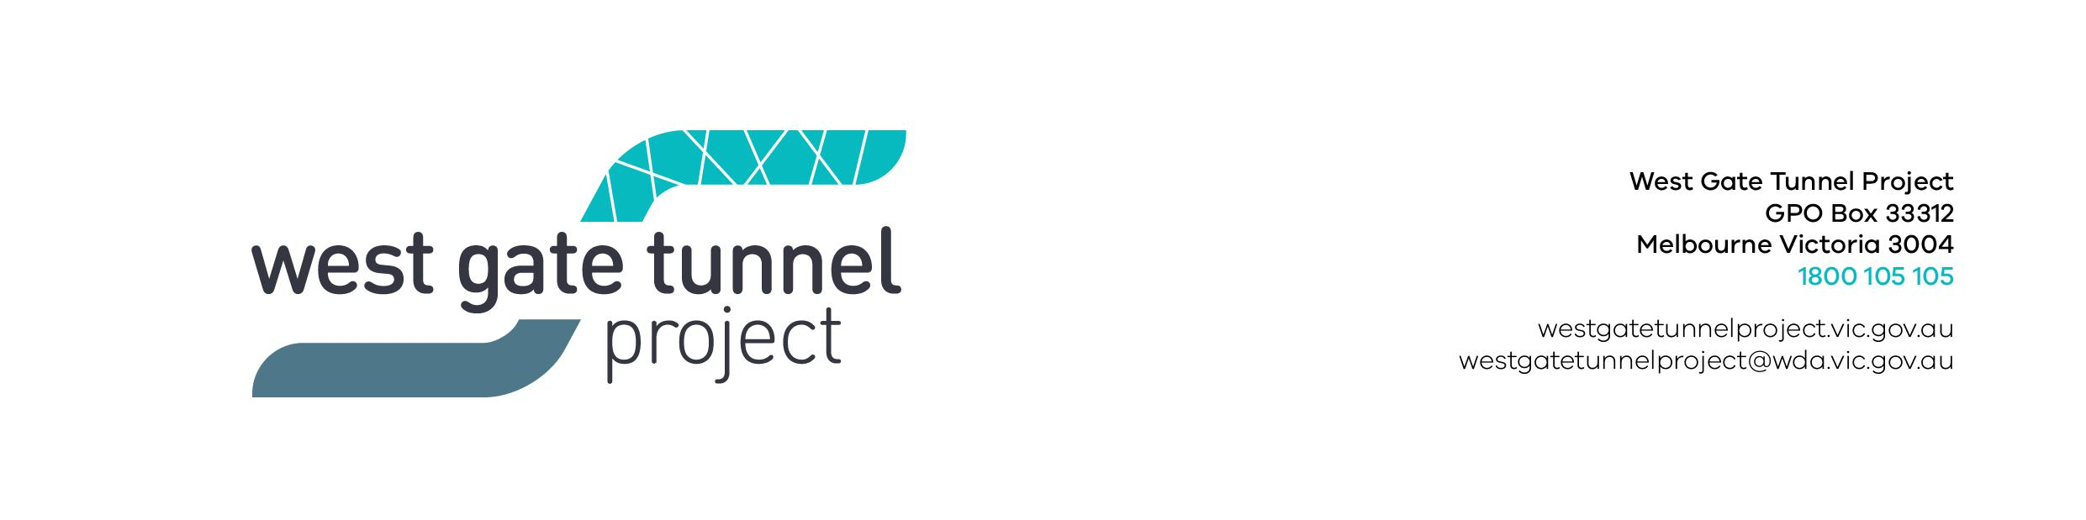

Reference: EAS1804.001

17 April 2018
        - WORKS NOTIFICATION: Footscray Road site investigations, site establishment and traffic changes

Investigation works on Footscray Road
Ongoing until July 2018

Until July 2018, we will be continuing investigative works on Footscray Road, between the Maribyrnong River and Docklands, looking to identify utility services and better understand ground conditions in the area.

Investigation work will include:
- electronic scanning of roads and footpaths
- non-destructive digging to identify underground services such as gas and water
- drilling bore holes up to 40 metres in depth
- test piles within the project area
- removing some shrubs if required in work zones, mostly within the centre median

Night time lane closures will be in place at times. All lanes will remain open during the day.

Site establishment and traffic changes on Footscray Road
May 2018 – August 2018
A construction site will be set up at the old Melbourne Market site on Footscray Road.
The existing building will be removed using hand tools and excavators. We will then set up our facilities, including sheds and offices. Once established in August, we will have up to 500 staff working at this site.
Key details:
- the section of service road fronting this site will need to be closed to general traffic
- the section of footpath fronting this site will need to be closed to pedestrians
- a clearly signed detour will be in place for drivers and pedestrians
- some vegetation within the site will need to be removed

Location of works and traffic changes on Footscray Road
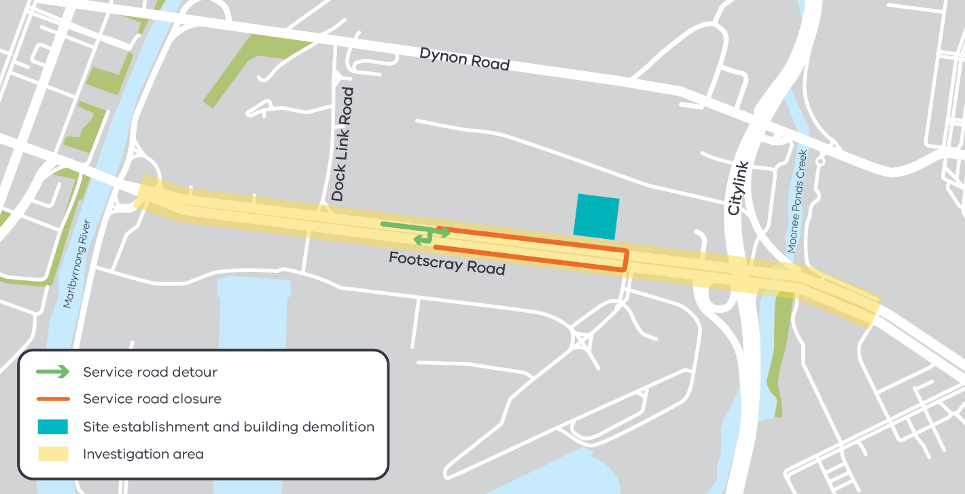

Managing construction and traffic changes

Construction activity and traffic changes will be actively managed to minimise disruption as much as possible, including:
- clear signage and traffic controllers to direct traffic
- working with businesses to minimise local impacts
- providing regular updates about our works
- monitoring and altering conditions as needed to maintain traffic flow, access and safety
- managing any environmental impacts including dust

Please note that works may be rescheduled in the event of bad weather or other unavoidable circumstances.
Contact us
Please contact us if you have any questions or feedback about these works.

 | westgatetunnelproject.vic.gov.au |  | facebook.com/westgatetunnelproject
 | westgatetunnelproject@wda.vic.gov.au |  | @westgatetunnel
 | 1800 105 105 |  | West Gate Tunnel Project  GPO Box 4509  Melbourne Victoria 3001

For updates and more information about our works please visit westgatetunnel.vic.gov.au or contact us using the details below.

