20 August 2020
EAS2008.02

Works notification: Wurundjeri Way Extension

Works on the Wurundjeri Way Extension are progressing with ongoing piling within the railyards (E Gate). As part of this extension, preparatory works on Wurundjeri Way will start in September. We will be locating services and removing vegetation in preparation for gas relocation works (APA Gas) which are due to commence in September, and future civil works that are required for the widening of Wurundjeri Way.

Building the Wurundjeri Way Extension

Works on Wurundjeri Way are occurring on 3 and 4 September 2020 overnight. These works will take place on Wurundjeri Way from the west of La Trobe Street to the Footscray Road T-intersection.

Works will include:
- Locating services
- Soil sampling
- Vegetation removal
- Service relocation
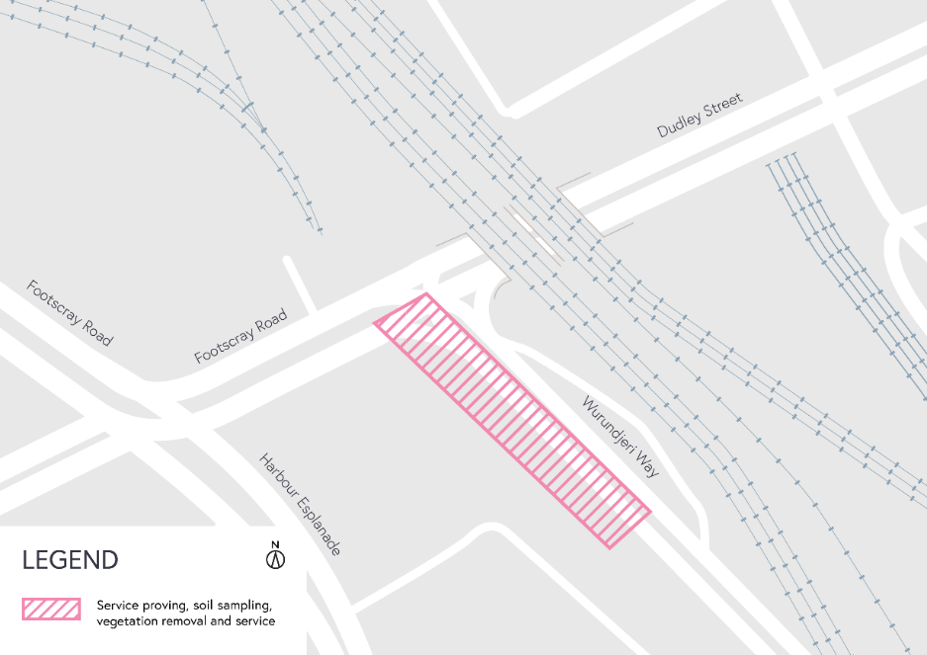

When:
- Vegetation removal on 3 and 4 September overnight from 10:00pm – 5:00am.
- Service relocation commencing 14 September from 9:00pm – 5:00am for a period of up to two months.

What to expect during construction:
- Works completed at night time
- Temporary single lane closures during the works
- We will notify you if there are any significant changes to the timing of our works
- Traffic management will be in place to manage changed conditions including temporary access changes and signage to guide road users and cyclists
- Dust will be managed on-site
- Vegetation removal works can create increased levels of noise and may also cause some vibration
- Assessments have been conducted, which indicate the noise levels are expected to remain within permissible levels as documented in the project’s Environmental Performance Requirements.

Coronavirus COVID-19 update
The health and safety of our workers is our key priority as we continue to deliver the West Gate Tunnel Project, as is supporting social distancing and the wearing of masks in line with current health advice. We have strict protocols in place to protect the safety of our construction workforce and the community. These include enhanced industrial cleaning arrangements, and measures to reduce staff contact, including staggered shifts and physical distancing. For more information and advice about Coronavirus, please visit coronavirus.vic.gov.au.

Please note that works sometimes need to be rescheduled in the event of bad weather or other unavoidable circumstances.
For updates and more information about our works, please visit westgatetunnelproject.vic.gov.au or call us on 1800 105 105.

Thank you
We appreciate our work can be disruptive and thank you for your understanding and cooperation.

