Chapter 26
Greenhouse gas

Chapter 26

Greenhouse gas

This chapter provides an assessment of the greenhouse gas impacts associated with the construction and operation of North East Link. This chapter is based on the impact assessment presented in Technical Report R – Greenhouse gas.
Changes to climate have been observed globally, including increased atmospheric and sea surface temperatures, increased sea levels, increased water vapour in the atmosphere, and decreased sea and glacier ice. In Australia, climate change affects temperature, rainfall, snow, tropical cyclones and fire weather. The increase of atmospheric carbon dioxide (CO₂) concentrations since around 1750 is the largest contributing factor to global climate change.
What is the greenhouse effect?
The greenhouse effect is a process that warms the Earth’s surface. When the sun’s energy reaches the Earth’s atmosphere, some of it is reflected back to space and the rest is absorbed and re-radiated by greenhouse gases. Greenhouse gases include water vapour, carbon dioxide, methane, nitrous oxide, ozone and some artificial chemicals such as chlorofluorocarbons (CFCs). By increasing the concentration of greenhouse gases in the atmosphere, climatic changes are being exacerbated.

Construction and operation of North East Link would involve activities that generate CO₂ and other greenhouse gases which could contribute to the greenhouse effect and climate change. It is therefore important to quantify the greenhouse gas emissions from the project to understand the scale at which it contributes to broader emissions. Management of activities to reduce greenhouse gas emissions is important in the efforts to reduce national and global emissions, and reduce climate change effects in the future.
The North East Link EES scoping requirements set out the matters to be addressed in the greenhouse gas study as follows:
- The need to consider the commitment to achieve a climate resilient community and economy with net zero emissions by 2050 in designing and assessing the project
- Describe the proposed approach to design, construction methods, materials and equipment to reduce energy use, including vehicle emissions, during construction and operation over the life of the project
- Evaluate the greenhouse gas emissions associated with the design, construction and operation of the project in accordance with Greenhouse Gas Assessment Workbook for Road Projects (TAGG) and the Australian National Greenhouse Accounts Factors
- Evaluate compliance with the policy principles and provision of SEPP Air Quality Management related to energy efficiency and greenhouse gas emissions
- Identify the contribution to the State’s transport greenhouse gas emissions with reference to projections in 2050
- Describe the environmental performance requirements to set greenhouse gas generation outcomes that the project must achieve.
The greenhouse gas assessment estimated the amount of greenhouse gas emissions caused by the construction and operation of North East Link.
The greenhouse gas assessment is one component of the overall sustainability approach for North East Link. The other key elements of the sustainability approach including consideration of climate scenarios and adaptation responses are addressed in the following report:
- EES Attachment I – Sustainability approach.
This assessment responds to the requirements of the SEPP Air Quality Management (AQM) to estimate greenhouse gas emissions associated with North East Link. The requirements of the Protocol for Environmental Management (Greenhouse Gas Emissions and Energy Efficiency in Industry) to identify and implement best practice measures associated with reducing greenhouse gas emissions from the tunnel ventilation system was assessed in Attachment VI – Works Approval Application for the project and is summarised in Technical report R – Greenhouse gas.

Method
Informed by the risk assessment described in Chapter 4 – EES assessment framework, the greenhouse gas assessment involved the following key tasks:  - Review of relevant legislation and policy at a national, state and local level  - Establishment of a study area for construction, operation and maintenance of North East Link. This was defined as emissions of the entire alignment and the emissions due changes in traffic assessed over the broader Melbourne road network. | What are the risk categories?  Risk levels were categorised as very low, low, medium, high or very high. When an impact is a known consequence of the project, the rating is indicated as ‘planned’. The results of the initial risk assessment were used to prioritise the focus of the impact assessments.
Emissions were calculated for a period spanning up to 50 years but presented as annual figures for ease of comparison with emissions for Victoria and Australia
- Establishment of existing conditions for the assessment as greenhouse gas emissions in Victoria and Australia
- Risk assessment to prioritise issues for the impact assessment
- Assessment of the potential greenhouse gas emissions during the construction and operation of North East Link. The assessment included Scope 1 and Scope 2 greenhouse gas emissions sources and select Scope 3 emissions sources. The definitions of emissions scopes are taken from the National Greenhouse and Energy Reporting Act 2007 and National Greenhouse and Energy Reporting Regulations 2018 as follows:
  - Scope 1: The release of greenhouse gas into the atmosphere as a direct result of North East Link Project activities. For instance, the combustion of fuel in construction equipment
  - Scope 2: The release of greenhouse gas into the atmosphere as a direct result of one or more activities that generate electricity, heating, cooling or steam that is consumed by the North East Link Project through purchases. For instance, the consumption of electricity by the tunnel boring machine (TBM)
  - Scope 3: Other indirect release of greenhouse emissions. For instance, emissions associated with the production of raw materials consumed during construction such as steel.
The assessment was undertaken in accordance with the following guidelines and standards:
  - Greenhouse Gas Assessment Workbook for Road Projects published by the Transport Authorities Greenhouse Group (2013) and the supporting calculator, Carbon Gauge release 01.8
  - National Greenhouse and Energy Reporting (Measurement) Determination (2008)
  - National Greenhouse Accounts Factors (NGA Factors) published by the Department of Environment and Energy (2018)
  - Infrastructure Sustainability Council of Australia (ISCA) Infrastructure Sustainability (IS) Tool (2018).
- Development of Environmental Performance Requirements (EPRs) in response to the impact assessment. The residual risk ratings and the assessment of impacts presented in this chapter assume implementation of the EPRs. Refer to Chapter 27 – Environmental management framework for the full list of EPRs.

Existing conditions
Climate change and greenhouse gas emissions are global issues. As such, the existing conditions assessment for North East Link establishes the regional context for greenhouse gas emissions to compare the project emissions against.
In alignment with the Kyoto Protocol and its pledge to the United Nations Framework Convention on Climate Change (UNFCCC), under the Cancun Agreement Australia has a target of reducing emissions to 5 per cent below 2000 levels by 2020. This was updated at the Conference of the Parties (COP) 21 (Paris, 2015) to a commitment that Australia will reduce emissions by 26 to 28 per cent on 2005 levels by 2030.
The Victoria Government has set a target of net-zero emissions by 2050, which will require greenhouse gas emissions to be reduced to the extent possible with the remaining emissions counteracted through greenhouse gas offsetting.
National emissions for 2016 were reported to be 532,971 kt CO₂-e, representing approximately a 3 per cent reduction in emissions on the 2000 total of 551,786 kt CO₂-e.
Emissions for Victoria in 2016 were reported to be 115,103 kt CO₂-e, an approximate 2 per cent reduction on the 2000 Victorian total of 117,757 kt CO₂-e.
The most current available data for greenhouse gas emissions from road transportation for Australia and Victoria are summarised in Table 26-1.
Table 26-1 2016 road transportation emissions
Vehicle type | Australia (kt CO₂-e) | Victoria (kt CO₂-e)
Cars | 44,276 | 11,168
Light commercial vehicles | 15,411 | 3,738
Heavy-duty trucks and buses | 22,651 | 5,001
Motorcycles | 294 | 72
Total | 82,633 | 19,979

Construction impact assessment

For construction of North East Link, the key greenhouse gas emissions sources would include fuel and electricity use for construction vehicles and machinery and the production and consumption of materials.
The one risk pathway that relates to greenhouse gas for the construction of the project is described in Table 26-2 and potential impacts are discussed below.
How do materials generate greenhouse gas emissions?
The production of all materials requires the use of energy which is termed ‘embodied energy’. This is associated with the manufacture and transport of goods. This embodied energy is considered in the assessment of greenhouse gas for North East Link.

The release of greenhouse gas emissions is considered a ‘planned’ effect because it is known that emissions would be released during construction.
This section estimates the amount of emissions before EPRs were implemented. It is therefore likely the actual amount of emissions released would be lower than these estimates.
Table 26-2 Risk table: Construction
Risk ID | Risk pathway | Risk rating
Risk GH01 | Land clearing and consumption of materials and electricity generated from fossil fuels, operation of plant and equipment, and transportation of materials and equipment during construction result in the release of greenhouse gas emissions which could contribute to global climate change. | Planned (major consequence)

The schedule for North East Link expects the project to be completed over seven years. The total calculated greenhouse gas emissions for construction is approximately 1970 kt CO₂-e, which equates to 289 kt CO₂-e per annum (risk GH01). This represents 0.25 per cent of the Victorian emissions from all sectors in 2016, and 0.05 per cent of the national 2016 emissions.
The estimated greenhouse gas emissions from the construction of North East Link by source are summarised in Table 26-3. Most greenhouse gas emissions from construction activities result from the release of greenhouse gas emissions through the use of construction materials, which account for approximately 81 per cent of emissions, followed by the operation of plant and equipment (electricity use), accounting for 7 per cent as shown in Figure 26-1. A high proportion of the electricity use during construction is due to the operation of tunnel boring machines.
Table 26-3 Estimated greenhouse gas emissions for North East Link construction (seven-year period)
Emission source category | Emission source | Scope 1 (kt CO₂-e) | Scope 2 (kt CO₂-e) | Scope 3 (kt CO₂-e) | Total (kt CO₂-e)
Construction
Fuel use | Electricity generation | 1 | - | <1 | 1
 | Site vehicles | 1 | - | <1 | 1
 | Transportation of spoil | 38 | - | 2 | 40
 | Plant and equipment | 62 | - | 12 | 74
 | Demolition and earthworks | 62 | - | 5 | 67
 | Vegetation removal | <1 | - | <1 | <1
Electricity use | Operation of plant and equipment, including tunnel boring machines | - | 134 | 12 | 146
Materials | Construction materials | - | - | 1627 | 1627
 | Liming treatment of acid sulfate soils | - | - | 59 | 59
Land use changes | Vegetation removal | 5 | - | - | 5
Total (kt CO₂-e) |  | 169 | 134 | 1,717 | 2,020
* Due to rounding, figures may appear to not add correctly
- = Not applicable
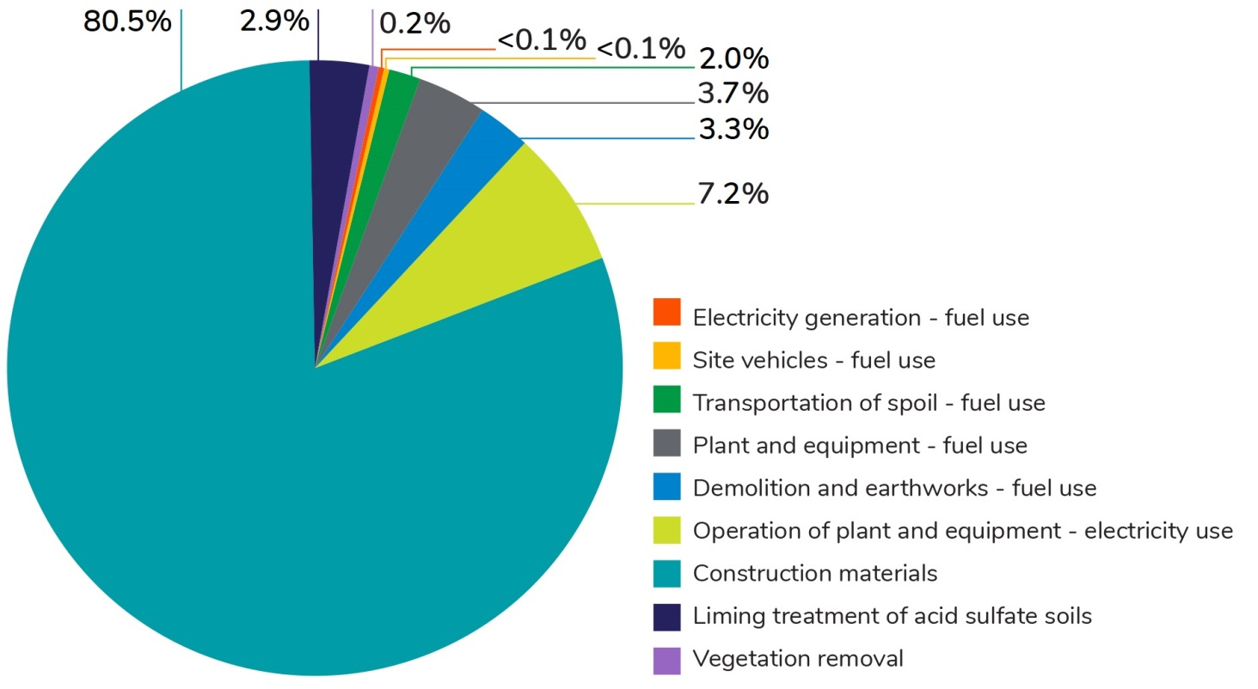
Figure 26-1 Percentage of greenhouse gas emissions by source for construction of North East Link
The assessment has enabled the primary sources of emissions from construction of North East Link to be identified. EPRs have been developed to support initiatives to minimise greenhouse gas emissions as described in Section 26.5.

Operation impact assessment
The key greenhouse gas emission sources for North East Link operations would be electricity use associated with operating and maintaining the tunnels and emissions from vehicles using the road network. The assessment of vehicle emissions has focused on a comparison of emissions for a ‘with project’ and no-project scenario.
The release of greenhouse gas emissions is considered to be a ‘planned’ effect because release of emissions is certain to occur. This section estimates the amount of emissions based on the proposed operation activities for North East Link. Emissions associated with the design of North East Link have been assumed to be immaterial as international travel, which would be the key contribution to greenhouse gas emissions, would largely not be required.
Two risk pathways have been identified for greenhouse gas for the operation of North East Link. These are described in Table 26-4 and the potential impacts are discussed in the next sections.
Table 26-4 Risk table – operation
Risk ID | Risk pathway | Risk rating
Risk GH02 | Operational and maintenance activities including consumption of fossil fuels for electricity generation, operation of plant and equipment and transportation of materials and equipment result in greenhouse gas emissions, which could contribute to global climate change. | Planned (moderate consequence)
Risk GH03 | Operation of the North East Link will cause a change in vehicle flow through Metropolitan Melbourne which may result in an increase or decrease in the overall vehicle emissions. | Planned (moderate consequence)

Operation emissions from electricity consumption and maintenance
The total greenhouse gas emissions per annum from North East Link operation (including maintenance) are estimated to be approximately 84 kt CO₂-e (risk GH02). This represents 0.07 per cent of the Victorian emissions from all sectors, and 0.02 per cent of the national emissions in 2016. Most greenhouse gas emissions from North East Link operation would be associated with operating the tunnels, accounting for approximately 96 per cent of emissions as shown in Figure 26-2.
Table 26-5 summarises the estimated annual greenhouse gas emissions once North East Link was operating (including maintenance) for a 50-year period, by source and scope.
Table 26-5 Estimated greenhouse gas emissions for North East Link operation per annum
Emission source category | Emission source | Scope 1 (kt CO₂-e) | Scope 2 (kt CO₂-e) | Scope 3 (kt CO₂-e) | Total (kt CO₂-e)
Operations
Electricity use | Operation of tunnel (eg pumps, lighting and ventilation) | - | 74 | 7 | 81
 | Operation of other systems (eg signalling, toll gantries, lighting and operations centre) | - | 2 | <1 | 2
Maintenance
Materials | Maintenance materials | 1 | - | <1 | 1
Total (kt CO₂-e) |  | 1 | 76 | 7 | 84
* Due to rounding, figures may appear to not add correctly
- = Not applicable
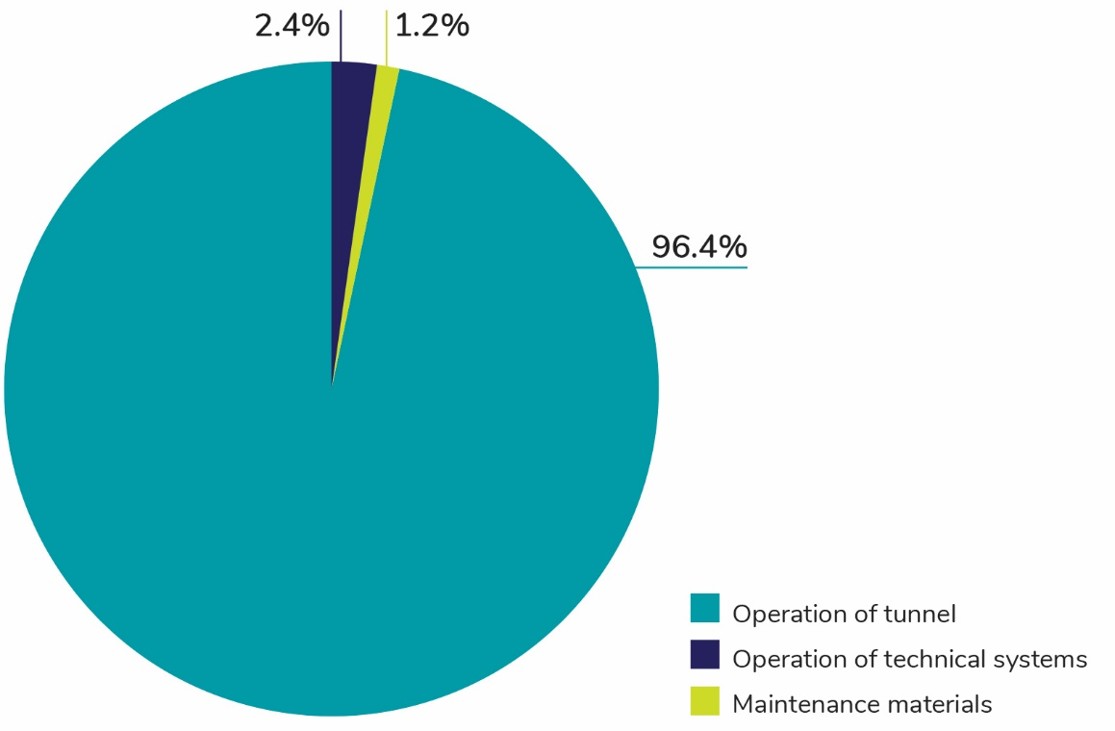
Figure 26-2 Percentage greenhouse gas emissions by source for operation of North East Link
The assessment has enabled the primary sources of emissions from operation of North East Link to be identified. EPRs have been developed to support initiatives to minimise greenhouse gas emissions as described in Section 26.5.

Operation emissions from vehicle traffic
To assess the changes to vehicle emissions from North East Link, the greenhouse gas assessment used inputs from strategic traffic modelling for the project as presented in Chapter 9 – Traffic and transport. Based on this modelling, greenhouse gas emissions were calculated for ‘with project’ and ‘no project’ scenarios (where the road network remains in current condition) (risk GH03).
The assessment has used the outputs from the strategic model to estimate greenhouse gas emissions from vehicle traffic across the Melbourne (statistical division) road network including the regional areas of Geelong, Ballarat, Bendigo and Traralgon.
Table 26-6 and Table 26-7 show model outputs for the metropolitan Melbourne road network for the ‘with project’ and ‘no project’ scenarios in 2026 and 2035. The analysis indicates a marginal decrease of 0.04 per cent and 0.13 per cent respectively in greenhouse gas emissions in 2026 and 2036.
Table 26-6 Estimated 2026 greenhouse gas emissions from road traffic on the metropolitan Melbourne road network
Vehicle type | 2026 no project forecast  (kt CO₂-e/year) | 2026 with project forecast  (kt CO₂-e/year) | Change in emissions  (kt CO₂-e/year) | Change in emissions  (%)
Car | 16,851 | 16,906 | +56 | 0.33%
Light commercial vehicle | 1,178 | 1,175 | -3 | -0.29%
Heavy commercial vehicle | 3,805 | 3,744 | -62 | -1.62%
Total | 21,835 | 21,825 | -10 | -0.04%

Table 26-7 Estimated 2036 greenhouse gas emissions from road traffic on the metropolitan Melbourne road network (kt CO₂-e per average weekday)
Vehicle type | 2036 no project forecast  (kt CO₂-e/year) | 2036 with project forecast  (kt CO₂-e/year) | Change in emissions  (kt CO₂-e/year) | Change in emissions  (%)
Car | 20,005 | 20,058 | +53 | 0.27%
Light commercial vehicle | 1,420 | 1,414 | -7 | -0.48%
Heavy commercial vehicle | 4,701 | 4,622 | -79 | -1.69%
Total | 26,126 | 26,093 | -33 | -0.13%
In the scenarios modelled, emissions from the traffic network were lower for the ‘with project’ than for ‘no project’ scenario. The results show that while North East Link would increase greenhouse gas emissions from cars, this would be more than offset by a larger reduction in emissions from heavy vehicles. This is likely to be as a result of heavy vehicles moving off local roads and on to North East Link.
Estimates were made of the vehicle kilometres travelled for the ‘with project’ and ‘no project’ scenarios for 2026 and 2036 as shown in Table 26-8 and Table 26-9.
While North East Link would result in a higher daily number of kilometres travelled, the 2026 and 2036 ‘with project’ scenarios would also mean less emissions per vehicle kilometre travelled than the 2026 and 2036 ‘no project’ scenarios. This reduction is due to the more efficient way that vehicles would travel in the two ‘with project’ scenarios. For example, a vehicle travelling slowly in a stop-start manner would generally consume more fuel and emit more greenhouse gas emissions than a vehicle travelling in a more consistent manner at a higher speed.
Estimates of greenhouse gas emissions do not factor in any improvement in vehicle fuel efficiency over time or the uptake of electric vehicles. Fuel efficiency of vehicles is anticipated to improve in the future, which would reduce greenhouse gas emissions rates of vehicles and future greenhouse gas emissions under both scenarios assessed.
Table 26-8 Estimated 2026 greenhouse gas emissions per vehicle kilometre travelled
 | 2026 no project forecast | 2026 with project forecast | Difference  (%)
Vehicle kilometres travelled (VKT) per day | 149,471,719 | 150,641,662 | 0.78%
Total vehicle emissions/day (kg CO₂-e) | 66,165,342 | 66,136,120 | -0.04%
Emissions per VKT (kg CO₂-e/VKT) | 0.442 | 0.439 | -0.82%

Table 26-9 Estimated 2036 greenhouse gas emissions per vehicle kilometre travelled
 | 2036 no project forecast | 2036 with project forecast | Difference  (%)
Vehicle kilometres travelled (VKT) per day | 173,024,654 | 174,361,744 | 0.77%
Total vehicle emissions/day (kg CO₂-e) | 79,170,953 | 79,070,552 | -0.13%
Emissions per VKT (kg CO₂-e/VKT) | 0.458 | 0.453 | -0.89%

Contribution to Victorian target
Victoria has a target to achieve net-zero emissions by 2050. This impact assessment shows that while there would be an annual reduction in greenhouse gas emissions from the operation of the road network due to North East Link, these would be counteracted by the greenhouse gas emissions associated with operating the tunnels. However, the scale of operational emissions is small in the context of Victoria’s overall emissions. North East Link would not represent a barrier to Victoria achieving its 2050 net-zero emissions target.

Environmental performance requirements
Environmental performance requirements (EPRs) have been developed to minimise greenhouse gas emissions for North East Link.
A Sustainability Management Plan for North East Link would be developed and implemented to meet, as a minimum, the sustainability targets set for the project and specified ratings under the Infrastructure Sustainability Council of Australia’s Infrastructure Sustainability Rating Tool (EPR SCC1).
Sustainable design practices would be integrated into the design process to minimise, to the extent practicable, greenhouse gas emissions from the construction and operation of North East Link (EPR SCC2).
Best practice measures for energy usage would be applied for the tunnel ventilation and lighting systems in accordance with the Protocol for Environmental Management (Greenhouse Gas Emissions and Energy Efficiency in Industry) (EPR SCC3).
Further detail of these measures is provided in Technical report R – Greenhouse gas.

Conclusion
This chapter has assessed greenhouse gas emissions associated with North East Link.
The key findings of the assessment are:
- Greenhouse gas emissions during the construction of North East Link would be from two key sources: the manufacture of construction materials and electricity consumption for the tunnel boring machines. Total emissions over the seven-year construction period were estimated at 2,020 kt CO₂-e. On an annualised basis, the estimated greenhouse gas emissions for constructing North East Link represents 0.25 per cent of Victorian and 0.05 per cent of national emissions for 2016.

- The largest emission source for North East Link operation would be from operating the tunnels, which account for 96 per cent of the 84 kt CO₂-e per annum operational (including maintenance) greenhouse gas emissions. This represents 0.07 per cent of the Victorian emissions from all sectors in 2016, and 0.02 per cent of the national 2016 emissions.
- For greenhouse gas emissions related to vehicle traffic, North East Link would marginally reduce emissions due to heavy vehicles using North East Link instead of local roads.
Sustainability would be promoted through the development and implementation of a Sustainability Management Plan (EPR SCC1), integrating sustainable design practices in to design processes (EPR SCC2) and using best practice measures for energy usage for tunnel ventilation and lighting systems (EPR SCC3). Project EPRs are described in full in Chapter 27 – Environmental management framework.
In response to the greenhouse gas study objectives described at the beginning of this chapter, effects of the project on greenhouse gas emissions have been assessed and EPRs have been identified to minimise adverse effects.

