- RATIONALE AND PROJECT DESCRIPTIONS

SECTION PAGE SECTION PAGE

  - Introduction 2.2
  - Project rationale 2.2

  - Bonbeach level crossing removal project 2.12
    - Rail trench 2.12
    - Bonbeach Railway Station 2.12
2.3 | Benefits | 2.4 2.6.3 Railway infrastructure and utilities 2.13
2.3.1 | Improve transport safety in the | 2.6.4 Road, cyclist and
 | Edithvale and Bonbeach areas | 2.4 pedestrian infrastructure 2.13
2.3.2 | Reduce traffic congestion in the | 2.6.5 Surface water management 2.14
 | Edithvale and Bonbeach areas | 2.5
2.3.3 | Generate local jobs and stimulate
 | the local economy | 2.5 | 2.6.7 | Urban design | 2.14
2.3.4 | Facilitate additional train services |  | 2.7 | Construction | 2.14
 | on the Frankston rail line | 2.5 | 2.7.1 | Construction activity | 2.14
2.4 | Project development | 2.6 | 2.7.2 | Construction hours and workforce | 2.17
2.4.1 | LXRP Business Case | 2.6 | 2.7.3 | Construction traffic | 2.18
2.4.2 | Why a rail trench under the road? | 2.6 | 2.7.4 | Construction work sites | 2.18
2.4.3 | Technical design constraints | 2.8 | 2.7.5 | Indicative construction schedule | 2.19
2.5 | Edithvale level crossing removal project | 2.8 | 2.7.6 | Waste and spoil management | 2.20
2.5.1 | Rail trench | 2.8 | 2.8 | Operation and maintenance | 2.21
2.5.2  2.5.3 | Edithvale Railway Station  Railway infrastructure and utilities | 2.9  2.10 | 2.9 | Addressing sustainability and climate change within project designs | 2.22
2.5.4 | Road, cyclist and |  | 2.9.1 | Sustainability | 2.22
2.5.5 | pedestrian infrastructure  Surface water management | 2.10  2.10 | 2.9.2 | Climate change | 2.22
2.5.6 | Groundwater management | 2.10
2.5.7 | Urban design | 2.12

2.6.6 Groundwater management 2.14

Introduction

This chapter describes the rationale, development, design, construction and operation of the proposed Edithvale and Bonbeach level crossing removal projects (the projects).
The description of the projects has been developed to provide an understanding of all components, processes and development stages, and to enable assessment of their likely potential environmental effects.
The project description includes specific commitments to minimise those aspects of the projects that have the potential to generate negative impacts.

Project rationale

The endorsed Victorian Government Business Case for the Level Crossing Removal Project (LXRP) sets out the wide-ranging benefits of removing 50 level crossings across Melbourne (Victorian Government, 20171). The Edithvale and Bonbeach level crossings are two of the nominated 50 level crossings to be removed in the LXRP. The program also includes the Metropolitan Network Modernisation Program which comprises new train stations, improved public transport access, and improved pedestrian and cycling links.
Prior to the commencement of the LXRP, level crossings have been removed one at a time or in pairs, and over many years. While this approach goes some way toward addressing localised issues, the scale of the problem is so big that it calls for a strategic approach and corresponding scale of investment.
Melbourne is Australia’s fastest growing city, heading towards a population of six million by 2031 and more than 7.8 million by 2051. As the city grows, reliable and highly efficient transport networks are essential
to moving more and more people and goods around the city, attracting new businesses, residents, jobs, and maintaining Melbourne’s liveability.

1 Victorian Government (2017). Level Crossing Removal Project Program Business Case.

Project description, the risk assessment, and the Environmental
Performance Requirements

The descriptions within this chapter present a feasible and conservative design, construction and operational approach for each project which form the basis of the assessments presented in this EES.
A comprehensive risk assessment has been undertaken (see Attachment II Environmental Risk Report) to confirm that all the aspects of the projects, as described here, that could have significant environmental impacts are identified and sufficiently defined. Where an
aspect of either project has been found to present an environmental risk, the risk has been investigated in detail to understand what the potential impact may be, and how it may be avoided, minimised or managed.
The Environmental Performance Requirements (EPRs) define the environmental outcomes that
must be achieved during design, construction
and operation of the Edithvale and Bonbeach level crossing removal projects, regardless of the detailed design solutions adopted. They may also represent specific measures developed in this EES to avoid, reduce or manage potential impacts.
While the key components of the projects such as the trenches, stations and new intersections would not change, the final detailed design and construction methodology may differ from what is presented here. For example, the design would seek to minimise the length of the trenches and stations would have a high quality architectural treatment. However, they would be governed by the EPRs to ensure that the environmental effects generated are consistent with, and no worse than, the impacts discussed in this EES.

  - Edithvale and Bonbeach Environment Effects Statement | Rationale and project descriptions

Victorian Government policies and plans recognise that without an immediate and major enhancement in the capacity and efficiency of the city’s transport system, Melbourne’s liveability, accessibility and productivity cannot be sustained. To this end, the State Government is investing in road and rail projects designed to ensure the transport system keeps pace with the city’s growth into the future.
Section 5.6 of the Business Case sets out the LXRP in the broader context including the Transport Integration Act 2010 and Victorian Government policy, guidelines and plans.
There are 178 level crossings on Melbourne’s metropolitan (electrified) rail network – more than any other Australian city. Each of these crossings represents a major conflict point between rail, road and pedestrian traffic. All of them contribute to some extent to congestion, safety and amenity problems on the city’s transport system and many inhibit improvements to the capacity of both the road and rail networks. Level crossings also limit opportunities for urban renewal and development.
It is clear that without some intervention, a significant number of roads across Melbourne, many of which are important commuter and freight routes, would effectively be closed for considerable periods of time if there is an increase in the frequency of train services – causing even longer delays, higher costs, greater frustration and increased safety risks.
The LXRP is a critical enabler of other major rail projects, including the Cranbourne-Pakenham line upgrade and the Melbourne Metro Rail Tunnel Project. These major projects will transform Melbourne’s transport network and are expected to have a significant impact on Melbourne’s city structure, by encouraging households and businesses to locate along high capacity rail corridors, due to the significant accessibility improvements these projects provide. This will deliver economic and social outcomes that will benefit the Victorian economy.
For the first time, the Victorian Government has a long-term, strategic plan for removing level crossings to systematically address the safety and congestion problems associated with this outdated feature of Melbourne’s transport system, and create better connected, liveable and thriving communities.
The LXRP involves the removal of 50 level crossings, including at Edithvale and Bonbeach, in a coordinated program. Eleven level crossings have already been removed by the end of 2017, a further 13 are underway and all 50 will be removed by the end of 2022.

Benefits

The removal of the Edithvale and Bonbeach level crossings aligns with the Victorian Government’s aims to improve safety, deliver benefits to the transport network and create thousands of jobs.
Melbourne’s level crossings are dangerous and congested, provide the opportunity for unsafe behaviours, and place an increasing burden on the operation of both the road and rail networks. When boom gates are down, level crossings increase congestion on roads, delaying private vehicles, buses and commercial traffic.
Between 2005-2014, a third of Australia’s collisions between trains and vehicles occurred in Victoria, and over half of collisions between trains and pedestrians occurred in Melbourne. There were 149 collisions between trains and vehicles or pedestrians on Melbourne’s rail network that resulted in 22 serious injuries and 38 fatalities.

    - Improve transport safety in the Edithvale and Bonbeach areas
Prior to the commencement of the Level Crossing Removal Project (LXRP), there were 178 level crossings across the electrified rail network. All level crossings are dangerous, presenting safety risks to road and rail users alike, including pedestrians and cyclists. Removing any level crossing will create safer communities, significantly reducing the risk of serious or fatal collisions.
Level crossings provide opportunity for risk-taking behaviour, with people attempting to avoid delays, ignoring signals and boom gates. Twenty people died after being hit by a train between 2005 and 2014 at the 50 crossings to be removed, with more than 60 collisions and almost 700 near misses also occurring at those 50 sites.
The Edithvale and Bonbeach level crossings contributed to these safety concerns in the 10 years to 2015:
      - At Edithvale, there was one fatality, one collision between a vehicle and a train, and seven near misses involving trains and pedestrians.
      - At Bonbeach, there was one collision between a vehicle and train, one near miss involving a train and a pedestrian, and eleven near misses involving trains and vehicles.
Removing the Edithvale and Bonbeach level crossings would eliminate these safety concerns.
The opportunity to contribute towards safer communities arises not only from reducing the risk of accidents at these crossings, but also from providing better designed station precincts to improve safety for the community in the wider vicinity of the crossings.
The projects would create open station forecourts, with more space and better visibility and accessibility for pedestrians through removing the interface with the train lines. A shared user path along Station Street would improve safety for pedestrians and particularly for cyclists through creating off-road infrastructure
that would encourage more people to cycle to the stations. Provision of modern station infrastructure would improve the user experience, and ensure a high level of Disability Discrimination Act 1992 (DDA) compliant accessibility to the platforms.
Replacing the Edithvale and Bonbeach stations and improving the amenity would contribute to improved transport safety.

Reduce traffic congestion in the Edithvale and Bonbeach areas
The Edithvale and Bonbeach projects would reduce congestion through removing the level crossings and improving the station precinct design.
The level crossings at Edithvale and Bonbeach contribute to the increasing levels of congestion on Melbourne’s roads, which costs the Victorian economy $3 billion every year (Victorian Government, 20172). They also limit the number of train services that can operate on each line.
In the five years to May 2017, Metro Trains Melbourne (MTM) recorded approximately 1,500 incidents of signal faults at, or on the approach to, the 50 level crossings identified for removal which have resulted in the cancellation of 2,500 trains, or delay of a further 6,000 trains. This presents a significant cost to commuters, road users, and freight in terms of travel time delays and lost productivity. Types of recorded faults include issues with boom gates, warning bells and pedestrian gates, which further increase the risk of collisions, serious injury or fatalities.
Edithvale Road is a key arterial road, linking the Nepean Highway and bayside areas to Melbourne’s eastern suburbs and to the Mornington Peninsula. The importance of Edithvale Road is highlighted on weekends during summer as it provides a key connection to a safe, patrolled beach. Almost 14,000 vehicles per weekday use the Edithvale Road level crossing. The boom gates are down at Edithvale Road for an average of 42 minutes during the weekday morning peak between 7:00 am and 9:00 am, significantly impacting the vehicles who use the level crossing.
Station Street/Bondi Road at Bonbeach is used by nearly 4,500 vehicles per weekday to access the suburb of Bonbeach and the arterial road network. The boom gates are down for an average of 45 minutes in the morning two-hour peak, limiting local access.
Removing the Edithvale and Bonbeach level crossings would eliminate these delays.

Generate local jobs and stimulate the local economy
The removal of both level crossings would generate hundreds of jobs within the local areas for the duration of the construction program. The size of the workforce would vary throughout the construction, increasing to a peak of several hundred people during the main occupation. During this time, workers would help to stimulate the local economy through supporting local businesses in both the Edithvale and Bonbeach precincts.

Facilitate additional train services on the Frankston rail line
Public Transport Victoria (PTV) has forecast a 42 per cent growth in the train patronage on the Frankston rail line during the two-hour morning peak period between 2015 and 2031. The increasing population is putting significant pressure on the rail network. Increasing the number of services on the corridor is constrained by many factors, including the impact to the road network and resulting congestion due to additional boom gate down time. There is a total of 30 level crossings along the Frankston line, and each of them contributes to this constraint. Removing key crossings enables additional trains to run while preserving or enhancing the operation of important roads and routes, and provides a significantly safer environment at each crossing.
Each weekday, over 200 passenger train services (112 to Melbourne and 122 from Melbourne) pass through the Edithvale and Bonbeach level crossings. Up to six freight trains to and from the Port of Hastings also use the corridor each day, and the regional trains which operate between Frankston and Stony Point periodically travel to the city for maintenance.
Removing the Edithvale and Bonbeach level crossings would contribute to enabling more train services on the Frankston rail line.

2 Victorian Government (2017). Level Crossing Removal Project Program Business Case.

Project development
The development of each project has progressed across the following key phases:
      - Preliminary options assessment – A number of options for removing the level crossings were investigated.
      - Design solution – The ‘rail under road’ or ‘trench’ option was selected for the Edithvale and Bonbeach level crossing removals as a result of technical assessments, environmental considerations and a comprehensive community consultation program.
      - Design – The design was developed further, alongside environmental investigations to inform the EES.
Across each of the development phases, the projects’ designs were refined through an iterative process involving technical and environmental assessments and community and stakeholder consultation.
This process has ensured the objectives of the projects are met, that the relevant legislative and policy requirements are addressed and the potential risks and adverse environmental impacts are minimised.

LXRP Business Case
The LXRP Business Case describes that a wide range of potential options were reviewed, assessed and refined to establish a budget envelope for delivering a credible range of options at each level crossing removal site.
Relevant to the Edithvale and Bonbeach level crossing removal projects, an Options Assessment Framework was developed to assess and shortlist a range of options at each site in a consistent manner that meets
the LXRP objectives and timelines. The application of the framework resulted in the identification of a feasible solution for the removal of the level crossing (such as rail under road or road over rail), plus the Metropolitan Network Modernisation Program improvements (including new train stations, improved public transport access, and new pedestrian and cycling links) and amenity improvements such as landscaping and streetscape improvements. The Business Case recognised that there may be other feasible options for removing level crossings at some sites.
Further detailed investigation and public consultation was conducted to inform the recommended solution.
Opportunities to provide integrated development of state-owned land within and nearby existing rail and road corridors as part of the LXRP were also considered, but no opportunities have been identified for the Edithvale and Bonbeach projects.

Why a rail trench under the road?
A number of options for removal of the level crossings were investigated for Edithvale and Bonbeach, including:
      - Closure of Edithvale Road and/or Station Street/Bondi Road (refer Figure 2.1A).
      - Road over rail: This option would involve raising the road over the rail line with the existing rail line to remain at grade (refer Figure 2.1B).
      - Road under rail: This option would involve building a new road underpass with a rail bridge over the road to retain rail levels (refer Figure 2.1C).
      - Rail over road: This option would involve raising the rail line onto a rail bridge or embankment, with a rail bridge over the road (refer Figure 2.1D).
      - Rail under road: This option would involve lowering the rail line beneath the existing road. A new bridge would be built to maintain the road at its existing level (refer Figure 2.1E).
      - Hybrids: Hybrid solutions involve changing the grades of both the road and rail to reduce the height of the elevated infrastructure. Options include either:
        - Lowering the road and elevating the rail.
        - Lowering the rail and elevating the road.

Figure 2.1 Level crossing removal options considered

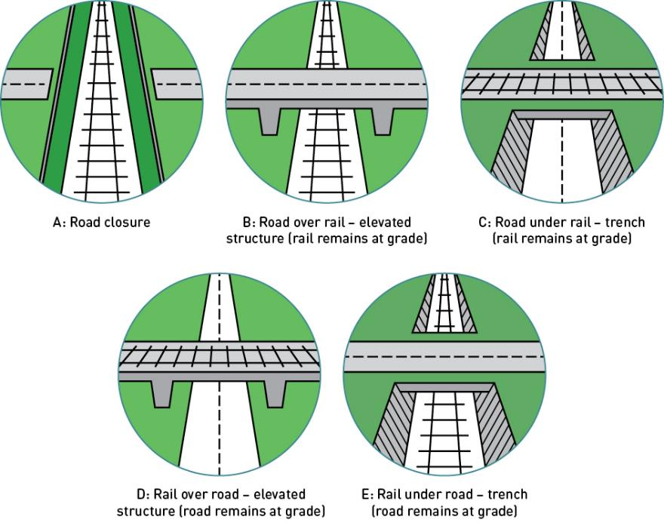

These options were explored to assess their feasibility. It was found that although technically feasible:
          - Closure of roads (Figure 2.1A) essentially represents the boom gates remaining permanently lowered, preventing road vehicles from crossing the rail corridor. This would significantly increase traffic congestion as the vehicles that currently use the Edithvale and Bonbeach level crossings would be redirected to, and increase congestion and safety risks at other crossings in the area such as at Chelsea Road and Lochiel Avenue. Edithvale Road is a declared arterial road linking Edithvale and surrounding suburbs to the Nepean Highway, the Mornington Peninsula Freeway (M11) and to Melbourne’s eastern suburbs via Springvale Road, Eastlink and Westall Road, and serves as a key strategic route. Station Street/Bondi Road provides a critical connection for the Bonbeach suburb
to the arterial road network. Closing both or either would result in a poor outcome for the road network.
          - Changing the elevation of the existing roads (i.e. road over rail, road under rail and hybrid options) (Figure 2.1B and Figure 2.1C) were considered less desirable than altering the rail corridor. They would require changes to road elevations resulting in:
            - complex and potentially unsafe road geometries
            - significant land acquisition of residential properties to maintain connectivity from (for example) Edithvale Road to Station Street
            - negative impacts for the surrounding urban form and local connectivity.
The impacts of acquisition to private property, and potentially commercial premises, were considered too great to consider these options further.
The ‘rail over road’ (Figure 2.1D) and ‘rail under road’ (Figure 2.1E) options were considered feasible and short-listed for presentation to the community in a series of comprehensive consultation sessions over a 12-month period, as discussed in Chapter 12 Stakeholder and community engagement.

The ‘rail under road’ option (Figure 2.1E) was selected for both the Edithvale and Bonbeach level crossing removals following the consideration of outcomes from a series of technical and preliminary environmental assessments, and social considerations that were identified during the comprehensive stakeholder and community consultation program.
The proposed option was selected following consideration of:
      - Alignment with LXRP objectives, including more efficient and reliable transport networks, better connected, liveable, safer and thriving communities.
      - Project outcomes including cost, time and delivery risk, urban design standards and protection of future assets.
      - Project impacts including land acquisition and land use impacts, environmental impacts and temporary impacts during construction.
The following sections describe the rail under road (trench) proposed option for each project.

Technical design constraints
Rail and road design must adhere to strict parameters as discussed where applicable in Sections 2.5 and 2.6. This sets constraints on the technical design for safety and operational reasons including:
      - maximum track gradients of two per cent
      - minimum clearances between the tracks and the underside of bridges and other structures of 5.75 metres
      - maintaining access in accordance with the Disability Discrimination Act 1992 (DDA)
      - replacement of pedestrian crossings in their current locations.

Edithvale level crossing removal project

This section outlines the key components of the Edithvale level crossing removal project, including a trench, railway station, and ancillary infrastructure.

    - Rail trench
The removal of the level crossing at Edithvale Road, Edithvale where it crosses the Frankston rail line is proposed to occur through lowering the rail line into a trench up to 1,300 metres long located between Lochiel Avenue and Berry Avenue. The trench would require installation of up to 1,200 metres of piles along both sides of the trench to varying depths in a configuration such as that shown in Figure 2.2. Refer to the text box on page 2.15 for a description of piling.

Figure 2.2 Indicative profile of the trench walls at Edithvale

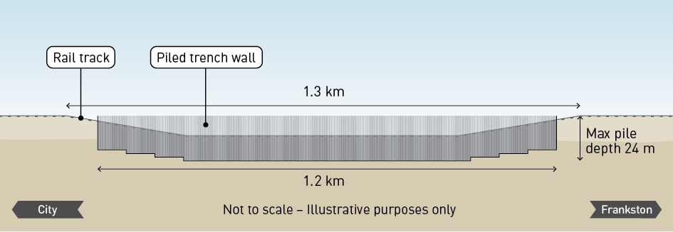

The length and depth of the trench are determined by a number of factors, including:
      - A maximum track gradient of two per cent, with the Lochiel Avenue level crossing constraining the northern extent of the trench.
      - A required 5.75 metre clearance between the tracks and the underside of the Edithvale Road Bridge, such that the final level of the tracks would be approximately 8 metres below ground level.
      - The depth of the base slab and water storage tank is such that the maximum depth of excavation required is approximately 14 metres below ground level.
In terms of width, the trench is constrained by the width of the rail corridor between Nepean Highway and Station Street. At its widest point, the trench would be up to 24 metres wide (including the width of the piles, tracks and island platform), and narrow to approximately 14 metres at both ends.

    - Edithvale Railway Station
The existing station would be demolished and replaced with new station infrastructure. At street level,
on a deck over the trench on the north side of Edithvale Road, a new station building would be constructed with ticketing and bicycle storage facilities, potential for a small-scale retail space and provision of facilities for potential future use by Protective Services Officers.
The station precinct would also include 38 car park spaces (34 for commuters, one for disabled use, two
for staff and one for emergency vehicles) on a deck over the trench to the south of Edithvale Road, accessed from Station Street. The number of spaces provided represents no net loss of commuter parking relative
to the existing conditions, while other informal commuter car parking and short-term car parking will be provided along Station Street and Nepean Highway.
DDA compliant access will be provided to the new island platform situated in the trench and between the tracks.
The car park deck would be offset from Edithvale Road to create a void over the platforms. Maintaining
a void would enable passive ventilation of the platform area, improving amenity and sustainability outcomes (i.e. reduced energy demands).
Project components are shown conceptually in Figure 2.3.

Figure 2.3 Schematic design for Edithvale

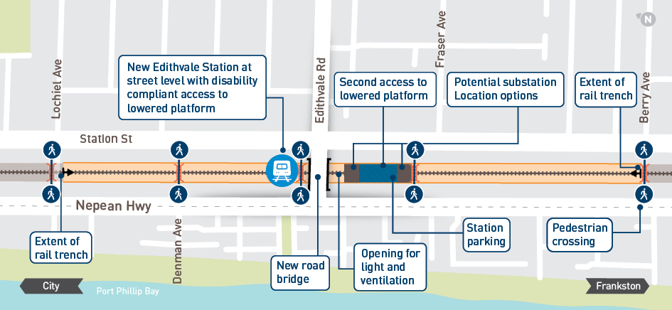

    - Railway infrastructure and utilities
New rail infrastructure to be reinstated includes the tracks, electrical and signalling systems. In addition, a new electrical substation would be required to address the increased power demand for trains on the
Frankston corridor. The substation would be enclosed within security fencing and consist of a prefabricated building with an approximate footprint of 35 metres long, seven metres wide and six metres tall. Two options have been identified for the location of the substation, as shown in Figure 2.3. Each option is adjacent to the proposed car park deck over the railway (north or south of the car park deck) such that the total length of this deck would be approximately 140 metres long.
To protect the trench, and ensure safety for the community at street level, a 0.8 to 1.8 metre tall concrete crash barrier would be required along the top of the trench. A screen to prevent items being thrown onto the railway would be included on top of the crash barrier up to a total height of 2.4 metres.
While not railway infrastructure, the corridor currently accommodates utility services such as electrical and telecommunication services for the surrounding community. These would require relocation in consultation with the utility owners who would undertake the relocation works. Other services that may require relocation include gas, water and sewerage. Works to relocate services would occur under separate approvals outside the scope of this EES.

Road, cyclist and pedestrian infrastructure
Edithvale Road would be reinstated in its existing location on a road bridge over the trench. Some modifications of the layouts and signalling at the Station Street and Nepean Highway intersections may be required to balance the needs of the general traffic, public transport, cyclists and pedestrians. Intersection modifications would be informed by traffic analysis and consultation with Kingston City Council (Council) and VicRoads during the detailed design phase of the project.
Bus stops on Station Street and Edithvale Road would be retained, however, changes to the intersection layouts could require minor relocation of bus stops.
A shared user path (for pedestrians and cyclists) would be provided alongside the trench on Station Street to improve safety and access in and around the new station precinct.
Cross-corridor connectivity would be retained through the provision of two DDA compliant bridges over the trench, with a third such crossing incorporated at grade into the car parking deck. The locations of these bridges would be confirmed in consultation with Council and incorporate community feedback, and require:
      - a 2.4 metre barrier where bridges cross the railway to comply with railway standards and maintain public safety
      - a clearance of 5.75 metres above the tracks, such that the closer they are to the end of the trench, the higher they need to be and the longer the DDA compliant ramp.

Surface water management
The trench would be designed to prevent groundwater from entering the trench and avoid the need for ongoing dewatering. However, rain would fall into the trench and require management.
A stormwater tank would be incorporated into the base of the trench to meet MTM requirements for accommodating rainfall equivalent to a 1 in 100-year two-hour storm. This equates to a volume of up to 800 cubic metres, including an allowance for the climate change scenario discussed in Section 2.9.
The design solution for discharging and treating collected stormwater would be developed in conjunction with Council and Melbourne Water to ensure the project meets stormwater management requirements.

Groundwater management
Through the risk and impact assessment process, a need to manage groundwater was identified to reduce the potential changes to groundwater levels and the associated impacts.
To manage potential impacts predicted through the initial assessment, an EPR was developed which would reduce the magnitude and extent of project-induced groundwater level changes at Edithvale. As outlined in Chapter 5 Modelling the water environment, an engineering solution was developed and modelled to demonstrate that a mitigation measure could be adopted to minimise the impact of the project on groundwater levels to achieve the performance outcomes in EPR_GW2 (refer Chapter 9 Environmental Management Framework).

The engineering solution modelled for this EES comprises the installation of a passive horizontal drain, which is an underground pipe that would be installed around the outside of, and adjacent to, the pile walls. The pipe would be installed at a depth that is permanently below the naturally variable water table, and perforated to allow groundwater inflow and outflow.
Without the engineering solution, the groundwater levels ‘upstream’ of the trench (i.e. inland) would rise, and drop on the ‘downstream’ side of the trench. The passive horizontal drain would provide a permeable connection between both sides of the trench, allowing groundwater to move more freely around the trench and minimise the difference in groundwater levels on either side of the trench. Figure 2.4 provides a schematic representation of the passive horizontal drain.

Figure 2.4 Schematic representation of the passive horizontal drain
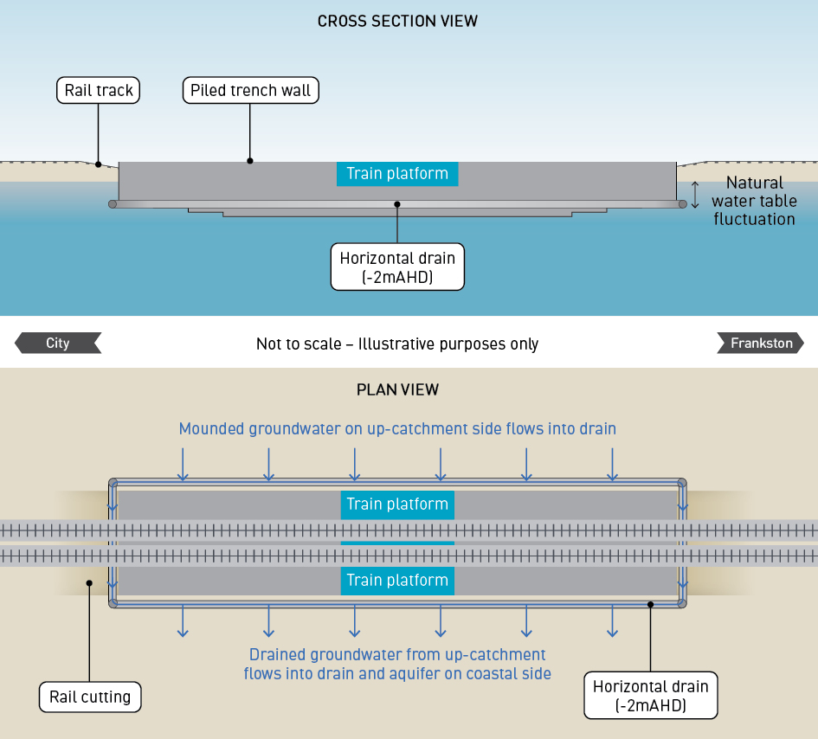

The engineering solution developed for this EES demonstrates that EPR_GW2 could be achieved to mitigate the potential impacts predicted at Edithvale. Prior to construction of the trench, an independent peer review would be undertaken by appropriately qualified specialists to confirm that the proposed engineering solution, or any variation or alternative to it, would achieve EPR_GW2. The rationale and further discussion regarding the effectiveness of this solution and EPR_GW2 is discussed in Chapter 5 Modelling the water environment.

Urban design
All aspects of the proposed project, including the station buildings, barriers and screens, car parking, substation and landscaping would be designed in accordance with the Urban Design Guidelines discussed in Chapter 11 Urban design approach and presented in Attachment VII Urban Design Guidelines – Edithvale.

Bonbeach level crossing removal project

This section outlines the key components of the Bonbeach level crossing removal project, including a trench, railway station, and ancillary infrastructure.

Rail trench
The removal of the level crossing at Station Street/Bondi Road, Bonbeach where it crosses the Frankston rail line is proposed to occur through lowering the rail line into a trench up to 1,200 metres long located between Golden Avenue and The Glade. The trench would require installation of piles along both sides of the trench to varying depths in a configuration such as that shown in Figure 2.5.

Figure 2.5 Indicative profile of the trench walls at Bonbeach

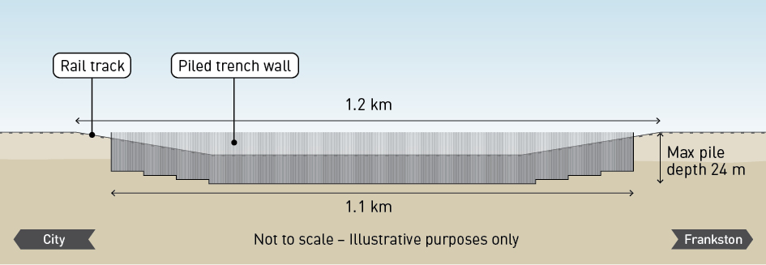

The length and depth of the trench are determined by a number of factors, including:
      - A maximum track gradient of two per cent.
      - A required 5.75 metre clearance between the tracks and the underside of the Bonbeach Road Bridge, such that the final level of the tracks would be approximately 8 metres below ground level.
      - The depth of the base slab and water storage tank is such that the maximum depth of excavation required is approximately 14 metres below ground level.
In terms of width, the trench is constrained by the width of the rail corridor between Nepean Highway and Station Street. At its widest point, the trench would be up to 24 metres wide (including the width of the piles, tracks and island platform), and narrow to approximately 14 metres at both ends. The trench would be within the existing rail corridor.

Bonbeach Railway Station
The existing station would be demolished and replaced with new station infrastructure. At street level, on a deck over the trench on the north side of Station Street/Bondi Road, a new station building would be constructed with ticketing and bicycle storage facilities.
The station precinct would also include 39 car park spaces (35 for commuters, one for disabled use, two for staff and one for emergency vehicles) on a 90 metre deck over the trench to the south of Station Street/Bondi Road, accessed from Station Street. The number of spaces provided represents no net loss of commuter parking relative to the existing conditions, while other informal commuter car parking and short-term car parking will be provided along Station Street and Nepean Highway.

DDA compliant access will be provided to the new island platform situated in the trench and between the tracks.
The car park deck would be offset from Station Street/Bondi Road to create a void over the platforms, for the same reasons as described for Edithvale station.
Project components are shown conceptually in Figure 2.6.

Figure 2.6 Schematic design for Bonbeach

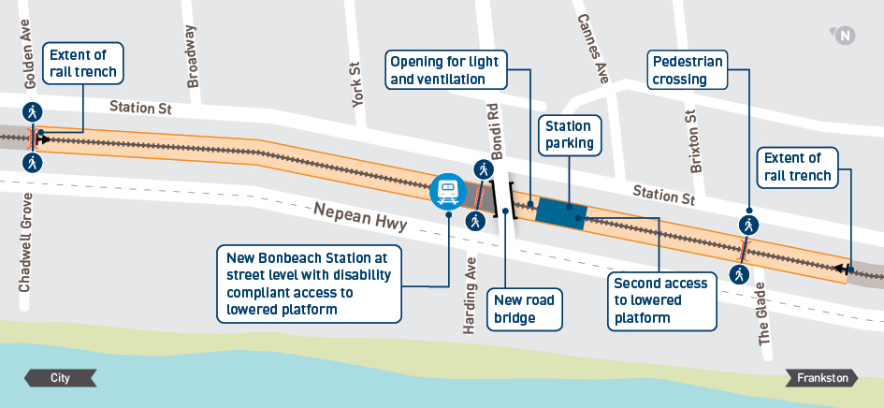

    - Railway infrastructure and utilities
New rail infrastructure to be reinstated includes the tracks, electrical and signalling systems.
To protect the trench, and ensure safety for the community at street level, a 0.8 to 1.8 metre tall concrete crash barrier would be required along the top of the trench. A screen to prevent items being thrown onto the railway would be included on top of the crash barrier up to a total height of 2.4 metres.
While not railway infrastructure, the corridor currently accommodates utility services such as electrical and telecommunication services for the surrounding community. These would require relocation in consultation with the utility owners who would undertake the relocation works. Other services that may require relocation include gas, water and sewerage. Works to relocate services would occur under separate approvals outside the scope of this EES.

Road, cyclist and pedestrian infrastructure
Station Street/Bondi Road would be reinstated in its existing location on a road bridge over the trench. Some modifications of the layouts and signalling at the Station Street and Nepean Highway intersection may be required to balance the needs of general traffic, public transport, cyclists and pedestrians.
Intersection modifications would be informed by traffic analysis and consultation with Council and VicRoads during the detailed design phase of the project.
Provision would be made on Station Street for bus stops to be added in the future.
A shared user path would be provided alongside the trench on Station Street to improve safety and access in and around the new station precinct.
Cross-corridor connectivity would be retained through the provision of two DDA compliant bridges over
the trench. The locations of these bridges would be confirmed in consultation with Council and incorporate stakeholder and community feedback, and require:
- a 2.4 metre barrier where bridges cross the railway to comply with railway standards and maintain public safety
- a clearance of 5.75 metres above the tracks, such that the closer they are to the end of the trench, the higher they need to be and the longer the DDA compliant ramp.

Surface water management
The trench would be designed to prevent groundwater from entering the trench and avoid the need for ongoing dewatering. However, rain would fall into the trench and require management.
A stormwater tank would be incorporated into the base of the trench to meet MTM requirements for accommodating rainfall equivalent to a 1 in 100-year two-hour storm. This equates to a volume of up to 800 cubic metres, including an allowance for the climate change scenario discussed in Section 2.9.
The design solution for discharging and treating collected stormwater would be developed in conjunction with Council and Melbourne Water to ensure the project meets stormwater management requirements.

Groundwater management
An engineering solution, similar to that proposed at Edithvale, is not considered necessary at Bonbeach as the direction of groundwater flow is different. The pile wall configuration proposed (shown indicatively
in Figure 2.5) includes measures that minimise potential impacts to groundwater, including stepped depths of impermeable piles. The stepped pile depths provide the necessary structural support for the trench while minimising the extent to which the piles extend into the groundwater and the associated disruption
to groundwater flow. For further information and the outcomes of the impact assessment in relation to this see Chapter 5 Modelling the water environment.

Urban design
All aspects of the proposed project, including the station buildings, barriers and screens, car parking, substation and landscaping would be designed in accordance with the Urban Design Guidelines discussed in Chapter 11 Urban design approach and presented in Attachment VIII Urban Design Guidelines – Bonbeach.

Construction

This section discusses the construction elements across the two projects. As both projects would occur concurrently, there is a high level of commonality between the two projects, and the following discussion therefore applies to both projects unless otherwise specified.
Key construction activities and requirements for the projects are outlined in the sections below and provide the basis for preparing the EES and assessing the potential impacts of the projects. Construction details would be subject to further refinement as the projects progress, however any changes to the activities and requirements outlined below would need to be in accordance with the EPRs set out in Chapter 9 Environmental Management Framework.

    - Construction activity
There are four phases to the construction activity, which are anticipated to take a total of 18 months. The four phases are:
      - site establishment and services relocation
      - piling
      - main rail occupation
      - completion.
The Frankston rail service would continue to run during all but the occupation phase, except for occasional overnight and weekend disruptions when buses would replace trains.
An indicative schedule is presented in Section 2.7.5.

Site establishment and services relocation
A program of preparatory and ancillary works includes identification and relocation of utility services such as water, electricity, gas and telecommunications. These would be undertaken to ensure there are none within the construction areas prior to commencement of major construction activities. This work would be undertaken in conjunction with, and delivered by, the affected utility service provider in accordance with their usual processes and are outside the scope of this EES and associated project approvals.
Preparatory and ancillary works typically include activities such as:
- Removal of vegetation within the project footprints.
- Establishment of necessary access points and haul routes alongside the tracks and/or a level base from which to operate the piling rig, including removal of fencing and other necessary infrastructure.
- Establishment of on-site offices and staff amenities, site fencing and way-finding signage where necessary around works to ensure the safety and security of the community (including train operations), plant and equipment, and the workforce.
- Undertaking further soil investigations to inform detailed design and construction methods.
- Establishment of environmental and traffic management controls.
To assist with the site preparatory works and services relocation works, short term closures of the rail line (i.e. overnight or weekend) and traffic restrictions may be required from time to time.

Piling phase
The main construction task to be completed prior to the main rail occupation would be the piling associated with the walls of the trench.
The piles along both sides of each trench would be installed progressively while trains are running.
Piling rigs operating on the Nepean Highway side of the rail corridor would likely require temporary closure of the easternmost traffic lane and any adjacent car-parking in the vicinity of the rig. Rigs on the Station Street side would also require temporary occupation of parallel car-parks, where they exist, and some temporary lane closures. The temporary lane closures would move along the corridor with the rig as piling works progressively move along the rail corridor.
Piling across Edithvale Road and Station Street/Bondi Road would require temporary short-term closure
of these roads at the level crossing. Alternative routes would be advertised prior to the closure of the roads. Short term closures of the rail line (i.e. overnight or weekends) may also be required from time to time.

What is a pile?

A pile or piling is a vertical structural element of a foundation, driven or drilled into the ground.

For the trenches associated with the Edithvale and Bonbeach projects, the piled wall is likely to be constructed using concrete piles. A hole is drilled (or ‘bored’) into the ground and the soil is removed prior to filling the hole with steel reinforcement and concrete.
This type of pile would have no impacts associated with vibration. However, alternative piling types could be used that consist of either steel ‘sheet’ piles, or ‘driven’ piles.
The piles would either be hammered or vibrated into the ground. These alternative retaining wall types have also been considered as part of the EES.
All of these various types of piling would have a common feature, being that they would form a watertight structure preventing ground water from entering the rail trench where the extent of the trench is beneath the water table. Piling
methods are shown schematically in Figure 2.7.

Figure 2.7 Piling methods: (a) bored pile; (b) sheet pile; (c) driven piles

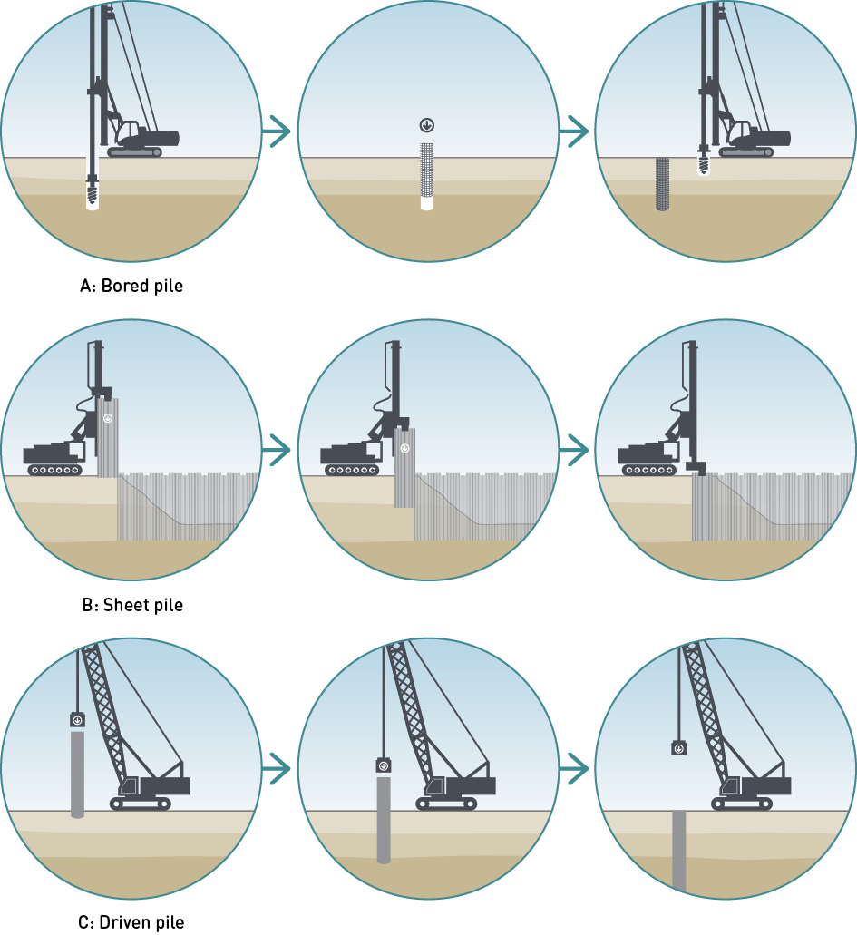

Main rail occupation
The overall closure or ‘occupation’ of railway infrastructure is expected to be 10 weeks.
This includes four weeks to remove the existing Edithvale and Bonbeach Stations and six weeks to excavate the trenches, lay new tracks and commission new infrastructure.
Approximately four weeks prior to excavation of the trenches, the existing Edithvale and Bonbeach train stations would be closed and demolished to facilitate the completion of piling in these areas. During this four-week period prior to the main occupation trains would still run, however, passengers who use these two stations would be required to use alternative stations nearby.
The main six-week rail occupation would require the closure of the railway between Frankston and Mordialloc (refer text box), and during this period, a train replacement bus service would be provided.

Major construction activities include:
- removal of existing rail and road infrastructure
- construction of the Edithvale Road and Station Street/Bondi Road bridges
- excavation of the trench and construction of the base slab and waterproofing. It is anticipated that the excavation to construct the trench would take approximately two weeks, subject to weather
- construction of new platforms and new station infrastructure
- installation and commissioning of new rail infrastructure (i.e. ballast, rail, power, signalling).
Activities would occur 24 hours a day, seven days a week until rail services resume at the completion of the rail occupation.
The anticipated six-week duration of the main rail occupation is subject to detailed design, construction staging and weather. The time of year has yet to be determined, and would be identified in conjunction with relevant stakeholders, including Public Transport Victoria, MTM, other level crossing projects and Melbourne Metro Rail Authority.

Why will the railway be closed between Frankston and Mordialloc

Trains cannot run while certain construction activities are being undertaken including excavation, construction of new stations and relocation of services in the rail corridor.
There is not sufficient space in the rail corridor to construct new tracks adjacent to the proposed trenches to enable services to continue during excavation and construction of new station infrastructure.
It is therefore necessary to close the railway while these works are undertaken. This means a bus service would operate between Frankston and Mordialloc.
It is not possible to run trains further south than Mordialloc because the infrastructure required to terminate trains and move them from the south bound track to the north bound track
is only available at Mordialloc.
The majority of the works during the site establishment and piling phase can be undertaken without closing the rail corridor and interrupting passenger and freight services. However, there would be periodic and unavoidable closures required from time to time, for works such as the relocation of some services and other works where it may not be possible or safe to continue railway operations. These closures would typically occur overnight or during weekends.

Completion phase
Following the main rail occupation, the level crossings would have been removed with trains resuming service through the trenches. Further activities would be required as part of project completion works such as landscaping, car parking, pedestrian/cycle paths and the train station fit out.

Construction hours and workforce

Site establishment, services relocation and piling phases
Site preparation and piling works would occur during normal day time hours, defined by the EPA Victoria Noise Control Guidelines (Publication 1254) as:
- 7:00 am to 6:00 pm weekdays
- 7:00 am to 1:00 pm Saturdays.
There may be times when unavoidable works would be required outside of these hours, such as oversized deliveries to site, works that have to occur outside those hours to minimise disruption to road and rail users, or completion of concrete pours that commence prior to 6:00 pm.
The construction workforce would be expected to be between approximately 50 to 150 people per day for these works.

Main rail occupation
Works during the main occupation at both project locations and each construction compound would occur 24 hours a day, seven days per week for the six week duration estimated for the main occupation. The construction workforce may peak in the order of 200 personnel per day during the main occupation. This would be expected to reduce steadily over four to five months following the main occupation through to completion.

Construction traffic

Site establishment, services relocation and piling phases
Prior to any works occurring on site, a construction management plan would be developed including a traffic management plan.
Construction works and staging, including material deliveries and parking for the workforce would
be planned so that construction traffic disruptions are kept to a minimum and access would be provided to nearby residents and businesses.

Main rail occupation
During the main occupation, the number of vehicle trips to each project would be expected to peak between 1,300 and 1,600 vehicles per day during the first half of the occupation. This includes vehicles of all types, with approximately 1,000 trucks per day removing spoil and 300 staff vehicles moving between construction compounds and each site. In addition, the project would be expected to generate 300 to 500 vehicles trips per day associated with workers travelling to and from work. For the remainder of the occupation, vehicle numbers between 400 and 600 per day would be expected, comprising the workforce, supervisors and material deliveries.
Vehicle movements between the construction compounds and the sites would follow a predetermined route in accordance with a traffic management plan to be prepared prior to construction.

Construction work sites
To minimise disruption at and around the two project sites, one or more separate site compounds (or ‘laydown areas’) would be established for site offices, storage of materials and plant, amenities for workers, secure container storage, short-term storage for waste and potentially workforce parking. The laydown area(s) would be required to be in use for all of the anticipated 18 month construction duration.
Currently such a site has not been identified. Following the engagement of a contractor, they would identify one or more sites that are suitable for this purpose. Selection and operation of such a site is commonplace for construction projects such as these.
The two project sites are well served by arterial roads with Nepean Highway adjacent to the rail corridor, and Edithvale Road providing connection to Eastlink, Mornington Peninsula Freeway, Springvale Road and other arterial roads. While the location of the laydown areas is not yet known, the traffic movements between the laydown area(s) and the project areas can occur, mainly via roads intended for heavy vehicle use.
The assessments presented in this EES do not consider laydown areas. Depending on the site(s) selected,
a separate planning approval process may be required which would need to be informed by site investigation and consultation.
The laydown area(s) would be reinstated following works to their pre-project condition, or as agreed with the landholder. The nature of reinstatement and any improvement works would be agreed with the landowner and other stakeholders, potentially including (but not necessarily limited to) Council and VicRoads.

Indicative construction schedule
An indicative construction schedule for the concurrent delivery of both projects is shown in Figure 2.8.

Figure 2.8 Indicative construction schedule

Month | 1 | 2 | 3 | 4 | 5 | 6 | 7 | 8 | 9 | 10 | 11 | 12 | 13 | 14 | 15 | 16 | 17 | 18
Laydown area(s) in use
Site establishment and services relocation
Site establishment
Services relocation
Piling
Piling
Main rail occupation
Remove infrastructure, excavation of trench, construction of road bridge and rail infrastructure
Completion
Completion of train station and car park deck; Substation
Completion works and clean-up of sites (local and arterial roads, shared user path, pedestrian bridge installation, landscaping, lighting, site remediation)

    - Waste and spoil management
Approach
Spoil is defined as waste soil or rock resulting from excavation activities. The anticipated volume of spoil within each trench (including piling and stormwater storage) is approximately 140,000 cubic metres. As soil is excavated it de-compacts (or ‘bulks up’), so that the total volume of soil to be managed is conservatively assumed to be approximately 180,000 cubic metres. This EES has considered the conservative bulked volume to ensure that mitigation measures for waste and spoil management would be effective.
Spoil generated by construction activities would be managed in accordance with the waste management hierarchy as defined in the Environment Protection Act 1970 (Vic). This designates the most to least preferable treatments for waste, as follows:
      - Avoidance: not feasible given the proposal is to build a trench, however the design would ensure that spoil volumes are minimised
      - Re-use: opportunities for re-use would be explored prior to the commencement of works, however the sandy nature of soils is not generally suitable for reuse where soil is required to have a structural element (i.e. fill under road or rail embankments)
      - Recycling: this has similar challenges as the re-use of spoil
      - Recovery of energy: not applicable for soils
      - Treatment: this is required if spoil is contaminated. It may be required prior to re-use or disposal, subject to opportunities available and capacity or requirements of licenced disposal sites
      - Containment: not feasible given the proposal is to build a trench
      - Disposal: disposal to landfill facilities licenced to receive soils of the type excavated for these projects.
Those options considered feasible and practicable for spoil management, in order of preference include re-use or disposal (with treatment, if required).
Landfill facilities exist and a number of these have been identified as suitable for receiving the spoil from the two projects based on current and forecast capacity. However, in consideration of other major infrastructure projects that would concurrently be under construction (including the Melbourne Metro Rail Tunnel Project and West Gate Tunnel Project), the landfill facility to be used would be determined just prior to the commencement of construction.

The final disposal strategy would be developed in accordance with EPA Victoria requirements, particularly in regard to managing any contamination, acid sulfate soils, and groundwater entrained within the soil, and whether spoil would be stockpiled or taken immediately to landfill. Haulage routes would follow Station Street to the nearest designated arterial road, then follow arterial roads to the ultimate re-use or disposal site. Where roads other than Station Street or designated arterials are required to be used, this would be done in consultation with VicRoads and the relevant local authority, with appropriate notice given to any affected residents.

Operation and maintenance
When complete, the rail infrastructure would be owned by VicTrack and operated in accordance with VicTrack’s network demand and environmental management system. The operation of the network is outside LXRA’s control, however it is an important consideration in the design and assessment of the projects to understand the potential impacts of the projects following completion. Ongoing monitoring and associated mitigation requirements set out by the EPRs would be implemented following completion of the projects
by the relevant organisation.
Given the proposed change in the rail gradients that would result from the construction of the rail trench, it is anticipated that diesel services, including freight trains, may increase the ‘notch’ (i.e. power or throttle) setting of engines on the inclines as they exit the trench. Assessments within this EES have been undertaken on this basis to present a more conservative assessment.
Maintenance of the infrastructure would be undertaken in accordance with existing requirements.

Addressing sustainability and climate change within project designs

Sustainability
The projects would be designed and delivered to meet sustainability standards under two assessment tools:
      - Minimum 4 star rating under the Green Building Council of Australia (GBCA) Green Star rating tool, applicable to stations.
      - ‘Excellent’ rating under the Infrastructure Sustainability Council of Australia (ISCA) Infrastructure Sustainability (IS) rating tool, applicable to non-station infrastructure.
These tools and the standards that the projects would achieve against each are discussed in Chapter 10
Sustainability and climate change.

Climate change
The longevity of the infrastructure requires consideration of climate change projections so that the design of each project ensures that future climate change would not threaten the viability of the infrastructure.
LXRA has adopted the following scenario set out by the Intergovernmental Panel on Climate Change (IPCC) Fifth Assessment Report (CSIRO, 2015; Grose et al., 2015):
      - The Representative Concentration Pathway (RCP) 8.5 scenario as it relates to projected climate conditions in 2090.
While these scenarios are used to model a broad array of climate variables (i.e. temperature, wind speeds, evaporation and soil moisture), the key variables are rainfall intensity and sea level rise. LXRA, in consultation with Melbourne Water as the relevant authority in regard to flood management, require that the two projects address Scenario RCP8.5 as extrapolated to 2100. This is consistent with Melbourne Water’s Planning for Sea Level Rise Guidelines 2017 which apply scenario RCP8.5 and identify the following key metrics, relative to current local conditions, that are to be addressed within the designs:
      - an increase in rainfall intensity of 19 per cent by 2100
      - sea level rise of 0.8 metres over and above the existing 1 in 100-year flood levels.
The design presented within this chapter, and the assessments presented in this EES and supporting technical reports, incorporate these projections as appropriate (for example, the surface water management systems discussed in Sections 2.5.5 and 2.6.5).
To ensure that a broader array of climate change factors would be considered and adaptation measures are in the detailed design, LXRA requires its contractors to undertake and implement a climate change risk assessment in accordance with Criteria Cli-1 and Cli-2 as defined by the ISCA IS rating tool. This
is discussed further in Chapter 10 Sustainability and climate change.

2.22 Edithvale and Bonbeach Environment Effects Statement | Rationale and project descriptions

