TUN1905.01

22 May 2019

Works notification: Southern portal site establishment and utilities relocation
From early June and over the next few months, you may notice more activity as we commence works to establish our construction site at the end of New and Watson Street, South Kingsville. These works are the construction of the West Gate Tunnel outbound southern portal.

Some of the works taking place within our site include:
- vegetation removal;
- installing buildings and facilities for work crews;
- creating safe access points for the site;
- building internal roads and car parking, and
- relocation of utility services.

Utility services investigation and relocations – Truman, Watson and New Streets

Before the construction site can be established, we need to complete service investigations and relocations over two weeks from early June, on Watson Street and at the end of New and Truman Street.

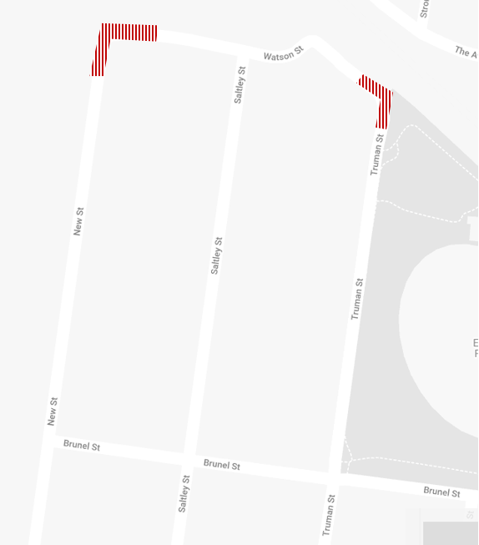
What to expect:
- Full road closures and changed traffic conditions at times at the end of Truman, Watson and New Streets (refer to the map for approximate locations) for up to two weeks.
- Traffic management and local detours will be in place for residential access.
- The working hours for these investigations are Monday to Saturday 7am – 6pm.
- Adjacent residents will be kept informed closer to the time around the start of works and if required, any temporary water service interruptions.
- Works include saw cutting, trenching, installing conduits, and asphalting.
The red area shows the approximate locations for the service works from June.

WANT TO BE KEPT IN THE LOOP FOR ROAD CLOSURES OR WORKS IN NEW AND TRUMAN STREETS?
If you would like email updates for the works in this notification please email the project team at info@wgta.vic.gov.au and type “New St Updates” in the subject line.

While we expect this work will have some low level associated noise, we will take steps to minimise noise and will monitor any impacts. Thank you for your patience while we undertake these important activities.

Please note that works are subject to change and could be rescheduled in the event of bad weather or there are updates to the investigations scheduled. For more information about the upcoming works and traffic changes, please contact us.

Contact us
Please contact us if you have any questions or feedback about these works.

westgatetunnelproject.vic.gov.au info@wgta.vic.gov.au
1800 105 105
facebook.com/westgatetunnelproject
@westgatetunnel
West Gate Tunnel Project GPO Box 4509
Melbourne Victoria 3001
Interpreter service: 13 14 50

