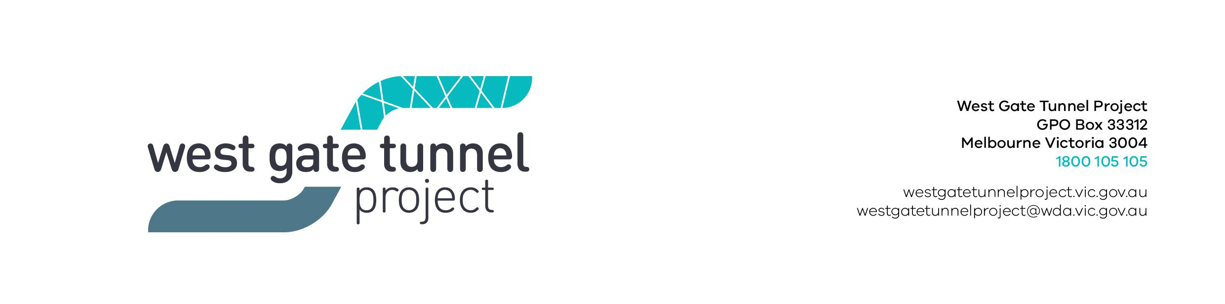
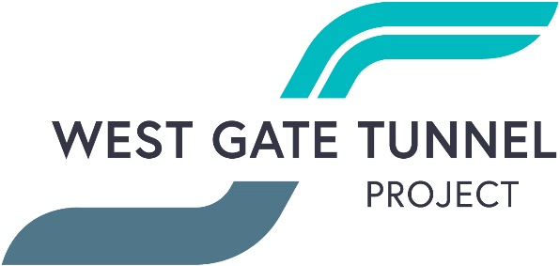
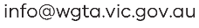

Reference: WES1902.16
27 February 2019
Works reminder – temporary disruptions

We’re continuing to excavate the road along Fogarty Avenue to install a new drainage pipe and move some overhead power lines underground. As part of these works, Fogarty Avenue will be temporarily closed at the intersection of your street.
Temporary closure of Fogarty Avenue
Tuesday 5 March to Tuesday 26 March 2019

- vehicle access along Fogarty Avenue between Deleware Street and Cranbrook Street will be temporarily blocked from Tuesday 5 March to Tuesday 26 March 2019;
- your driveway and footpath access will be maintained;
- a local detour will be in place during this time; and
- parking along sections of Fogarty Avenue will be unavailable during this time – please see the map below for location details.

Waste collection:
The closure of Highgate Street and Fogarty Avenue intersection will limit access for waste collection trucks. As a result, can you please place rubbish bins on the west side of Highgate Street for collection between Tuesday 5 March to Tuesday 26 March 2019 – please see the map below for location details.

What you could expect:
- an increase in construction vehicles within the area;
- construction noise from rock breaking during excavation, use of machinery and trucks;
- you may notice localised dust and minor vibration during these works;
- water spray trucks will be used to help manage dust and dirt and truck loads covered when dirt and rock are being transported; and
- traffic changes will be required and signed detours will be in place – latest traffic updates are available at www.westgatetunnelproject.vic.gov.au/traveldisruptions.

These works will generally be carried out from Monday to Friday between 7am - 6pm and Saturdays between 7am - 1pm.

When works are scheduled out of hours that may have a direct impact on you, we will provide further information to you before works start.

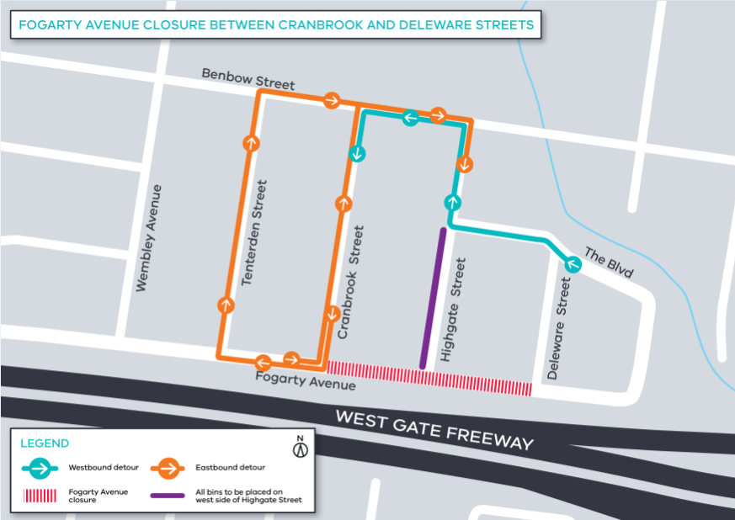

Please note that works may be rescheduled in the event of bad weather or other unavoidable circumstances.
For updates and more information about our works please visit westgatetunnel.vic.gov.au or contact us using the details below.

Contact us
Please contact us if you have any questions or feedback about these works.
 | westgatetunnelproject.vic.gov.au |  | facebook.com/westgatetunnelproject
 | info@wgta.vic.gov.au |  | @westgatetunnel
 | 1800 105 105 |  | West Gate Tunnel Project  GPO Box 4509  Melbourne Victoria 3001
 | Interpreter service: 13 14 50

