WES1910.03
28 October 2019

Notification of works: Buchanan Road realignment
As part of widening the West Gate Freeway, we need to realign the Buchanan Road / Lynch Road corner. From Monday 11 November to Friday 13 December, the road will be fully closed in the area shown on the map below.
We will also remove two power poles and power lines located near the corner of Buchanan Road. Removing these power lines will not affect power supply to homes in the area.
Where
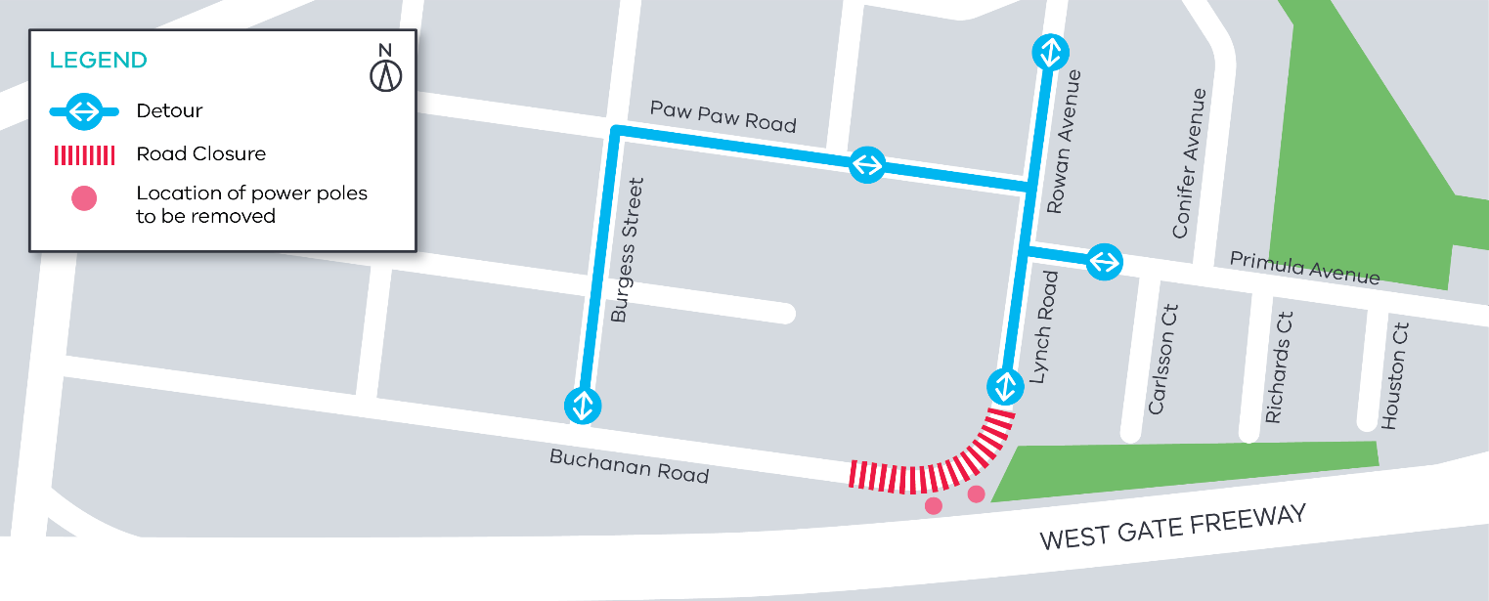
A fully signed detour route will be in place while the road is closed. Traffic will be diverted along Burgess Street and Paw Paw Road as per the map.
When:
- From Monday 11 November to Friday 13 December 2019 - Monday to Friday from 7am to 6pm and Saturday 7am to 1pm.

If we need to work at night or outside our normal working hours, we’ll let you know in advance if works will directly impact you.
What’s involved
Work will include:
- removing two power poles and associated power lines
- excavating and earthmoving
- constructing a section of realigned road pavement
- laying new asphalt.
The latest traffic updates are available at westgatetunnelproject.vic.gov.au/traveldisruptions
What to be aware of:
- construction vehicles including excavators and earthmoving equipment will be moving in and out of the work area
- construction noise from trucks, compactors, road saws and general construction machinery
- access to and from the construction site will be from Buchanan Road
- dust and dirt will be minimised by using water spray trucks, street sweepers and covering dirt and rock when it is being transported.

Please note that works may be rescheduled in the event of bad weather or other unavoidable circumstances.
For updates and more information about our works please visit westgatetunnel.vic.gov.au or contact us using the details below.

Contact us
Please contact us if you have any questions or feedback about these works.
 | westgatetunnelproject.vic.gov.au |  | facebook.com/westgatetunnelproject
 | info@wgta.vic.gov.au |  | @westgatetunnel
 | 1800 105 105 |  | West Gate Tunnel Project  GPO Box 4509, Melbourne VIC 3001
 | Interpreter service: 13 14 50

