19 June 2020 WES2006.05

Works notification: Installation of new noise wall panels
The West Gate Tunnel Project team will soon begin installing the concrete noise wall panels in some areas of your neighbourhood.

We will install new noise wall panels onto recently installed posts as they become available and as we can access areas. The locations for panel installation are determined by the order in which work needs to be completed to allow the next stage of works to progress.

The new noise walls will be around eight-to-nine metres high. In some sections, they will be topped with pale blue and green coloured acrylic panels. Where space permits, planting will be used to screen the noise walls.

The new noise walls will provide you much better protection from freeway noise than the old noise walls. They have been designed to achieve a daytime average noise level of 63dB(A) at nearby houses, which will mean a significant reduction in noise levels for many residents.

Location and timing of works

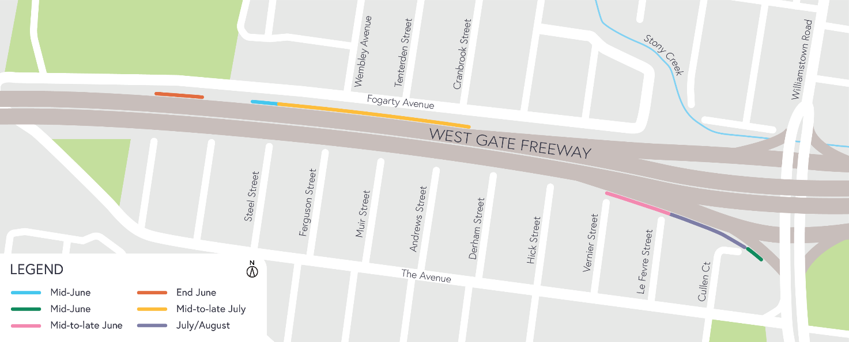

IMPORTANT: If you require more information, you’re welcome to contact us to arrange a phone catch up. Contact details over page.

Hours of work

These works will generally be carried out from Monday to Friday between 7am - 6pm and Saturdays between
7am - 1pm, however some night works may be required. When works are scheduled out of hours and may have a direct impact on you, we will provide further information to you before works start.

What you can expect during the works:
- construction vehicles, including trucks and cranes, will be moving in and out of the work areas
- low level noise from cranes installing the noise wall panels
- main access to the construction sites will be via our work area from the freeway side with minimal site access required via local roads
- traffic changes including lane, road and ramp closures may be required. The latest traffic updates are available at westgatetunnelproject.vic.gov.au/traveldisruptions
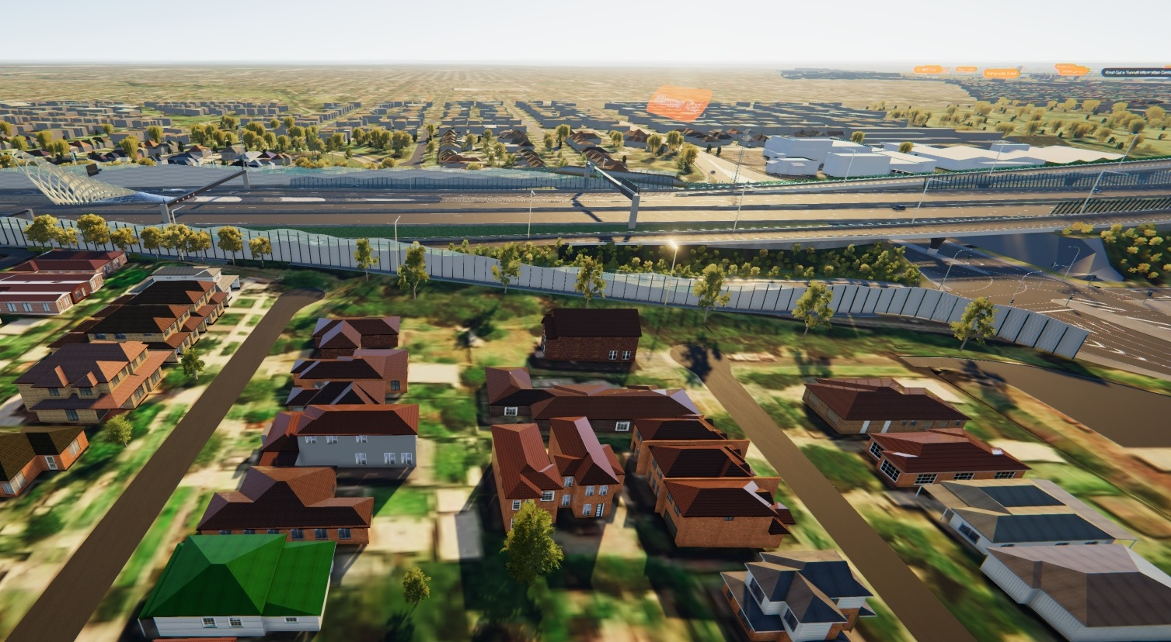
Artist’s impression of the noise walls looking north across Cullen Court and Le Fevre Street

Coronavirus COVID-19 update

The health and safety of our workers is our key priority as we continue to deliver the West Gate Tunnel Project, as is supporting physical distancing measures in line with current health advice. We have strict protocols in place to protect the safety of our construction workforce and the community. These include enhanced industrial cleaning arrangements and measures to reduce staff contact including staggered shifts and physical distancing. For more information and advice about Coronavirus, please visit coronavirus.vic.gov.au.
For updates and more information about our works, please visit westgatetunnelproject.vic.gov.au or call us on 1800 105 105.
Please note that works may be rescheduled in the event of bad weather or other unavoidable circumstances.

