16 September 2020 WES2006.03(R)

Works update: Newport Rail Bridge   
hydro-blasting daytime works

We recently let you know that we will be undertaking hydro-blasting works at Newport Rail Bridge, including the need for night works in late September.

Please be advised that these night works, which were planned to commence next week, will now be undertaken during the day due to the extension of the Stage 4 restrictions. We hope this is less disruptive to you and your neighbours.

**Daytime works Monday to Saturday, starting 21 September   
Dates:** From 21 September until late September and take approximately five days to complete  
**Times:** From 7am to 5pm  
  
Note the above dates may change based on weather conditions.

**Hydro blasting**

Hydro blasting is noisy work. It uses very high-pressure water to remove concrete on the edges of the existing bridges to expose the internal steel reinforcing bars. We have installed sound mats around the machine to help reduce the noise it creates – see the image below. This will be the last of the hydro-blasting works at the Newport Rail Bridge for 2020.

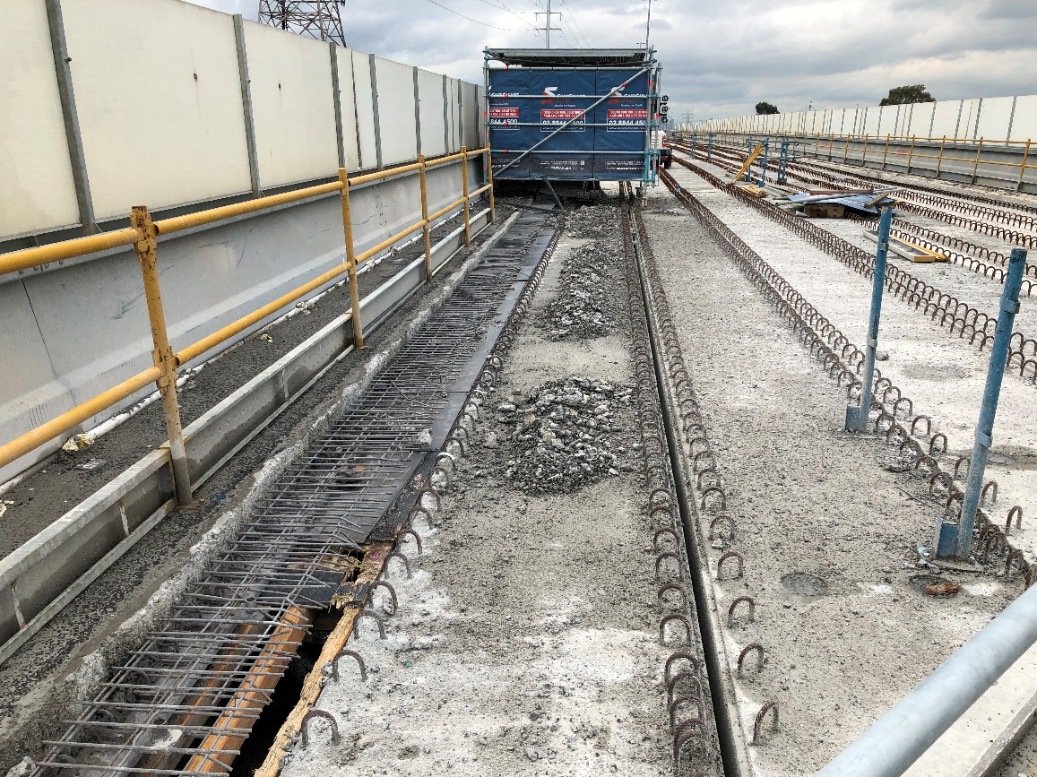

*Acoustic panels surround the hydro-blasting machine*

**What to expect during this work:**

* noise from high pressure water jets
* traffic management on The Avenue. Local access will be maintained to sporting clubs and properties
* increase in construction vehicles using designated routes, including local roads
* traffic changes will be in place. The latest traffic updates are available at westgatetunnelproject.vic.gov.au/disruptions.

**Location of works**

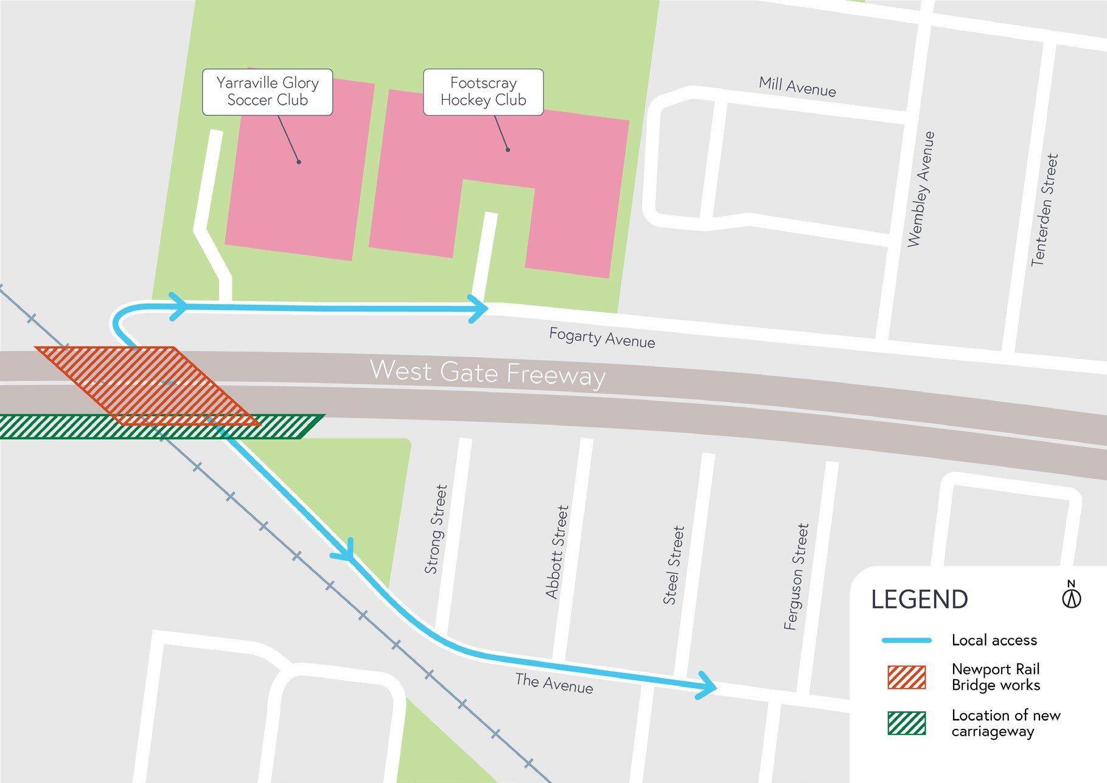



# C:\Users\jshekho\AppData\Local\Microsoft\Windows\INetCache\Content.Outlook\LIMXYOVU\qrcode.56308154.png **Coronavirus COVID-19 update**

The health and safety of our workers is our key priority as we continue to deliver the West Gate Tunnel Project, as is supporting social distancing and the wearing of masks in line with current health advice. We have strict protocols in place to protect the safety of our construction workforce and the community. These include enhanced industrial cleaning arrangements, and measures to reduce staff contact, including staggered shifts and physical distancing. For more information and advice about Coronavirus, please visit coronavirus.vic.gov.au.

**For updates and more information about our works, please visit westgatetunnelproject.vic.gov.au or call us on 1800 105 105.**

**Please note that works may be rescheduled in the event of bad weather or other unavoidable circumstances.**