16 November 2020

Traffic diversions: Williamstown Road and Blackshaws Road, late November 2020

There is an upcoming overnight closure of the West Gate Freeway that will require freeway traffic to be detoured via Williamstown Road and Blackshaws Road.
Timing
The one night closure is currently scheduled for Saturday 21 November 2020, between 11pm and 7am. However, as there are other associated works underway, the closure may need to occur on Saturday 28 November 2020, between 10pm and 7am.
You can find updates about freeway closures on our Facebook page (@WestGateTunnelProject) or the Big Build disruptions map at bigbuild.vic.gov.au/disruptions/, or by calling 1800 105 105 at any time.
Why we need to close the West Gate Freeway
This overnight closure of the West Gate Freeway is required to pour the concrete deck on the new pedestrian overpass between Muir Street and Fogarty Avenue. This work can only be done safely when there is no traffic below the pedestrian overpass.
The overpass is scheduled to open later this year and will provide a greatly improved north-south connection between Spotswood and Yarraville that will be fully accessible for all community members to use. The new pedestrian overpass at Rosala Avenue is now open to the community, providing a vital connection for pedestrians and cyclists.
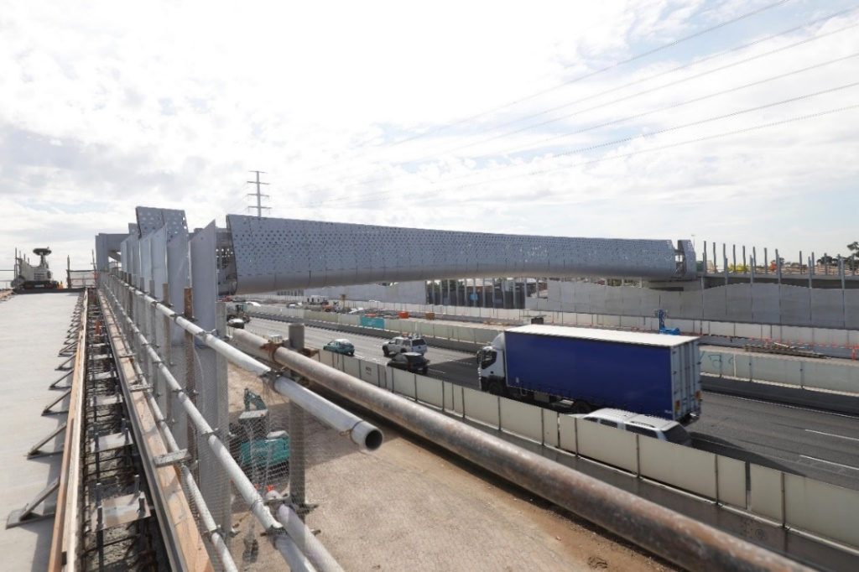
Image: the newly installed pedestrian overpass at Muir Street, Spotswood, above the West Gate Freeway

Future freeway closures
We understand that overnight closures on the freeway are disruptive for residents and we thank you for your patience and understanding. Unfortunately, there are limited options for diverting traffic and motorists will need to use Williamstown Road and Geelong Road or Melbourne Road and Blackshaws Road to exit and re-enter the freeway. However, we are always looking at the freeway closure program to ensure that these detours are used only when we cannot safely complete these works without closing the West Gate Freeway.
Provide your feedback
Your feedback is important and helps to ensure that impacts are better managed and communicated. If you have comments or questions about the Project, please call 1800 105 105 or email info@wgta.vic.gov.au.
We’ve also launched a new Facebook Group for people to keep updated about works near them. See more of what’s happening behind the scenes and join the discussion at: facebook.com/groups/westgatefreewayconstructionupdates
For updates and more information about our works, please visit westgatetunnelproject.vic.gov.au, call us on 1800 105 105, or follow us on Facebook at facebook.com/WestGateTunnelProject/.
Please note that works may be rescheduled in the event of bad weather or unexpected impacts to the construction program.

