23 February 2021 WES2102.02R
Works notification: Simcock Avenue, Spotswood – power line works

Following on from the notification we sent you in mid-January, The West Gate Tunnel Project have rescheduled works on an overhead power line on Simcock Avenue to Saturday 27 February, from 5pm until 1am Sunday 28 February.
The works will require our team to remove and reinstate an overhead power line as part of our preparations for the construction of the new Hyde Street outbound entry ramp to the West Gate Freeway.
To safely do this work it will require the closure of a small section of Simcock Avenue between Hall Street and Booker Avenue. Traffic management will be in place during the works to assist motorists or pedestrian to move safely in the area.
What to expect during these works:
The works are not expected to be noisy to neighbouring homes, however during the Simcock Avenue closure, vehicles will need to detour via Hall Street to the eastern section of Hudson Road and Booker Street.
There will be short power disruptions to some businesses during these works. You will be contacted by Jemena directly if you are impacted.
A truck with an elevated work platform will be on site to complete the works, along with a small number of light construction vehicles and traffic management services.
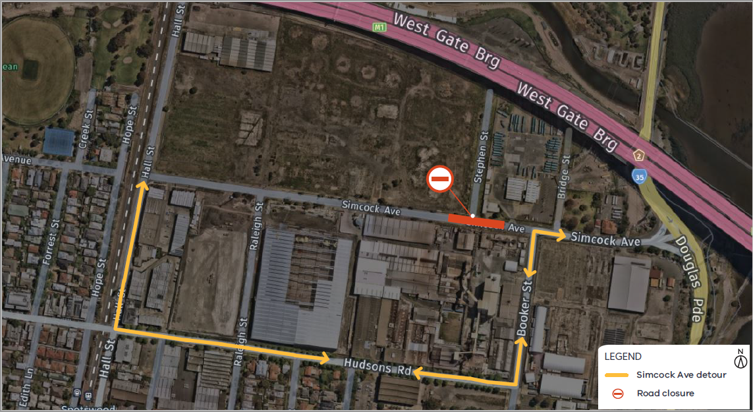
Please note that works are subject to change and may be rescheduled in the event of unexpected impacts to the construction program. Thank you for your patience during these works.
For updates and more information about our works please visit westgatetunnelproject.vic.gov.au.

