EAS19JUL.002
08 July 2019

Notification: Maribyrnong River bridge works
Works to construct the new bridges across the Maribyrnong River, linking the new West Gate Tunnel to the elevated roadway above Footscray Road, continues. This notification provides an update on these works.
Marine piling and marine traffic in the Maribyrnong River

Piling works within the Maribyrnong River are expected to start from 22 July 2019 and will be completed over six stages, taking approximately 12 months. Marine traffic management will be established to keep recreational river users safe during piling, and will include:

- Buoys being placed to assist navigation around the works in the river; and
- Using variable message signs (VMS) to advise users of the changes.
To ensure the safety of workers and river users, temporary river closures will be in place during the lifting of 2m diameter pile tubes required for these works. Signage and river traffic management will indicate these lifts at the time.
Noise and vibration may be noticeable during these activities however, assessments have been conducted, which indicate the noise levels are expected to remain within permissible levels.
Works are planned to take place between Mondays and Saturdays, 7am to 5pm.
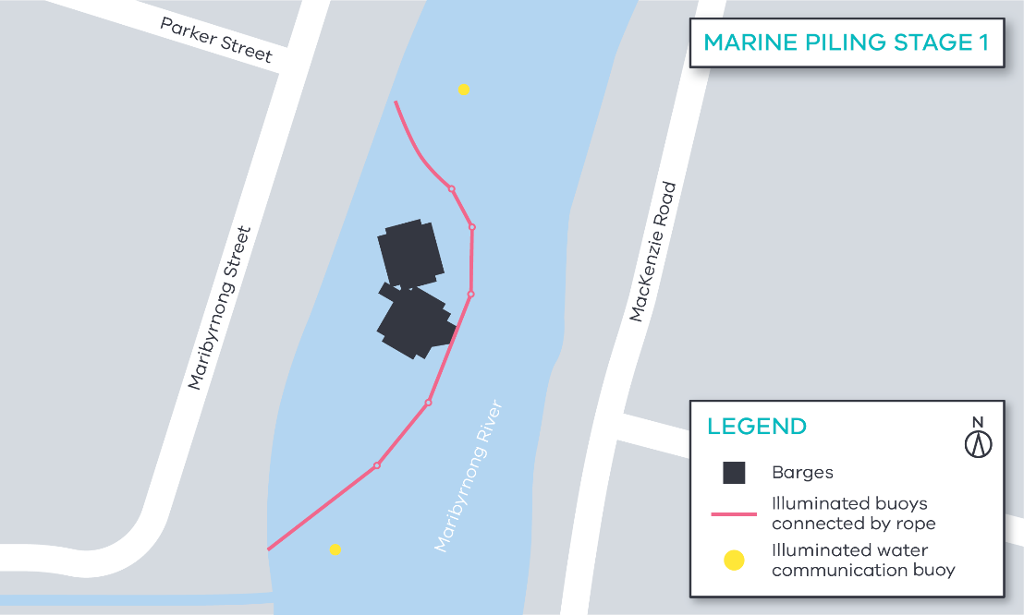
Figure 1- Marine piling location stage 1
What is Marine Piling
Marine piling is the process of building deep foundations into the ground below sea level to support structures such as a bridge.

To install the piles, a steel tube is driven into the ground, the water encased in the tube is removed and reinforced steel and concrete is put into the tube to form the pile.
Piling works and pier construction on Maribyrnong River banks
River bank piling works and pier construction started in May and will continue for approximately 12 months. These works are to build the foundations for the bridges over the Maribyrnong River, as well as support the banks of the river.

Piles are constructed using a combination of methods including: driven piling, bored piling and sheet piling. This activity is followed by the construction of the plie cap and the piers.

Ongoing general construction activity is happening in the works area, including movement of construction plant and equipment.

Works are planned to take place between Mondays and Saturdays, 7am to 5pm.

Utility relocations
Utility works continue within the area including power relocation works in Maribyrnong, Lyons, Whitehall and Youell streets, which will be ongoing until late August.
These works will be staged and delivered using a combination of open trenching, underground drilling and cable installation. These works will be delivered by the utility providers’ preferred contractors and supported by the Project team.
Additional utility relocations will be required in 2020, which will include telecommunications, water and gas. We’ll notify of these works closer to the date.
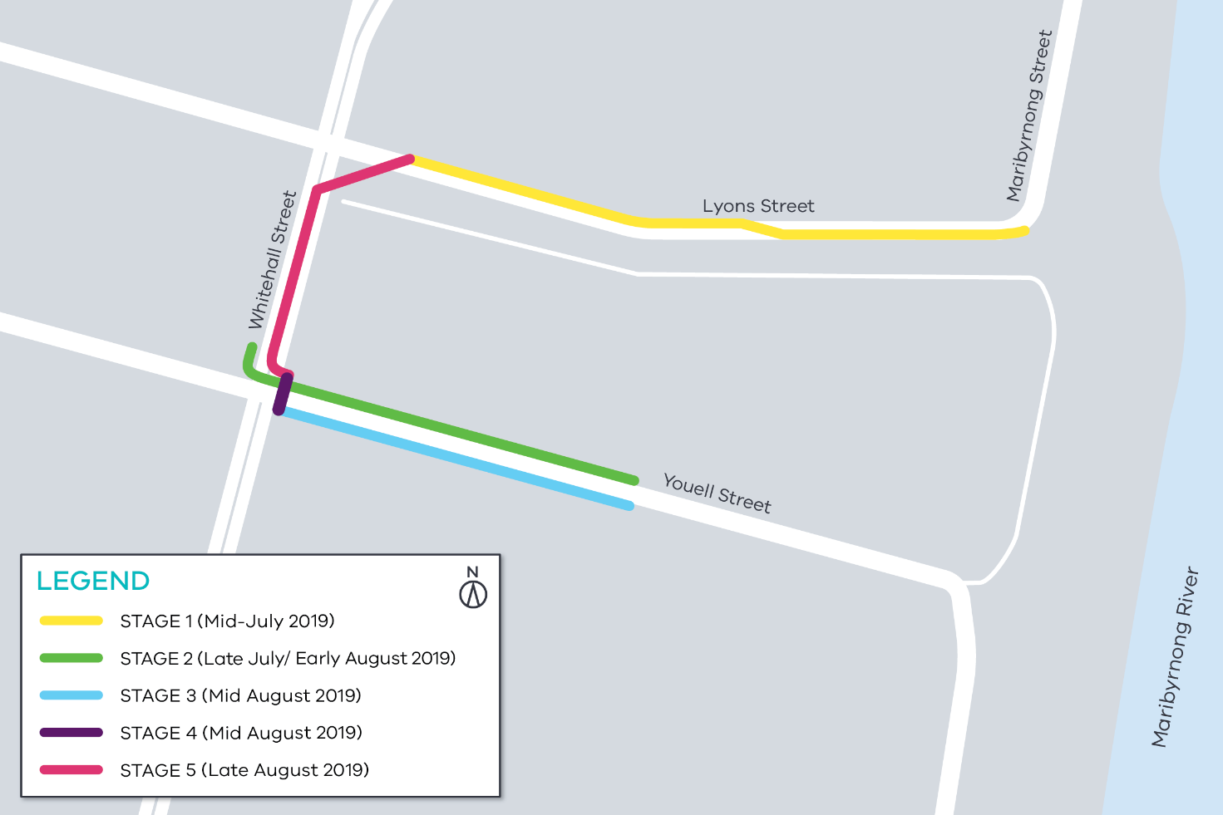
Works have been scheduled to take place at night to minimise impact to the community.
Figure 2- Power relocation works

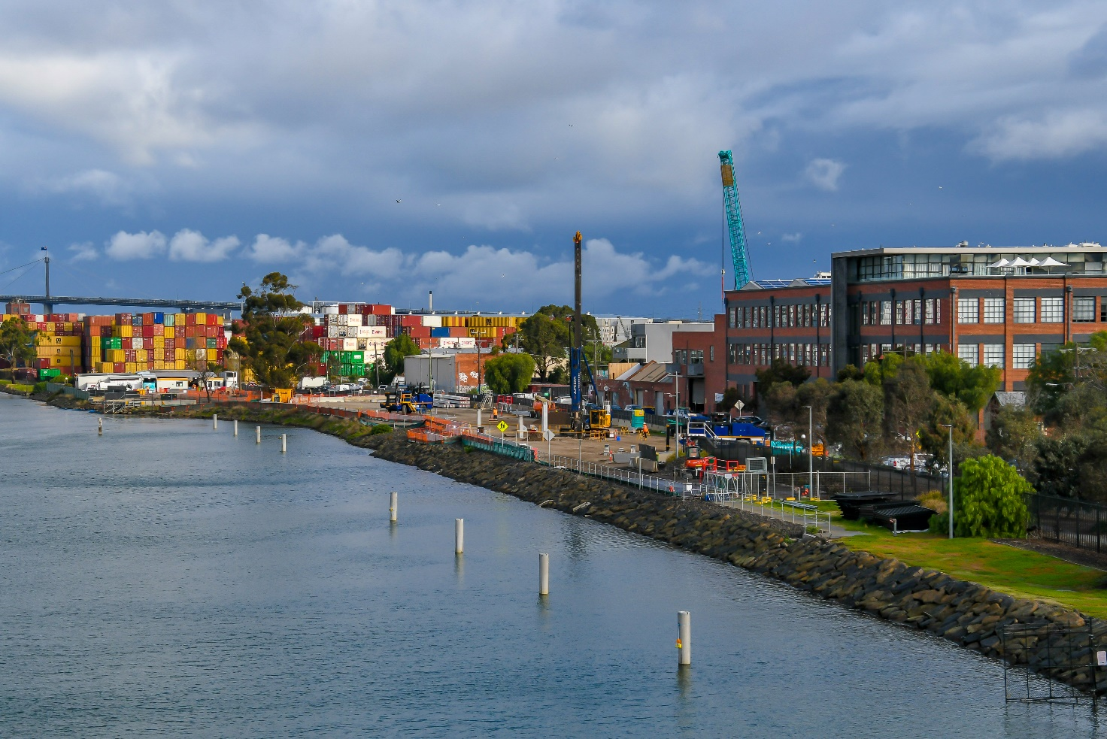
Figure 3- Construction site on west bank of Maribyrnong River

MacKenzie Road works

Works to begin realigning Mackenzie Road started in June and are ongoing. These works create more space for piling activity on the Maribyrnong River bank and for the future rebuild of MacKenzie Road.

Works include implementing traffic management, road works, vegetation removal, kerb removal, road preparation and a traffic switch to the new road section. Traffic flow along MacKenzie Road will be maintained during these works.

These activities will take place at night to minimise impact to the truck and freight industry.

Local road and parking changes
To enable our teams to undertake the works safely and efficiently, some temporary road changes may take place, including removal of car parking spaces and occasional road closures (if required). Traffic management will be in place to advice of any changes

There will also be an increase in construction vehicle movements in the area, as we transport equipment and material to and from our work sites.

What to expect during construction
- We will notify you if there are any significant changes to the timing of our works.
- Traffic management will be in place to manage changed conditions including temporary access, changes to car parking spaces and signage to guide road users and cyclists.
- Dust managed on site.
- Piling works can create increased levels of noise and vibration.
- Assessments have been conducted, which indicate the noise levels are expected to remain within permissible levels as documented in the project’s Environmental Performance Requirements.
Contact us

Please contact us if you have any questions or feedback about these works.
 | westgatetunnelproject.vic.gov.au |  | facebook.com/westgatetunnelproject
 | info@wgta.vic.gov.au |  | @westgatetunnel
 | 1800 105 105 |  | West Gate Tunnel Project  GPO Box 4509  Melbourne Victoria 3001
 | Interpreter service: 13 14 50

We thank you for your patience during these works. We will continue to notify you as these works progress.

