16 April 2021 WES2104.01

Works notification: Walking and cycling path along Fogarty Avenue

At the start of the year we let you know that we will begin building a section of the Federation Trail extension, along Fogarty Avenue from Newport Rail Bridge to The Boulevard.
Before we can start constructing the new Federation Trail section, we will set up safety barriers and remove the old timber noise wall panels. Noise protection will be provided by the new concrete noise panels that have now been installed.
A one-way traffic arrangement will also be in place on Fogarty Avenue, from Wembley Avenue to The Boulevard. This is so we have enough space to safely construct the walking and cycling path, while at the same time keeping Fogarty Avenue open to traffic
The one-way traffic arrangement will remain in place from Monday 3 May until works are completed in late 2021.
Federation Trail works between Newport Rail Bridge and The Boulevard
From 3 May – late 2021
Works will include:
- setting up a one-way traffic arrangement on Fogarty Avenue, from Wembley Avenue to The Boulevard. See map on the next page for details.
- short-term road closures so we can install barriers with screening, to establish a safe construction site. If you are directly impacted, we will let you know the dates for these closures nearer to the time
- removing old timber noise walls and vegetation along Fogarty Avenue, between Newport Rail Bridge to Williamstown Road
- pouring concrete to form the new shared use path
- repairing kerb and placing new asphalt in sections along Fogarty Avenue
- completing the drainage pits along Fogarty Avenue

During this time:
- Driveway and footpath access to residential properties along Fogarty Avenue will be maintained
- Street parking along Fogarty Avenue, from Wembley Avenue to The Boulevard, will be unavailable while the works take place

Waste collection:
- There will be no changes to waste collection while these works take place

Hours of work
Our usual hours of work are Monday to Friday between 7am-6pm, and Saturdays between 7am-1pm. However, night works are sometimes required. When works are scheduled out of hours, or if you are located close to the works, we will provide you with further information before the works start.
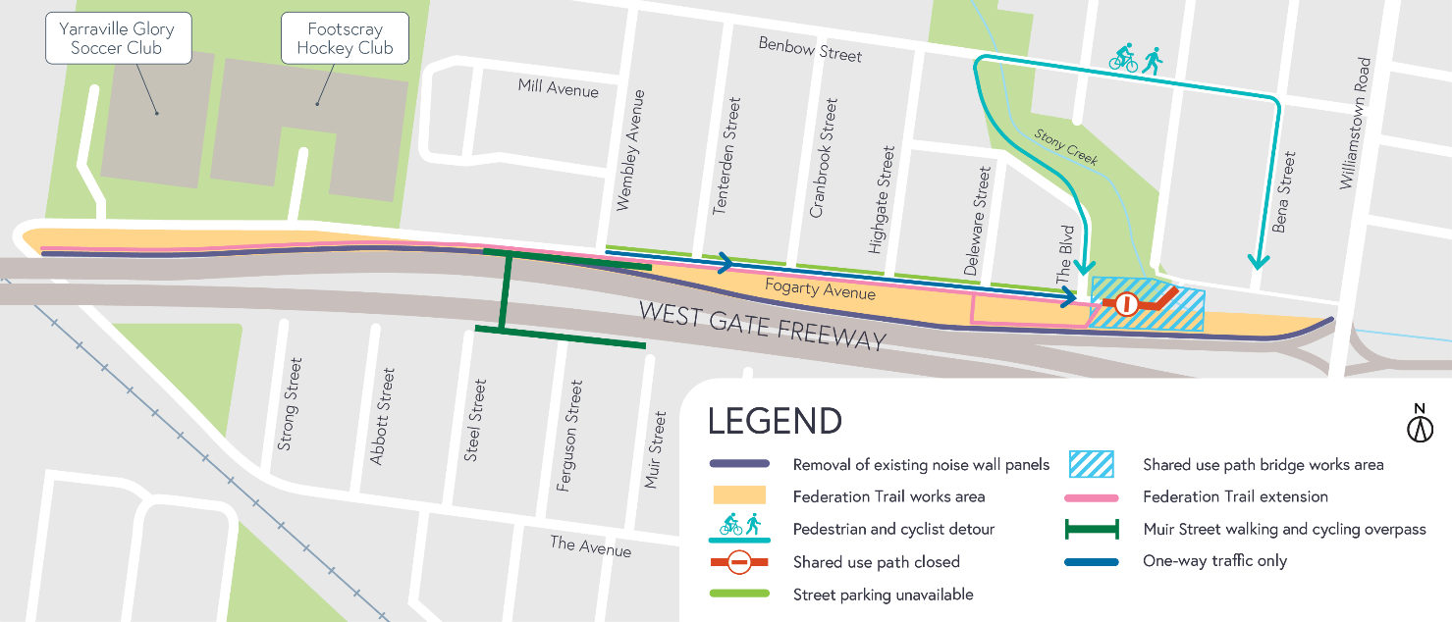
Works area

What to expect during these works
- work will be completed behind safety barriers
- construction vehicles including water trucks and concrete trucks will be moving in and out of the work areas via our approved access routes including local roads Highgate Street, Benbow Street, Severn Street, The Avenue and Fogarty Avenue.
- construction noise from work activities including machinery and trucks. Vibration might be experienced as we build the base of the shared user path using a roller
- water spray trucks and road sweepers will be used to manage dust and dirt during works. Trucks removing dirt and rock from the site will be covered
- traffic changes including lane and road closures will be required. Signed detours will be in place.
For the latest traffic updates visit bigbuild.vic.gov.au/disruptions
Please note that works are subject to change and may be rescheduled in the event of unexpected impacts to the construction program. Thank you for your patience during these works.

For updates and more information about our works please visit westgatetunnelproject.vic.gov.au.

