Chapter 1
Introduction

Chapter 1

Introduction

Purpose of this document
The purpose of the Environment Effects Statement (EES) is to assess the positive and negative environmental effects of the proposed North East Link.
North East Link (‘the project’) would connect Melbourne’s freeway network between the M80 Ring Road (otherwise known as the Metropolitan Ring Road) and the Eastern Freeway. It would be a safe and efficient freeway connection for 100,000 vehicles per day, reducing travel times, getting trucks off local roads and linking key growth areas in the north and south-east.
The primary focus of the EES is to assess how the project could impact the environment, encompassing the physical, ecological, heritage, cultural, health, social, economic and transport aspects. This has been undertaken through the preparation of 18 technical reports, with the findings presented in the EES. Based on these assessments, the EES considers how adverse impacts can be avoided, minimised, offset and managed to achieve acceptable environmental outcomes.
The EES provides the public and stakeholders with information about North East Link and the opportunity to make submissions relating to the potential environmental effects of the project. It includes an Environmental Management Framework (EMF) and a set of Environmental Performance Requirements (EPRs) for North East Link that will apply to the further development and implementation of the project. The EPRs define the environmental outcomes that must be achieved during construction and operation of North East Link.

Project overview

Location and design overview
North East Link is a proposed new freeway-standard road connection that would complete the missing link in Melbourne’s metropolitan ring road, giving the city a fully completed orbital connection for the first time. North East Link would connect the M80 Ring Road to the Eastern Freeway, including upgrades to the Eastern Freeway. The project would also support a range of complementary projects including additional walking and cycling paths and modifications to the wider road and public transport network. These would be subject to separate approvals where applicable.
The following section describes the North East Link alignment and project elements, noting the ongoing development of the design.
- M80 Ring Road to the northern portal – from the M80 Ring Road at Plenty Road, and the Greensborough Bypass at Plenty River Drive, North East Link would extend to the northern portal near Blamey Road utilising a mixture of above, below and at surface road sections. This would include new road interchanges at the M80 Ring Road and Grimshaw Street.
- Northern portal to southern portal – from the northern portal the road would transition into twin tunnels that would connect to Lower Plenty Road via a new interchange, before travelling under residential areas, Banyule Flats and the Yarra River to a new interchange at Manningham Road. The tunnels would then continue to the southern portal located south of the Veneto Club.
- Eastern Freeway – from around Hoddle Street in the west through to Springvale Road in the east, modifications to the Eastern Freeway would include widening to accommodate future traffic volumes and new dedicated bus lanes for the Doncaster Busway. There would also be a new interchange at Bulleen Road to connect North East Link to the Eastern Freeway.
These elements are illustrated in Figure 1-1.
The project would also improve existing bus services from Doncaster Road to Hoddle Street through the Doncaster Busway as well as pedestrian connections and the bicycle network with connected walking and cycling paths from the M80 Ring Road to the Eastern Freeway.
The project boundary shown in the figure defines the area within which the works would be located and the land subject to the planning approval as described in Chapter 3 – Legislative framework.
For a detailed description of the project, refer to Chapter 8 – Project description.

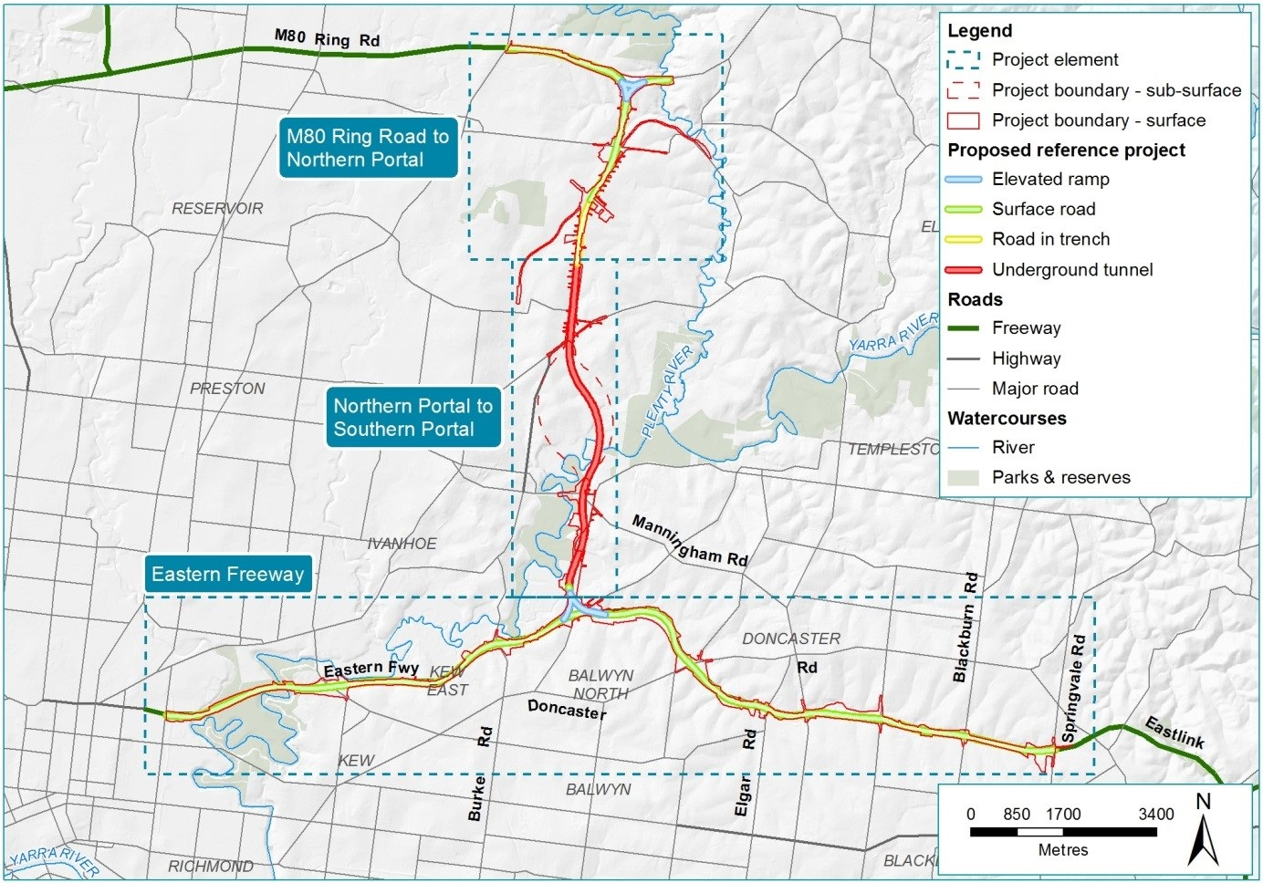
Figure 1-1 Overview of North East Link

Project objectives and guiding principles
North East Link has been designed to support business and job growth in Melbourne’s north, east and south-east, and to improve cross-city connectivity and help address critical traffic, freight and amenity issues.
Project objectives and guiding principles have established the broad strategic direction for the design and development of North East Link. These were informed by the objectives of the Transport Integration Act 2010 (Vic) and Plan Melbourne 2017–2050, and are listed in Table 1-1 and Table 1-2.
Table 1-1 Project objectives
Objective 1 | Objective 2 | Objective 3 | Objective 4
Improve business access and growth in Melbourne’s north, east and south-east | Improve household access to employment and education in Melbourne’s north, east and south-east | Improve freight and supply chain efficiency and industrial growth across the north, east and south-east | Improve access, amenity and safety for communities in the north-east

Table 1-2 Guiding principles
Guiding principle 1 | Guiding principle 2 | Guiding principle 3 | Guiding principle 4
Minimise impacts on communities | Minimise impacts on environmental and cultural assets | Minimise impacts during the construction phase | Optimise the efficient use of resources

Consistent with and complementary to the project objectives and guiding principles, sustainability is a key driver for North East Link. The approach to integration of sustainability with construction and operation of the project is set out in Attachment I – Sustainability approach.

Project benefits
As examined in the North East Link Business Case, the project is anticipated to benefit Victorian businesses, communities and the wider economy.
For businesses in the north, east and south-east of Melbourne, North East Link would connect key employment and activity centres, reduce congestion and increase network capacity for cross-city movements. This would benefit businesses by enhancing the efficiency of transport and reducing associated costs and enabling greater connection to residential areas and workers.
Businesses involved in, and which rely on, the physical delivery of goods would particularly benefit from North East Link through reduced transport costs and greater efficiency of supply chains. The increased productivity would also promote investment and industrial growth around Melbourne.
Reduced congestion and enhancing connectivity would increase job options for people living in Melbourne’s north, east and south-east. This would help boost household incomes and support the development of more local employment hubs to generate new economic opportunities.
More efficient links between the north, east and south-east would reduce the reliance on local and arterial roads, reducing the number of private and heavy vehicles moving through some residential areas. This would benefit residents and businesses with better air quality, improved safety on local roads, reduced noise pollution and greater ability for residents to connect with local facilities while minimising congestion.
Reduced congestion on local and arterial roads as well as upgraded facilities would improve walking, cycling and public transport networks. New, dedicated bus lanes would operate along the Eastern Freeway between Doncaster Road and Hoddle Street. Improvements to the existing walking and cycling network would create continuous and integrated off-road paths between the M80 Ring Road and the Eastern Freeway as well as improvements to routes along the Eastern Freeway.
Further detail of these benefits can be found in the North East Link Business Case.

Project timeline
If approved, North East Link would be constructed over seven years with the main works contract awarded in 2020 following decisions on the key approvals in late 2019. On this basis, the project is expected to be fully operational in 2027.

Project proponent
The Major Transport Infrastructure Authority (MTIA) is the proponent for North East Link. The MTIA is an administrative office within the Victorian Department of Transport with responsibility for overseeing major transport projects.
North East Link Project (NELP) is an organisation within MTIA that is responsible for developing and delivering North East Link. NELP is responsible for developing the reference project and coordinating development of the technical reports, engaging and informing stakeholders and the wider community, obtaining key planning and environmental approvals and coordinating procurement for construction and operation.

Environment Effects Statement
This EES describes the potential positive and negative effects of a project on the environment, encompassing the ecological, physical, heritage, cultural, health, social and economic aspects. It describes the existing environment, identifies potential environmental effects and recommends ways to avoid, minimise, offset or manage any significant effects.

Requirement for an EES
Victoria’s Environment Effects Act 1978 (‘Environment Effects Act') establishes a process under which the Minister for Planning may require the proponent of a project to prepare an EES.
On 2 February 2018, the Minister for Planning declared North East Link to be ‘public works’ under Section 3(1) of the Environment Effects Act, which was published in the Victorian Government Gazette on 6 February 2018 (No. S 38 Tuesday 6 February 2018). This declaration triggered the requirement for the preparation of an EES to inform the Minister’s assessment of the project and the subsequent determinations of other decision-makers.
The Minister's reasons for making the Order under the Environment Effects Act included that the 'project is a large-scale infrastructure construction project, with construction effects to span several years' and 'some potential effects lasting beyond the construction period'. The Minister noted the project is proposed to be constructed in an intensively developed area used by many residents, businesses and commuters, and that works have the potential for significant environmental effects on a range of environmental values. The Minister determined the EES process will provide a 'robust, transparent and integrated framework' through which potential environmental effects can be rigorously assessed and 'the effectiveness of proposed measures to avoid, minimise, manage and offset environmental effects and related risks can be evaluated'.

Scoping requirements
The scoping requirements, published by the Minister for Planning, detail the specific matters to be investigated and documented in the EES. The EES may also address other significant issues not identified in the scoping requirements that emerge during the EES investigations.
Victoria’s Department of Environment, Land, Water and Planning (DELWP) published the draft scoping requirements on 22 May 2018 and invited public comment on the draft document. After considering public submissions, the Minister for Planning published final scoping requirements on 24 June 2018. This EES has been prepared in accordance with the final scoping requirements.
In response to the scoping requirements, 18 technical reports have been prepared, covering the wide range of environmental aspects relevant to North East Link. For details of the assessment framework adopted to evaluate environmental effects refer to Chapter 4 – EES assessment framework.
The scoping requirements set out the following evaluation objectives for the EES:
Transport capacity, connectivity and traffic management – To increase transport capacity and improve connectivity to, from and through the northeast of Melbourne, particularly freight movement via the freeway network instead of local and arterial roads, while managing the effects of the project on the broader and local road, public transport, cycling and pedestrian transport networks.
Health, amenity and environmental quality – To minimise adverse air quality, noise and vibration effects on the health and amenity of nearby residents, local communities and road users during both construction and operation of the project.
Social, business, land use and infrastructure – To manage effects of the project on land use and the social fabric of the community with regard to wellbeing, community cohesion, business functionality and access to goods, services and facilities.
Landscape, visual and recreational values – To minimise adverse effects on landscape values, visual amenity, recreational and open space values and to maximise the enhancement of these values where opportunities exist.
Habitat and biodiversity – To avoid or minimise adverse effects on vegetation (including remnant, planted and regenerated) listed rare and threatened species and ecological communities, habitat for listed threatened species, listed migratory species and other protected flora and fauna, and address offset requirements for residual environmental effects, consistent with relevant State policies.
Cultural heritage – To avoid or minimise adverse effects on Aboriginal and historical cultural heritage values.
Land stability – To avoid or minimise adverse effects on land stability from project activities, including tunnel construction and river and creek crossings.
Waste management – To manage excavated spoil and other waste streams generated by the project in accordance with the waste hierarchy and relevant best practice principles.
Catchment values – To avoid or minimise adverse effects on the interconnected surface water, groundwater and floodplain environments.
Greenhouse gases – To demonstrate the project will contribute to the need for an effective, integrated and climate change-resilient transport system that provides a wide range of travel choices for all Victorians.

EES process
The EES process is designed to be rigorous and transparent, with opportunities for input from stakeholders and the wider community. The EES process is summarised in Figure 1-2.
As described in Section 1.3.1, the Minister for Planning first made a decision on the requirement for an EES and subsequently published the scoping requirements (discussed above in Section 1.3.2). The EES documents the findings from the technical reports which address the potential impacts of the project on the specific environmental matters set out in the scoping requirements.
The Minister then authorised the release of the completed North East Link EES for exhibition, providing members of the public opportunity to make formal written submission on the EES.
Following the public exhibition of the EES, an Inquiry and Advisory Committee, appointed by the Minister for Planning, will consider the EES and public submissions. The inquiry will make recommendations to assist the Minister’s assessment of the environmental effects under the Environment Effects Act.
The Minister’s assessment makes recommendations about whether the environmental effects of the project are acceptable, including with any modifications or any further management measures. In preparing the Minister’s assessment, the Minister considers all relevant information, including the EES documents, public submissions and the report from the Inquiry and Advisory Committee.
Relevant decision-makers for the key project approvals are then required to consider the Minister’s assessment, as discussed in Section 1.4.
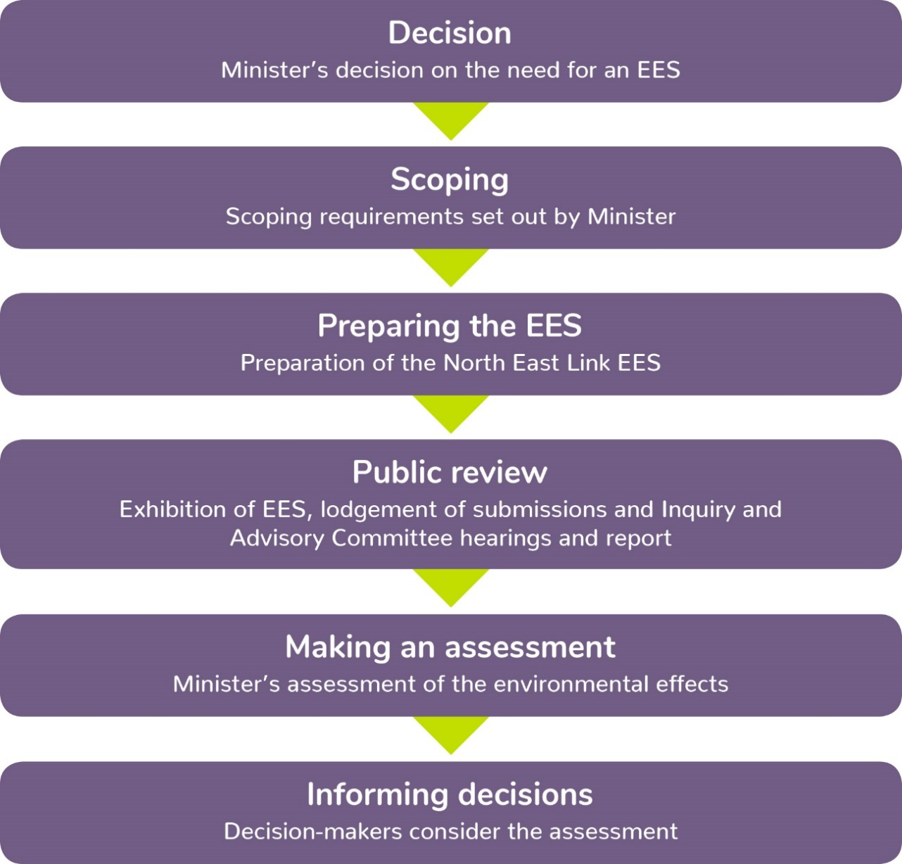
Figure 1-2 EES process

Project approvals
North East Link must obtain a number of statutory approvals before it can proceed. These approvals are summarised below, with further details provided in Chapter 3 – Legislative framework.

Australian Government approvals
The Environment Protection and Biodiversity Conservation Act 1999 (Cwlth) (‘EPBC Act’) provides a legal framework to protect and manage designated matters of national environmental significance (NES) and Commonwealth land. If the Australian Government’s Minister for the Environment decides under the EPBC Act that a project could potentially have a significant impact on matters of NES or Commonwealth land, the project is designated a ‘controlled action’ that must be assessed and approved by the Minister before the project can proceed.
The project was referred to the Australian Government’s Department of the Environment and Energy on 17 January 2018. On 13 April 2018 the project was decided to be a ‘controlled action’, requiring assessment and approval under the EPBC Act. The Minister for Environment decided the project would be assessed by a Public Environment Report in accordance with the Guidelines for the content of a Draft Public Environment Report, issued by the Minister on 10 July 2018.
As the project intersects with Commonwealth land, the bilateral agreement accrediting the EES process with the assessment of impacts on Commonwealth matters does not apply, and therefore a separate process is required to be followed for the Australian and Victorian government environmental approvals.
A separate set of documentation will assess the environmental effects of the project on Commonwealth land and matters of NES to inform the Australian Government’s Minister for Environment’s decision about whether approval should be given under the EPBC Act. This documentation has been developed in parallel to the EES.

Victorian Government approvals
The EES for North East Link is not an approval in itself but will inform the Minister’s assessment of the environmental effects of the project. The Minister’s assessment will inform decisions relating to the following key approvals:
- Amendments to planning schemes for the cities of Banyule, Boroondara, Nillumbik, Manningham, Whitehorse, Whittlesea and Yarra under the Planning and Environment Act 1987 (Vic)
- Works Approval Application under the Environment Protection Act 1970 (Vic).
A Cultural Heritage Management Plan under the Aboriginal Heritage Act 2006 (Vic) has been prepared in parallel to the EES.
A range of secondary approvals and consents may also be required in the project delivery phase. Details of these approvals are described in Chapter 3 – Legislative framework.

Approach to EES assessment
The EES has adopted a performance based approach and has assessed a reference project. The reference project is not the final design for North East Link, however it demonstrates the project's feasibility and ability to achieve acceptable outcomes.
The EES assessments have developed EPRs that set the environmental outcomes to be achieved during design, construction and operation regardless of the solution adopted. This approach is designed to ensure NELP achieves acceptable outcomes whilst providing some flexibility for the contractor to determine how to achieve the EPRs.
If North East Link is approved, the subsequent procurement process may result in design refinements, which will be required to satisfy the EPRs for the project and be located within the designated project boundary. Further information on the approach to EES assessment is provided in Chapter 4 – EES assessment framework.

Structure of the EES
The structure and content of the EES aligns with the evaluation objectives set out in the scoping requirements. The EES is structured into five parts: a summary report which presents the key findings of the EES, the EES main report, technical reports, attachments and a supporting map book as shown in Figure 1-3.
The EES main report includes introductory chapters that provide background on the project and context for the assessment, and technical chapters, which describe the key potential impacts associated with the project. These are supported by the technical reports and attachments.
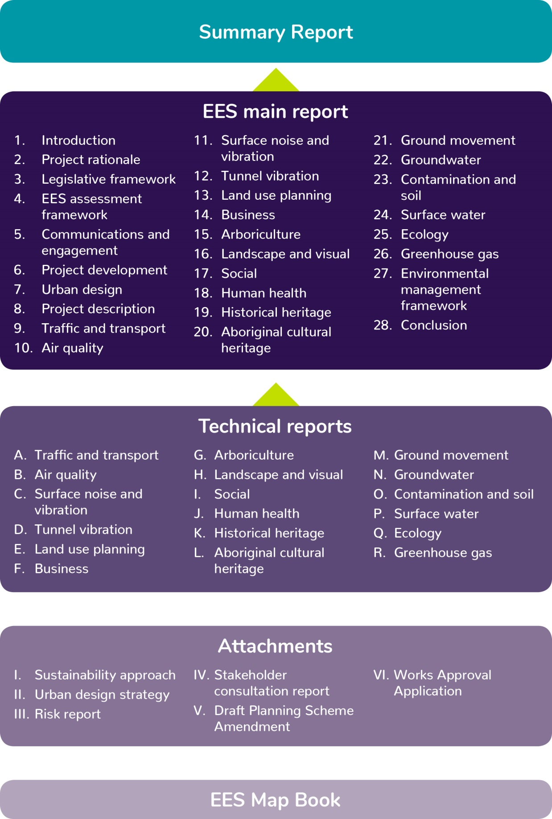
Figure 1-3 Structure of the EES

