Chapter 8
Project description

Chapter 8

Project description

Introduction
This chapter describes the design, construction and operation of North East Link.
The project description described in this chapter is based on the reference project that has been developed for North East Link (‘the project’). The reference project represents a feasible means by which the project could be designed, constructed and operated. It forms the basis of the impact assessments in this Environment Effects Statement (EES) and has been used to develop the environmental performance requirements (EPRs) for the project, setting the environmental outcomes that must be achieved by the project, irrespective of the ultimate design solution selected for the project.
A competitive tender process would be used to select the preferred tenderer’s design for the project, once the outcomes of the EES assessment process are known. The selected design may differ from the design used for the reference project. However the selected design would need to be developed within the approved project area and comply with each of the EPRs set for the project as approved by the Minister for Planning following the EES assessment process. As the design for the project is ongoing, components of the project design as discussed in this chapter may change.

The EPRs are the minimum environmental outcomes that must be achieved for the design, construction and operation of North East Link. The EPRs are set out in Chapter 27 – Environmental management framework.
This chapter should be read in conjunction with the EES Map book.
The EES Map book
The Map book consists of:
- Horizontal alignment plans
- Vertical alignment plans
- Typical cross sections

Project elements

Overview
North East Link is a proposed new freeway-standard road connection that would complete the missing link in Melbourne’s Metropolitan Ring Road, giving the city a fully completed orbital connection. North East Link would include a new north-south motorway to connect the M80 Ring Road (otherwise known as the Metropolitan Ring Road) to the Eastern Freeway, and also includes upgrades to the Eastern Freeway. The project would also support the provision of a range of complementary and associated works, such as the improvement of walking and cycling connections.
The following section describes the North East Link alignment and the key project elements.

- M80 Ring Road to the northern portal – from the M80 Ring Road at Plenty Road, and the Greensborough Bypass at Plenty River Drive, North East Link would extend to the northern portal near Blamey Road utilising a mixture of above, below and at surface road sections. This would include new road interchanges at the M80 Ring Road and Grimshaw Street.
What are the project elements?
The project elements are the main areas the project has been divided into based on the similarity in design and associated construction activities.

- Northern portal to southern portal – from the northern portal the road would transition into twin tunnels that would connect to Lower Plenty Road via a new interchange, before travelling under residential areas, Banyule Flats and the Yarra River to a new interchange at Manningham Road. The tunnels would then continue to the southern portal located south of the Veneto Club.
- Eastern Freeway – from around Hoddle Street in the west through to Springvale Road in the east, modifications to the Eastern Freeway would include widening to accommodate future traffic volumes and new dedicated bus lanes for the Doncaster Busway. There would also be a new interchange at Bulleen Road to connect North East Link to the Eastern Freeway
These elements are illustrated in Figure 8-1.
The project would also improve existing bus services from Doncaster Road to Hoddle Street through the Doncaster Busway as well as pedestrian connections and the bicycle network with connected shared use paths from the M80 Ring Road to the Eastern Freeway.

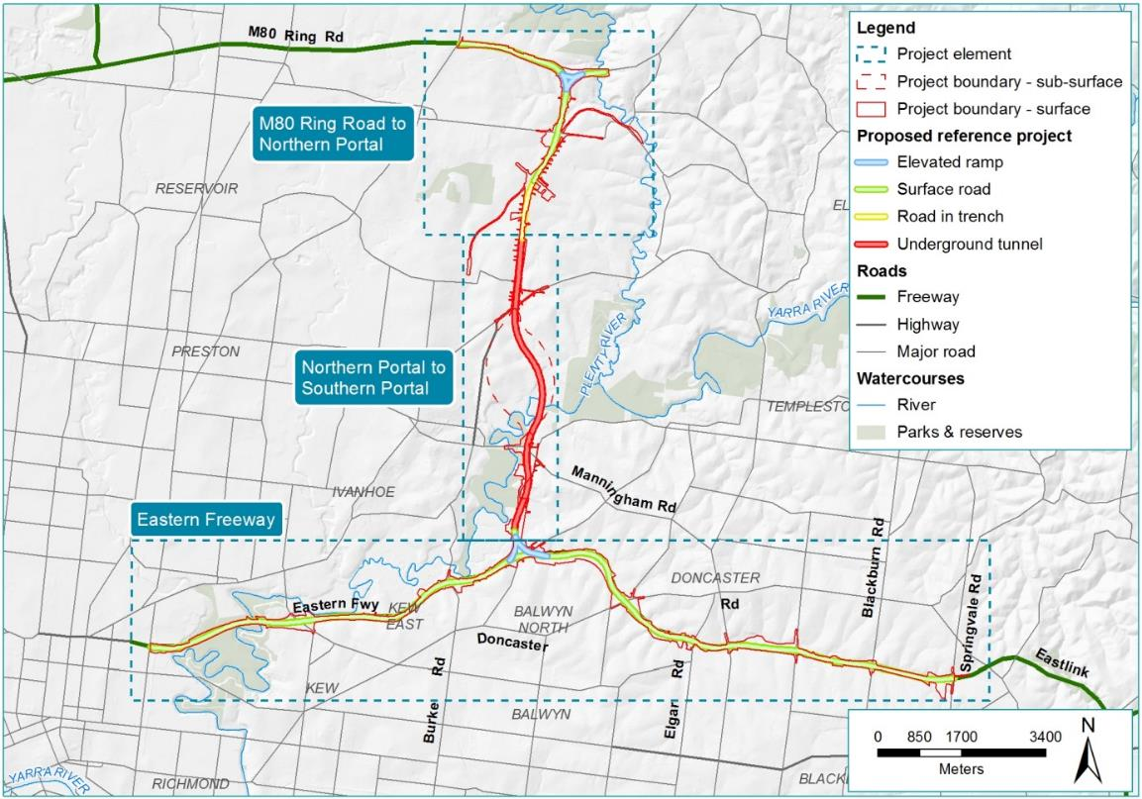
Figure 8-1 Overview of North East Link

M80 Ring Road to northern portal
The northern element of North East Link would extend from the M80 Ring Road to the northern portal near Blamey Road. The project would include sections of road at ground surface, elevated roads for the M80 Ring Road interchange, and roads below the ground surface level where they connect to the northern portal.
The design of this project element would include:
- New and upgraded road sections extending from the M80 Ring Road at Plenty Road, and the Greensborough Bypass at Plenty River Drive in the north to Blamey Road in the south and alterations to arterial and local roads.
- New land bridges over the new road, where it is in a trench, between Watsonia railway station and Blamey Road, to maintain east to west connectivity.
- New interchanges at the M80 Ring Road and Grimshaw Street to separate North East Link through traffic.
- Modifications to the Watsonia railway station car park.
- Extending the length of the current Hurstbridge rail underpass (just north of Watsonia railway station) due to the footprint of North East Link main carriageways and Grimshaw Street ramps and service roads. There is also the potential to require upgrades to rail signalling infrastructure.
- Noise walls would be required in some areas to mitigate noise in residential areas.
- New and modified walking and cycling paths.
- Changes to waterways and drainage features in the northern section of Banyule Creek.
- Alterations to utilities, including communications towers, electricity transmission lines, and a water mains pressure reducing station.
The M80 Ring Road to northern portal element is shown in Figure 8-2.
Examples of environmental considerations in the design
The project’s land bridges have been designed to provide some of the following benefits:
- Movement and connectivity for pedestrians, cyclists and vehicles
- Biodiversity by creating habitat and vegetation connections
- Amenity by providing green open space.

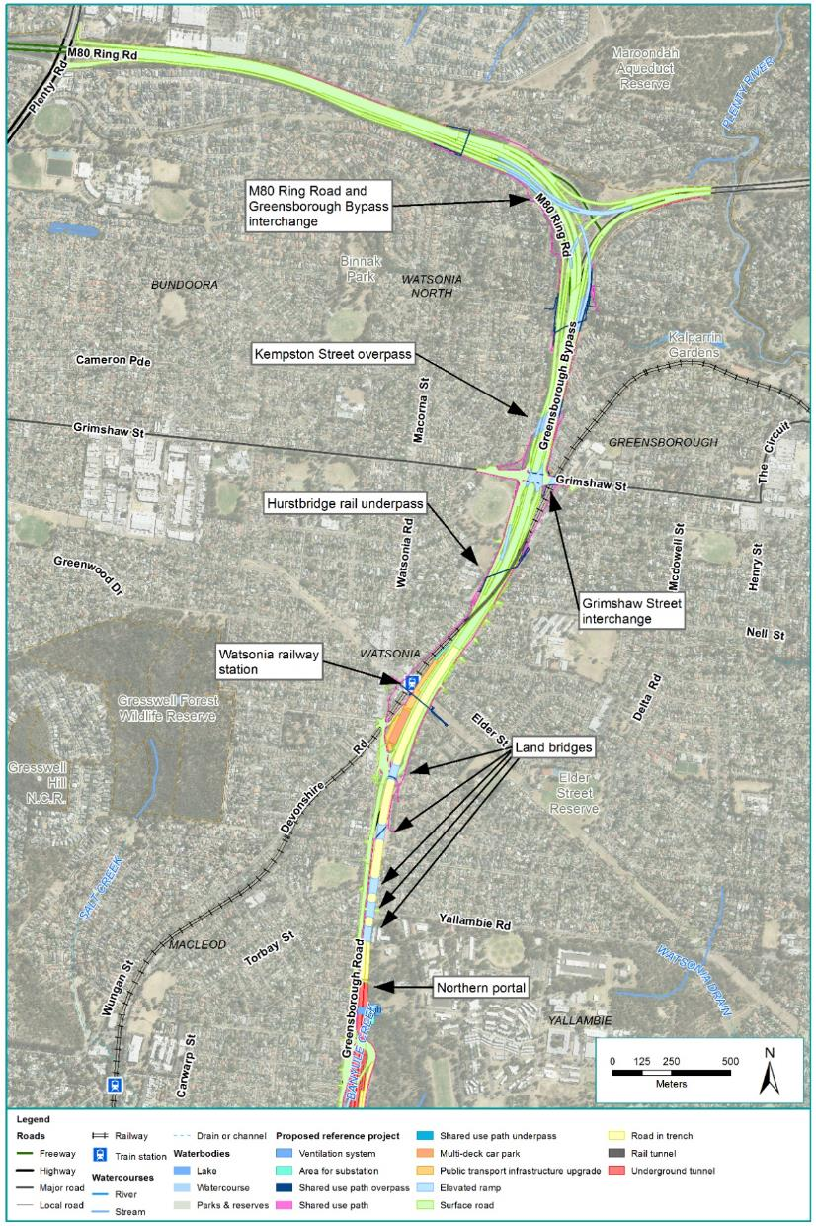
Figure 8-2 M80 Ring Road to northern portal

Road design
The roadway design of the M80 Ring Road to northern portal element can be separated into three sections:
- M80 Ring Road interchange to Grimshaw Street interchange
- Grimshaw Street interchange to Watsonia railway station
- Watsonia railway station to the northern portal.

M80 Ring Road interchange to Grimshaw Street interchange
A new interchange would connect the M80 Ring Road and Greensborough Bypass to North East Link. The free flowing interchange with multiple carriageways would allow traffic to enter and exit North East Link and maintain access to existing non-tolled connections.
The modifications to the road would include widening and the introduction of new elevated ramps to achieve full grade separation at the interchange.
The interchange is shown and described in Figure 8-3.
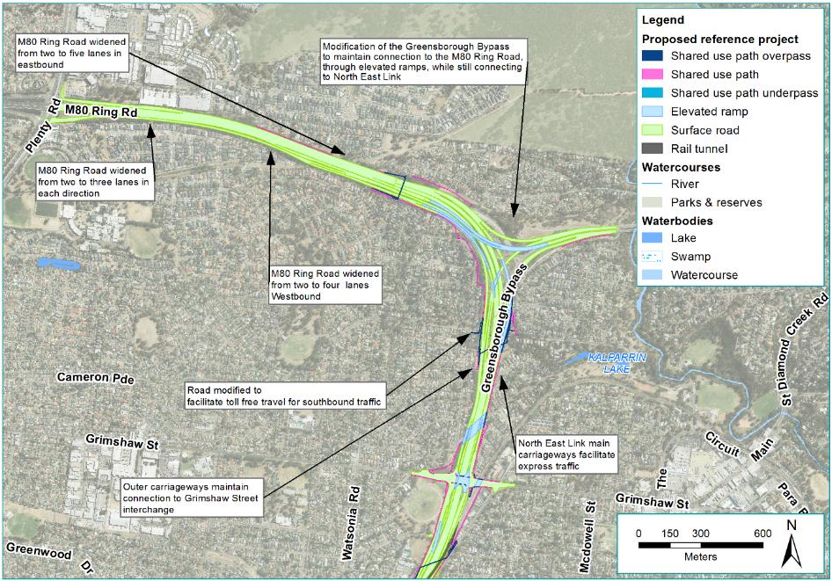
Figure 8-3 M80 Ring Road interchange to Grimshaw Street interchange

Grimshaw Street interchange to Watsonia railway station
A new interchange would allow for northbound and southbound entry and exit from North East Link to Grimshaw Street in addition to maintaining through lanes for eastbound and westbound traffic on Grimshaw Street.
The modifications to the road would include widening, full grade separation and upgrades to the interchange to provide additional traffic capacity for traffic. North East Link would pass beneath Grimshaw Street, with Grimshaw Street being lifted approximately one metre to accommodate North East Link passing beneath. Non-tolled connections along the Greensborough Bypass would be maintained. The interchange is shown and described in Figure 8-4.

Changes at the rail interface
North East Link would interface with the Hurstbridge rail corridor between Grimshaw Street and Watsonia railway station. Modifications to existing road bridges would be required at Grimshaw Street, Greensborough Road and potentially at Watsonia Road. This would require rail infrastructure to be modified to accommodate changes to the structures above it. Consideration to fire safety and ventilation would also be needed during detailed design. The rail interface changes are shown and described in Figure 8-4.
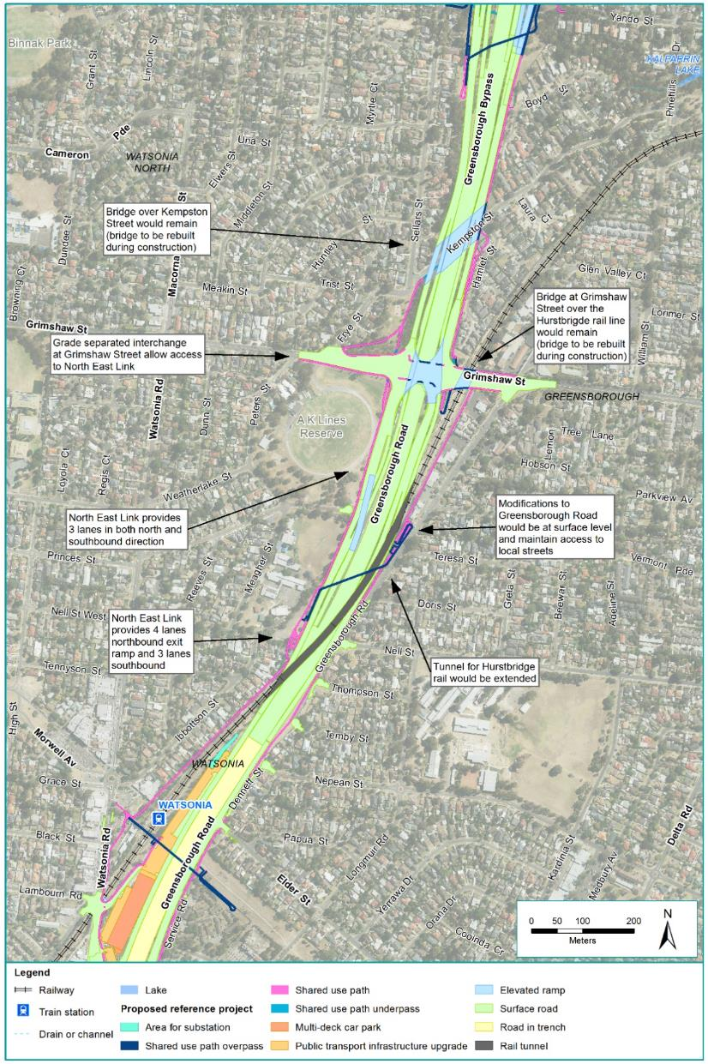
Figure 8-4 Grimshaw Street interchange to Watsonia railway station

Watsonia railway station to the northern portal
The North East Link carriageways would descend into a trench adjacent to the Watsonia railway station car park until reaching the northern portal.
The modifications to existing roads would include widening, full grade separation and the addition of land bridges to maintain access for pedestrians and in some cases vehicles. Greensborough Road would be modified so it is separated from North East Link.
This road section is shown and described in Figure 8-5.
Land bridges
Five land bridges would be constructed between Grimshaw Street and Lower Plenty Road. They would consist of approximately 8,500 m² of public open space and provide parkland between West Mayling Reserve and Winsor Reserve.
The area would provide informal parkland for recreation and active transport opportunities with a series of walking paths and a north-south cycling and walking route. The path network would connect Watsonia Neighbourhood Centre (including Watsonia railway station) and the communities to the south.
Trees and landscape planting would assist the green character of the area, providing shade and potential habitat, and filtering views of North East Link infrastructure from adjacent residential areas and roads.
The land bridges would be designed in accordance with the Urban Design Strategy. See Chapter 7 – Urban design and EES Attachment II – Urban Design Strategy.
Schematic cross sections of the road trench and land bridge between Watsonia railway station and Lower Plenty Road are shown in Figure 8-6 and Figure 8-7 respectively.
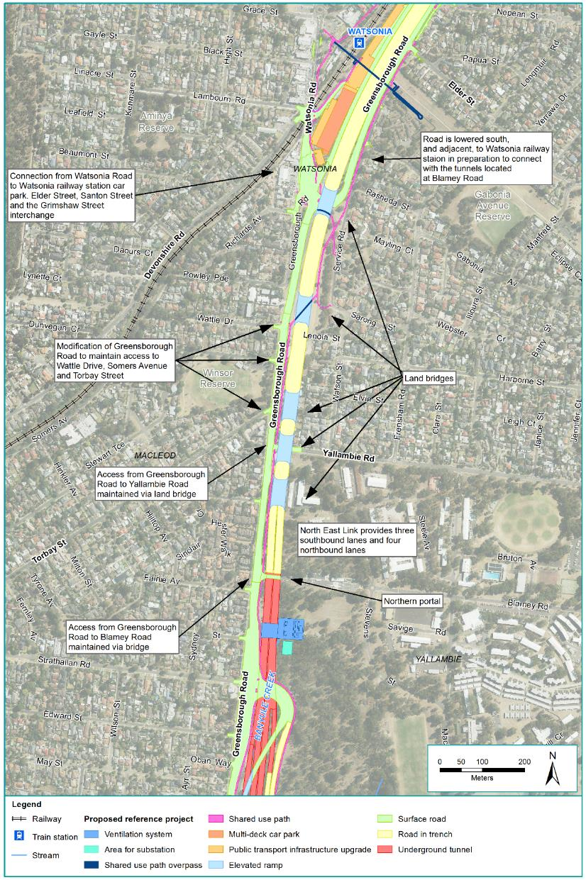
Figure 8-5 Watsonia railway station to the northern portal
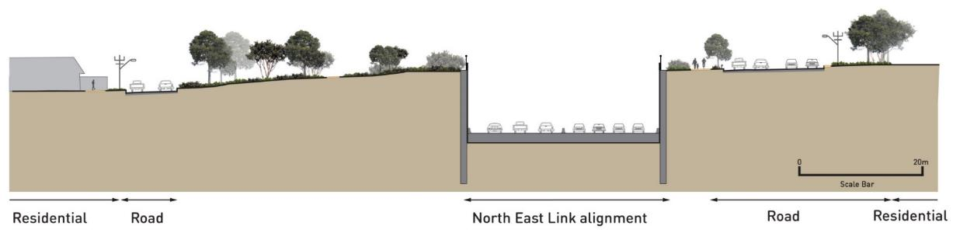 | 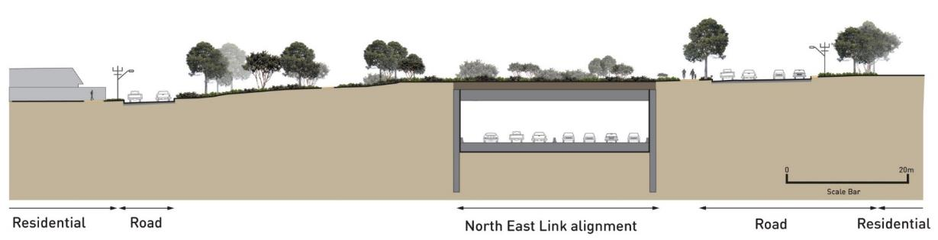
Figure 8-6 Indicative schematic cross section of trench facing south | Figure 8-7 Indicative schematic cross section of land bridge facing south

Noise walls
New or modified noise walls would be provided along North East Link to achieve noise objectives.
Specific noise objectives for the project are detailed in Chapter 11 – Surface noise and vibration.
New or modified noise walls in the M80 Ring Road to the northern portal element would be constructed:
- Next to residential zones to the south east and south west of the M80 Ring Road interchange
- Next to residential zones to the east and west of North East Link, between the M80 Ring Road, Watsonia Road intersection and Elder Street
- Next to residential zones in the vicinity of the Grimshaw Street interchange.
The locations of proposed noise walls are presented in the EES Map book. Noise walls would be designed in accordance with the project’s urban design principles, objectives and guidelines in EES Attachment II – Urban Design Strategy.

Walking and cycling

North East Link would also improve the walking and cycling network, enhancing connectivity and safety for walkers and cyclists.

Walking and cycling paths
North East Link would include the following new paths between the M80 Ring Road interchange and the northern portal:
- A shared use path on the south-western side of the M80 Ring Road and Greensborough Bypass interchange from the Macorna Street shared use overpass to the Hakea Street shared use overpass
- A shared use path along the western side of North East Link between Kempston Street and the Greensborough Road and Watsonia Road intersection (which includes a cyclist only section)
- A shared use path along the eastern side of North East Link between Yando Street and Grimshaw Street and the Greensborough Road and Watsonia Road intersection
Shared use paths
A shared use path (SUP) is a path that may be used by walkers and cyclists. North East Link shared use paths have been designed to be not less than three metres wide. The majority of the walking and cycling paths proposed are shared use paths although some sections of cyclist only and pedestrian only path are also included in the design.

- A shared use path a between the Greensborough Road and Watsonia Road intersection and Yallambie Road.
The following paths would be realigned and reconstructed:
- The Greensborough Bypass path on the eastern side of the Greensborough Bypass between Plenty River and Grimshaw Street
- The M80 Ring Road path on the northern side of the M80 Ring Road in the vicinity of Killarney Ridge
- The M80 Ring Road path on the northern side of the M80 Ring Road east of the Macorna Street Bridge
- The path adjacent to Greensborough Road between Yallambie Road and the northern portal.

Walking and cycling crossings
The following crossings would be constructed or modified:
- The existing shared use overpass connecting Macorna Street to the M80 Ring Road path over the M80 Ring Road would be demolished and replaced with a new Disability Discrimination Act (DDA)-compliant overpass with ramps and stairs
- A new overpass would be constructed between Yando Street and Hakea Street linking new and upgraded paths and providing a DDA-compliant east-west crossing. The existing underpass used by walkers and cyclists would be retained and extended
- The existing at-grade crossing of the Greensborough Bypass path at Kempston Street would be replaced with an underpass of Kempston Street
- Two underpasses would be constructed under Grimshaw Street to connect to new and existing paths on the eastern and western sides of North East Link
- A new shared use overpass would be constructed to replace the existing Nell Street overpass, north of its existing location
- A new shared use overpass would be constructed to link the power line easement to Watsonia Road, near Watsonia railway station. This overpass would cross North East Link and the rail line.
Anti-throw screens, public safety barriers and privacy screens would be integrated with the design of walking and cycling crossings where they are needed.
A visualisation of a shared use path is shown in Figure 8-8.
The paths and crossings identified above are shown in Figure 8-9.
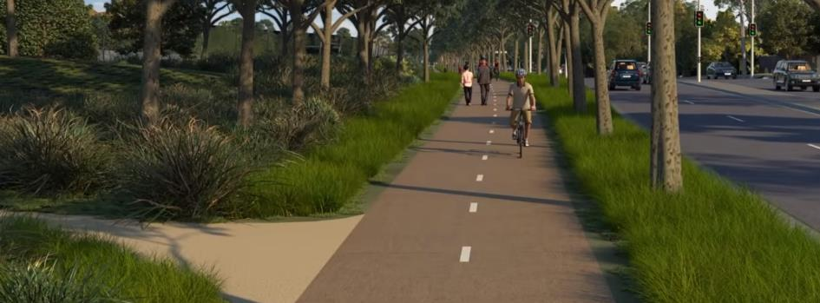
Figure 8-8 Visualisation of a shared use path
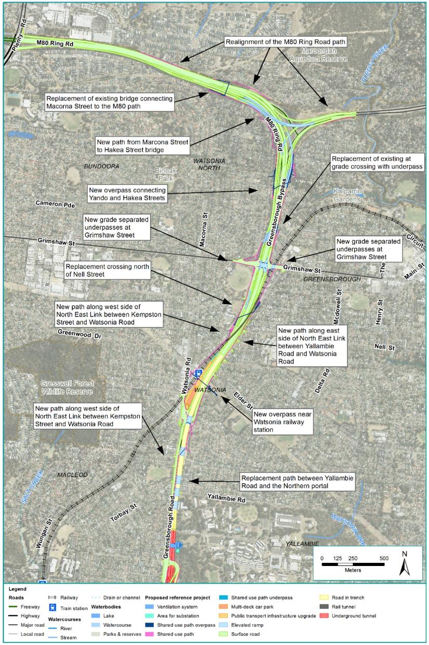
Figure 8-9 New and modified walking and cycling connectivity in the M80 Ring Road to northern portal element

Waterway modifications
Banyule Creek would be realigned from near its origins within the Simpson Barracks through to Lower Plenty Road. South of Lower Plenty Road the form of Banyule Creek would not be modified.
Within Simpson Barracks, Banyule Creek would be replaced by two pipes, one on either side of the North East Link alignment. These pipes act as a diversion to connect adjacent catchments. The water within the pipes would be directed to the existing culvert under Lower Plenty Road and from this point the creek would follow its existing alignment through the residential areas of Viewbank and Rosanna.
For further detail on changes to Banyule Creek see Technical report P – Surface water.

Drainage and stormwater management
In accordance with Austroads Guidelines to Road Design – Part 5, the design of North East Link would incorporate spill containment within new and upgraded road sections to protect the environment from liquid chemical spills. Spill containment would be designed in accordance with Austroads Guidelines.
Water Sensitive Urban Design (WSUD) features would be integrated into the M80 Ring Road to northern portal element to manage hydrology and water quality.
WSUD features are proposed in a number of locations including:
- Around the M80 Ring Road interchange
- Grimshaw Street interchange
- Watsonia railway station.

Utilities
Key utilities that intersect or are in close proximity to the M80 Ring Road to northern portal element of North East Link would need to be protected, relocated or avoided to maintain their function. The key utilities that may be affected by the project are summarised in Table 8-1.
Table 8-1 Key utilities in the M80 Ring Road to northern portal element
Utility type | Description
Communication stations and towers | Two telecommunications towers located near the north-east corner of the M80 Ring Road and Plenty Road interchange would be relocated to the following:  - One to be moved further east into the vegetated area within the M80 Ring Road reserve  - One to be moved further north along Plenty Road.  A telecommunications tower located on the north of the M80 Ring Road connection to the Greensborough Bypass would be relocated east.  A wireless telecommunications station located between the Hurstbridge rail line and Greensborough Highway to the north-east of Watsonia railway station would be relocated to the Watsonia railway station car park.
Gas | An existing licensed transmission gas main which currently runs along Morwell Avenue in Watsonia, and crosses the alignment at Elder Street (opposite Watsonia railway station) would be avoided as part of the project works.
Electricity transmission lines | Electricity transmission lines (66 kV) currently crossing Greensborough Bypass and running along the power easement would be reinstalled overhead across North East Link in line with the power easement.  Two 220 kV transmission towers are located within the Watsonia railway station car park would be relocated to the eastern side of North East Link within the power easement.
Pressure reducing station | The Melbourne Water Watsonia pressure reducing station would be relocated approximately 300 metres east of its current location.
Water mains | Due to the relocation of the pressure-reducing station, three water mains that currently run east to west to the immediate north of Drysdale Street and which connect to the station would also need to be relocated.

Northern portal to southern portal
The tunnels would extend from the northern portal at Blamey Road to the southern portal south of the Veneto Club, Bulleen. The road through this section would be in tunnels with an interchange at Manningham Road providing connection to the new roadway.
The project design in this element of North East Link would include:
- A new road extending from the northern portal to the southern portal including twin three-lane tunnels and associated interchanges at Lower Plenty Road and Manningham Road
- Noise walls at the ramps at the Manningham Road interchange to mitigate noise in residential areas
- New and improved walking and cycling paths
- Changes to waterways and drainage
- Utility works around communications towers and the main sewer along Bulleen Road
- New ancillary infrastructure to support the project, including additional power, an operations centre, tunnel ventilation system and water treatment facilities.
The northern portal to southern portal element is shown in Figure 8-10.
Examples of environmental considerations in the design
The decision to build a significant portion of North East Link as tunnels has enabled direct impacts on property and areas of ecological and heritage value to be reduced. Direct impacts on Banyule Flats, the Warringal Parklands, the Yarra River as well as the Heide Museum of Modern Art and other residential properties have been avoided.
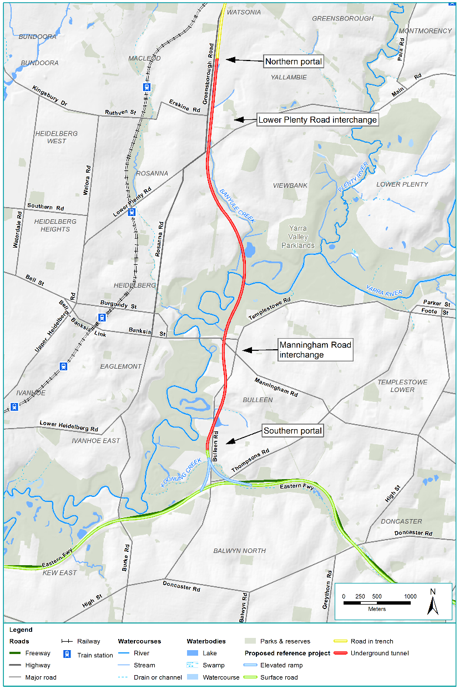
Figure 8-10 Northern portal to southern portal element

Road design
The road design within the northern portal to southern portal element can be separated into four sections:
- Lower Plenty Road interchange
- Tunnels
- Manningham Road interchange (reference project and alternative design)
- Southern portal and Bulleen Road.

Lower Plenty Road interchange
The interchange at Lower Plenty Road would provide for northbound and southbound vehicle movements to and from Lower Plenty Road and Greensborough Road.
Southbound vehicles on North East Link could exit to Lower Plenty Road via an exit ramp. This exit would be located inside the tunnel, south of the northern tunnel portal. This means that oversized vehicles travelling southbound along the M80 Ring Road would have to exit to Grimshaw Street to exit before the tunnel.
Traffic on Lower Plenty Road would enter the northbound carriageway via a ramp from Lower Plenty Road.
Vehicles on Greensborough Road and Lower Plenty Road that wish to travel southbound through the tunnel would enter a ramp from Greensborough Road opposite Strathallan Road. Similarly, northbound vehicles in the tunnel, wishing to exit onto Greensborough Road or Lower Plenty Road, would do so via an exit ramp near the tunnel portal. This ramp would exit onto Greensborough Road opposite Strathallan Road.
Placarded and oversized vehicles travelling southbound on the link from the M80 Ring Road or Greensborough Bypass would exit at Grimshaw Street, before the Lower Plenty Road interchange and the southbound tunnel.
The Lower Plenty Road interchange is shown and described in Figure 8-11.
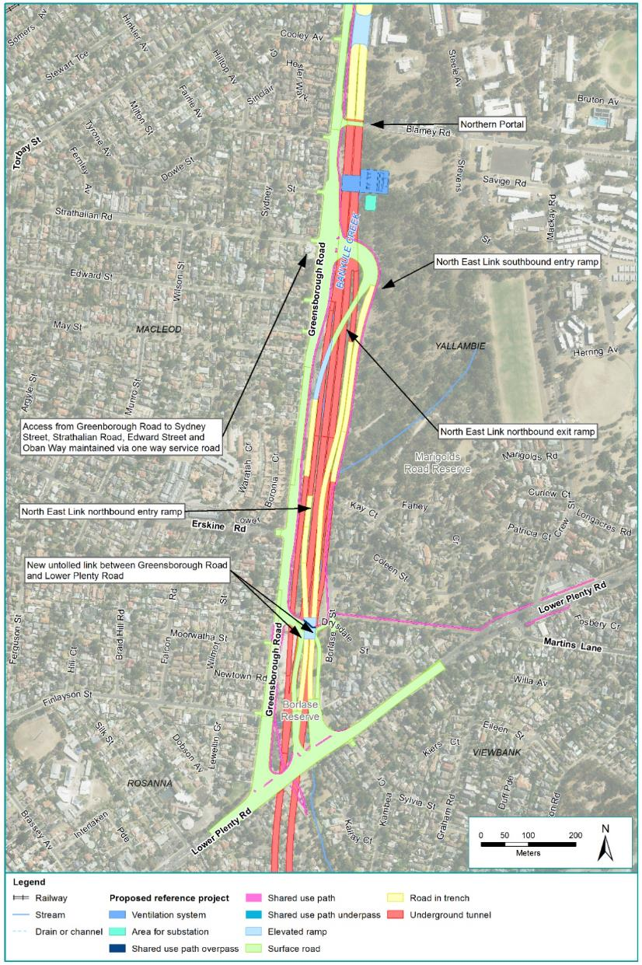
Figure 8-11 The Lower Plenty Road interchange

Tunnels
North East Link would include approximately six kilometres of twin three-lane tunnels from Blamey Road through to south of the Veneto Club in Bulleen. An indicative longitudinal section of the tunnels is shown in Figure 8-12.
At its deepest point, in the vicinity of Sevenoaks Avenue in Heidelberg, the top of the tunnel would be approximately 40 metres underground. The proposed tunnel alignment would run underneath the Yarra River, where the top of the tunnel would be approximately more than 20 metres beneath the river.
The twin tunnels would feature three traffic lanes in each direction with an internal vertical clearance of 4.9 metres. Over-dimensional vehicles and placarded vehicles would not be permitted to use the tunnels. Lanes would be 3.5-metres wide with a 1-metre left shoulder and 0.5-metre right shoulder.
An 80 km/h speed limit would be posted with a lane use management system and associated overhead signage installed to manage opening and closing of lanes as required, to optimise traffic flows, respond to incidents or allow for maintenance of the tunnels.
The tunnels would be designed in accordance with metropolitan fire brigade requirements, consistent with AS 4825-2011 (Tunnel Fire Safety) and would incorporate a range of features to address fire and safety risks including systems for incident detection, smoke management, emergency lighting, communications with tunnel users and back-up power during emergencies. For further detail on public safety in the tunnels see Section 8.9.3.
The tunnels would be constructed using three different tunnelling methods: cut and cover, bored, and mined. The shape and dimensions of the tunnels sections would vary depending on the construction technique used as described in Section 8.7.4 and reflected in Figure 8-13.
All sections of the tunnels, regardless of the method used to construct them, would have cross passages connecting the two tunnels at approximately 120 metre intervals. The cross passages would have a vertical clearance of 2.1 metres and allow for emergency access to and from the tunnels and maintenance work. In the event of a significant incident, the non-incident tunnel would be the main means of controlling egress from the tunnel system.
The cut and cover section of the tunnels would have varying horizontal distances between the tunnels, from a minimum of approximately 2.5 metres at the portals, and reaching approximately 15 metres at the tunnel boring machine (TBM) interface. The whole length of the bored and mined tunnels would be separated horizontally by approximately 15 metres.
The indicative alignment and the vertical geometry of the tunnels, indicating the gradient and depth below surface along their course are presented in the EES Map book.
Ancillary infrastructure such as the tunnel ventilation system, power supply and water treatment are discussed in Section 8.4.6.
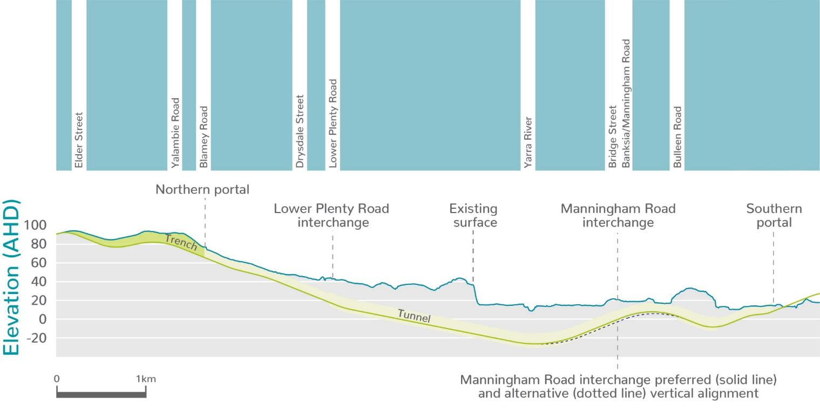
Figure 8-12 Indicative long section of tunnels

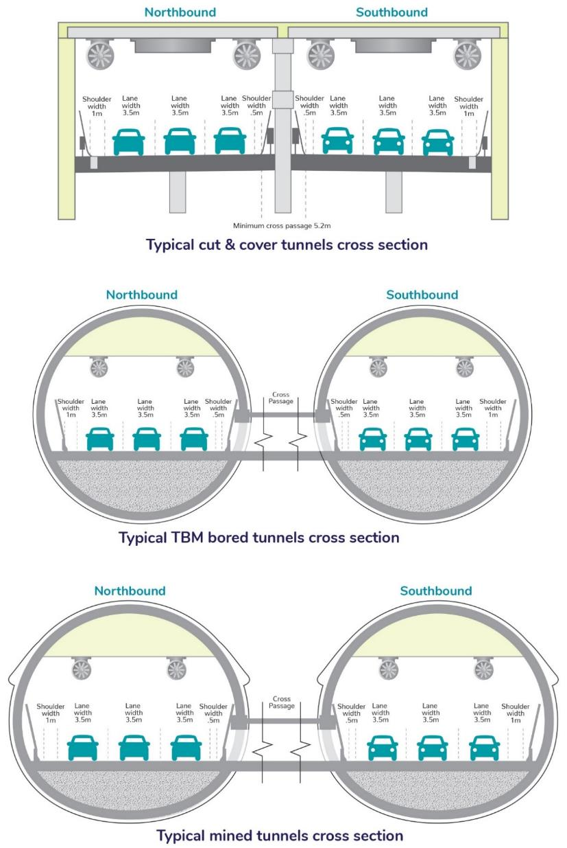
Figure 8-13 Cut and cover, bored and mined tunnel construction techniques

Manningham Road interchange

The Manningham Road interchange would connect North East Link to Manningham Road while maintaining access for eastbound and westbound traffic on Manningham Road. The interchange would consist of a combination of underground and surface infrastructure extending from Bridge Street to Golden Way. As indicated in Figure 8-12 above, the alignment would need to be close to the surface at Bridge Street to provide adequate grades to facilitate the interchange.
The interchange at Manningham Road has two design options; the reference project and the alternative design. These are described below. Road closures required for both interchange designs are noted in Section 8.9.2.

Reference project
For the reference project, the Manningham Road interchange would have a minimum of 10 metres distance between the top of the tunnels and the ground surface above at Bridge Street. Ground improvement may be required over the TBM tunnels in Banksia Park, north of Bridge Street. More detail on ground improvement works is provided in Section 8.7.4. The reference project includes a northbound direct entry ramp to North East Link at Bulleen Road, at the southbound exit ramp terminal intersection located opposite Avon Street
The Manningham Road interchange design is shown in Figure 8-14.

Alternative design
The Manningham Road interchange alternative design includes the following modifications:
- Minimum distance of 12.5 metres—2.5 metres more than the reference project—between the bored tunnels and ground surface at Bridge Street, with ground improvement also potentially required north of Bridge Street
- Deeper tunnel and ramp structures
- A ‘loop alignment’ for the northbound entry ramp.
The alternative design for the Manningham Road interchange is shown in Figure 8-15.

Southern portal and Bulleen Road
Bulleen Road would be modified to include connections to the ramps of the Manningham Road interchange. This includes road widening lane reconfiguration to allow connection to the interchange and to maintain access to Manningham Road.
The southern portal would connect to the Eastern Freeway interchange with Bulleen Road modified to retain access to adjoining property from the Trinity Grammar entrance to Thompsons Road. This is described further in Section 8.5.
Bulleen Road would be raised above existing levels from the Trinity Grammar entrance to Thompsons Road, including a section that would be raised onto a viaduct to pass over the North East Link roadway connecting to the Eastern Freeway to and from the east.
This southern portal and Bulleen Road section is shown and described in Figure 8-16.
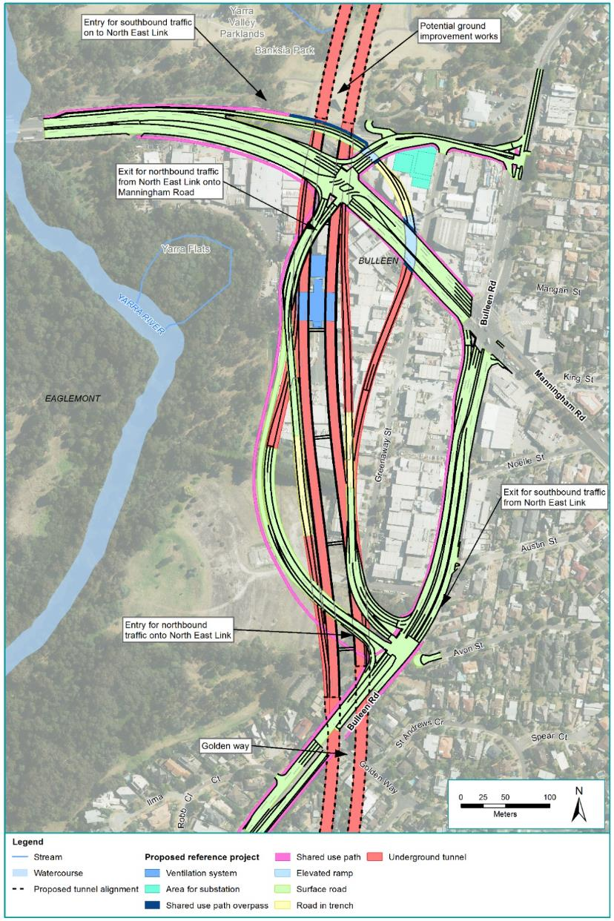
Figure 8-14 Manningham Road interchange (reference project)
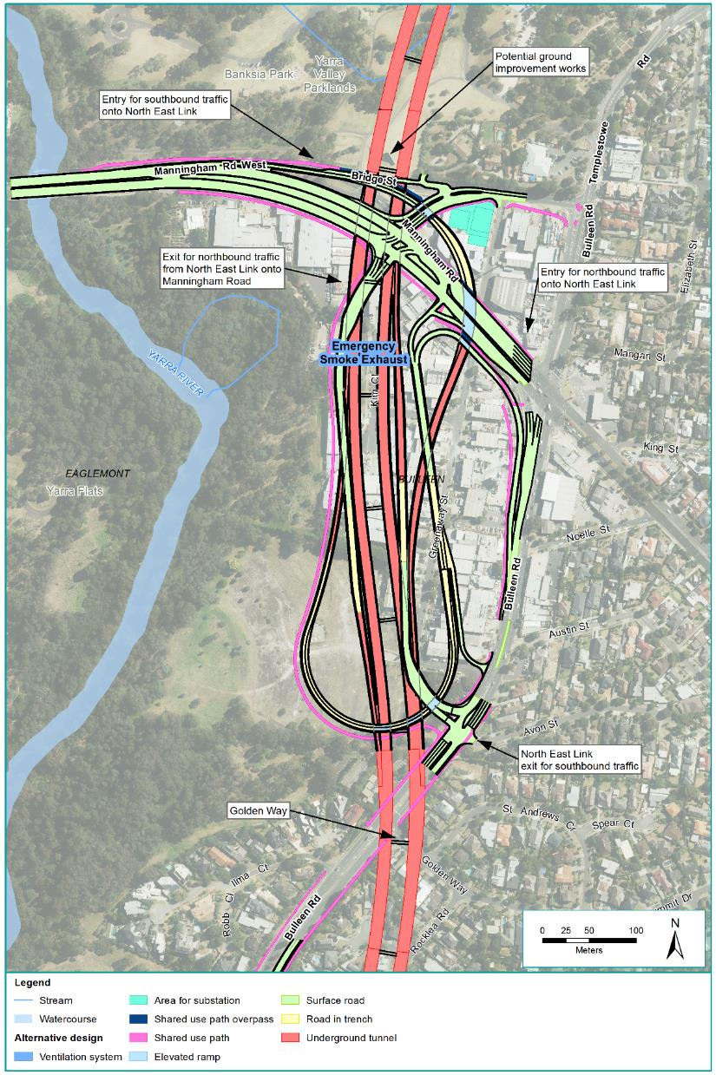
Figure 8-15 Manningham Road interchange (alternative design)
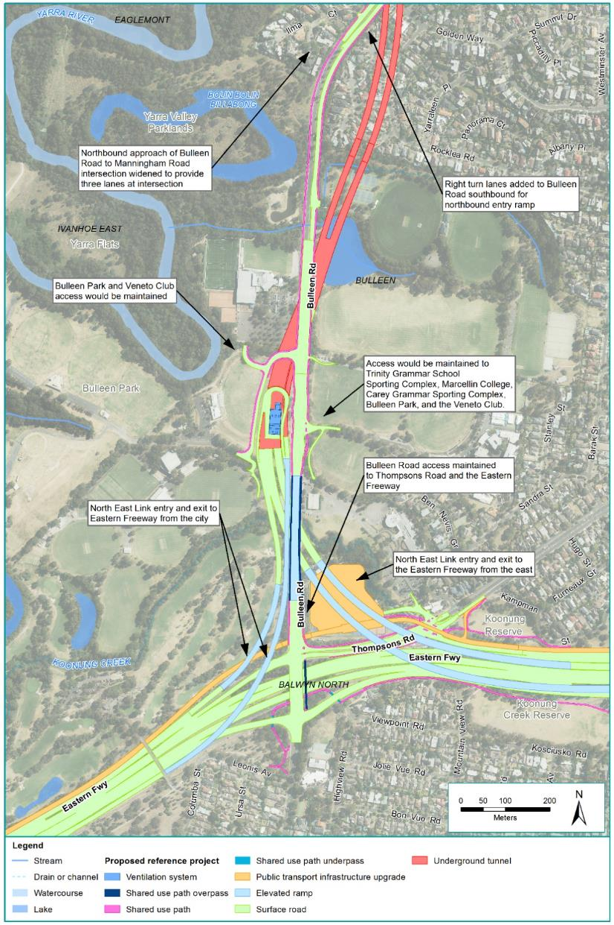
Figure 8-16 Southern portal and Bulleen Road

Noise walls
New or modified noise walls would be provided along the project to achieve noise objectives.
The noise objectives for North East Link are set out in Chapter 11 – Surface noise and vibration and Technical report C – Surface noise and vibration.
New or modified noise walls in the northern portal to southern portal element would be constructed abutting residential zones to the east and west of North East Link at the:
- Lower Plenty Road interchange
- Ramps connecting to the Southern portal.
The locations of proposed noise walls are presented in the EES Map book. Noise walls would be designed in accordance with the project’s urban design principles, objectives and guidelines set out in EES Attachment II – Urban Design Strategy.

Walking and cycling
North East Link would also improve the walking and cycling network, enhancing connectivity and safety for walkers and cyclists.
While the majority of the project south of Lower Plenty Road to the southern portal would be in tunnels, additional paths and crossings would be provided.

Walking and cycling paths
North East Link would include the following new paths:
- A shared use path between the Lower Plenty Road and Martins Lane intersection and the realigned Greensborough Road path via Drysdale Street.
- A shared use path from Banksia Street adjacent to the Yarra River to the Avon Street and Bulleen Road intersection.
- A shared use path along the eastern side of Bulleen Road from the Avon Street and Bulleen Road intersection to Thompsons Road and a pedestrian path on the western side of Bulleen Road from Ilma Court to the Veneto Club.
Additionally, the existing Greensborough Bypass path would be realigned between the northern portal and Lower Plenty Road.

Walking and cycling crossings
The following new crossings would be constructed:
- A new underpass of Lower Plenty Road connecting a realigned Greensborough Road path to River Gum Walk
- A new bridge, shared with traffic, across North East Link at Drysdale Street.
Anti-throw screens, public safety barriers and privacy screens would be integrated with the design of walking and cycling crossings where they are needed.
The paths and crossings identified above are shown in Figure 8-17.
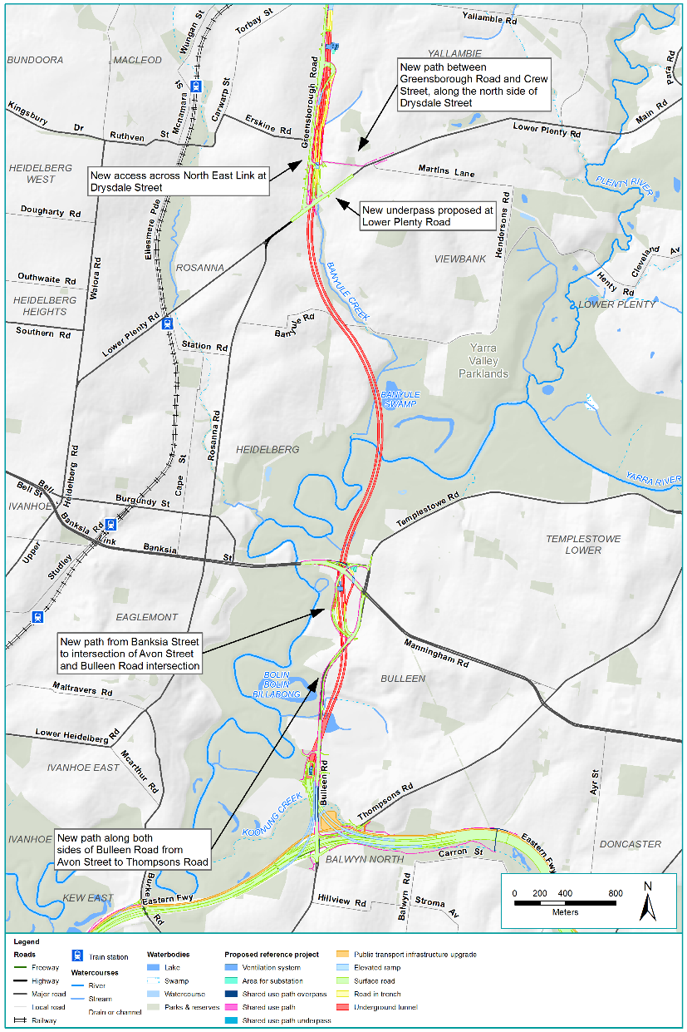
Figure 8-17 New and modified walking and cycling connectivity in northern portal to southern portal element

Drainage and stormwater management
In accordance with Austroads Guidelines to Road Design – Part 5, the design of North East Link would incorporate spill containment within new and upgraded road sections to protect the environment from liquid chemical spills. Spill containment would be designed in accordance with Austroads Guidelines.
Water Sensitive Urban Design (WSUD) features would be incorporated into the northern portal to southern portal element to manage hydrology and water quality.
WSUD features are proposed in a number of locations including:
- Lower Plenty Road interchange
- Manningham Road interchange (water treatment facility, see Section 8.4.6)
- Bulleen Road near the southern portal.

Utilities
Key utilities that intersect or that are in close proximity to the northern portal to southern portal element of North East Link would need to be protected, relocated or avoided to maintain their function. The key utilities that may be affected by the project are summarised in Table 8-2.
Table 8-2 Key utilities in the northern portal to southern portal element
Utility type | Description
Communication towers | A wireless telecommunications base station at Greenaway Street in Bulleen would be relocated to the corner of Bulleen Road and Bridge Street.
Sewer | The Melbourne Water Yarra East Main sewer which currently runs along Bulleen Road would be relocated to avoid a conflict with the North East Link tunnels.

Other ancillary infrastructure

Tunnel ventilation system
The tunnel ventilation system would be designed to:
- Provide for the health and safety of people using the tunnels during normal operation, heavy traffic conditions and emergency conditions
- Ensure the air quality inside and outside the tunnels meets the applicable air quality criteria
- Minimise energy consumption.
Two tunnel ventilation structures are proposed: one in the vicinity of the northern tunnel portals and one at the southern tunnel portals. Each ventilation structure would include a ventilation outlet, ventilation building and an electrical substation. The ventilation structures would be approximately 40 metres high above the local surface level. At the southern tunnel portal, the ventilation building would be approximately 15 metres high, 25 metres wide and 67 metres long. At the northern tunnel portal, the ventilation building would be approximately eight metres high, 47 metres wide and 94 metres long. The electrical substation at each tunnel portal would be approximately six metres high, 22 metres wide and 30 metres long.
The emergency smoke exhaust system would consist of exhaust points at the northern portal, Manningham Road interchange and at the southern portal. This would operate only in the case of an emergency.
All structures would be designed in accordance with EPA Victoria requirements and the project’s urban design principles, objectives and guidelines set out in EES Attachment II – Urban Design Strategy.
A schematic design and description of the tunnel ventilation system is shown in Figure 8-18.
How a tunnel ventilation system works
Ventilation systems are proven to be an effective means of safely dispersing vehicle emissions from tunnels into the atmosphere. They work by drawing fresh air from the tunnel entry, which is then pushed through the tunnel by the movement of vehicles (often described as the piston effect) and jet fans. Before the tunnel exit, air is pushed along the tunnel and up into ventilation structures and dispersed to the atmosphere where it mixes with fresh air which dilutes the emissions to very low levels.
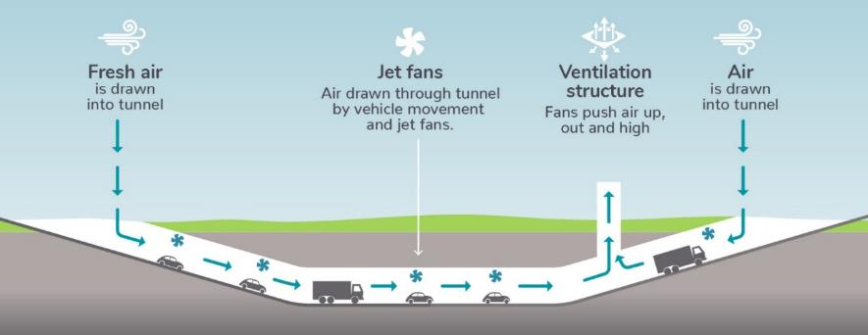
Figure 8-18 Schematic diagram of the tunnel ventilation system

Power supply
Additional power supply capacity would be required to power the TBMs and other activities to construct the tunnels and for tunnel-related facilities once North East Link was operating.
The estimated load to supply power for the TBM and other construction activities is approximately 30 Mega Volt Amps (MVA) and so a new zone substation would be required. The new zone substation would be located at the Manningham Road interchange, which is the proposed location of the TBM launch site. Upgrades to the 66 kV network would also be required including new larger poles and cables on their existing alignment and an upgrade of the Heidelberg Zone Substation (which is outside the project boundary and would be subject to separate approvals).
A similar arrangement would be required for the alternative northern TBM launch site. Upgrade works of the 66kV network located around the northern portal would be required. These works may require upgrades to the North Heidelberg Zone Substation (which is outside the project boundary and would be subject to separate approvals).
The estimated load to supply power to operate the tunnels and associated infrastructure is approximately 14 MVA. A zone substation would be built at the Manningham Road interchange for this purpose. An additional substation would also be located at the northern portal to help provide power to operate the tunnels.

Operations centre
A motorway operations centre would be built to oversee the operation of North East Link. The centre would coordinate services including routine maintenance and incident response.
The centre would be located at the Manningham Road interchange and accommodate offices, an operations room, equipment rooms, emergency vehicle staging area, maintenance facilities and car parking for employees.
An alternative motorway operations centre within the Watsonia railway station car park would be required to support the main operations centre.

Water treatment facilities
Water treatment facilities would be required to treat water captured within the tunnels so it is of a suitable quality to be discharged. The treatment facilities would include settlement ponds and recycled water storage tanks and would be located within the Manningham Road interchange and at the southern portal. As part of the fire management system, deluge tanks would be required in the vicinity of the northern portal and at the Manningham Road interchange.

Eastern Freeway
The Eastern Freeway upgrades would occur from around Hoddle Street in the west to Springvale Road in the east. They would include widening the freeway and new dedicated bus lanes between Doncaster Road and Hoddle Street (the ‘Doncaster Busway’).

The design of the Eastern Freeway element of North East Link would include:
- Upgrades to the Eastern Freeway between the east side of Hoddle Street to Springvale Road
- The addition of the Eastern Freeway interchange to connect the existing freeway to the new section of North East Link
Examples of environmental considerations in the design
New noise walls would be placed along the Eastern Freeway and existing walls would be upgraded to mitigate the noise for residents adjacent to the freeway.

- A new dedicated busway along the Eastern Freeway (the Doncaster Busway) with a new Park and Ride facility at Bulleen Road and an upgrade to the Doncaster Park and Ride
- Upgrades to noise walls including new walls in some areas
- New and improved walking and cycling paths
- Changes to waterways and drainage including the diversion and piping of Koonung Creek in some areas.
These design elements are shown in Figure 8-19.
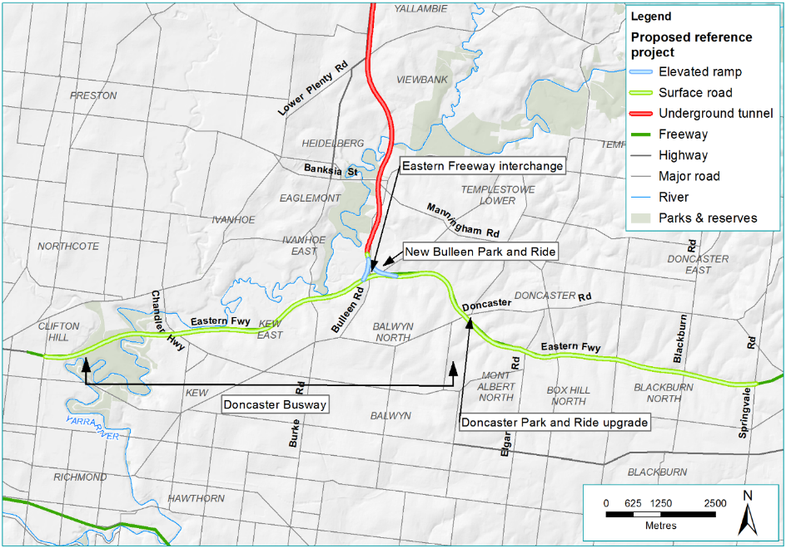
Figure 8-19 Eastern Freeway element

Road design
The roadway design within the Eastern Freeway element can be separated into four sections:
- Hoddle Street to Bulleen Road
- Eastern Freeway interchange
- Bulleen Road to Springvale Road
- The Doncaster Busway.

Hoddle Street to Bulleen Road
The Eastern Freeway would be upgraded to provide additional traffic capacity while maintaining existing access. Modifications would include widening to allow for more traffic lanes, realigning the lanes for traffic and adding the Doncaster Busway (discussed in The Doncaster Busway section further below).
The Hoddle Street to Bulleen Road section is shown and described in Figure 8-20.
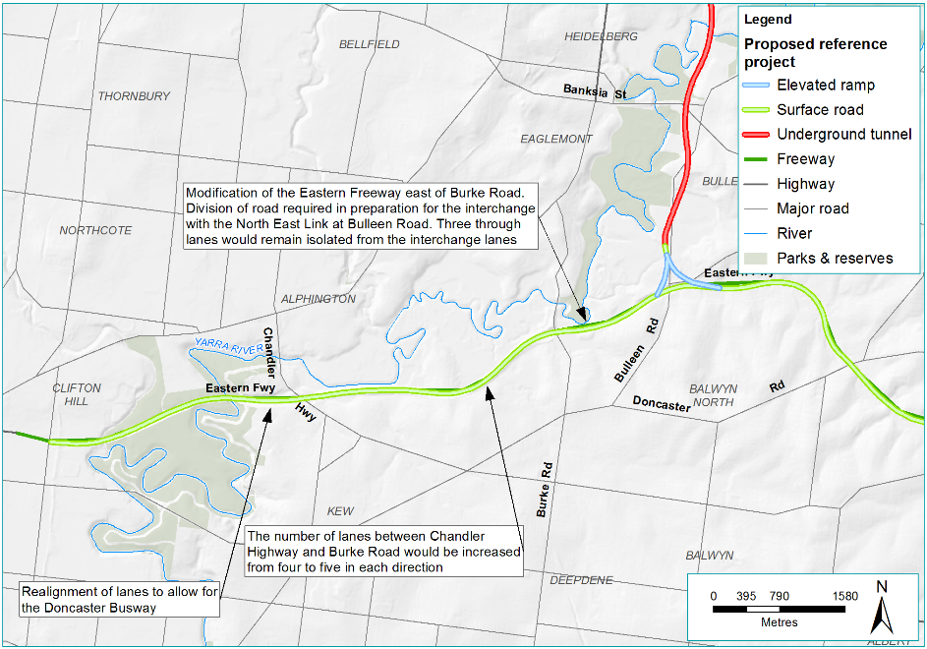
Figure 8-20 Hoddle Street to Bulleen Road

Eastern Freeway interchange

The North East Link would connect to the Eastern Freeway with a new interchange at Bulleen Road providing for all movements via elevated ramps between the tunnels portal and the Eastern Freeway carriageway. The existing functionality at the Bulleen Road and Thompsons Road interchange would be maintained.
Traffic would be free-flowing on east-facing ramps between North East Link and the Eastern Freeway. Ramp metering would contain ramp signals to control west-facing traffic connections to the Eastern Freeway
Ramp metering
Ramp metering regulates the rate and spacing of traffic entering onto the freeway with traffic lights and is proven to improve the overall performance (vehicle speeds and capacity) of a motorway network.

The Eastern Freeway interchange is shown and described in Figure 8-21.
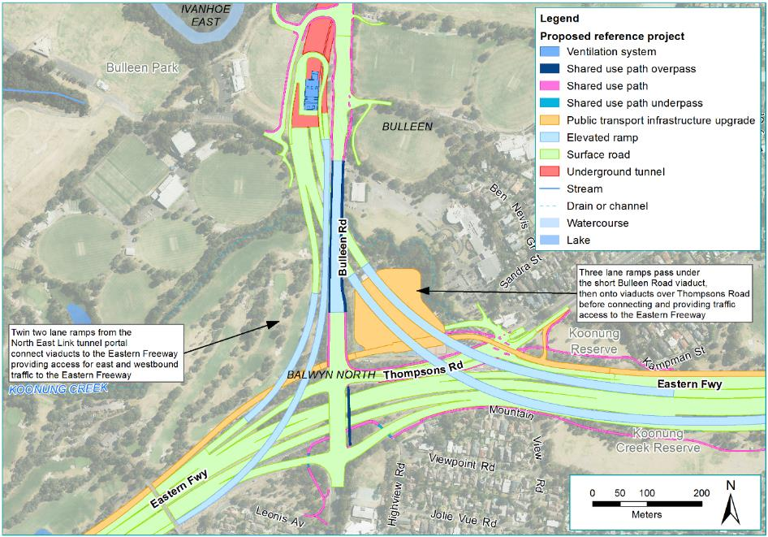
Figure 8-21 Eastern Freeway interchange

Bulleen Road to Springvale Road
The Eastern Freeway would be upgraded to provide additional traffic capacity while maintaining existing access. Modifications would include widening to allow for more traffic lanes, realigning the lanes for traffic and adding the Doncaster Busway (see below).
The Bulleen Road to Springvale Road section is shown and described in Figure 8-22.
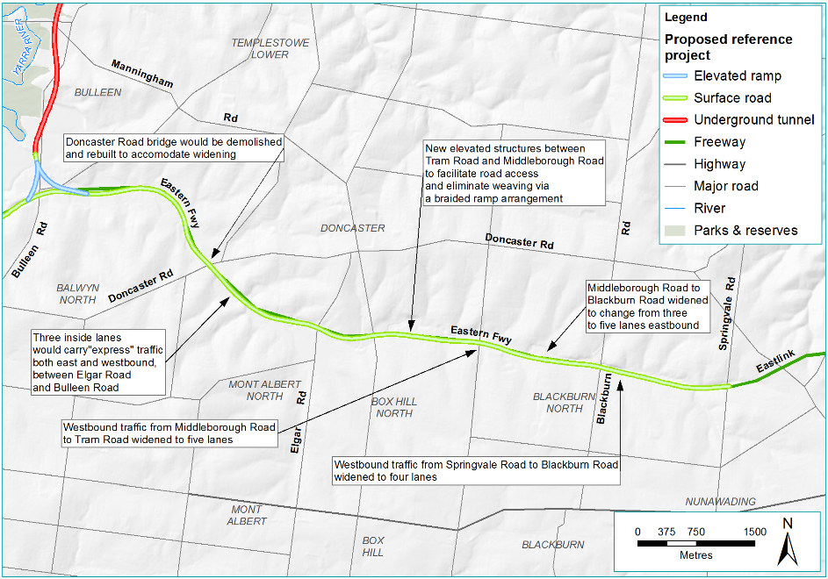
Figure 8-22 Bulleen Road to Springvale Road

The Doncaster Busway
The Eastern Freeway would be upgraded to allow for the Doncaster Busway. The Doncaster Busway would include a new dedicated bus lane in each direction between Doncaster Road and Hoddle Street.
Modifications would include widening of the Eastern Freeway and new ramps at the Chandler Highway interchange, as well as realignment of the lanes to accommodate the dedicated busway. A new Bulleen Park and Ride facility (ground level only) would be built at the Eastern Freeway interchange and the Doncaster Park and Ride could be upgraded as a multi-level car park to maintain current parking capacity.
The Doncaster Busway is shown and described in Figure 8-23.
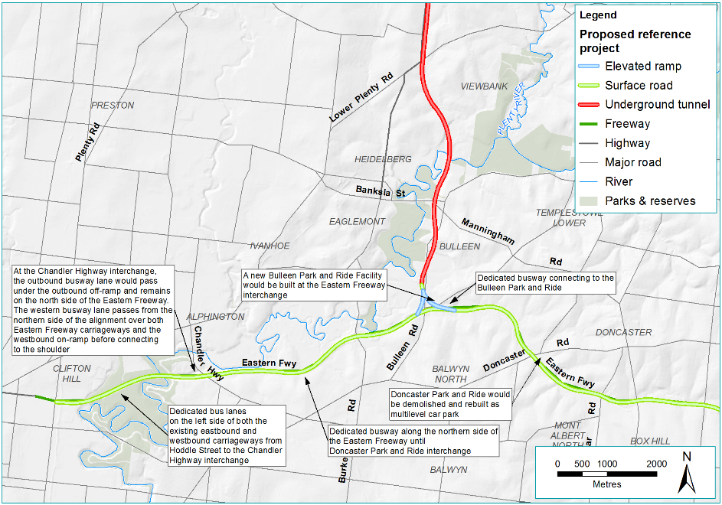
Figure 8-23 Doncaster Busway

Noise walls
Existing noise barriers extend along sections of the Eastern Freeway. North East Link would relocate and upgrade these existing noise walls and provide new noise walls where required to meet the project’s noise objectives. These noise objectives are set out in Chapter 11 – Surface noise and vibration. The noise objectives for North East Link would mean that current noise levels may reduce for some residents along the Eastern Freeway.
New or modified noise walls in the Eastern Freeway element would be constructed abutting the residential and open space zones to the north and south of the freeway, from Hoddle Street through to Springvale Road.
The locations of proposed noise walls are presented in the EES Map book. New or modified noise walls would be designed in accordance with the North East Link urban design principles, objectives and guidelines in EES Attachment II – Urban Design Strategy.

Walking and cycling
North East Link would also improve the walking and cycling network, enhancing connectivity and safety for pedestrians and cyclists.

Walking and cycling paths
North East Link would provide the following new paths along the Eastern Freeway:
- A path from the Main Yarra Trail at Merri Creek to where the Main Yarra Trail re-joins the Eastern Freeway alignment east of Chandler Highway, with shared use and separated pedestrian and cyclist sections
- A shared use path at freeway-level under the Belford Road bridge
- A shared use path adjacent to the new Doncaster Busway, bypassing the circuitous route around the Burke Road Billabong Reserve
- A shared use path connecting the new path along Bulleen Road to the existing Koonung Creek Trail east of Thompsons Road.
Upgrades to the paths adjacent to the Eastern Freeway would facilitate east-west movement and accommodate the proposed freeway alignment, including:
- Realignment of sections of the Koonung Creek Trail, north of the Eastern Freeway between the Bullen Road and Doncaster Road interchanges
- Reconstruction and widening of the path between Belford Road and the Burke Road off-ramp
- Realignment of sections of the Koonung Creek Trail, south of the Eastern Freeway between the Elgar Road and Tram Road interchanges
- Realignment of the Koonung Creek Trail, south of the Eastern Freeway and west of the Koonung Creek Wetlands.

Walking and cycling crossings
The following new crossings would be constructed:
- A shared use underpass of the Chandler Highway outbound off-ramp adjacent to the Doncaster Busway
- A shared use underpass of the Burke Road outbound off-ramp adjacent to the Doncaster Busway
- Two shared use underpasses, one to the west and one to the east of Bulleen Road, south of the Eastern Freeway under the on and off-ramps to provide a bypass of the existing at-grade crossing of Bulleen Road for users of the Koonung Creek Trail
- A shared use overpass of the Eastern Freeway, adjacent to the existing Bulleen Road bridge to connect new and existing paths.
A shared use underpass of Doncaster Road, north of the Eastern Freeway adjacent to the Doncaster Busway to connect sections of the Koonung Creek Trail.
The existing crossings of the Eastern Freeway, at the following locations between Bulleen Road and Springvale Road would be demolished and rebuilt as shared use crossings:
- Estelle Street between Bulleen Road and Doncaster Road
- Heyington Avenue between Doncaster Road and Elgar Road
- Eram Road between Tram Road and Middleborough Road
- Boronia Grove Reserve between Middleborough Road and Blackburn Road
- Kett Street west of Springvale Road.
Additionally, a new Yarra River shared use crossing would be constructed on the northern side of the Eastern Freeway connecting to paths on each side of the river.
Anti-throw screens, public safety barriers and privacy screens would be integrated with the design of walking and cycling crossings where they are needed.
The walking and cycling paths and crossings described above and key features are indicated in Figure 8-24. For further detail on shared use path locations, see the EES Map Book.
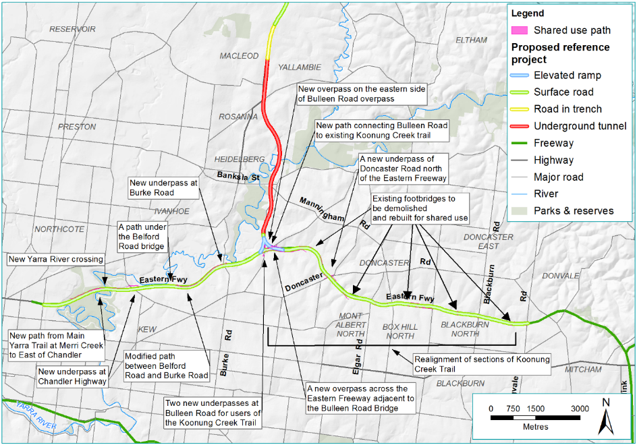
Figure 8-24 Upgrades to walking and cycling network

Changes to Koonung Creek

Diversions
To allow for the widening of the Eastern Freeway, three sections of Koonung Creek, with a total approximate length of 600 metres, would be diverted from their current course. The diversions would involve realigning the creek along these sections and installing a new naturalised channel. Works on the floodplain would also provide for the required flood storage.

Enclosure and covering
To allow for the widening of the Eastern Freeway, an additional five sections of Koonung Creek with a total approximate length of one kilometre, would also be converted into a closed culvert system. existing creek bed would be demolished and replaced with a culvert which would be covered with soil, effectively creating a piped waterway.
For further detail on changes to Koonung Creek see Technical report P – Surface water.

Drainage and stormwater management
In accordance with Austroads Guidelines to Road Design – Part 5, the design of North East Link would incorporate spill containment within new and upgraded road sections to protect the environment from liquid chemical spills. Spill containment would be designed in accordance with Austroads Guidelines.
Water Sensitive Urban Design (WSUD) features would be incorporated into the Eastern Freeway element to manage hydrology and water quality.
WSUD features are proposed in a number of locations including:
- Between Hoddle Street and Bulleen Road along the northern side of the Eastern Freeway
- In proximity to the Eastern Freeway interchange
- Between Bulleen Road and Blackburn Road on the northern and southern sides of the Eastern Freeway.

Water management

Groundwater management

Groundwater management is a critical consideration for structures designed and built below ground. The proposed approach to groundwater management for North East Link is:
- The trench section adjacent to Watsonia railway station to near Blamey Road would be designed to be drained during the project’s construction and operation.
- The cut and cover tunnel sections from Blamey Road to Lower Plenty Road would be managed in two parts. The northern part would be drained during the project’s
What is a drained structure?
A drained structure, in the context of groundwater only, refers to a permeable structure which allows for the seepage of groundwater into the structure.
In the case of the trench section, it can be built as a drained structure as it sits above the water table, and so there should not be any seepage of groundwater into the structure.

construction and operation and the southern part would be drained during construction, and tanked once North East Link was operating. The cut and cover tunnel section at the Manningham Road interchange and at Bulleen would be designed to be partially drained during construction and tanked once North East Link was operating.
- The bored tunnel beneath the Banyule Flats and Warringal Parklands would be constructed using a closed face pressurised TBM and be immediately lined with precast concrete sections. This method would minimise groundwater inflows during the project’s construction and operation.
- The mined tunnel sections would be drained during construction and tanked once North East Link was operating.
The ground improvement section also considers some aspects of groundwater and its management. See Section 8.7.4 for more details on ground improvement works.
Disposal of groundwater at all times must comply with relevant legislation and guidelines and is further discussed in Technical report 22 – Groundwater.
What is a tanked structure?
Tanking is a term used to describe ‘waterproofing’ structures below ground. When a structure is tanked it is designed to be sealed and aims to prevent groundwater leaks into the structure.
In the case of the TBM-bored tunnels, precast segments which are assembled together from a circle would be made off-site and brought to site to line the tunnels. Once these segments were installed, the tunnels would become a tanked structure.

Flood mitigation
Protection from flooding would be required around the North East Link tunnel portals. The northern portal would be located in the catchment of the Banyule Creek. The Manningham Road interchange and southern portal would be located within the Yarra River floodplains. Mitigation would be provided in the form of flood walls using noise walls and traffic barriers, with their height based on the flood level for which protection would be required.
Flood walls would be constructed around the ramp portals at the Lower Plenty Road interchange. These would be up to approximately 1.5 metres above the existing ground level.
Flood protection, including flood walls and flood gates would be required for ramp portals at the Manningham Road interchange and southern portal. These would be up to approximately 7 metres at the Manningham Road interchange and up to approximately 9.0 metres at the southern portal above the existing ground level.

Construction
The construction methods and schedule program outlined in this section are for the reference project of North East Link, which was the basis for the EES assessment.

Overview of construction works
The construction of North East Link would involve a combination of above and below ground works. The construction methods are indicated in Figure 8-25 below for each project element.
The main activities associated with each construction stage are listed in Table 8-3.
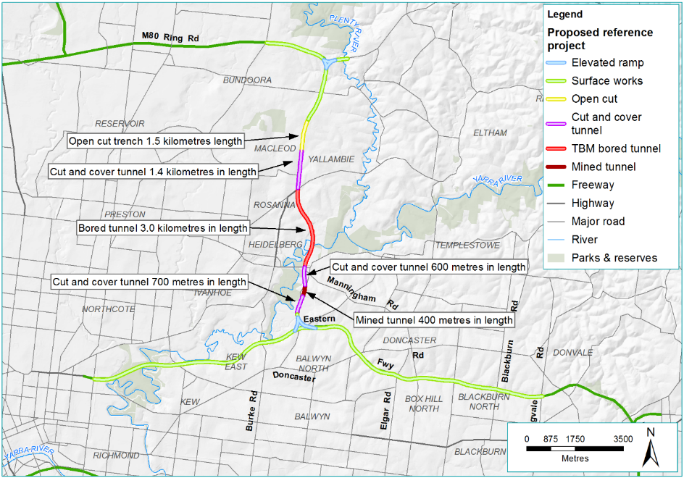
Figure 8-25 North East Link construction methods

Table 8-3 Main construction activities
Construction stage | Activity
Mobilisation activities | - General earthworks including topsoil removal, clearing and grubbing vegetation  - Relocation, adjustment or installation of new utility services  - Demolition of buildings and structures, including site clearance  - Establishment of construction compounds and construction worker parking areas  - Construction of temporary noise walls  - Construction of roadworks and kerb realignment for temporary access points for construction vehicles  - Construction of temporary substation, ramps, bridges and viaducts  - Relocation and diversion of walking and cycling paths
Main construction period | - Construction of retaining walls and diaphragm walls including piling  - Major excavations for tunnel portal construction  - Construction of TBM launch and retrieval facilities and associated support infrastructure  - Ground treatment to stabilise soils  - Tunnel construction using TBMs, mining and cut and cover techniques  - Storage and removal of spoil  - Construction of cross passages, ventilation structures and access shafts  - Construction of ramps and viaducts at the M80 Ring Road and Eastern Freeway interchanges  - Installation of water quality treatment facilities  - Installation of water sensitive urban design features for surface water run-off management  - Construction of road pavements and installation of road furniture, including traffic management measures to facilitate the works  - Construction of noise walls  - Construction of flood walls  - Construction of ventilation structures and fire safety outlets  - Construction of land bridges to facilitate local connections  - Road widening and improvement works  - Integrated landscaping and urban design
Final stages of construction | - Installation of a Freeway Management System  - Installation of fire and life safety equipment in tunnel  - Installation of overhead gantries, signage and other related traffic management systems  - Laying pavement, asphalt and line marking  - Restoration of work areas and construction of shared use paths

Construction assumptions
Key assumptions relating to construction are summarised as follows:
- A large on-site workforce would be engaged during the construction of North East Link, requiring access to and from major work areas
- A reasonable area for materials laydown is required at each construction compound (that is, construction methods are not relying entirely on a just-in-time logistics strategy)
- Local and emergency vehicle access would be maintained
- Pedestrian and cycling connectivity would be maintained
- Construction operations would be required to comply with approval requirements and conditions
- Minimise impacts on adjacent property amenities (including open spaces)
- Monitoring would be established in accordance with all approval requirements and conditions
- Access to businesses and residences near construction locations would be maintained where practicable or alternate arrangements would be agreed
- Transport management plans would be developed and approved before construction started
- Appropriate practices to ensure safe working in an operating road and rail environment would be established
- Acquisition of private properties would be conducted in accordance with the Land Acquisition and Compensation Act 1986 (Vic).

Indicative construction schedule
An indicative construction schedule for the reference project is provided in Figure 8-26.
*Key utilities works includes key utility relocations and power substation construction.
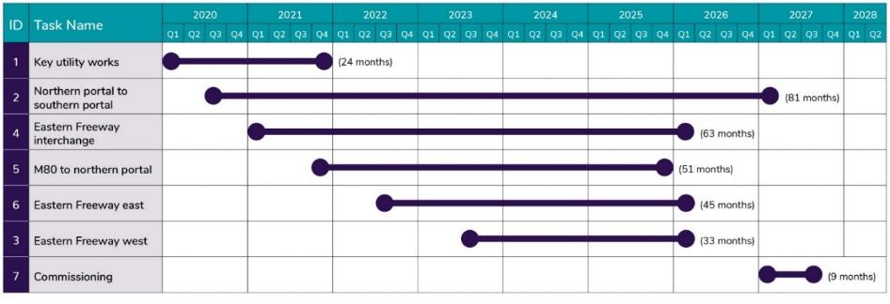
Figure 8-26 Indicative construction schedule

Construction methods

Construction of the tunnels
Three types of tunnel construction methods are proposed for North East Link. These include cut and cover tunnel construction, TBM-bored tunnelling, and mined tunnelling. This is in response to the project alignment, existing ground conditions and the objective to minimise above ground disturbance where possible. These techniques are described in the following sections.

Cut and cover tunnels

The main cut and cover tunnel sections of North East Link would be between Blamey Road and Lower Plenty Road, Bridge Street and Golden Way/Bulleen Road and Rocklea Street and the southern portal.
There are two commonly used sequences for constructing cut and cover tunnels including ‘bottom-up’ and ‘top-down’.
What are cut and cover tunnels?
Cut and cover construction involves using excavation equipment to dig a large trench in the ground in which the rectangular tunnel structure is constructed.

Bottom-up is described below and is the method assumed for the reference project:
      - Installation of retaining walls before excavation starts
      - Soil would be excavated to the first strut level; this must be installed before the excavation proceeds any further. The struts are installed to support the retaining walls, which in turn supports the ground on the outside of the structure
      - The soil is then excavated to the next strut level, and the process above in step 2 is repeated until the final depth is reached
      - At the formation level, the base slab is constructed, which allows the removal of the lowest strut
      - The next level slab is then constructed, followed by the removal of the strut near to that slab level, and the process in step 4 is repeated until the roof slab is constructed
      - Following the completion of the roof slab, soil is backfilled to the top strut level before the strut is removed. This is followed by backfilling the top of the underground structure and reinstating the surface area.
The steps to construct a cut and cover tunnel are illustrated in Figure 8-27.
The process is similar for constructing roads in a trench, but with the exception that no structures are added to cover the trench from above.
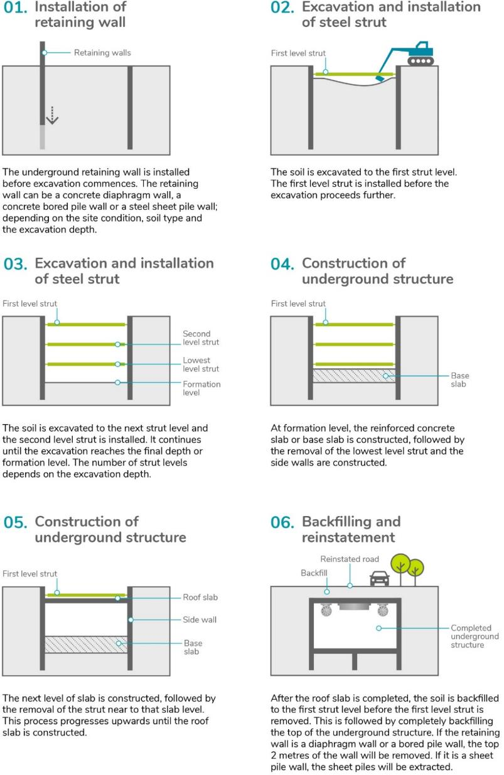
Figure 8-27 'Bottom-up' cut and cover construction method

TBM bored tunnels

The twin tunnels between Lower Plenty Road and Bridge Street would be constructed using Tunnel Boring Machines (TBM).
A TBM can be configured to safely excavate through a variety of soil and rock strata, while installing the pre-cast concrete tunnel lining as excavation progresses. Figure 8-28 shows the basic components of an Earth Pressure Balance TBM, which is a type of closed-face TBM.
Why use a tunnel boring machine?
Using a closed-faced pressurised TBM minimises disruption at surface level, limits the disturbance to the surrounding ground and groundwater and can produce a concrete-lined single-pass tunnel. TBMs are used to construct underground infrastructure all over Australia and around the world.

 | Pressure bulkhead |  | Mixing arms |  | Tail skin
 | Cutting wheel |  | Screw conveyor |  | Backfill grout
 | Excavation chamber |  | Segment erector |  | Segmental tunnel lining
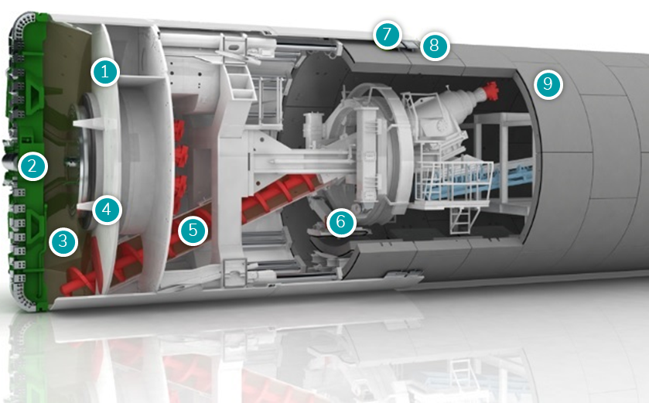
Figure 8-28 Tunnel boring machine
(Source: Herrenknecht, Tunnelling Systems, image, viewed 16 May 2018 <https://www.herrenknecht.com/en/products/core-products/tunnelling/epb-shield.html>)
Two TBMs, each approximately 15.7 metres in diameter would be used for North East Link. These would be assembled at the TBM launch site as they are too large to be transported by road. The TBMs would operate continuously for 24 hours per day, seven days per week, progressing at an estimated average rate of 60 metres per week and producing on average 20,000 m³ of tunnel spoil per week.

Mined tunnels

A short section of the twin tunnels (approximately 400 metres in length) south of the Manningham Road interchange would be constructed using the ‘mined tunnel’ method. This would typically involve road headers to undertake the excavation.
The mined section would be adjacent to Bulleen Road between Avon Street and just south of Rocklea Road as shown in Figure 8-25. Two road headers would be used with an average production of up to 10 metres per week.
Spoil from the mined tunnels would be transported from the road header by trucks to the main spoil management area at the TBM launch site for removal.
What is a road header?
A road header is an excavation machine consisting of a boom-mounted rotating cutter head, a loading device, and a crawler track to move the machine forward into the rock face. Road headers are the preferred technique for the mined tunnel.
Figure 8-29 shows a road header in operation.

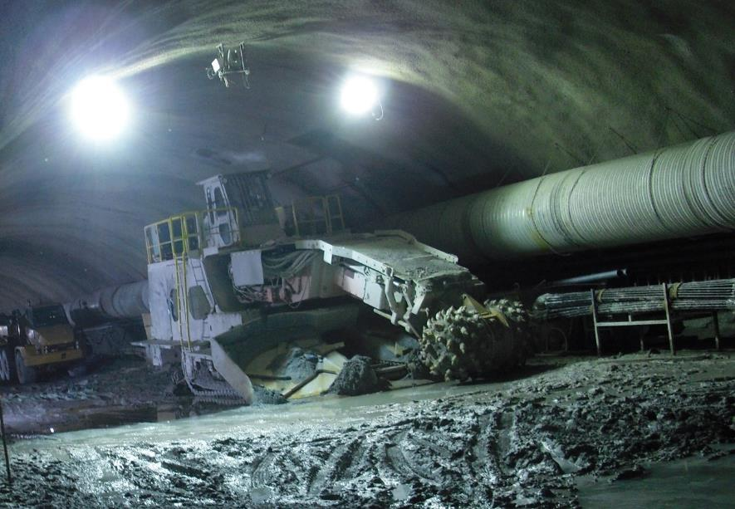
Figure 8-29 Roadheader (Airport Link, Brisbane, 2010)

Sewer tunnel
The Bulleen Road sewer would require realignment to avoid conflict with the North East Link tunnels. The realigned sewer would be placed within a tunnel of around 1.8 metres in diameter and would be 4 to 16 metres below the ground surface.
The sewer tunnel would be constructed to the east side of Bulleen Road, from Avon Street to the Bulleen Road (adjacent to the Bulleen Swim Centre). It would be constructed using a combination of pipe jacking and an open trench method (including a cofferdam) for where the sewer tunnel crosses the dam adjacent to Trinity Grammar.
The realigned sewer location compared with the existing location is identified in Figure 8-30. Construction would include:
- Launch and retrieval shaft
  - Launch shafts would be approximately nine metres in diameter and require a site of at least 1500 m²
  - Retrieval shafts would be approximately eight metres in diameter and require a site of at least 800 m²
- The cofferdam (a water tight enclosure) would be approximately four metres deep consistent with the depth of the sewer at this location
- The open trench would be up to eight metres wide to allow for pipe laydown and other equipment such as cranes and excavations in the working space
- Following the completion of the tunnelling works the shafts would be back filled leaving only a man hole for permanent access to the sewer
- Construction duration for the sewer realignment is anticipated to be 10 months.
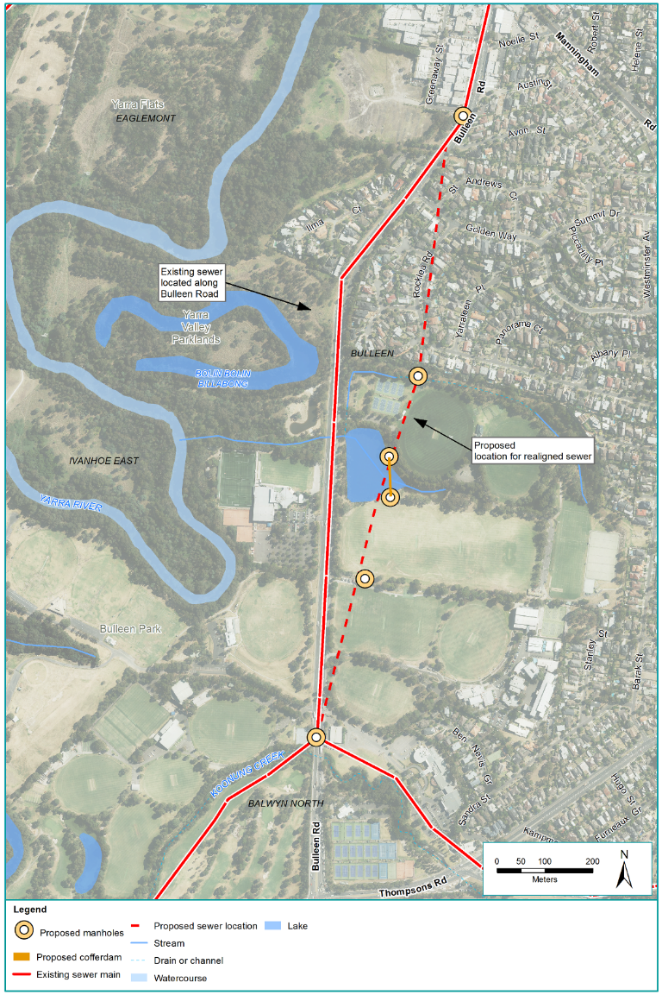
Figure 8-30 Sewer tunnel realignment

Earthworks
Extensive earthworks would be required along the majority of the North East Link alignment including works associated with the M80 Ring Road and Eastern Freeway. The majority of earthworks would involve excavation, including the cut and cover and trench structures, with minor embankment fills. For further detail on spoil management see Section 8.8.2.

Ground improvement

Ground improvement works would be required at the southern end of the TBM tunnels, just north of Bridge Street. The ground improvement would be required to stabilise ground conditions over the top of and beside the tunnels where there is a small distance between the top of the tunnel and the ground surface. If required, the type of ground treatment would be determined through the detailed design development of North East Link.
What are ground improvement works?
Ground improvement is a construction process that is used to change the properties of soil to allow the ground to become more suitable for construction.

Freeway widening
North East Link would include the widening of the M80 Ring Road and Eastern Freeway to provide additional traffic lanes and allow for turning movements the project would introduce to the road network.
Road widening would occur into the median or beyond the road shoulders depending on the location. A typical sequence for widening into the median would involve:
- Establishing traffic management measures
- Shifting traffic towards the outside shoulders to create the median work area
- Constructing median widening
- Shifting traffic to accommodate a temporary staging area for other works such as new viaducts
- Line marking and then shifting traffic onto the final alignment.
Before widening works started, construction areas would be separated from vehicle traffic by safety barriers in accordance with Road Management Act 2004 and associated regulation requirements (Vic).

Bridge construction
North East Link would require the construction of a number of new bridges and the upgrade of a number of existing bridges and elevated structures. These include road bridges, foot bridges and land bridges. There are several bridge design options available that may be applied throughout North East Link including precast concrete, steel box girder, voided slab, match cast segmental and incrementally-launched bridge superstructures. Piers, beams, decks and parapets would be constructed from either end of the bridges or from above at a safe clearance to traffic.
Road widening would generally occur before bridge works started so that traffic could be diverted clear of proposed bridge approaches and supporting pier locations. With road widening complete, traffic could be moved around safe work zones created for bridge foundation works (piling) through to pier construction and superstructure installation.
Once completed, bridge works could be easily isolated from live traffic and then brought online through temporary lane closures, barriers and signage.

Potential construction compounds

Overview of construction compounds
A number of potential construction compounds for North East Link have been identified and these are shown in Figure 8-31, Figure 8-32, Figure 8-33 and Figure 8-34. All potential compounds are subject to ongoing discussions with local councils and key stakeholders. The activities undertaken at these locations would vary and include offices, construction laydown, staff amenities, and vehicle and equipment storage and spoil management, with the duration of occupancy at each site ranging from one to six years.

Primary TBM tunnelling works areas
The TBM tunnelling work area would be within a construction compound that contains an acoustic shed, workshops, offices and storage facilities for the works. Two options are proposed for the location of the TBM tunnelling works area:
- Northern TBM launch site: Lower Plenty Road extending north to Blamey Road and described as the Northern TBM launch site. The TBM would be retrieved in the construction compound just north of the Manningham Road interchange
- Southern TBM launch site: Bridge Street extending south to Golden Way and described as the Southern TBM launch site. The TBM would be retrieved at the construction compound just north of Lower Plenty Road.
z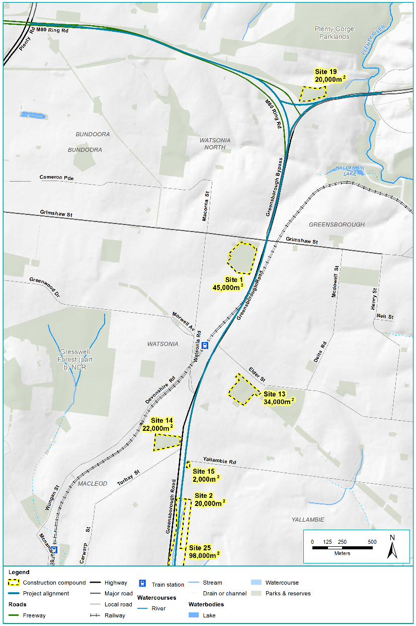
Figure 8-31 Construction compounds from the M80 Ring Road to northern portal
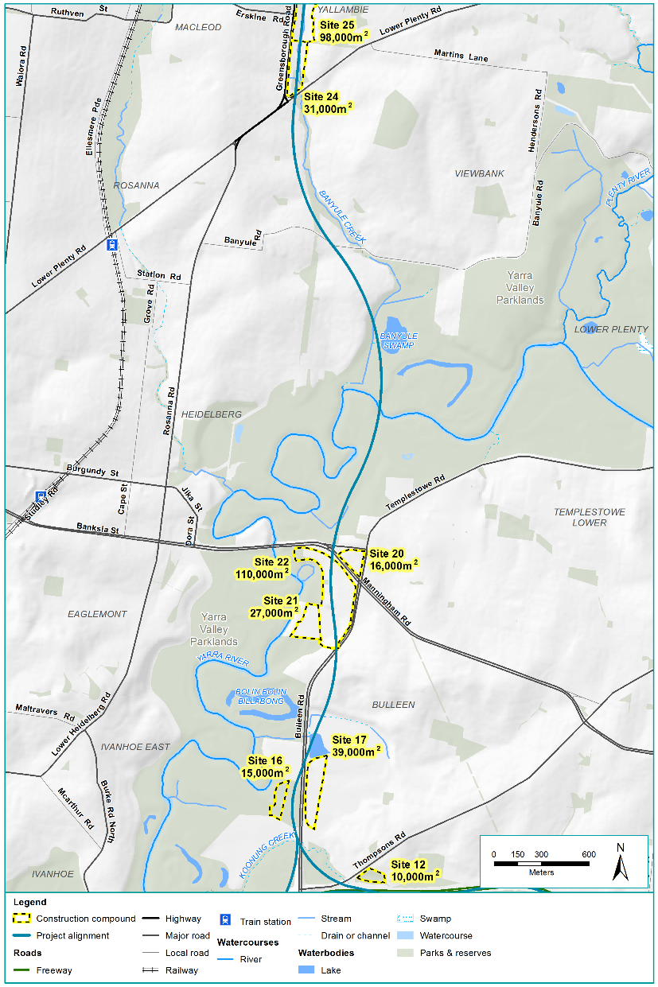
Figure 8-32 Construction compounds from northern portal to southern portal
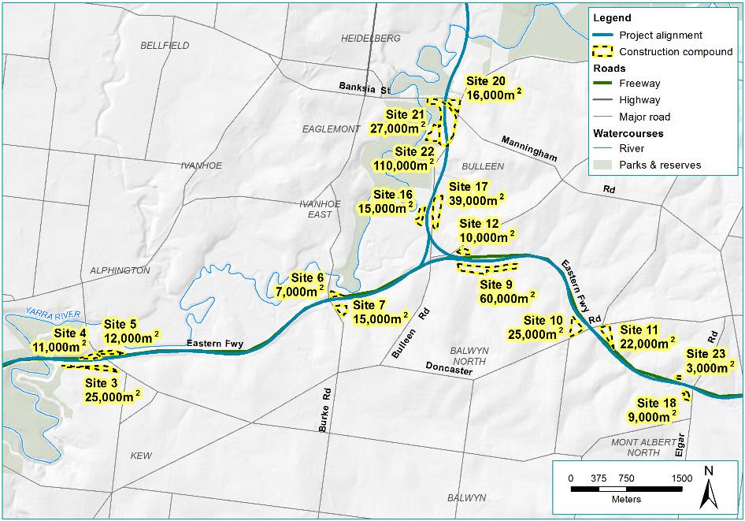
Figure 8-33 Construction compounds along the Eastern Freeway (west of Bulleen Road)
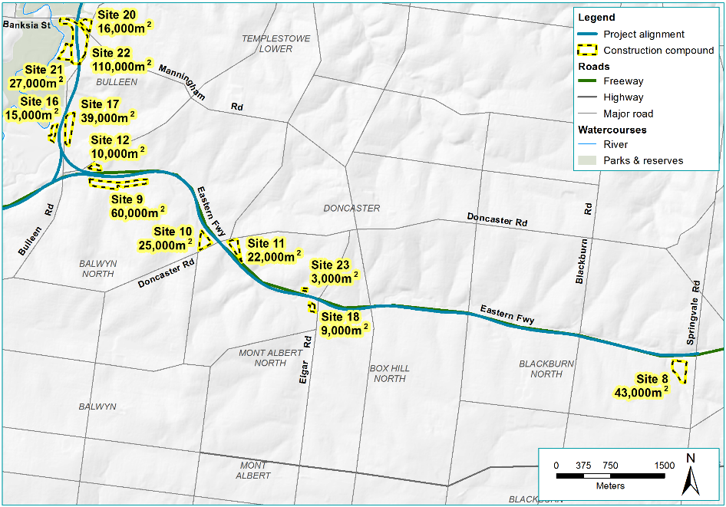
Figure 8-34 Construction compounds along the Eastern Freeway (east of Bulleen Road)

Construction timing, hours and workforce
Construction activities would occur simultaneously across the three project elements to limit the overall duration of construction. Activities would be planned to minimise impacts and regular communications would keep communities informed of construction progress.
Due to the nature and volume of the required works, some construction activities would need to be undertaken outside of normal daytime working hours. Anticipated works during evening and night time would include:
- Works within the M80 Ring Road, Eastern Freeway and arterial road reserves
- Works over or in the immediate vicinity of the Hurstbridge rail line
- Tunnelling works
- Spoil handling and transport
- Delivery of oversized equipment and materials.
A Construction Noise and Vibration Management Plan would be developed and implemented to minimise noise impacts, including from evening and night time activities that are unavoidable and cannot meet the construction noise targets.
Tunnelling would be a continuous activity and would be undertaken over 24 hours, 7 days a week.
The construction workforce would vary in size over the course of the construction period and is expected to peak at around 2,800 people across the project alignment per shift. Car parking for the construction workforce would be included at the construction compounds.
The construction workforce required for each element of North East Link is listed in Table 8-4.
Table 8-4 Construction workforce for North East Link
Project element | Estimated construction workforce (peak per shift)
M80 Ring Road to northern portal | 675
Northern portal to southern portal | 1,000
Eastern Freeway | 1,125

Construction materials
A variety of materials would be required to construct North East Link. While excavated spoil would be reused where possible, certain elements of the project such as road pavement and structural embankments require material of a higher quality which cannot be generated from excavated spoil. Indicative quantities key materials are:
- Asphalt – 300,000 m³
- In situ concrete – 735,000 m³
- Pre-cast concrete – 320 000 m³
- Steel – 215,000 tonnes
- Imported fill – 650,000 m³
- Imported cement treated crushed rock – 150,000 m³
- Imported crushed rock – 100,000 m³.

Traffic and transport management during construction

Road closures and changed traffic arrangements
Effective management of traffic impacts on roads, footpaths and bike paths adjacent to the project during its construction would be crucial. Contractors would prepare and implement Transport Management Plans identifying appropriate construction traffic routes temporary diversions and measures to manage local traffic disruptions. See Technical report A – Traffic and transport for further detail.

Public transport
Rail passenger operations would be temporarily disrupted where North East Link crosses the Hurstbridge rail line around Watsonia railway station during the project’s construction. It is anticipated that a mix of after last before first, weekend and extended week-long occupations would be required to complete the bridge widening works.

Car parking
Existing car parking facilities at Watsonia railway station and at the Doncaster Park and Ride would be affected during construction. At these locations, temporary car parking would be provided to maintain existing levels of available parking. Separate places would be provided for construction staff parking.

Spoil and waste management
Spoil is waste material brought up during the course of an excavation, tunnelling or mining. North East Link would generate spoil during construction which would be managed around the project or transported away from the project via designated haulage routes.

Spoil generated
The indicative spoil volume estimate the project would generate is provided in Table 8-5.
Table 8-5 Source and amount of spoil generated from North East Link
Element | Amount generated
M80 Ring Road to northern portal | 2,155,000 m³
Northern portal to southern portal* | 3,265,000 m³
Eastern Freeway | 680,000 m³
Total | 6,100,000 m³
* Estimates are based on in situ volumes (solid volumes) to be excavated, not on ex situ (excavated) volumes

Spoil management
Management of spoil would include measures to prevent silt run-off to waterways and to suppress dust. These measures include acoustic sheds, covering of piles and trucks, watering and are described in detail in Chapter 23 – Contamination and soil and Technical report O – Contamination and soil.
Opportunities to reuse spoil would be investigated as set out in Section 8.8.4 (Waste management). Nevertheless, spoil that is unable to be reused would be removed from the storage sites by truck via designated haulage routes (Section 8.8.3). A number of potential reuse, management and disposal sites have been identified for surplus spoil and other opportunities may be realised at the time of construction.
Spoil from the tunnel excavations would be transported by conveyor to spoil management facilities that would be within the primary tunnelling work area.
The primary tunnelling work areas would be at the Northern TBM launch site or at the Southern TBM launch site construction compounds. From these facilities, the majority of the spoil would be loaded onto trucks and removed from site to off-site landfill areas. See Section 8.8.3 for further information on truck haulage routes.
In addition to tunnel spoil, other work areas along the project would generate surplus spoil during construction. These materials would be managed on the individual construction compounds in the vicinity of the works or transported off-site for disposal.
During the detailed design of North East Link, the contractor would be required to adopt waste management handling practices consistent with the Environment Protection Act 1970 (Vic) when assessing options for spoil management. For further detail on spoil management, see Technical report O – Contamination and soil.

Spoil haulage routes
Construction haulage routes have been identified to provide construction-related traffic with efficient access to the Eastern Freeway and arterial road network and between worksites. This would minimise the impacts on local traffic and roads wherever possible to transport spoil from the construction compounds to potential land fill sites.
Spoil would be hauled to sites near Dandenong or Epping. Sites to the east of Bulleen Road along the Eastern Freeway are proposed to haul to Dandenong, while the bulk of the spoil from the remaining construction sites is proposed to be hauled to Epping. Spoil coming from the tunnelling works would use Bell Street and either Sydney Road, High Street or Plenty Road to access Epping. Sites north of Lower Plenty Road would use Greensborough Road and the M80 Ring Road to access Epping. Rosanna Road would only be used to move contaminated material from sites north of Lower Plenty Road to Dandenong. For further information on spoil haulage traffic see Technical report A – Traffic and transport.
The indicative construction haulage routes are shown in Figure 8-35.
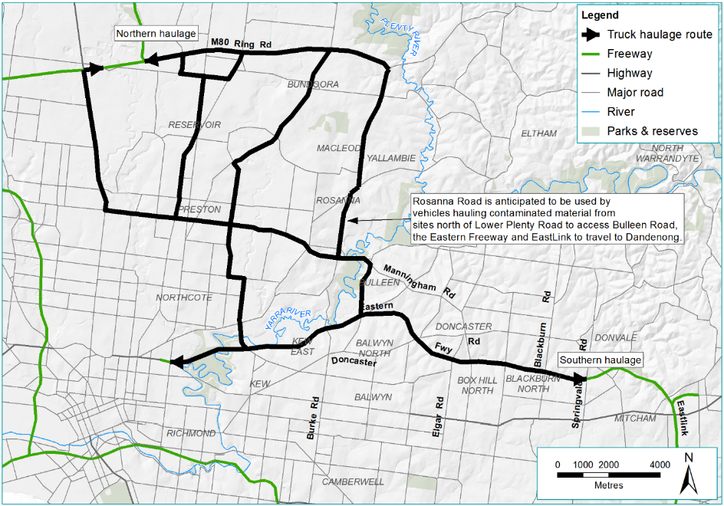
Figure 8-35 Indicative construction haul routes

Waste management
Waste management would be undertaken in accordance with the principles set out in the Environment Protection Act 1970 (Vic) and waste management hierarchy shown in Figure 8-36. Construction waste streams such as concrete, metal, green wastes and spoil would be segregated for recycling or reuse.
Waste disposal methods would be selected based on the classification of waste material in the EPA Victoria Industrial Waste Resource Guidelines. All wastes generated during the construction of North East Link would be transported, managed and disposed of in accordance with the relevant EPA Victoria requirements.
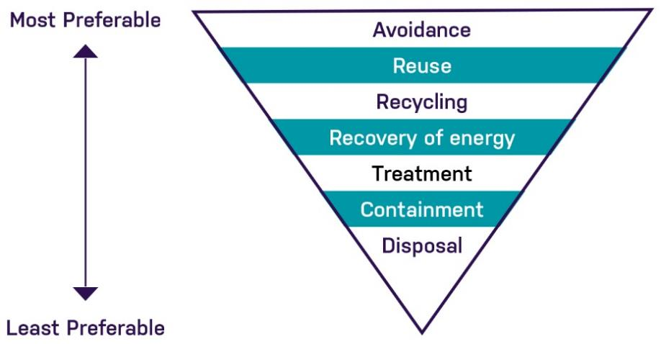
Figure 8-36 Waste management hierarchy
Source: EPA Victoria, Waste, image, viewed 17 May 2018 <http://www.epa.vic.gov.au/your-environment/waste>

Operation
It is anticipated that North East Link would be fully operating in 2027 but some sections of the project may be completed before this date.

Key operational and maintenance activities
Following construction of North East Link, the key operation activities would include:
- Operation and maintenance of the overall link through the motorway control centre and several maintenance sites
- Operation and maintenance of the tunnel ventilation system and other traffic management safety systems
- Operation and maintenance of water treatment facilities
- Operation and maintenance of the motorways power supply (substations)
- Maintenance of landscaping, paths and WSUD features
- Operation and maintenance of the tolling system.

Road closures and changed traffic arrangements
Proposed permanent road closures on the existing road network are related to the placement of the Manningham Road interchange. These are presented in Section 8.4.1 above, Figure 8-14 and Figure 8-15 above and summarised below in Table 8-6.
Table 8-6 Proposed permanent road closures
Existing road | Modification | Reason for change | Functionality and alternative access
Greenaway Street – Between Manningham Road and Bulleen Road | Closed | Due to the Manningham Road interchange and construction of open cut and mined tunnels | The extent of land required for a major freeway interchange design at this location completely removes Greenaway Street and the properties it provides access to.
Kim Close – Adjacent to Greenaway Street | Closed | Due to the Manningham Road interchange and construction of open cut and mined tunnels | The extent of land required for a major freeway interchange design at this location completely removes Kim Close and the properties it provides access to.
Avon Street – access from Avon Street to Bulleen Road | Closed | Reconstructing Bulleen Road and the interchange ramp terminal intersection being introduced opposite Avon Street, which closes access to Avon Street. | Provides a safety benefit by removing a local road intersection from within an arterial road signalised intersection. Also prevents ‘rat-running’ from exit ramp into Avon Street.
Nell Street – access from Nell Street to Greensborough Road | Closed | Greensborough Road is truncated at Nell Street due to the alignment of North East Link and Greensborough Road east | Nell Street west of Longmuir Street becomes a cul-de-sac. All other existing access is maintained.
Thompson Street – access from Thompson Street to Greensborough Road | Closed | Greensborough Road is truncated at Doris Street due to the alignment of North East Link and Greensborough Road east | Thompson Street becomes a cul-de-sac at the western end with access to Thompson Street via Longmuir Road
Temby Street – access from Temby Street to Greensborough Road | Closed | Greensborough Road is truncated at Doris Street due to the alignment of North East Link and Greensborough Road east | Temby Street becomes a cul-de-sac at the western end with access to Temby Street via Longmuir Road

The freeway motorway management system
A Motorway Management System is proposed for the new north-south section of the project as well as the upgraded Eastern Freeway in order to safely and efficiently operate the project and would include the following elements:
- Co-ordinated ramp metering at entry points to North East Link to ensure smooth traffic flow
- Electronic lane use management system which includes capability to alter the speed of traffic to increase safety and optimise traffic flow, with the capability to close lanes for incidents and maintenance
- Integration or effective interfacing with VicRoads freeway management and the connecting major road network
- Incident detection and response mechanisms for the tunnels and surface roads
- Variable message signing system including information signing system in the tunnels
- Over height vehicle management including detection and diversion on approach to the tunnels
- Radio broadcast technology to communicate with drivers in the tunnels.
VicRoads as the Melbourne traffic network operator would manage the ramp metering system installed at entry ramps and the application of the dynamic vehicle speed limit management. Metering would be applied to the entry ramps in accordance with VicRoads standards with adequate ramp storage to minimise impacts on the surface road network.

At locations where there are complex traffic movements involving weaving and merging it is proposed to separate traffic into dedicated carriageways separated by physical barriers. This would ensure smooth traffic flow and safety of drivers. On the Eastern Freeway for outbound direction traffic originating in the city, three inner lanes in each direction would be essentially express lanes to and from the city between Chandler Highway and Middleborough Road, within their own carriageway physically separated from the outer three lanes. The outer three lanes in each direction would be the ‘collector-distributor’ carriageways, providing dedicated access to and from the Eastern Freeway and other on ramps and off-ramps.
The tunnels between the northern and southern portal would be designed and built to operate with three traffic lanes in each direction. The tunnels would have a sufficient vertical clearance for vehicles of normal dimensions. Over-dimensional vehicles would be unable to use the tunnels. Placarded vehicles would also be banned from the tunnels due to the fire and life safety risk posed by these vehicles. To provide for over-dimensional and placarded vehicles that would not be able to use the tunnels, a designated alternative route would be prescribed on the existing road network.
Each tunnel would be marked as three lanes with minimal shoulders. Overhead lane use management system signage would manage speed and the opening and closing of lanes as required, to optimise traffic flows, respond to incidents or for tunnel maintenance.
Procedures would be established to respond traffic incidents during tunnel operations including breakdowns, small accidents and debris on road surfaces. Measures have been incorporated into the tunnel design to enable rapid responses to keep traffic moving and minimise impacts on the wider road network.
A video-based automatic incident detection system within the tunnels would be the primary means to identify incidents. In the event of an incident, incident response vehicles would be dispatched from the operations centre at the Manningham Road interchange.
The tunnel design would also incorporate a range of features to detect, manage and control fire and safety incidents quickly and efficiently. Public safety in tunnels is also described in Section 8.4.1. These features would include:
- Incident and fire detection system
- Smoke management and automatic fire deluge (sprinkler) systems
- Emergency public address and radio broadcasting systems
- Closed-circuit television surveillance
- Traffic and personnel evacuation management systems to enable rapid tunnel closure and active management
- Back-up power for emergency systems, including emergency lighting and signage
- Emergency services communications.

The tolling system
Toll-free roads for local trips would be maintained between the Eastern Freeway and the M80 Ring Road. There would be no tolls on the Eastern Freeway as a part of North East Link. Between the M80 Ring Road and Watsonia Road, Greensborough Road would be rebuilt on either side of North East Link and kept open for local toll-free trips. Between Watsonia Road and Lower Plenty Road, Greensborough Road would run next to North East Link and be kept open for local toll-free trips. Bullen Road would also remain toll-free.
Tolling points would be installed for North East Link between the M80 Ring Road and the connection to the Eastern Freeway in the following locations:
- Between the M80 Ring Road and Grimshaw Street; mainline only, not applicable to the rebuilt Greensborough Bypass
- Between Grimshaw Street and Lower Plenty Road
- Between Lower Plenty Road and Manningham Road
- Between Manningham Road and the Eastern Freeway.
Each tolling point location would contain a gantry and associated shelter. Each gantry would contain associated lighting and would also emit a blue light when operating similar to that used on existing toll roads. The lighting is designed to meet the requirements of international and Australian Standards concerning electrical safety and eye safety. The proposed lights would be directed down towards the toll points to minimise potential light spill. The gantries would be serviced for operations and maintenance purposes via person-accessible walkways above the gantries.

Existing truck bans
There are no truck curfews proposed for North East Link. VicRoads has permanently implemented curfews on the following roads:
- Greensborough Bypass – Rosanna Road (Grimshaw Street to Banksia Street)
- Lower Plenty Road (Greensborough Road to Waiora Road)
- Waiora Road (Kingsbury Drive to Bell Street)
- Waterdale Road (Kingsbury Drive to Bell Street)
- Lower Plenty Road – Main Road (Wattletree Road to Greensborough Road)
- Para Road (Grimshaw Street – Lower Plenty Road)
- St. Helena Road – Karingal Drive
- Bolton Street
- Ryans Road – Wattletree Road.
These curfews have been included in the strategic modelling for North East Link. No additional truck bans have been considered in the strategic modelling. The locations of current truck curfews are shown in Figure 8-37.
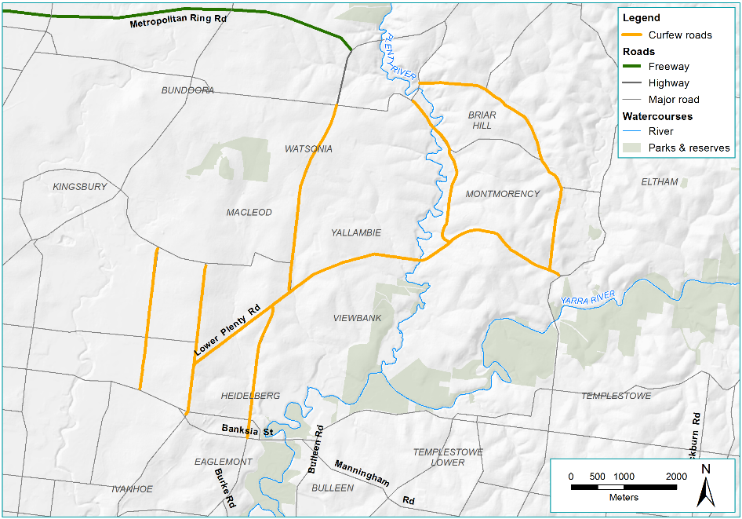
Figure 8-37 Current north-eastern suburban truck curfew locations
These road restrictions have been permanently implemented, with no additional truck curfews used in the strategic traffic modelling. The curfews restrict vehicles in excess of 16.5 tonnes from the area between 10:00 pm and 6:00 am. This is discussed further in Technical report A – Traffic and transport.

Public transport
Existing on-road bus services would be retained and public transport would be enhanced with the addition of the Doncaster Busway. The functionality of the Doncaster Busway is described earlier in Section 8.5.

Complementary to the Doncaster Busway, a bus station and a Park and Ride facility would be built near the corner of Bulleen Road and Thompsons Road. This is shown in Section 8.5 and would be managed by Transport for Victoria to provide car parking for 300 to 400 commuter vehicles. The Doncaster Park and Ride facility would be modified to align with the Doncaster Busway and to maintain the existing 400 car parking spaces. The Doncaster Busway would not preclude a future rail line.
North East Link would be located close to Watsonia railway station. Access across the North East Link alignment and into the Watsonia railway station precinct would be maintained. While car parking areas at the station would need to be reconfigured, the existing number of car parks would be retained. Potential impacts to public transport services are assessed in Technical report A – Traffic and transport.
Works associated with the North East Link crossing of the Hurstbridge rail line near Grimshaw Street may require the modification of the rail signalling and electrical networks along this line.

Property acquisition
A number of properties would need to be acquired for the development of North East Link. Where possible, construction sites, infrastructure and other aspects of the project would be located at sites to avoid temporary occupation and permanent acquisition.
Acquisition would be undertaken in accordance with the Land Acquisition and Compensation Act 1986 (Vic) and the Major Transport Projects Facilitation Act 2009 (Vic). The typical notice periods from the start of the statutory acquisition process to possession is 24 months for businesses and 12 months for residences.
Acquisition of open space that may be required for the construction and operation of North East Link is discussed in Section 8.11. Properties that would be affected are summarised in Table 8-7.
The Table 8-7 summary count is based on property numbers categorised by land use (residential, commercial or other). It should be noted that a commercial property is not one and the same as a business, as there may be multiple businesses on a single property, or there may be a single business occupying multiple properties.

M80 Ring Road to northern portal
For the M80 Ring Road and the northern portal element, 18 residential, six commercial and nine other properties would need to be acquired for North East Link.

Northern portal to southern portal
The North East Link tunnels would pass beneath a number of predominantly residential properties or open space. Some ground improvement works may be required near the southern tunnel portal which may involve some temporary occupation of public and private land. For further information on ground improvement works see Section 8.7.4. The diversion of Yarra East Main sewer may have possible sub-surface property impacts. For further information, see section 8.7.4 Construction methods (sewer tunnel) in conjunction with the EES Map book.
In the northern portal to southern portal element, 97 commercial, 18 residential and 16 other properties would be acquired. The majority of these commercial properties are within the Bulleen Industrial Precinct which is bordered by Bridge Street, Bulleen Road and the Yarra River. Boroondara Tennis Centre and part of the Freeway Public Golf Course would be permanently acquired to allow for the construction of the Eastern Freeway interchange and a Park and Ride facility.
The diversion of the Yarra East Main sewer would affect approximately 21 properties either by sub-surface impact or by introduction of an easement. This includes impacts to Trinity Grammar and Marcellin College. As these works are in close proximity to the mined tunnel, some of these properties are also counted in the Strata numbers identified in Table 8-7. For further detail on the diversion of the Yarra East Main sewer, see Section 8.7.4 Sewer tunnel.

Eastern Freeway
No residential properties would need to be acquired for North East Link in the Eastern Freeway element.
Along the Eastern Freeway, a number of properties would be temporarily occupied for construction activities, mainly public open spaces including Musca Street Reserve, Koonung Creek Reserve, Elgar Park sports ground, Katrina Street Reserve, Yarra Bend Park, Fairlea Reserve and the Eastern Freeway Linear Reserve. The Doncaster Park and Ride would also be temporarily occupied during construction of the Doncaster Road bridge.

Table 8-7 Properties affected by North East Link
Project Element | Permanent |  |  |  |  |  | Temporary |  |  |  |  |  | Strata (below ground)
 | Private |  |  | Public |  |  | Private |  |  | Public
 | Commercial | Residential | Other | Council | Crown | Commonwealth/ State Agency | Commercial | Residential | Other | Council | Crown | Commonwealth/ State Agency
M80 Ring Road to the northern portal | 6* | 18* | 5ª | 0 | 0 | 4^{b} | 0 | 0 | 2^{c} | 4^{d} | 0 | 2e | 0
Northern portal to the southern portal | 97*^{r} | 18 | 7^{f, o} | 6^{g} | 1h | 2^{p,q} | 0 | 0 | 2^{i} | 0 | 0 | 0 | 237
Eastern Freeway | 0 | 0 | 0 | 3^{j} | 0 | 0 | 1* | 0 | 1^{k} | 6^{l} | 3^{m} | 2^{n} | 0
Sub-total | 103 | 36 | 12 | 9 | 1 | 6 | 1 | 0 | 5 | 10 | 3 | 4
Total | 151* |  |  | 16 |  |  | 6 |  |  | 17 |  |  | 237
Table Notes:
* Denotes that figure includes publicly owned property leased to private commercial or residential tenant as described in Section 8.10.  a) Common property (residential), 1 x VicRoads vacant houses (leased for storage purposes), partial rear yard (Ibbottson Street Watsonia)  b) Public school sports ground (Watsonia Primary School), VicRoads vacant land, DHHS public housing grounds – no dwellings acquired, Vic Track owned parcel at 58 Watsonia Road – part of Station carpark and also partially occupied by private business  c) Watsonia library carpark (Anglican Church owned), electricity substation | d) AK Line Reserve sports ground, Winsor Reserve sports ground, Gabonia Ave reserve and Watsonia Heights Football Club (shared land parcel), Gillingham Reserve, Watsonia North  e) Trist St Reserve (DHHS owned), Frensham Reserve electricity easement  f) 4 x common property (commercial), private vacant – ex drive in site, private school sports ground (Carey Grammar)  g) Templestowe Football Ground, public open space, 2 x council owned carpark, Koonung Creek waterway, Borlase Reserve – Council (also partially owned by Vic Roads | h) Crown land occupied by Bulleen Art and Garden business  i) 2 x private school sports grounds (Marcellin College and Trinity Grammar)  j) Freeway Golf Course, Boroondara Tennis Centre, Koonung Creek Linear Park (partial)  k) Kew Golf Course – Dam  l) Musca St Reserve, Koonung Creek Reserve, Elgar Park sports ground, Katrina St Reserve, Koonung Reserve (Kampman St), Eastern Freeway Linear Reserve (Junction road) | m) Yarra Bend Park, Fairlea Reserve, Eastern Freeway Linear Reserve (Crown Land portion)  n) Doncaster Park and Ride, Melbourne Water, 1565 Burke Rd  o) Part of Veneto Club carpark  p) Simpson Barracks (Commonwealth owned)  q) Melbourne Water easement  r) Bulleen Swim Centre

Public open space
Public open spaces are the publicly accessible areas that are used for a variety of environmental conservation, social and recreational purposes including active and passive recreation. A diverse range of public open spaces are located within the vicinity of North East Link, such as parks, walking trails and reserves of various sizes. This does not include privately-owned publicly accessible spaces such as privately-owned sporting facilities.
A large amount of public land would be required for the construction of North East Link due to construction activities and compounds. Once the project is constructed, the amount of public open space permanently required would be much less than required for construction. A summary of the public open space that North East Link would impact during its construction and operation is contained in Table 8-8. The change in occupation and unavailability or loss of public open space during construction or permanently, has a range of impacts that are discussed primarily in Chapter 17 – Social.
New public space would be provided through land bridges built over North East Link in Watsonia. These are discussed in Section 8.3.1.
Table 8-8 Public open space impacted during construction and operation
Public open space | Construction % | Operation %
A K Lines Reserve | 96 | 3
Banksia Park | 14 | 0
Borlase Reserve | 100 | 58
Boronia Grove Reserve | 23 | 0
Bulleen Park | 15 | 7
Columba Street Reserve | 5 | 0
Creekbend Reserve | 24 | 1
Dights Falls Reserve | 2 | 0
Eastern Freeway Linear Reserve | 65 | 1
Elgar Park | 43 | 9
Fairlea Reserve | 25 | 4
Frank Sedgman Reserve | 10 | 0
Frensham SEC Reserve | 100 | 5
Gabonia Avenue Reserve | 94 | 0
Gillingham Reserve | 26 | 4
Gray Street Reserve | 51 | 0
Jack O'Toole Reserve | 32 | 0
Kate Campbell Reserve | 15 | 0
Katrina Street Reserve | 18 | 0
Koonung Creek Linear Park (Doncaster/Donvale/Box Hill North) | 60 | 8
Koonung Creek Linear Park (Blackburn North) | 48 | 9
Koonung Creek Reserve (Balwyn North) | 83 | 19
Koonung Creek Reserve (Doncaster East/Blackburn North) | 19 | 0
Koonung Reserve | 64 | 14
Leonis Avenue Reserve | 99 | 5
Maugie Street Reserve | 100 | 0
Muscat Street Reserve | 50 | 0
Park Avenue Reserve | 27 | 3
Pipeline Reserve | 3 | 0
Stanton Street Reserve | 100 | 4
Tram Road Reserve | 12 | 2
Trist Street Reserve | 100 | 4
Unnamed reserve (behind the Boroondara Tennis Centre, bordered the Bulleen Swim Centre) | 100 | 35
Unnamed reserve (eastern side of Bulleen Rd between Avon St and Golden Way) | 48 | 0
Unnamed reserve (eastern side of Bulleen Rd, between Golden Way and the Trinity Sports Complex) | 58 | 1
Unnamed reserve (following the western side of Bulleen Rd, from Ilma Ct following the residential area) | 100 | 0
Unnamed reserve (western side of Bulleen Road, between Tao's restaurant and Ilma Ct) | 100 | 0
Unnamed reserve in power easement west of Watsonia Station | 100 | 0
Unnamed reserve located at 48A Sellars Street in watsonia North, in the road reserve area of the Greensborough Highway (PFI: 642652) | 100 | 0
Unnamed reserve located south of Doncaster Road, between Hender Street to the east and the Eastern Freeway to the west (643082) | 100 | 49
Unnamed reserve to the north of Earl Street, between Peel Street to the east and Princess Street to the west (998876) | 1 | 0
Watsonia Road Reserve | 100 | 20
Watsonia Station Carpark Reserve | 100 | 76
Winsor Reserve | 95 | 0
Yarra Bend Park | 3 | 0
Yarra Flats (Northern) | 2 | 0
Yarra Flats (Southern) | 5 | 0

