Chapter 13
Other approvals and conditions
September 2019

Chapter 13

Other approvals and conditions

Introduction
The PER Guidelines require the PER to include information on any other approvals and approval conditions that apply or are likely to apply to the action, including details of any local or State Government planning scheme, plan or policy under any planning system that deals with the action. This chapter discusses:
- Assessment of the action under Victoria’s Environment Effects Act 1978
- The range of approvals required for North East Link under Victoria’s planning and environmental laws
- Key Victorian Government and local planning policies that deal with the action
- How the proposed Planning Scheme Amendment (PSA) for the action would provide for the prevention, minimisation and management of relevant impacts
- The monitoring, enforcement and review procedures that are proposed to apply to the action.

Overview
An overview of the planning, environmental and heritage legislation applicable to North East Link is shown in Figure 13-1.
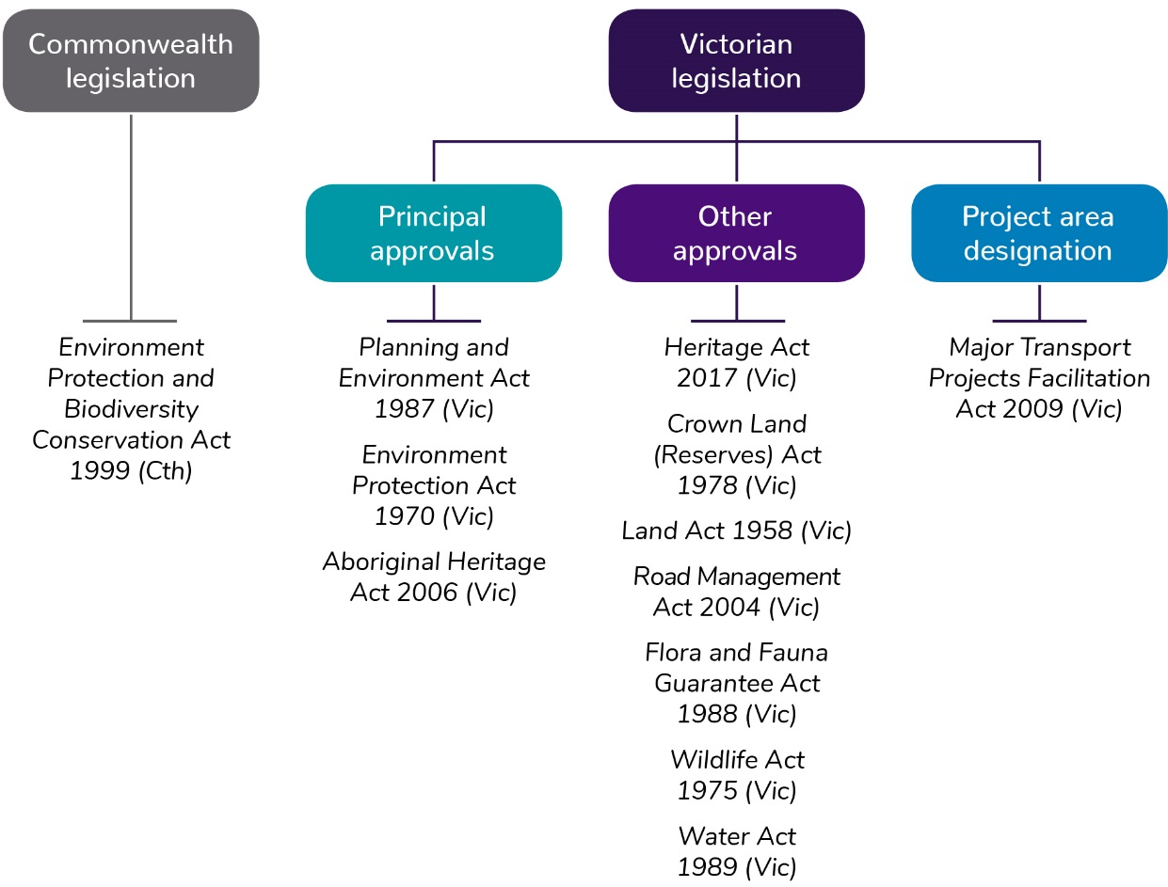
Figure 13-1 Overview of planning, environmental and heritage legislation applicable to North East Link
North East Link Project (NELP) has prepared an Environment Effects Statement (EES) for the action under Victoria’s Environment Effects Act 1978 and is in the process of applying for principal planning and environment approvals for North East Link including:
- A PSA authorising use and development of the action
- A works approval under the Environment Protection Act for the installation of the road tunnel ventilation system required for the action
- An Aboriginal Cultural Heritage Management Plan under Victoria’s Aboriginal Heritage Act 2006.
These and other statutory approvals and consents required for North East Link are discussed in more detail in the following sections.

Approvals required under State planning and environmental laws

Principal State approvals

Environment Effects Act 1978 (Vic)
On 2 February 2018, the Victorian Minister for Planning declared North East Link to be 'public works' under Victoria’s Environment Effects Act 1978, requiring NELP to prepare an EES for the action. An EES has been prepared in accordance with the scoping requirements issued by the Minister for Planning in May 2018.
Under the Environment Effects Act, the EES was exhibited for public comment and submission, and an Inquiry and Advisory Committee has been appointed to consider the EES, public submissions, conduct a hearing and report to the Minister for Planning on the acceptability of the environmental impacts of the action. The Minister for Planning will then assess the environmental effects of North East Link after considering the Inquiry and Advisory Committee’s report, public submissions and relevant material. The Minister's assessment will then be provided to statutory decision-makers who must consider the Minister's assessment before deciding whether to grant relevant statutory approvals required for the action.
A key part of the EES is a set of Environmental Performance Requirements (EPRs) that are proposed to apply to the design, development and operation of North East Link in accordance with the Environmental Management Framework (EMF) also included in the EES. EPRs are discussed in further detail in Chapter 10 – Proposed avoidance and mitigation measures.
Subject to the outcomes of the EES assessment process, it is proposed the final EPRs and EMF are approved by the Minister for Planning under the PSA required for North East Link.

Planning and Environment Act 1987 (Vic)
Implementation of the action would require a PSA under Victoria’s Planning and Environment Act 1987. The PSA would amend the Banyule, Boroondara, Manningham, Nillumbik, Whitehorse, Whittlesea and Yarra planning schemes to apply a project-specific planning control governing use and development of North East Link in accordance with specified conditions. These conditions would include the requirement that North East Link is developed in accordance with an EMF and final set of EPRs approved by the Victorian Minister for Planning. The PSA would also introduce a Design and Development Overlay to protect the structural integrity of the tunnels and operation of North East Link. The draft PSA was exhibited concurrently with the EES.

Environment Protection Act 1970 (Vic)
Victoria’s Environment Protection Act 1970 regulates certain activities having impact on the environment and prohibits the occupier of 'scheduled premises' from undertaking any activity that is likely to cause the discharge or emission of waste to the environment, unless authorised to do so.
A works approval is required for the road tunnel ventilation system under the Environment Protection Act. The works approval application was exhibited concurrently with the EES. An environmental discharge licence would also be required under the Act for the operation of the tunnel ventilation system.

Aboriginal Heritage Act 2006 (Vic)
Victoria’s Aboriginal Heritage Act 2006 and the associated Aboriginal Heritage Regulations 2018 provide protection for Aboriginal places, objects and human remains. Under the Act and Regulations, if a project proponent is required to prepare an EES under the Environment Effects Act, it must also prepare a Cultural Heritage Management Plan (CHMP) for the area in which works are to be carried out.
The CHMP involves an assessment of the potential impacts of the action on Aboriginal cultural heritage and preparation of management and contingency measures to protect Aboriginal cultural heritage in the project boundary. NELP is preparing a CHMP in consultation with the Wurundjeri Woi-wurrung Cultural Heritage Aboriginal Corporation (WWCHAC).

Secondary approvals
Once North East Link has been assessed and the principal State and Commonwealth approvals have been obtained, other approvals would be required to enable implementation of North East Link. These are known as secondary approvals.
Table 13-1 provides an overview of the secondary approvals required under Victorian legislation for the delivery of North East Link.
Table 13-1 Secondary approvals required under Victorian legislation
Legislation | Approvals required
Heritage Act 2017 (Vic) | - Permit for impact to places on the Victorian Heritage Register  - Consent for impacts to places on the Victorian Heritage Inventory
Road Management Act 1988 (Vic) | - Consent for works on freeways and arterial roads  - Consent for works on municipal roads
Flora and Fauna Guarantee Act 1988 (Vic) | - Permit to take protected or threatened species as a result of vegetation clearing
Wildlife Act 1975 (Vic) | - Authorisation to translocate fauna habitat
Water Act 1989 (Vic) | - Licence to construct, alter, operate or decommission works on, over or under Banyule Creek, Yarra River, Koonung Creek and Merri Creek  - Licence to construct groundwater bores for monitoring, dewatering or reinjection  - Licence to extract groundwater or for aquifer recharge

Project area designation

Major Transport Projects Facilitation Act 2009 (Vic)
The purpose of Victoria’s Major Transport Projects Facilitation Act 2009 (MTPF Act) is to facilitate the delivery of major transport projects declared under the Act. North East Link was declared by the Premier under Section 10 of the MTPF Act on 28 June 2018. The MTPF Act applies to North East Link with the exception of Part 3 (Assessment and approval of major transport projects) and Part 8 (Assessment Committees). This means that if North East Link is granted the principal environmental and planning approvals, the project authority will be able to use the project delivery provisions to deliver the project, including those relating to:
- Land acquisition and assembly including private, council and Crown land
- Road construction, deviation, closure and management
- Dealing with utilities.
The project delivery provisions are only available once the project area is designated after approval of the PSA.

Relevant State and local planning policies

State-wide and regional planning policies
A number of State and regional policies including those associated with planning and environmental matters are applicable to North East Link.

Land use planning
The Planning Policy Framework (PPF) outlines State-wide and regional strategic planning issues and is common in content across all Victorian planning schemes.
North East Link is considered to be predominantly consistent with the PPF, particularly the objective of Clause 11.01-1R (Metropolitan Melbourne) which recognises North East Link as a potential transport project of regional importance in the ‘Melbourne 2050 plan’. This states the need ‘to strengthen transport links on national networks for the movement of commodities as well as improving transport connection in and between regional cities, town and Melbourne to encourage delivery of high quality integrated settlements’.
The tunnels component beneath the Yarra River aligns with the objectives of Clause 12.03-1R (Yarra River Protection) which seeks to ‘maintain and enhance the natural landscape character of the Yarra River corridor’.
Through the implementation of the relevant EPRs relating to noise and other emissions, North East Link would align with Clause 13.05 – 1S (Noise Abatement) which seeks to ‘assist the control of noise effects on sensitive land uses’ and Clause 13.06 – 1S (Air Quality Management) which seeks to ‘assist the protection and improvement of air quality’.
North East Link would also contribute to meeting the aim of relevant parts of Clause 18 (Transport) as it would assist in creating ‘a safe and sustainable transport system by integrating land use and transport’ and contribute to the management of the road system ‘to achieve integration, choice and balance by developing an efficient and safe network’ (Clause 18.02–3S Road System).
The PPF at Clause 18.01–2S (Transport System) also seeks to ‘locate and design new transport routes and adjoining land uses to minimise disruption or residential community and their amenity'. With the implementation of the mitigation measures to address traffic, noise, air quality, visual and overshadowing impacts, the amenity of residential areas would be protected.
The Victorian Government’s long-term metropolitan planning strategy, Plan Melbourne 2017–2050 provides guidance on the development and growth of Melbourne over the next 35 years and is the key strategy for supporting jobs, housing and transport. Plan Melbourne seeks to integrate long-term land use, infrastructure and transport planning. North East Link is recognised in Plan Melbourne as an action that would contribute to an integrated transport system connecting people to jobs and services.
Victoria’s Yarra River Protection (Wilip-gin Birrarung murron) Act 2017 provides an overarching policy and planning framework to coordinate and harmonise planning for the use, development and protection of the Yarra River, its parklands and other land in its vicinity. A purpose of the Act is to protect the Yarra River and the surrounding parcels of public land as one living and integrated natural entity.
The Yarra Strategic Plan contains a long-term community vision and land use framework plan. The Act contains the Yarra Protection Principles. The Yarra River Action Plan (2017) contains specific actions.

Environmental protection
State environment protection policies (SEPPs) are subordinate legislation made under the provisions of the Environment Protection Act to provide more detailed requirements and guidance for the application of the Act to Victoria. Under the Environment Protection Act, the requirements in environmental regulations, works approvals, licences and other regulatory tools must be consistent with SEPPs.
SEPPs aim to safeguard the environmental values and human activities (beneficial uses) that need protection in Victoria from the effect of pollution and waste.
Table 13-2 describes the SEPPs that are relevant to North East Link.
Table 13-2 State environment protection policies relevant to the action
SEPP | Description
State Environment Protection Policy (Waters) | SEPP (Waters) sets a statutory framework for the protection of the uses and values of Victoria’s fresh and marine water environments, including:  - The uses and values of the water environment that the community and government want to protect (beneficial uses)  - The objectives and indicators which describe the environmental quality required to protect beneficial uses  - Guidance to local councils, catchment management authorities, water authorities and state government agencies to protect and rehabilitate water environments to a level where environmental objectives are met and beneficial uses are protected.
State Environment Protection Policy (Ambient Air Quality) | SEPP (Ambient Air Quality) sets air quality objectives and goals for the whole state. The SEPP adopts the requirements of the National Environment Protection Council (Ambient Air Quality) Measure (NEPM). This NEPM sets standards, goals, monitoring and reporting protocols for six common pollutants: carbon monoxide (CO), nitrogen dioxide (NO₂), photochemical oxidants (as ozone), sulfur dioxide (SO₂), lead and particles as PM₁₀ and PM_{2.5}. The SEPP also includes a separate objective for visibility reducing particles, which is not included in the NEPM.
State Environment Protection Policy (Air Quality Management) | SEPP (Air Quality Management) establishes the framework for managing emissions into the air environment in Victoria from all sources of air pollutants, so the air quality objectives outlined in SEPP (Ambient Air Quality) are met to achieve the cleanest air possible, having regard to the economic and social development of Victoria. The management framework and attainment program for protection of the air environment contained in SEPP (Air Quality Management) address not only ambient (or regional) air quality, but also the management of particular sources (for example, industry, motor vehicles and open burning) and local air quality impacts, including air toxics, odorous pollutants, greenhouse gases and ozone depleting substances.
State Environment Protection Policy (Control of Noise from Commerce, Industry and Trade) | Recognising that planning schemes may permit industrial areas or activities to be located near residential zones, the SEPP (Control of Noise from Commerce, Industry and Trade) aims to protect people from the effects of noise in these noise-sensitive areas. The policy is also used as a planning tool. The policy requires new and proposed industries to be designed so as to not exceed the noise limits outlined in the SEPP.
State Environment Protection Policy (Prevention and Management of Contamination of Land) | The SEPP (Prevention and Management of Contamination of Land) establishes general uses of land in Victoria and provides a mechanism for determining whether these uses are being protected, such as indicators and objectives of use in assessing impacts.  The SEPP also identifies the links between the environmental audit system and the statutory planning system, ensuring sites that need to be audited are subject to audit, and that any conditions associated with the audit outcome are implemented.  The SEPP further sets out requirements for the prevention of contamination, reinforces the role of the waste hierarchy in selecting preferred approaches for site clean-up and identifies measures by which people can access relevant information on site contamination.

Local planning policy
The PPF also provides for local policy in the form of the Municipal Strategic Statement (MSS) and Local planning policies.

Banyule
Local planning policy in the Banyule Planning Scheme recognises the municipality is principally developed for residential purposes, with the notable exception of large areas of publicly-owned land (primarily in the vicinity of waterways), public and private golf courses, commercial centres including the La Trobe National Employment Innovation Cluster (NEIC) and Watsonia Neighbourhood Centre, identified industrial areas such as Heidelberg West and Greensborough, and large-scale institutional uses such as the Austin and Mercy Hospitals, the Austin Repatriation Hospital and the Simpson Army Barracks.
The MSS recognises that Banyule has a generally well connected transport system with many of the municipality’s regional arterial roads provide access to the western suburbs and Melbourne Airport and linkages to residential areas in the northern growth corridor and other inner suburban places of employment and industrial areas of south-east Melbourne. Nonetheless, Clause 21.07 (Transport and Infrastructure) identifies the following relevant key issues for transport:
- Many arterial roads that perform a regional function are congested. Future changes that affect Banyule’s road networks need to be monitored and assessed
- Residents have a high dependency on private vehicles
- Expected population growth will increase travel demand within and across Banyule
- Adverse impacts resulting from increasing freight movements across the Banyule road network.
While North East Link would likely increase private vehicle use, it would also likely improve congestion across Banyule’s local road network and reduce the adverse impacts from existing freight-related travel across the municipality.
North East Link would pass through a number of suburbs within the central corridor of Banyule. The Banyule City Council Neighbourhood Character Strategy (2012), Clause 22.02 (Residential Neighbourhood Character Policy), Clause 21.04 (Land use) and Clause 21.06 (Built Environment) detail the important attributes of each suburbs respective neighbourhood character, and their respective development guidelines. Clause 21.05 (Natural Environment) is also relevant to North East Link in identifying the following key issue to ‘discourage land use and development that detrimentally effects Banyule’s environmental or conservation values’.

Boroondara
Boroondara City Council considers the protection of neighbourhood amenity and heritage as a key priority and the development of 20-minute neighbourhoods around the municipality’s major activity centres in addition to the preservation and enhancement of the open space network and neighbourhood amenity.
The Yarra River and environs forms part of the northern and western border of the municipality and contains some of Boroondara’s regional open space while providing a significant landscape feature in the municipality. The Yarra River, Koonung Creek and Gardiners Creek support important riverine ecosystems and environments.
Environment and open space objectives of the Boroondara MSS, including in Clause 21.03 (Environment and Open Space) refer to the importance of the municipality’s open space assets and identify the need to provide for distribution of open space in the municipality with an emphasis on filling gaps in the provision of open space.

Nillumbik
The Shire of Nillumbik forms part of a metropolitan ‘green wedge’ and features regionally significant open spaces, Plenty Gorge Park and the Yarra River, which have high environmental value.
Local policy in the Nillumbik Planning Scheme identifies the need to preserve the network of strategic habitat links north-south along the waterways (from Kinglake National Park to Yarra River).

Manningham
The City of Manningham has one of the largest networks of parks and open space, and its local planning policy encourages strategic landscaping and community infrastructure improvements.
Clause 22.10 refers to the Bulleen Gateway Policy and identifies that:
- Bulleen is a major gateway to Manningham and adjoins the Yarra Valley Parkland and the Yarra River
- The MSS encourages the improvement and enhancement of the visual amenity and function of the Bulleen Gateway area.
Relevant objectives and policy include:
- To encourage appropriate built form to enhance this gateway to the municipality
- View lines between development and adjoining parklands to be protected and enhanced through the sensitive siting and design of buildings and works.

Whitehorse
The Whitehorse City Council local planning policy identifies the key themes of environment, housing, economic development and infrastructure. A key aim of the Whitehorse local planning policy is to protect and enhance the municipality’s open spaces including the Koonung Creek and surrounding parkland.

Whittlesea
The Whittlesea City Council local planning policy identifies objectives including:
- To facilitate the safe and efficient movement of freight in a manner that minimises the impact on sensitive land uses
- To improve transport options and accessibility outcomes for residents.
North East Link facilitates the safe and efficient movement of freight by directing it away from local roads therefore reducing the impact on sensitive land uses. North East Link would also improve active transport options and accessibility for residents by providing walking and cycling infrastructure.

Yarra
The Yarra City Council local planning policy aims to increase residential density around Major Activity Centres and along transport corridors while preserving existing historic heritage and open space in the municipality. Yarra particularly focuses on boosting sustainable transport use and reducing car dependence.
Clause 21.06 refers to Transport and identifies that:
- Yarra needs to reduce car dependence by promoting walking, cycling and public transport use as viable and referable alternatives. This is also a key message of Melbourne 2030 and fundamental to the health and well-being of the community.
North East Link responds to this policy through upgrades to cycling and walking infrastructure including the North East Bicycle Corridor located in areas near the City of Yarra. North East Link would also improve access to public transport in the municipality with the busway which includes bus stops on Hoddle Street.

Prevention, minimisation and management of relevant impacts
An EMF has been developed for North East Link as part of the EES. As part of the EMF, a set of EPRs have been developed that apply to the design, construction and operation of North East Link. The EPRs have been informed by relevant Victorian environmental legislation and policy requirements to minimise environmental risks and avoid, reduce or offset environmental impacts identified through the EES risk and impact assessment process.
The EMF and EPRs are discussed in further detail in Chapter 10 – Proposed avoidance and mitigation measures. Subject to the outcomes of the EES assessment process, it is proposed the final EMF and EPRs are approved by the Victorian Minister for Planning under the PSA required for North East Link.
A range of environmental management plans would be developed and implemented for the construction and operation of North East Link. These would support implementation of the EMF and EPRs. Plans would include Construction Environmental Management Plans (CEMPs), including sub plans for specific issues, Worksite Environmental Management Plans (WEMPs), and an Operation Environmental Management Plan.

Monitoring, enforcement and review procedures
A range of regulatory monitoring, enforcement and review procedures apply to a project of this size. Compliance with the EMF and EPRs would be mandated and enforced by NELP on behalf of the Victorian Government through the contractual arrangements established between the Victorian Government and contractors appointed for delivery of North East Link.
An independent environmental auditor would also be appointed by NELP. The independent environmental auditor would review the environmental management plans and proposed management measures before the construction or operation works that are the subject of the plans starts. The independent environmental auditor would carry out regular audits of compliance with the environmental management plans.

