Executive Summary
September 2019

Executive Summary
Melbourne is Australia’s fastest growing capital city. North East Link (the action) is a proposed new road project that would give Melbourne a fully completed, freeway-standard orbital connection for the first time. North East Link is Victoria’s largest ever road project and includes Victoria’s longest twin road tunnel and Melbourne’s first dedicated high speed busway. North East Link is being assessed under Australian and Victorian laws to determine if it can achieve acceptable environmental outcomes. This Public Environment Report contains information about North East Link and its relevant impacts on the following Matters of National Environmental Significance (MNES) under the Commonwealth Environment Protection and Biodiversity Conservation Act 1999.

North East Link

Background and description
In December 2016, the Victorian Government announced its commitment to delivering North East Link and completing Melbourne’s metropolitan ring road. The commitment followed confirmation in the Government’s five-year Victorian Infrastructure Plan of North East Link as one of several ‘catalyst’ infrastructure projects designed to stimulate economic, business and jobs growth and deliver long-term benefits for Victorians.
In May 2018, the North East Link business case was released. Subsequently, the Victorian Government confirmed it would proceed with North East Link along the preferred corridor identified in the business case. Work continued throughout 2018 to refine North East Link’s design, including specialist and technical investigations, traffic studies and community and stakeholder consultation. This work culminated in the development of a ‘reference project’ for North East Link, which identifies a feasible way for the action to be designed, constructed and operated.
The reference project comprises the following main components:
- Surface works along the M80 Ring Road (otherwise known as the Metropolitan Ring Road) east of Plenty Road and a new interchange linking the M80 Ring Road, Greensborough Bypass and North East Link
- Surface works to construct North East Link south of the M80 Ring Road through to Yallambie and Macleod
- Works to place North East Link in twin tunnels between Yallambie and Bulleen, with new interchanges at Lower Plenty Road and Manningham Road to link North East Link with the local area
- A new interchange connecting North East Link to the Eastern Freeway at Bulleen Road
- Widening of the Eastern Freeway largely within the road reserve from Chandler Highway through to Springvale Road
- Construction of a new dedicated busway from Doncaster Road to Hoddle Street
- Walking and cycling connections (shared use paths) from the M80 Ring Road to the Eastern Freeway
- Land bridges over North East Link in Watsonia, creating approximately 0.85 hectares of new public open space to facilitate local connections.
The figure below shows an overview of the proposed North East Link.
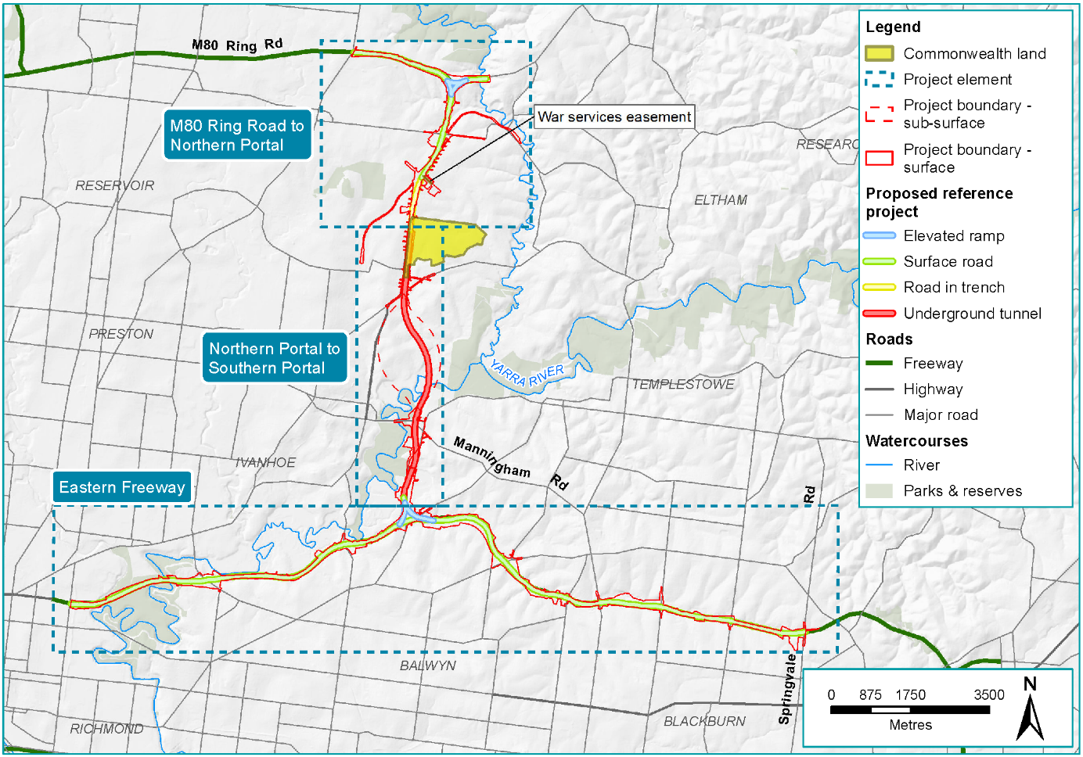
Figure ES–1 Overview of North East Link

North East Link would provide a safe and efficient freeway connection for up to 135,000 vehicles per day by 2036, reducing travel times and congestion, drawing trucks away from local roads and linking key growth areas in Melbourne’s north, north-east and south-east. North East Link has been designed to support business and jobs growth in Melbourne’s north and north-east, improve cross-city connectivity and address critical traffic, freight and amenity issues.
North East Link is expected to deliver significant transport and traffic improvements, along with substantial benefits for businesses, commuters, communities and the wider economy. As business and freight users would receive a large proportion of these benefits, North East Link is expected to result in strong productivity gains across the Melbourne and Victorian economies, stimulating economic activity and creating new jobs.

Designing and planning to minimise impacts

High-level project objectives have established the broad strategic direction for the design and development of North East Link. These objectives focus on improving transport connections and access for businesses and households, improving freight and supply chain efficiency and industrial growth, and improving safety and amenity for communities.
Guiding principles have been defined for North East Link which aim to minimise impacts on communities and environmental and cultural assets, minimise impacts during the construction phase and make the most efficient use of resources.
In accordance with these principles, the planning and design process undertaken for North East Link has sought to minimise environmental impacts through measures such as:
North East Link responsibilities
The proponent for North East Link is the State of Victoria through the Major Transport Infrastructure Authority (MTIA), an administrative office in relation to the Victorian Department of Transport that oversees major transport projects.
North East Link Project (NELP) is the division within MTIA that is responsible for developing and delivering North East Link.

- Tunnelling under environmentally sensitive areas along the Yarra River floodplain, which has greatly reduced the potential for impacts on terrestrial and aquatic fauna species
- Adopting the smallest practicable project boundary to avoid unnecessary loss of high value habitat and, as far as possible, using areas that have previously been disturbed
- Declaring a number of ‘no-go zones’ for surface works because of their ecological or heritage significance
- Refining North East Link’s design to minimise planted tree removals and protect as many trees as possible, and incorporating a requirement to replace urban tree canopy lost due to North East Link and achieve a net gain in tree canopy cover over time.

Public Environment Report

Background
On 18 January 2018, North East Link was referred to the Australian Government’s Department of the Environment and Energy (DoEE) under the Commonwealth Environment Protection and Biodiversity Conservation Act 1999 (EPBC Act). On 13 April 2018, a delegate of the Minister for the Environment and Energy determined that North East Link is a ‘controlled action’ under the EPBC Act due to the likely significant impacts on Matters of National Environmental Significance (MNES) protected under the Act: listed threatened species and ecological communities, listed migratory species and the environment of Commonwealth land.
The delegate of the Minister also determined that North East Link would be assessed by Public Environment Report (PER). On 10 July 2018, DoEE provided guidelines for the preparation of a draft PER. Following public exhibition of the draft PER and the receipt and consideration of public and stakeholder comments, this final PER has been provided to DoEE for a decision about whether to approve the controlled action under the EPBC Act and, if so, on what conditions.
This PER contains information about North East Link and its relevant impacts to enable the public, stakeholders and the Minister for the Environment and Energy to understand the environmental consequences of North East Link as they relate to the protected MNES. The PER process is separate from the Environment Effects Statement (EES) being prepared concurrently under Victoria’s Environment Effects Act 1978. The EES process considers a wide range of potential environmental impacts associated with North East Link and proposes a comprehensive suite of Environmental Performance Requirements (EPRs) that set out the minimum environmental outcomes North East Link must achieve across its design, construction and operation phases.

Assessing impacts for the PER
This PER presents the findings of detailed assessments of the:
- Potential presence of and relevant impacts on listed threatened species, communities and migratory species (see PER Technical Appendix A − Flora and Fauna technical report)
- Water resources that may support listed threatened species, communities and migratory species and the potential impacts of North East Link on these resources (see PER Technical Appendix B − Groundwater technical report and PER Technical Appendix C − Surface water technical report)

- Potential impacts on environmental matters on Commonwealth land (see PER Technical Appendix D – Commonwealth land technical report). This technical report has been informed by the assessments undertaken for PER technical reports A, B and C in relation to ecology, groundwater and surface water.
In addition to these technical reports, the PER has been informed by the 18 technical studies undertaken for the Victorian EES process. These studies include comprehensive assessments of North East Link’s potential ecology, arboriculture, ground water and surface water impacts. These studies have assisted in determining the scope and focus of the PER technical reports and the development of measures to avoid, mitigate or manage impacts.
Consultation
NELP recognises that consultation with affected parties, communities and stakeholders is essential for achieving high quality outcomes from North East Link. NELP has conducted an extensive program of public engagement using a wide range of communications tools, media and activities to keep the public informed about the project’s progress, provide opportunities to participate in the project’s design and development, and respond to community and stakeholder concerns.
For the PER, NELP also consulted with DoEE, the Department of Defence (the owner of Simpson Barracks) and the Simpson Barracks management team. To understand the views and concerns of those living and working at Simpson Barracks, an information drop-in session was held at the Barracks in September 2018.
During the exhibition period, NELP invited the public to make written submissions on the draft PER. Attachment VIII – Submissions report provides a summary of the issues raised in submissions and provides a response to each issue. It also outlines whether changes have been made to the PER in response to this issue and where the change was made.

Each technical study undertaken for the PER has adopted the following approach:
- Describing the environment − Existing environmental assets, values and uses that may be affected by North East Link were identified. Methods adopted included literature reviews, desktop assessments of ecological databases, likelihood of occurrence assessments. In addition, the Flora and Fauna technical report included extensive field assessments and targeted surveys for listed threatened species and communities identified as having a moderate to high likelihood of occurring within the project boundary.
- Assessing impacts – An impact is a positive or negative change resulting from North East Link. Impacts can be the direct result of an activity associated with North East Link or can occur indirectly, such as impacts on habitat for threatened species due to a change in groundwater conditions. The nature and extent of any impact was measured in relation to existing conditions, considering the differences between scenarios with and without North East Link. Consideration was also given to possible cumulative effects due to other major infrastructure projects under construction in Melbourne around the same time as North East Link.
- Avoiding, mitigating and offsetting impacts − Measures to avoid and mitigate impacts were developed. These include legislative controls, industry standards, guidelines and other requirements that are typically incorporated into the delivery of major transport projects, along with project-specific targets and actions. Where impacts could not be reduced through avoidance and mitigation measures, environmental offsets have been proposed in accordance with the EPBC Act Environmental Offsets Policy and Victoria’s Guidelines for the removal, destruction or lopping of native vegetation.
- Assessing the significance of impacts − The significance of the relevant impact was assessed against the EPBC Act Significant Impact Guidelines for each MNES and the environment of Commonwealth land. This assessment took into account the likely effectiveness of measures to avoid and mitigate and then, if required, offset for potential impacts and any facilitated impacts.

Impacts on species listed under the EPBC Act
While habitat within the project boundary is highly urbanised and fragmented, it does support some native flora and fauna species and ecological communities. Forty listed threatened species (25 fauna species and 15 flora species), 25 migratory species and five listed threatened ecological communities were identified as potentially occurring within five kilometres of the North East Link project boundary. This PER focuses on the listed species known to be present or to have preferred habitat present within the project boundary.

Listed threatened flora species
Land clearing required for North East Link’s construction would impact Matted Flax-lily Dianella amoena, listed as endangered under the EPBC Act. Matted Flax-lily is a small, perennial, tufted lily that occurs in grassland and grassy woodland habitats across south-east Australia. Up to 95 individual plants/patches at five discrete sites would be cleared for North East Link: 83 plants/patches at Simpson Barracks/Borlase Reserve, four at the M80 Ring Road interchange and one patch and seven individual plants at three locations along the Hurstbridge rail line. The total number of patches/plants removed may be reduced further as refinements are made to North East Link’s design during the detailed design phase.
Removed plants would be translocated to suitable alternative sites in accordance with an approved Salvage and Translocation Plan, as agreed with the Victorian Department of Environment, Land, Water and Planning (DELWP) and the Commonwealth. Translocation of Matted Flax-lily has been undertaken successfully for other major projects; the methods are well documented and include taking clones for each plant removed, maintaining stock in an approved nursery and closely monitoring the progress of the population over time. With successful translocation, the residual impact of North East Link on Matted Flax-lily is not considered to be significant. There is unlikely to be any long-term decline in the population or any additional threat to the viability of the species.
It is possible that groundwater drawdown (the lowering of the water table due to construction activities or as a result of water seeping into structures located below the water table) in the vicinity of the southern portal could affect the habitat of the River Swamp Wallaby-grass Amphibromus fluitans, listed as vulnerable under the EPBC Act. A small amount of drawdown of between 0.1 and 0.5 metres (according to initial and further modelling undertaken as described in Section 4.1) is predicted at Bolin Bolin Billabong, which is considered a suitable environment for the species. Any effects are expected to be minor, given the context of the natural seasonal flooding and drying cycles that periodically refresh the Yarra River floodplain wetlands and that Melbourne Water actively manage the hydrological regime of the billabong. It should also be noted that a targeted search for this species failed to locate any individuals and it is considered unlikely that an important population of River Swamp Wallaby-grass is present within the project boundary. Prior to construction, a final targeted survey would be undertaken at the Trinity Grammar wetlands to ascertain whether the species is present within the project boundary. If present, NELP would salvage stolons (the creeping root system) and translocate into suitable nearby habitat. Accordingly, residual impacts are anticipated to be low and non-significant.
Clover Glycine Glycine latobeana (listed as vulnerable under the EPBC Act) was also not recorded during targeted surveys conducted for the PER. However, it could be present in better quality remnant patches of plains Grassy Woodland and Riparian Woodland at Simpson Barracks, Banyule Reserve and some elevated flats along Koonung Creek. Residual impacts on this species are anticipated to be minimal, if any.

Listed threatened fauna species
The Swift Parrot Lathamus discolour is listed as critically endangered under the EPBC Act and is considered likely to occasionally visit flowering trees within the project boundary. The main potential impact of North East Link on the Swift Parrot would be localised loss of this occasional foraging habitat. There is no evidence to suggest that the parrots rely on these trees or use them regularly or would be displaced by their removal. The trees beside Macleod Station may be an exception to this, with up to 40 Swift Parrots having been observed in these trees. Only minor works are proposed in this location and every effort would be made to avoid impacts to these trees during North East Link’s construction. Accordingly, the residual impact of North East Link on the Swift Parrot is expected to be minor.
Residual impacts on the Australian Painted Snipe Rostratula australis, the Australasian Bittern Botaurus poiciloptilus (both listed as endangered under the EPBC Act) and the Growling Grass Frog Litoria raniformis (listed as vulnerable) are expected to be negligible. Tunnelling would avoid impacts on Banyule Swamp and other floodplain environments, which are considered the most suitable habitats for these species. Best-practice surface water management during construction and operation would reduce the potential for any impacts on wetlands, billabongs and waterways that may be visited by or provide habitat for these species. In the longer term, North East Link’s new drainage and water treatment features may provide new habitat opportunities for these and other species.
The Grey-headed Flying-fox Pteropus poliocephalus (listed as vulnerable under the EPBC Act) is common across Melbourne and small numbers were observed flying overhead at several locations during surveys conducted for the PER including at Yarra Bend Park at Fairfield. This colony is a Nationally Important Flying-fox Camp and has been designated a ‘no-go zone’ for surface works. Construction works in this location would include a bridge upgrade and widening of the Eastern Freeway, but this is unlikely to cause disturbance significant enough to impact the Grey-headed Flying-fox. This section of the Eastern Freeway is already very noisy and well-lit and so the construction of North East Link is not expected to markedly increase noise or light levels and disturb the camp. North East Link is not expected to decrease the size of this colony.
As no modifications are proposed to the Yarra River, no impacts are anticipated on any listed threatened aquatic species likely to be present in the river (such as Macquarie Perch Macquaria australasica and Australian Grayling Prototroctes maraena). These species are unlikely to be present in Banyule or Koonung Creeks or in disconnected waterbodies such as the Bolin Bolin Billabong and Banyule Swamp.

Listed migratory species
Latham’s Snipe Gallinago hardwickii is listed as a migratory species under the EPBC Act. Latham’s Snipe is a summer visitor to south-eastern Australia (present only from August to March), returning each year to Japan and eastern Russia to breed during the northern hemisphere summer. Latham’s Snipe is a highly mobile species that forages in wet and flooded grasslands, with the most suitable habitat likely to be around the Yarra River and its associated floodplain in the Banyule Flats and Banyule Swamp area. Tunnelling under these areas would avoid impacts on the species, while best-practice surface water and groundwater management during construction and operation would reduce the potential for any impacts on wetlands and waterways that may be visited by Latham’s Snipe. As with other species that prefer wetland and floodplain habitat, North East Link’s new drainage and water treatment features may provide increased habitat opportunities for Latham’s Snipe. The residual impact on this species is expected to be negligible.
There is no evidence that areas within the project boundary support any other listed migratory species.

Listed threatened ecological communities
Grassy Eucalypt Woodland of the Victorian Volcanic Plain (GEWVVP) is listed as a critically endangered ecological community under the EPBC Act. GEWVVP does not occur within the project boundary. One small patch of GEWVVP (approximately 1.5 hectares) occurs outside of the project boundary along the M80 Ring Road. This patch is currently managed by the City of Whittlesea and has been designated a ‘no-go zone’ for North East Link.
While nearby construction activities have the potential to facilitate weed encroachment onto the ‘no-go zone’, the composition of the understory in the GEWVVP patch is unlikely to be affected negatively as it is already almost totally dominated by introduced weeds. The mitigation measures proposed for North East Link would require contractors to take measures to avoid the spread or introduction of weeds during construction. No residual impacts are expected following the implementation of these measures.
No listed threatened ecological communities were identified in areas of the Yarra River floodplain; however, the important and regionally significant ecological values associated with Bolin Bolin Billabong and Banyule Flats/Warringal Parklands would be protected by designating these areas as ‘no-go zones’ for surface works.

Water-related impacts
Changes to groundwater and surface water resources due to North East Link have the potential to affect MNES and the environment on Commonwealth land.

Groundwater changes
Groundwater drawdown is predicted to occur around the northern and southern portals and along the tunnel alignment west of Banyule Creek, with the greatest disturbance to groundwater levels likely to occur during construction. Well-tested construction methods would be used to maintain and protect groundwater quality. The Groundwater Management Plan prepared for North East Link would include methods to identify, treat and dispose of any captured groundwater, monitoring of dewatering activities and their potential impacts on acid sulfate soils, protection of waterways and groundwater dependent ecosystems (GDEs), and contingency actions if interventions are needed.
A Groundwater Dependent Ecosystem Monitoring and Mitigation Plan would monitor flora, fauna and ecological communities potentially impacted by groundwater drawdown during North East Link's construction and operation. This would include monitoring of groundwater levels in the area around Bolin Bolin Billabong and topping up water in the billabong if required during construction. Measures would be adopted to protect GDEs that support listed threatened species, such as watering of stressed vegetation during construction.
Once construction is completed, groundwater levels would gradually be restored towards a new equilibrium. However, long-term groundwater drawdown of approximately three metres is expected to have an impact in the Simpson Barracks area.
Since the groundwater assessment was completed for the original exhibited version of the PER (using the initial modelling), additional data from the North East Link groundwater bore monitoring network has become available. Based on this new data, further modelling has been undertaken. The discussion below describes the findings from both the initial modelling and the further modelling.
According to the initial modelling, at the end of construction, in the absence of any mitigation measures, seven large trees on Commonwealth land would have a moderate to high likelihood of being negatively affected, and a further 13 large trees would have a low likelihood of being negatively affected on Commonwealth land. Nineteen large trees (on Commonwealth land within Simpson Barracks) were assessed as having a moderate to high likelihood of being negatively impacted by groundwater drawdown by 2075, and so potential to decline in health and/or to die prematurely, while a further eight large trees would have a low chance of being impacted in the absence of any mitigation measures.
According to the further modelling undertaken, at the end of construction, in the absence of any mitigation measures, a total of 45 large trees on Commonwealth land would have a moderate to high likelihood of being negatively affected, and a further one large tree would have a low likelihood of being negatively affected. Eight trees would have a moderate to high likelihood of being negatively affected by 2075, and so potential to decline in health and/or to die prematurely, while a further eight large trees would have a low chance of being impacted in the absence of any mitigation measures.
Watering during construction is a mitigation measure that is likely to reduce the number of trees affected in the short-term. Any large trees predicted to be affected over the long-term would be offset in accordance with the Victorian Guidelines.
Following the adoption of design and mitigation measures, residual impacts to waterway flows from groundwater changes are expected to be negligible and no significant impacts to MNES arising from changes in groundwater are anticipated.

Surface water changes
Runoff from exposed surface areas at construction work sites and permanent above ground structures, discharges from the tunnel drainage system and spills would have the potential to affect water quality during construction and operation. These impacts would be minimised by implementing a Surface Water Management Plan that mandates best practice sediment and erosion control, and by requiring all discharges and runoff from North East Link to meet State Environment Protection Policy (Waters) requirements and comply with EPA Victoria’s Best Practice Environmental Management Guidelines for Urban Stormwater. Water quality would be monitored prior to and during construction. New water treatment features − such as a large wetland at the M80 Ring Road and Greensborough Road interchange, bioretention ponds and storage dams − would be incorporated into the design to prevent pollutants from entering waterways.
While construction activities within Banyule Creek and Koonung Creek would alter the natural features and characteristics of these creeks, both waterways are highly urbanised and heavily modified and have poor water quality. All works on waterways would be undertaken to the satisfaction of Melbourne Water. Any waterway modifications would be required to mitigate changes to water flows and minimise the potential for erosion and sediment plumes. Appropriate measures would be taken to maintain the bank stability of waterways. Contractors would be required to maximise the visual and aesthetic amenity and environmental conditions of these waterways. Any long-term impact would be minimal with respect to any habitat that may support MNES.
With the adoption of appropriate management and controls, the potential for changes in surface water quality to affect MNES during construction and operation would be limited.

Impacts on the environment of Commonwealth land
Commonwealth land would be acquired at two locations, shown in the figures below.
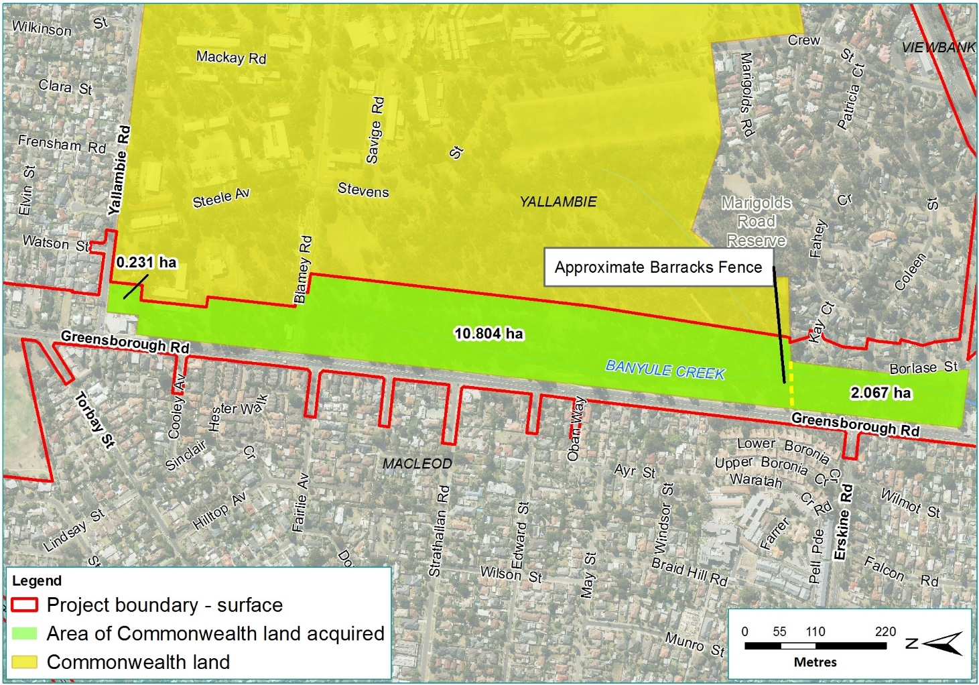
Figure ES–2 Area of Simpson Barracks (and unfenced area to the south) to be acquired.

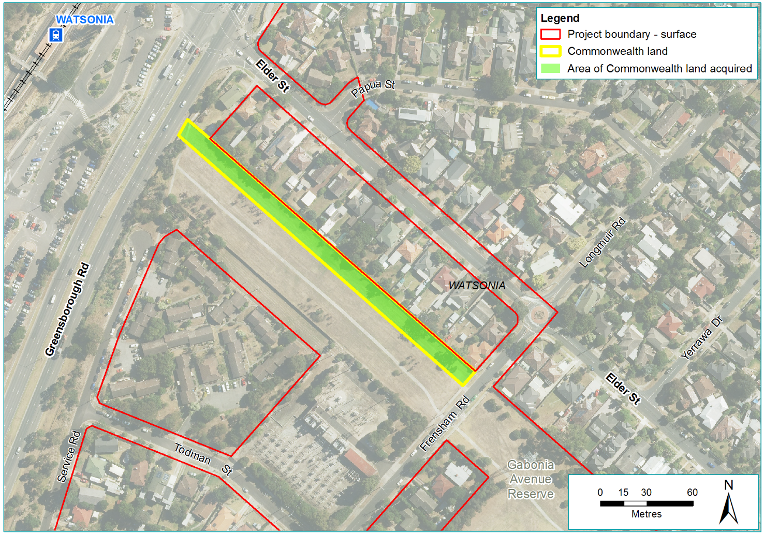
Figure ES–3 War service easement to be acquired.

This land comprises:
- An area of approximately 11 hectares within the western boundary of Simpson Barracks in Yallambie, along with an additional area of approximately two hectares to the south of the Barracks that is unfenced and publicly accessible. This land is owned by the Department of Defence.
- A strip of land of approximately 0.3 hectares to the rear of residential properties on Elder Street in Watsonia (War Service Homes). This land is an easement for electricity transmission lines and is owned by the Director of War Service Homes.
These areas of land would need to be obtained via transfer from the Commonwealth to the State of Victoria.

Simpson Barracks
Established in 1943, Simpson Barracks is a working Australian Army barracks and training facility. More than 2,360 people work on the site, including full-time defence personnel, reservists, trainers and contractors. Between 10 and 15 per cent of full-time personnel live at the Barracks, along with all trainees.
The area within Simpson Barracks directly affected by North East Link largely comprises Plains Grassy Woodland (EVC 55), dominated by River Red Gum Eucalyptus camaldulensis. Parts of this community are mapped as GDEs.
Approximately 10.976 hectares of Plains Grassy Woodland (21 per cent of the remnant native vegetation at Simpson Barracks) would be removed, including a number of Studley Park Gum trees. These losses would be offset in accordance with the EPBC Act Environmental Offsets Policy and Victoria’s Guidelines for the removal, destruction or lopping of native vegetation. As discussed previously, according to the further modelling, at the end of construction, in the absence of any mitigation measures, a total of 45 large trees would have a moderate to high likelihood of being negatively affected, and a further one large tree would have a low likelihood of being negatively affected. Eight large trees within the Barracks are assumed to have a moderate to high chance of being lost by 2075 due to changes in groundwater levels and would be offset (see Water-related impacts). To mitigate these impacts, short-term watering, or similar mitigation, would reduce the number of trees impacted due to construction activities. Furthermore, any large trees predicted to be affected over the long-term would be offset in accordance with the Victorian Guidelines.
Patches of endangered Matted Flax-lily would be translocated (see Impacts on species listed under the EPBC Act). As the overall local population of Matted Flax-lily is expected to increase over time, no offsets are proposed.
The flora and fauna study carried out for this PER (see PER Technical Appendix A − Flora and Fauna technical report) recorded and mapped 44 individuals of Studley Park Gum within the project boundary at Simpson Barracks, and are therefore directly impacted. An additional three individuals of Studley Park Gum, outside the project boundary, were identified as potentially indirectly impacted by groundwater drawdown due to the tunnel construction.
The project proposes to implement mitigation based on the Studley Park Gum Groundwater Dependent Ecosystem Monitoring and Mitigation Strategy to monitor the health of at risk trees and implement mitigation measures (such as watering) throughout the construction phase of the project. The project is expected to have a significant residual impact on Studley Park Gum as an element of the environment on Commonwealth land (noting that Studley Park Gum is not listed under the EPBC Act). NELP proposes to contribute to the conservation of Studley Park Gum by establishing new habitat through the implementation of the Studley Park Gum Management Framework. This would include collecting seed and establishing a new population of Studley Park Gum.
In addition to the above, at the State level native vegetation offsets would be provided based on the Victorian Guidelines (DELWP, 2017a) to offset for the removal of native vegetation (which Studley Park Gum trees form part of) directly impacted by the project, and three Studley Park Gum trees expected to experience premature mortality due to long term groundwater drawdown.
As Simpson Barracks contains relatively large areas of remnant woodland in an otherwise urbanised landscape, it is likely to attract and support a range of fauna. However, because it is surrounded by urbanisation and has been considerably disturbed historically, it is generally degraded and consequently unlikely to support the full range of threatened and non-threatened fauna that would have occurred there historically. Loss of habitat from the Barracks is not expected to have any significant impacts on listed threatened species that may occasionally visit the area. Woodland and grassland habitats within Simpson Barracks support a small population of Eastern Grey Kangaroos Macropus giganteus and are also likely to be used by other common fauna species. Disturbance and displacement of some of these animals would be unavoidable, but is expected to be minor. The proposed habitat loss is unlikely to impact the viability of the current Eastern Grey Kangaroo population in Simpson Barracks.
As buildings and structures from the World War 2 period have been removed and replaced over the years, there are no heritage places on the relevant Commonwealth land that are recognised through statutory listings and controls. The land required for North East Link includes the Assembly Place and Lone Pine Commemorative Planting (two Aleppo Pines Pinus halepensis planted in 2005), formerly used for ceremonial purposes. This place is considered to be significant as contributing to the overall historical values of the Barracks and as having a social value for current and former barracks personnel. NELP is consulting with the managers of Simpson Barracks about options for relocating and maintaining the functions and elements of the Assembly Place elsewhere within the Barracks. Overall, heritage values on Simpson Barracks are considered to be unaffected by North East Link.
During construction, there may be temporary impacts on people working and living at Simpson Barracks. These impacts could include changes in accessing the Barracks, higher noise levels and dust emissions from land clearing and other construction activities. Construction works would be managed in accordance with a Construction Environmental Management Plan (CEMP), a Transport Management Plan, as well as environmental laws and standards, including EPA Victoria and VicRoads guidelines and State Environment Protection Policies. Access to the Barracks would be maintained at all times. Following the adoption of these measures (see Avoiding, mitigating and offsetting impacts), construction-related impacts would not be significant.
Once construction is completed, some natural landscape features within the Barracks would change and the ventilation structure would alter views from some places. Post-construction planting would minimise any landscaping impacts. Application of the Urban Design Strategy would provide a guide for the design of the ventilation structure near the northern portal of the North East Link tunnel so it appears as an attractive sculptural element in the landscape and existing vegetation would screen its lower half. Any residual visual impacts would be low.
The permanent acquisition of part of Simpson Barracks is expected to have only a negligible impact on access to open space: the land within the Barracks is not accessible to the public and there are considerable other areas of open space available within surrounding suburbs to compensate for the unfenced, publicly accessible land no longer being available for recreation activities.

War Service Homes easement
This vacant strip of land is mostly modified grassy open space, containing four isolated trees and some amenity plantings. A shared use path runs along the western edge of the site. The landscape is dominated by existing electricity transmission towers.
No listed threatened species were recorded on the easement and the removal of trees from this strip of land is not considered significant.
Following construction, there would be visual changes to the easement, with relocated electricity transmission towers, new noise walls and a new shared use path overpass featuring prominently. While these changes would be significant, these changes should be seen within the context of the existing landscape and the improvements and benefits these structures would provide.
Overall, there would be minimal impacts from the permanent acquisition of a small part of the War Service Homes easement. While the easement and adjacent Frensham SEC Reserve would be occupied for the duration of the construction phase, almost all (95 per cent) of the reserve would be available for recreation activities after construction works are completed. The whole of the reserve and easement would also benefit from new noise walls provided to meet North East Link’s traffic noise criteria at nearby residential locations.

Avoiding, mitigating and offsetting impacts
North East Link would be delivered in accordance with measures developed in response to the impact assessment to avoid and mitigate impacts on MNES and Commonwealth land.
The EES prepared as part of the Victorian approvals process has assessed North East Link’s potential environmental effects on the whole of environment, establishing a detailed set of EPRs in the process. The EPRs define the minimum environmental objectives and outcomes North East Link must achieve. This flexible, performance-based approach allows contractors to determine how EPRs would be achieved while developing and optimising the final North East Link design. This enables a delivery model that is flexible and encourages innovation through the procurement process.
Measures to avoid, mitigate and offset impacts on MNES and Commonwealth land were developed in parallel with and would be required by the EPRs. The avoidance and mitigation measures proposed in this PER are stand-alone requirements to those specified in the EES and EPRs.

Specific environmental outcomes
North East Link would seek to achieve three specific environmental outcomes for MNES and the environment of Commonwealth land, summarised in the table below These outcomes address where North East Link is likely (without translocation or mitigation measures) to have a significant and unavoidable direct impact on MNES or the environment of Commonwealth land. Environmental outcomes were developed with consideration to the matter to be protected, the nature and extent of relevant impacts, and the effectiveness of avoidance and mitigation measures in reducing impacts. Environmental outcomes, including the baseline data and proposed monitoring to demonstrate progress towards achieving these, are summarised below.
Table ES–1 Proposed environmental outcomes for North East Link
Title | Environmental outcome | Compliance, measurement and reporting
Outcome 1:  Matted Flax-lily | Matted Flax-lily populations directly impacted by North East Link must be translocated in accordance with a Salvage and Translocation Pan prepared to the satisfaction of DoEE. There must be a net gain in the number of Matted Flax-lily plants/patches due to North East Link, measured by comparing the pre-impact and 10 year post-impact number of Matted Flax-lily plants/patches within the North East Link project boundary and approved translocation recipient sites. | - Compliance with Matted Flax-lily Salvage and Translocation Plan required as a condition of contracts  - Pre-translocation (and pre-construction) survey of the number of plants/patches within the project boundary  - 10-year monitoring plan to assess translocation progress and success over time, incorporating thresholds of plant condition and survivorship at which additional management actions would be required  - Reports submitted to DoEE and DELWP within three months after salvage, after the initial translocation and again after the first three months of monitoring. Annual summary reports then prepared for 10 years
Outcome 2:  Native vegetation on Commonwealth land | Remnant native vegetation removal on Commonwealth land must be minimised to the extent practicable. All remnant vegetation removed from Commonwealth land as a result of North East Link must be offset in accordance with the principles of the EPBC Act Offsets Policy and the assessment and offset requirements of the Victorian Guidelines for the removal, destruction or lopping of native vegetation. Offset sites for vegetation removed from Commonwealth land must be secured to the satisfaction of the Department of Environment and Energy (DoEE) and Victoria’s Department of Environment, Land, Water and Planning (DELWP) before vegetation removal on Commonwealth land starts. | - Requirements to avoid and minimise native vegetation removal and implement measures to protect native vegetation, incorporated in contracts  - Offset sites secured to the satisfaction of DoEE and DELWP prior to vegetation removal commencing  - Reports on compliance submitted as required to the Victorian Minister for Planning and DoEE
Outcome 3:  Studley Park Gum on Commonwealth land | The Studley Park Gum Management Framework must be implemented to support establishment of a new population of Studley Park Gum. A Groundwater Dependent Ecosystem Monitoring and Mitigation Strategy must be developed and implemented to mitigate impacts on Studley Park Gum associated with groundwater drawdown. | - Requirements to avoid and minimise impacts on Studley Park Gum and to protect trees to be retained, incorporated in contracts  - Development and implementation of the Studley Park Gum Management Framework and corresponding management plan  - Development and implementation of a Groundwater Dependent Ecosystem Monitoring and Mitigation Plan based on the Studley Park Gum Groundwater Dependent Ecosystem Monitoring and Mitigation Strategy  - Reports on compliance submitted as required to the Victorian Minister for Planning and DoEE

Avoidance and mitigation measures
In addition to specific measures already discussed, a range of other requirements proposed for North East Link are relevant to avoiding or mitigating impacts on MNES and the environment of Commonwealth land. These include:
- Refining North East Link’s footprint during detailed design to minimise the removal of native vegetation and fauna habitat, and impacts on habitat connectivity and listed threatened species
- Preparing and implementing a detailed Construction Environment Management Plan with reference to EPA Victoria’s Best Practice Environmental Management: Environmental Guidelines for Major Construction Sites, which must incorporate requirements for:
  - Managing any fauna displaced due to vegetation removal in compliance with Victoria’s Wildlife Act 1975 and Fisheries Act 1995

  - Reporting any finding of threatened flora or fauna and stopping clearing works until an evaluation is undertaken and approval granted to proceed
  - Avoiding the spread or introduction of weeds and pathogens
  - Avoiding or minimising intense noise and vibration impacts in or near the Yarra River
  - Protecting fauna habitat values in waterbodies that are modified for drainage purposes
- Developing Transport Management Plans to minimise traffic impacts on local streets, businesses and communities during construction
- Implementing specific plans to minimise dust and air quality impacts, and noise and vibration impacts during construction
- Designing lighting during construction and operation to minimise light spillage into significant fauna habitat
- Implementing a Tree Protection Plan so that retained trees are adequately protected from construction or related activities and monitoring of trees subject to protection for two years after construction works are completed
Other approvals and conditions
The principal approvals required under Victorian legislation for the project to proceed are:
- Amendments to local planning schemes under the Planning and Environment Act 1987
- A works approval under the Environment Protection Act 1970 to install the tunnel ventilation structures
- A Cultural Heritage Management Plan (CHMP) under the Aboriginal Heritage Act 2006 approved by the Wurundjeri people and Aboriginal Victoria.
Once these principal approvals are obtained, other approvals would be required including permits, consents, authorisations and licences under the Heritage Act 2017, Road Management Act 2004, Flora and Fauna Guarantee Act 1988, Wildlife Act 1975 and Water Act 1989.
These approvals, and any conditions attached to them, would further contribute to avoiding and mitigating potential adverse impacts generated by the project.

- Implementing a Tree Canopy Replacement Plan to re-establish trees and urban forest canopy cover lost as a result of North East Link and achieve a net gain in tree canopy cover over time
- Designing noise walls and elevated structures to minimise overshadowing and shading impacts.
In a number of areas − such as traffic noise, air quality and groundwater levels and quality − the proposed mitigation measures for North East Link provide for monitoring to be carried out post-construction and for contingency actions to be taken if specific thresholds, levels or outcomes are not achieved.
A list of all proposed measures is provided in Chapter 10.
Many of these measures have been applied successfully to manage similar impacts for recent major transport projects in Victoria. They have also been subject to rigorous review as part of the Victorian EES process and further refined in response to comments and suggestions from a range of Victorian agencies and stakeholders, including DELWP, EPA Victoria, Melbourne Water and the relevant local councils.

Offsets
Environmental offsets are measures that compensate for or counterbalance environmental impacts that remain after mitigation measures are implemented. Under the EPBC Act, offsets are not required where these residual impacts are not considered to be significant or could be reasonably avoided or mitigated.
The impact assessments conducted for the PER found that, with implementation of avoidance and mitigation measures (including salvage and translocation of Matted Flax-lily, and Victorian offsets for native vegetation removal), North East Link is not expected to have a significant residual impact on Matted Flax-lily and native vegetation on Commonwealth land.
The impact assessments conducted for the PER found that with mitigation, there would a significant residual impact on Studley Park Gum. Accordingly, Commonwealth offsets under the EPBC Act have been proposed in the form of creation of new habitat for a protected matter which is a type of direct offset under the EPBC Act Environmental Offsets Policy. NELP proposes to contribute to the conservation of Studley Park Gum by establishing new habitat through the implementation of the Studley Park Gum Management Framework. This would include collecting seed and establishing a new population of Studley Park Gum.
Under Victorian legislation, offsetting is required to compensate for the loss of native vegetation that contains large trees and scattered native trees in accordance with the Guidelines for the removal, destruction or lopping of native vegetation. All native vegetation losses due to North East Link would be offset in accordance with these Victorian requirements, including those occurring on Commonwealth land. This approach has been agreed in principle with DoEE.
Expected project-wide offset requirements include a general offset amount for lost habitat (including for vegetation removal at Simpson Barracks), a species offset amount (to compensate for habitat losses for the Grey-headed Flying-fox, the Australian Grayling, Yarra Pygmy Perch Nannoperca obscura, Melbourne Yellow-gum Eucalyptus leucoxylon subsp. connata and Small Golden Moths Diuris basaltica) and offsets for 179 large trees. Offsets would be required to make a contribution to Victoria’s biodiversity equivalent to the contribution made by the native vegetation being removed.

Reinstatement of disturbed areas
The approach to reinstating disturbed areas would be developed by each construction contractor and reviewed by an Independent Environmental Auditor. Urban Design and Landscape Plans would be prepared for North East Link in accordance with the North East Link Project Incorporated Document and submitted to the Victorian Minister for Planning for approval. These plans would reflect the Urban Design Strategy and include landscaping designs and plans for reinstated areas.
Where appropriate, tree replacement and landscaping would use locally indigenous species and be sufficiently diverse to maximise habitat value and connectivity for native fauna.

Accountability
Contractors would be required to comply with conditions arising from the PER process as a condition of North East Link contracts. The EPRs, including the PER avoidance and mitigation measures, would be implemented through a set of environmental documents. The environmental documents would describe in detail how the PER conditions and EPRs would be addressed and complied with during detailed design, construction and operation of North East Link.
Contractors would also be required to prepare and implement environmental documents including an Environmental Strategy, CEMP and Operation Environment Management Plan (OEMP). These plans would describe in detail how the contractors would achieve compliance with the PER (and EPRs), approval conditions and relevant laws and regulations. They would also set out how environmental risks would be identified, managed and mitigated.
Environmental documentation specifically relevant to MNES and Commonwealth land, would be submitted to the DoEE for review and approval, including a Matted Flax-lily Salvage and Translocation Plan, Offset Strategy and Offset Management Plan for native vegetation removal on Commonwealth land. These plans would also be prepared to the satisfaction of DELWP.
The Victorian Government would appoint an Independent Environmental Auditor to review and verify environmental documentation prepared by contractors and undertake regular audits of activities to verify compliance with environmental documentation and approval conditions. Audits would occur during construction and for at least the first two years of operation of North East Link. Compliance would be further assured through specific monitoring programs undertaken as part of the CEMP, OEMP and technical plans.
NELP would report regularly on compliance with the approval requirements to the Victorian Minister for Planning and other approval authorities during construction and for up to two years after North East Link opens.
These comprehensive governance arrangements for environmental management would assist in identifying and managing North East Link’s environmental risks, and avoiding, managing and mitigating adverse impacts.

Economic and social matters

The PER Guidelines require analysis of the economic and social impacts of the action, reflecting Section 136(1)(b) of the EPBC Act. Information in this section is drawn largely from the 2018 business case prepared for North East Link.

Context
Melbourne is the nation’s fastest-growing capital and is on-track to be a city of eight million people by 2051. This population growth is increasing the demand for travel around the city. To remain a liveable, productive and competitive city, Melbourne’s transport network must provide reliable travel options and choices to extract maximum value, opportunity and productive potential from the city.
Employment opportunities
The construction workforce for North East Link is expected to peak at around 2,800, Economic modelling conducted for the business case predicted additional employment supported by North East link during the construction phase to be approximately 10,300 jobs.
Once operating, North East Link is likely to attract new businesses to locations with improved labour market accessibility and business-to-business accessibility. The business case predicted that the project would attract an additional 5,500 jobs to businesses in the city’s north and north-east.

While Melbourne has good radial connections, other trips including trips across Melbourne and orbital travel around the outer suburbs are not well served. Jobs, services and other activities have subsequently become harder to access. By improving the cross-city network, North East Link is expected to address three critical transport-related pressures:
- Poor cross-city movements and the related growing congestion during peak periods on arterial roads through the city’s north-east and on roads crossing the Yarra River
- Inefficient freight movement between Melbourne’s north and south-east, which is undermining business competitiveness and productivity, increasing transport costs and constraining high value industries
- Congestion and heavy vehicles on local and arterial roads, leading to longer and less predictable travel times for residents, reduced access to local services and other important destinations, and exposure of residents to higher levels of traffic noise and vehicle emissions.

Socio-economic benefits
Addressing these challenges is expected to deliver substantial socio-economic benefits, including:
- Significant traffic and transport improvements, including redistribution of traffic away from local roads, less congestion, faster travel times across the north-east, faster and more reliable travel times for freight, and large decreases in the number of trucks using arterial roads. Overall, North East Link is expected to deliver $103.5 billion in transport benefits
- More productive businesses through improved connectivity to freight and export gateways, with more than half a billion dollars ($590 million) in economic value expected to accrue to businesses across the life of North East Link
- More competitive and efficient supply chains, reducing transport costs for businesses and productivity benefits across the economy. Improvements would result in a reduction of freight vehicle operating costs of an estimated $148 million each year, with further savings of $427 million each year from better freight connectivity
- Greater accessibility for households through reduced congestion and faster travel times improving access to employment and education, expanding the range and number of jobs available and boosting household incomes
- Liveable communities and neighbourhoods, as lower traffic volumes on local roads through the north-east deliver improved air quality, less traffic noise and fewer road accidents and new and upgraded walking and cycling connections.
The Cost Benefit Analysis undertaken for the North East Link business case found that North East Link has an estimated Benefit-Cost Ratio of 1:3, meaning that for every dollar spent on North East Link, the Victorian and national economies would receive $1.30 of value in return.

Social impacts
North East Link has been designed to avoid as far as practicable, disruption to households, businesses and community facilities. This has resulted in the relatively small number of properties needing to be acquired: 36 residential properties would be permanently acquired and approximately 100 businesses would be impacted by acquisition (three would be impacted by temporary occupation with the remainder impacted by full or partial acquisition). Land acquisition impacts to businesses are concentrated in the Bulleen Industrial Precinct.
Residential and commercial property acquisition would be undertaken in accordance with Victoria’s Land Acquisition and Compensation Act 1986 and Major Transport Projects Facilitation Act 2009. Compensation would be provided for land owners and occupants with an interest in properties acquired for North East Link and for displaced businesses.
Construction of North East Link could disrupt households, businesses and community facilities due to traffic disruption, noise and dust emissions, and altered access arrangements. These impacts would be minimised by implementing a Construction Environmental Management Plan and through the use of Traffic Management Plans outlining temporary access arrangements.

Conclusion
Impacts on one MNES − the listed threatened flora species Matted Flax Lily − and on remnant native vegetation and Studley Park Gum on Commonwealth land at Simpson Barracks would be unavoidable. Translocation, mitigation and offset measures have been proposed to address these impacts. North East Link would also be required to achieve specific environmental outcomes in relation to these matters.
Overall, the anticipated transport, economic, social and other benefits of North East Link are expected to outweigh any residual impacts on MNES and the environment on Commonwealth land. There may also be opportunities to provide new or alternative habitat for listed threatened species. On balance, the PER has concluded that the controlled action under the EPBC Act is justified.

