10 May 2021

Works notification: Dynon Road shared use path works
Construction of the shared use path along Dynon Road is progressing in the rail corridor near North Melbourne Station.
Once completed, the new bridge will provide a safe path for pedestrians and cyclists travelling along Dynon Road to North Melbourne.

What to expect
Bored piling will be occurring within the nearby rail corridor. Low level noise, vibration and light may be experienced. The project will have monitoring in place for the duration of the works.

When
Day and night works will commence from 9pm Friday 21 May and continue until 4am Monday 24 May 2021.

Thank you
We appreciate our work can be disruptive and thank you for your understanding and cooperation.

If you have any queries or concerns, please give us a call on 1800 105 105 or visit
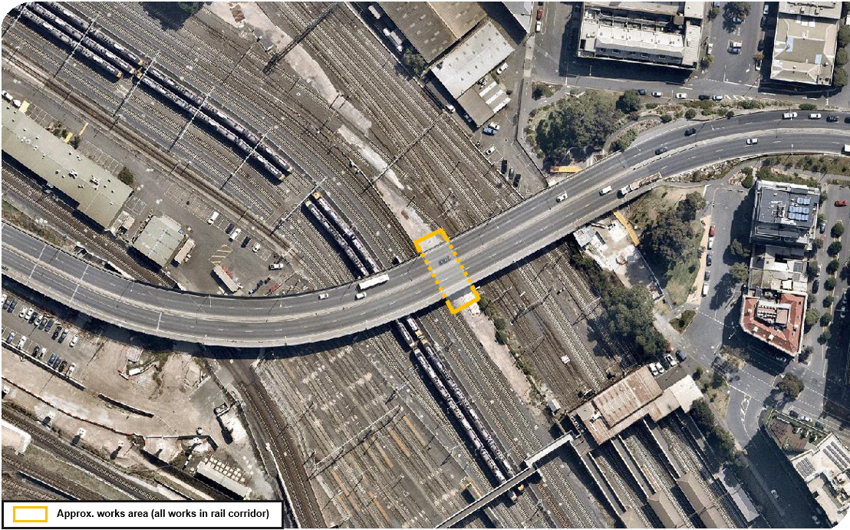
westgatetunnelproject.vic.gov.au

westgatetunnelproject.vic.gov.au info@wgta.vic.gov.au
1800 105 105
West Gate Tunnel Project Info Centre Corner of Somerville Rd and Whitehall St Yarraville VIC 3013
Follow us on social media Please contact us if you would like this
information in an accessible format.

Translation service – For languages other than English, please call 13 14 50.

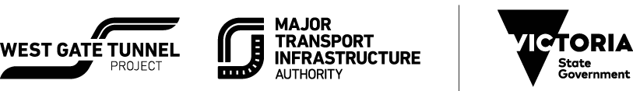

Authorised by the Victorian Government, 1 Treasury Place, Melbourne

