12 July 2021 WES2107.01

Dohertys Road weekend closure
From 8pm Friday 23 July until 5am Monday 26 July, the West Gate Tunnel Project team will be closing Dohertys Road (heading east towards the city) between Gordon Luck Avenue and Grieve Parade. This is so we can add the final layer of road surface.
Access to businesses will remain available via Dohertys Road heading west – please follow all signage and direction of traffic controls on site.
 | Impact | Date
 | Access to Altona Memorial Park and Floral Lawn Cemetery via Whitaker Drive (right in and right out only) | 23 July until 26 July 2021
 | Traffic changes between Gordon Luck Avenue and Grieve Parade:  - Closure of Dohertys Road heading east  - Closure of a lane on Dohertys Road heading west  A detour will be in place via Cherry Lane / Kororoit Creek Road and Grieve Parade. | 23 July until 26 July 2021
 | Detour of bus service 414 – please check PTV website for more details. | 23 July until 26 July 2021
 | Increase in truck movements | 23 July until 26 July 2021

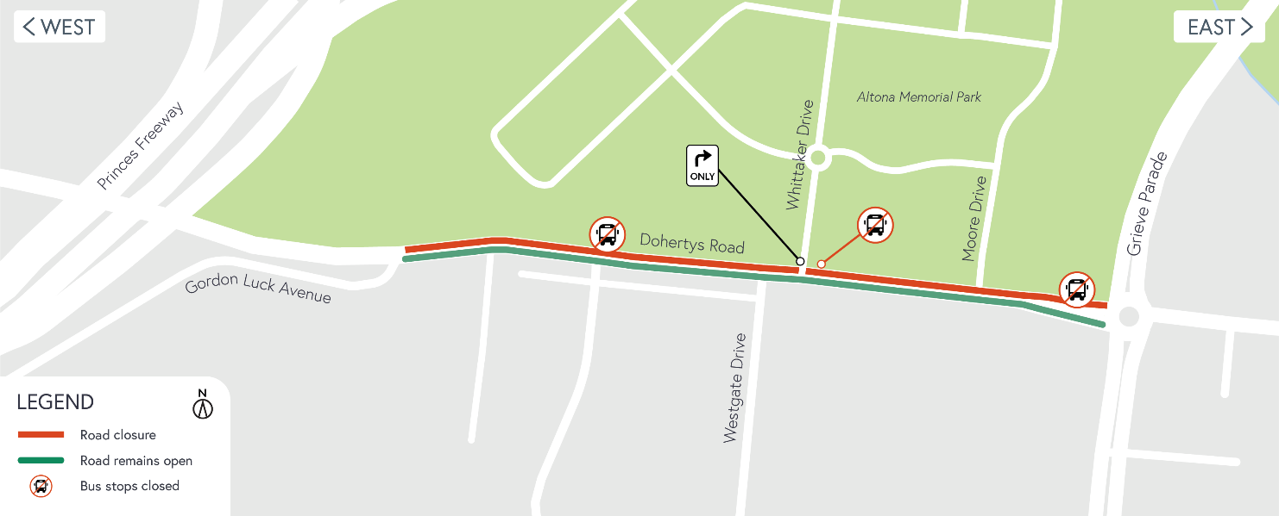
Location of works
To minimise the disruption to businesses and road users along Dohertys Road we have decided to do these works over one weekend when traffic volumes are usually lower, and we can get the works done quicker. We need to work during the day because for asphalt to set correctly the temperature needs to be within a certain range, and now that we're in winter, it is too cold overnight.
If the weather is poor and temperatures are too cold, we will need to reschedule the works. Please follow us on Facebook or sign up to traffic updates for the latest information.
To learn more about the impacts above, please don’t hesitate to give the team a call on 1800 105 105 or email us on info@wgtp.vic.gov.au.
Subscribe for traffic updates
As mentioned above, we will need to close Dohertys Road over a weekend. If you would like to sign up to receive weekly traffic alert emails please email us on info@wgta.vic.gov.au or call 1800 105 105.
Alternatively, for latest updates, dates of closures and detour route information visit: bigbuild.vic.gov.au/disruptions.

What you can expect during the works:
- Work will be completed behind safety barriers with construction vehicles moving in and out of work areas
- Access to businesses will be maintained – please follow signage and direction of traffic controllers on site
- Traffic impacts, including road and lane closures on Dohertys Road. The latest traffic updates are always available at bigbuild.vic.gov.au/disruptions
Hours of work
These works will be done 24 hours a day over the weekend, from 8pm Friday 23 July until 5am Monday 26 July.
Thank you
We appreciate our work can be disruptive and thank you for your understanding.
For updates or any concerns about these works, please visit westgatetunnelproject.vic.gov.au or call 1800 105 105.

