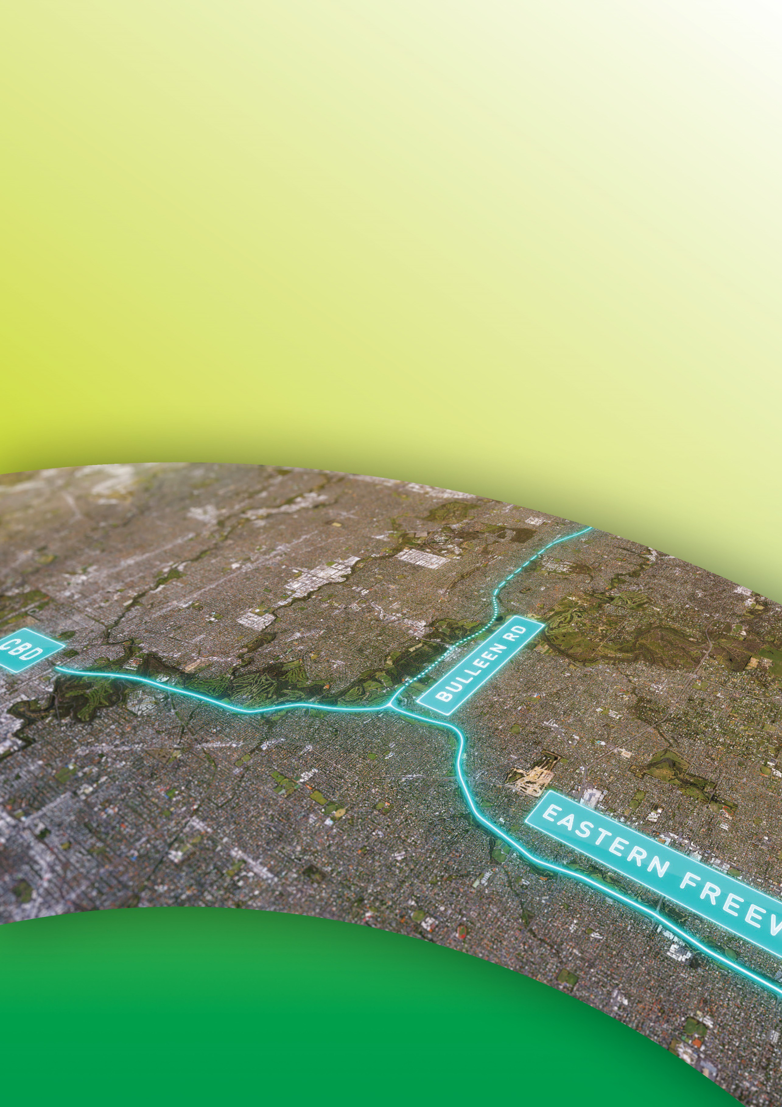
Public Environment Report

Attachment IV Options assessment
September 2019

Contents
Attachment IV Options assessment IV-1
- Introduction IV-1
  - Purpose of this attachment IV-1
  - Overview IV-1
- Assessment of feasible tunnel options IV-3
  - Overview IV-3
  - Tunnel length (northern end) IV-4
  - Tunnel length (southern end) IV-9
  - Tunnel width – Two vs. three lanes within tunnels IV-14
  - Location of the primary tunnelling work area IV-15
- Assessment of feasible interchange options IV-16
  - Overview IV-16
  - M80 Ring Road and Greensborough Bypass interchange IV-19
  - Grimshaw Street interchange IV-22
  - Lower Plenty Road interchange IV-24
  - Manningham Road interchange IV-29
  - Eastern Freeway interchange IV-32
- Assessment of feasible options to upgrade the Eastern Freeway IV-33
  - Overview IV-33
  - Eastern Freeway widening IV-34
  - Tram Road to Middleborough Road short trips IV-36
- Assessment of feasible Doncaster Busway options IV-38
  - Overview IV-38
- The reference project IV-42

Attachment IV – Options assessment | IV–iii

Public Environment Report

Tables
Table IV-1 Reference project assessment criteria – key aspects IV-2

Figures
Figure IV-1 Design options for tunnels IV-4
Figure IV-2 Option A: TBM tunnel to north of Grimshaw Street IV-5
Figure IV-3 Option B (reference project): Trench from Elder Street to Blamey Road IV-7
Figure IV-4 Option B (reference project):
Indicative schematic cross section of trench IV-8
Figure IV-5 Option A: Viaduct over Bulleen Road IV-9
Figure IV-6 Option B.1: TBM tunnels to Eastern Freeway IV-11
Figure IV-7 Option B.2: Cut and cover tunnels to Eastern Freeway IV-12
Figure IV-8 Option C (reference project): Mined tunnels and short viaduct IV-13
Figure IV-9 North East Link key interchange locations IV-17
Figure IV-10 Design options for interchanges IV-18
Figure IV-11 Option A: North East Link as an elevated road over
Greensborough Bypass at the M80 Ring Road interchange IV-20
Figure IV-12 Option B (reference project):
M80 Ring Road interchange at grade road IV-21
Figure IV-13 Option A: Grimshaw Street service road layout – no interface IV-23
Figure IV-14 Option B (reference project):
Grimshaw Street service road layout – interface with Grimshaw Street IV-24
Figure IV-15 Option A.1: Elongated loop ramps IV-25
Figure IV-16 Option A.2: Single point urban intersection IV-26
Figure IV-17 Option B: New interconnected road IV-27
Figure IV-18 Option C (reference project): Lower Plenty Road interchange IV-28
Figure IV-19 Option B: Manningham Road interchange
(reference project proposed design) IV-31
Figure IV-20 Option C: Manningham Road interchange
(reference project alternative design) IV-32

IV–iv | Attachment IV – Options assessment

Figure IV-21 Design options for Eastern Freeway IV-33
Figure IV-22 Option B (reference project):
Schematic lane diagram of Eastern Freeway upgrades IV-35
Figure IV-23 Option B (reference project):
Short trips between Tram Road and Middleborough Road IV-37
Figure IV-24 Design options for Doncaster Busway IV-38
Figure IV-25 Option A: Doncaster busway central median from Victoria Park and
north side from Burke Road IV-39
Figure IV-26 Option B: Doncaster Busway outside lanes from Hoddle Street, central median from Chandler Highway
and north side from Burke Road IV-40
Figure IV-27 Option C (reference project): Doncaster Busway IV-42

Attachment IV Options assessment

Introduction

Purpose of this attachment
This attachment describes the feasible alternatives (‘options’) within the preferred corridor for North East Link and outlines how they were assessed. It provides the rationale for the form of the action assessed in the Public Environment Report (PER).

Overview
With the announcement of the preferred corridor, North East Link was envisaged to include the following design elements:
- A tunnelled section, with a minimum length from Blamey Road to Manningham Road (described in Section 2)
- A section of the road in a trench, extending from Blamey Road to Watsonia railway station, running alongside Simpson Barracks (described in Section 2)
- Interchanges at M80 Ring Road (otherwise known as the Metropolitan Ring Road)/ Greensborough Bypass, Grimshaw Street, Lower Plenty Road, Manningham Road and the Eastern Freeway (described in Section 3)
- Upgrades to the Eastern Freeway to increase its capacity in both directions, with dedicated carriageways between Middleborough Road and Burke Road to separate through traffic from traffic entering and exiting the freeway (described in Section 4)
- A new Doncaster Busway system along the Eastern Freeway from Doncaster Park and Ride to Hoddle Street (described in Section 5).

North East Link Project undertook further investigation of feasible options within the corridor for these design elements to develop the reference project. This attachment provides a summary of the options investigated.

Public Environment Report

A set of criteria were used to assess the options associated with the different design elements.
These criteria were developed to reflect the transport system objectives and decision-making principles informed by the Transport Integration Act 2010 (Vic). Refer to PER Chapter 2 – Objective of the action for further detail.

Key aspects of the criteria are described in Table IV-1 and referenced throughout this attachment.

Table IV-1 Reference project assessment criteria – key aspects

Criteria | Key aspects of criteria | Transport system objectives
Traffic and transport | - Functionality of layout  - Accessibility of layout | Integration of transport and land use
Design | - Compliance with standards and best practice including gradient and configuration of road geometry, maintenance access, occupational health and safety and clearances | Efficiency, coordination and reliability
Land planning and environment | - Land acquisition  - Visual impact  - Environmental impact (including impact on matters of national environmental significance) | Environmental sustainability, Safety health and wellbeing
Stakeholder and community | - Residential and business accessibility and impacts  - Minimise displacement impacts | Social and economic inclusion
Financial | - Whole of life considerations | Economic prosperity

Community and stakeholder feedback received via community information sessions, Community Liaison Groups, stakeholder meetings and other engagement activities were also considered as part of the options investigation. Responses to feedback are discussed in PER Chapter 14 – Consultation.

Assessment of feasible tunnel options

Overview
Tunnels would extend from Blamey Road in the north to south of Veneto Club in the south, built as a combination of driven (using a tunnel boring machine (TBM)), mined and cut and cover tunnel construction methods. Tunnels would contain three lanes in each direction.

During design development, other options assessed for the tunnelled section of North East Link included:
- Extending the tunnel north of Blamey Road
- Extending the tunnel south to the Eastern Freeway
- Narrowing the tunnel to two lanes instead of three
- Potential location options for the primary administration and construction for the tunnelling works.

See Figure IV-1 for a graphic representation of these options. The options in bold relate to the reference project, as described in the following sections.
Why are we tunnelling?
Protecting the Yarra River, its tributaries, floodplains, surrounding environment and culturally significant sites such as Bolin Bolin Billabong is a core requirement for North East Link.
Early feedback from community consultation identified that these environmentally and culturally sensitive areas are highly valued by the Traditional Owners of the land – the Wurundjeri people – and the local community.
There are also many residential properties within the project boundary, other sensitive receptors (such as schools) and local businesses.
Tunnelling would minimise potential impacts to homes, community spaces and culturally and environmentally significant areas.

Public Environment Report

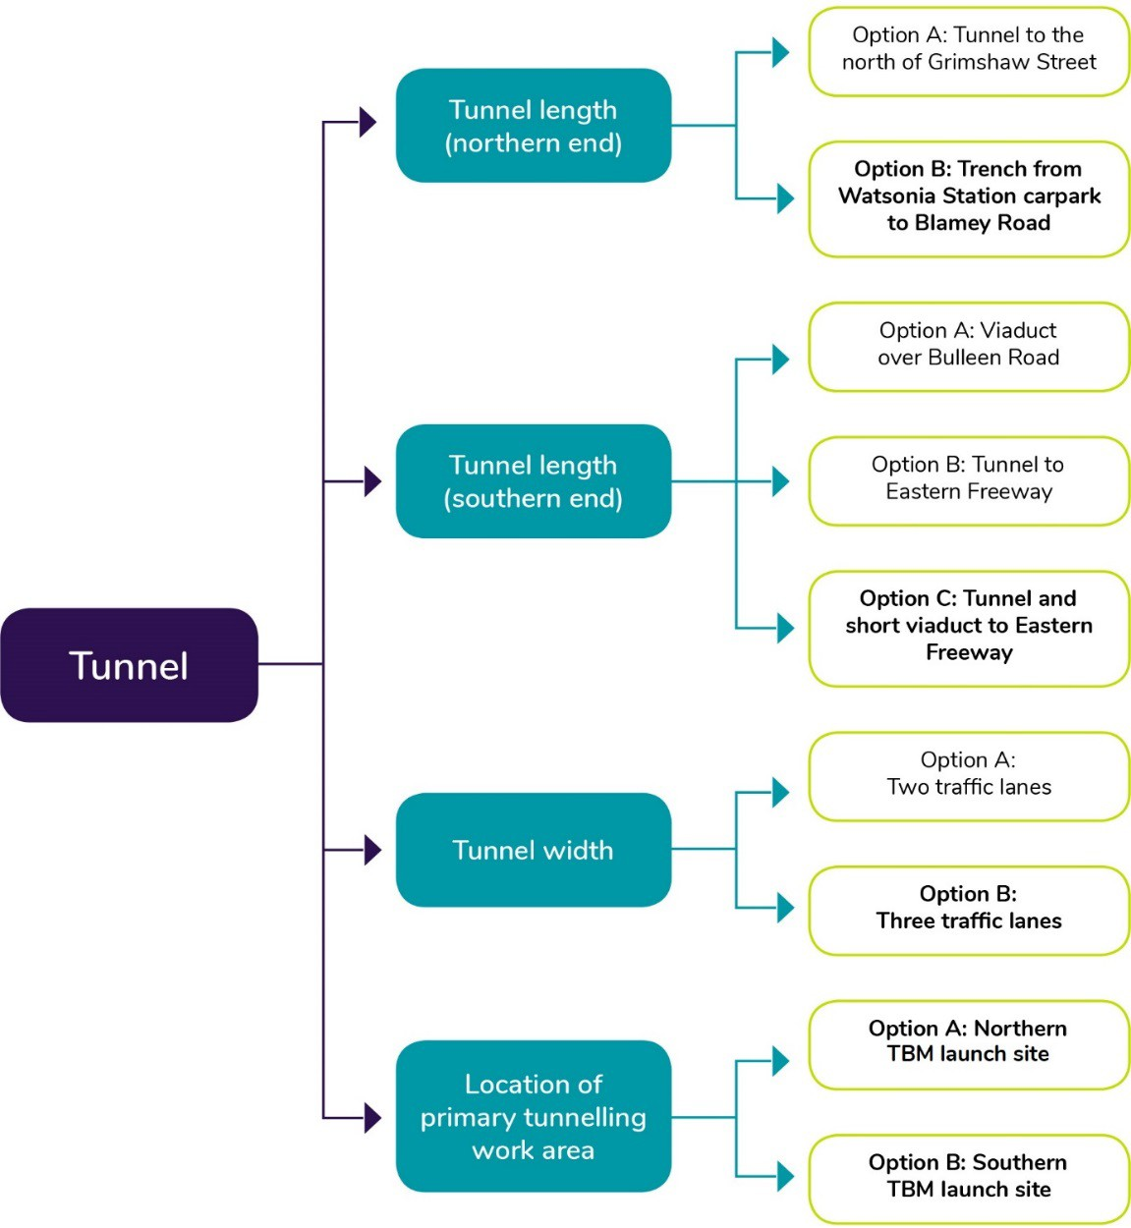

Figure IV-1 Design options for tunnels

Tunnel length (northern end)
The section between the M80 Ring Road and Lower Plenty Road has a number of design challenges due to the need to provide interchanges at the M80 Ring Road, Grimshaw Street and Lower Plenty Road, and because the ground in this area rises steeply to the north. Two key options were assessed for this section of road:
- Option A: Continuation of the tunnel past Lower Plenty Road to Grimshaw Street
- Option B (reference project): A trench from Elder Street to Blamey Road.

Option A: Tunnel continuing from Lower Plenty Road under Greensborough Bypass to the north of Grimshaw Street
This option (as shown in Figure IV-2) was originally considered for this section of North East Link as it would minimise, and in some cases entirely avoid, impacts to Grimshaw Street, AK Lines Reserve, the Watsonia Primary School, Watsonia railway station and Simpson Barracks.
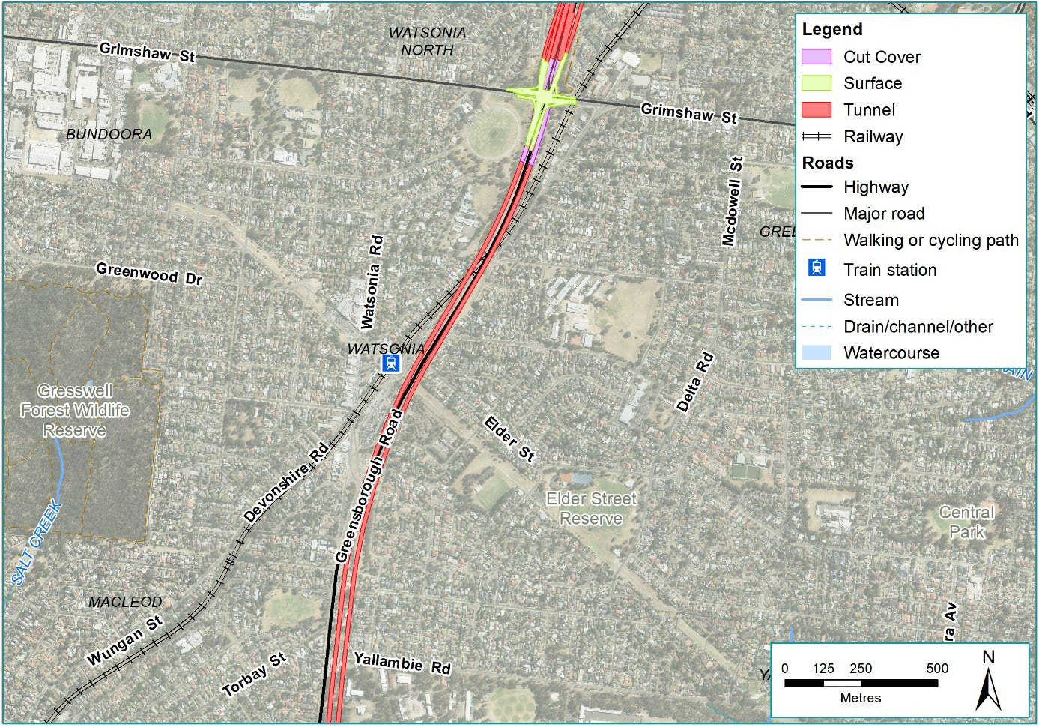
Figure IV-2 Option A: TBM tunnel to north of Grimshaw Street

Public Environment Report

Despite these advantages, key issues with this tunnelling option were identified, including:
- Traffic and transport
Due to the challenging topography of the area, the gradient of the ramps from the tunnel would be too steep for vehicles to exit the tunnel at these interchanges at Grimshaw Street and Lower Plenty Road (ramp gradients of around eight per cent). This is because the ground is considerably higher at the northern end of the project (at the M80 Ring Road), and steadily falls towards the south. Under this tunnelled option, the Lower Plenty Road interchange could not be constructed, and ramps could only be provided to the north at the Grimshaw Street interchange. This would provide connections north to the M80 Ring Road and Greensborough Bypass, but not to the south. This would remove access onto North East Link from Lower Plenty Road and significantly limit access from Grimshaw Street.
- Design
To avoid impacting the Hurstbridge rail line, the tunnel would need to be well below the rail corridor near the intersection with Greensborough Road. However, this would mean the tunnel would be too deep to provide entry and exit ramps to Grimshaw Street that have appropriate and safe gradients for vehicles.
- Land planning and environment
Despite avoiding impacts at Simpson Barracks, this option would still require acquisition of residential properties on the east side of Sellars Street. This would facilitate the at-grade interchange at the M80 Ring Road and Greensborough Bypass.

Due to the range of disadvantages associated with the extension of the tunnel to the north, this option was removed from further consideration. This was largely due to the inability to provide safe and acceptable entry and exit to North East Link.

Option B (reference project): Trench beginning adjacent to Watsonia railway station carpark to Blamey Road
This option (shown in Figure IV-3 and Figure IV-4) would lower the North East Link carriageways into a trench structure adjacent to the Watsonia railway station car park. Heading south, the trench structure would slowly descend, until Blamey Road, where the road would transition into a cut and cover tunnelled section. Once the tunnel reaches Lower Plenty Road, driven tunnels, using TBMs would commence.
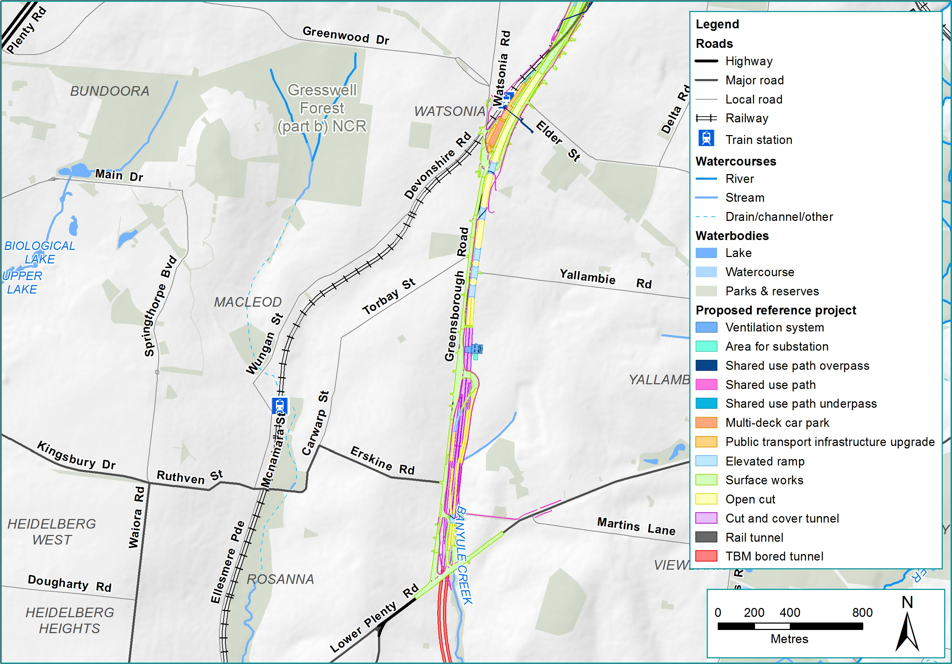
Figure IV-3 Option B (reference project): Trench from Elder Street to Blamey Road

Public Environment Report

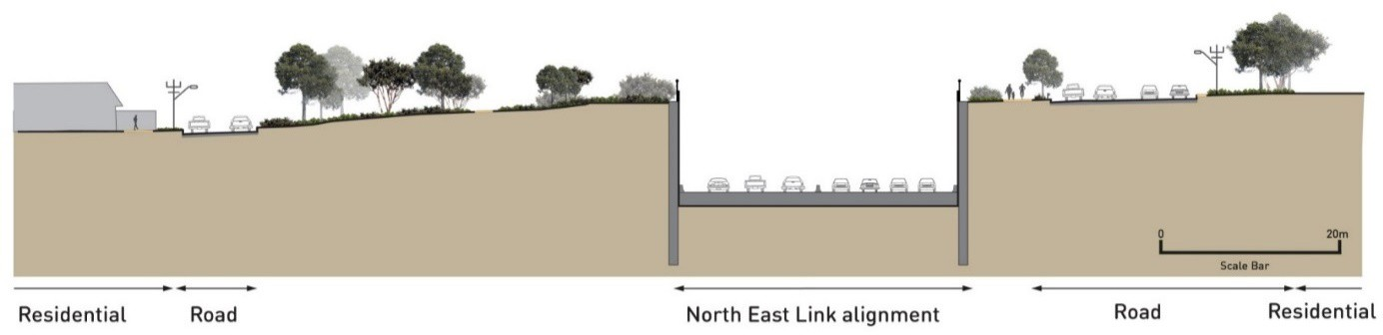

Figure IV-4 Option B (reference project): Indicative schematic cross section of trench

The trench option was progressed through to the reference project as it responds to the following aspects of the criteria:
What are over dimensional vehicles and vehicles carrying dangerous goods?
Over-dimensional vehicles are vehicles that exceed 5.0 metres high,
5.0 metres wide or 30.0 metres long, or 100.0 tonnes gross mass.
The tunnels cannot contain these vehicles given the limited overhead clearance for large vehicles.
Vehicles carrying dangerous goods of sufficient quantity and type to be a ‘placarded load’ are also prohibited from being transported via tunnel.
Over-dimensional vehicles and vehicles carrying dangerous goods typically represent less than one per cent of total vehicles travelling within the north-east.
- Design
This option provides a horizontal and vertical geometry that responds to the challenging topography within this area. This enables the construction of safe entry and exit ramps at Lower Plenty Road and Grimshaw Street.
- Traffic and transport
This option would reduce the number of large vehicles travelling south on Greensborough Road to Rosanna Road (via Lower Plenty Road). These vehicles would then use existing designated routes on the arterial road network to travel to their destinations, including Rosanna Road and Bulleen Road. These over- dimensional vehicles and some vehicles carrying dangerous goods (those that are placarded loads) would not be able to travel in the road tunnels, consistent with CityLink, EastLink and the yet to be constructed West Gate Tunnel Project.
- Land planning and environment
The impacts to properties on the east side of Sellars Street associated with Option A above would also be largely mitigated or removed entirely under this option.

However, because the trench would run along the existing Greensborough Road, this design would impact some residential properties and the Simpson Barracks to the east side of Greensborough Road. These impacts are associated with land acquisition, ecology and arboriculture.

Tunnel length (southern end)
The options to extend the tunnel on the southern end between Manningham Road and the Eastern Freeway need to consider a number of challenges. These include significant existing traffic volumes on Bulleen Road, the ramp grades required to connect to the Eastern Freeway, interfaces with the Koonung Creek and the consideration of a number of sensitive receptors including residential properties, Bolin Bolin Billabong, community facilities, sporting grounds and school facilities.
Three key options were assessed for this section of road:
  - Option A: Viaduct from Manningham Road to the Eastern Freeway over Bulleen Road
  - Option B: Continuation of the tunnel from Manningham Road to the Eastern Freeway under Bulleen Road
  - Option C (reference project): Continuation of the tunnel from Manningham Road to the south of the Veneto Club and viaduct to the Eastern Freeway under Bulleen Road.

Option A: Viaduct over Bulleen Road
This option (shown in Figure IV-5) includes an elevated structure south of Manningham Road interchange over Bulleen Road to connect North East Link to the Eastern Freeway in all directions.
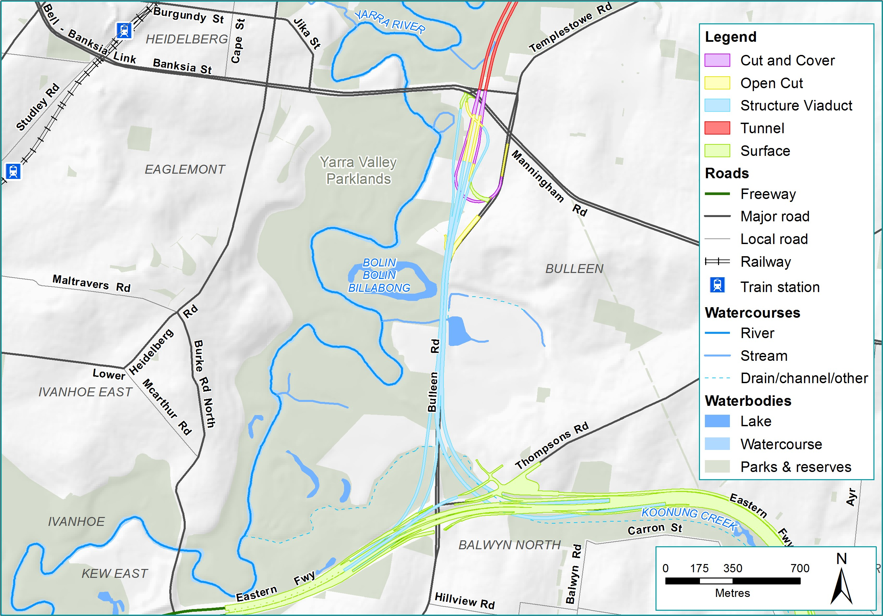
Figure IV-5 Option A: Viaduct over Bulleen Road

Public Environment Report

While a long viaduct would provide efficient traffic functionality, one key issue with this option included:
- Land planning and environment
This option would require significant permanent impacts to residential properties and community facilities south of Manningham Road. Also due to the elevated structures, there would be significant visual and amenity impacts to the community facilities and schools around Bulleen Road. However, this option would minimise impacts within the floodplain.

While this option provides for optimal traffic performance, the visual and amenity impacts to the surrounding facilities were considered too significant to progress this option.

Option B: Tunnel to Eastern Freeway
This option continues North East Link in tunnel south of Manningham Road to the Eastern Freeway, connecting to the Eastern Freeway in tunnel to the east and west.

The purpose of this option is to avoid residential property acquisition south of Manningham Road and avoid the visual and amenity impacts associated with a viaduct structure along Bulleen Road associated with Option A above.

A tunnel concept was considered as two options:
- Option B.1: TBM tunnels – this option would use a TBM to construct the tunnels connecting North East Link to the Eastern Freeway. This is presented in Figure IV-6.

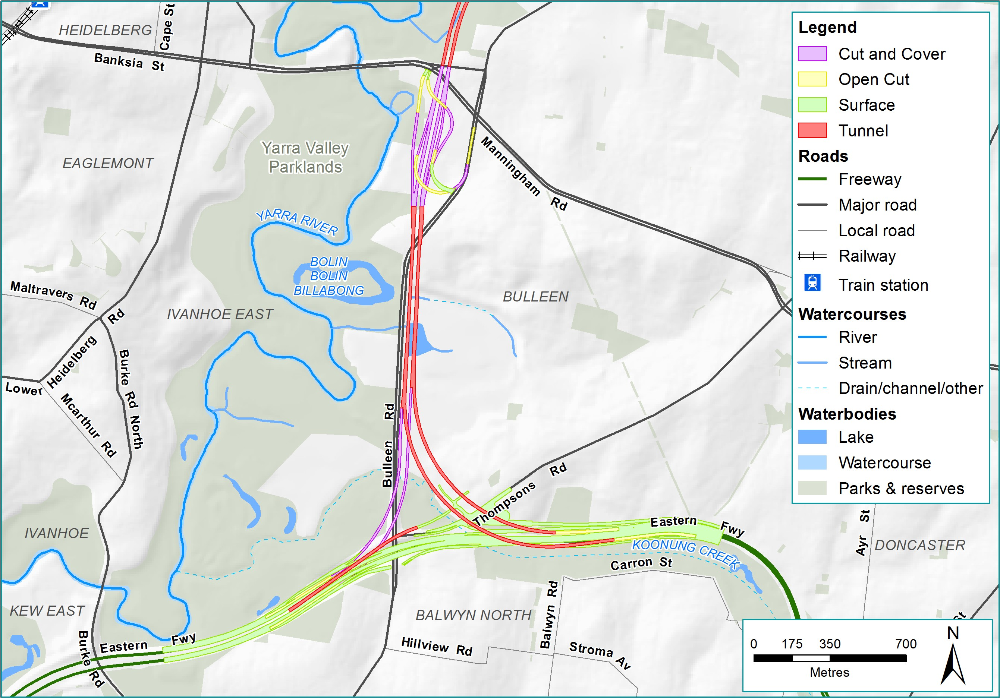
Figure IV-6 Option B.1: TBM tunnels to Eastern Freeway

Public Environment Report

- Option B.2: Cut and cover tunnels – this option would apply a cut and cover construction methodology, which would require surface level clearing to facilitate the construction of the tunnel. This would result in additional surface level impacts and extensive property acquisition. This is presented in Figure IV-7.
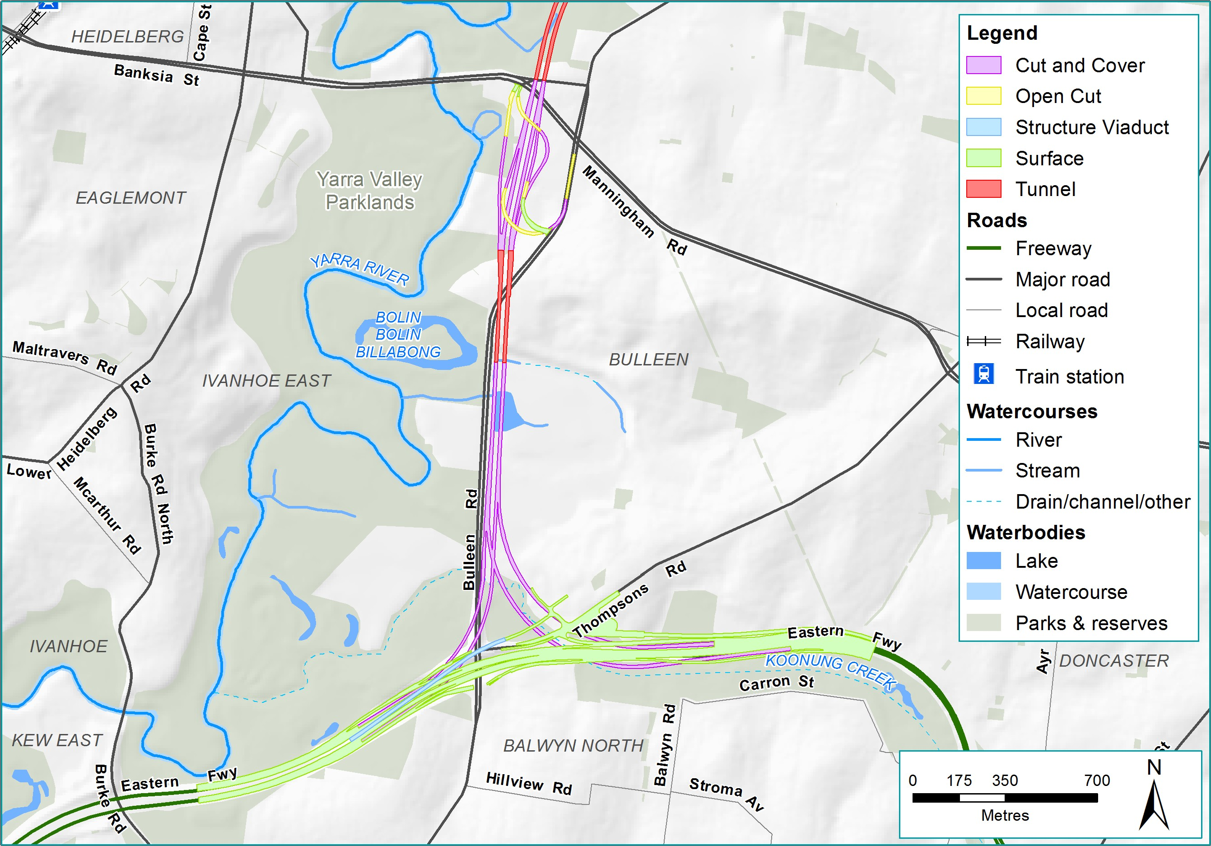
Figure IV-7 Option B.2: Cut and cover tunnels to Eastern Freeway

Despite the advantages of a tunnelled option minimising visual impacts, this option was removed from further consideration due to a number of issues:
- Traffic and transport:
The design layout for this option would not provide an acceptable level of traffic functionality. This is due to the tight radius curve of the east-facing tunnel (on the eastern side of Bulleen Road) which would not provide sufficient stopping sight distance.
- Land planning and environment:
This option would also require a larger area at the Eastern Freeway in order to accommodate the tunnel portals and the ventilation structures, which would have permanent impacts on parkland, community facilities and would impact residential properties (as a result of the cut and cover methodology).

Through an assessment of the advantages and disadvantages associated with Options A and B, Option C was developed.

Option C (reference project): Tunnel to the south of the Veneto Club
and short viaduct to the Eastern Freeway
This option (Figure IV-8) consists of a combination of the two options assessed above. From the Manningham Road interchange, the North East Link tunnels would pass under residential properties on the east side of Bulleen Road to the escarpment on the north side of the Trinity Grammar School Sporting Complex. The tunnels would then continue from the escarpment to the west side of Bulleen Road with tunnel portals to the south of the Veneto Club property. From the tunnel portals, ramp connections to Eastern Freeway east and west would climb on viaducts that connect to the Eastern Freeway carriageways. This option would retain access for community facilities onto Bulleen Road.
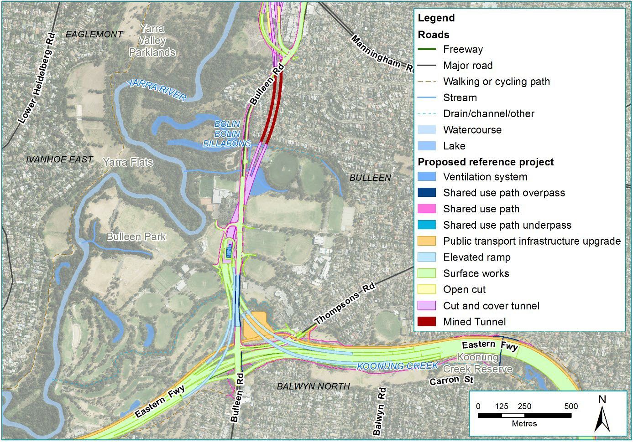
Figure IV-8 Option C (reference project): Mined tunnels and short viaduct

Public Environment Report

Key benefits of this option include:
- Land planning and environment
This option would avoid impacts to residential properties on both sides of Bulleen Road due to the tunnelling method underneath residential properties.
- Traffic and transport
The design of the viaduct structure to the Eastern Freeway would provide a suitable gradient for Bulleen Road to retain access for community facilities and provide efficient traffic functionality onto the Eastern Freeway.

While Option C provides an improved outcome for this section of North East Link compared with options A and B, there are some disadvantages associated with Option C. These include significant property impacts to community facilities such as Boroondara Tennis Centre, Bulleen Oval, tennis/netball courts within Carey Grammar Sports Complex, the football oval used by Yarra Junior Football League, the Freeway Public Golf Club, the Bulleen Swim Centre and the visual impact associated with the viaduct structures to the Eastern Freeway.

On balance, this option was progressed through to the reference project due to the advantages associated with the design. While there are a number of community facilities impacted, this option avoids all direct residential property impacts in this location.

Tunnel width – Two vs. three lanes within tunnels
Early project assessment looked at the lane options for the tunnels, specifically whether the tunnels would have two or three lanes in each direction.

Option A: Two traffic lanes
If the tunnels were constructed with two traffic lanes, this would reduce the tunnel width and the total area required for construction and operation. Tunnels with two lanes would be less expensive to construct, compared with wider tunnels.

However, two lanes in each direction would not be considered adequate to carry the traffic volumes expected for North East Link, as discussed below.

Option B (reference project): Three traffic lanes
The estimated daily capacity of the tunnels would be 140,000 vehicles a day. Traffic modelling predicts the tunnels would carry up to 125,000 vehicles a day by the year 2036. The tunnels are also expected to be the busiest section of North East Link during operation.

If the North East Link tunnels were constructed with two lanes in each direction, it is expected that upgrading to three lanes in each tunnel would be required not long after North East Link starts operating, which would be costly and disruptive.

As a result, early traffic studies showed that three lanes in each tunnel would be a better traffic and transport solution and provide the capacity required for projected initial and future traffic volumes. The tunnels would be designed and built to operate with three traffic lanes in each direction.

Location of the primary tunnelling work area
The reference project includes two options for the location of the primary administration and construction for the tunnelling works. These are at the following locations:
  - Option A: Lower Plenty Road extending north to Blamey Road and described as the Northern TBM launch site
  - Option B: Bridge Street extending south to Golden Way and described as the Southern TBM launch site.

Both launch options exist within the project boundary. While the construction layouts for north and south sites change depending on if the launch site is located there, this only means that precise locations of construction sheds/laydown areas change.

Public Environment Report

Assessment of feasible interchange options

Overview
Why do we need interchanges?
The decision to locate additional interchanges between North East Link’s connections to the M80 Ring Road and Eastern Freeway was made giving consideration to:
- The existing road network – Grimshaw Street, Lower Plenty Road and Manningham Road are the three arterial roads that intersect with the North East Link alignment.
- The VicRoads SmartRoads framework and Transport for Victoria’s Movement and Place Framework – SmartRoads is an approach to managing Victoria’s arterial road network that aims to better link transport to adjacent land use, by providing a set of guiding principles for road use by transport mode, place of activity and time of day. Transport for Victoria is also currently developing the Movement and Place Framework to replace the SmartRoads road use hierarchy. The framework defines categories for each road link with respect to functionality, transport mix and environmental conditions to guide the planning and development of an integrated transport network. This also extends to the design of people-friendly streets and defining the best outcomes for cycling, walking and place making.
- Traffic studies and modelling of the origins and destinations of vehicles travelling on North East Link – These studies have identified that interchanges at these locations would allow people to use North East Link to more easily access their destinations in the north-east.
- The ability to provide access to residential and employment areas – Interchanges with key arterial roads would allow vehicles travelling on North East Link to travel to and from employment and residential areas in the north-east such as the La Trobe National Employment and Innovation Cluster.

Figure IV-9 highlights the location of proposed interchanges at the M80 Ring Road, Grimshaw Street, Lower Plenty Road, Manningham Road and the Eastern Freeway which would provide access to major population and employment centres.

Figure IV-10 summarises the options considered for each of the interchanges.

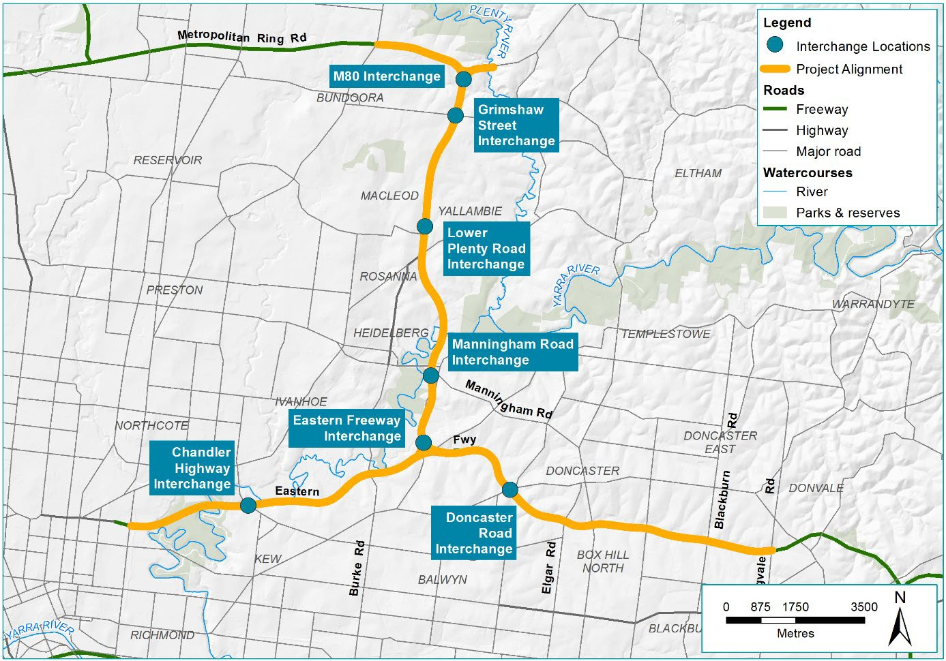

Figure IV-9 North East Link key interchange locations

Public Environment Report

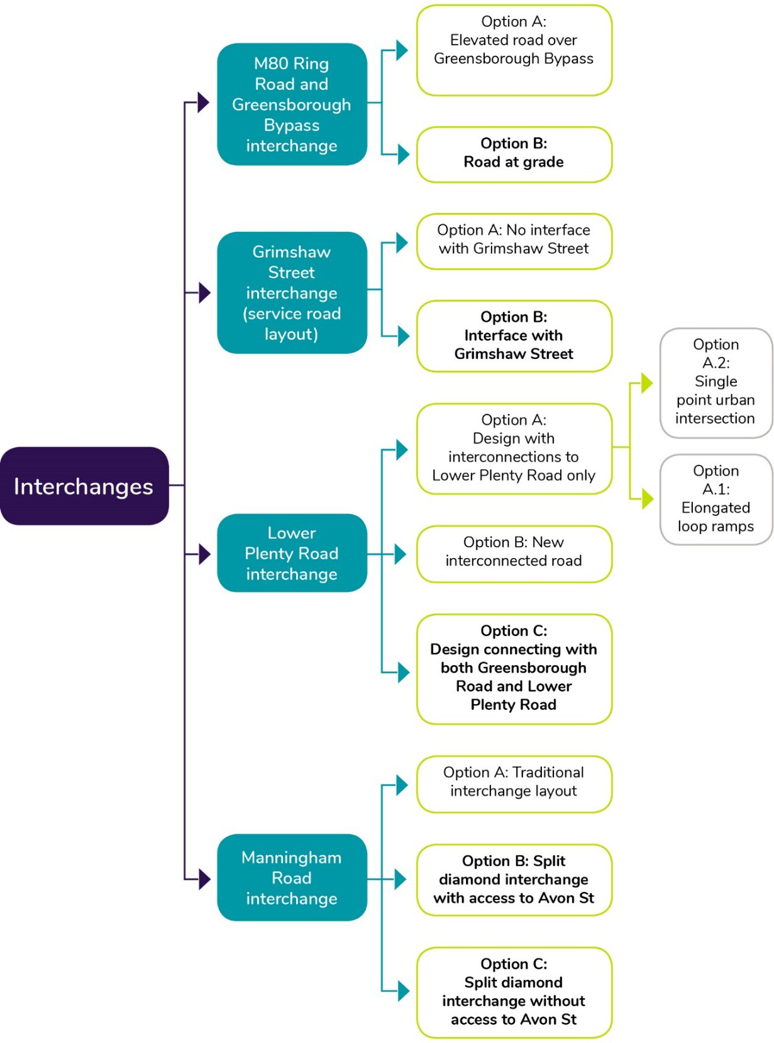

Figure IV-10 Design options for interchanges

M80 Ring Road and Greensborough Bypass interchange
The purpose of the new interchange is to provide connectivity to the Greensborough Bypass to the east, the M80 Ring Road to the west and south onto North East Link and to remove the signal constraints that are currently at this interchange.

The structure of this interchange was dependent on a number of key challenges and decision points in the options development process.

As explained in Section 2, North East Link tunnels would extend from Lower Plenty Road in the north, to south of the Veneto Club, Bulleen in the south. As a result of the tunnel design (described in Section 2.1), the options for the interchange at the M80 Ring Road and Greensborough Bypass were narrowed to two key options. This includes:
- Option A: An elevated road
- Option B (reference project): A road at-grade.

Option A: Elevated road over Greensborough Bypass
North of Grimshaw Street, this option (shown in Figure IV-11) would elevate North East Link on a viaduct structure, to separate the Greensborough Bypass from North East Link movements.
This option was considered as it would retain all existing local access including to Grimshaw Street, Greensborough Road, Greensborough Bypass, Elder Street, Watsonia railway station and the associated commuter car park.

Public Environment Report

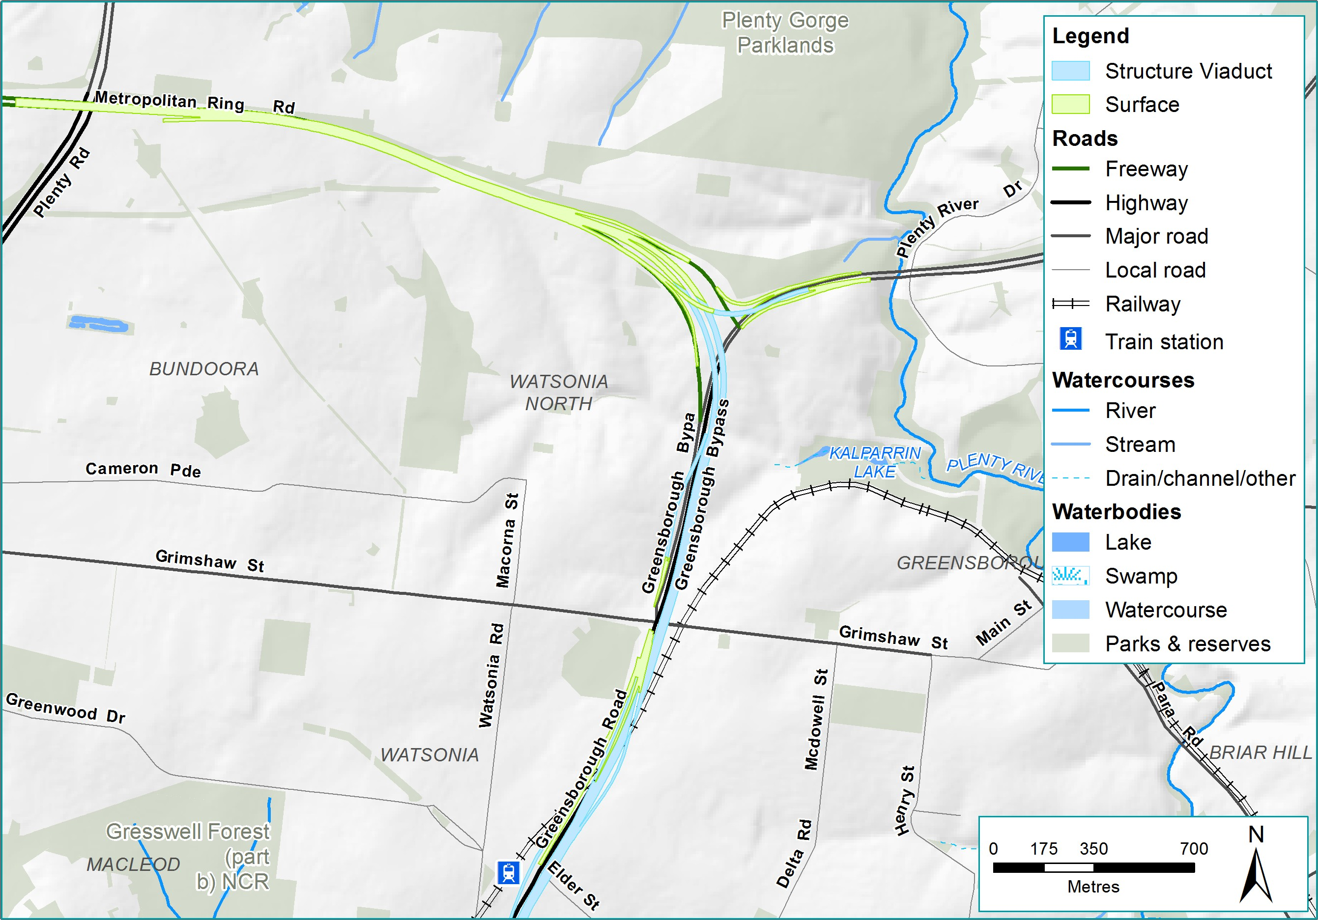
Figure IV-11 Option A: North East Link as an elevated road over Greensborough Bypass at the M80 Ring Road interchange

However, this option was removed from further consideration, due to a number of disadvantages. These include:
- Traffic and transport
This option would not provide a free-flowing exit (without traffic lights) for traffic travelling north of Grimshaw Street. This would require traffic to exit to the Greensborough Bypass, and pass through the Grimshaw Street intersection in the same way it currently operates.
- Land planning and environment
A large elevated freeway within a built up urban area would have significant visual and amenity impacts to the surrounding community and residential area. This option was removed from further consideration due to these significant impacts.

Option B (reference project): A road at-grade
This option (shown in Figure IV-12) would consist of a free flowing interchange with multiple carriageways, providing connectivity from M80 Ring Road to the west, Greensborough Bypass to the east and North East Link to the south. This at-grade configuration provides a number of advantages including:
  - Traffic and transport
This option improves service road and local road access (including pedestrian overpasses), and allows for intersections at Grimshaw Street and Lower Plenty Road.
  - Land planning and environment
This structure also minimises visual and amenity impacts as it would be located within the existing M80 Ring Road and Greensborough Bypass road corridors.

As this option mitigates the key issues identified in the previous option, this was carried through as the preferred interchange and alignment structure.
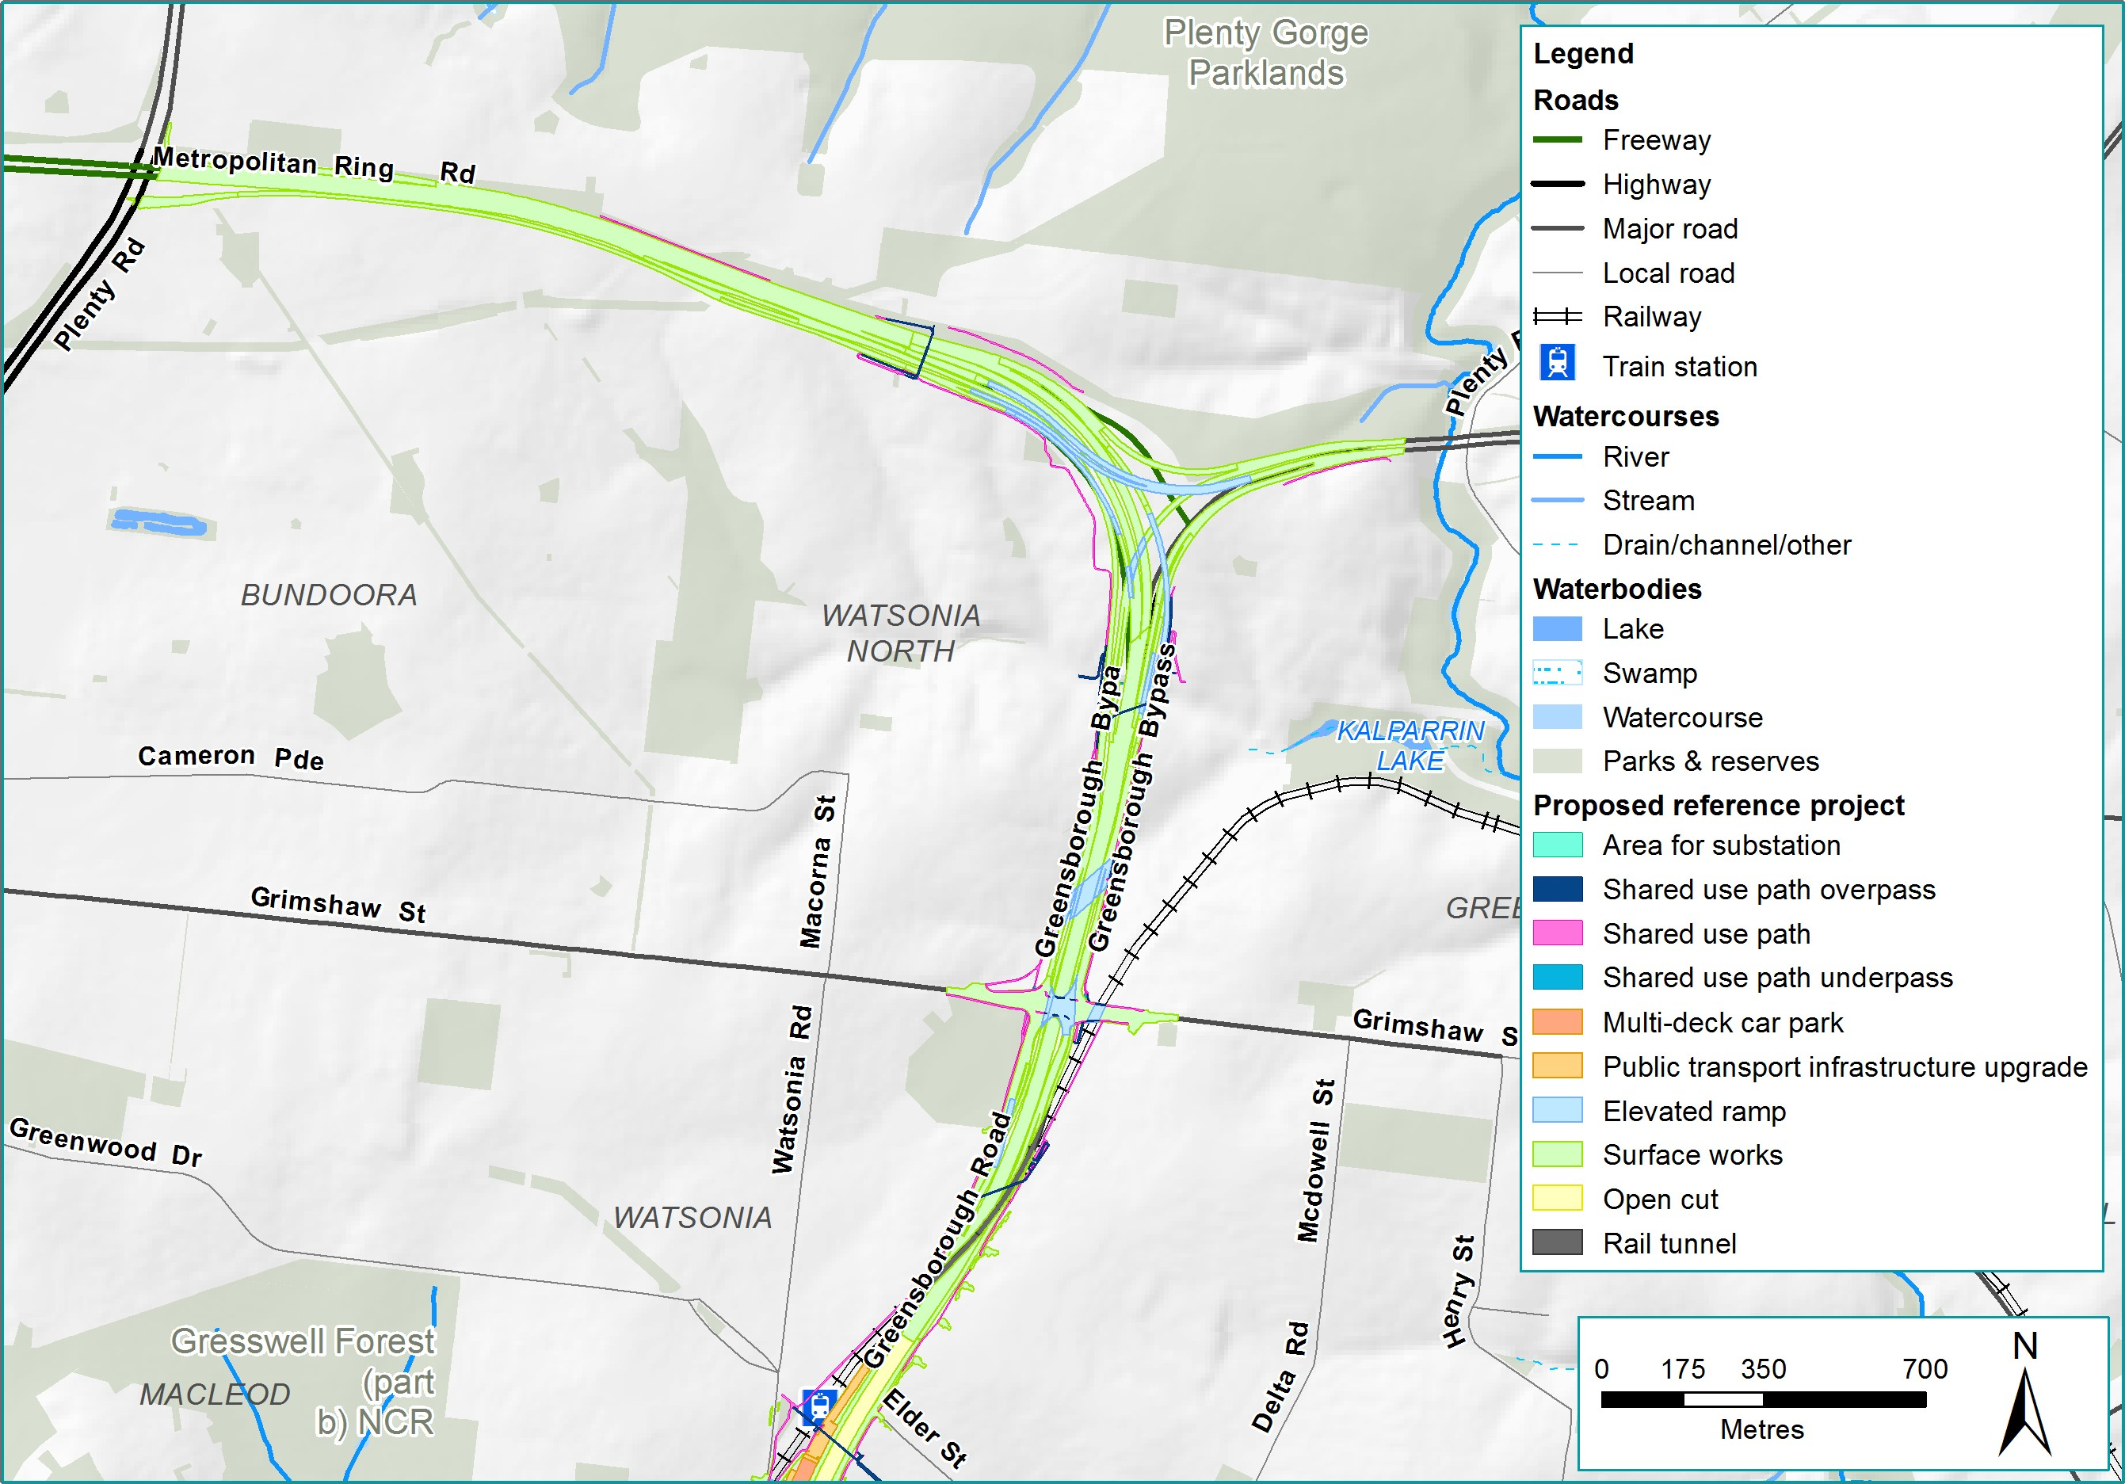
Figure IV-12 Option B (reference project): M80 Ring Road interchange at grade road

Public Environment Report

Grimshaw Street interchange
Following the selection of the preferred option for the M80 Ring Road interchange as an at-grade road, explained in the above section, the layout of the Grimshaw Street interchange was largely predetermined and takes a single point interchange design configuration. North East Link would be separated vertically from Grimshaw Street to cater for free flowing traffic to and from North East Link. This would be achieved by balancing the lowering of North East Link carriageways and raising of Grimshaw Street.

Key options associated with this interchange were related to the service road provision and local road access around Grimshaw Street. Two options for the service road provision around Grimshaw Street were assessed:
- Option A: No interface with Grimshaw Street
- Option B (reference project): Interface with Grimshaw Street.

Option A: No interface with Grimshaw Street
This option (shown in Figure IV-13) contained a service road on the eastern side of the intersection that does not interface with Grimshaw Street. To facilitate access, this service road involved a new roundabout located to the south-east of the Grimshaw Street interchange. This was proposed to reduce the number of local movements at the Grimshaw Street interchange, while retaining local connectivity to Watsonia Neighbourhood Village shopping centre.

This option was removed from further consideration due to the inconsistency with criteria around:
- Land planning and environment
This option would require additional land acquisition at AK Lines Reserve and Watsonia Primary School compared with the reference project.
- Design
This option creates a number of design challenges associated with the interface between the new service road infrastructure and the Hurstbridge rail line.

However, the option of providing service roads at this interchange was continued, which led to the development of Option B described below.

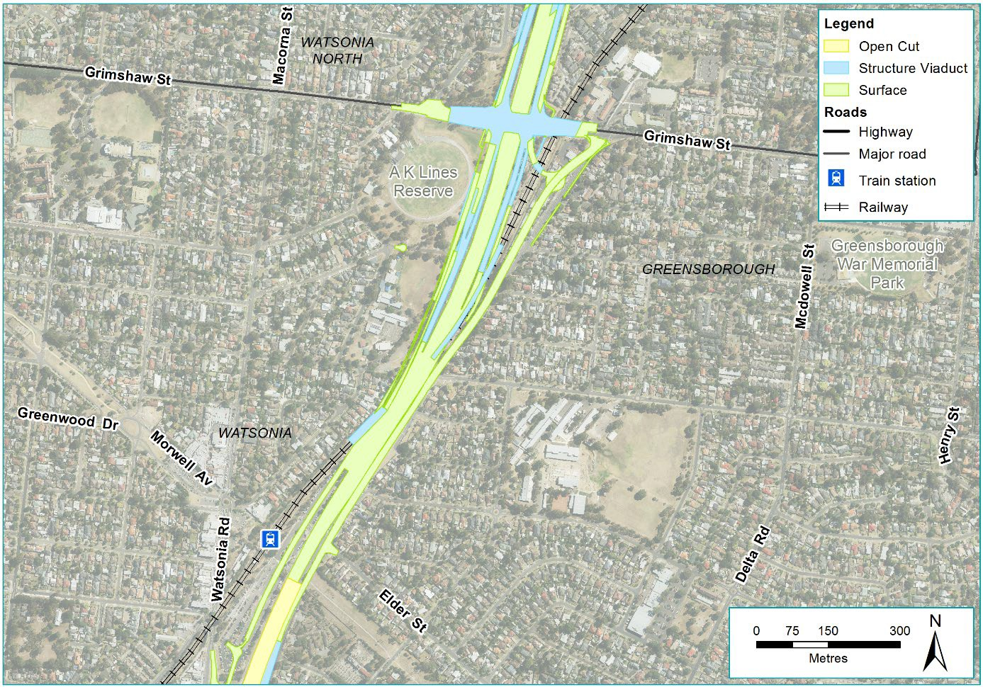

Figure IV-13 Option A: Grimshaw Street service road layout – no interface

Option B (reference project): Interface with Grimshaw Street
This option (shown in Figure IV-14) would provide service roads which interface with Grimshaw Street by providing grade separated carriage ways under North East Link, and service roads extending from the M80 Ring Road interchange for local movements on the eastern and western sides of North East Link. Key benefits of this option include:
  - Traffic and transport
This would improve traffic functionality and provide circuitous local access to Watsonia railway station (replacing the current direct access from Elder Street), while still providing connectivity between Watsonia Neighbourhood Village and Grimshaw Street. At the Grimshaw Street interchange, the service roads would interface with the main interchange allowing movements in all directions.

Public Environment Report

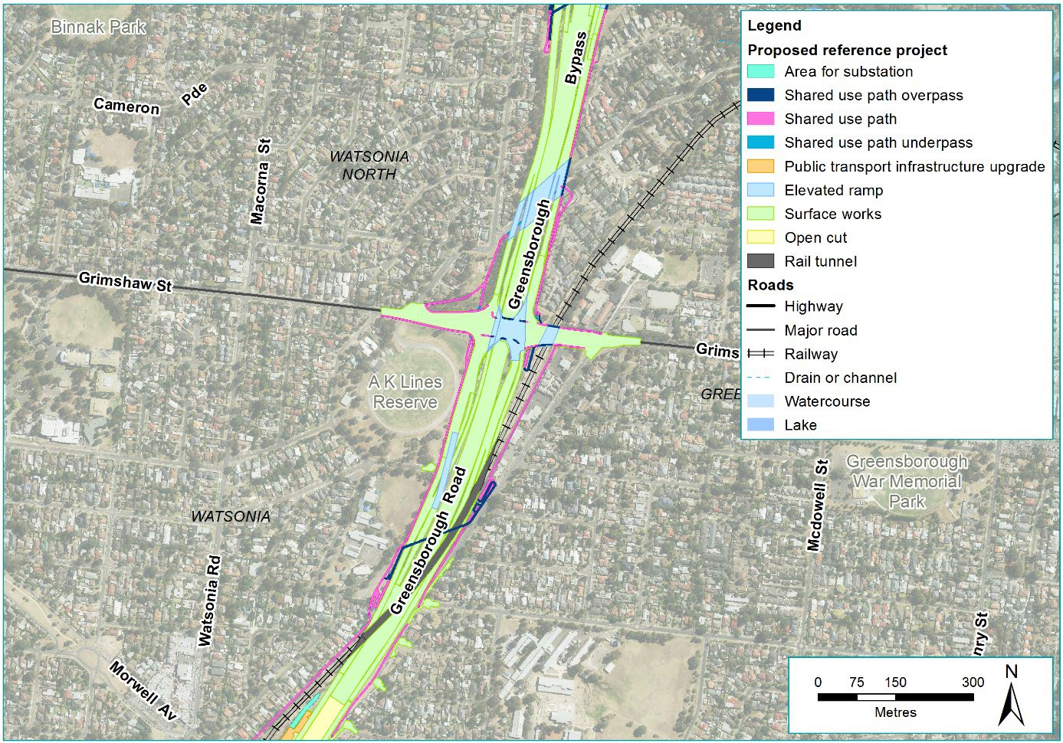
Figure IV-14 Option B (reference project): Grimshaw Street service road layout – interface with Grimshaw Street

Lower Plenty Road interchange
At Lower Plenty Road, North East Link would enter a twin three lane tunnel section and continue south. An intersection at Lower Plenty Road would provide full entry and exit connectivity for traffic. Key challenges associated with this interchange include requirements to:
- Provide suitable grades for the entry and exit ramps
- Provide cover suitable for a tunnel
- Minimise impacts to the community.

As a result of these competing challenges, a number of configurations were considered for this interchange. Three main options assessed were:
- Option A: Standard interchange design
- Option B: New interconnected road design
- Option C (reference project): Greensborough Road centric design.

Option A: Design with interconnections to Lower Plenty Road only
This option looked at providing a design at Lower Plenty Road, where the road connects at a single point. This design concept was explored in a number of ways seeking to achieve the required design functionality and traffic performance.

Two options that applied this design concept are outlined below:

Option A.1: Elongated loop ramps (shown in Figure IV-15)

This option would significantly increase the interchange footprint and increase the impact on Simpson Barracks land. Due to these increased impacts, this option was not continued.
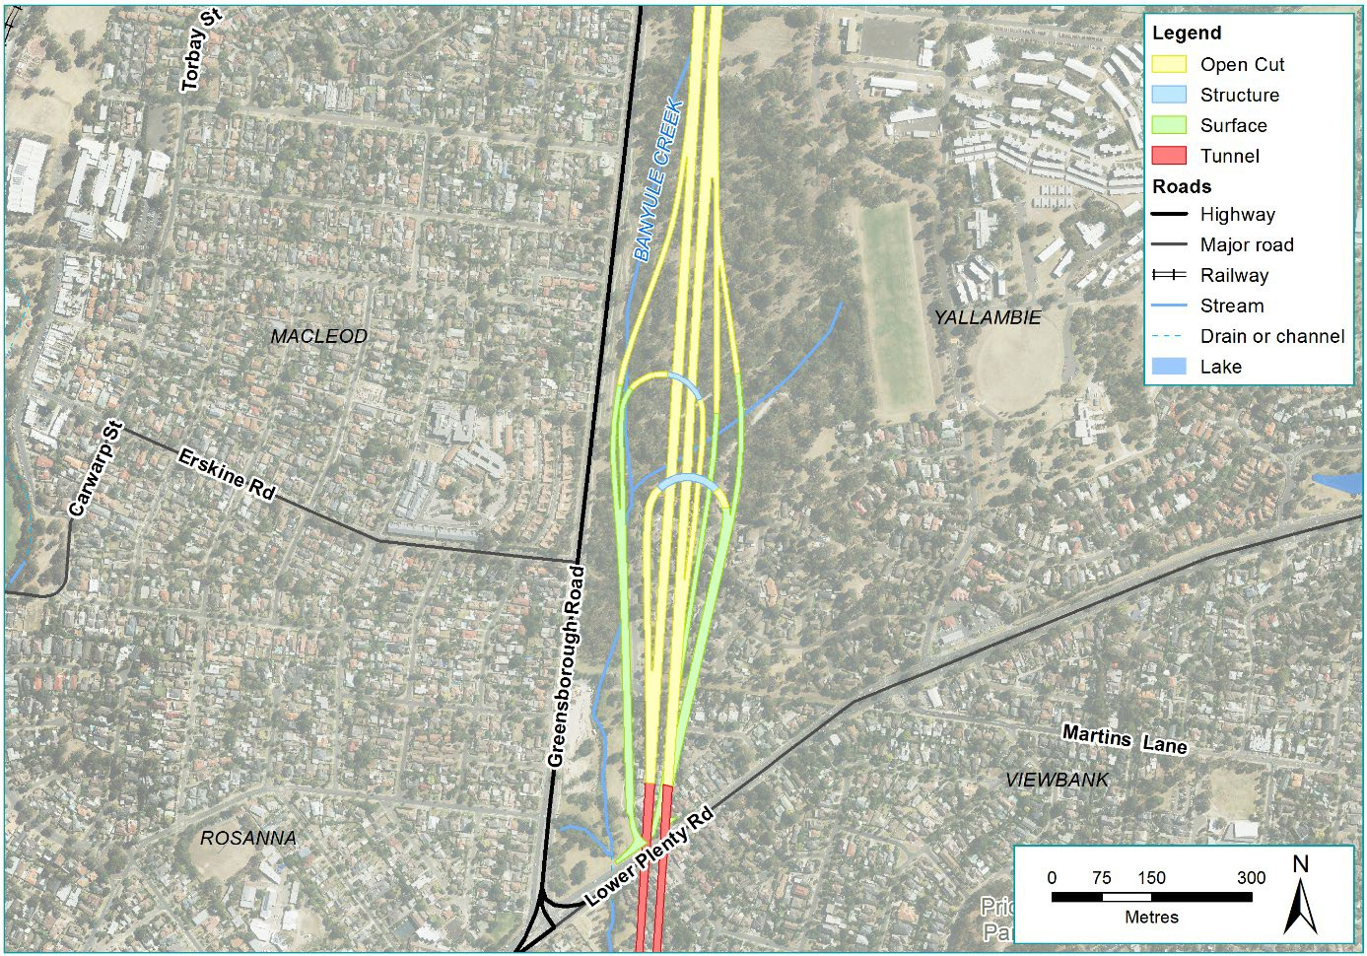
Figure IV-15 Option A.1: Elongated loop ramps

Public Environment Report

Option A.2: Single point urban intersection (shown in Figure IV-16). This option would provide a single point urban interchange with ramps north and south of Lower Plenty Road. However, these ramps to the south would have significant impact on residential properties south of Lower Plenty Road. Due to the scale of this additional permanent residential impact, this option was removed from further consideration.
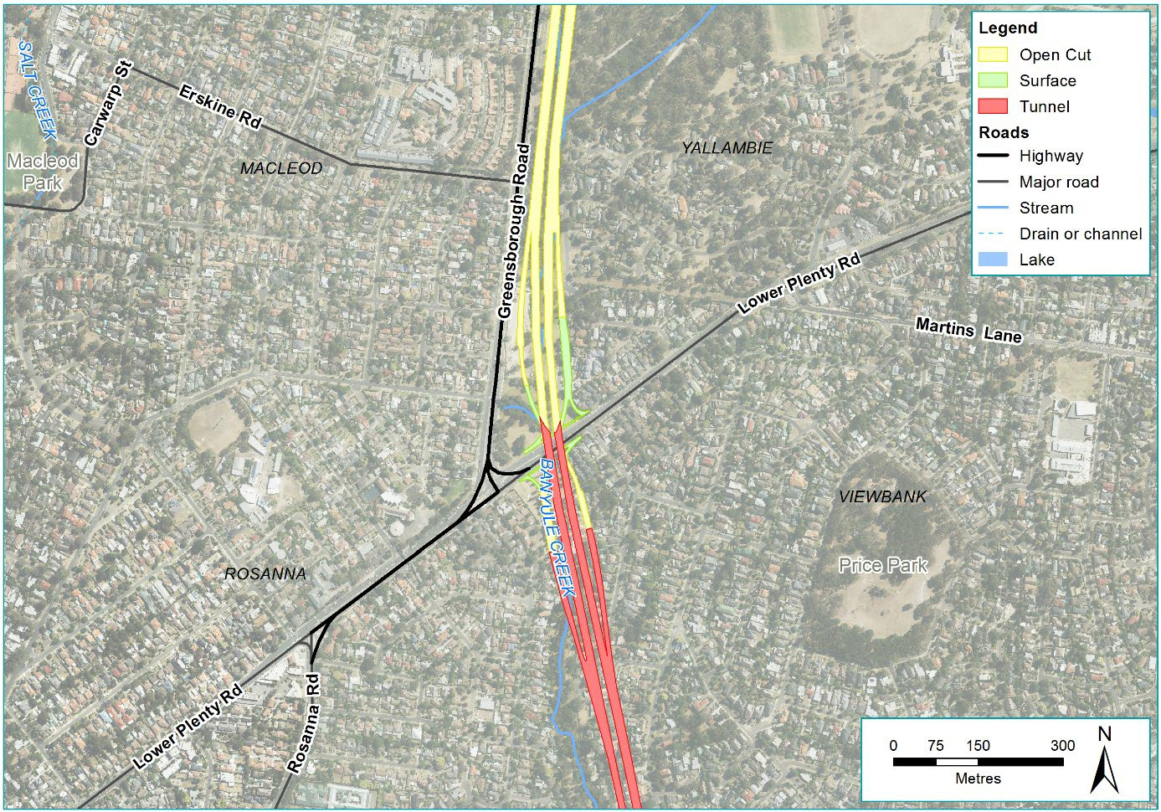
Figure IV-16 Option A.2: Single point urban intersection

Key criteria elements identified the disadvantages with these options. These included:
- Traffic and transport
Traffic performance issues were identified in the assessment of this option due to the close proximity to the existing intersection of Lower Plenty Road with Greensborough Road.
- Land planning and environment
Assessment of these options identified that a significant number of residential properties and additional land (when compared to the reference project) at Simpson Barracks would be required to facilitate the construction and operation of North East Link.

Due to a number of impacts, Option A, a standard interchange design, was removed from further consideration and deemed unsuitable for this location.

Option B: New interconnected road
This option (shown in Figure IV-17) would provide a new interconnected road between Greensborough Road and Lower Plenty Road. Focusing on improved traffic performance, this interchange layout would allow for North East Link movements to run separately from intersection traffic on Lower Plenty Road and Greensborough Road. However, this option would have major impacts on residential properties and Simpson Barracks, and leave a number of properties isolated and surrounded by major roads. Because of the significant property impacts, and inconsistency with the land planning and environment criterion, this option was removed from further consideration.
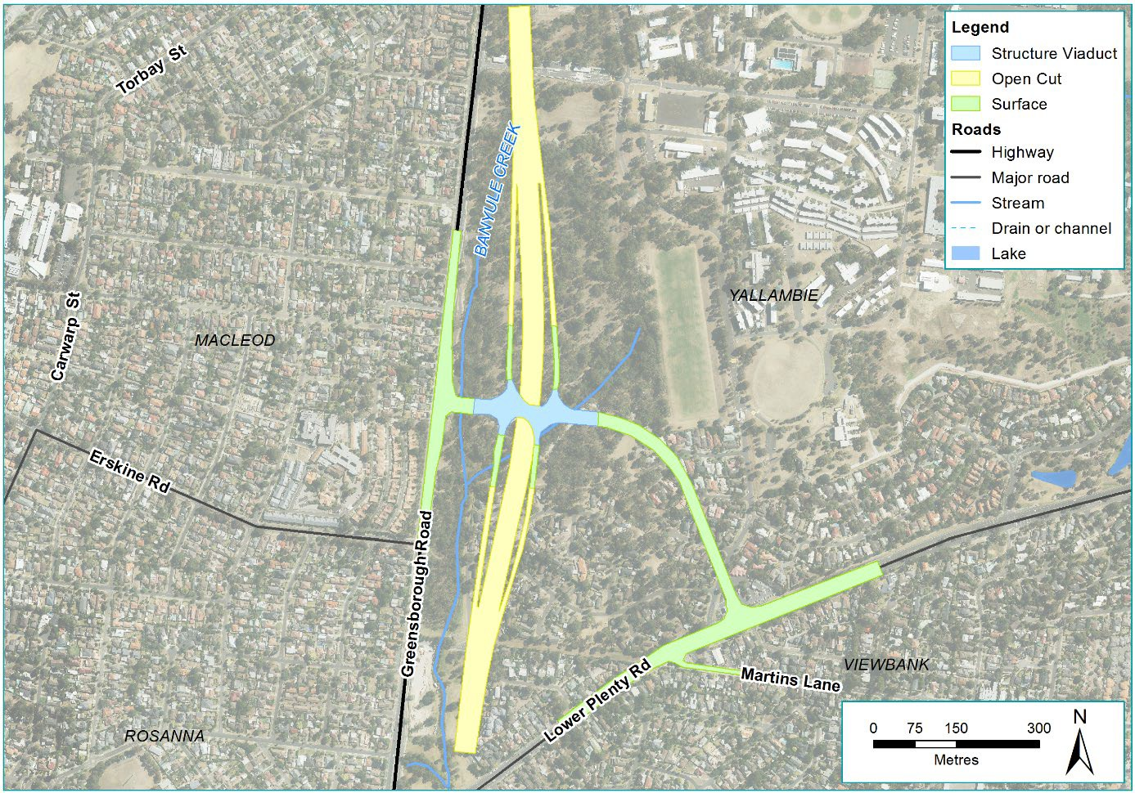
Figure IV-17 Option B: New interconnected road

Public Environment Report

Option C (reference project): Design connecting with both Greensborough Road and Lower Plenty Road
As a result of impacts to Simpson Barracks and residential properties associated with Options A and B considered above, an option interchange design Option C was developed (shown in Figure IV-18).
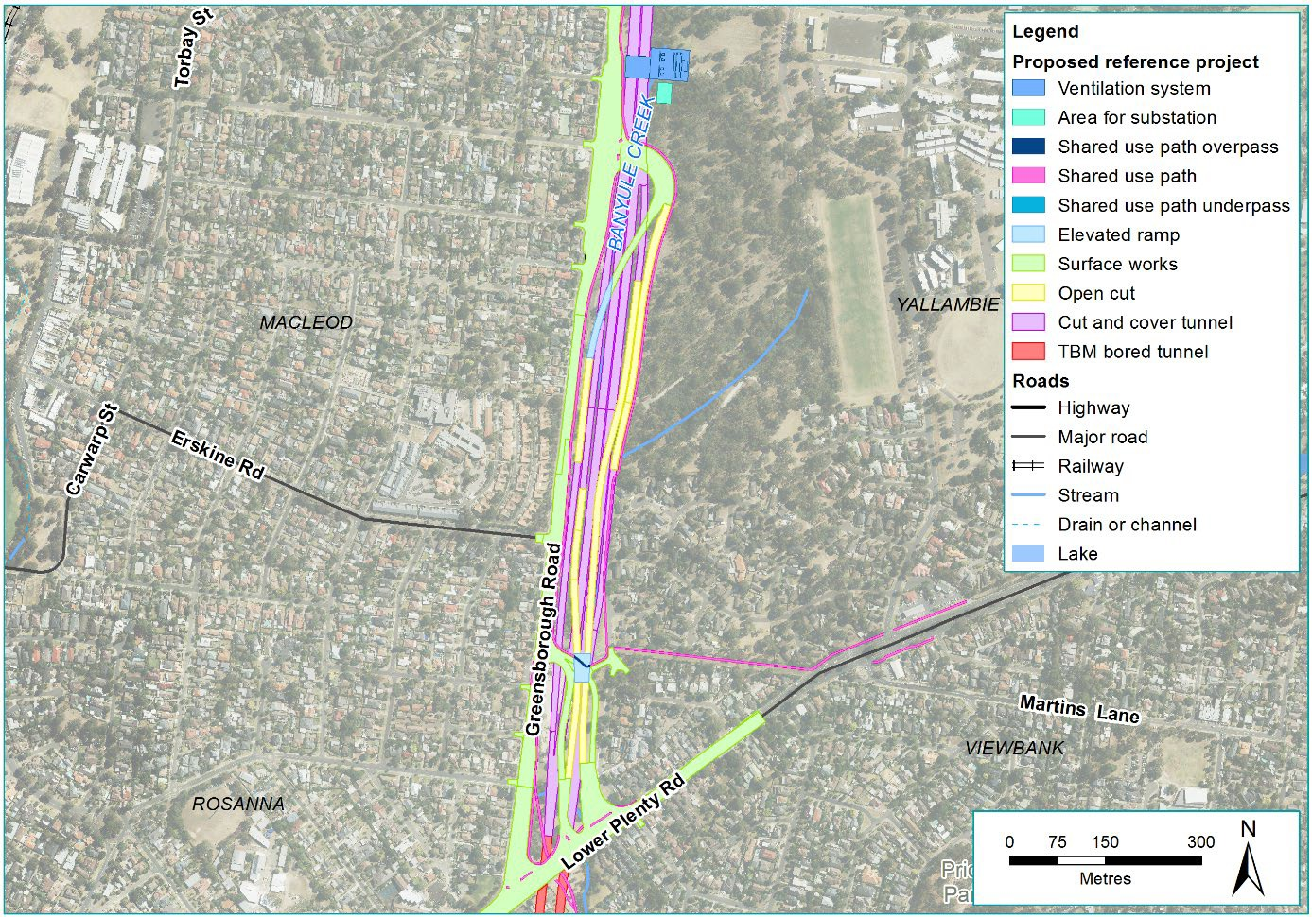
Figure IV-18 Option C (reference project): Lower Plenty Road interchange

Option C would provide for all movements northbound and southbound, and transitions from a trench structure into tunnel. Southbound vehicles on North East Link north of the interchange would be able to exit to Lower Plenty Road via an exit ramp before the tunnel portal. This would enable oversized vehicles and placarded loads (vehicles carrying dangerous goods) that are travelling southbound to exit North East Link before the tunnel begins. Traffic on Lower Plenty Road would be able to enter the northbound carriageway via a ramp from Lower Plenty Road. Vehicles on Greensborough Road and Lower Plenty Road wishing to travel southbound in the tunnel would enter a ramp from Greensborough Road opposite Strathallan Road. Similarly, northbound vehicles in the tunnel wishing to exit to Greensborough Road or Lower Plenty Road would do so via an exit ramp near the tunnel portal, and come up to Greensborough Road opposite Strathallan Road. Despite these benefits, this layout still impacts Simpson Barracks (to a lesser extent than options A and B) and leads to a traffic functionality scenario which is less than optimal. This is due to the complex ramp layouts which are not as intuitive for drivers as in Option B.
Ultimately, the significant benefit of this option is that it aligns with the land planning and environment criterion around minimising land acquisition. This is because it contains the intersection within the road reserve (Greensborough Road) as much as practicable to reduce property impacts. While a small number of residential properties north of Lower Plenty Road would need to be acquired, there is a significant reduction in impacts to Simpson Barracks and removal of impacts to residential properties south of Lower Plenty Road. This option is therefore the preferred option and is included in the reference project.

Manningham Road interchange
The Manningham Road interchange provides access to both the southbound and northbound tunnels from Manningham Road and includes modifications to Manningham Road to maintain access to Bridge Street.

Key challenges associated with this interchange include:
- The challenging grade conditions associated with a portal interchange layout
- A number of significant community facilities and sensitive receptors
- A number of commercial and industrial properties.

As a result of these competing challenges, three key interchange layout options were considered:
- Option A: Traditional interchange layout
- Option B (reference project): Split diamond interchange with access to Avon Street
- Option C (reference project, alternative design): Split diamond interchange without access to Avon Street.

Public Environment Report

Option A: Traditional interchange layout (diamond style interchange)
The feasibility of constructing a simpler diamond interchange for the Manningham Road interchange to avoid the requirement for large looped entry and exit ramps was considered. A number of issues were identified in assessing this option including:
- Design
This option was found to be inefficient due to unacceptably steep ramp grades from and into the tunnels and insufficient capacity, as connections would only be provided to Manningham Road and not Bulleen Road.
- Land planning and environment
This option would impact the area north of Bridge Street including the grounds of the Heide Museum of Modern Art, due to the requirement for a shallow, mined tunnel at this location. This would require significant surface construction works that would have an unacceptable impact on properties and stakeholders surrounding the interchange.

The assessment found that a diamond interchange at Manningham Road was not practicable as the impacts were considered to be too great at the concept phase. Accordingly, this option was not developed any further (no design drawings progressed) and a more location-specific and in some sections, complex, solution was developed.

Option B: Split diamond interchange with access to Avon Street
(reference project proposed design)
In this option (shown in Figure IV-19), the North East Link tunnel levels would be raised through the interchange site (to a minimum cover of 10 metres underneath Heide Museum of Modern Art) to simplify the design, the loop alignment is removed and there is a northbound direct entry ramp connecting to Bulleen Road at the southbound exit ramp terminal intersection located opposite Avon Street. This would reduce the cost of construction and reduce impacts to the Bulleen Industrial Precinct.

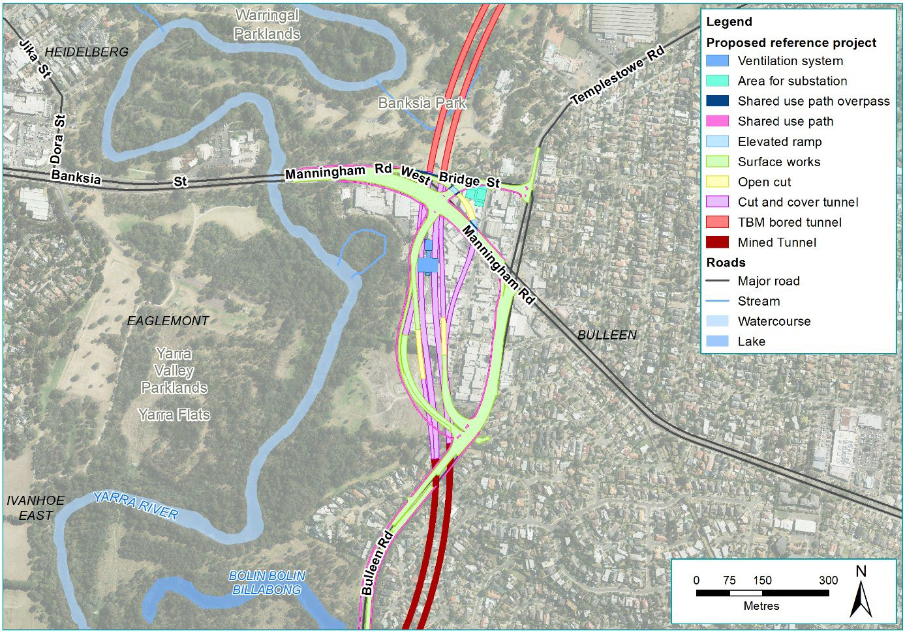

Figure IV-19 Option B: Manningham Road interchange (reference project proposed design)

Option C: Split diamond interchange without access to Avon Street (reference project alternative design)
Consisting of a combination of underground and surface roads extending from south of Bridge Street to just north of Golden Way, this option would provide entry to the northbound tunnel via Manningham Road for westbound traffic through a loop, and to the southbound tunnel via Manningham Road for eastbound traffic (as shown in Figure IV-20).

Public Environment Report

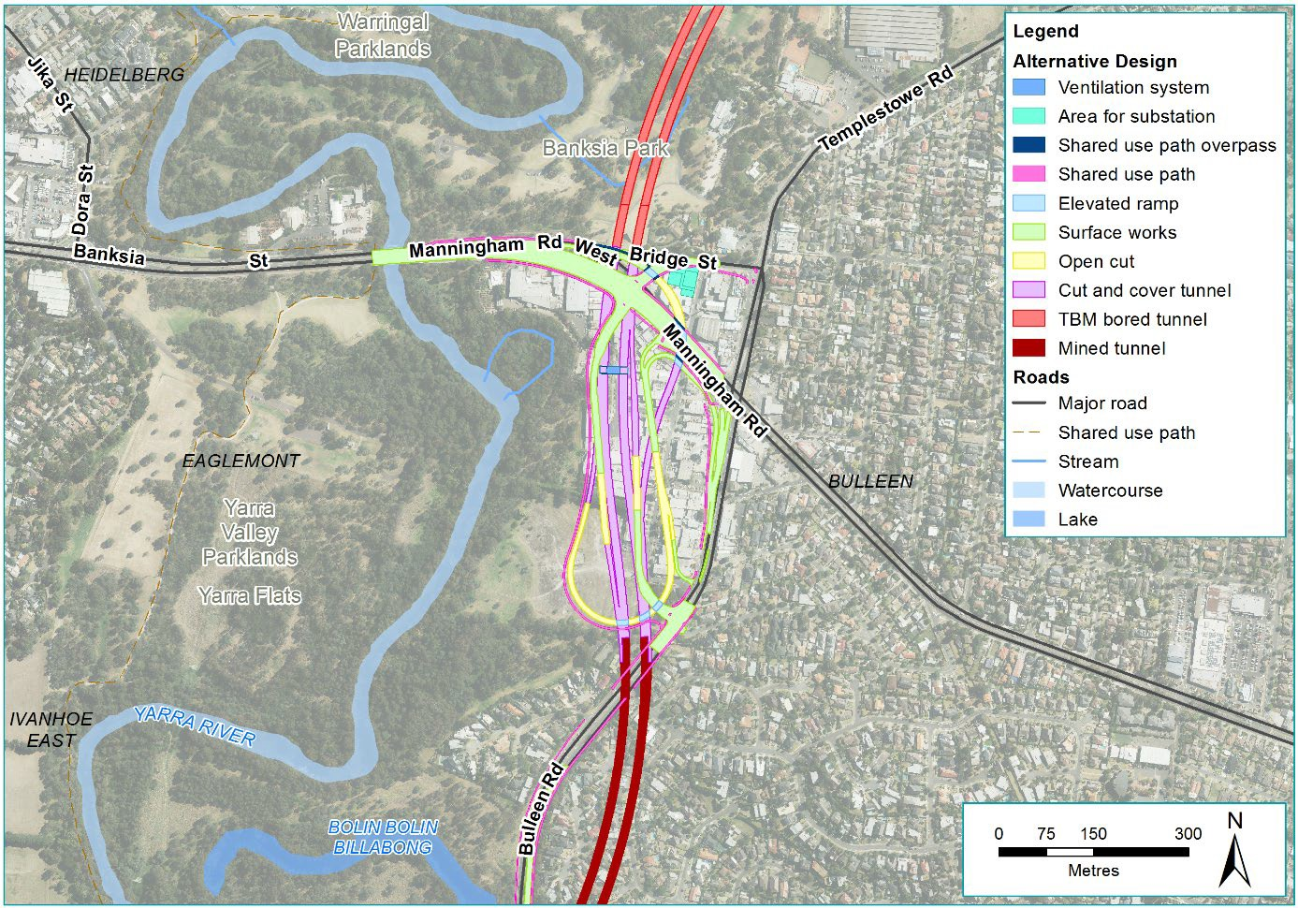
Figure IV-20 Option C: Manningham Road interchange (reference project alternative design)

Northbound tunnel traffic could exit via a ramp to Manningham Road and southbound traffic could exit via a ramp to Bulleen Road. This option would remove surface-level impacts on the Heide Museum of Modern Art by providing a minimum cover of 12.5 metres to the crown of the tunnel, which avoids the requirement for surface construction works north of Bridge Street. This interchange layout would also avoid impacts to residential properties south of the interchange. In addition, this option would minimise ramp grades and provides satisfactory traffic performance. However, this option would be expensive due in part to the deep and extensive cut and cover construction required, the complexity of the interchange design and the major impact on the Bulleen Industrial Precinct.

Eastern Freeway interchange
The options associated with the Eastern Freeway interchange at the southern end of North East Link were largely determined by the tunnel alignment and elevation of the interchange. This was assessed in Section 2.3 above as part of the southern end tunnel length assessment.

Assessment of feasible options to upgrade the Eastern Freeway

Overview
Where North East Link connects into the Eastern Freeway at Bulleen Road, demand for travel along the Eastern Freeway is expected to increase significantly. According to traffic modelling, approximately 75 per cent of traffic would travel easterly along the Eastern Freeway and 25 per cent to the west.
Why upgrade the Eastern Freeway?
The Eastern Freeway is one of the last metropolitan freeways in Melbourne to be upgraded to a fully managed motorway. Daily weekday traffic volumes along the Eastern Freeway range from 128,000 to 178,000 vehicles per day. Congestion can be attributed to three key challenges:
- Merging and weaving at interchanges
- Constrained capacity of the freeway ramps
- Constrained sections of road between interchanges.
North East Link would compound this traffic congestion.

The Eastern Freeway would be upgraded and modernised between Hoddle Street in the west and Springvale Road in the east to integrate effectively with North East Link, and to cater for the increasing traffic volumes and changing travel demands and also provide greater capacity.

Upgrade works would include the widening of the Eastern Freeway to accommodate additional lanes and new dedicated bus lanes between Doncaster Road and Hoddle Street (the ‘Doncaster Busway’) (outlined in Section 5).

The options considered for the Eastern Freeway are illustrated in Figure IV-21.
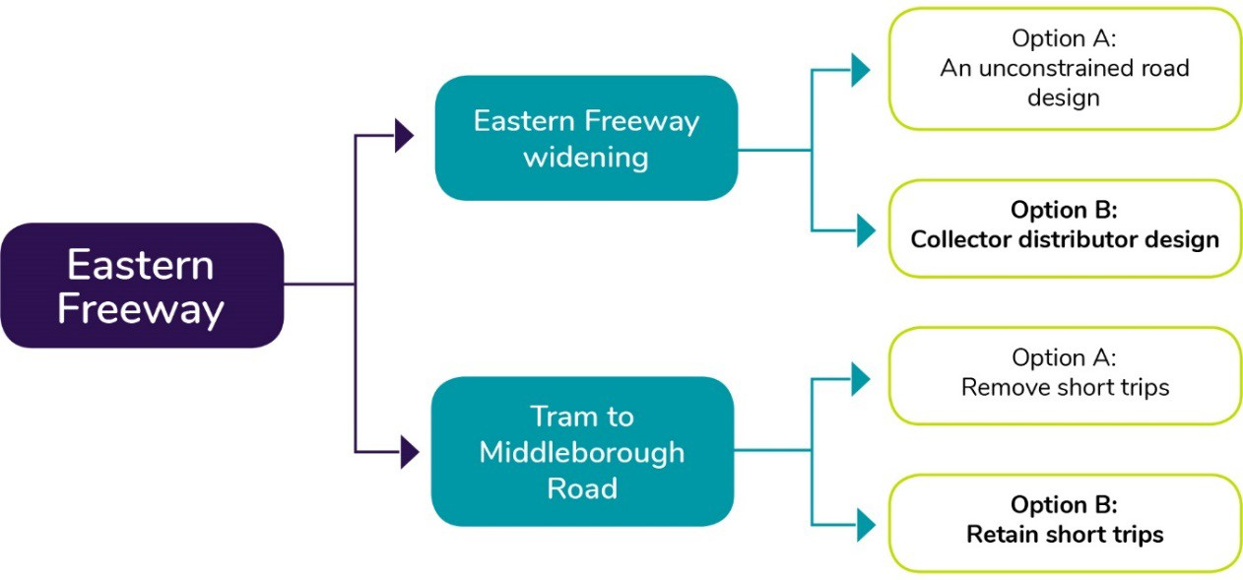
Figure IV-21 Design options for Eastern Freeway

Public Environment Report

Eastern Freeway widening
Two key road design options were available for the layout of the Eastern Freeway widening:
- Option A: An unconstrained road design
- Option B (reference project): A collector distributor design.

Option A: An unconstrained road
The current layout of the Eastern Freeway is an unconstrained road where cars in any lane can merge and weave across the corridor in both directions. When high volumes of traffic enter and exit the freeway, the merging and weaving tangles traffic, slows it down and causes congestion.
Short distances between entries and exits on the Eastern Freeway intensify the problem, as
drivers are trying to move into the left lane to exit, at the same time as traffic is trying to merge on to the freeway.

This road layout, together with insufficient road width, has resulted in parts of the Eastern Freeway, particularly around Bulleen Road, operating close to capacity. During peak periods of the day, some sections are significantly over capacity: Station Street to Elgar Road, Elgar Road to Doncaster Road, and Doncaster Road to Bulleen Road in the PM peak and Springvale Road to Blackburn Road in the AM peak.

As a result of the existing traffic conditions, and the compounding impact of the construction of North East Link, widening using an unconstrained road design was not investigated further.

Option B (reference project): Collector-distributor design
A collector-distributor design for the Eastern Freeway would separate traffic travelling on ‘express way’ carriageways, from traffic entering and exiting the freeway on local access carriageways.
These lanes would be separated by solid safety barriers. Traffic entering the freeway from the city and Chandler Highway would be able to access express lanes straight through to Middleborough Road, Blackburn Road, Springvale Road and the EastLink tunnel. This would accommodate weaving away from the express carriageway, and minimise the number of entry and exit points, while still providing additional capacity. To facilitate this capacity, new lanes would be added between Bulleen Road and Springvale Road, and between Chandler Highway and Bulleen Road to separate traffic staying on the freeway from traffic getting on and off North East Link and Bulleen Road.
By minimising weaving, this design solution would improve the efficiency of the freeway and the safety of drivers. Additional lanes would provide capacity to support the existing levels of traffic as well as the additional traffic as a result of North East Link. This collector-distributor design layout was identified as the preferred option for the reference project. It is shown in Figure IV-22.

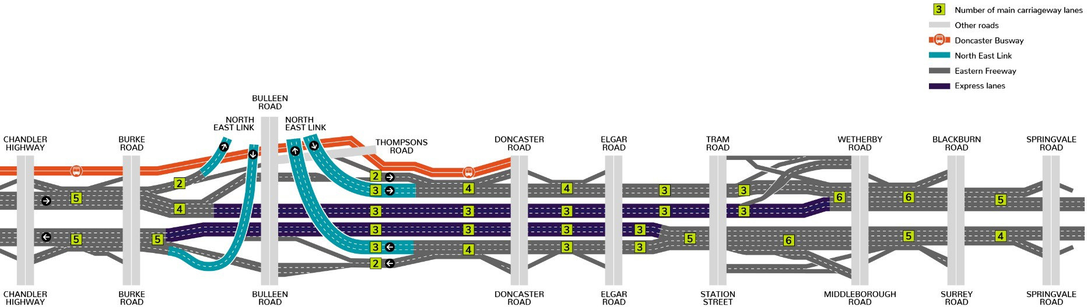

Figure IV-22 Option B (reference project): Schematic lane diagram of Eastern Freeway upgrades

Public Environment Report

Tram Road to Middleborough Road short trips
The section of the Eastern Freeway between Tram Road and Middleborough Road is currently used by locals for short trips between Doncaster and Box Hill.

These short trips can be completed via the entry and exit ramps on both carriageways. While trips like this are usually undesirable on the freeway system, at this location this link provides a useful function in the road network, and is used by approximately 400–500 vehicles an hour. This is largely because the nearest alternative arterial road routes, Doncaster Road and Whitehorse Road, are remote from the Eastern Freeway and there are no easily useable local road options between Doncaster Road and Whitehorse Road.

In the context of the collector-distributor design proposed for the Eastern Freeway, two options for these short trips were considered:
- Option A: Remove short trips
- Option B (reference project): Retain short trips.

Option A: Remove short trips
This option looked at removing the short trip functionality due to the short distance between the entry ramp from Middleborough Road and the exit ramp to Tram Road. Facilitating this movement would require vehicles travelling in express lanes in the centre of the freeway to cross multiple lanes to reach the exit ramp at Middleborough Road. This kind of weaving has the potential to congest the freeway.

However, due to the significant number of locals who rely on these short trips, if removed, locals would need to use already congested local roads including Doncaster Road and Whitehorse Road. As a result, this option to remove short trips was not considered further, and further work was completed to identify whether short trips could be retained without compromising the functionality and safety of the freeway.

Option B (reference project): Retain short trips
This option provides a design solution which would retain short trips without impacting freeway functionality.
What are braided ramps?
Braided ramps are grade separated ramps which look like a braid from above. They are used to separate merging traffic to improve safety and ease congestion. They can minimise merging and weaving of traffic and maximise freeway capacity.
This would be facilitated by providing dedicated lanes along braided ramps between Tram Road and Middleborough Road, which weave over and under each other to avoid merging and weaving on and off the freeway (as shown in Figure IV-23).

This design option would untangle these traffic movements on the freeway, keep traffic off local roads, maintain traffic flow along the Eastern Freeway and keep drivers safe.
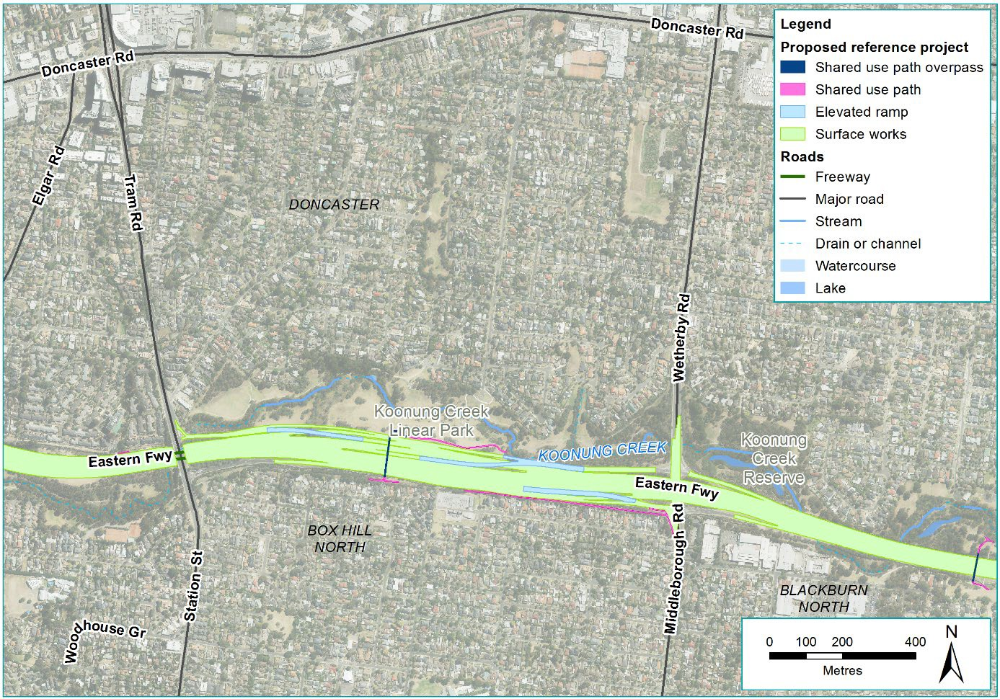
Figure IV-23 Option B (reference project): Short trips between Tram Road and Middleborough Road

Public Environment Report

Assessment of feasible Doncaster Busway options

Overview

Why provide a busway?
The Doncaster Busway, as part of North East Link, is expected to:
- Enable buses to bypass congestion on the Eastern Freeway and its entry and exit ramps
- Improve the reliability of bus travel times along the Eastern Freeway, with the Doncaster Busway travel time along the Eastern Freeway between Doncaster Road and Hoddle Street predicted to be up to 30 per cent faster in 2036 when compared with the non-upgraded Eastern Freeway with no Doncaster Busway improvements
- Allow a higher frequency of services to be implemented, due to faster and more reliable trips between Doncaster Road and Hoddle Street.

Three options for the Doncaster Busway along the Eastern Freeway were assessed as described in Figure IV-24 below.
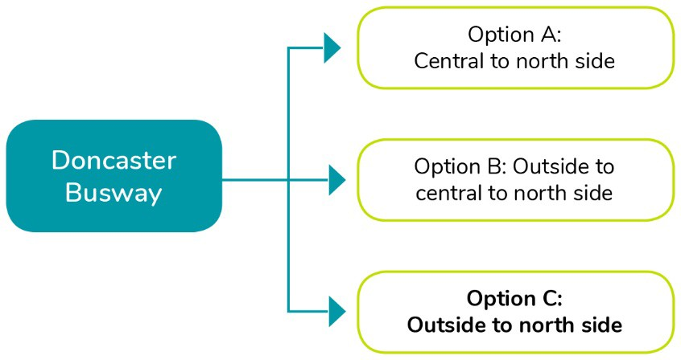

Figure IV-24 Design options for Doncaster Busway

Option A: Central median from Victoria Park and north side from Burke Road
This option (as shown in Figure IV-25) would provide for a two-lane, two-way carriageway for the exclusive use of scheduled bus services predominantly along the median reservation of the Eastern Freeway from east of Hoddle Street to west of the Bulleen Road interchange with the Eastern Freeway. From just east of Burke Road the busway would move across the eastbound carriageway of the freeway (on an elevated structure) then travel along the northern edge of the freeway to Doncaster Road in the east. At its western end, the busway would connect to the Victoria Park railway station precinct (east of the rail line) via an elevated structure over the westbound Eastern Freeway carriageway.
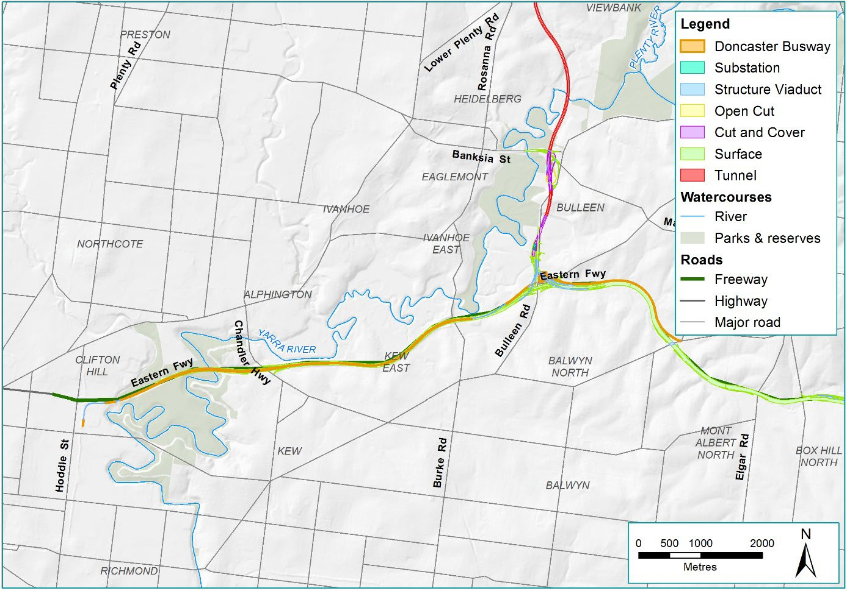
Figure IV-25 Option A: Doncaster busway central median from Victoria Park and north side from Burke Road

Option A was discounted due to key challenges for safely operating and maintaining dedicated bus lanes in the central median of an operational freeway. This design and functional layout would challenge emergency service access to the busway and also may create safety issues for passengers and other traffic if a bus broke down.

Public Environment Report

Further, Transport for Victoria advised the busway was to connect directly to Hoddle Street at its western end rather than directly to Victoria Park railway station. Transport for Victoria wishes to preserve an option for a potential future link from the Eastern Freeway busway to Victoria Park railway station.

Option B: Outside lanes from Hoddle Street, central median from Chandler Highway and north side from Burke Road
This option (shown in Figure IV-26) would provide a dedicated busway on the existing shoulders of the Eastern Freeway between Hoddle Street and Chandler Highway. From Hoddle Street (in both directions), the busway would shift to the central median via underpasses at the Chandler Highway. East of Chandler Highway the busway would remain in the median up to the east of Burke Road before moving to the north side of the freeway, as described in Option A.

Option B was discounted due to issues related to the ramp structures at Chandler Highway.

As described in Option A above, Option B was also removed from further consideration due to key challenges with being able to safely operate and maintain dedicated bus lanes in the central median of an operational freeway.
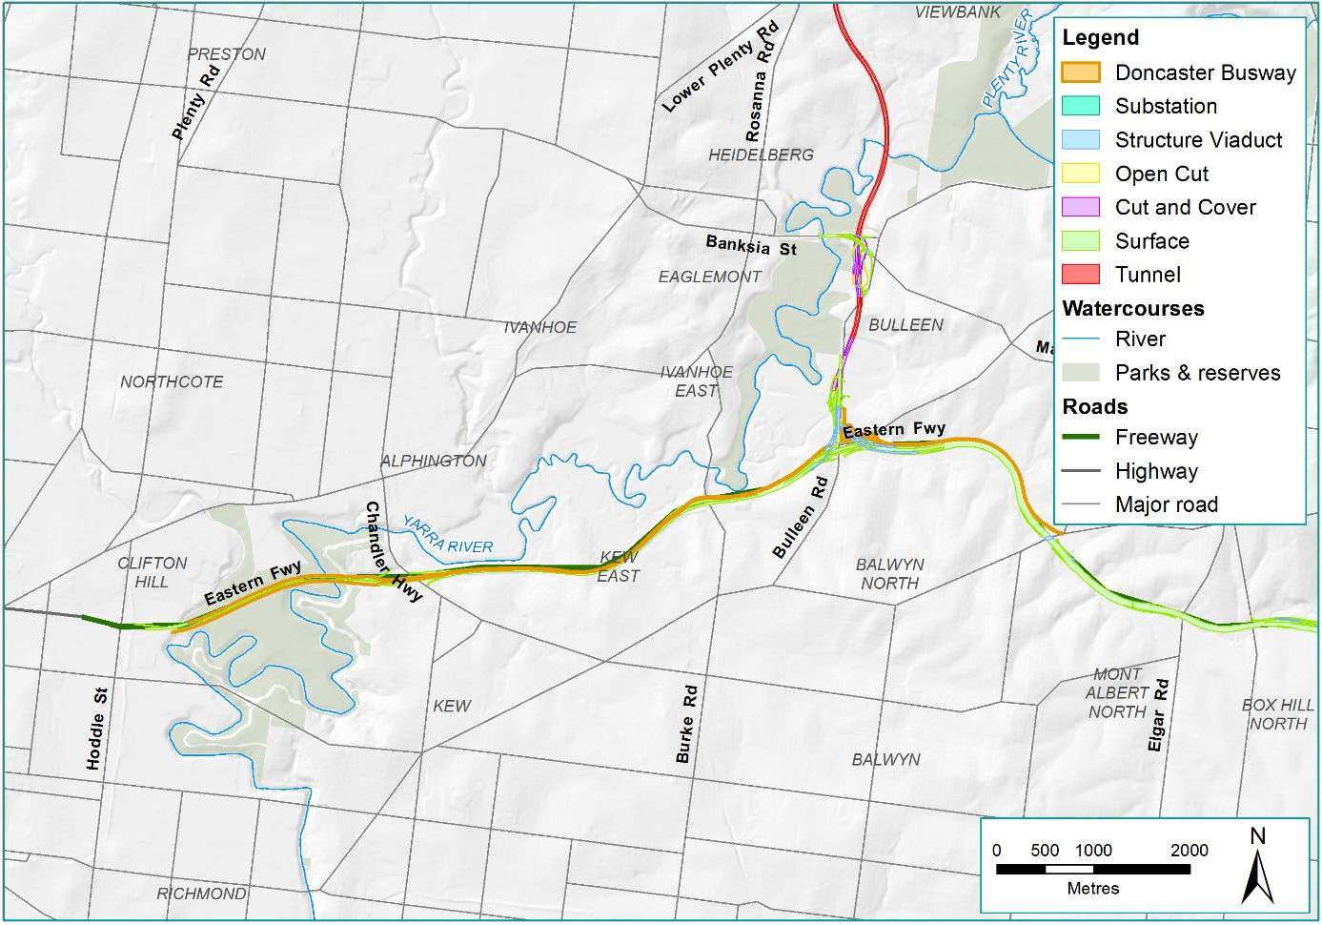
Figure IV-26 Option B: Doncaster Busway outside lanes from Hoddle Street, central median from Chandler Highway and north side from Burke Road

Option C (reference project): Outside lanes from Hoddle and north side from Chandler Highway
This option (shown in Figure IV-27) would include new dedicated bus lanes on the existing shoulders of both the east and west carriageways from Hoddle Street to the Chandler Highway interchange.
From the Chandler Highway interchange, the outbound busway lane would pass under the outbound off-ramp and remain on the north side of the Eastern Freeway. The inbound busway lane would pass from the northern side of the alignment over both Eastern Freeway carriageways and the inbound on- ramp before connecting to the shoulder. This overpass would be about the same height as Chandler Highway. Connections to and from the Chandler Highway and the busway west of Chandler Highway would also be accommodated. To provide sufficient space for the new dedicated bus lanes, traffic lanes would be shuffled into the median strip to avoid further land acquisition.
Further development and analysis, including consultation with other agencies and bus operators, has found that Option C would provide the most acceptable and efficient outcome. This busway option would provide the following beneficial outcomes:
- A direct connection to the existing bus lanes on Hoddle Street and improved travel times
- It would not preclude bus stations at Chandler Highway and Burke Road
- It would allow bus routes on Chandler Highway to connect to the busway.

Public Environment Report

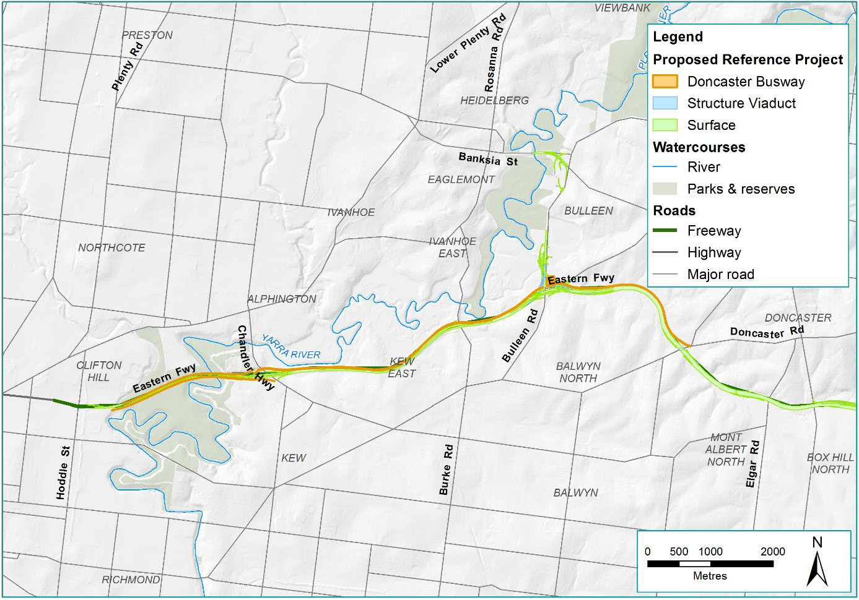
Figure IV-27 Option C (reference project): Doncaster Busway

The reference project
Following the review and refinement of options for the different key design elements, the reference project was developed for assessment as a part of the PER. In addition to the options described above, key changes made to the design elements were influenced by community and stakeholder engagement and the specialist studies.

Through a number of community design update information sessions and ongoing engagement with stakeholders and the community, key issues relevant to the community and stakeholders were incorporated into the options assessment for the reference project (see PER Chapter 14 – Consultation for details on when and how feedback was sought).

The specialist assessments of the impacts of North East Link undertaken through the PER and Environment Effects Statement (EES) processes also influenced the refinement of the reference project. This largely occurred through the identification of key impacts and collaboration with the design team to identify where impacts could be avoided or where they needed to be managed through the design.

For a complete overview of the reference project, see PER Chapter 3 – Description of the action.

