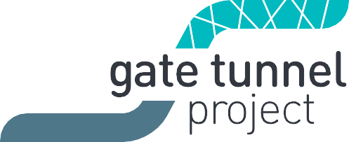
West Gate Tunnel Project
GPO Box 33312
Melbourne Victoria 3004
1800 105 105
westgatetunnelproject.vic.gov.au westgatetunnelproject@wda.vic.gov.au

Reference: TUN1805.1

3 May 2018

Works notification:

Ongoing works on Whitehall Street and Hyde Street – May and June 2018

A range of works are continuing through May and June as we prepare to divert a section of the North Yarra Main Sewer ahead of tunnelling works starting in 2019.

Upcoming works on Whitehall Street and Hyde Street

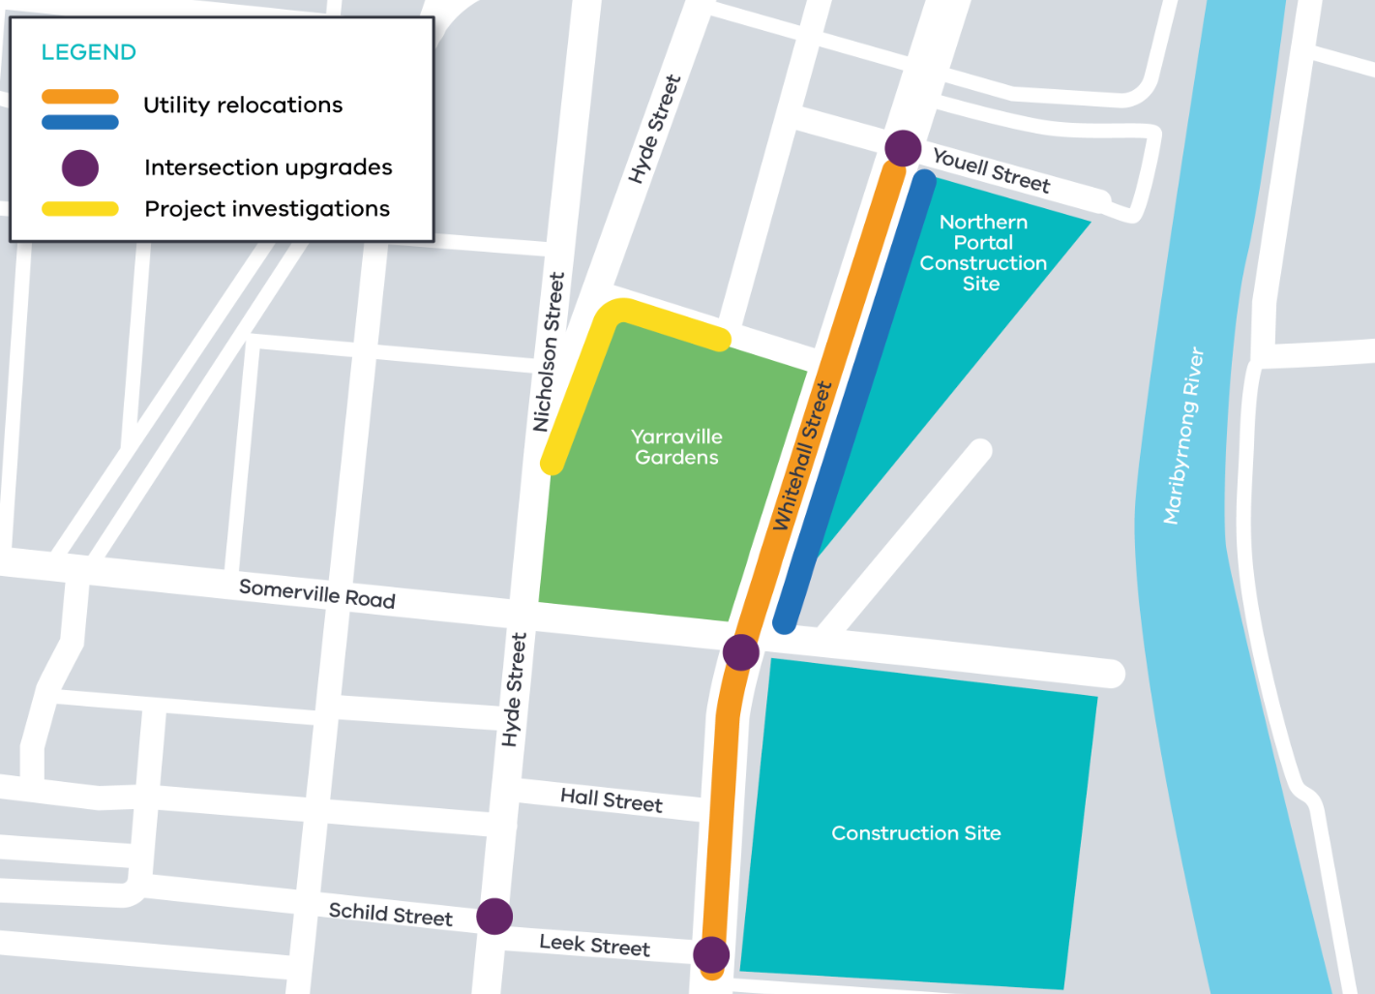

Working hours for works outlined in this notification are:
- Day works: Monday to Friday 6am-6pm and Saturday 6am-4pm
- Night works: Sunday to Thursday 7pm – 5:30am

Managing construction
Construction will be actively managed to minimise disruption as much as possible.
- Clear signage and traffic controllers to manage changed traffic conditions
- Regular updates about our works
- Monitoring and altering conditions as needed to maintain traffic flow, access and safety
- Monitoring and managing any environmental impacts such as dust
- Access to properties maintained at all times

Whitehall Street
Relocation of water and gas services – 13 May to early June
- Working on Whitehall Street, between Earsdon Street and Youell Street
- Day and night works
- Some or all lanes on sections of Whitehall Street will need to be closed at times while we work, with clearly signed detours in place for drivers (night only)
- No disruption to gas or water services

Relocation of electricity services – 16 May to late June
- Working along the Whitehall Street shared user path, between Somerville Road and Youell Street
- Day and night works
- Closure of the shared use path at times while we work, with safe and clearly signed detours in place for cyclists and pedestrians
- Some car parking on the east side of Whitehall Street unavailable at times while we work
- No disruption to electricity services

Intersection upgrades at Youell Street, Somerville Road and Leek Street – 16 May to mid June
- Installing new signals and making road modifications
- Night works only
- Some overnight lane and road closures needed while we work, with short term detours directing traffic around the works via Hyde Street and back onto Whitehall Street
- Existing truck curfews will remain in place

Hyde Street
Intersection upgrade at Leek Street – 16 May to mid June
- Installing new signals and making road modifications
- Day works only
- No entry from Hyde Street into Leek Street at times while we are working
- Traffic management in place to manage changed conditions including signage to guide drivers, cyclists and pedestrians safety around the area

Project investigations – 16 May to late May
- Working along the shared use path next to Yarraville Gardens and on Harris Street
- Day works only for approximately three days
- Traffic management in place to manage changed conditions including temporary access changes to some car parking spaces, and signage to guide road users, cyclists and pedestrians.

Please note that works are subject to change and may be rescheduled in the event of bad weather or updates to the construction schedule. For updates and more information about our works please visit westgatetunnel.vic.gov.au or contact us using the details below.
Contact us
Please contact us if you have any questions or feedback about these works.
westgatetunnelproject.vic.gov.au | facebook.com/westgatetunnelproject
westgatetunnelproject@wda.vic.gov.au | @westgatetunnel
1800 105 105 | West Gate Tunnel Project  GPO Box 4509  Melbourne Victoria 3001
Interpreter service: 13 14 50

