Reference: WES1902.18
7 March 2019
Works update – temporary driveway disruption

Construction is well underway on Paringa Road to safely relocate some existing power lines that currently run along the West Gate Freeway, to underground. As part of these works, sections of Paringa Road are being progressively closed to vehicles in stages until May 2019 for the initial phase of works.
Temporary disruption to your driveway access
As our team has discussed with you, vehicle access to your driveway will be temporarily blocked from Wednesday 13 March until approximately Wednesday 10 April.
There will be further works in this area in May 2019 that will impact your driveway access. More information will be provided before these works start.
During this time:
- vehicle access to the staged works area on Paringa Road and some parking will be blocked;
- you can park your vehicle outside the construction area and walk to your property. Please see the map over the page for location details.
- footpath access to your property will remain open at all times; and
- the carpark behind the 16 shops will remain open.
If you require any assistance with carrying items to or from your vehicle during the day, please ask one of our friendly onsite team who will be able to assist you.

When you need to move your vehicle:
- please ensure your vehicle is moved out of your driveway by 10pm on Tuesday 12 March 2019 if you wish to use your car during the works.

Where to park your vehicle when driveway access to your property is blocked:
- it is recommended that you park your vehicle on Paringa Road outside our construction area or in a neighbouring street.

Waste collection changes:
- while works are directly outside your property and vehicle access is blocked, please place your rubbish bins in Bond Street on the east side (the Millers Road side) so they can be collected by the waste contractor;
- please ensure that your bin is moved to this location by 11pm on Tuesday nights while the works are occurring, for collection by Council early on Wednesday mornings.

What you could expect:
- an increase in construction vehicles within the area;
- an increase in construction noise during the day from our machinery and trucks;
- water spray trucks to help manage dust and dirt and loads will be covered when dirt and rock are being transported.

These works will generally be carried out from Monday to Friday between 7am - 6pm and Saturdays between 7am - 3pm.

There are also underground bore works required under the West Gate Freeway at Chambers Road. These works will be carried out at night starting on Sunday 17 March for approximately four weeks, with site establishment during the day from Saturday 16 March 2019. These works will generally be carried out from Sunday to Thursday from 8pm – 5am

Please note that works and timings may change in the event of bad weather or other unavoidable circumstances.
For updates and more information about our works please visit westgatetunnel.vic.gov.au or contact us using the details below.

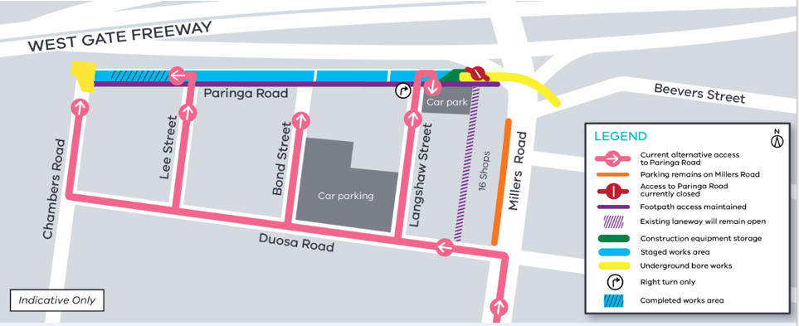

Contact us
Please contact us if you have any questions or feedback about these works.
 | westgatetunnelproject.vic.gov.au |  | facebook.com/westgatetunnelproject
 | info@wgta.vic.gov.au |  | @westgatetunnel
 | 1800 105 105 |  | West Gate Tunnel Project  GPO Box 4509  Melbourne Victoria 3001
 | Interpreter service: 13 14 50

