WES1908.06

16 August 2019

Works notification: Rosala Avenue walking and cycling overpass and local road access

As part of widening the West Gate Freeway, we are installing a new walking and cycling overpass connecting Rosala Avenue and Richards Court. The new overpass will be 6.1 metres high, 60 metres long and three metres wide over the freeway. It will be fully accessible to all users.

We have finished building the ramp and bridge abutment on the north side of the freeway (near Richards Court) and are now building those features on the southern side (near Rosala Avenue). We have completed piling for the abutments and piers on the south side and are moving onto the remaining work outlined below.

When
- installation of the scaffold and formwork (a wooden mould) for the overpass abutment is now underway and is expected to be completed by the end of August
- pre-cast beams and panels which support the overpass ramp will be lifted into place using a crane in early September
- construction of the concrete overpass ramp will take place from September until November
- other work in this area, including building the new noise walls, installing freeway drainage and constructing new lanes on the freeway will continue until early 2020.

Local road site access
Our works have entered a new stage. As we progress works on the southern side of the West Gate Freeway, the way we access our construction site also needs to change. We now need to enter our work site from gates on Irwin Avenue, Rosala Avenue and Freemans Road/Misten Avenue (please see the map over the page).

Up until recently we mostly accessed this work site from an entrance on the freeway, however lane changes, drainage work and the location of the pier of the existing overpass and freeway barriers has restricted space for construction vehicles to move around on site. We need, therefore, to have multiple entry points to the site.

Site gates will only be open when access is required and will not be left open for extended periods.

Keeping local roads clean
Winter conditions are making our work sites muddy. We try to keep local roads as clean as possible. We have processes in place to monitor and clean dirt and mud tracked onto local roads, including using a street sweeper regularly when conditions are wet and dusty.

Where
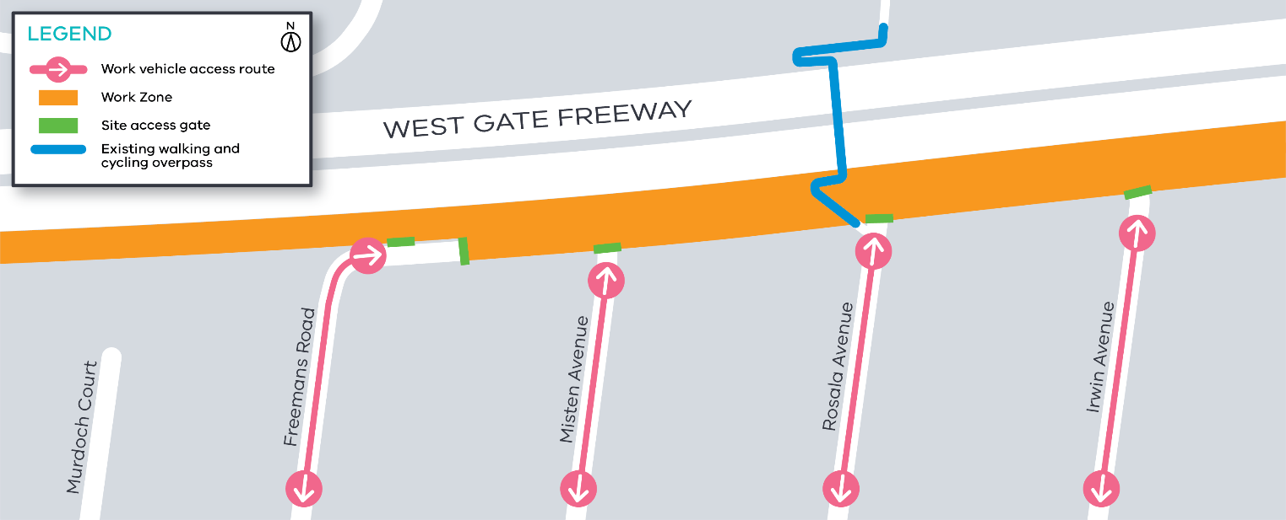

What you can expect during the works
- construction vehicles including piling rigs, excavators, concrete trucks and pumps, earthmoving equipment and cranes moving in and out of work areas
- construction noise from our machinery and trucks will increase at times while we carry out piling and excavation works
- work machinery might need to park on local roads for short periods of time
- dust and dirt will be minimised by using water spray trucks, street sweepers and covering dirt and rock when it’s transported
- traffic changes including lane, road and ramp closures might be required. The latest traffic updates are available at westgatetunnelproject.vic.gov.au/traveldisruptions

Our works will generally be carried out from Monday to Friday between 7am - 6pm and Saturdays between 7am - 1pm, however some night works might be required. If works are scheduled out of hours or at night we’ll provide further information to you before works start.

Please note works might be rescheduled in the event of bad weather or other unavoidable circumstances.

Thank you for your patience while we carry out these important works.

Contact us
Please contact us if you have any questions or feedback about these works.
 | westgatetunnelproject.vic.gov.au |  | facebook.com/westgatetunnelproject
 | info@wgta.vic.gov.au |  | @westgatetunnel
 | 1800 105 105 |  | West Gate Tunnel Project  GPO Box 4509, Melbourne VIC 3001
 | Interpreter service: 13 14 50

